Okeanos Explorer ROV Dive Summary
Dive Information
Dive Map | 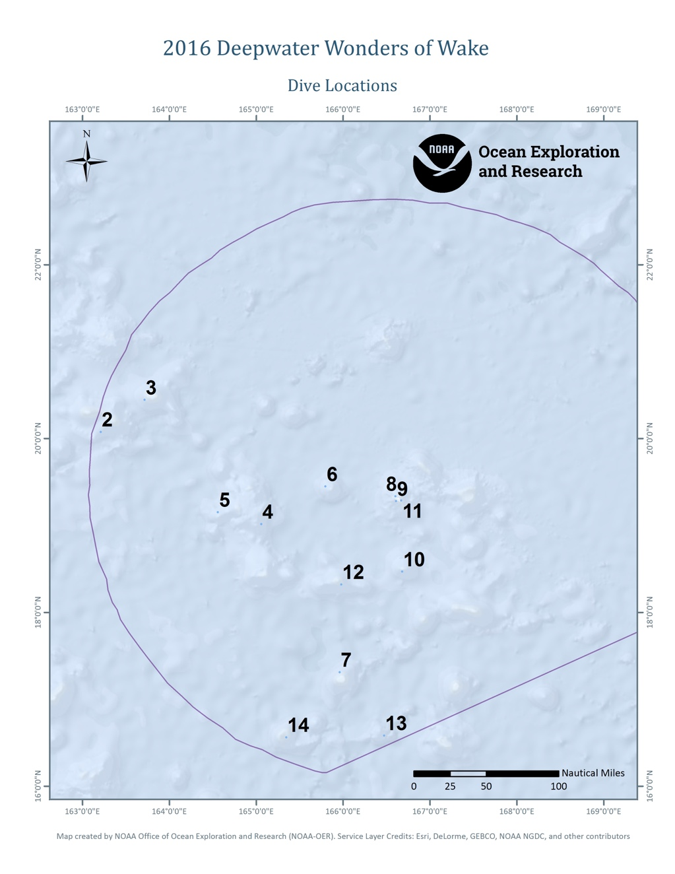
Site Name | McDonnell Guyot
Expedition Coordinator(s) | Brian RC Kennedy
ROV Lead(s) | Dan Rogers
Science Team Lead(s) | Chris Kelly and Jasper Konter
General Area Descriptor | Wake Atoll unit of PRIMNM
ROV Dive Name
Cruise | EX-16-06
Leg | 0
Dive Number | 4
Equipment Deployed
ROV | Deep Discoverer (D2)
Camera Platform | Seirios
ROV Measurements | CTD | Depth | Altitude
 | Scanning Sonar | USBL Position | Heading
 | Pitch | Roll | HD Camera 1
 | HD Camera 2 | Low Res Cam 1 | Low Res Cam 2
 | Low Res Cam 3 | Low Res Cam 4 | Low Res Cam 5
Equipment Malfunctions | Before the ROV reached bottom the ship lost power and the dive was aborted.
ROV Dive Summary  (from processed ROV data) | Dive Summary: EX1606_DIVE04  ^^^^^^^^^^^^^^^^^^^^^^^^^^^^^^^^^^^^^^^^^^^^^^^^^^^  In Water: 2016-08-03T20:53:07.902000  19°, 00.893' N ; 165°, 03.482' E  Out Water: 2016-08-03T22:33:17.216000  19°, 01.713' N ; 165°, 04.377' E  Dive duration: 1:40:9  Bottom Time: N/A  Max. depth: 766.0 m
Special Notes
Scientists Involved  (please provide name, location, affiliation, email) | none
Purpose of the Dive | NA
Description of the Dive | Before the ROV reached bottom the ship lost power and the dive was aborted.

Please direct inquiries to:
NOAA Office of Ocean Exploration & Research
1315 East-West Highway (SSMC3 10th Floor)
Silver Spring, MD 20910
(301) 734-1014

