Okeanos Explorer ROV Dive Summary
Dive Information
Dive Map |  | 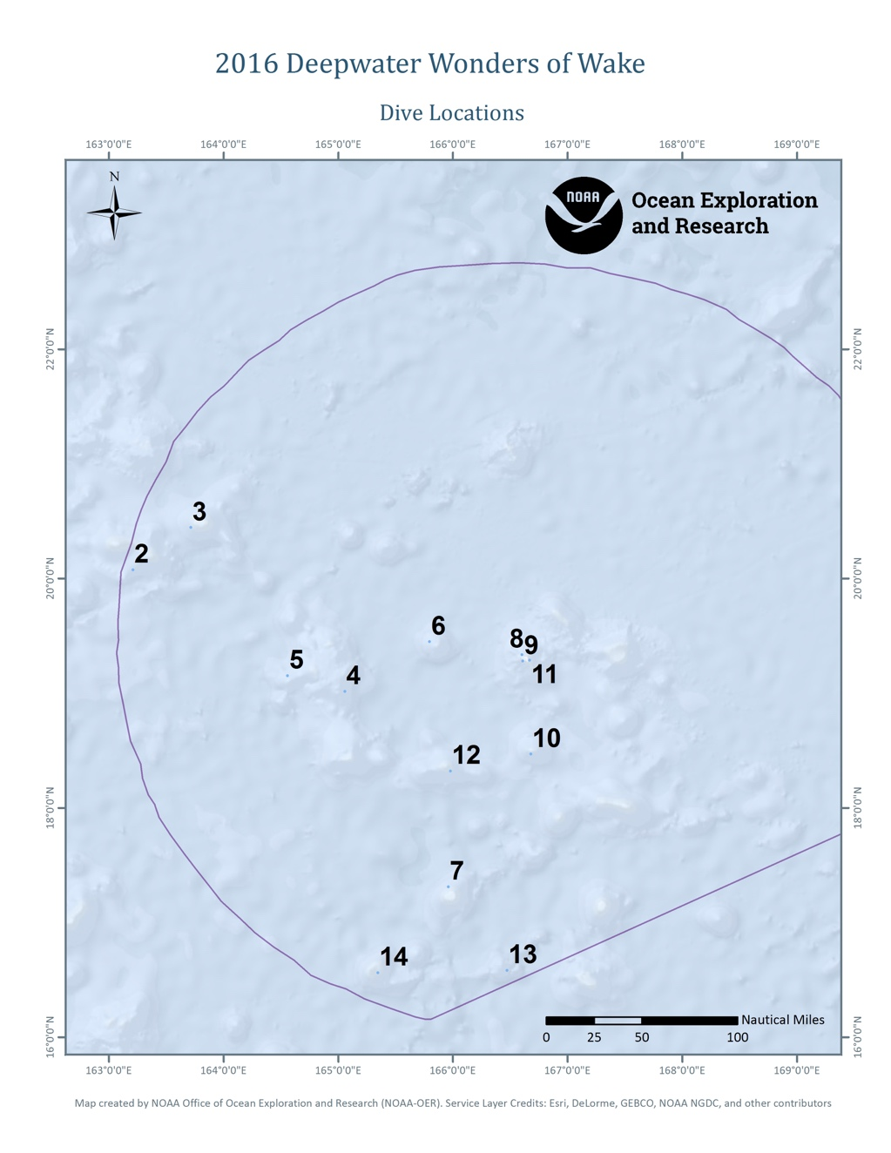
Site Name |  | Delilah Guyot (Seamount 3)
Expedition Coordinator(s) |  | Brian RC Kennedy
ROV Lead(s) |  | Dan Rogers
Science Team Lead(s) |  | Chris Kelley and Jasper Konter
General Area Descriptor |  | Wake Unit of the Pacific Remote Islands Marine National Monument
ROV Dive Name
Cruise |  | EX-16-06
Leg |  | 0
Dive Number |  | 03
Equipment Deployed
ROV |  | Deep Discoverer (D2)
Camera Platform |  | Seirios
ROV Measurements |  | CTD |  | Depth | Altitude
 |  | Scanning Sonar |  | USBL Position | Heading
 |  | Pitch |  | Roll | HD Camera 1
 |  | HD Camera 2 |  | Low Res Cam 1 | Low Res Cam 2
 |  | Low Res Cam 3 |  | Low Res Cam 4 | Low Res Cam 5
Equipment Malfunctions |  | None
ROV Dive Summary  (from processed ROV data) |  | Dive Summary: EX1606_DIVE03  ^^^^^^^^^^^^^^^^^^^^^^^^^^^^^^^^^^^^^^^^^^^^^^^^^^^  In Water: 2016-08-02T20:24:38.251000  20°, 26.812' N ; 163°, 42.995' E  Out Water: 2016-08-03T04:35:05.677000  20°, 26.763' N ; 163°, 43.531' E  Off Bottom: 2016-08-03T03:35:50.826000  20°, 26.748' N ; 163°, 43.225' E  On Bottom: 2016-08-02T21:36:22.085000  20°, 26.627' N ; 163°, 42.862' E  Dive duration: 8:10:27  Bottom Time: 5:59:28  Max. depth: 1984.4 m
Special Notes
Scientists Involved  (please provide name, location, affiliation, email) |  | Name Affiliation Email  Jasper Konter University of Hawaii jkonter@hawaii.edu  Kelley Chris University of Hawaii ckelley@hawaii.edu  Asako Matsumoto Planetary Exploration Research Center (PERC), Chiba Institute of Technology amatsu@gorgonian.jp  Bruce Mundy NOAA NMFS PIFSC bruce.mundy@noaa.gov  Charles Wahle NOAA MPA Center charles.wahle@noaa.gov  Deborah Glickson Harbor Branch Oceanographic Institute dglickson@fau.edu  Kenneth Sulak USGS ksulak@usgs.gov  Michael Vecchione NOAA/NMFS/NSL vecchiom@si.edu  Nicole Morgan Florida State University nmorgan@fsu.edu  Nolan Barrett HBOI-FAU barrettnh@g.cofc.edu  Scott France University of Louisiana at Lafayette france@louisiana.edu  Tina Molodtsova P.P.Shirshov Institute of Oceanology RAS tina@ocean.ru  Tara Harmerluke Stockton University Tara.Luke@stockton.edu
Purpose of the Dive |  | The purpose of the dive was to survey of the deepwater coral and sponge community on a ridge extending from Delilah guyot (Smoot, 1991) inside the northwestern part of the Wake Monument. The depth of the top of this seamount is similar to the adjacent seamounts, and fits with the expectation that it is approximately 100 Ma old (Cretaceous). The dive was planned to be entirely within the optimal depth range for the formation of Mn crusts (i.e., 1,000-2,500 m). Dense communities of deepwater corals and sponges have also been discovered at these depths and on this type of topography. The ridge was therefore expected to be Mn crusted and documenting the animals found at the site should increase our knowledge of the species that are potentially at risk from deep sea mining activities in the future. Documenting Mn crust communities is furthermore a major CAPSTONE priority. Another purpose of this dive was to provide data and samples for use in determining the geologic history of this seamount. The geology of the seamounts in this area of the Pacific is poorly understood.
Description of the Dive |  | This southwest rift zone was similar in orientation and topography and Samson guyot where dive 2 took place. The ROV (D2) reached the bottom at about 21:33 UTC, at a depth of about 1990m. The seafloor during this dive was characterized with some steeper and more level sections that hosted mainly massively covered rock, and more sand-covered Mn-encrusted rock, respectively. The steeper sections appeared to consist of small knobs and hills seemingly built by pillow lavas (i.e. pillow mounds), subsequently covered in inch-scale Mn crust, as suggested by a few steeply-sided examples for which the sides appeared partly collapsed. Two geology samples were taken from the bottom of two of these mounds, one near the beginning of the dive, and one about ¾ of the way to the top. Particularly one of these looks like a pillow fragment, the other is too thickly encrusted to determine the material within the Mn.  The animals at the landing site included a few primnoids (Narella sp), chrysogorgiids (Chrysogorgia sp), sponges (Aspidoscopulia sp), antipatharians (Trissopathes sp), as well as a polychelid lobster, crinoids, and a cusk eel (Bassozetus sp). As we moved upslope, the number of animals increased significantly and it became clear that the highest densities occurred on the edges of the ridge, particularly the northwestern edge. The favored substrate appeared to be the massively coated hills and boulders, likely because these locations optimize exposure to currents bringing food. Several of the boulders were very dense with life, including coralliids (Hemicorallium sp) primnoids, a few paramuriceids, paragorgiids, and acanthogorgiids, anemones, and mushroom corals (Pseudanthomastus and Anthomastus sp). Of particular interest was the observation of a beautiful blue shrimp that appeared to be in the Aristeidae family. The surrounding flatter substrate was not as densely populated however a few eels were recorded (Synaphobranchus sp), as well as seastars (Calliaster sp), long-legged shrimp (Nematocarcinus sp) and feather stars (Glyptometra sp). Further upslope, the coral and sponge community expanded with the presence of large bamboo fans (Jasonisis sp, Keratoisis sp), large primnoids (Paracalyptrophora sp) chrysogorgiids (branched Iridogorgia sp, Calyptrophora sp) and sponges (Poliopogon sp, Lefroyella sp, Bolosominae, Farrea sp). Amongst these animals were a few seastars (Evoplosoma sp), a few more fishes (myctophid?, Ilyophis sp?) and anemones. The two biological collections were a colony of Hemicorallium and a weird sponge that we called coined the “kebab sponge.
Overall Map of the ROV Dive Area |  |  | Close-up Map of Main Dive Site
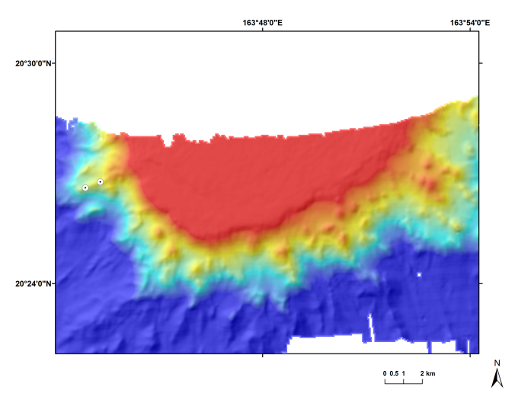 |  |  | 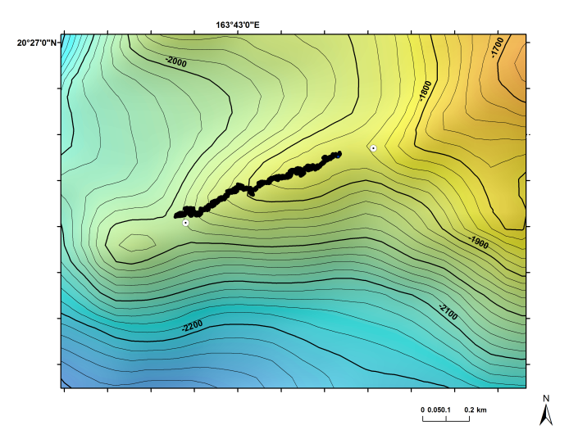
Map showing the dive plan start and end points |  |  | Map showing the actual dive track with start and end points.
Representative Photos of the Dive
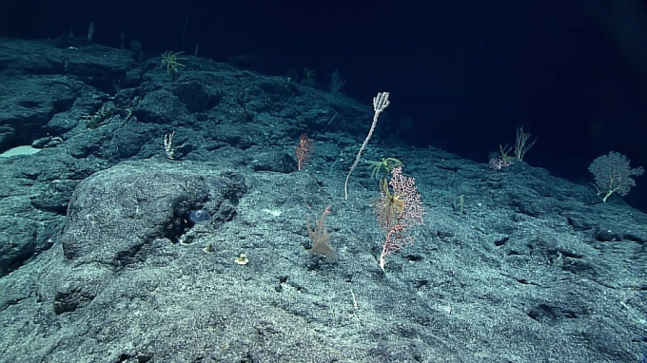 |  |  | 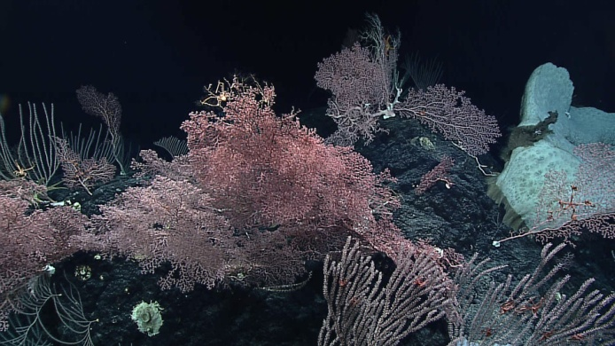
- Modest density of corals and sponges near the landing site. |  |  | - High density coral and sponge community found on hills and blocks toward the high point of the ridge.
Samples Collected
  - Sample
Sample ID | 1606_DIVE03_SPEC01GEO |  | - [in situ image of spe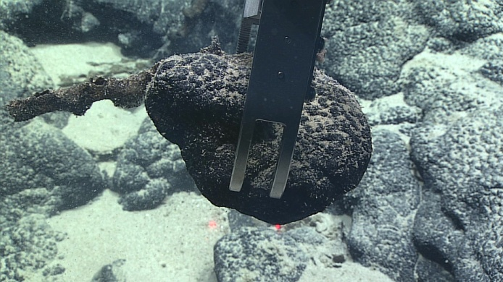cimen here]
Date (UTC) | 20160802
Time (UTC) | 22:28:41
Depth (m) | 1976.855
Temperature (°C) | 2.11927
Field ID(s) | mn encrusted rock
Comments
Sample
Sample ID | 1606_DIVE03_SPEC02BIO |  | - [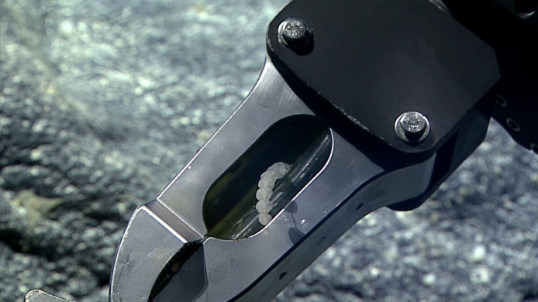in situ image of specimen here]
Date (UTC) | 20160803
Time (UTC) | 0:05:13
Depth (m) | 1890.5744
Temperature (°C) | 2.08363
Field ID(s) | Kebab sponge
Comments
Sample
Sample ID | 1606_DIVE03_SPEC03GEO |  | - 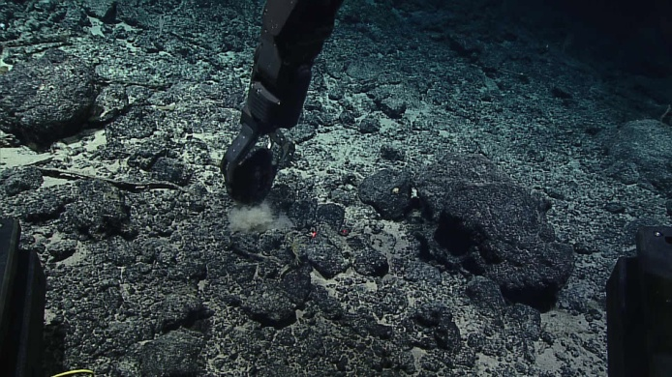
Date (UTC) | 20160803
Time (UTC) | 1:25:36
Depth (m) | 1857.2514
Temperature (°C) | 2.14459
Field ID(s) | Mn crusted rock
Comments | One commensal glass sponge and one baby stalked crinoid.
Sample
Sample ID | 1606_DIVE03_SPEC04BIO |  | - 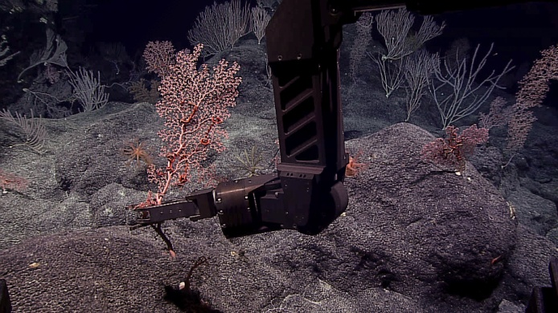
Date (UTC) | 20160803
Time (UTC) | 3:01:51
Depth (m) | 1846.7753
Temperature (°C) | 2.24615
Field ID(s) | Hemicorallium sp
Comments | Two commensals, both ophiuroids in the family Astroschematidae.

Please direct inquiries to:
NOAA Office of Ocean Exploration & Research
1315 East-West Highway (SSMC3 10th Floor)
Silver Spring, MD 20910
(301) 734-1014

