Okeanos Explorer ROV Dive Summary
Dive Information
Dive Map |  | 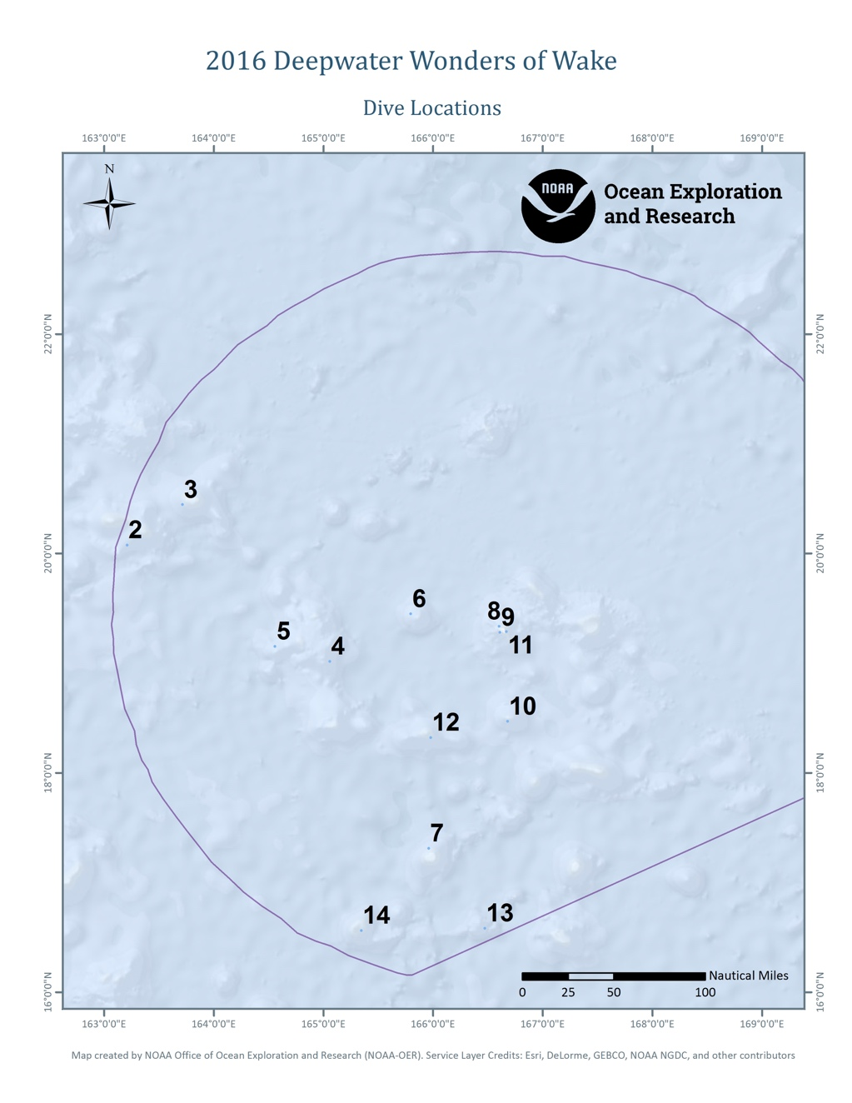
Site Name |  | Seamount #2 (unofficial name: Sampson)
Expedition Coordinator(s) |  | Brian RC Kennedy
ROV Lead(s) |  | Dan Rogers
Science Team Lead(s) |  | Chris Kelly and Jasper Konter
General Area Descriptor |  | Wake Atoll Unit of PRIMNM
ROV Dive Name
Cruise |  | EX-16-06
Leg |  | 0
Dive Number |  | 2
Equipment Deployed
ROV |  | Deep Discoverer (D2)
Camera Platform |  | Seirios
ROV Measurements |  | CTD |  | Depth | Altitude
 |  | Scanning Sonar |  | USBL Position | Heading
 |  | Pitch |  | Roll | HD Camera 1
 |  | HD Camera 2 |  | Low Res Cam 1 | Low Res Cam 2
 |  | Low Res Cam 3 |  | Low Res Cam 4 | Low Res Cam 5
Equipment Malfunctions |  | The ROV experienced a hydraulic leak on the initial descent that required the ROV to be recovered repaired and redeployed without the port upper swing arm.
ROV Dive Summary  (from processed ROV data) |  | Dive Summary: EX1606_DIVE02  ^^^^^^^^^^^^^^^^^^^^^^^^^^^^^^^^^^^^^^^^^^^^^^^^^^^  In Water: 2016-08-01T20:33:34.057000  20°, 04.550' N ; 163°, 12.728' E  Out Water: 2016-08-02T06:34:51.386000  20°, 04.503' N ; 163°, 13.119' E  Off Bottom: 2016-08-02T05:22:29.727000  20°, 04.580' N ; 163°, 12.722' E  On Bottom: 2016-08-02T02:32:29.886000  20°, 04.476' N ; 163°, 12.578' E  Dive duration: 10:1:17  Bottom Time: 2:49:59  Max. depth: 2250.7 m
Special Notes
Scientists Involved  (please provide name, location, affiliation, email) |  | First Name Last Name Organization Email Address  Jasper Konter University of Hawaii jkonter@hawaii.edu  Kelley Chris University of Hawaii ckelley@hawaii.edu  Allison Miller University of Guam a33miller@gmail.com  Amy Baco-Taylor Florida State university abacotaylor@fsu.edu  Andrea Quattrini Harvey Mudd College aquattrini@g.hmc.edu  Asako Matsumoto Planetary Exploration Research Center (PERC), Chiba Institute of Technology amatsu@gorgonian.jp  Bruce Mundy NOAA NMFS PIFSC bruce.mundy@noaa.gov  Charles Wahle NOAA MPA Center charles.wahle@noaa.gov  Deborah Glickson Harbor Branch Oceanographic Institute dglickson@fau.edu  Diva Amon University of Hawaii divaamon@gmail.com  Kenneth Sulak USGS ksulak@usgs.gov  Michael Vecchione NOAA/NMFS/NSL vecchiom@si.edu  Nolan Barrett HBOI-FAU barrettnh@g.cofc.edu  Scott France University of Louisiana at Lafayette france@louisiana.edu  Patty Fryer University of Hawaii pfryer@soest.hawaii.edu  Tara Harmerluke Stockton University Tara.Luke@stockton.edu
Purpose of the Dive |  | The objective of the dive was to conduct a survey of the deepwater coral and sponge community on a ridge extending from this guyot inside the northwestern part of the Wake Monument. We expected the ridge to be Mn crusted and the goal was to increase our knowledge of the animals that are potentially at risk from deep sea mining activities in the future. Documenting Mn crust communities is a major CAPSTONE priority. A second objective of this dive is to provide data and samples for use in determining the geologic history of this seamount. This geology of the seamounts in this area of the Pacific is poorly understood, and it has never been explored or sampled before to our knowledge.
Description of the Dive |  | The ROV (D2) reached the bottom at about 02:27 UTC time, at a depth near 2240m. This location represents the southwest side of Sampson Seamount (unofficial name by Smoot, 1991). Given its depth and morphology, we expect that this seamount is a Cretaceous guyot. The dive location focuses on one of the volcanic rift zones that emanate from the central guyot platform. During this shorter dive (due to some technical difficulties), the bottom was quite massively coated in Mn crust. Along the entire ridge, we observed layered rock coated in Mn crust. The layers could be seen through the coating as tilted beds, truncated at the ridge crest. Near the end of the dive track, a smaller section of the ridge was more massive, likely representing some coated volcanic rocks.  As the ROV ascended, the terrain remained steep with massive coating, and very rare loose pieces of rock (one was sampled near the beginning of the dive; a volcaniclastic sedimentary rock with Mn crust). The Mn crust mimicked the underlying shapes, but did show mm-cm scale texture. Relief along the ridge was up to meter scale. The original dive track was designed to pass through a more level section, followed by another steep section, but due to the shortened time available, we only reached this intermediate level section. A slight amount of light-colored sediment covered the rocky bottom here.  The massive, rocky bottom (potentially combined with the southeasterly current) proved to be a location of relatively high animal density. The steeper section during the first half of the dive was dominated by small primnoid octocorals, likely in the genus Narella but also a few Candidella cf gigantea. Most of the former had only 2 branches suggesting they were not just young colonies but something different from what we had seen in Hawaii and the Marianas. Interspersed between these were a large number of black corals, including a few Bathypathes and Stauropathes sp. as well as numerous colonies of either a Heteropathes or Trissopathes sp. Glass sponges were also common and included colonies in the genera Tretopleura, Caulophacus, Aspidoscopulia, Farrea, Hyalonema, Poliopogon, and Bolosoma. A few anemones were aseen, one possibly in the family Exocoelactinidae, and a several fish that included one rattail (Kumba sp) and several cutthroat eels (Synaphobranchus and Ilyophis sp).  In the latter half of the dive where the terrain leveled out, we encountered a modest but dense stand of large bamboo corals concentrated along a rise and prominent boulder on top, including Jasonisis sp?, Keratoisis sp, and at least one other species branching at the nodes. A few chrysogorgiids were mixed in the stand, all believed to be in the genus Chrysogorgia, as well as a very small unbranched stylasterid?? which occurred in patches. Of particular interest was the observation of a rare seastar (Pythonaster sp) on a sponge. We also saw other echinoderms during the dive that included ophiuroids and unstalked crinoids. Two samples were taken during the dive that included one Mn crusted volcaniclastic rock that appeared to be mostly sedimentary, and two colonies of the Heteropathes/Trissopathes sp. When the rock was examined in the lab, we found 2 intact and 1 broken colony of the tiny stylasterid coral.
Overall Map of the ROV Dive Area |  |  | Close-up Map of Main Dive Site
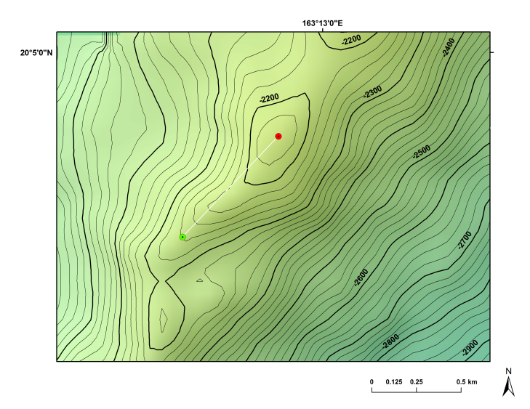 |  |  | 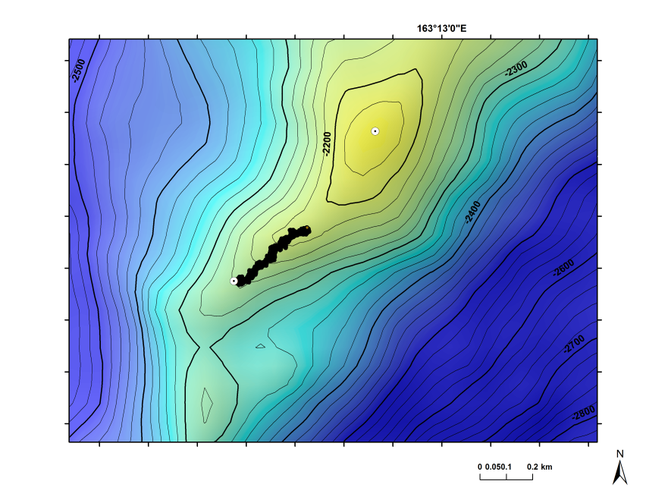
Proposed start (green) and end (red) points for Dive 02 |  |  | Actual dive track compared to planned start and end points
Representative Photos of the Dive
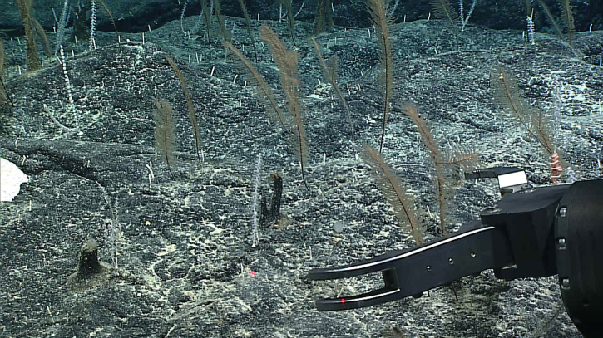 |  |  | 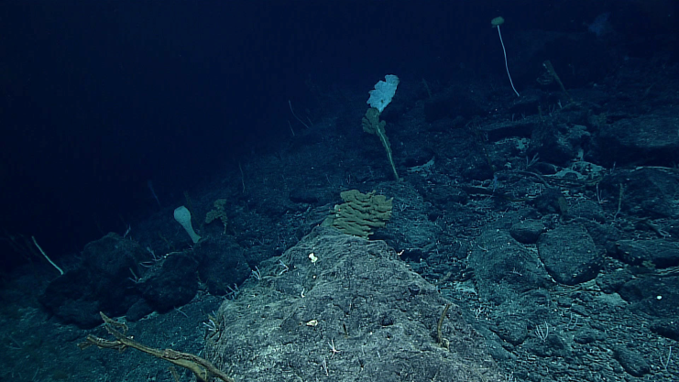
- [Descriptive caption here] |  |  | - [Descriptive caption here]
Samples Collected
  - Sample
Sample ID | SPEC01GEO |  | - 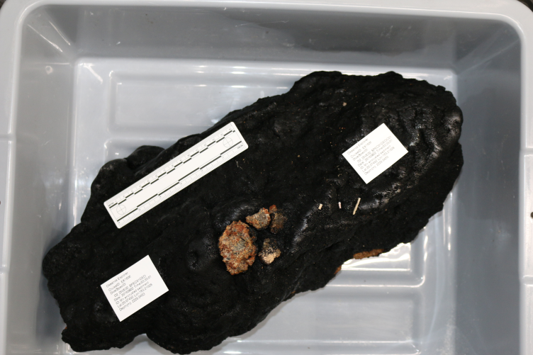
Date (UTC) | 20160802
Time (UTC) | 03:33:01
Depth (m) | 2229
Temperature (°C) | 1.9
Field ID(s)
Comments | Mn crusted volcaniclastic rock; broken pieces came up in Starboard rock box and show small vesicular basalt fragments, altered glass, and secondary minerals.
Sample
Sample ID | SPEC02BIO |  | - 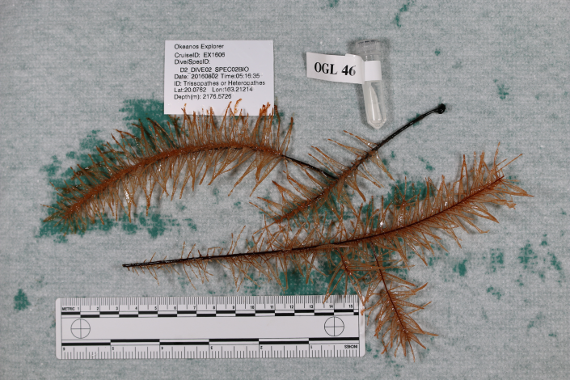
Date (UTC) | 20160802
Time (UTC) | 05:16:35
Depth (m) | 2177
Temperature (°C) | 2177
Field ID(s)
Comments | Two colonies of Heteropathes/Trissopathes collected with one grab by the manipulator
Sample
Sample ID | SPEC01GEO_C1 |  | - 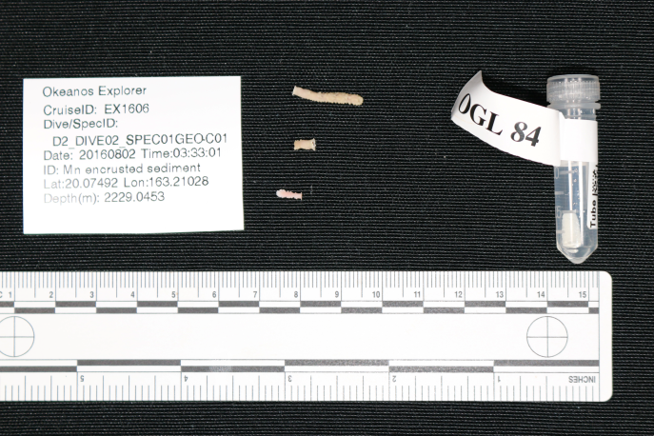
Date (UTC) | 20160802
Time (UTC) | 03:33:01
Depth (m) | 2229
Temperature (°C) | 1.9
Field ID(s) | Tiny stylasterid?? coral found attached to the rock
Comments

Please direct inquiries to:
NOAA Office of Ocean Exploration & Research
1315 East-West Highway (SSMC3 10th Floor)
Silver Spring, MD 20910
(301) 734-1014

