Okeanos Explorer ROV Dive Summary
Site Name | Romeo and Juliet |  |  |  | 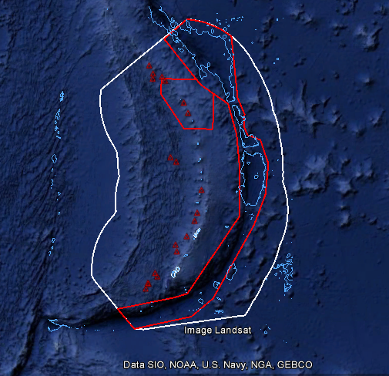
ROV Lead/Expedition Coordinators | Jim Newman/  Kasey Cantwell
Science Team Leads | Shirley Pomponi (HBOI)  Patty Fryer (UH)
General Area Descriptor | Areas in and around the Marianas Trench Marine National Monument
ROV Dive Name | Cruise |  | Leg |  |  | Dive Number
 | EX1605 |  | 3 |  |  | DIVE22
Equipment Deployed | ROV: |  | Deep Discoverer
 | Camera Platform: |  | Seirios
ROV Measurements | CTD |  | Depth |  |  | Altitude
 | Scanning Sonar |  | USBL Position |  |  | Heading
 | Pitch |  | Roll |  |  | HD Camera 1
 | HD Camera 2 |  | Low Res Cam 1 |  |  | Low Res Cam 2
 | Low Res Cam 3 |  | Low Res Cam 4 |  |  | Low Res Cam 2
Equipment Malfunctions
ROV Dive Summary  (From processed ROV data) | Dive Summary: EX1605L3_DIVE22  ^^^^^^^^^^^^^^^^^^^^^^^^^^^^^^^^^^^^^^^^^^^^^^^^^^^  In Water: 2016-07-08T21:55:04.641000  Out Water: 2016-07-09T04:46:02.788000  Dive duration: 6:50:58  Bottom Time: 6:10:19  **Data restricted for UCH**
Special Notes | Some data on this form is restricted for UCH. A non-restricted copy can be obtained upon request.
Scientists Involved  (please provide name / location / affiliation / email) | Diva Amon University of Hawaii divaamon@hawaii.edu  Robert Carney Louisiana State Univ rcarne1@lsu.edu  William Clancey HBOI/IHMC wclancey@ihmc.us  Scott France University of Louisiana at Lafayette france@louisiana.edu  Patricia Fryer Univ. Hawaiʻi at Mānoa (UHM) pfryer@hawaii.edu  Deborah Glickson FAU-Harbor Branch Oceanographic Institute dglickson@fau.edu  Tara Harmer Luke Stockton University luket@stockton.edu  Chris Kelley University of Hawaii Manoa ckelley@hawaii.edu  David Lotz National Park Service david_lotz@nps.gov  Asako Matsumoto Chiba Institute of Technology (Chitech) amatsu@gorgonian.jp  Jennifer McKinnon East Carolina University mckinnonje@ecu.edu  Tina Molodtsova P.P.Shirshov Institute of Oceanology RAS tina@ocean.ru, tina.molodtsova@gmail.com  Nicole Morgan Florida State University nmorgan@fsu.edu  Shirley Pomponi FAU spomponi@fau.edu  James Pruitt CNMI Historic Preservation Office jpruitt.hpo@gmail.com  Gene Rankey University of Kansas grankey@ku.edu  Hans Van Tilburg NOAA ONMS hans.vantilburg@noaa.gov  Frank Cantelas NOAA OER Frank.Cantelas@noaa.gov  Megan Lickliter-Mundon Texas A&M University NAP m.lickliter@gmail.com  Jeremy Kinney Smithsonian National Air and Space Museum kinneyj@si.edu  Valerie Grussing NOAA ONMS Maritime Heritage Program  Rachel Matheny TAMU/ Smithsonian National Air and Space Museum  Amanda Netburn NOAA OER amanda.netburn@noaa.gov  Wendy Coble DPAA wendy.m.coble.civ@mail.mil  Andrew Pietruszka University of Delaware andrewpi@udel.edu  Richard Wills DPAA richard.k.wills.civ@mail.mil  Jennifer Nasarenko DPAA  Abel Dean DPAA  Shydaea Townes DPAA  Matt Dornback NCEI matt.dornback@noaa.gov  Charlie Wilkins OMAO charles.e.wilkins@noaa.gov  Jason Meyer Meyer Hydrographic jason7seas@gmail.com  Derek Sowers OER derek.sowers@noaa.gov  Delgado Jim NOAA ONMS MHP james.delgado@noaa.gov  Nolan Barrett College of Charleston/ HBOI barrettnh@g.cofc.edu
Purpose of the Dive
The purpose of this dive was to investigate a series of sonar anomalies mapped by the Okeanos Explorer during EX1605L1. These anomalies were believed to be potential wreckage sites of a one or more of the dozen aircraft that were lost between Tinian and Saipan during WWII. Tinian and Saipan served as major air bases during the final year of WWII with B-29 bombers flying long-range missions to Japan. Many aircraft were lost on take-off and landing due to mechanical problems and pilot error. The lost aircraft have great significance to American history yet none of the B-29s that crashed in the Saipan Channel have ever been discovered. The primary targets that we investigated are ROMEO and JULIET, located approximately 150m apart.
Description of the Dive:
The ROV D2 landed near the intact wing of a B-29 Superfortress. The wing is upside down with landing gear and three of the four engines still attached. The ROV did a perimeter survey during which we saw apparent fire damage to the exhaust manifold and the nacelle on the one remaining engine on the right side of the wing (starboard). The starboard and port landing gear wings was retracted into the wings with the rubber tires intact. Ditching the aircraft damaged the lower parts of the two engine nacelles of the left wing (port) more so than was observed on the right wing. Some distance from the wing we encountered wreckage from the forward section of the B-29 that contained the lower part of the forward gun turret, a cylindrical tube with the gun barrels buried in the sediment, and the flight engineer's control panel with many gauges. While searching the for possible multibeam sonar targets D2 came across a lot of debris from the crash and discovered the nearly intact horizontal stabilizer from the B-29's tail. All of the wreckage and debris seems to represent one aircraft although portions of the forward and aft sections of the fuselage were not found.

The science team observed a great deal of modern metal cans, bottles and plastic trash entangled and trapped in the wreckage. One member of the science team commented that for many years and into the 1970's Saipan dumped its municipal solid waste collections directly into Tinian Channel.
Overall Map of ROV Dive Area |  |  |  | Close-up Map of Main Dive Site
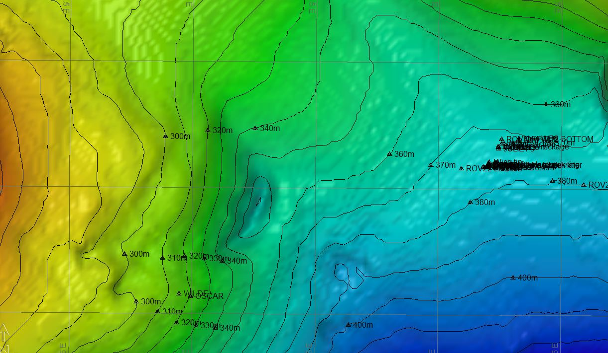 |  |  |  | Restricted for UCH
Representative Photos of the Dive
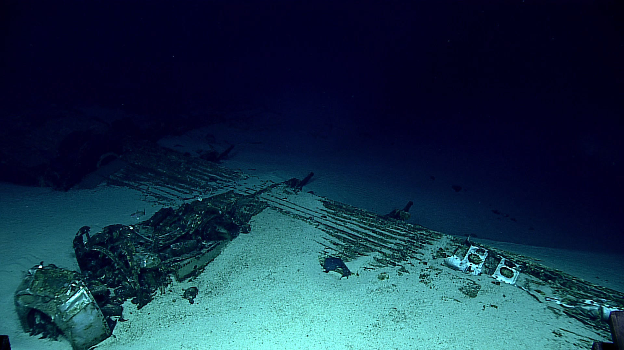 |  |  |  | 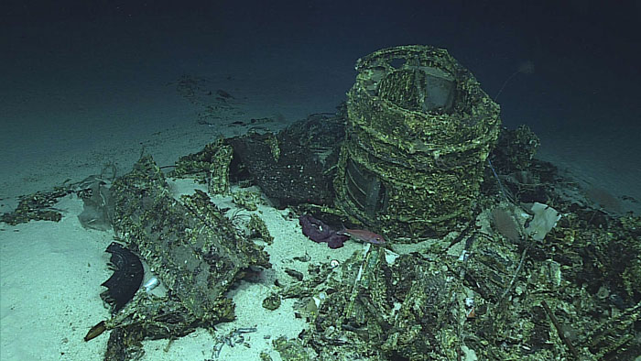
Shortly after the ROVs descended, a wing of a B29 Superfortress was discovered. The B-29 Superfortress, one of the largest aircraft flown by the United States in World War II, had a wingspan measuring just over 141 feet. The wing came to rest on the sea floor upside down with the landing gear and three of the radial engines still attached. |  |  |  | The forward gun turret, located some distance from the wing, is evidence that the aircraft broke apart. A panel of dials found in the wreckage is part of the flight engineer’s station, indicating this section of wreckage is a part of the B-29s forward section.
Samples Collected
This was a non-disturbance archaeology dive. No samples were collected.
Please direct inquiries to: |  | NOAA Office of Ocean Exploration & Research  1315 East-West Highway (SSMC3 10th Floor)  Silver Spring, MD 20910  (301) 734-1014

