NOAA Ocean Exploration Program

2016 Deepwater Exploration of the Marianas

EX-16-05 Leg 1 Cruise Report

Guam and the Commonwealth of the Northern Mariana Islands
Guam to Saipan, Northern Mariana Islands

Dr. Deborah Glickson, Science Lead, Florida Atlantic University,
Harbor Branch Oceanographic Institute
Dr. Diva Amon, Science Lead, University of Hawaii at Manoa
Lindsay McKenna, Mapping Lead, NOAA Office of Ocean Exploration & Research
Kelley Elliott, Expedition Coordinator, NOAA Office of Ocean Exploration & Research

April 30, 2017
NOAA Office of Ocean Exploration and Research
1315 East-West Hwy, SSMC3 RM 10210
Silver Spring, MD 20910

Table of Contents

1. Introduction 4
2. Objectives 6
3. List of Participants 6
4. Methodology 9
4.1 ROV seafloor surveys 9
4.2 Specimen collections 9
4.3 Seafloor mapping 10
4.4 Education and outreach activities 11
5. Clearances and Permits 11
6. Expedition Schedule 12
7. Expedition Map 14
8. Results 16
8.1 ROV seafloor surveys 16
8.2 Specimen collections 20
8.3 Seafloor mapping 26
8.4 Education and outreach products 28
9. Conclusion 29

1. Introduction

NOAA OER Okeanos Explorer Operations
NOAA’s Office of Ocean Exploration and Research (OER) is the only federal organization dedicated to exploring our unknown ocean. OER works with partners to identify priority areas for exploration; support innovations in exploration tools and capabilities; and encourage the next generation of ocean explorers, scientists, and engineers. The publicly available data and information gained from our expeditions and the research we fund gives resource managers, the academic community, and the private sector the information they need to identify, understand, and manage ocean resources for this and future generations of Americans.

NOAA Ship Okeanos Explorer is the only federal vessel dedicated to exploring our largely unknown ocean for the purpose of discovery and the advancement of knowledge about the deep ocean. America’s future depends on understanding the ocean. We explore the ocean to make valuable scientific, economic, and cultural discoveries, and we explore because ocean health and resilience are vital to our economy and to our lives. Exploration supports NOAA mission priorities and national objectives by providing high-quality scientific information about the deep ocean to anyone who needs it.

In close collaboration with government agencies, academic institutions, and other partners, OER conducts deep-ocean exploration expeditions using advanced technologies on the Okeanos Explorer. From mapping and characterizing previously unseen seafloor to collecting and disseminating information about ocean depths, this work helps to establish a foundation of information and fill data gaps. Data collected on the ship follow federal open-access data standards and are publicly available shortly after an expedition ends. This ensures the delivery of reliable scientific data needed to identify, understand, and manage key elements of the ocean environment.

2016 Deepwater Exploration of the Marianas Expedition
The 2016 Deepwater Exploration of the Marianas Expedition is the fourth in a series of expeditions that comprises the “Campaign to Address Pacific monument Science, Technology, and Ocean Needs” (CAPSTONE). CAPSTONE is a major multi-year foundational science effort to collect baseline information in unknown and poorly known deepwater areas of U.S. marine protected areas in the central and western Pacific Ocean. Previous expeditions have focused on collecting baseline information in and around the Papahānaumokuākea Marine National Monument, and the Johnston Atoll and Wake Island Units of the Pacific Remote Islands Marine National Monument (PRIMNM). Future expeditions are planned to explore additional Units of PRIMNM, Rose Atoll Marine National Monument, the National Marine Sanctuary of American Samoa, and likely the Phoenix Islands Protected Area.

The Marianas Trench Marine National Monument (referred to here as “The Monument”) was established in January 2009 through a presidential proclamation under the authority of the Antiquities Act of 1906. The Monument was established for the purpose of protecting objects of interest such as the subduction system in the trench, submerged volcanoes, hydrothermal vents, coral reef ecosystems, and biologically diverse ecosystems where chemosynthetic and photosynthetic organisms exist side by side.

The Monument consists of three units: the Islands Unit, the Volcanic Unit, and the Trench Unit. The Volcanic Unit and the Trench Unit are additionally designated as National Wildlife Refuges, the “Mariana Trench National Wildlife Refuge” (aka “Trench Unit/Refuge”) and “Mariana Arc of Fire National Wildlife Refuge” (aka “Volcanic Unit/Arc of Fire Refuge”).

The Islands Unit encompasses the waters and submerged lands of the three northernmost Mariana Islands (Farallon de Pajaros, Maug, and Asuncion) from the mean low water line to approximately 50 nautical miles offshore. These waters include healthy coral reefs made up of roughly 300 different coral species and a very high density of top predators, including large numbers of sharks.

The Volcanic Unit/Arc of Fire Refuge includes the submerged lands within a one nautical mile radius of the center of each of the 18 active submarine volcanoes and hydrothermal vents in the region. Hydrothermal vents have some of the harshest conditions on the planet, including extremely high temperature water and highly acidic fluids. Even so, there are many species that make vents their homes, including some that are found only at these habitats. Vent communities include animals that have developed symbiotic relationships with chemosynthetic bacteria, such as tubeworms, shrimp, and mussels, as well as other animals like snails, anemones, and squat lobsters.

The Trench Unit/Refuge encompasses the submerged lands within the Mariana Trench, extending from the northern limit of the U.S. Exclusive Economic Zone (EEZ) of the Commonwealth of the Northern Mariana Islands (CNMI) to the southern limit of the EEZ adjacent to the U.S. Territory of Guam.

This part of the Monument is approximately 940 nautical miles long and 38 nautical miles wide along the Mariana Trench seafloor. It includes Sirena Deep at about 10,700 m (35,000 feet), the second deepest point on Earth, remarkable for its steep walls, distinctive geologic features, and deep-ocean life forms. The deepest areas of the Mariana Trench are likened to an inverted chain of islands, where each “peak” points downward, and like islands, each feature can be geologically and biologically unique.

The unique geology, geochemistry, rare biological conditions, and pristine ecosystems of the Monument provide an ideal location for interdisciplinary research. Because the area has a distinct position in the biogeography of the Pacific as a place where a high number of regional endemic and unusual species assemblages thrive, the Mariana Archipelago and Monument holds outstanding potential for making globally significant scientific contributions.

Despite decades of previous work in the region, much of the Monument and surrounding areas remain unexplored. The three legs of the 2016 Deepwater Exploration of the Marianas expedition worked within the U.S. Exclusive Economic Zone of Guam and the CNMI to help identify and better understand new geological phenomena and habitats – such as extreme life living in the deepest oceanic trench on the planet, enormous mud volcanoes, active hydrothermal vents, chemosynthetic communities, and possibly deep-sea coral and sponge habitats.

Large deep-water areas of the Monument and CNMI in the north remain unmapped with modern sonar. Mapping efforts may reveal new discoveries such as seamounts or other geologic features, providing insight into the plate tectonic processes that create ocean floor features and new discoveries into the continued creation of the continents and connectivity to all life on Earth.

Baseline data from this expedition will help improve our understanding of the deep-ocean habitats of the Mariana archipelago and the connections between communities at different seamounts and hydrothermal vent sites. Data collected will also provide critical information for the development of management plans for Monument areas; support local scientists and managers seeking to understand and manage precious corals and bottom fish resources; and provide a foundation of information to stimulate follow-on exploration, research and management activities.

EX-16-05 Leg 1 is the first of three cruises for the expedition. The leg began on April 20 in Guam and ended on May 11 in Saipan. Operations covered a wide area of the U.S. EEZ focused on the southern half of the CNMI, Guam, and the MTMNM.

2. Objectives
The expedition addressed science themes and priority areas put forward by NOAA scientists and resource managers, local CNMI management agencies, and the broad ocean-science community. The primary objective of the expedition was to survey deep-water areas in and around the CNMI and the MTMNM that had not been previously surveyed, in order to provide baseline information to support management and science needs. Specifically, this expedition sought to:
- Explore the diversity and distribution of benthic habitats – including bottomfish habitats, deep-sea and precious coral communities, hydrothermal vents, mud volcanoes, seamounts, and trench and subduction-zone habitats;
  - Collect data on habitat size and extent, and animal diversity and density;
  - Focus imaging operations on potential new, rare, and poorly-documented animals as well as dominant members of the communities;
  - Collect and preserve biological samples of potential new species, new records, dominant community members if not easily recognized, and other animals to aid in site characterization;
- Identify and characterize vulnerable deep-water marine habitats, particularly high-density communities of deep-sea corals. While the Islands Unit of the Monument is renowned for incredible shallow coral reefs and a high density of top predators, there have been no previous focused efforts to discover and document deep-sea coral and sponge communities in the region;
- Survey and characterize priority bottomfish fishery areas and areas likely to host precious corals, and design surveys to investigate whether there is a depth and/or site overlap between the two fisheries. Deep-water bottomfish habitats below ~250m have not been characterized in the region. While the precious coral fishery is listed as a managed fishery in Guam and CNMI, no precious coral beds have been identified to date and only anecdotal accounts have been published of their presence in this region of the Pacific;
- Collect biological and geological data and samples on seamounts within the Prime Crust Zone (PCZ), particularly focusing on ridge tops and summit margins. Seamounts to the east of the Mariana Trench lie along the western boundary of the Prime Crust Zone (PCZ), which harbors the richest and most commercially valuable crusts on Earth;
- Collect geologic data and samples to aid in the understanding of the geologic history of the Pacific and Marianas Plate and the Izu-Bonin-Mariana Arc System, including potential relevance to plate tectonic processes, subduction-zone geology, and volcanic arc and island formation;
- Ground-truth acoustic data using video imagery and characterize associated habitat;
- Provide a foundation of publicly accessible data and information products to spur further exploration, research, and management activities in the future.

3. List of Participants

At-Sea Mission Personnel:
Name | Role | Affiliation
Kelley Elliott | Expedition Coordinator | NOAA Office of Ocean Exploration and Research (OER)
Lindsay McKenna | Mapping Team Lead | NOAA OER
Deborah Glickson | Science Team Lead (Geology) | Florida Atlantic University/UCAR
Diva Amon | Science Team Lead (Biology) | University of Hawaii/UCAR
Kevin Jerram | Mapping Watch Lead | University Corporation for Atmospheric Research (UCAR)
Andy O'Brien | Data Management | UCAR/Global Foundation for Ocean Exploration(GFOE)
Jim Newman | Engineering Group Lead 1 | UCAR/GFOE
Chris Ritter | Engineering Group 2 | UCAR/GFOE
Jeff Laning | Engineering Group 3 | UCAR/GFOE
Levi Unema | Engineering Group 4 | UCAR/GFOE
Joshua Carlson | Engineering Group 5 | UCAR/GFOE
Andy Lister | Engineering Group 6 | UCAR/GFOE
Sean Kennison | Engineering Group 7 | UCAR/GFOE
Karl McLetchie | Engineering Group 8 | UCAR/GFOE
Daniel Rogers | Engineering Group 9 | UCAR/GFOE
Tara Smithee | Engineering Group 10 | UCAR/GFOE
Brian Kennedy | Engineering Group 11 | UCAR/GFOE
Ed McNichol | Engineering Group 12 | UCAR/GFOE
Roland Brian | Engineering Group 13 | UCAR/GFOE
Caitlin Bailey | Engineering Group 14 | UCAR/GFOE
Table 1. Names, roles and affiliation of the mission team onboard
NOAA Ship Okeanos Explorer for Leg 1 of the expedition.

Shore-based science team:
Shore based science team members participate from remote exploration command centers and from their home locations.

Name | Affiliation | Expertise | Participation Location / Mode
Brian Greene | Association for Marine Exploration | Ichthyology | Kona, HI
Patricia Fryer | University of Hawaiʻi at Mānoa | Geology/Petrology | Honolulu, HI (UH ECC)
Maria Celia Machel Malay | University of Guam Marine Laboratory | Benthic biology, crustaceans, invertebrates in general, Biogeography | Guam
Rodney Tibbatts | Guam Division of Aquatic & Wildlife Resources | Deep water fish, ichthyology | Guam
Melissa Anderson | University of Ottawa & GEOMAR Helmholtz Centre for Ocean Research Kiel | Economic Geology | Kiel, Germany
Allison Miller | National Park Service | Invertebrate biology and molecular phylogenetics | Guam
David Burdick | University of Guam Marine Laboratory | Mesophotic benthic communities, focus on corals | Guam
Dick Randall | University of Guam | Fish | Guam
Alexander Kerr | University of Guam | Holothuroidea | Guam
Asako Matsumoto | Chiba Institute of Technology | Deep-sea corals | Tokyo, Japan
Mary Wicksten | Texas A&M University | Invertebrate zoology | College Station, TX
Robert Stern | University of Texas at Dallas | IBM arc system geology | Dallas, TX
Gene Rankey | University of Kansas | Carbonate geology | Lawrence, KS
Scott France | University of Louisiana at Lafayette | Deep-sea corals, benthic invertebrates | Lafayette, LA
Shirley Pomponi | Florida Atlantic University | Benthic biology - sponges | Fort Pierce, FL (FAU ECC)
Amy Baco-Taylor | Florida State University | Benthic ecology, deep-sea corals and sponges | Tallahassee, FL
Nicole Morgan | Florida State University | Benthic biology | Tallahassee, FL
Christopher Mah | National Museum of Natural History (Smithsonian) | Starfish, echinoderms, deep-sea biology, etc. | Washington, DC
Mike Ford | NOAA Fisheries | Jellyfish | Silver Spring, MD (SS ECC)
Amanda Netburn | NOAA Ocean Exploration & Research | Water column | Honolulu, HI (IRC ECC) & Silver Spring, MD (SS ECC)
Tara Harmer Luke | Stockton University | Deep sea biology | Galloway, NJ
Santiago Herrera | University of Toronto, WHOI | Benthic biology | Toronto, Canada
Michael Perfit | University of Florida | Geology, Petrology, Geochemistry | Fort Pierce, FL
Amanda Demopoulos | U.S. Geological Survey | Benthic ecology | Gainesville, FL
Taylor Heyl | Woods Hole Oceanographic Institution | Biology | Woods Hole, MA
Timothy Shank | Woods Hole Oceanographic Institution | Benthic biology | Woods Hole, MA
Stace Beaulieu | Woods Hole Oceanographic Institution | Benthic biology | Woods Hole, MA
Julie Huber | Marine Biological Laboratory | Microbiology | Woods Hole, MA
Chris Kelley | University Hawaiʻi at Mānoa | Deep-Sea Ecology; Fishes, Sponges, Corals | Honolulu, HI (UH ECC)
Allen Andrews | NOAA Fisheries | Fishes and corals | Honolulu, HI (IRC ECC)
Bruce Mundy | NOAA Pacific Islands Fisheries Science Center | Ichthyology (fish identification and biogeography) | IRC ECC
Jeffrey Drazen | University Hawaiʻi at Mānoa | Deep-sea fishes | UH ECC
Mackenzie Gerringer | University Hawaiʻi at Mānoa | Deep-sea Fishes, Hadal Trenches | UH ECC
Brian Glazer | University Hawaiʻi at Mānoa | Hydrothermal | Honolulu, HI (UH ECC)
Les Watling | University Hawaiʻi at Mānoa | Benthic biology, octocorals | Honolulu, HI (UH ECC), Maine
Sonia Rowley | University. Hawaiʻi at Mānoa | Biogeography & taxonomy of Octorallia, benthic biology | Honolulu, HI (UH ECC)
Maryjo Brounce | California Institute of Technology | Geological oceanography | Pasadena, CA
Andrea Quattrini | Harvey Mudd College | Benthic bio | Claremont, CA
Bill Chadwick | NOAA Pacific Marine Environmental Laboratory | Geology, volcanology | Newport, OR
Robert Embley | NOAA Pacific Marine Environmental Laboratory | Geology | Newport, OR
Lisa Levin | Scripps Institution of Oceanography | Benthic biology | La Jolla ,CA
Jonathan Kellogg | University of Victoria | Vent circulation | Vancouver, BC
Tina Molodtsova | P.P.Shirshov Institute of Oceanology RAS | Deep-sea corals, benthic biology | Moscow, Russia
Table 2. Name, affiliation, expertise and participation location of the shore-based science team who participated cruise leg 1 of the expedition.

4. Methodology
In order to accomplish its objectives, the expedition made use of the Okeanos Explorer’s:
- two-body remotely operated vehicle system (ROVs Deep Discoverer and Seirios) to conduct daytime seafloor surveys, as well as to collect limited numbers of specimens to help further characterize the deep-water fauna and geology of the region;
- mapping systems (Kongsberg EM302 multibeam sonar, Knudsen 3260 subbottom profiler, Kongsberg EK60 split-beam fisheries sonars, and Teledyne Acoustic Doppler Current Profilers) to conduct nighttime mapping operations and when the ROV was on deck; and
- high-bandwidth satellite connection for real-time ship to shore communications.

4.1 ROV seafloor surveys
ROV dive operations were conducted to support the expedition objectives, including characterizing bottomfish and precious coral habitats, hydrothermal vents, seamounts, mud volcanoes, and habitats within the trench. Dive sites were chosen using high-resolution bathymetry data, when available. With the exception of one site (Esmeralda Crater), all chosen dive locations were previously unexplored by ROV. At Esmeralda Crater, there had been a previous Jason dive in 2006, but our dive explored a different area of the crater.

During each dive, the ROV descended onto the seafloor and then moved from waypoint to waypoint, documenting the geology and biology of the area. Onboard and shore-based scientists identified each encountered organism to the lowest possible taxon. For this purpose, scientists used the online pilot version of the OER Benthic Deepwater Animal Identification Guide (http://oceanexplorer.noaa.gov/okeanos/animal_guide/animal_guide.html), as well as the online HURL animal guide (https://www.soest.hawaii.edu/HURL/animals/id/). Additionally, onboard and shore-based scientists provided geological interpretations of the observed substrate throughout each ROV seafloor survey.

4.2 Specimen collections
A limited number of geological and biological samples were collected on the seafloor using the manipulator arms and biological and geologic collection boxes on the Deep Discoverer. For each collected specimen, the date, time, latitude, longitude, depth, salinity, temperature and dissolved oxygen content were recorded at the time of collection. Geological specimen collections targeted samples for age dating and geochemical composition. Biological specimen collections targeted samples that represented potential new species, range extensions of animals not previously known to occur in the region, or dominant species in the area.

Once specimens were brought back onto the deck of the ship, they were examined for commensal organisms, labeled, photographed and inventoried into a database containing all relevant metadata. Any commensal organisms found were separated from the sample and processed separately. Geological samples were air dried and placed in rock bags. These samples will be shipped to Oregon State University’s Marine Geology Repository after the 2016 field season, where they will be analyzed in the laboratory for their chemical composition and geologic age. Biological samples were processed for DNA extractions using a kit provided by the Ocean Genome Legacy (OGL). For this purpose, a small subsample, consisting of ~1 cm² of tissue, was removed from the original sample and processed using the OGL DNA extraction kit. The remainder of the biological sample was preserved in 95% ethanol. Some of these specimens were also frozen. Additionally, several samples had subsamples taken and preserved in 10% buffered formalin for future histological examinations, with some of the subsamples transferred to 70% ethanol after three days. Full details of the preservation of each biological sample can be seen in Table 6 below.

After the 2016 field season, all DNA samples will be sent to OGL for DNA sequencing and storage, whereas the biological specimens preserved in ethanol and formalin will be sent to the National Museum of Natural History, Smithsonian Institution, for taxonomic identification and permanent storage. Some corals and sponges may also be subsampled and provided to Bishop Museum.

4.3 Seafloor mapping
Mapping operations included EM 302 multibeam, EK 60 singlebeam, Knudsen subbottom profile, and ADCP data collection. The schedule of operations included overnight transit mapping and mapping whenever the ROV was on deck. Lines were planned to maximize either edge matching of existing data or data gap filling in areas where existing bathymetry coverage existed. In regions with no existing data, exploration transit lines were planned to optimize potential discoveries. Targeted mapping operations were conducted in the vicinity of: (1) Santa Rosa Reef, (2) Esmerelda Crater, (3) Farallon de Medinilla (4) Saipan and Tinian Islands, and (5) the active “black smoker” hydrothermal vent field. Furthermore, shallow water mapping to search for several lost B29 bombers from WWII was conducted in the vicinity of Saipan and Tinian. These sites are of interest to researchers and managers including the State Historic Preservation Officer, National Park Service, U.S. Navy, the Department of Defense (program that accounts for MIAs) and several academics.

4.4 Education and outreach activities
A primary goal of NOAA's Office of Ocean Exploration and Research is to encourage the next generation of ocean explorers, scientists, and engineers. Working in partnership with NOAA Fisheries, the 2016 Deepwater Exploration of the Marianas expedition had a particular emphasis on engaging the local community in Guam and Saipan – through public presentations, ship tours, live interactions with museums and schools, and partnerships. Some of these activities were conducted by the team onboard the ship and others were conducted by the team on shore. All of these activities support overall NOAA and expedition objectives of engaging and inspiring the next generation.

A number of outreach and education activities were conducted both before and during the expedition. Activities preceding the expedition included (1) an education webinar hosted by NOAA’s Office for Exploration and Research on April 12, (2) briefing the CNMI Senate about the expedition on April 15, (3) a presentation about the expedition at a National Park Service "Science Sunday" Seminar in Guam on April 17, and (4) hosting ship tours for media and teachers in Guam who took part in OER’s education professional development workshop on April 18 and 19. Activities conducted during the expedition included (1) live interactions with high school students in Guam and Saipan, and (2) interviews with media. Activities conducted after the expedition included: (1) ship tours for VIPs, media and the general public on May 12 and 13, and (2) a presentation of cruise results to Northern Marianas College and the Asia Pacific Academy of Science, Education and Environmental Management on May 15.

A new Internet-1 based Exploration Command Center (ECC) was brought online at UnderwaterWorld Guam. This ECC allows scientists and managers in the region to participate in 2016 and Okeanos Explorer expeditions and beyond, to share the expedition with visiting students and the general public, to conduct live interactions with Okeanos Explorer, and to stream live video from other telepresence-enabled vessels. Members of the Expedition team participated in a sneak preview opening event on April 18 at UnderwaterWorld Guam to debut their newly established ECC prior to the start of the first cruise of the Expedition.

The expedition also received “Signature” coverage on NOAA’s oceanexplorer.noaa.gov website. Coverage featured a mission plan, background essays, daily updates, photo and video updates, mission logs, live video, media resources, an education section and K-12 lesson plans.

5. Clearances and Permits
A Scientific Research License application to conduct work on the submerged lands extending 3nm surrounding the Northern Marianas Island was approved and received from the CNMI Department of Lands and Natural Resources, Division of Fish and Wildlife on April 15, 2016. This license is effective from April 20 to July 27, 2016. The expedition also received a CNMI Fish and Game License (license number 03345-2016), which covers sample collections effective from April 20 to July 27, 2016. Both licenses are attached in Appendix F.

The expedition was planned and conducted by NOAA as an agency of the U.S. Federal government, in partnership with NOAA NMFS Pacific Islands Regional Office Marine National Monument Program. We do not require a permit to work in the MTMNM.

In order to support or conduct Marine Scientific Research within the U.S. EEZ, work funded, authorized and/or conducted by NOAA must be compliant with the National Environmental Policy Act (NEPA). NOAA Administrative Order (NAO) 216-6 describes NOAA’s specific obligations with regard to NEPA compliance. Among these is the need to review all NOAA-supported projects with respect to their environmental consequences. In compliance with NAO 216-6 and NEPA, a memorandum describing the project’s scientific sensors’ possible effects on the environment was submitted for the project. As expected with ocean research with limited time or presence in the marine environment, the project was determined to not have the potential to result in any lasting changes to the environment. As defined in Sections 5.05 and 6.03.c.3 (a) of NAO 216-6, this is a research project of limited size or magnitude or with only short-term effects on the environment and for which any cumulative effects are negligible, and as such, the project is categorically excluded from the need to prepare a full-scale NEPA environmental assessment. The categorical exclusion met the requirements of NAO 216-6 and NEPA, and authorizes the Marine Scientific Research conducted for the project.

Additionally, informal consultation was initiated under Section 7 of the Endangered Species Act (ESA), requesting NOAA Fisheries’ Protected Resources Division concurrence with our biological evaluation determining that 2016 Marianas Expedition and all other planned Okeanos Explorer operations during the 2016-17 field season, may affect, but are not likely to adversely affect, ESA-listed marine species. The informal consultation was completed on February 3, 2016 when NOAA OER received a signed letter from the Regional Administrator of NMFS Pacific Islands Regional Office, stating that NMFS concurred with OER’s determination that the proposed Okeanos Explorer cruises were not likely to adversely affect ESA-listed marine species.

6. Expedition Schedule
The expedition was planned for a total of 21 days at sea, from April 20 to May 11, 2016, departing from Guam and ending in Saipan. There were 20 scheduled dives, with 19 dives achieved (Table 3). We lost one dive due to a mechanical problem with the ship’s winch (flag sheave block), with no time lost to weather.

Table 3. Schedule of the EX1605 Leg 1 Deepwater Exploration of the Marianas.
Date | Activity | Dive # | Site Name
04/18/2016 | - Morning ship tour for Educators  - Mission personnel arrive.  - Training of mission personnel and preparation for departure.  - Evening: Opening event at UnderwaterWorld Guam
04/19/2016 | - Training of mission personnel and preparation for departure.  - Afternoon ship tour for media
04/20/2016 | - Depart Guam  - CTD Pogo operations at Fina Nagu Caldera A  - Overnight mapping at Santa Rosa Reef to define 400m contour and get dive site coverage
04/21/2016 | - Dive Santa Rosa North  - Continued overnight mapping at Santa Rosa to try to define the 400m contour | Dive 1 | Santa Rosa North
04/22/2016 | - Dive Santa Rosa South  - Overnight mapping at Santa Rosa and Galvez Banks  - Transit to Sirena Canyon | Dive 2 | Santa Rosa South
04/23/2016 | - Dive Sirena Canyon  - Transit mapping over the trench to Enigma Seamount | Dive 3 | Sirena Canyon
04/24/2016 | - Dive "Enigma Seamount"  - Very slow recovery of ROVs due to flag sheave block malfunction | Dive 4 | "Enigma Seamount"
04/25/2016 | - Early morning recovery of ROVs.  - Ship stayed on station for most of the day to keep a steady deck for repairs. Repair of flag sheave block. ADCP data collected all day.  - Evening/overnight transit mapping over the trench to Fina Nagu caldera chain
04/26/2016 | - Morning CTD operations at Fina Nagu Caldera C  - A few mapping passes at Fina Nagu Caldera D  - Dive Fina Nagu Caldera D  - Overnight mapping over Toto caldera | Dive 5 | Fina Nagu Caldera D
04/27/2016 | - Morning mapping/CTD operations at Fina Nagu Caldera A  - Dive Fina Nagu Caldera C  - Live interaction w/ UWW Guam during dive  - Overnight mapping focused on Santa Rosa north | Dive 6 | Fina Nagu Caldera C
04/28/2016 | - Dive Fina Nagu Caldera A  - Overnight transit mapping, including overtop of Pika, Archaean, South Backarc | Dive 7 | Fina Nagu Caldera A
04/29/2016 | - Dive NW Guam Seamount  - Post dive interference testing with the ADCPs  - Overnight transit mapping | Dive 8 | NW Guam Seamount
04/30/2016 | - Dive Mariana back-arc at 15.4°N (young lava flows)  - Overnight mapping of previously unmapped area, adding coverage  to Falkor EM302 data. Interference testing with ADCP. | Dive 9 | Young Lava Flows
05/01/2016 | - Dive Mariana back-arc at 15.5°N (hydrothermal vent targets)  - Overnight transit mapping including edge matching and building coverage to Falkor EM302 data along a boundary of the back arc area. | Dive 10 | New Vent Field at 15.5N
05/02/2016 | - Dive Mariana back-arc at 17.0°N (hydrothermal vent targets)  - Mapping with all sonars over hydrothermal vent site  - Overnight transit mapping | Dive 11 | New Vent Field at 17N
05/03/2016 | - Dive Zealandia  - Live interaction w/ UWW Guam during dive- Overnight transit mapping | Dive 12 | Zealandia
05/04/2016 | - Dive Kunanaf Hulo’ mud volcano  - Overnight transit mapping | Dive 13 | Kunanaf Hulo’ Mud Volcano
05/05/2016 | - Morning mapping of Pigafetta to improve map grid for dive. Subbottom mapping over middle of Pigafetta Guyot.  - Dive at Pigafetta Guyot.  - Overnight transit mapping. | Dive 14 | Pigafetta Guyot
05/06/2016 | - Morning mapping of Enrique Guyot to improve map grid for dive. Subbottom mapping over middle of Enrique Guyot  - Dive Enrique Guyot  - Overnight transit mapping. | Dive 15 | Enrique Guyot
05/07/2016 | - Morning mapping of Del Cano Guyot to improve map grid for dive. Subbottom mapping over middle of Del Cano Guyot  - Dive Del Cano Guyot  - Overnight transit mapping | Dive 16 | Del Cano Guyot
05/08/2016 | - Dive Farallon de Medinilla North  - Focused mapping north of FDM to map 400m contour  - Transit mapping to Esmeralda Bank. | Dive 17 | Farallon de Medinilla North
05/09/2016 | - Dive Esmeralda Bank. Live interaction with Saipan Southern High School during dive.  - Overnight mapping of Esmerelda Crater water column | Dive 18 | Esmeralda Bank
05/10/2016 | - Dive Esmeralda Crater  - Conducted Underwater Cultural Heritage (UCH) mapping survey | Dive 19 | Esmeralda Crater
05/11/2016 | - Conducted UCH mapping survey  - Pull into port in Saipan
05/12/2016 | - Morning cruise wrap-up and preparation for ship tours  - Afternoon: Public ship tours  - Evening: Most mission personnel depart
05/13/2016 | - Morning: Tours for VIPs  - Afternoon: Cruise wrap-up
05/14/2015 | - Remaining mission personnel depart

7. Expedition Map
Leg 1 of the expedition began in Guam and ended in Saipan. This leg focused on the southern portion of the Marianas. The first dives were located south and west of Guam, dedicated to fisheries, precious corals, geology, and trench habitats. We then transited northward along the Marianas back-arc for some geology and hydrothermal-vent dives, followed by more fisheries dives, before transiting eastward across the Mariana trench to investigate three Cretaceous-age seamounts and a mud volcano. Finally, we transited across the trench to just west of the active volcanic arc for more fisheries and precious-coral dives, as well as one dive on an active volcano. Mapping was conducted during all transits. After completing ROV dive operations on May 10, the Okeanos Explorer conducted an Underwater Cultural Heritage mapping survey and then transited to Saipan.
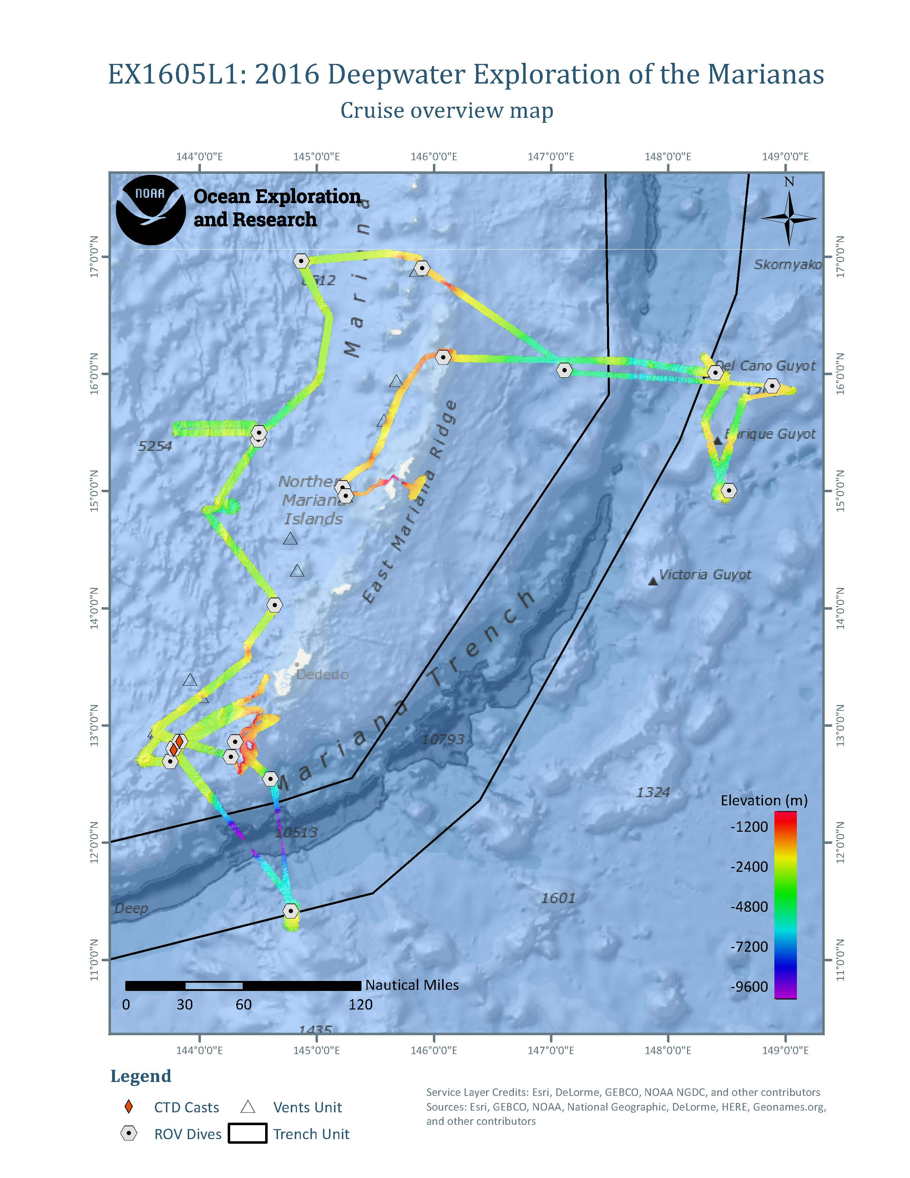
Figure 2. Map showing the locations of the 19 ROV dives, 3 CTD casts, and bathymetry data collected during EX1605 Leg 1.

8. Results

8.1 ROV seafloor surveys
Depth ranges explored during ROV surveys ranged between 240 m and 4,996 m, and bottom times ranged between 2:56 h and 7:33 h. Linear distances covered during ROV surveys ranged between 190 m and 1,470 m. During the 19 dives, the ROV spend a total of 105:18 h on the bottom and covered an estimated total linear distance of 13.075 km, yielding an average of 124 m surveyed per hour of bottom time (Table 4).

Table 4. Summary information for the 19 ROV dives conducted during EX1605 Leg 1.
Dive # | Date | Location | Start  Lat.  (N) | Start  Lon.  (E) | End  Lat.  (N) | End  Lon.  (E) | Max.  Depth  (m) | Bottom  Time (h:m) | Est. Distance (m) | Geo. Samples* | Bio. Samples* | Comm. Samples  * | Main Objective(s)
1 | 4/21/2016 | Santa Rosa North | 12.8605 | 144.3041 | 12.8548 | 144.3064 | 634 | 6:39 | 700 | 2 | 1 | 4 | Fisheries, precious corals
2 | 4/22/2016 | Santa Rosa South | 12.7322 | 144.2683 | 12.7319 | 16.2771 | 581 | 6:57 | 900 | 2 | 3 | 2 | Fisheries, precious corals
3 | 4/23/2016 | Sirena Canyon | 12.5377 | 144.6073 | 12.5377 | 144.6043 | 4996 | 4:01 | 700 | 2 | 3 | 1 | Abyssal communities, geologic history
4 | 4/24/2016 | Enigma Seamount | 11.4167 | 144.7827 | 11.4125 | 144.7843 | 3784 | 3:44 | 800 | 3 | 2 | 0 | Seamount, geologic history
5 | 4/26/2016 | Fina Nagu Caldera D | 12.6934 | 143.7496 | 12.7000 | 143.7475 | 2974 | 5:29 | 750 | 3 | 2 | 1 | Geologic history
6 | 4/27/2016 | Fina Nagu Caldera C | 12.7968 | 143.7810 | 12.7956 | 143.7888 | 2755 | 5:30 | 670 | 2 | 2 | 1 | Geologic history
7 | 4/28/2016 | Fina Nagu Caldera A | 12.8614 | 143.8309 | 12.8616 | 143.8283 | 2379 | 5:18 | 760 | 2 | 1 | 0 | Geologic history, hydrothermal vents
8 | 4/29/2016 | NW Guam Seamount | 14.0244 | 144.6424 | 14.0211 | 144.6367 | 1343 | 6:19 | 480 | 1 | 2 | 0 | Seamount; Geologic history,  fisheries
9 | 4/30/2016 | Young Lava Flows | 15.4373 | 144.5057 | 15.4322 | 144.5047 | 4068 | 5:25 | 700 | 3 | 0 | 0 | Geologic history
10 | 5/1/2016 | New Vent Field at 15.5N | 15.4982 | 144.5097 | 15.4924 | 144.5047 | 3930 | 5:30 | 640 | 2 | 0 | 0 | Hydrothermal vents
11 | 5/2/2016 | New Vent Field at 17N | 16.9607 | 144.8667 | 16.9610 | 144.8700 | 3296 | 6:25 | 600 | 1 | 1 | 0 | Hydrothermal vents
12 | 5/3/2016 | Zealandia | 16.9034 | 145.8997 | 16.8964 | 145.8968 | 655 | 7:06 | 800 | 0 | 3 | 1 | Fisheries, precious corals
13 | 5/4/2016 | Kunanaf Hulo’ Mud Volcano | 16.0275 | 147.1148 | 16.0304 | 147.1118 | 3703 | 4:01 | 650 | 1 | 1 | 1 | Mud volcano
14 | 5/5/2016 | Pigafetta Guyot | 15.8963 | 148.8865 | 15.8910 | 148.8826 | 2039 | 5:32 | 725 | 1 | 2 | 2 | Seamount;  Mn-habitats
15 | 5/6/2016 | Enrique Guyot | 15.0047 | 48.5184 | 15.0034 | 148.5161 | 2269.4 | 2:56 | 725 | 1 | 1 | 0 | Seamount;  Mn-habitats
16 | 5/7/2016 | Del Cano Guyot | 16.0114 | 48.3991 | 16.0043 | 148.3981 | 1928 | 3:39 | 635 | 0 | 0 | 0 | Seamount;  Mn-habitats
17 | 5/8/2016 | Farallon de Medinilla North | 16.1390 | 46.0783 | 16.1317 | 146.0772 | 508.7 | 7:08 | 700 | 1 | 1 | 1 | Fisheries, precious corals
18 | 5/9/2016 | Esmeralda Bank | 15.0291 | 45.2226 | 15.0357 | 145.2254 | 530.2 | 7:33 | 640 | 0 | 2 | 5 | Fisheries, precious corals
19 | 5/10/2016 | Esmeralda Crater | 14.9577 | 45.2478 | 14.9626 | 145.2614 | 337 | 6:06 | 500 | 0 | 0 | 0 | Hydrothermal Vents
Total: |  |  |  |  |  |  |  | 105:18:00 | 13,075 | 27 | 27 | 19
*Lists the number of morphotypes rather than the number of individuals.

Many different deep-sea habitats were explored in the southern Mariana Island region during EX1605L1 (Figure 3). Six high-density coral communities and two medium-density coral communities, as well as several sponge communities were observed. Many types of corals were documented including primnoids, isidids, chrysogorgiids, paragorgiids, stylasterids, desmophyllids, plexaurids, and more. The corals and sponges provided habitat and shelter for many other animals. There were also six dives (Dives 1, 2, 12, 17, 18, and 19) focused on collecting data on deep-water bottom fishery habitats where species of deep-water snapper, grouper, roughy, tuna, pomfret, and jack were documented. These dives were also designed to survey for precious corals and to investigate whether there was overlap between the ranges of the two resources. Although the precious-coral fishery is listed as a managed fishery in Guam and CNMI, no precious coral beds had been identified prior to this cruise and only anecdotal accounts of their presence in this region of the Pacific existed. The ROV surveys conducted on this expedition confirmed the presence of precious corals – documenting pink, red, gold, and bamboo corals – however, fewer were documented than expected. We also found through our ROV observations that while there was little overlap observed between bottomfish and precious coral habitats, there was overlap between bottomfish and non-precious coral habitat.

Dive 3 collected baseline information on the faunal community in the lesser-known abyssal depths at Sirena Canyon in the Marianas Trench Marine National Monument (Figure 3). A new active high-temperature hydrothermal vent field on Dive 11 in the Mariana back-arc spreading center that was composed of multiple chimneys was also discovered, including a chimney that was over 30 m tall (Figure 3). The field included at least two different chimney sites, plus multiple areas of diffuse flow and a circular crater feature (origin as yet undetermined) with extinct sulfides. Accompanying fauna such as munidopsids, actiniarians, gastropods, shrimp, tubeworms etc., showed clear zonation consistent with what we assume is distance from vent fluid. We also saw extinct hydrothermal chimneys on another dive and extinct iron oxide chimneys in Esmeralda Crater on Dive 19 (Figure 3).

Dive 9 surveyed a new lava flow that was no more than two years old. Comparison of bathymetry collected in 2013 and 2015 indicated an eruption had occurred in the intervening years, creating new lava rock over 100 m thick. We visited three 60-m pillow mounds that were composed almost entirely of glassy pillow lavas. Samples of these glassy lavas were collected and will be analyzed to determine the original composition of the erupting lava. Several calderas were visited to investigate how biological communities changed with geologically-younger substrate on Dives 5, 6 and 7.

An unexpected discovery during Dive 12 was the discovery of a rare high-density community of basket stars and crinoids at Zealandia Bank. Dive 13 surveyed the crest of the Kunanaf Hulo’ mud volcano. We were unable to find active seepage (typically associated with mud volcanoes), and instead documented a sedimented abyssal-plain habitat that was inhabited by many deposit feeders and also suspension-feeding sponges with Relicanthus (a cnidarian similar to an anemone) living on their stalks (an association rarely seen before) (Figure 3).

Three dives (Dives 14, 15 and 16) surveyed Cretaceous-age guyots with heavy ferromanganese crusts for initial characterization of the biological communities (Figure 3). These guyots are located within the Prime Crust Zone (PCZ) – the area of the Pacific with the highest concentration of commercially-valuable deep-sea minerals. Knowledge of habitat structure and communities on ferromanganese-encrusted seafloor prompt further research and discussion relevant to planning and managing the effects of deep-sea mining.. Each guyot surveyed had distinct geology and species assemblages. Manganese-encrusted rocks were collected at these sites, as well as on almost every other dive during the expedition. There were also two other seamounts visited: on Dive 8 and Dive 4 where the highest densities of trash were recorded for this leg of the expedition.

Hundreds of different types of animals observed during video surveys, and included cnidarians, sponges, echinoderms, arthropods, mollusks, tunicates, bryozoans, ctenophores, fishes, etc. Preliminary estimates suggest that most of the 46 species collected during this leg will be new to science, although confirmation is needed by taxonomists. These include multiple corals, sponges, crustacea and echinoderms. Additionally, there were also many animals seen during the dives that were suspected to be new species but were not collected, including a purple and yellow stalked crinoid, an orange stalked crinoid (a new genus), a blue tilefish, an asteroid, a beautiful jellyfish, a predatory sponge and many more. There were also many new records for the Mariana region representing range and sometimes depth extensions for these species. These included a slit shell snail (cf. Bayerotrochus teramachii), a jellynose eel (Guentherus kati), a gorgonocephalid basket star, several cusk eels, a large blind lobster (Acanthocaris tenuimana) and two nudibranchs, among others.
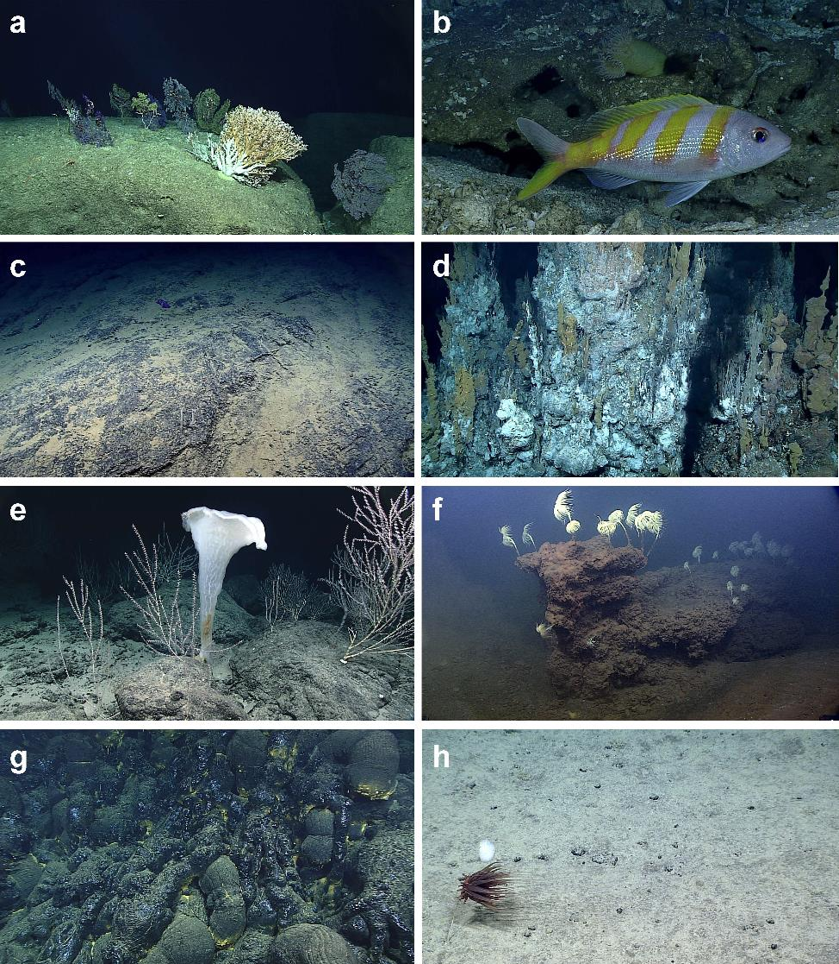
Figure 3. Deep-sea habitats encountered during EX1605L1. (a) High-density coral community at Santa Rosa North; (b) bottomfish habitat at Farallon de Medinilla; (c) the abyssal region of the Mariana Trench at Sirena Canyon; (d) an active hydrothermal-vent field 17N; (e) the Pigafetta Guyot in the Prime Crust Zone; (f) the active volcanic Esmeralda Crater; (g) fresh lava flows at the site ‘Young Lava Flows’; (h) a heavily-sedimented area of Kunanaf Hulo’ mud volcano.

8.2 Specimen collections
A total of 73 samples were collected during the expedition, including 27 geologic samples, 27 biological samples, and 19 commensal samples. The geological specimens included glassy pillow extrusions, carbonates, sedimentary rocks encrusted with manganese, hydrothermal vent sulfides, and basalts (some of which were also covered in manganese crust) (Table 5 and Figure 4).

Table 5. Inventory of geological samples collected during EX1605L1.
Sample # | Sample ID | Preservation | Site | Date | Time UTC | Latitude | Longitude | Depth m | Salinity | Temp 'C | Oxygen mg/l
DIVE01_SPEC01GEO | Basalt | Dry | Santa Rosa North | 20160420 | 23:08:24 | 12.85992 | 144.30429 | 596.0811 | 34.48534 | 5.77295 | 2.43838
DIVE01_SPEC02GEO | Carbonate | Dry | Santa Rosa North | 20160421 | 0:30:32 | 12.85807 | 144.30559 | 544.6907 | 34.48718 | 5.76113 | 2.4201
DIVE02_SPEC02GEO | Carbonate with Mn | Dry | Santa Rosa South | 20160421 | 22:46:20 | 12.73248 | 144.26872 | 543.4915 | 34.46434 | 6.67814 | 2.306
DIVE02_SPEC03GEO | Carbonate with Mn | Dry | Santa Rosa South | 20160422 | 1:29:17 | 12.73252 | 144.27318 | 346.702 | 34.3863 | 7.87471 | 2.58514
DIVE03_SPEC01GEO | Basalt with Mn | Dry | Sirena Canyon | 20160423 | 0:53:19 | 12.53934 | 144.60667 | 4967.8017 | 34.74141 | 1.50515 | 4.87612
DIVE03_SPEC03GEO | Sedimentary | Dry | Sirena Canyon | 20160423 | 2:42:26 | 12.5386 | 144.60502 | 4899.3132 | 34.69367 | 1.50629 | 4.82277
DIVE04_SPEC01GEO | Sedimentary with Mn | Dry | Enigma Seamount | 20160423 | 23:06:24 | 11.41676 | 144.78289 | 3781.0683 | 34.68387 | 1.54118 | 4.37462
DIVE04_SPEC02GEO | Sedimentary with Mn | Dry | Enigma Seamount | 20160424 | 0:06:36 | 11.41559 | 144.78348 | 3754.5252 | 34.6886 | 1.54135 | 4.47323
DIVE04_SPEC04GEO | Basalt | Dry | Enigma Seamount | 20160424 | 1:39:36 | 11.41313 | 144.78414 | 3684.1057 | 34.68523 | 1.533 | 4.41693
DIVE05_SPEC01GEO | Basalt with Mn | Dry | Fina Nagu Caldera D | 20160425 | 23:51:13 | 12.69344 | 143.74962 | 2970.7243 | 34.66918 | 1.67745 | 3.93191
DIVE05_SPEC02GEO | Basalt with Mn | Dry | Fina Nagu Caldera D | 20160426 | 1:24:44 | 12.6945 | 143.74903 | 2938.7875 | 34.66959 | 1.67842 | 3.96013
DIVE05_SPEC05GEO | Basalt | Dry | Fina Nagu Caldera D | 20160426 | 4:51:51 | 12.69918 | 143.74789 | 2675.6261 | 34.66179 | 1.70306 | 3.85569
DIVE06_SPEC01GEO | Basalt with Mn | Dry | Fina Nagu Caldera C | 20160427 | 0:08:04 | 12.7968 | 143.78128 | 2737.8168 | 34.66297 | 1.74678 | 3.87514
DIVE06_SPEC03GEO | Basalt with Mn | Dry | Fina Nagu Caldera C | 20160427 | 4:06:39 | 12.79558 | 143.78758 | 2578.1232 | 34.66211 | 1.74587 | 3.83946
DIVE07_SPEC01GEO | Hydrothermal vent sulphide | Dry | Fina Nagu Caldera A | 20160427 | 23:18:03 | 12.86181 | 143.83205 | 2297.9819 | 34.64771 | 1.99174 | 3.60066
DIVE07_SPEC03GEO | Basalt with Mn | Dry | Fina Nagu Caldera A | 20160428 | 1:33:40 | 12.86116 | 143.8286 | 2294.6914 | 34.64619 | 2.0036 | 3.60313
DIVE08_SPEC02GEO | Basalt | Dry | NW Guam Seamount | 20160429 | 0:10:53 | 14.02169 | 144.6406 | 1209.6871 | 34.57257 | 3.75871 | 2.64257
DIVE09_SPEC01GEO | Pillow extrusion | Dry | Young Lava Flows | 20160429 | 23:17:05 | 15.43742 | 144.50557 | 4056.1005 | 34.6811 | 1.66375 | 4.16593
DIVE09_SPEC02GEO | Pillow basalt | Dry | Young Lava Flows | 20160430 | 2:23:56 | 15.43482 | 144.50415 | 3964.6304 | 34.68444 | 1.65325 | 4.20654
DIVE09_SPEC03GEO | Pillow extrusion | Dry | Young Lava Flows | 20160430 | 3:50:31 | 15.43274 | 144.50495 | 4062.4588 | 34.68204 | 1.65194 | 4.22031
DIVE10_SPEC01GEO | Pillow extrusion | Dry | New Hydrothermal Vent Field 1 | 20160501 | 3:34:12 | 15.4932 | 144.50809 | 3820.6279 | 34.67749 | 1.62814 | 4.24515
DIVE10_SPEC02GEO | Pillow extrusion | Dry | New Hydrothermal Vent Field 1 | 20160501 | 3:49:57 | 15.4929 | 144.50773 | 3807.9553 | 34.68317 | 1.62968 | 4.13199
DIVE11_SPEC01GEO | Hydrothermal vent sulphide | Dry | New Hydrothermal Vent Field 2 | 20160502 | 3:20:43 | 16.96176 | 144.86891 | 3286.8611 | 34.66831 | 1.68013 | 4.03858
DIVE13_SPEC01GEO | Mn-encrusted rock | Dry | Kunanaf Hulo Seamount | 20160503 | 23:14:07 | 16.02721 | 147.11463 | 3677.3178 | 34.6852 | 1.50377 | 4.45974
DIVE14_SPEC01GEO | Mn-encrusted rock | Dry | Pigafetta Guyot | 20160504 | 22:05:29 | 15.89633 | 148.88668 | 2004.6537 | 34.63172 | 2.07082 | 3.3612
DIVE15_SPEC01GEO | Mn-encrusted rock | Dry | Enrique Guyot | 20160506 | 0:37:24 | 15.00455 | 148.51825 | 2266.4091 | 34.6467 | 1.90932 | 3.52711
DIVE17_SPEC02GEO | Carbonate | Dry | Farallon de Medinilla | 20160508 | 3:25:13 | 16.13222 | 146.07819 | 258.3868 | 34.86913 | 18.25271 | 5.81503

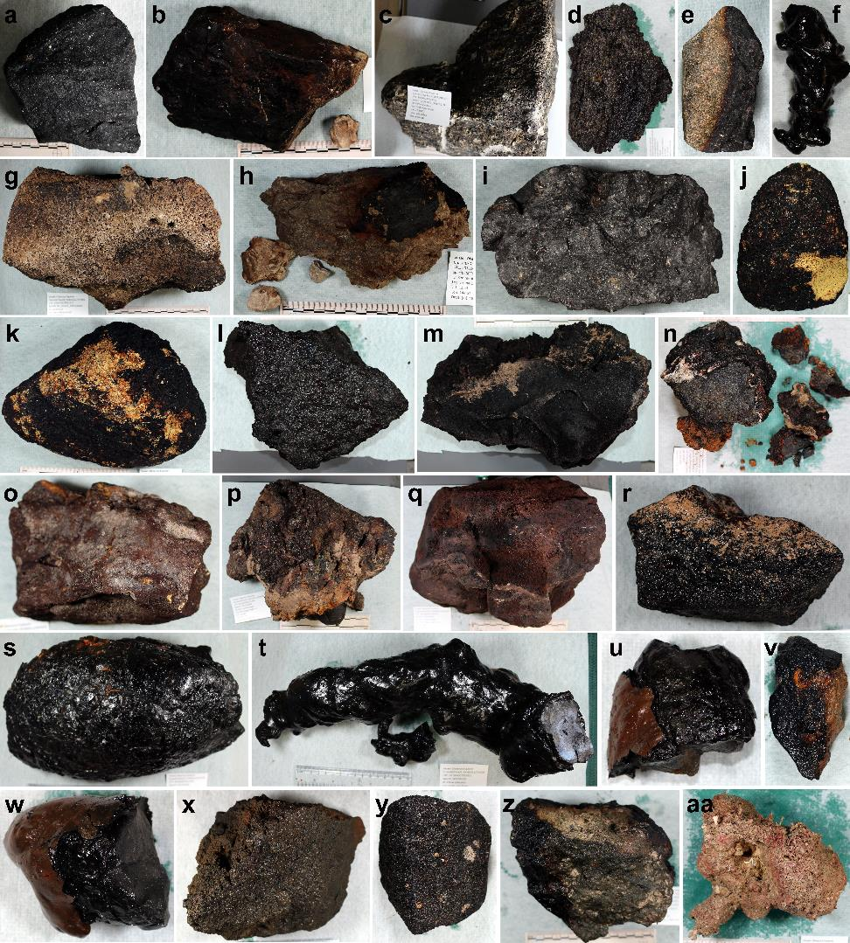Figure 4. Laboratory photographs of the 27 geological specimens collected during EX1605L1..(a) DIVE01_SPEC01GEO; (b) DIVE02_SPEC02GEO; (c) DIVE01_SPEC02GEO; (d) DIVE07_SPEC03GEO; (e) DIVE03_SPEC01GEO; (f) DIVE09_SPEC01GEO; (g) DIVE02_SPEC03GEO; (h) DIVE03_SPEC03GEO; (i) DIVE04_SPEC04GEO; (j) DIVE04_SPEC02GEO; (k) DIVE04_SPEC01GEO; (l) DIVE06_SPEC01GEO; (m) DIVE06_SPEC03GEO; (n) DIVE07_SPEC01GEO; (o) DIVE05_SPEC05GEO; (p) DIVE05_SPEC02GEO; (q) DIVE05_SPEC01GEO; (r) DIVE08_SPEC02GEO; (s) DIVE09_SPEC02GEO; (t) DIVE09_SPEC03GEO; (u) DIVE10_SPEC02GEO; (v) DIVE13_SPEC01GEO; (w) DIVE10_SPEC01GEO; (x) DIVE11_SPEC01GEO; (y) DIVE14_SPEC01GEO; (z); DIVE15_SPEC01GEO; (aa) DIVE17_SPEC02GEO.

There were 27 biological samples that were purposely collected, as well as 19 samples that were incidentally collected as commensal organisms on other samples. In total, these samples amounted to over 117 individuals. Biological samples (not limited to one individual) collected include 14 corals, nine sponges, four brittle stars, two hydrozoans, one actiniarian, one ctenophore, one zoantharian, four squat lobsters, one shrimp, one hermit crab, two barnacles, one holothurian, one basket star, three crinoids, and one tunicate (Table 6; Figures 5 and 6). Most of these specimens are thought to be new species and/or new records for the Mariana region.

Table 6. Inventory of biological samples collected during EX1605L1.
Sample # | Sample ID | Group | # Ind. | Preservation | OGL  Vial # | Site | Date | Time UTC | Latitude | Longitude | Depth m | Salinity | Temp 'C | Oxygen mg/l
DIVE01_SPEC02GEOCO1 | Ophiuroidea | Brittle star | 1 | 95% ETOH | 119 | Santa Rosa North | 20160421 | 0:30:32 | 12.85807 | 144.30559 | 544.6907 | 34.48718 | 5.76113 | 2.4201
DIVE01_SPEC02GEOCO2 | Ophiuroidea | Brittle star | 1 | 95% ETOH | 120 | Santa Rosa North | 20160421 | 0:30:32 | 12.85807 | 144.30559 | 544.6907 | 34.48718 | 5.76113 | 2.4201
DIVE01_SPEC02GEOCO3 | Ophiuroidea | Brittle star | 1 | 95% ETOH | 121 | Santa Rosa North | 20160421 | 0:30:32 | 12.85807 | 144.30559 | 544.6907 | 34.48718 | 5.76113 | 2.4201
DIVE01_SPEC03BIO | Chrysogorgiidae | Coral | 1 | 95% ETOH | 16 | Santa Rosa North | 20160421 | 3:07:35 | 12.85583 | 144.30615 | 354.8415 | 34.32402 | 9.03303 | 3.26928
DIVE01_SPEC03BIOCO1 | Munididae | Squat lobster | 2 | 95% ETOH | 118 | Santa Rosa North | 20160421 | 3:07:35 | 12.85583 | 144.30615 | 354.8415 | 34.32402 | 9.03303 | 3.26928
DIVE02_SPEC01BIO | Madrepora sp. | Coral | 1 | 95% ETOH | 18 | Santa Rosa South | 20160421 | 21:44:23 | 12.73216 | 144.26836 | 575.2917 | 34.4735 | 6.07926 | 2.38527
DIVE02_SPEC01BIOCO1 | Desmophyllum sp. | Coral | 1 | 95% ETOH | 19 | Santa Rosa South | 20160421 | 21:44:23 | 12.73216 | 144.26836 | 575.2917 | 34.4735 | 6.07926 | 2.38527
DIVE02_SPEC01BIOCO2 | Chirostylidae | Squat lobster | 1 | 95% ETOH | 123 | Santa Rosa South | 20160421 | 21:44:23 | 12.73216 | 144.26836 | 575.2917 | 34.4735 | 6.07926 | 2.38527
DIVE02_SPEC04BIO | Hyocrinidae | Crinoid | 1 | 95% ETOH | 122 | Santa Rosa South | 20160422 | 2:20:05 | 12.73242 | 144.27451 | 320.1722 | 34.33843 | 9.38392 | 3.4157
DIVE02_SPEC05BIO | Lepidisis sp. | Coral | 1 | 95% ETOH | 17 | Santa Rosa South | 20160422 | 3:43:04 | 12.73217 | 144.27577 | 298.316 | 34.37186 | 11.61839 | 4.48057
DIVE03_SPEC02BIO | Comatulida | Crinoid | 1 | 95% ETOH and 4% Formalin | 124 | Sirena Canyon | 20160423 | 1:18:42 | 12.53925 | 144.60623 | 4954.7989 | 34.69734 | 1.50829 | 4.89713
DIVE03_SPEC04BIO | Galatheathuria sp. | Sea cucumber | 1 | 95% ETOH | 125 | Sirena Canyon | 20160423 | 3:19:48 | 12.53793 | 144.60438 | 4862.9395 | 34.69691 | 1.5119 | 4.85372
DIVE03_SPEC05BIO | Cladorhizidae sp. 1 | Sponge | 1 | 95% ETOH and Frozen | 126 | Sirena Canyon | 20160423 | 3:36:57 | 12.53774 | 144.60419 | 4856.6343 | 34.69049 | 1.50394 | 4.77179
DIVE03_SPEC05BIOCO1 | Ophiuroidea | Brittle star | 9 | 95% ETOH | 127 | Sirena Canyon | 20160423 | 3:36:57 | 12.53774 | 144.60419 | 4856.6343 | 34.69049 | 1.50394 | 4.77179
DIVE04_SPEC03BIO | Primnoidae | Coral | 1 | 95% ETOH | 20 | Enigma Seamount | 20160424 | 0:36:50 | 11.41489 | 144.78372 | 3736.5856 | 34.69566 | 1.53443 | 4.41438
DIVE04_SPEC05BIO | Primnoidae | Coral | 1 | 95% ETOH | 21 | Enigma Seamount | 20160424 | 02:16:09 | 11.41264 | 144.78422 | 3642.9573 | 34.68231 | 1.55472 | 4.25617
DIVE05_SPEC03BIO | Hyalonema sp. - orange | Sponge | 1 | 95% ETOH | 129 | Fina Nagu Caldera D | 20160426 | 2:10:51 | 12.69524 | 143.74933 | 2935.1605 | 34.66748 | 1.69353 | 3.96784
DIVE05_SPEC03BIOCO1 | Scallpellidae | Barnacle | 1 | 95% ETOH | - | Fina Nagu Caldera D | 20160426 | 2:10:51 | 12.69524 | 143.74933 | 2935.1605 | 34.66748 | 1.69353 | 3.96784
DIVE05_SPEC04BIO | Hyalonema sp. - white | Sponge | 1 | 95% ETOH | 128 | Fina Nagu Caldera D | 20160426 | 3:01:13 | 12.69609 | 143.74915 | 2894.6303 | 34.67932 | 1.70944 | 3.98077
DIVE06_SPEC02BIO | Isididae | Coral | 1 | 95% ETOH | 22 | Fina Nagu Caldera C | 20160427 | 0:51:58 | 12.79628 | 143.78181 | 2711.8696 | 34.70204 | 1.74085 | 3.90475
DIVE06_SPEC04BIO | Pleurogorgia sp. | Coral | 1 | 95% ETOH | 23 | Fina Nagu Caldera C | 20160427 | 5:12:18 | 12.79569 | 143.78889 | 2509.7045 | 34.65982 | 1.79788 | 3.82085
DIVE06_SPEC04BIOCO1 | Actiniaria | Anemone | >20 | 95% ETOH and 4% Formalin | 130 | Fina Nagu Caldera C | 20160427 | 5:12:18 | 12.79569 | 143.78889 | 2509.7045 | 34.65982 | 1.79788 | 3.82085
DIVE07_SPEC02BIO | Ascidiacea | Tunicate | 1 | 95% ETOH | 131 | Fina Nagu Caldera A | 20160428 | 0:41:26 | 12.86129 | 143.83028 | 2378.2378 | 34.64655 | 2.01302 | 3.61498
DIVE08_SPEC01BIO | Lepidisis sp. | Coral | 1 | 95% ETOH | 24 | NW Guam Seamount | 20160428 | 23:56:12 | 14.02175 | 144.64052 | 1209.5705 | 34.56856 | 3.60121 | 2.66495
DIVE08_SPEC03BIO | Cladorhizidae sp. 2 | Sponge | 1 | 95% ETOH and frozen; 4% Formalin to 70% ETOH | 132 | NW Guam Seamount | 20160429 | 3:18:07 | 14.02064 | 144.63747 | 1229.3378 | 34.5726 | 3.43611 | 2.73124
DIVE11_SPEC02BIO | Isididae | Coral | 1 | 95% ETOH | 25 | New Hydrothermal Vent Field 2 | 20160502 | 4:14:01 | 16.9613 | 144.86918 | 3292.6033 | 34.54563 | 1.88107 | 4.09966
DIVE12_SPEC01BIO | Hexapathes sp. | Coral | 1 | 95% ETOH and 4% Formalin | 26 | Zealandia Bank | 20160502 | 22:32:30 | 16.90288 | 145.89918 | 599.4688 | 34.34396 | 6.3034 | 2.06094
DIVE12_SPEC01BIOCO1 | Munididae | Squat lobster | 2 | 95% ETOH | 133 | Zealandia Bank | 20160502 | 22:32:30 | 16.90288 | 145.89918 | 599.4688 | 34.34396 | 6.3034 | 2.06094
DIVE12_SPEC02BIO | Gorgonocephalidae | Basket star | 1 | 95% ETOH and Frozen | 134 | Zealandia Bank | 20160503 | 2:11:19 | 16.89968 | 145.89747 | 374.7809 | 34.36361 | 12.47086 | 5.42212
DIVE12_SPEC03BIO | Lithistid | Sponge | 1 | 95% ETOH | 135 | Zealandia Bank | 20160503 | 3:57:41 | 16.89718 | 145.89712 | 310.2147 | 34.54562 | 15.05496 | 6.26748
DIVE13_SPEC01GEOCO1 | Crinoidea | Crinoid | 1 | 95% ETOH | 136 | Kunanaf Hulo Seamount | 20160503 | 23:14:07 | 16.02721 | 147.11463 | 3677.3178 | 34.6852 | 1.50377 | 4.45974
DIVE13_SPEC02BIO | Caulophacus sp. | Sponge | 1 | 95% ETOH | 137 | Kunanaf Hulo Seamount | 20160504 | 2:22:36 | 16.03034 | 147.11219 | 3701.0278 | 34.68806 | 1.48329 | 4.49437
DIVE14_SPEC01GEOCO1 | Hydrozoa | Hydroid | 1 | 95% ETOH | 138 | Pigafetta Guyot | 20160504 | 22:05:29 | 15.89633 | 148.88668 | 2004.6537 | 34.63172 | 2.07082 | 3.3612
DIVE14_SPEC02BIO | Bolosominae sp. 3 | Sponge | 1 | 95% ETOH | 139 | Pigafetta Guyot | 20160505 | 0:48:16 | 15.89389 | 148.88518 | 2027.862 | 34.63118 | 2.09072 | 3.4234
DIVE14_SPEC03BIO | Isididae | Coral | 1 | 95% ETOH | 28 | Pigafetta Guyot | 20160505 | 3:05:15 | 15.8914 | 148.88324 | 1965.6363 | 34.62791 | 2.13315 | 3.26753
DIVE14_SPEC03BIOCO1 | Cirripedia | Barnacle | 1 | 95% ETOH | - | Pigafetta Guyot | 20160505 | 3:05:15 | 15.8914 | 148.88324 | 1965.6363 | 34.62791 | 2.13315 | 3.26753
DIVE15_SPEC02BIO | Porifera sp. | Sponge | 1 | 95% ETOH and 4% Formalin | 140 | Enrique Guyot | 20160506 | 1:41:53 | 15.00418 | 148.51727 | 2190.9216 | 34.64435 | 1.95199 | 3.50755
DIVE17_SPEC01BIO | Plexauridae | Coral | 1 | 95% ETOH | 29 | Farallon de Medinilla | 20160508 | 0:32:20 | 16.13436 | 146.08179 | 279.9554 | 34.5863 | 15.29593 | 5.70465
DIVE17_SPEC01BIOCO1 | Hydrozoa | Hydroid | 1 | 95% ETOH | 141 | Farallon de Medinilla | 20160508 | 0:32:20 | 16.13436 | 146.08179 | 279.9554 | 34.5863 | 15.29593 | 5.70465
DIVE18_SPEC01BIO | Demospongiae | Sponge | 1 | 95% ETOH and Frozen | 142 | North Esmeralda Bank | 20160509 | 0:49:03 | 15.03162 | 145.22342 | 364.2557 | 34.33058 | 11.41658 | 4.51962
DIVE18_SPEC01BIOCO1 | Paguridae | Hermit crab | 5 | 95% ETOH | 143 | North Esmeralda Bank | 20160509 | 0:49:03 | 15.03162 | 145.22342 | 364.2557 | 34.33058 | 11.41658 | 4.51962
DIVE18_SPEC02BIO | Chrysogorgiidae | Coral | 1 | 95% ETOH | 30 | North Esmeralda Bank | 20160509 | 1:39:27 | 15.03185 | 145.22355 | 339.7821 | 34.2951 | 10.21001 | 3.9733
DIVE18_SPEC02BIOCO1 | Ctenophora | Comb jelly | >30 | 95% ETOH | 144 | North Esmeralda Bank | 20160509 | 1:39:27 | 15.03185 | 145.22355 | 339.7821 | 34.2951 | 10.21001 | 3.9733
DIVE18_SPEC02BIOCO2 | Zoantharia | Zoanthid | 10 | 95% ETOH | 145 | North Esmeralda Bank | 20160509 | 1:39:27 | 15.03185 | 145.22355 | 339.7821 | 34.2951 | 10.21001 | 3.9733
DIVE18_SPEC02BIOCO3 | Munididae | Squat lobster | 1 | 95% ETOH | - | North Esmeralda Bank | 20160509 | 1:39:27 | 15.03185 | 145.22355 | 339.7821 | 34.2951 | 10.21001 | 3.9733
DIVE18_SPEC02BIOCO4 | Lebbeus sp. | Shrimp | 1 | 95% ETOH | - | North Esmeralda Bank | 20160509 | 1:39:27 | 15.03185 | 145.22355 | 339.7821 | 34.2951 | 10.21001 | 3.9733

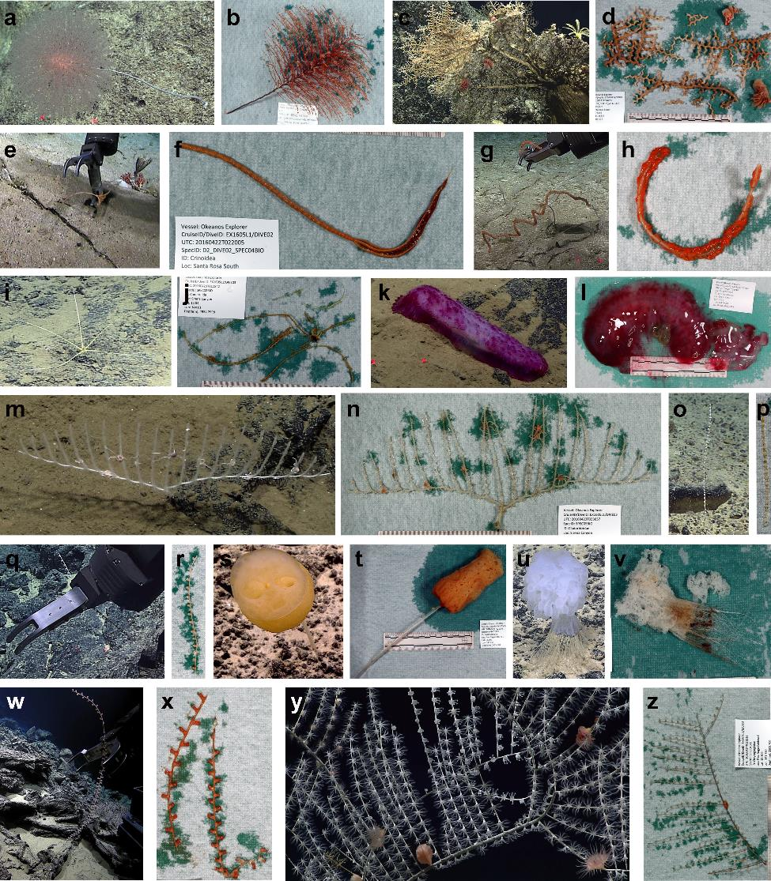
Figure 5. In situ (left) and laboratory (right) photographs of the first 13 biological samples collected during EX1605L1. (a) Chrysogorgia sp. in situ; (b) Chrysogorgia sp. in lab; (c) Madrepora sp. with commensal Desmophyllum sp. in situ; (d) Madrepora sp. in lab; (e) Crinoidea sp. in situ; (f) Crinoidea sp. in lab; (g) Lepidisis sp. in situ; (h) Lepidisis sp. in lab; (i) Comatulida sp. in situ; (j) Comatulida sp. in lab; (k) Galatheathuria sp. in situ; (l) Galatheathuria sp. in lab; (m) Cladorhizidae sp. 1 in situ; (n) Cladorhizidae sp. 1 in lab; (o) Primnoidae sp. in situ; (p) Primnoidae sp. in lab; (q) Primnoidae sp. in situ; (r) Primnoidae sp. in lab; (s) Hyalonema sp. orange in situ; (t) Hyalonema sp. orange in lab; (u) Hyalonema sp. white in situ; (v) Hyalonema sp. orange in situ; (w) Isididae sp. in situ; (x) Isididae sp. 1 in lab; (y) Pleurogorgia sp. with commensal actinarians in situ; (z) Pleurogorgia sp. in lab.
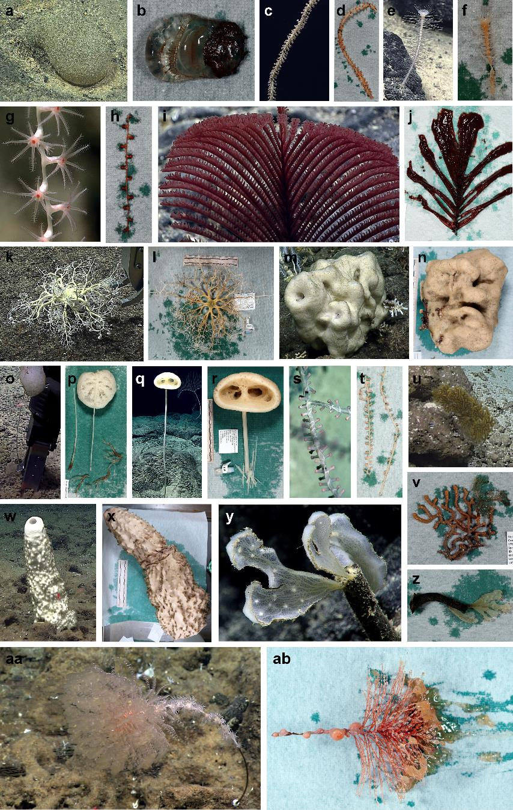
Figure 6. In situ (left) and laboratory (right) photographs of the last 14 biological samples collected during EX1605L1. (a) Ascidacea sp. in situ; (b) Ascidacea sp. in lab; (c) Lepidisis sp. in situ; (d) Lepidisis sp. in lab; (e) Cladorhizidae sp. 2 in situ; (f) Cladorhizidae sp. 2 in lab; (g) Isididae sp. in situ; (h) Isididae sp. in lab; (i) Hexapathes sp. in situ; (j) Hexapathes sp. in lab; (k) Gorgonocephalidae sp. in situ; (l) Gorgonocephalidae sp. in lab; (m) Lithistid sp. in situ; (n) Lithistid sp. in lab; (o) Caulophacus sp. in situ; (p) Caulophacus sp. in lab; (q) Bolosominae sp. 3 in situ; (r) Bolosominae sp. in lab; (s) Isididae sp. in situ; (t) Isididae sp. in lab; (u) Plexauridae sp. in situ; (v) Plexauridae sp. orange in situ; (w) Demospongiae sp. in situ; (x) Demospongiae sp. in lab; (y) Porifera sp. in situ; (z) Porifera sp. in lab; (aa) Chrysogorgia sp. with commensal benthic ctenophores in situ; (ab) Chrysogorgia sp. with commensal benthic ctenophores in lab.

8.3 Seafloor mapping
The total area mapped by the Okeanos Explorer’s EM302 sonar during the expedition was 19,600 km². This included mapping data acquired both in transit between sites, as well as targeted multibeam surveys. Targeted mapping around Santa Rosa Reef captured a large portion of the 400 m contour, see figure 8. A repeated and detailed survey was conducted over Esmerelda Crater, with focus on collecting high quality EK60 data over this active underwater volcano. Well defined scattering layers were visible in all four EK60 frequencies, figure 9. One water column anomaly, consistent with gas seepage, was detected on one pass, however the anomaly was not detect on subsequent passes over the same area.

Immediately following the ROV dive at the newly discovered black smoker site at 17 N; the Okeanos Explorer mapped the water column over the vent field using the 18 kHz EK60 sonar and the multibeam sonar. Six passes were made over the field, transiting at 4-5 knots on various headings. There was a clear and repeatable signal in the split-beam echogram from the venting but less obvious indication in the multibeam data. This data is still being analyzed.

A targeted multibeam survey to search for several lost B-29 bombers from World War II was conducted in the Saipan/Tinian channel and west of Saipan in 50 to 800 m of water. The seafloor west of Saipan was marked with dense coral structures, making it difficult to differentiate between natural and manmade features on the seafloor. The bathymetry and backscatter data was provided to experts for further processing and analysis.

All the raw mapping data from this expedition was deemed unclassified and is available at the NCEI national achieves.

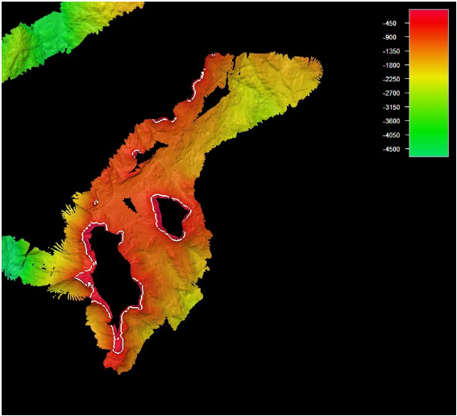
Figure 8. Map showing the bathymetry around Santa Rosa Reef, the white line shows the 400 m depth contour.

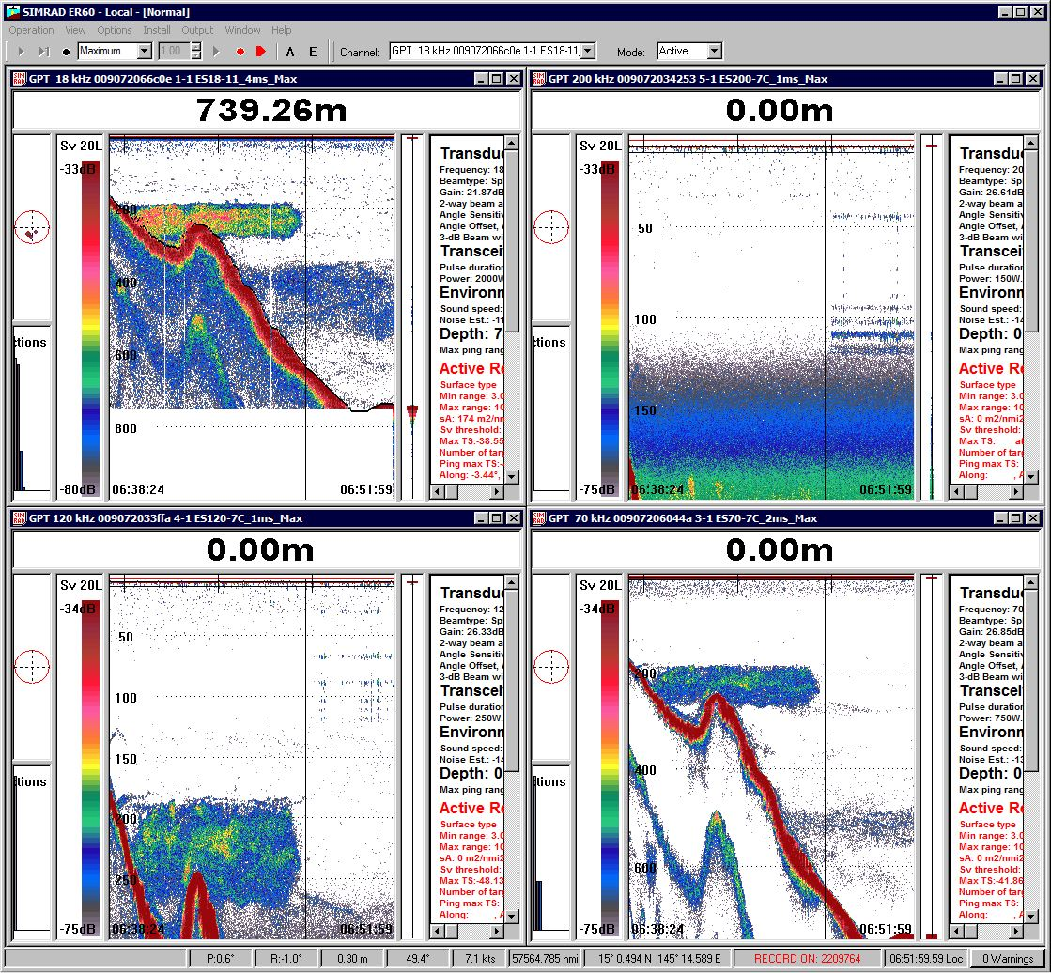
Figure 9. Scattering layer over Esmerelda Crater, the layer is visible over all four frequencies.

8.4 Education and outreach products
The expedition received news and media coverage by more than 70 outlets (including CNN, NPR, LA Times, Washington Post, Scientific American, USA Today, BBC) and conducted 7 interviews with media during the expedition. Live feeds of the expedition were continuously streamed throughout the expedition at UnderwaterWorld Guam and the Waikiki Aquarium. Additionally, the live video feeds of the expedition were streamed over the Internet and garnered more than 2.5 million views, greatly breaking the previous record for live video views of 700,000! The oceanexplorer website received ~440,000 views to web content developed specifically for the expedition by participants.

The Exploration Command Center at UnderwaterWorld Guam served as both a working space for scientists and a public outreach venue. Two live interactions were conducted with UnderwaterWorld Guam during Leg 1 and engaged 90 high school students in local robotics and marine geology clubs. A live interaction was also conducted with Saipan Southern High School and engaged 100 science students.

Ship tours were conducted for members of the public and VIPs in Saipan after the ship pulled into port in Saipan. 216 members of the public (including educators, scientists, CNMI agency experts and students) toured the ship on May 12. VIP tours of the ship were given on May 13 for 30 visitors including the Secretary of CNMI DLNR, representatives from the WPRFM Council and Northern Marianas College, NOAA partners, media, and educators, who participated in OER’s education professional development program.

9. Conclusion
EX1605 Leg 1 provided a great depth of baseline information to support management and science needs in CNMI and for the MTMNM. Noteworthy highlights include:
- Conducted 19 ROV dives for a total of over 105.3 hours of bottom time, and an estimated linear survey distance of 13.075 km. ROV surveys were conducted from 240 m to 4,996 m. Dives included:
  - Five within or adjacent to MTMNM boundaries;
  - Six to survey for precious coral or bottomfish fishery habitats;
  - Five at seamounts to look at deep-sea coral communities and manganese-encrusted seafloor habitats;
  - Eight focused on hydrothermal vents, mud volcanoes and associated communities;
  - Six to better understand the geologic history of the region.
- Observed hundreds of different species of animals. There were dozens of potential new species, as well as many records for the region. New species included three cladorhizid sponges, three hexactinellid sponges, a tilefish, a hydromedusae jellyfish, a seastar, two new species of crinoid, although there were likely many more. These should be confirmed at a later date.
- Collected 27 primary biological samples, each possibly an undescribed species, and 27 rock samples for use in age-dating and geochemical composition analysis. When commensals were included, 117 individual animals were sampled representing 46 different species.
- Conducted the first effort to discover and document deep-sea coral and sponge communities in the deep-waters of the Marianas. Documented six high density communities and two medium density communities. Also documented a rare high density community of basket stars and crinoids.
- Confirmed the presence of precious corals in the region, and surveyed deep-water bottomfish fishery habitats. Found that while there was little overlap observed between bottomfish and precious corals, there was overlap between bottomfish and non-precious coral habitat.
- Surveyed three Cretaceous-age guyots with heavy ferromanganese crusts for initial characterization of biological communities in advance of any potential mining activities. Each guyot had distinct geology and species assemblages.
- Collected baseline information on the faunal community at abyssal depths in the Marianas Trench Marine National Monument.
- Documented a new active high-temperature “black smoker” hydrothermal vent field on the Mariana Back Arc spreading center that was composed of multiple chimneys, including one that was over 30 m tall.
- Investigated a number of different geological features, including extinct calderas, active volcanoes, mud volcanoes, fresh lava flows, and carbonate platforms.
- Mapped areas of interest for fisheries resource managers, including the 400 m contour at Santa Rosa Bank and the north side of Farallon De Medinilla.
- Mapped just under 20,000 square kilometers of seafloor - an area nearly the size of New Jersey. This includes data of six sites that are included in the Vents Unit of the MTMNM.
- Conducted a mapping survey to search for several lost B29 bombers from WWII. These sites are of interest to researchers and managers including the State Historic Preservation Officer, National Park Service, U.S. Navy, the Department of Defense (program that accounts for MIAs) and several academics.
- Collected 22.5 TB of data including multibeam, single beam, subbottom, ADCP, CTD, XBT, surface oceanographic and meteorological sensor, video, image, and associated dive and video products.

