Okeanos Explorer ROV Dive Summary
Site Name | Esmerelda Crater and East Flank |  |  |  |  | 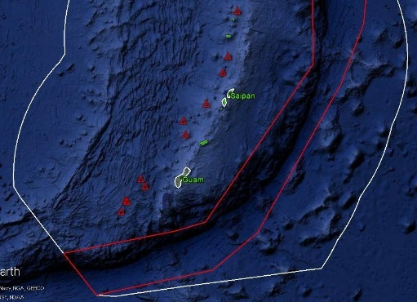
ROV Lead/Expedition Coordinator | Jim Newman / Kelley Elliott
Science Team Leads | Deborah Glickson & Diva Amon
General Area Descriptor | Southern Marianas
ROV Dive Name | Cruise Season |  | Leg |  |  |  | Dive Number
 | EX1605 |  | 1 |  |  |  | DIVE 19
Equipment Deployed | ROV: |  | Deep Discoverer
 | Camera Platform: |  | Seirios
ROV Measurements | D2 CTD |  | Depth |  |  |  | Altitude
 | Scanning Sonar |  | USBL Position |  |  |  | Heading
 | Pitch |  | Roll |  |  |  | HD Camera 1
 | HD Camera 2 |  | ROV HD 2 |  |  |  | Seirios CTD
 | Temperature Probe |  | D2 DO Sensor |  |  |  | Seirios DO sensor
Equipment Malfunctions | None.
ROV Dive Summary  (From processed ROV data) | Dive Summary: EX1605L1_DIVE19  ^^^^^^^^^^^^^^^^^^^^^^^^^^^^^^^^^^^^^^^^^^^^^^^^^^^  In Water: 2016-05-09T20:28:09.303000  14°, 57.482' N ; 145°, 14.831' E  Out Water: 2016-05-10T03:08:47.118000  14°, 57.773' N ; 145°, 15.736' E  Off Bottom: 2016-05-10T02:57:31.676000  14°, 57.757' N ; 145°, 15.686' E  On Bottom: 2016-05-09T20:50:49.944000  14°, 57.460' N ; 145°, 14.870' E  Dive duration: 6:40:37  Bottom Time: 6:6:41  Max. depth: 337.0 m
Special Notes
Scientists Involved  (please provide name / location / affiliation / email) | Bob Embley, NOAA PMEL; robert.w.embley@noaa.gov  Scott France, UL Lafayette; france@louisiana.edu  Patty Fryer, UH; pfryer@soest.hawaii.edu  Brian Greene, Association for Marine Exploration; bgreene@hawaii.edu  Tara Harmer Luke, Stockton University; Tara.Luke@stockton.edu  Julie Huber, MBL; jhuber@mbl.edu  Chris Kelley, UH; ckelley@hawaii.edu  Jonathan Kellogg, U Victoria; jkellogg@uvic.ca  Machel Malay, U Guam; machel.malay@gmail.com  Asako Matsumoto, Chiba Institute of Technology; amatsu@gorgonian.jp  Tina Molodtsova, Shirshov Institute of Oceanology; tina@ocean.ru  Bruce Mundy, NOAA PIFSC; bruce.mundy@noaa.gov  Amanda Netburn, NOAA OER; amanda.netburn@noaa.gov  Richard Pyle, Bishop Museum; deepreef@bishopmuseum.org  Robert Stern, UT Dallas; rjstern@utdallas.edu
Purpose of the Dive
Esmeralda Bank is an active volcano and almost certainly has vents in its central crater. According to Pacific Islands Benthic Habitat Mapping Center, the Bank appears to have experienced recent volcanic activity and shows signs of current hydrothermal circulation. Previous NOAA ROV dives in 2004 have been blocked by thick “smoke”; we decided to try to dive to see what is there. The preferred dive track is in the crater, beginning at 338 m, moving through the crater and up the ridge for ~ 660 m, ending at a depth of 262 m. The alternate track begins at 436 m, goes upslope for ~660 m, and ends at a depth of 247 m.

Description of the Dive:
We mapped Esmerelda Crater the evening before the dive. In addition to particulate-laden water in the crater (which we expected), there was also a plume-like feature that was imaged by the EK60 mid-water-column sonar at a depth of about 250 m on the east flank of the crater. We decided to alter our alternate dive plan to dive at the plume hit if we were required to abort the crater dive due to visibility.

We landed at a depth of 336 m in heavy sediment that appeared to be mostly iron precipitate. There was a ripple pattern that was probably caused by interference of currents in multiple directions, causing the surface to appear rounded and lumpy. There were color differences along the ripples due to sorting between heavies and fines, with white patches that were likely caused by bioturbation. As we moved to the northeast, we came across one large rock outcrop that hosted a large variety of biology which included many species of fish as well as stalked crinoids. A number of pagurids were also seen on the seafloor. The sediment ripple pattern was longitudinal at this point, and then became more star-shaped. We then encountered a cluster of extinct hydrothermal chimneys that were likely made of Fe oxides. At that point, the current became so strong that we needed to pull up from the bottom and move to the east flank site.

At the dive location outside of the crater, we saw heavy sediment without the iron staining in the crater, although a large pit showed layers of what looked like ash deposits, and we possibly saw some pumice. We also saw a clayey hardpan layer of uncertain origin. While there was evidence of a 2 degree C change in temperature as we approached the eastern flank above 240 m, we could not definitely pin it to an area of diffuse flow. The sedimented seafloor hosted two different species of pennatulacea, as well as small rocks seemed to host several large stalked crinoids and anemones. A new species of tilefish was observed, as well as several batfish. There were also a number of pagurids and banded ophiuroids living on the seafloor.

Map of ROV Dive Area
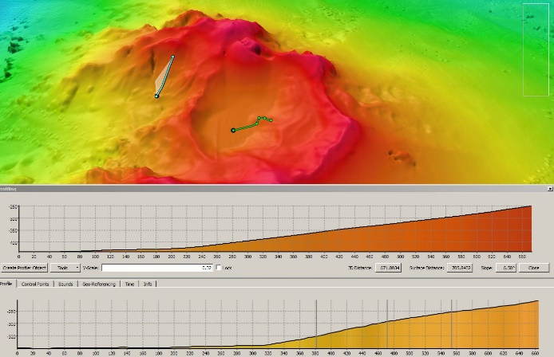 |  |  |  |  | 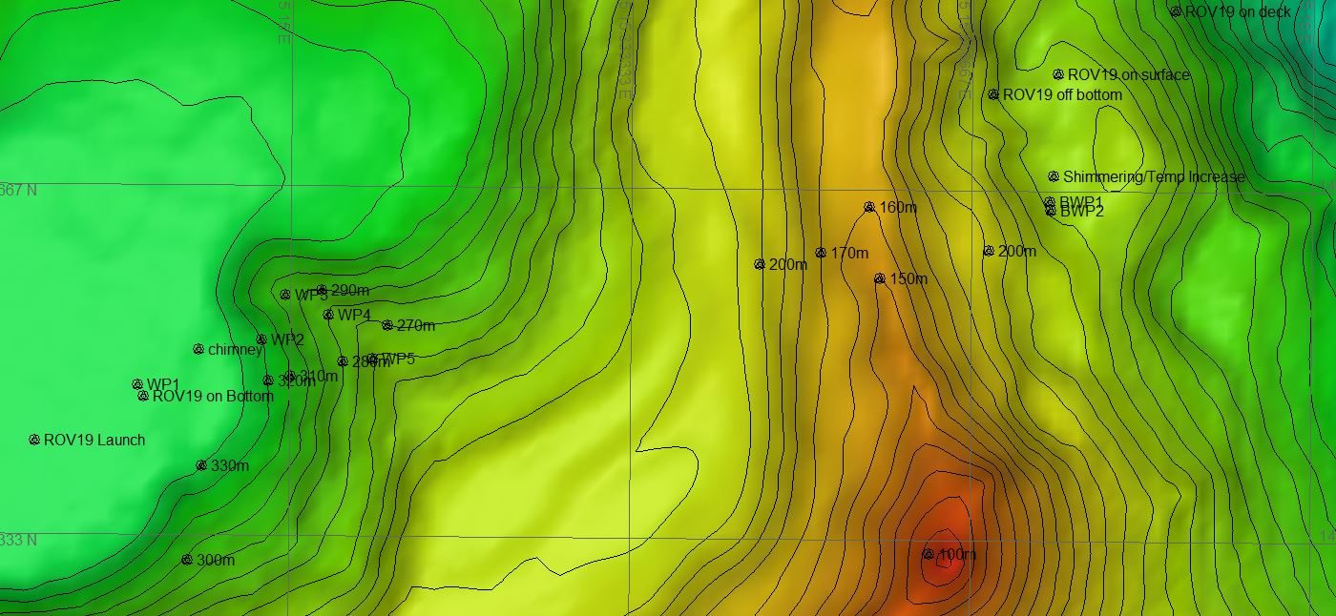
Fledermaus map of planned dive EX1605L1-DIVE19 track before plume hit identified. |  |  |  |  | Hypack screengrab of actual dive EX1605L1-DIVE19 track.
Representative Photos of the Dive
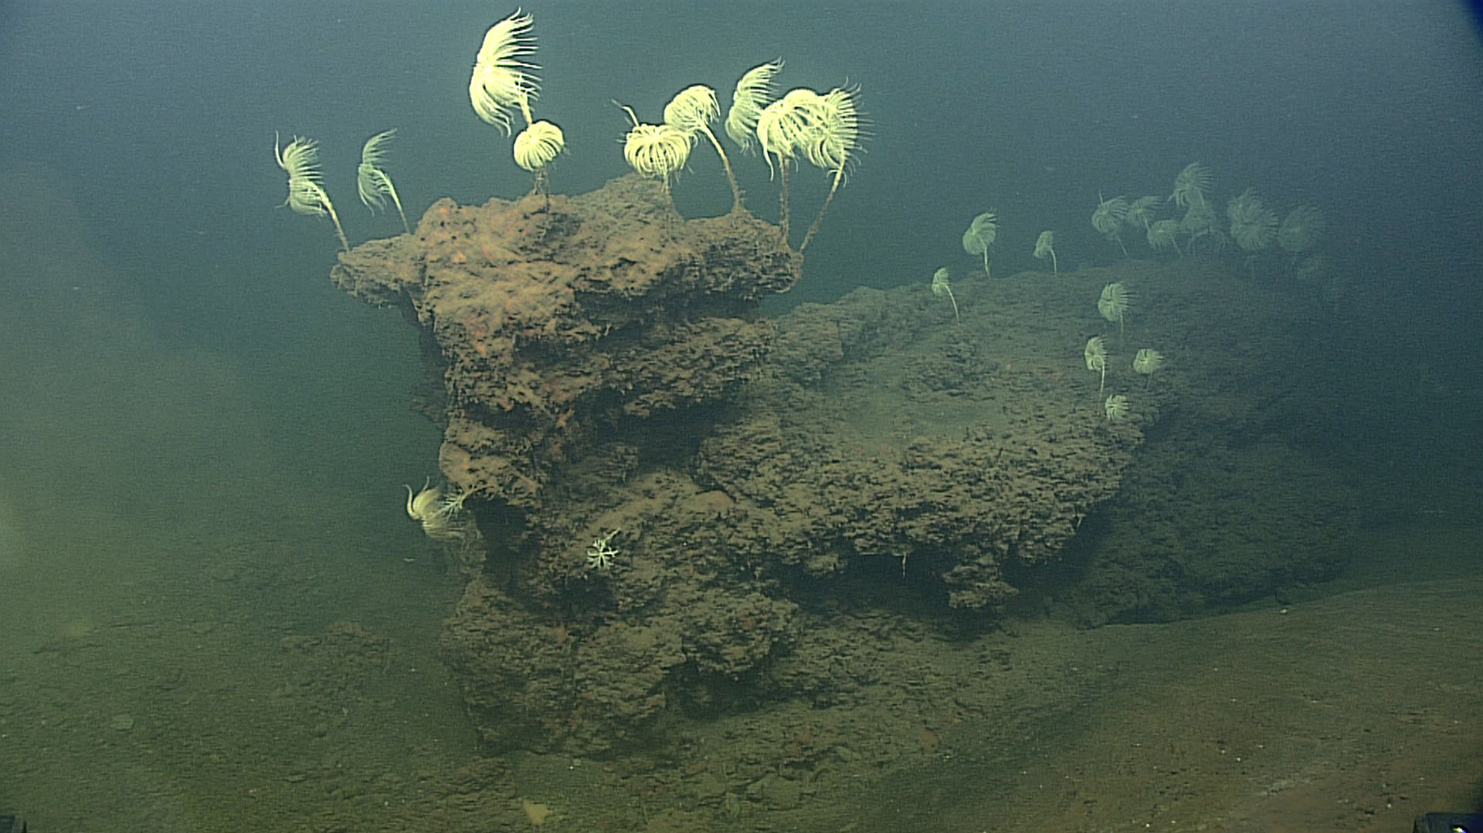 |  |  |  | 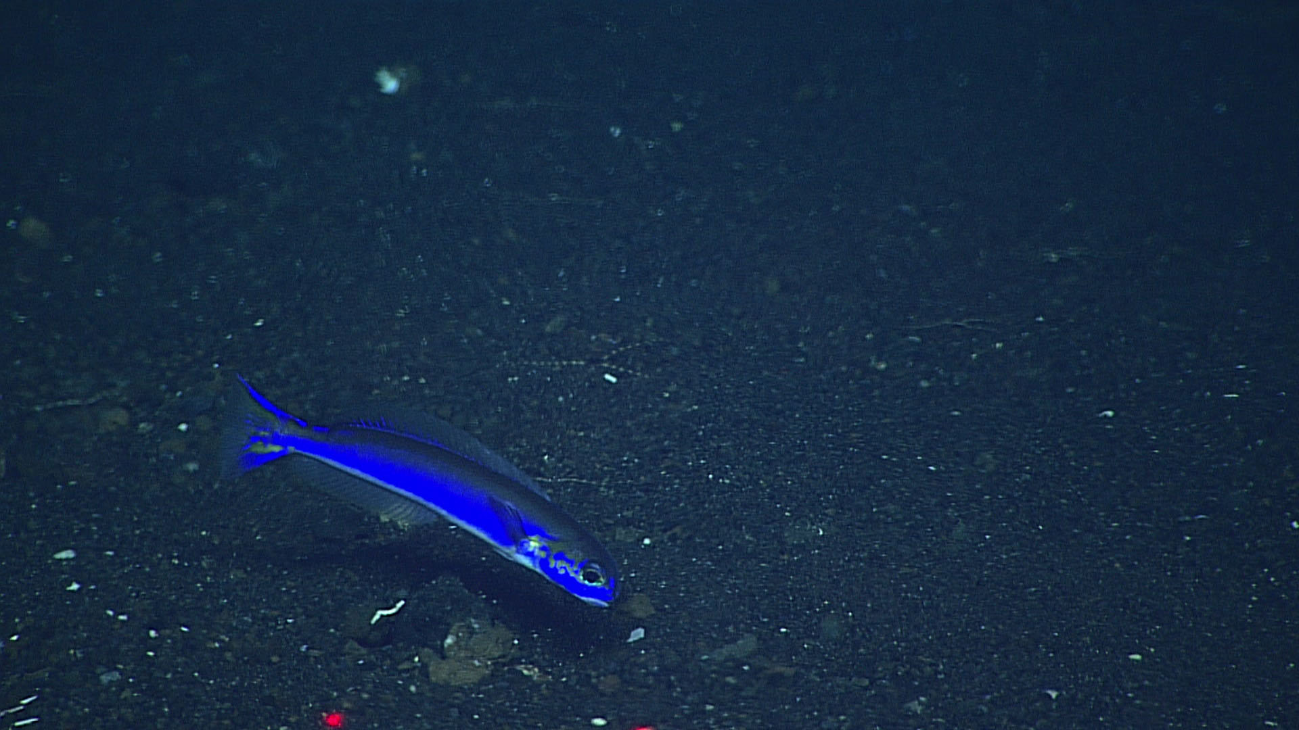
During the first part of the dive in the crater, several extinct hydrothermal iron chimneys were observed. The one pictured here had many stalked crinoids as well as fish inhabiting it. |  |  |  | The tilefish pictured here is likely a new species, and would also increase the depth range of this family worldwide significantly.
Samples Collected
None.
Please direct inquiries to: |  | NOAA Office of Ocean Exploration & Research  1315 East-West Highway (SSMC3 10th Floor)  Silver Spring, MD 20910  (301) 734-1014

