Okeanos Explorer ROV Dive Summary
Site Name |  |  | Enrique Guyot |  |  |  |  |  |  | 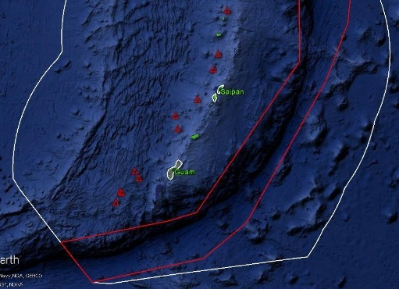
ROV Lead/  Expedition Coordinator |  |  | Jim Newman / Kelley Elliott
Science Team Leads |  |  | Deborah Glickson & Diva Amon
General Area Descriptor |  |  | Southern Marianas
ROV Dive Name |  |  | Cruise Season |  | Leg |  |  |  |  |  | Dive Number
 |  |  | EX1605 |  | 1 |  |  |  |  |  | DIVE 15
Equipment Deployed |  |  | ROV: |  | Deep Discoverer
 |  |  | Camera Platform: |  | Seirios
ROV Measurements |  |  | D2 CTD |  | Depth |  |  |  |  |  | Altitude
 |  |  | Scanning Sonar |  | USBL Position |  |  |  |  |  | Heading
 |  |  | Pitch |  | Roll |  |  |  |  |  | HD Camera 1
 |  |  | HD Camera 2 |  | ROV HD 2 |  |  |  |  |  | Seirios CTD
 |  |  | Temperature Probe |  | D2 DO Sensor |  |  |  |  |  | Seirios DO sensor
Equipment Malfunctions |  |  | There was a problem with a fiberoptic cable in the ROV tether, which delayed the dive by about 2 hours.
ROV Dive Summary  (From processed ROV data) |  |  | Dive Summary: EX1605L1_DIVE15  ^^^^^^^^^^^^^^^^^^^^^^^^^^^^^^^^^^^^^^^^^^^^^^^^^^^  In Water: 2016-05-05T23:01:59.884000  15°, 00.226' N ; 148°, 31.069' E  Out Water: 2016-05-06T04:42:59.972000  15°, 00.334' N ; 148°, 31.292' E  Off Bottom: 2016-05-06T03:23:25.790000  15°, 00.205' N ; 148°, 30.967' E  On Bottom: 2016-05-06T00:27:13.528000  15°, 00.283' N ; 148°, 31.102' E  Dive duration: 5:41:0  Bottom Time: 2:56:12  Max. depth: 2269.4 m
Special Notes
Scientists Involved  (please provide name / location / affiliation / email) |  |  | Patty Fryer, UH; pfryer@soest.hawaii.edu  Mackenzie Gerringer, UH; mgerring@hawaii.edu  Tara Harmer Luke, Stockton University; Tara.Luke@stockton.edu  Chris Kelley, UH; ckelley@hawaii.edu  Scott France, UL Lafayette; france@louisiana.edu  Asako Matsumoto, Chiba Institute of Technology; amatsu@gorgonian.jp  Tina Molodtsova, Shirshov Institute of Oceanology; tina@ocean.ru  Bruce Mundy, NOAA PIFSC; bruce.mundy@noaa.gov  Shirley Pomponi, FAU/HBOI; spomponi@fau.edu
Purpose of the Dive
This dive was on Enrique Guyot, a Cretaceous seamount just to the east of the trench. The dive had objectives that included exploring for high-density communities of deep-sea corals and sponges and doing an initial characterization of Mn-crust habitats on one of the presumed oldest seamounts on the Pacific plate. The dive was planned to begin at a depth of 2360 m and to move up along the ridge to the S-SW for ~725 m, to a depth of 2010 m.

Description of the Dive:
This dive began at a depth of 2260 m along a ridge on Enrique Guyot. We landed in an area of Mn-crusted volcanic rocks with light sediment. While most of the rocks looked intact, we were able to collect one quite early in the dive (D2_DIVE15_SPEC01GEO). As we slowly moved up the ridge, the rocks were quite blocky and looked intact, including a possible dike. However, many of the angular edges were rounded by Mn-crust, some of which had botryoidal texture. At about 2220 m depth, we encountered a tilted pillow lava ridge, and then several other faulted/fractured blocks with pillow lavas either flowing down the side or emplaced on top. The terrain was much steeper and more fractured than we had expected based on the 100-m and 50-m multibeam grids and this resulted in a slow-going dive to maximize the safety of the vehicles. Towards the end of the dive, we ended up on a pillow ridge that was a local high over 25 m high – much higher than the surrounding area. We flew over to another, lower plateau in an attempt to find the “main” ridge. While we did end up on a lower ridge, it was unclear whether we were actually on the ridge we had hoped to attain.

This dive had a high diversity of sponges and corals. Interestingly, the community had a high abundance of antipatharians. Octocorals such as Hemicorallium sp. and Pleurogorgia miltaris were also observed. Sponges included Poliopogon sp., Tretopleura sp., and others from the family Euretidae. Midway through the dive, a colony of small sponges with unidentified ‘white dots’ on their surfaces were observed. Three of these were collected (D2_DIVE15_SPEC01GEO).
Map of ROV Dive Area
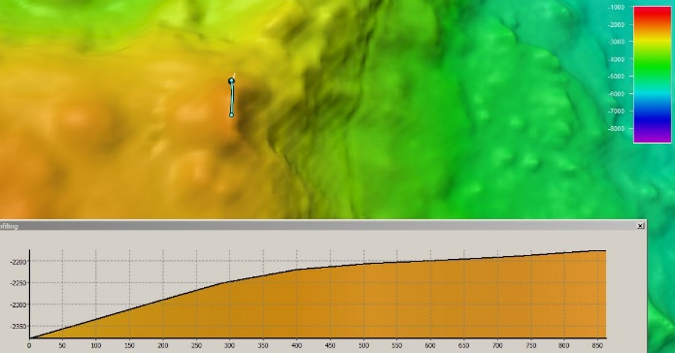 |  |  |  |  |  |  |  |  | 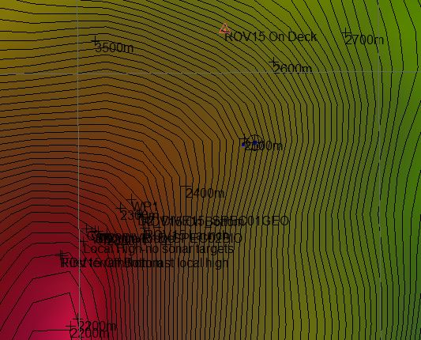
Fledermaus map of planned dive EX1605L1-DIVE15 track. |  |  |  |  |  |  |  |  | Hypack screengrab of actual dive EX1605L1-DIVE15 track.
Representative Photos of the Dive
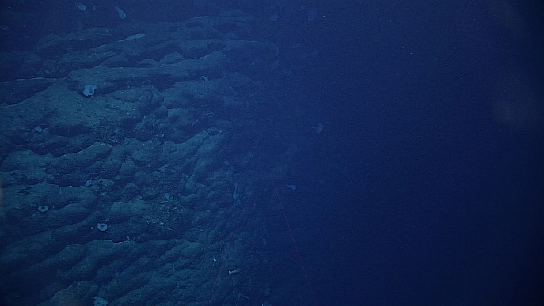 |  |  |  |  |  |  |  | 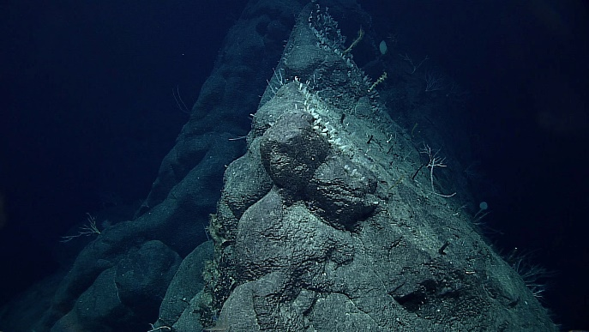
Most of the terrain during Dive 15 was comprised of sheer cliffs of tilted pillow lavas. |  |  |  |  |  |  |  | There were many sponge and coral aggregations that followed the ridges.
Samples Collected
Sample ID | D2_DIVE15_SPEC01GEO |  |  |  |  | 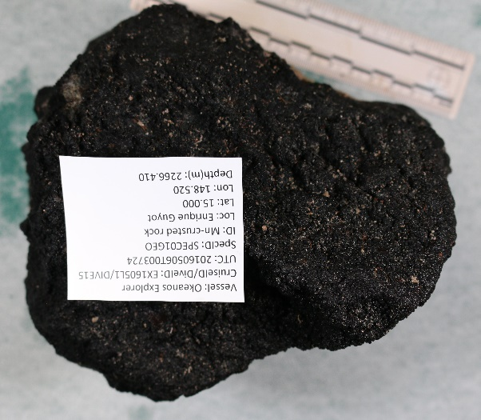
Date (UTC) | 20160506
Time (UTC) | 00:37:24
Depth (m) | 2266.41
Temperature (ºC) | 1.909
Field ID(s) | Mn-crusted rock
Comments | No commensals.
Sample ID |  | D2_DIVE15_SPEC02BIO |  |  |  |  | 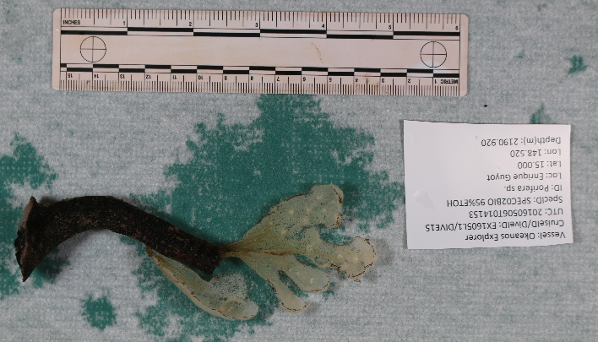
Date (UTC) |  | 20160506
Time (UTC) |  | 01:41:53
Depth (m) |  | 2190.92
Temperature (ºC) |  | 1.952
Field ID(s) |  | Porifera sp.
Comments |  | No commensals.
Please direct inquiries to: |  |  |  | NOAA Office of Ocean Exploration & Research  1315 East-West Highway (SSMC3 10th Floor)  Silver Spring, MD 20910  (301) 734-1014

