Okeanos Explorer ROV Dive Summary
Site Name |  |  | Pigafetta Guyot |  |  |  |  |  |  | 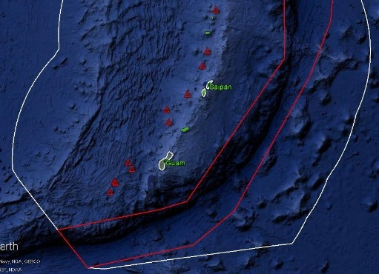
ROV Lead/  Expedition Coordinator |  |  | Jim Newman / Kelley Elliott
Science Team Leads |  |  | Deborah Glickson & Diva Amon
General Area Descriptor |  |  | Southern Marianas
ROV Dive Name |  |  | Cruise Season |  | Leg |  |  |  |  |  | Dive Number
 |  |  | EX1605 |  | 1 |  |  |  |  |  | DIVE 14
Equipment Deployed |  |  | ROV: |  | Deep Discoverer
 |  |  | Camera Platform: |  | Seirios
ROV Measurements |  |  | D2 CTD |  | Depth |  |  |  |  |  | Altitude
 |  |  | Scanning Sonar |  | USBL Position |  |  |  |  |  | Heading
 |  |  | Pitch |  | Roll |  |  |  |  |  | HD Camera 1
 |  |  | HD Camera 2 |  | ROV HD 2 |  |  |  |  |  | Seirios CTD
 |  |  | Temperature Probe |  | D2 DO Sensor |  |  |  |  |  | Seirios DO sensor
Equipment Malfunctions
ROV Dive Summary  (From processed ROV data) |  |  | Dive Summary: EX1605L1_DIVE14  ^^^^^^^^^^^^^^^^^^^^^^^^^^^^^^^^^^^^^^^^^^^^^^^^^^^  In Water: 2016-05-04T20:43:14.933000  15°, 53.824' N ; 148°, 53.338' E  Out Water: 2016-05-05T04:32:42.010000  15°, 53.449' N ; 148°, 53.374' E  Off Bottom: 2016-05-05T03:25:42.012000  15°, 53.462' N ; 148°, 52.959' E  On Bottom: 2016-05-04T21:52:49.109000  15°, 53.778' N ; 148°, 53.191' E  Dive duration: 7:49:27  Bottom Time: 5:32:52  Max. depth: 2038.9 m
Special Notes
Scientists Involved  (please provide name / location / affiliation / email) |  |  | Scott France, UL Lafayette; france@louisiana.edu  Patty Fryer, UH; pfryer@soest.hawaii.edu  Tara Harmer Luke, Stockton University; Tara.Luke@stockton.edu  Chris Kelley, UH; ckelley@hawaii.edu  Machel Malay, U Guam; machel.malay@gmail.com  Asako Matsumoto, Chiba Institute of Technology; amatsu@gorgonian.jp  Allison Miller, National Park Service; a33miller@gmail.com  Tina Molodtsova, Shirshov Institute of Oceanology; tina@ocean.ru  Bruce Mundy, NOAA PIFSC; bruce.mundy@noaa.gov  Andrea Quattrini; Harvey Mudd College; aquattrini@g.hmc.edu  Sonia Rowley, UH; srowley@hawaii.edu  Robert Stern; rjstern@utdallas.edu  Les Watling, UH; watling@hawaii.edu
Purpose of the Dive
This dive was on Pigafetta Guyot, a Cretaceous seamount just to the east of the trench. The dive’s objectives were to explore for high-density communities of deep-sea corals and sponges and do an initial characterization of Mn-crust habitats on one of the presumed oldest seamounts on the Pacific plate. The dive was planned to begin at a depth of 2045 m and to move along the ridge to the S-SW for ~725 m, to a depth of 2010 m.

Description of the Dive:
This dive began at a depth of 2005 m along a ridge on the lower terrace of Pigafetta Guyot. We believe that this ridge might be a slump block that was faulted away from the higher plateau. We landed in area of heavy sediment with ripple marks. We then saw some loose Mn-crusted rocks and collected one (D2_DIVE14_SPEC01GEO). As we moved up the slope, we saw smoothly rounded, low-relief morphologies for the rocks or indurated sediment, all covered with a heavy crust of botryoidal Mn crust and moderate to heavy sediment cover. Some of these areas were quite fractured or fissured, leading to an assumption of cemented sediment or Mn crust. Later in the dives, we found a few areas that looked like they could be possible outcrop of pillow lavas, although still covered with Mn crust and sediment. We had hoped to collect a sample of one of these rocks but were unable to. When we reached the local high at WP 2, the “pillow” morphologies were gone and the whole area was covered in sediment and Mn crust, with no indication of possible volcanics.

Most of the biology encountered on this dive was comprised of large coral colonies and sponges (Tretodictyum and Tretopleura). The number of Iridigorgia individuals seemed to increase to dominate the community as we moved up slope. There were two biology samples collected: Bolosominae (likely undescribed) (D2_DIVE14_SPEC02BIO) and an isidid coral with strange veining on the branches (D2_DIVE14_SPEC03BIO).
Map of ROV Dive Area
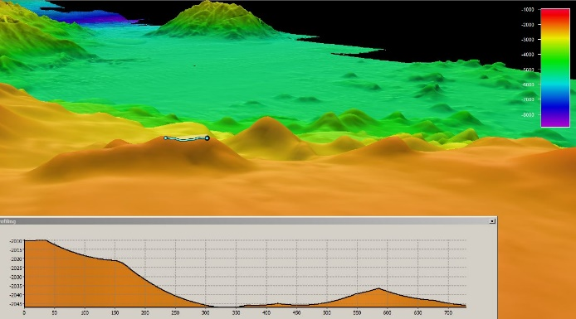 |  |  |  |  |  |  |  |  | 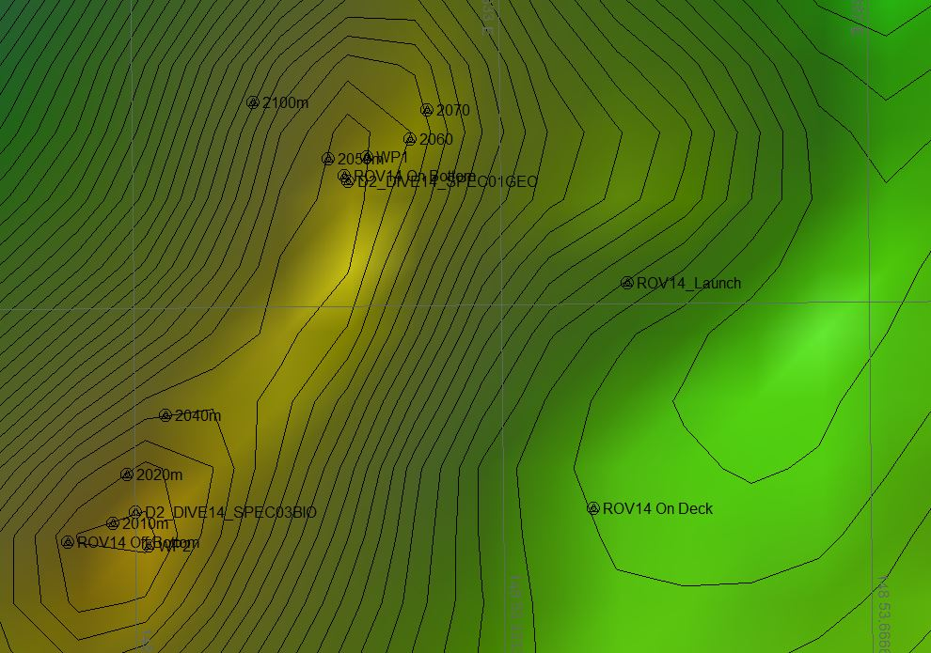
Fledermaus map of planned dive EX1605L1-DIVE14 track. |  |  |  |  |  |  |  |  | Hypack screengrab of actual dive EX1605L1-DIVE14 track.
Representative Photos of the Dive
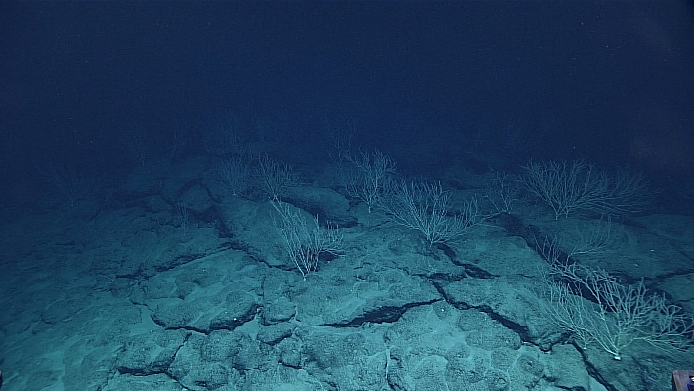 |  |  |  |  |  |  |  | 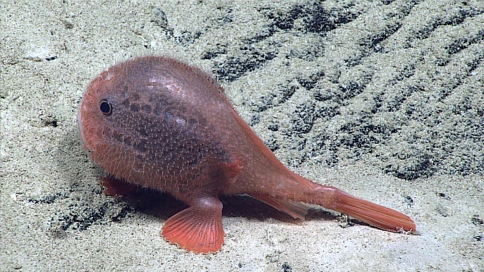
The substratum was mostly comprised of Mn-crust. These were colonized by octocorals, including from the family Isididae (pictured here). |  |  |  |  |  |  |  | A Chaunacops coloratus encountered on Dive 14.
Samples Collected
Sample ID | D2_DIVE14_SPEC01GEO |  |  |  |  | 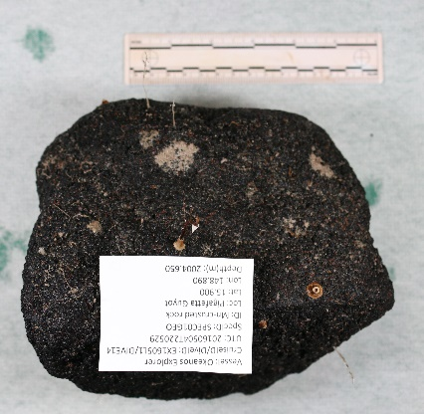
Date (UTC) | 20160504
Time (UTC) | 22:05:29
Depth (m) | 2004.65
Temperature (ºC) | 2.071
Field ID(s) | Mn-crusted rock
Comments | There were three commensal hydroids of the same morphotype (D2_DIVE14_SPEC01GEOCO1).
Sample ID |  | D2_DIVE14_SPEC02BIO |  |  |  |  | 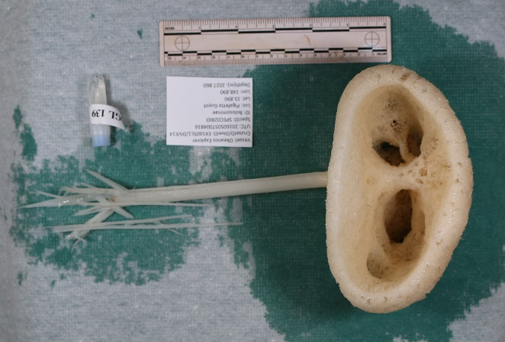
Date (UTC) |  | 20160505
Time (UTC) |  | 00:48:16
Depth (m) |  | 2027.86
Temperature (ºC) |  | 2.091
Field ID(s) |  | Bolosominae sp. (morphotype 3)
Comments |  | No commensals.
Sample ID |  | D2_DIVE014_SPEC03BIO |  |  |  |  | 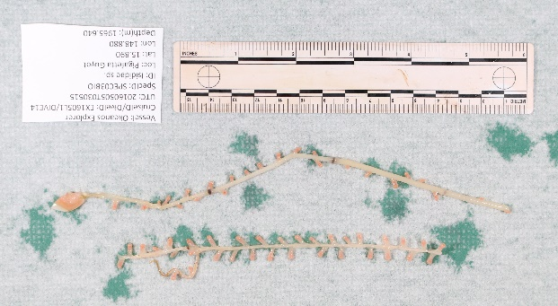
Date (UTC) |  | 20160505
Time (UTC) |  | 03:05:15
Depth (m) |  | 1965.64
Temperature (ºC) |  | 2.133
Field ID(s) |  | Isididae sp.
Comments |  | No commensals.
Please direct inquiries to: |  |  |  | NOAA Office of Ocean Exploration & Research  1315 East-West Highway (SSMC3 10th Floor)  Silver Spring, MD 20910  (301) 734-1014

