Okeanos Explorer ROV Dive Summary
Site Name |  |  | New Hydrothermal Vent Field 2 |  |  |  |  |  |  | 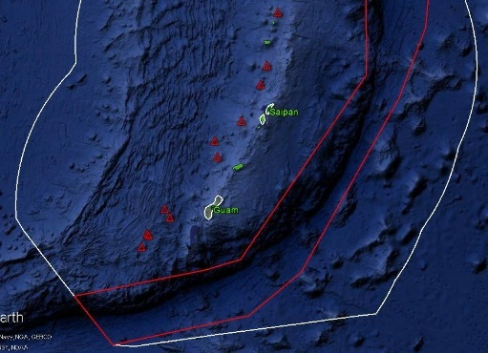
ROV Lead/  Expedition Coordinator |  |  | Jim Newman / Kelley Elliott
Science Team Leads |  |  | Deborah Glickson & Diva Amon
General Area Descriptor |  |  | Southern Marianas
ROV Dive Name |  |  | Cruise Season |  | Leg |  |  |  |  |  | Dive Number
 |  |  | EX1605 |  | 1 |  |  |  |  |  | DIVE 11
Equipment Deployed |  |  | ROV: |  | Deep Discoverer
 |  |  | Camera Platform: |  | Seirios
ROV Measurements |  |  | D2 CTD |  | Depth |  |  |  |  |  | Altitude
 |  |  | Scanning Sonar |  | USBL Position |  |  |  |  |  | Heading
 |  |  | Pitch |  | Roll |  |  |  |  |  | HD Camera 1
 |  |  | HD Camera 2 |  | ROV HD 2 |  |  |  |  |  | Seirios CTD
 |  |  | Temperature Probe |  | D2 DO Sensor |  |  |  |  |  | Seirios DO sensor
Equipment Malfunctions
ROV Dive Summary  (From processed ROV data) |  |  | Dive Summary: EX1605L1_DIVE11  ^^^^^^^^^^^^^^^^^^^^^^^^^^^^^^^^^^^^^^^^^^^^^^^^^^^  In Water: 2016-05-01T20:20:11.740000  16°, 57.849' N ; 144°, 52.000' E  Out Water: 2016-05-02T06:33:55.351000  16°, 57.638' N ; 144°, 52.712' E  Off Bottom: 2016-05-02T04:42:15.577000  16°, 57.661' N ; 144°, 52.200' E  On Bottom: 2016-05-01T22:16:55.880000  16°, 57.640' N ; 144°, 52.000' E  Dive duration: 10:13:43  Bottom Time: 6:25:19  Max. depth: 3296.6 m
Special Notes
Scientists Involved  (please provide name / location / affiliation / email) |  |  | Stace Beaulieu, WHOI; sbeaulieu@whoi.edu  Bill Chadwick, NOAA PMEL; william.w.chadwick@noaa.gov  Bob Embley, NOAA PMEL; robert.w.embley@noaa.gov  Scott France, UL Lafayette; france@louisiana.edu  Patty Fryer, UH; pfryer@soest.hawaii.edu  Mackenzie Gerringer, UH; mgerring@hawaii.edu  Tara Harmer Luke, Stockton University; Tara.Luke@stockton.edu  Santiago Herrera, U Toronoto/WHOI, sherrera@alum.mit.edu  Julie Huber, MBL; jhuber@mbl.edu  Chris Kelley, UH; ckelley@hawaii.edu  Machel Malay, U Guam; machel.malay@gmail.com  Asako Matsumoto, Chiba Institute of Technology; amatsu@gorgonian.jp  Allison Miller, National Park Service; a33miller@gmail.com  Tina Molodtsova, Shirshov Institute of Oceanology; tina@ocean.ru  Shirley Pomponi, FAU/HBOI; spomponi@fau.edu  Sonia Rowley, UH; srowley@hawaii.edu  Robert Stern, UT Dallas; rjstern@utdallas.edu  Les Watling, UH; watling@hawaii.edu  Michael Perfit, UF; mperfit@ufl.edu
Purpose of the Dive
This dive explored an area mapped with the Sentry AUV in December 2015 during a search for new hydrothermal vents on the seafloor (probably high-temperature black smoker chimneys). If vents were found, we planned to document animals living at and near the vents. The dive was planned to begin at a depth of 3292 m, and move from west to east for a total of ~600 m, ending at a depth of 3288 m.

Description of the Dive:
The dive began at a depth of 3292 m on a fairly flat part of the Mariana back-arc spreading center. As we approached the seafloor, there was fairly heavy black smoke obstructing the vision of the ROV. We landed about 50 m away from an active hydrothermal chimney that turned out to be a black smoker over 30 m high. The base of the chimney was extinct sulfide, but the top was completely active with several black smoker orifices, beehives structures, skinny little chimney spires, and both iron and anhydrite precipitate. We imaged the chimney and deployed the high temperature probe at a flange (~250 degrees C) and inside a small orifice (339 degrees C). As we moved toward the east, we saw another spire of the composite chimney (14-15 m tall). Later in the dive, we found a small patch of black smoke issuing from the seafloor and a patch of morphologically distinct, very skinny, little chimneys. We also found extensive microbial mat in the area, as well as on many of the inhabiting animals. We then encountered another 14-15 m tall black smoker chimney. This one had a large beehive structure on one face that was venting quite vigorously. We then investigated a 30-m-across crater-shaped feature, which turned out to be composed almost entirely of extinct sulfide and a few patches of diffuse flow. We collected a rock at the crater (D2 _DIVE11_SPEC01GEO). Our last site, to the southeast of the crater, was another actively venting site with multiple chimneys.

These active chimneys were host to a diverse and abundant assemblage of animals, many of which are endemic to vents in the Mariana region. These fauna also appeared to show clear zonation along the chimney structure and in peripheral areas. At the top of the chimney in the areas of most high temperature fluid, Chorocaris sp. shrimp and Paralvinella polychaetes. Also in the top region of the chimney but in areas of less intense flow, Alvinoconcha hessleri sp. gastropods, polynoids, several species of limpets (poss Shinkailepis sp.) and Austinograea wiliamsi crabs. Then in the lower and peripheral region of the vent chimney, there were many Marianactis bythios actiniarians as well as Munidopsis galatheids. Similar communities were seen at all active vent chimneys. In the areas of diffuse venting, a handful of Bathymodiolus mussels were also observed. The rim of the crater feature was home to many live Alvinoconcha hessleri. However, the bottom of the crater feature had an aggregation of dead Alvinoconcha shells. Some of these were being consumed by Phymorynchus gastropods and Munidopsis galatheids. Another interesting observation made during this dive was a large number of pregnant ophidiids or ophidiids with very distended abdomens.

Map of ROV Dive Area
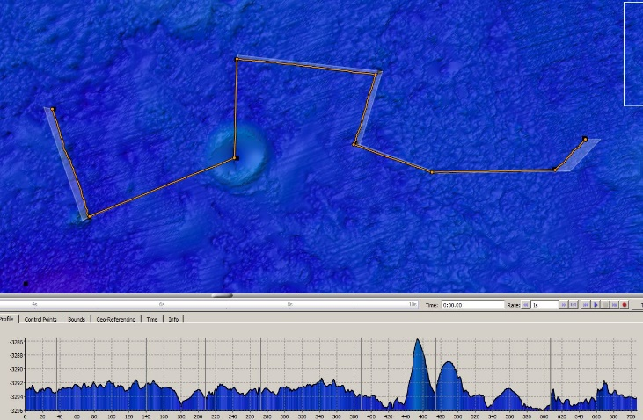 |  |  |  |  |  |  |  |  | 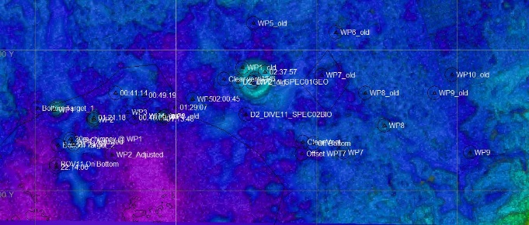
Fledermaus map of planned dive EX1605L1-DIVE11 track. |  |  |  |  |  |  |  |  | Hypack screengrab of actual dive EX1605L1-DIVE11 track.
Representative Photos of the Dive
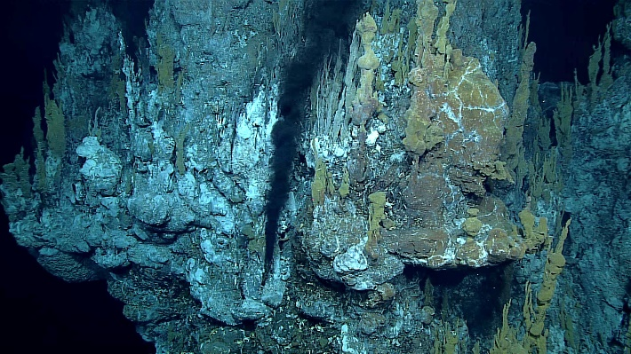 |  |  |  |  |  |  |  | 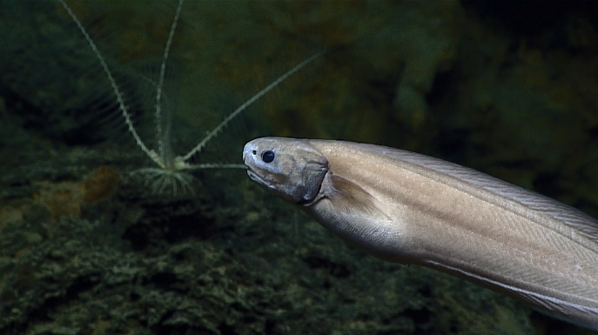
A black-smoker orifice on a 30-m hydrothermal chimney on DIVE 11. |  |  |  |  |  |  |  | One of the many pregnant deep-sea fish observed during DIVE 11.
Samples Collected
Sample ID | D2_DIVE11_SPEC01GEO |  |  |  |  | 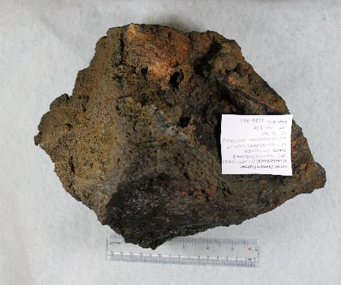
Date (UTC) | 20160502
Time (UTC) | 03:20:43
Depth (m) | 3286.9
Temperature (ºC) | 1.680
Field ID(s) | Hydrothermal sulfide
Comments | No commensals.
Sample ID |  | D2_DIVE11_SPEC02BIO |  |  |  |  | 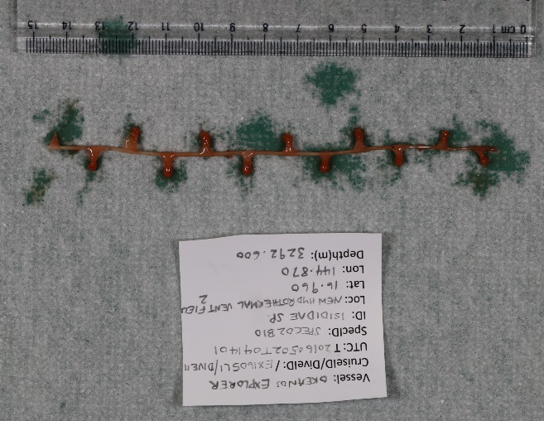
Date (UTC) |  | 20160502
Time (UTC) |  | 04:14:01
Depth (m) |  | 3292.6
Temperature (ºC) |  | 1.881
Field ID(s) |  | Isididae sp.
Comments |  | No commensals.
Please direct inquiries to: |  |  |  | NOAA Office of Ocean Exploration & Research  1315 East-West Highway (SSMC3 10th Floor)  Silver Spring, MD 20910  (301) 734-1014

