Okeanos Explorer ROV Dive Summary
Site Name |  |  | Young Lava Flows |  |  |  |  |  |  | 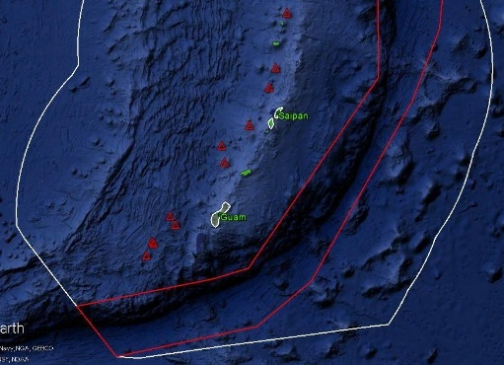
ROV Lead/  Expedition Coordinator |  |  | Jim Newman / Kelley Elliott
Science Team Leads |  |  | Deborah Glickson & Diva Amon
General Area Descriptor |  |  | Southern Marianas
ROV Dive Name |  |  | Cruise Season |  | Leg |  |  |  |  |  | Dive Number
 |  |  | EX1605 |  | 1 |  |  |  |  |  | DIVE 09
Equipment Deployed |  |  | ROV: |  | Deep Discoverer
 |  |  | Camera Platform: |  | Seirios
ROV Measurements |  |  | D2 CTD |  | Depth |  |  |  |  |  | Altitude
 |  |  | Scanning Sonar |  | USBL Position |  |  |  |  |  | Heading
 |  |  | Pitch |  | Roll |  |  |  |  |  | HD Camera 1
 |  |  | HD Camera 2 |  | ROV HD 2 |  |  |  |  |  | Seirios CTD
 |  |  | Temperature Probe |  | D2 DO Sensor |  |  |  |  |  | Seirios DO sensor
Equipment Malfunctions
ROV Dive Summary  (From processed ROV data) |  |  | Dive Summary: EX1605L1_DIVE09  ^^^^^^^^^^^^^^^^^^^^^^^^^^^^^^^^^^^^^^^^^^^^^^^^^^^  In Water: 2016-04-29T20:30:50.247000  15°, 26.156' N ; 144°, 30.033' E  Out Water: 2016-04-30T06:31:45.418000  15°, 26.162' N ; 144°, 30.872' E  Off Bottom: 2016-04-30T04:20:16.694000  15°, 25.931' N ; 144°, 30.285' E  On Bottom: 2016-04-29T22:54:47.854000  15°, 26.239' N ; 144°, 30.341' E  Dive duration: 10:0:55  Bottom Time: 5:25:28  Max. depth: 4068.5 m
Special Notes
Scientists Involved  (please provide name / location / affiliation / email) |  |  | Stace Beaulieu, WHOI; sbeaulieu@whoi.edu  Bill Chadwick, NOAA PMEL; william.w.chadwick@noaa.gov  Scott France, UL Lafayette; france@louisiana.edu  Patty Fryer, UH; pfryer@soest.hawaii.edu  Julie Huber, MBL; jhuber@mbl.edu  Chris Kelley, UH; ckelley@hawaii.edu  John Kellogg, U Victoria; jkellogg@uvic.ca  Asako Matsumoto, Chiba Institute of Technology; amatsu@gorgonian.jp  Tina Molodtsova, Shirshov Institute of Oceanology; tina@ocean.ru  Bruce Mundy, NOAA PIFSC; bruce.mundy@noaa.gov  Shirley Pomponi, FAU/HBOI; spomponi@fau.edu  Tara Harmer Luke, Stockton University; Tara.Luke@stockton.edu  Timothy Shank, WHOI; tshank@whoi.edu  Robert Stern, UTDallas; rjstern@utdallas.edu  Michael Perfit, UF; mperfit@ufl.edu
Purpose of the Dive
This dive explored a series of recent (2013-2015) lava flows and searched for hydrothermal vents or diffuse flow on the young lavas. Biology inhabiting the area was noted. The dive began at a depth of 4066 m, and moved south from pillow mound to mound for ~700 m (if possible), ending at a depth of 4055 m.

Description of the Dive:
This dive began at the base of a fresh pillow flow at a depth of 4064 m. As expected, the pillow flows were very fresh, with glassy surfaces and very little sediment. Some areas had an iron precipitate that may have been microbially-mediated (although there was no current microbial activity). These took the forms of flocculant, staining, and “rusticles.” We collected a sample at this location – the northernmost pillow mound (D2_DIVE09_SPEC01GEO). Some of the pillows looked a bit older due to sediment cover, but all pillows were approximately the same age. As we moved off the pillow mound to the south, we encountered an area of what looked like ash deposits or volcaniclastics, followed soon after by a field of broken pillows with some white authigenic deposits (D2_DIVE09_SPEC02GEO). We guessed that this was due to an explosive event, but then came upon a very steep-walled pillow mound (60 m high) where the pillow toes had fallen off after being erupted. There was some hydrothermal staining here as well. We then jumped to the southernmost of the 3 pillow mounds, where pillows with very glassy textures and some strange morphology (sticking out at 90 degrees into the air) were seen. We collected a particularly glassy and curly pillow extrusion (D2_DIVE09_SPEC03GEO).The biology on this dive was extremely scarce. In total, there were about four morphotypes observed: a Synallactidae holothurian, a Munidopsis squat lobster and many swimming polychaetes. One surprise of the dive was finding an area of diffuse flow (7 degrees C), where approximately four vent-endemic Chorocaris shrimp were seen.
Map of ROV Dive Area
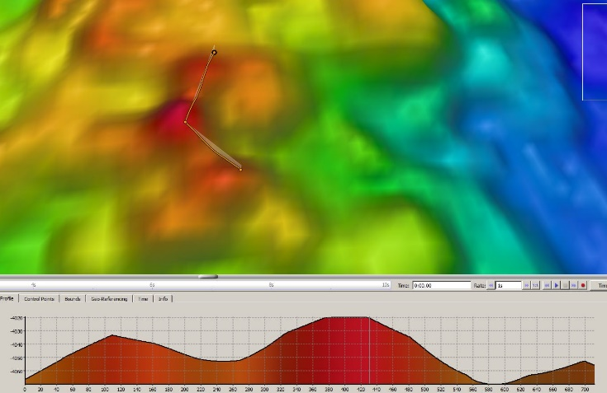 |  |  |  |  |  |  |  |  | 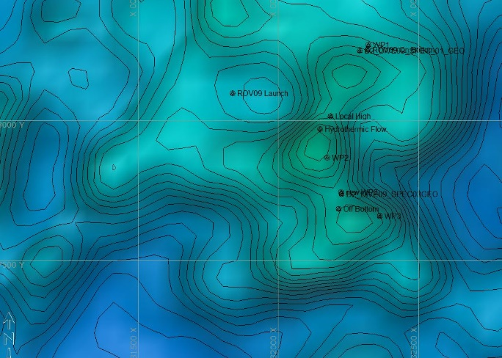
Fledermaus map of planned dive EX1605L1-DIVE09 track. |  |  |  |  |  |  |  |  | Hypack screengrab of actual dive EX1605L1-DIVE09 track
Representative Photos of the Dive
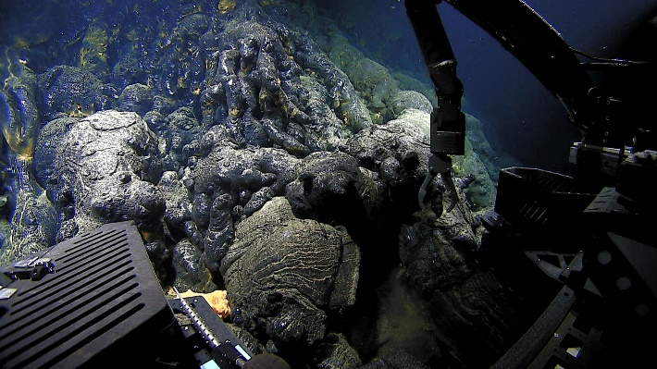 |  |  |  |  |  |  |  | 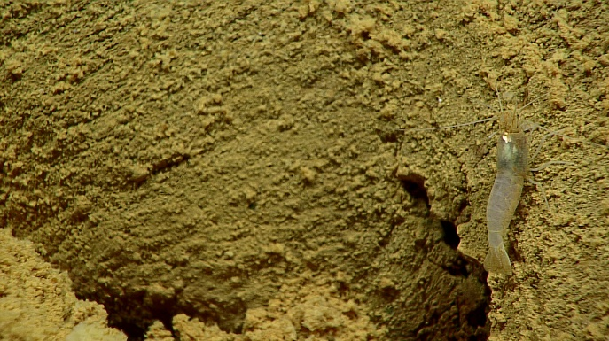
Glassy pillow extrusions being collected during DIVE 09. |  |  |  |  |  |  |  | A species of Chorocaris shrimp, a hydrothermal vent endemic, seen during DIVE 09.
Samples Collected
Sample ID | D2_DIVE09_SPEC01GEO |  |  |  |  | 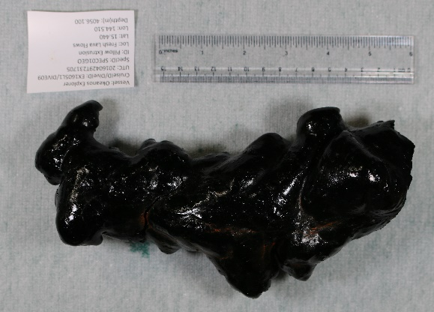
Date (UTC) | 20160429
Time (UTC) | 23:17:05
Depth (m) | 4056
Temperature (ºC) | 1.664
Field ID(s) | Pillow extrusion
Comments | No commensals.
Sample ID |  | D2_DIVE09_SPEC02GEO |  |  |  |  | 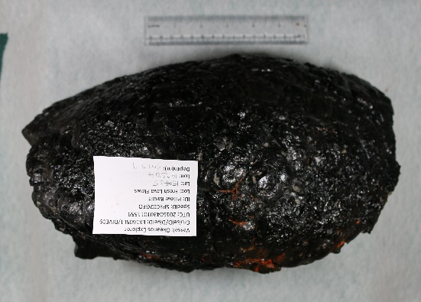
Date (UTC) |  | 20160430
Time (UTC) |  | 01:15:59
Depth (m) |  | 4047.9
Temperature (ºC) |  | 1.653
Field ID(s) |  | Pillow lava
Comments |  | No commensals.
Sample ID |  | D2_DIVE09_SPEC03BIO |  |  |  |  | 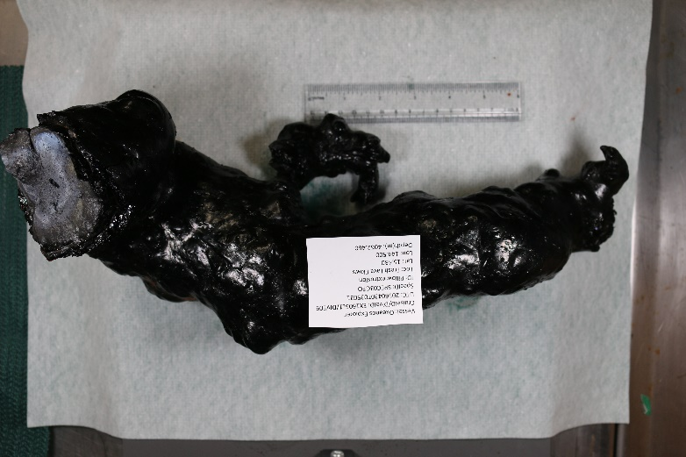
Date (UTC) |  | 20160430
Time (UTC) |  | 03:50:31
Depth (m) |  | 4062.5
Temperature (ºC) |  | 1.652
Field ID(s) |  | Pillow extrusion
Comments |  | No commensals.
Please direct inquiries to: |  |  |  | NOAA Office of Ocean Exploration & Research  1315 East-West Highway (SSMC3 10th Floor)  Silver Spring, MD 20910  (301) 734-1014

