Okeanos Explorer ROV Dive Summary
Site Name |  |  | Fina Nagu Caldera A |  |  |  |  |  |  | 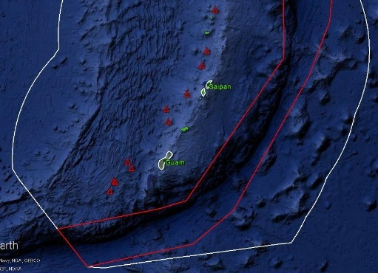
ROV Lead/  Expedition Coordinator |  |  | Jim Newman / Kelley Elliott
Science Team Leads |  |  | Deborah Glickson & Diva Amon
General Area Descriptor |  |  | Southern Marianas
ROV Dive Name |  |  | Cruise Season |  | Leg |  |  |  |  |  | Dive Number
 |  |  | EX1605 |  | 1 |  |  |  |  |  | DIVE 07
Equipment Deployed |  |  | ROV: |  | Deep Discoverer
 |  |  | Camera Platform: |  | Seirios
ROV Measurements |  |  | D2 CTD |  | Depth |  |  |  |  |  | Altitude
 |  |  | Scanning Sonar |  | USBL Position |  |  |  |  |  | Heading
 |  |  | Pitch |  | Roll |  |  |  |  |  | HD Camera 1
 |  |  | HD Camera 2 |  | ROV HD 2 |  |  |  |  |  | Seirios CTD
 |  |  | Temperature Probe |  | D2 DO Sensor |  |  |  |  |  | Seirios DO sensor
Equipment Malfunctions
ROV Dive Summary  (From processed ROV data) |  |  | Dive Summary: EX1605L1_DIVE07  ^^^^^^^^^^^^^^^^^^^^^^^^^^^^^^^^^^^^^^^^^^^^^^^^^^^  In Water: 2016-04-27T20:24:09.039000  12°, 51.689' N ; 143°, 49.771' E  Out Water: 2016-04-28T04:27:13.816000  12°, 51.844' N ; 143°, 50.116' E  Off Bottom: 2016-04-28T03:09:33.589000  12°, 51.694' N ; 143°, 49.700' E  On Bottom: 2016-04-27T21:51:01.723000  12°, 51.685' N ; 143°, 49.857' E  Dive duration: 8:3:4  Bottom Time: 5:18:31  Max. depth: 2379.1 m
Special Notes
Scientists Involved  (please provide name / location / affiliation / email) |  |  | Stace Beaulieu, WHOI; sbeaulieu@whoi.edu  Maryjo Brounce, CA Institute of Technology, mbrounce@gps.caltech.edu  Ben Frable, OSU; ben.frable@oregonstate.edu  Scott France, UL Lafayette; france@louisiana.edu  Patty Fryer, UH; pfryer@soest.hawaii.edu  Tara Harmer Luke, Stockton University; Tara.Luke@stockton.edu  Chris Kelley, UH; ckelley@hawaii.edu  Chris Mah, Smithsonian; brisinga@gmail.com  Asako Matsumoto, Chiba Institute of Technology; amatsu@gorgonian.jp  Bruce Mundy, NOAA PIFSC; bruce.mundy@noaa.gov  Shirley Pomponi, FAU/HBOI; spomponi@fau.edu  Tim Shank, WHOI; tshank@whoi.edu  Robert Stern, UT; rjstern@utdallas.edu  Les Watling, UH; watling@hawaii.edu
Purpose of the Dive
The Fina Nagu Volcanic Chain is poorly studied, and none of its several calderas have been examined by ROV or manned submersible for signs of hydrothermal activity or biological communities. Based on location, we thought that volcanic activity would increase northward but are not sure. Fina Nagu A is the most likely of the chain to harbor hydrothermal activity. This dive was planned to begin at 2321 m and to traverse 760 m upslope to the west, ending at a depth of 2234 m.

Description of the Dive:
The dive began on a saddle between two resurgent domes in the center of the caldera. We traversed east to the top of Dome #1, the central dome of the caldera. The traverse upslope was mostly volcaniclastic sediment and isolated blocks of Mn-coated basalt. Almost immediately upon landing, we saw evidence of hydrothermal alteration – iron oxidation. At the top of the dome, we encountered a 14-m tall extinct hydrothermal vent chimney and collected a sample (D2_DIVE07_SPEC01GEO). After imaging the chimney, we flew back to the saddle and traversed the eastern slope of Dome #2. As we moved upwards, we saw more volcaniclastics and outcrops of either sedimentary or igneous rock. The Mn crust was so heavy that it was hard to determine. We picked up a rock sample that appeared to be basalt (D2_DIVE07_SPEC03GEO). At the top of Dome #2, there was a rim of volcaniclastics and a small depression, upon which we found hydrothermal vent sulfides with several very small patches of very weak, diffuse hydrothermal flow (3-5.5 degrees C).

The biology on the extinct hydrothermal vent chimney was mainly comprised of suspension feeders except for some Desbruyeresia gastropods that were observed on exposed rocks of the interior of the hydrothermal-vent chimney. After moving off the chimney into the saddle between re-emergent domes where holothurians, predatory ascidians (Megalodicopia sp.), pectinid bivalves and an Umbellula sea pen (among other species) were noted. On the other re-emergent dome visited, in the area of diffuse hydrothermal flow, patches of polychaete tubes were observed.
Map of ROV Dive Area
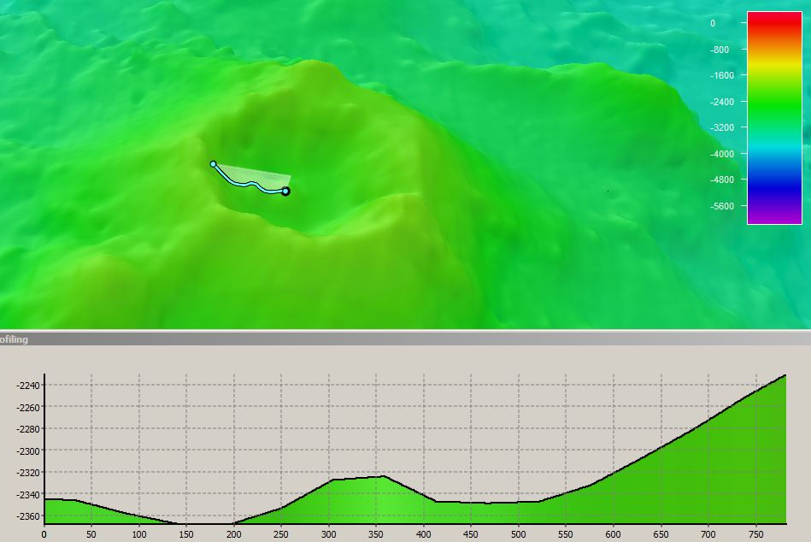 |  |  |  |  |  |  |  |  | 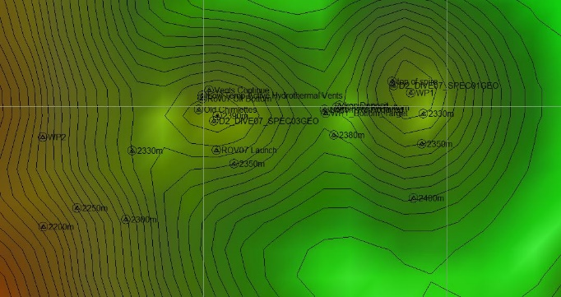
Fledermaus map of planned dive EX1605L1-DIVE07 track. |  |  |  |  |  |  |  |  | Hypack screengrab of actual dive EX1605L1-DIVE07 track
Representative Photos of the Dive
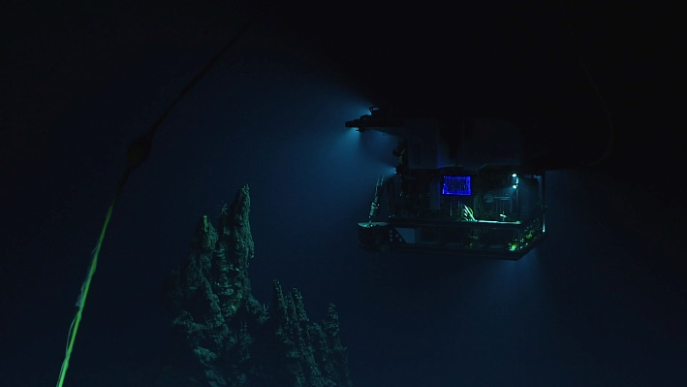 |  |  |  |  |  |  |  | 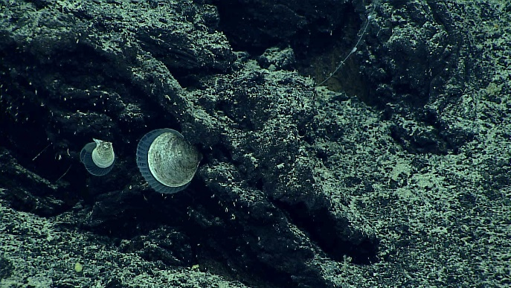
The extinct high-temperature chimney with D2 as viewed by Seirios |  |  |  |  |  |  |  | Pectinidae bivalves with mantles extended.
Samples Collected
Sample ID | D2_DIVE07_SPEC01GEO |  |  |  |  | 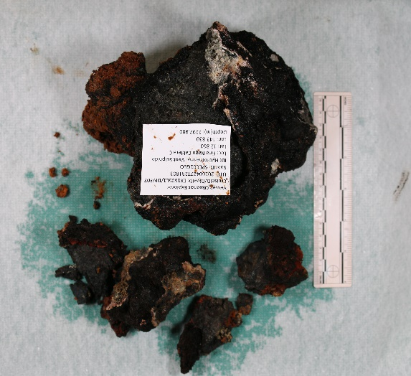
Date (UTC) | 20160427
Time (UTC) | 23:18:03
Depth (m) | 2297
Temperature (ºC) | 1.992
Field ID(s) | Hydrothermal vent sulfide pieces
Comments | No commensals.
Sample ID |  | D2_DIVE07_SPEC02BIO |  |  |  |  | 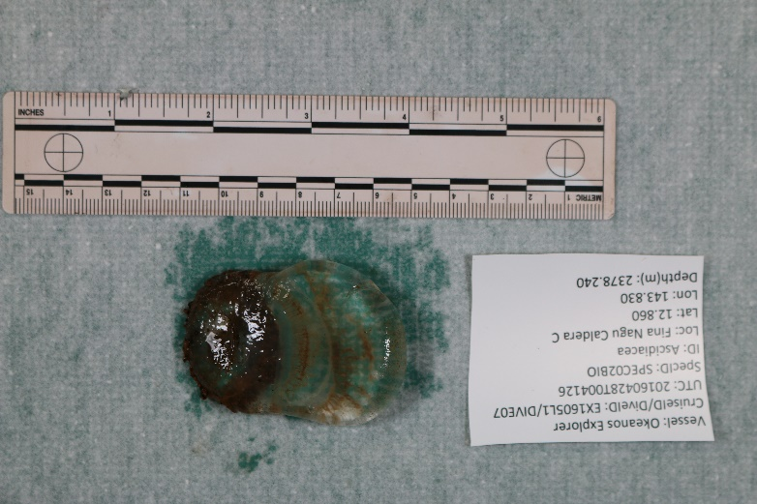
Date (UTC) |  | 20160427
Time (UTC) |  | 00:41:26
Depth (m) |  | 2378
Temperature (ºC) |  | 2.013
Field ID(s) |  | Ascidiacea: Megalodicopia sp.
Comments |  | No commensals.
Sample ID |  | D2_DIVE07_SPEC03GEO |  |  |  |  | 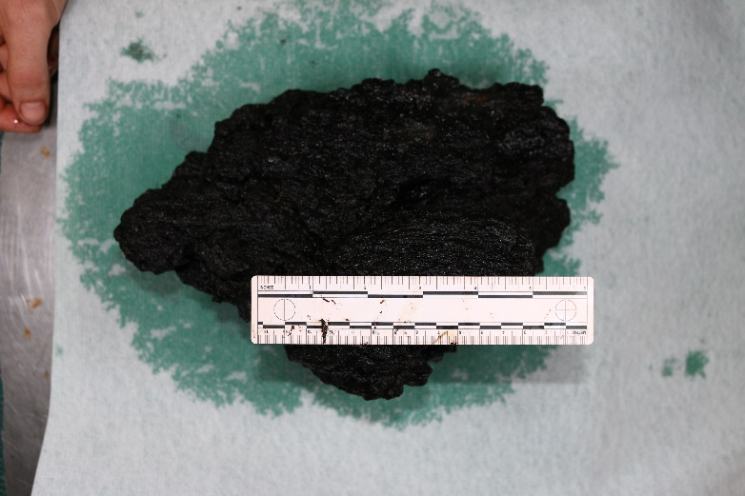
Date (UTC) |  | 20160427
Time (UTC) |  | 01:33:40
Depth (m) |  | 2294
Temperature (ºC) |  | 2.004
Field ID(s) |  | Mn-encrusted ropy basalt
Comments |  | No commensals.
Please direct inquiries to: |  |  |  | NOAA Office of Ocean Exploration & Research  1315 East-West Highway (SSMC3 10th Floor)  Silver Spring, MD 20910  (301) 734-1014

