Okeanos Explorer ROV Dive Summary
Site Name |  |  | Fina Nagu Caldera C |  |  |  |  |  |  |  | 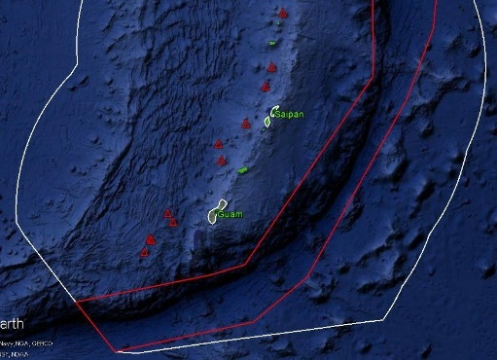
ROV Lead/Expedition Coordinator |  |  | Jim Newman / Kelley Elliott
Science Team Leads |  |  | Deborah Glickson & Diva Amon
General Area Descriptor |  |  | Southern Marianas
ROV Dive Name |  |  | Cruise Season |  | Leg |  |  |  |  |  |  | Dive Number
 |  |  | EX1605 |  | 1 |  |  |  |  |  |  | DIVE 06
Equipment Deployed |  |  | ROV: |  | Deep Discoverer
 |  |  | Camera Platform: |  | Seirios
ROV Measurements |  |  | D2 CTD |  | Depth |  |  |  |  |  |  | Altitude
 |  |  | Scanning Sonar |  | USBL Position |  |  |  |  |  |  | Heading
 |  |  | Pitch |  | Roll |  |  |  |  |  |  | HD Camera 1
 |  |  | HD Camera 2 |  | ROV HD 2 |  |  |  |  |  |  | Seirios CTD
 |  |  | Temperature Probe |  | D2 DO Sensor |  |  |  |  |  |  | Seirios DO sensor
Equipment Malfunctions
ROV Dive Summary  (From processed ROV data) |  |  | Dive Summary: EX1605L1_DIVE06  ^^^^^^^^^^^^^^^^^^^^^^^^^^^^^^^^^^^^^^^^^^^^^^^^^^^  In Water: 2016-04-26T21:57:45.607000  12°, 48.024' N ; 143°, 46.784' E  Out Water: 2016-04-27T06:44:45.314000  12°, 47.691' N ; 143°, 47.883' E  Off Bottom: 2016-04-27T05:10:06.852000  12°, 47.738' N ; 143°, 47.326' E  On Bottom: 2016-04-26T23:39:58.813000  12°, 47.806' N ; 143°, 46.860' E  Dive duration: 8:46:59  Bottom Time: 5:30:8  Max. depth: 2754.9 m
Special Notes
Scientists Involved  (please provide name / location / affiliation / email) |  |  | Stace Beaulieu, WHOI; sbeaulieu@whoi.edu  Maryjo Brounce, CA Institute of Technology, mbrounce@gps.caltech.edu  Scott France, UL Lafayette; france@louisiana.edu  Patty Fryer, UH; pfryer@soest.hawaii.edu  Tara Harmer Luke, Stockton University; Tara.Luke@stockton.edu  Chris Kelley, UH; ckelley@hawaii.edu  Asako Matsumoto, Chiba Institute of Technology; amatsu@gorgonian.jp  Tina Molodtsova, Shirshov Institute of Oceanology; tina@ocean.ru  Shirley Pomponi, FAU/HBOI; spomponi@fau.edu  Sonia Rowley, UH; srowley@hawaii.edu  Les Watling, UH; watling@hawaii.edu
Purpose of the Dive
The Fina Nagu Volcanic Chain is poorly studied, and none of its calderas, until this dive, had been imaged for signs of hydrothermal activity or biological communities. Based on the location of our dive, it was hypothesized that volcanic activity would increase northward through the calderas but are unsure. Fina Nagu C was expected to have some mature biology communities, but little biology was seen. This dive began at 2689 m, and traversed 670 m upslope to the north, ending at a depth of 2637 m.
Description of the Dive:
The dive began at 2575 m on a ridge/caldera wall between Fina Nagu B and C. After landing, we traversed the ridge upslope to the east to a depth of 2522 m. The ROV landed in an outcrop of lightly-sedimented pillow basalts. The pillows were striated and were mostly intact, and were emplaced on top of a ropy flow. We picked up a rock near this location, slightly upslope (D2_DIVE06_SPEC01GEO). As we continued to move upslope, the terrain remained mainly pillow basalts with some ropy and sheet flows. About 2 hours into the dive, we entered an area of shallow slopes covered in volcaniclastic sediment. It had widespread coverage, and in some instances there were ripple marks from the current. As we continued upslope there were isolated pillow outcrops partially covered by volcaniclastics. Eventually, as the slope steepened, we were again in large pillow outcrops. We collected our second rock sample in this area (D2_DIVE06_SPEC03GEO).

Biology was very sparse during the dive. Fauna observed included isidid bamboo corals, many Coleolus ascidians, a benthic ctenophore living on a sponge, a few holothurians, sponges, and crinoids. There were also some fish observed including a Aldrovandia halosaur and Kumba macrourid (D2_DIVE06_SPEC02BIO and D2_DIVE06_SPEC04BIO).

Map of ROV Dive Area
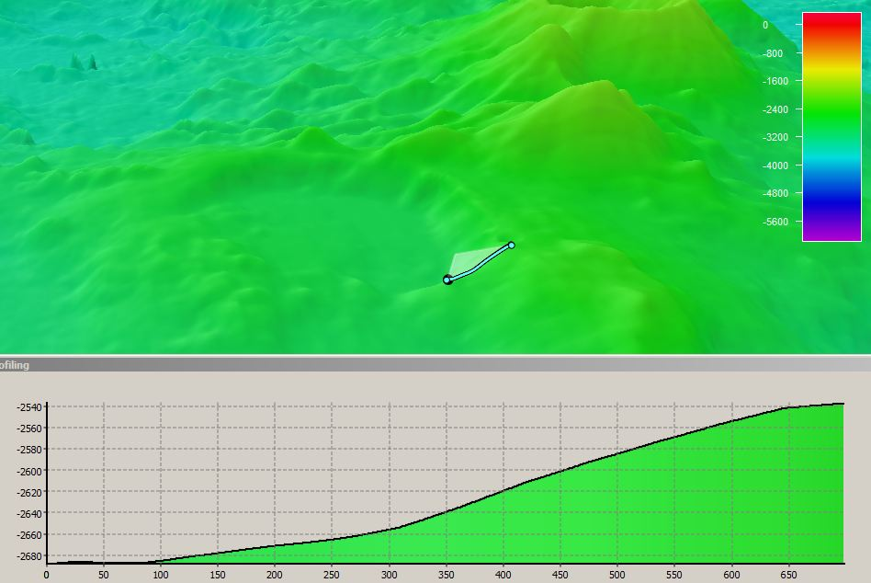 |  |  |  |  |  |  |  |  |  | 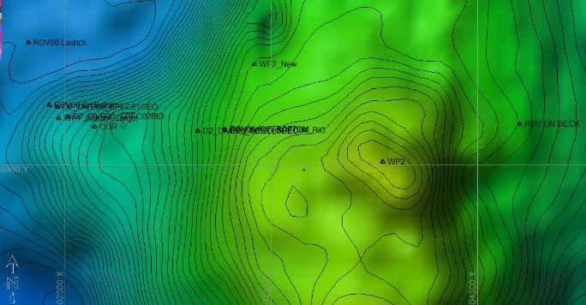
Fledermaus map of planned dive EX1605L1-DIVE06 track. |  |  |  |  |  |  |  |  |  | Hypack screengrab of actual dive EX1605L1-DIVE06 track
Representative Photos of the Dive
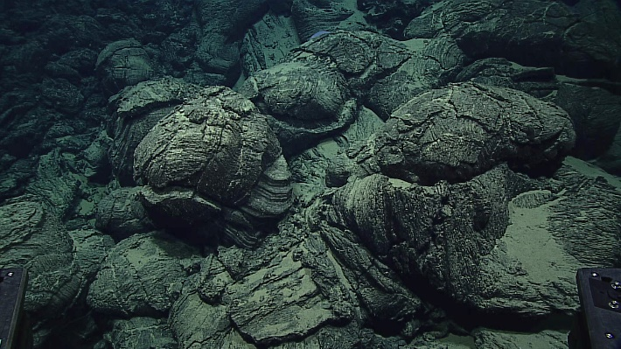 |  |  |  |  |  |  |  |  | 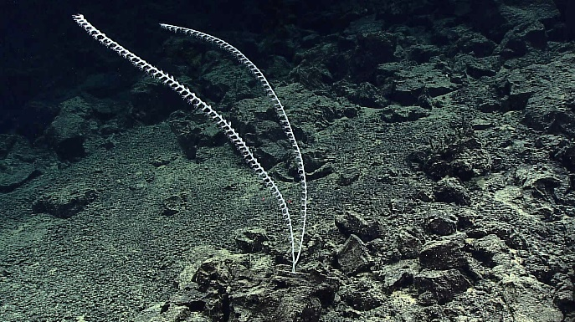
Pillow basalts during DIVE 06. |  |  |  |  |  |  |  |  | An isidid coral observed during DIVE 06.
Samples Collected
Sample ID | D2_DIVE06_SPEC01GEO |  |  |  |  | 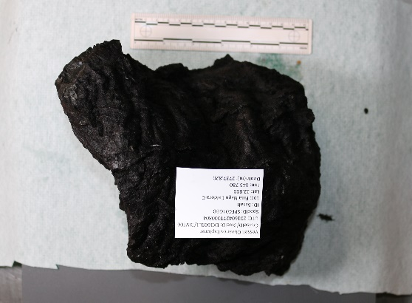
Date (UTC) | 20160427
Time (UTC) | 00:08:04
Depth (m) | 2737
Temperature (ºC) | 1.747
Field ID(s) | Mn-encrusted vesicular pillow basalt w/ropy flow structure
Comments | No commensals.
Sample ID |  | D2_DIVE06_SPEC02BIO |  |  |  |  | 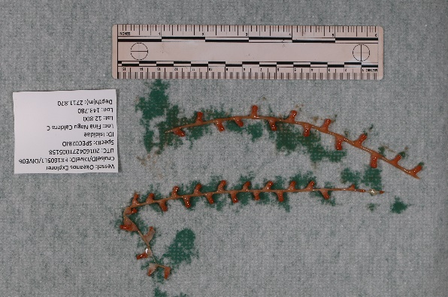
Date (UTC) |  | 20160427
Time (UTC) |  | 00:51:58
Depth (m) |  | 2712
Temperature (ºC) |  | 1.741
Field ID(s) |  | Isididae sp.
Comments |  | No commensals.
Sample ID |  | D2_DIVE06_SPEC03GEO |  |  |  |  | 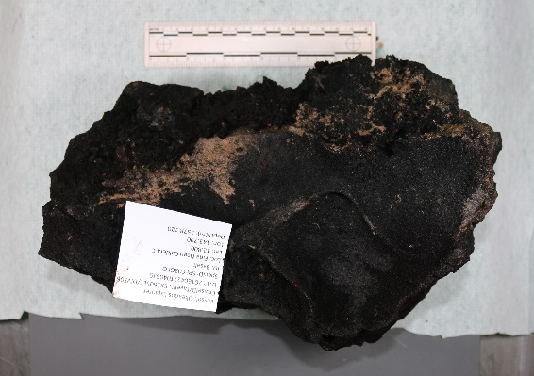
Date (UTC) |  | 20160427
Time (UTC) |  | 04:06:39
Depth (m) |  | 2578
Temperature (ºC) |  | 1.746
Field ID(s) |  | Mn-encrusted pillow basalt with glassy flow structure on bottom
Comments |  | No commensals.
Sample ID |  | D2_DIVE06_SPEC04BIO |  |  |  |  |  | 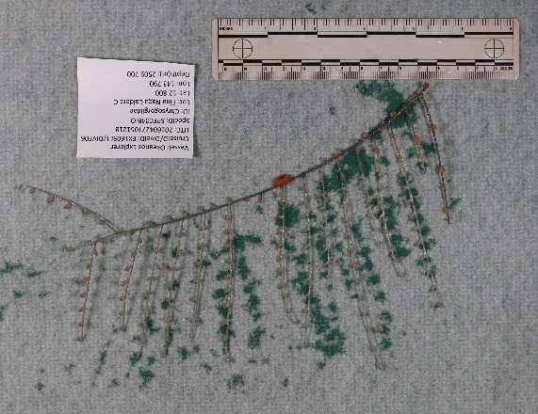
Date (UTC) |  | 20160427
Time (UTC) |  | 05:12:18
Depth (m) |  | 2509
Temperature (ºC) |  | 1.798
Field ID(s) |  | Chrysogorgiidae (Pleurogorgia) sp.
Comments |  | 20 anemones (some were stored in 4% formalin and 95% ETOH)
Please direct inquiries to: |  |  |  | NOAA Office of Ocean Exploration & Research  1315 East-West Highway (SSMC3 10th Floor)  Silver Spring, MD 20910  (301) 734-1014

