Okeanos Explorer ROV Dive Summary
Site Name |  |  | Fina Nagu Caldera D |  |  |  |  |  |  |  |  | 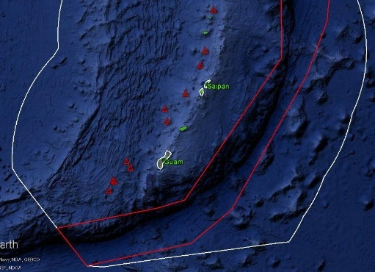
ROV Lead/Expedition Coordinator |  |  | Jim Newman / Kelley Elliott
Science Team Leads |  |  | Deborah Glickson & Diva Amon
General Area Descriptor |  |  | Southern Marianas
ROV Dive Name |  |  | Cruise Season |  | Leg |  |  |  |  |  |  |  | Dive Number
 |  |  | EX1605 |  | 1 |  |  |  |  |  |  |  | DIVE 05
Equipment Deployed |  |  | ROV: |  | Deep Discoverer
 |  |  | Camera Platform: |  | Seirios
ROV Measurements |  |  | D2 CTD |  | Depth |  |  |  |  |  |  |  | Altitude
 |  |  | Scanning Sonar |  | USBL Position |  |  |  |  |  |  |  | Heading
 |  |  | Pitch |  | Roll |  |  |  |  |  |  |  | HD Camera 1
 |  |  | HD Camera 2 |  | ROV HD 2 |  |  |  |  |  |  |  | Seirios CTD
 |  |  | Temperature Probe |  | D2 DO Sensor |  |  |  |  |  |  |  | Seirios DO sensor
Equipment Malfunctions
ROV Dive Summary  (From processed ROV data) |  |  | Dive Summary: EX1605L1_DIVE05  ^^^^^^^^^^^^^^^^^^^^^^^^^^^^^^^^^^^^^^^^^^^^^^^^^^^  In Water: 2016-04-25T21:49:57.964000  12°, 41.464' N ; 143°, 44.848' E  Out Water: 2016-04-26T06:36:57.110000  12°, 41.977' N ; 143°, 45.322' E  Off Bottom: 2016-04-26T05:09:05.212000  12°, 42.002' N ; 143°, 44.849' E  On Bottom: 2016-04-25T23:39:13.086000  12°, 41.605' N ; 143°, 44.975' E  Dive duration: 8:46:59  Bottom Time: 5:29:52  Max. depth: 2973.7 m
Special Notes
Scientists Involved  (please provide name / location / affiliation / email) |  |  | Stace Beaulieu, WHOI; sbeaulieu@whoi.edu  Scott France, UL Lafayette; france@louisiana.edu  Patty Fryer, UH; pfryer@soest.hawaii.edu  Tara Harmer Luke, Stockton University; Tara.Luke@stockton.edu  Chris Kelley, UH; ckelley@hawaii.edu  Alexander Kerr, University of Guam; alexander.kerr@aya.yale.edu  Asako Matsumoto, Chiba Institute of Technology; amatsu@gorgonian.jp  Tina Molodtsova, Shirshov Institute of Oceanology; tina@ocean.ru  Bruce Mundy, NOAA PIFSC; bruce.mundy@noaa.gov  Shirley Pomponi, FAU/HBOI; spomponi@fau.edu  Sonia Rowley, UH; srowley@hawaii.edu  Tim Shank, WHOI; tshank@whoi.edu  Daniel Wagner, NOAA; daniel.wagner@noaa.gov  Les Watling, UH; watling@hawaii.edu
Purpose of the Dive
The Fina Nagu Volcanic Chain is poorly studied, and none of its calderas, until this dive, had been imaged for signs of hydrothermal activity or biological communities. Based on the location of our dive, we think that volcanic activity would increases northward through the calderas but are unsure. Fina Nagu D was expected to have some mature biology communities, but little biology was seen. This dive began at 3029 m, and traversed 750 m upslope to the north, ending at a depth of 2692 m.
Description of the Dive:
The dive began at 2970 m and moved NNW up a ridge of the Fina Nagu D caldera wall.

The ROV touched down in fairly fresh-looking volcanics, with low MN-crust coatings and little sediment. We saw many lava morphologies on this dive, including pillows, ropy lava, blocky talus, and sheet flows. In one area we saw what looked like dikes also. As we moved up the slope, we saw many scree slopes with moderate to heavy sediment, and talus. There were isolated small outcrops, but it was not until about 2700 m that we transitioned almost entirely to outcrops, with less talus and less sediment. When we reached the local high (Waypoint 2), it was an enormous pile of blocky talus that looked fresh and mostly unsedimented. Geological samples were collected near the beginning of the dive (D2_DIVE05_SPEC02GEO), at the dike feature (D2_DIVE05_SPEC02GEO), and in the outcrops just before we reached the talus slope (D2_DIVE05_SPEC05GEO).

The biology tended to be comprised of mostly suspension-feeding organisms e.g. crinoids, sponges, isidids and stylasterids. Interesting animals of note included three possible new species of sponge, likely all Hyalonema spp. Two of these were collected (D2_DIVE05_SPEC03GEO and D2_DIVE05_SPEC04GEO). We also encountered a benthic siphonophore (dandelion), two swimming cf. Paleopatides sp., a mating pair of amphipods, a benthic ctenophore, and a predatory tunicate, Megalodicopia sp.
Map of ROV Dive Area
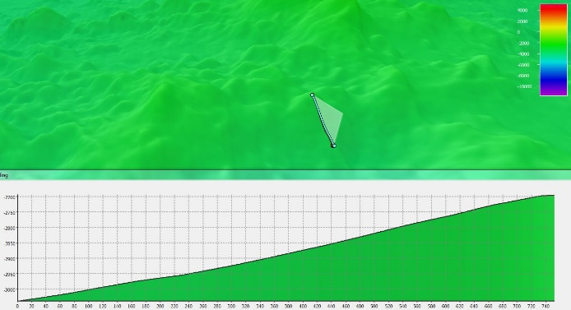 |  |  |  |  |  |  |  |  |  |  | 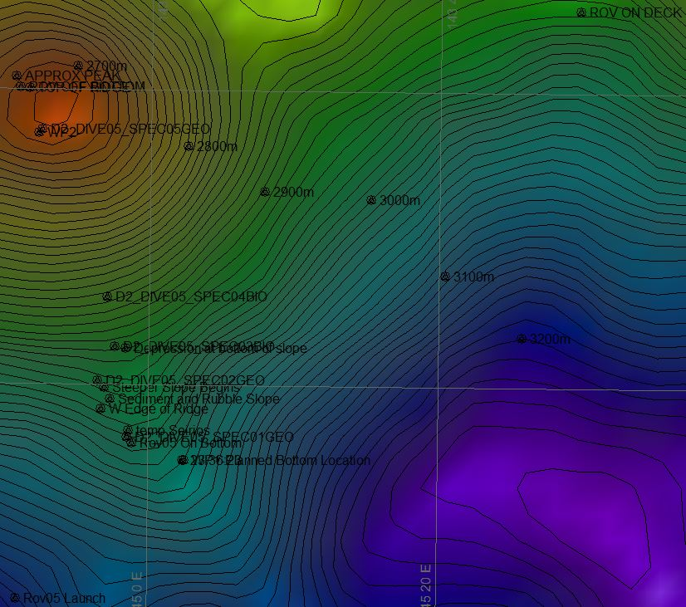
Fledermaus map of planned dive EX1605L1-DIVE05 track. |  |  |  |  |  |  |  |  |  |  | Hypack screengrab of actual dive EX1605L1-DIVE05 track
Representative Photos of the Dive
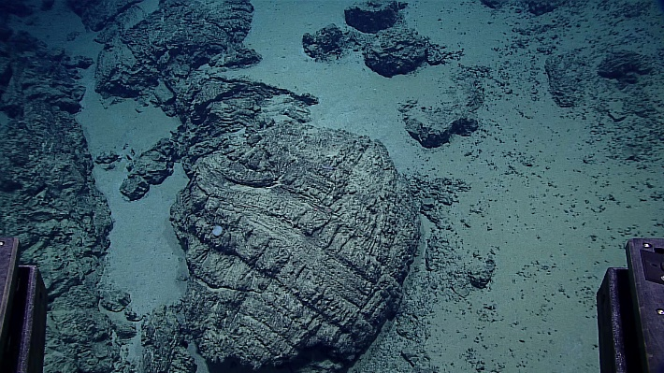 |  |  |  |  |  |  |  |  |  | 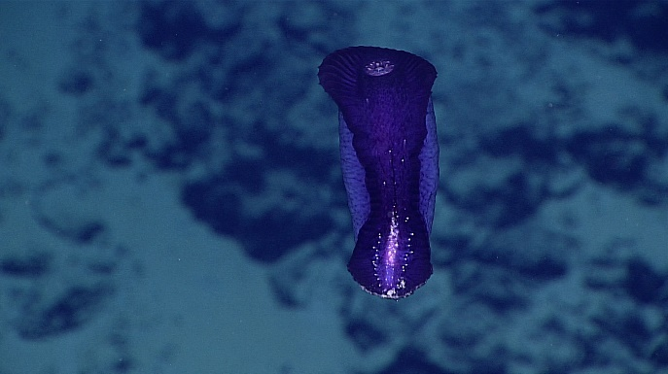
Some of the many pillow basalts encountered during DIVE 07. |  |  |  |  |  |  |  |  |  | A cf. Paleopatides sp. holothurian swimming.
Samples Collected
Sample ID | D2_DIVE05_SPEC01GEO |  |  |  |  | 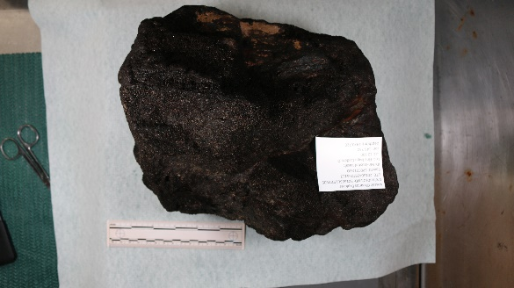
Date (UTC) | 20160425
Time (UTC) | 23:51:13
Depth (m) | 2970
Temperature (ºC) | 1.677
Field ID(s) | Mn-coated basalt
Comments | No commensals
Sample ID |  | D2_DIVE05_SPEC02GEO |  |  |  |  | 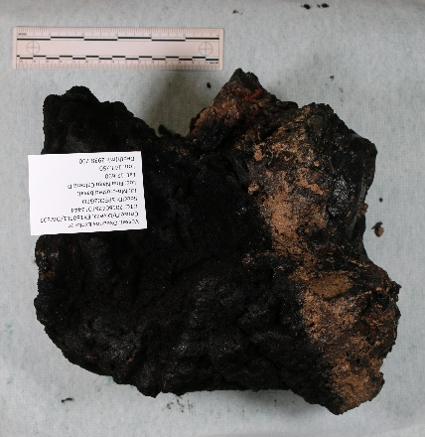
Date (UTC) |  | 20160426
Time (UTC) |  | 01:24:44
Depth (m) |  | 2938
Temperature (ºC) |  | 1.678
Field ID(s) |  | Mn-coated basalt
Comments |  | No commensals.
Sample ID |  | D2_DIVE05_SPEC03BIO |  |  |  |  | 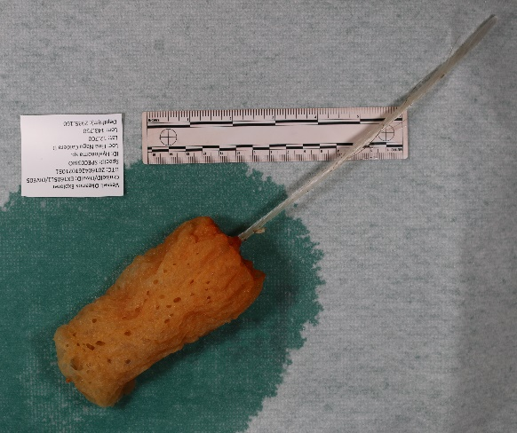
Date (UTC) |  | 20160426
Time (UTC) |  | 02:01:51
Depth (m) |  | 2935
Temperature (ºC) |  | 1.693
Field ID(s) |  | Hyalonema sp.
Comments |  | One commensal = Scalpellidae barnacle.
Sample ID |  | D2_DIVE05_SPEC04BIO |  |  |  |  |  | 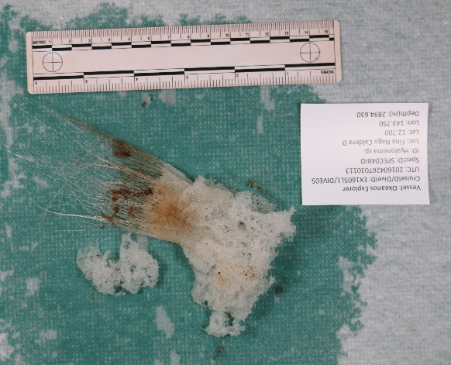
Date (UTC) |  | 20160426
Time (UTC) |  | 03:31:13
Depth (m) |  | 2894
Temperature (ºC) |  | 1.709
Field ID(s) |  | Hyalonema sp.
Comments |  | No commensals.
Sample ID |  | D2_DIVE05_SPEC05GEO |  |  |  |  |  |  | 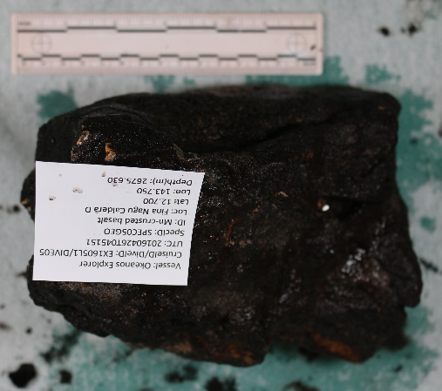
Date (UTC) |  | 20160426
Time (UTC) |  | 04:51:51
Depth (m) |  | 2675
Temperature (ºC) |  | 1.703
Field ID(s) |  | Basalt
Comments |  | No commensals.
Please direct inquiries to: |  |  |  | NOAA Office of Ocean Exploration & Research  1315 East-West Highway (SSMC3 10th Floor)  Silver Spring, MD 20910  (301) 734-1014

