Okeanos Explorer ROV Dive Summary
Site Name |  |  | Sirena Canyon |  |  |  |  |  |  |  |  | 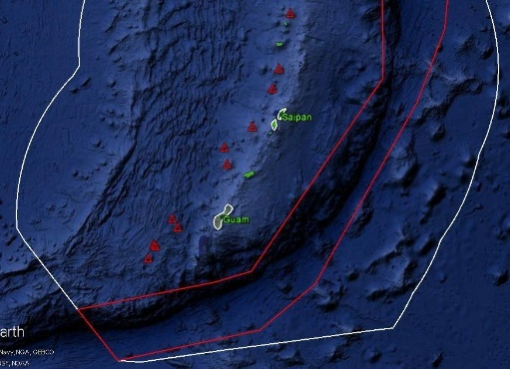
ROV Lead/Expedition Coordinator |  |  | Jim Newman / Kelley Elliott
Science Team Leads |  |  | Deborah Glickson & Diva Amon
General Area Descriptor |  |  | Southern Marianas
ROV Dive Name |  |  | Cruise Season |  | Leg |  |  |  |  |  |  |  | Dive Number
 |  |  | EX1605 |  | 1 |  |  |  |  |  |  |  | DIVE 03
Equipment Deployed |  |  | ROV: |  | Deep Discoverer
 |  |  | Camera Platform: |  | Seirios
ROV Measurements |  |  | D2 CTD |  | Depth |  |  |  |  |  |  |  | Altitude
 |  |  | Scanning Sonar |  | USBL Position |  |  |  |  |  |  |  | Heading
 |  |  | Pitch |  | Roll |  |  |  |  |  |  |  | HD Camera 1
 |  |  | HD Camera 2 |  | ROV HD 2 |  |  |  |  |  |  |  | Seirios CTD
 |  |  | Temperature Probe |  | D2 DO Sensor |  |  |  |  |  |  |  | Seirios DO sensor
Equipment Malfunctions |  |  | None
ROV Dive Summary  (From processed ROV data) |  |  | Dive Summary: EX1605L1_DIVE03  ^^^^^^^^^^^^^^^^^^^^^^^^^^^^^^^^^^^^^^^^^^^^^^^^^^^  In Water: 2016-04-22T20:43:42.944000  12°, 32.433' N ; 144°, 36.186' E  Out Water: 2016-04-23T06:15:10.906000  12°, 32.331' N ; 144°, 37.343' E  Off Bottom: 2016-04-23T03:39:16.865000  12°, 32.263' N ; 144°, 36.259' E  On Bottom: 2016-04-22T23:38:08.642000  12°, 32.391' N ; 144°, 36.439' E  Dive duration: 9:31:27  Bottom Time: 4:1:8  Max. depth: 4996.1 m
Special Notes |  |  | This dive was originally intended to begin at 6,000 m. Due to marginal weather for such a deep dive, the dive plan was amended to begin at 5,000 m.
Scientists Involved  (please provide name / location / affiliation / email) |  |  | David Burdick, U Guam; burdickdr@hotmail.com  Jeff Drazen, UH; jdrazen@hawaii.edu  Scott France, UL Lafayette; france@louisiana.edu  Patty Fryer, UH; pfryer@soest.hawaii.edu  Taylor Heyl, WHOI; theyl@whoi.edu  Tara Harmer Luke, Stockton University; Tara.Luke@stockton.edu  Mackenzie Gerringer, UH; mgerring@hawaii.edu  Santiago Herrera, WHOI; sherrera@alum.mit.edu  Chris Kelley, UH; ckelley@hawaii.edu  Asako Matsumoto, Chiba Institute of Technology; amatsu@gorgonian.jp  Tina Molodtsova, Shirshov Institute of Oceanology; tina@ocean.ru  Bruce Mundy, NOAA PIFSC; bruce.mundy@noaa.gov  Amanda Netburn, NOAA OER; amanda.netburn@noaa.gov  Andrea Quattrini, Harvey Mudd College; aquattrini@g.hmc.edu  Sonia Rowley, UH; srowley@hawaii.edu  Tim Shank, WHOI; tshank@whoi.edu  Les Watling, UH; watling@hawaii.edu
Purpose of the Dive
The objective of this dive was to observe the biology and geology in the deeper parts of the MTMNM along the side of a broad canyon that drops into the Sirena Deep – one of the deepest locations in the trench. Within the monument, little work has been done between 5000 and 8000 m. However, there has been more sampling in deeper areas e.g. at seep and mud volcano sites, and also at deep sites such as the Challenger Deep. Therefore, the dive track began at 4983 m and moved ~700 m in distance up steep topography to the west where the dive ended at 5865 m.
Description of the Dive:
The ROV touched down in an area of what appeared to be sedimented volcanic rock. The structures were not well-defined and were fractured. There were many areas with small talus or scree slopes and moderate sediment. D2_DIVE03_SPEC01GEO was collected in this area. The rock is partially covered with a Mn crust, but it is unclear if it is actually volcanic. There was a transition to layered rock, which may have all been sedimentary. These layered rocks were partially buried in sediment, and many appeared to be out of place. One idea was that they were large sedimentary blocks that had come down the slope as part of a mass-wasting event. We collected one such sample (D2_DIVE03_SPEC03GEO).

Fauna were relatively sparse but very diverse. There were at least four types of fish observed with Leucicorus cf. atlanticus being the most common seen on several occasions. Many different species of holothurians were also observed as well as at least three species of crinoids. One crinoid (D2_DIVE03_SPEC01BIO) and one holothurian (D2_DIVE03_SPEC04BIO) were collected. Many swimming polychaetes, three types of sponges, benthic ctenophores, Munidopsis squat lobsters and two types of isopods. At the end of the dive, a likely-new-species of cladhorizid sponge was collected, which had 9 ophiuroids living commensally on it (D2_DIVE03_SPEC05BIO).

Although there were opportunities for both biological and geological sampling along the slope, the flat we expected to see at the end of the dive did not materialize, so we were unable to compare faunal assemblages from slope to flat.
Map of ROV Dive Area
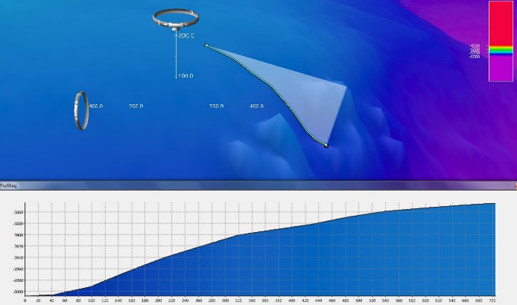 |  |  |  |  |  |  |  |  |  |  | 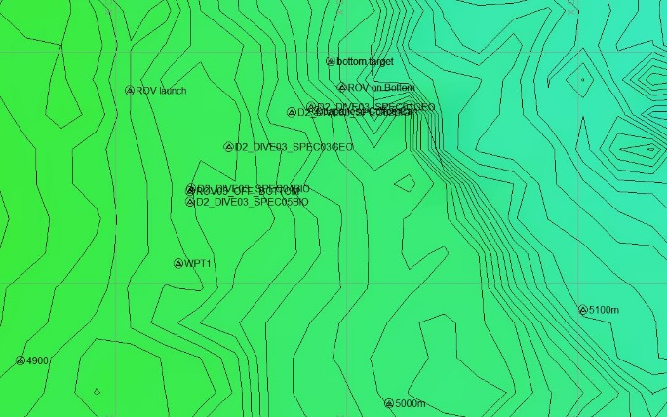
Fledermaus map of planned dive EX1605L1-DIVE03 track. |  |  |  |  |  |  |  |  |  |  | Hypack screengrab of actual dive EX1605L1-DIVE03 track
Representative Photos of the Dive
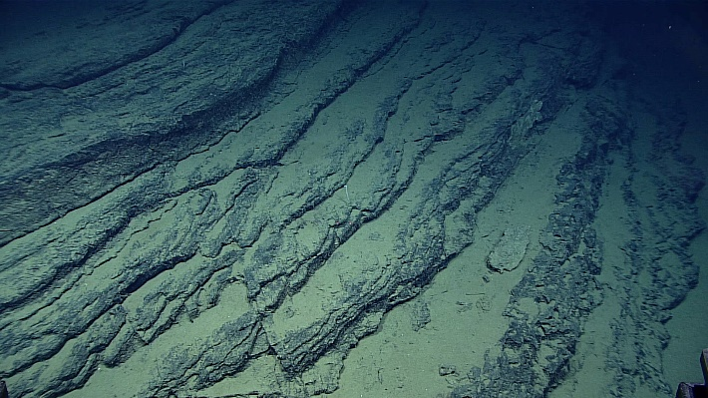 |  |  |  |  |  |  |  |  |  | 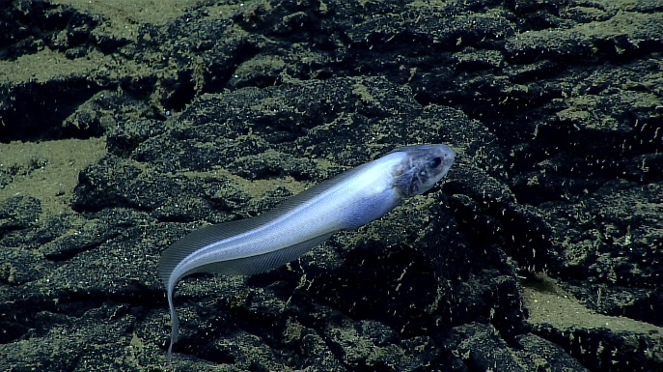
The predominant geology during the dive: lightly-sedimented sloping rock face |  |  |  |  |  |  |  |  |  | Leucicorus cf. atlanticus, many of which were observed on the dive.
Samples Collected
Sample ID | D2_DIVE03_SPEC01GEO |  |  |  |  | 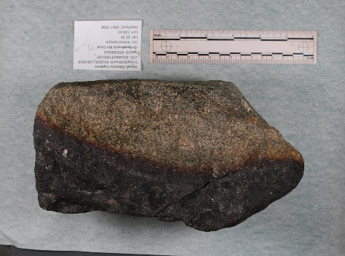
Date (UTC) | 20160423
Time (UTC) | 00:53:19
Depth (m) | 4968
Temperature (ºC) | 1.505
Field ID(s) | Basalt? with Mn crust
Comments | No commensals
Sample ID |  | D2_DIVE03_SPEC02BIO |  |  |  |  | 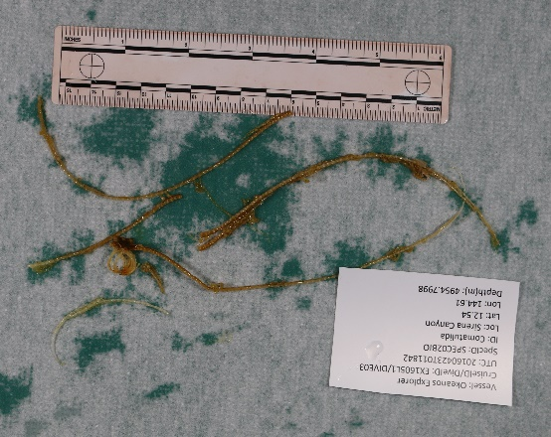
Date (UTC) |  | 20160423
Time (UTC) |  | 01:18:42
Depth (m) |  | 4954
Temperature (ºC) |  | 1.508
Field ID(s) |  | Comatulida
Comments |  | No commensals.
Sample ID |  | D2_DIVE03_SPEC03GEO |  |  |  |  | 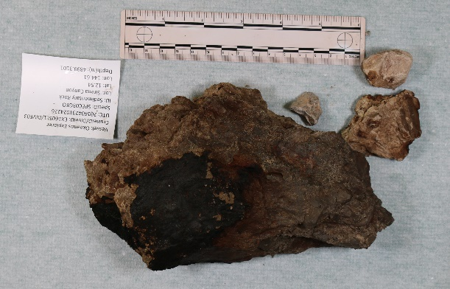
Date (UTC) |  | 20160423
Time (UTC) |  | 02:42:26
Depth (m) |  | 4899
Temperature (ºC) |  | 1.506
Field ID(s) |  | Sedimentary rock
Comments |  | No commensals.
Sample ID |  | D2_DIVE03_SPEC04BIO |  |  |  |  |  | 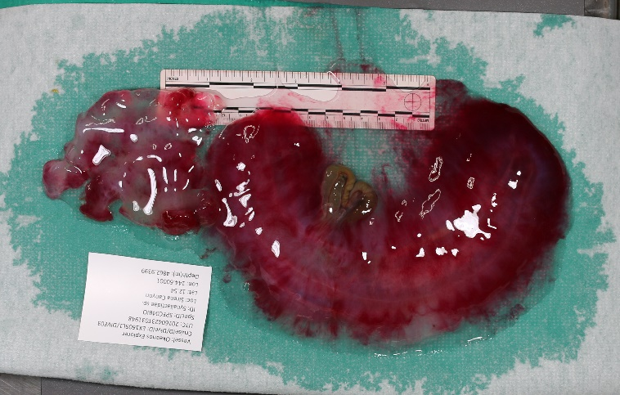
Date (UTC) |  | 20160423
Time (UTC) |  | 03:19:48
Depth (m) |  | 4863
Temperature (ºC) |  | 1.512
Field ID(s) |  | Holothuroidea, Synallactidae
Comments |  | No commensals.
Sample ID |  | D2_DIVE03_SPEC05BIO |  |  |  |  |  |  | 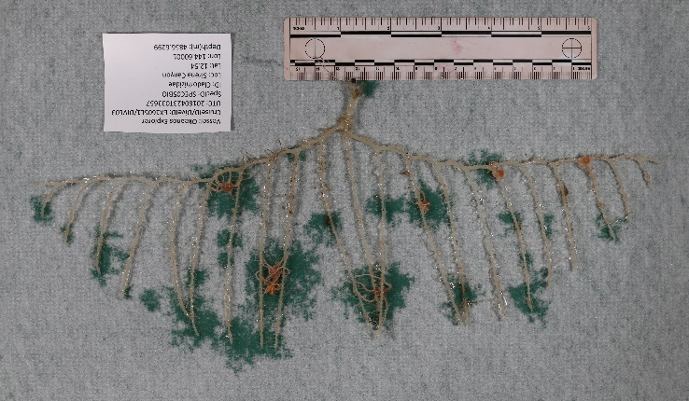
Date (UTC) |  | 20160423
Time (UTC) |  | 03:36:57
Depth (m) |  | 4857
Temperature (ºC) |  | 1.504
Field ID(s) |  | Cladhorizid sponge
Comments |  | Nine commensals: ophiuroids
Please direct inquiries to: |  |  |  | NOAA Office of Ocean Exploration & Research  1315 East-West Highway (SSMC3 10th Floor)  Silver Spring, MD 20910  (301) 734-1014

