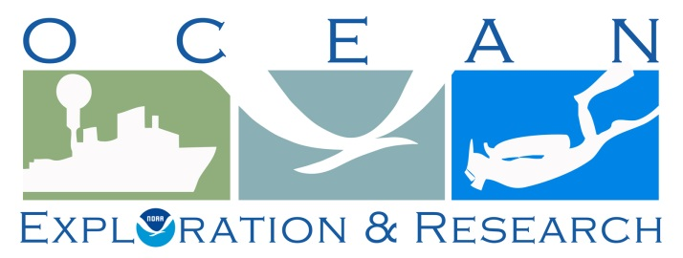

DRAFT Project Instructions

Date Submitted: February 2, 2016

Platform: NOAA Ship Okeanos Explorer

Project Number: EX-16-04

Project Title: CAPSTONE Wake Island PRIMNM (Preliminary Mapping)

Project Dates: March 23, 2016 – April 13, 2016

Prepared by: Derek Sowers, NOAA
Expedition Coordinator
Office of Ocean Exploration & Research

Approved by: ________________________ Dated: __________________
John McDonough
Deputy Director
Office of Ocean Exploration & Research

Approved by: ________________________ Dated: __________________
Captain Anne K. Lynch, NOAA
Commanding Officer
Marine Operations Center - Atlantic
I. Overview
A. Brief Summary and Project Period

The ocean is 95 percent unexplored, unknown, and unseen by human eyes. Resource managers cannot manage what they do not know. To understand, manage, and protect the ocean and its resources, NOAA believes it is critical to support a systematic program of ocean exploration, using the best of ocean technology to explore, discover, inform, educate, and motivate. Exploration of our largely unknown ocean supports key NOAA, national, and international goals related to a better understanding of the ocean that will benefit current and future generations. NOAA Ship Okeanos Explorer is helping us to better understand the unknown ocean by targeted exploratory mapping.

This document contains project instructions for EX-16-04, with operations expected to commence on March 23, 2016 in Kwajalein and conclude on April 13, 2016 in Guam. EX-16-04 is an exploratory mapping expedition, and is part of the multi-year Campaign to Address Pacific monument Science, Technology, and Ocean NEeds (CAPSTONE). NOAA priorities for the CAPSTONE campaign include a combination of science, education, outreach, and open data objectives that will support management decisions at multiple levels.

Understanding biogeographic patterns between and among the Pacific Monuments and Sanctuaries is a coordinating theme for CAPSTONE science priorities. Themes and objectives for the expedition series include:
- Acquire data to support priority Monument and Sanctuaries science and management needs, including habitat surveys in recently expanded boundary areas;
- Identification and characterization of vulnerable marine habitats - particularly high density deep sea coral and sponge communities;
- Characterization of seamounts within the Prime Crust Zone (PCZ). The PCZ is the area of the Pacific with the highest expected concentration of deep sea minerals, including rare metals and rare earth elements;
- Collect information on the geologic history of Central Pacific Seamounts, including those that are or may be relevant to our understanding of plate tectonics and subduction zone biology and geology; and
- Provide a foundation of publicly accessible data and information products to spur further exploration, research, and management activities.

Originally created by Presidential Proclamation 8336 of January 6, 2009, Pacific Remote Islands Marine National Monument (PRIMNM) boundaries were expanded by Presidential Proclamation 9173, dated September 29, 2014. The expansion includes waters adjacent to Jarvis and Wake Islands, and Johnston Atoll. EX-16-04 focuses on ocean mapping of the Wake Island unit of PRIMNM for exploratory baseline characterization. Wake Island is the northernmost atoll in the Marshall Islands geological ridge, and according to the US Fish & Wildlife Service, is perhaps the oldest living atoll in the world. The Wake Island Unit of PRIMNM contains 406,307 km² of ocean area within the US Exclusive Economic Zone. Very little multibeam data exists in this region, and this cruise will therefore be the most ambitious effort to date to explore this very large US marine protected area.

Multibeam and singlebeam mapping operations will be conducted 24 hours a day throughout the cruise. Sub-bottom profile mapping will be conducted 24 hours a day at the discretion of the CO. XBT and/or UnderwayCTD (UCTD) sound velocity casts in support of multibeam sonar mapping operations will be conducted at an interval defined by prevailing oceanographic conditions, but not to exceed 6 hours. All multibeam data will be fully processed according to standard onboard procedures and will be archived with the National Geophysical Data Center. Split-beam EK60 data will be archived at the National Oceanographic Data Center.

The total transit between Kwajalein and Guam is estimated to be approximately 1,745 nm long, not including survey lines conducted in mapping focus areas within Wake PRIMNM. Average transit speeds of 8.5-9.5 knots are required to collect good quality multibeam data during the expedition.

B. Days at Sea (DAS)
Of the 22 DAS scheduled for this project, 22 DAS are funded by a Line Office Allocation. This project is estimated to exhibit a Medium Operational Tempo.
C. Operating Area (include optional map/figure showing op area)
The operating area encompasses a large region of the Pacific Ocean between Kwajalein in the Marshall Islands and Guam (Figure 1). The focus of the expedition will be survey mapping in the Wake Island Unit of PRIMNM, with transit mapping between the departure and arrival ports designed to opportunistically map over numerous seamounts. The white boxes shown indicate the highest priority regions within the Wake Atoll Unit of PRIMNM to conduct survey mapping operations. The exact survey areas and survey ship track lines will be determined during the expedition based on weather conditions and additional input from scientists and agency managers.

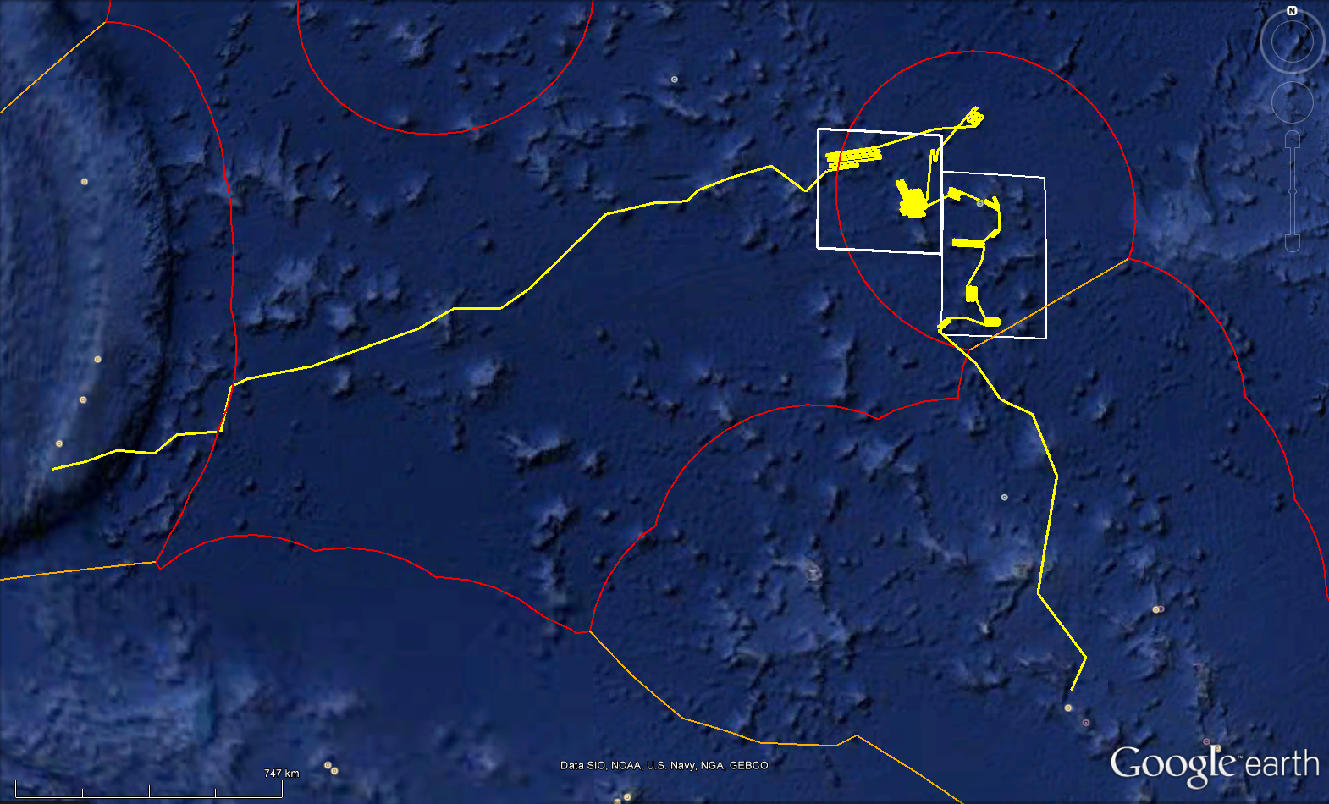Figure 1: EX-16-04 operating area. The yellow line indicates the approximate ship trackline for expedition, including the transits to and from the main working grounds near Wake Atoll. White boxes indicate the highest priority regions within the Wake Atoll Unit of PRIMNM to conduct survey mapping operations. The red lines show the approximate location of the US EEZ boundaries. Map made with Google Earth Pro.
Guam
Kwajalein
Wake Atoll
(PRIMNM)
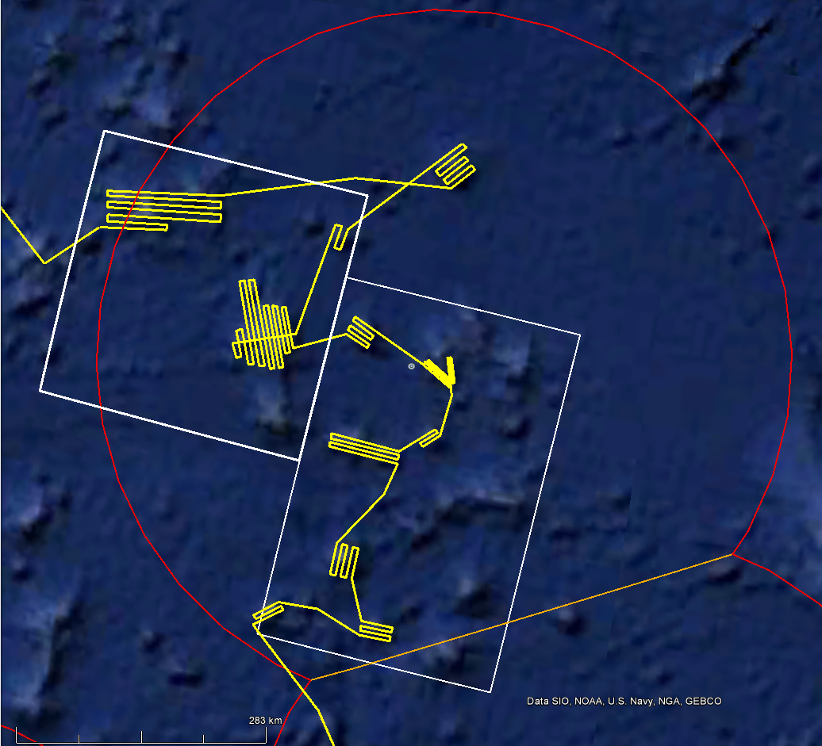
Figure 2. Draft survey mapping strategy to cover high priority seamount features and the area just south of Wake Atoll. This expedition will focus on seamounts in the western half of Wake Atoll PRIMNM. Exact survey lines to be determined in the field.

Table 1: Approximate transit waypoints (degrees decimal minutes) for transit from Kwajalein to Wake Island Unit of PRIMNM.

Waypoint # | Latitude (North) | Longitude (East) | Description
1 | 8 42.18 | 167 49.83 | Start transit from Kwajalein
2 | 9 22.77 | 168 10.60 | Transit, seamount mapping
3 | 10 49.25 | 167 7.36 | Transit, seamount mapping
4 | 13 17.26 | 167 41.39 | Transit, seamount mapping
5 | 14 37.49 | 167 12.59 | Transit, seamount mapping
6 | 14 58.07 | 166 29.22 | Transit, seamount mapping
7 | 15 45.34 | 165 58.15 | Transit, seamount mapping
8 | 16 27.87 | 165 11.05 | Arrive to Wake Unit, PRIMNM

Table 2: Approximate transit waypoints (degrees decimal minutes) for transit from Wake Atoll Unit of PRIMNM to Guam.

Waypoint # | Latitude (North) | Longitude (East) | Description
1 | 19 59.16 | 162 53.40 | Start transit from Wake PRIMNM
2 | 19 32.23 | 162 22.75 | Transit, seamount mapping
3 | 20 6.68 | 161 38.19 | Transit, seamount mapping
4 | 19 52.14 | 160 38.36 | Transit, seamount mapping
5 | 19 36.70 | 159 57.56 | Transit, seamount mapping
6 | 19 22.33 | 159 42.26 | Transit, seamount mapping
7 | 19 21.45 | 158 56.91 | Transit, seamount mapping
8 | 19 7.35 | 157 53.67 | Transit, seamount mapping
9 | 17 32.60 | 156 11.21 | Transit, seamount mapping
10 | 17 7.30 | 155 32.65 | Transit, seamount mapping
11 | 17 9.53 | 154 33.40 | Transit, seamount mapping
12 | 16 43.35 | 153 44.19 | Transit, seamount mapping
13 | 15 55.42 | 151 19.52 | Transit, seamount mapping
14 | 15 38.36 | 149 48.68 | Transit, seamount mapping
15 | 15 27.44 | 149 24.07 | Transit, seamount mapping
16 | 14 29.80 | 149 15.77 | Transit, seamount mapping
17 | 14 23.67 | 148 8.45 | Transit, seamount mapping
18 | 13 59.12 | 147 37.53 | Transit, seamount mapping
19 | 14 1.50 | 146 41.70 | Transit, seamount mapping
20 | 13 44.60 | 145 53.47 | Transit, seamount mapping
21 | 13 31.69 | 144 57.96 | Arrive to Guam

D. Summary of Objectives
MARCH 23 – APRIL 13, 2016 (Kwajalein - Guam)
During EX-16-04 multibeam data will be collected 24 hours a day, almost entirely over previously unexplored regions. This mapping expedition will provide essential baseline mapping and reconnaissance of the region prior to EX-16-06, enabling ROV dive locations to be planned partially in advance.
The following are cruise objectives for EX-16-04:

- Collect 24-hr/day deep water multibeam (EM 302), split-beam (EK60), and sub-bottom sonar data (Knudsen 3260).
a. Conduct 24-hour mapping operations for the duration of the cruise
b. Collect bathymetric, seafloor backscatter, and water column backscatter data.
c. Sub-bottom sonar 24-hr data collection will be at the discretion of the CO.

- Conduct emergency drills. Drills may include some or all of the following as determined by CO:
- Fire/Damage Control
- Abandon Ship
- Man-Over-Board
- Steering Casualty
- Oil Spill/ Hazmat spill

- Data management objectives:

- Conduct water column sound velocity profile measurements via UCTD or XBT.
  - Test the ship’s 3 XBT hand-launchers and UCTD.
  - Water column sound velocity casts will be collected at regular intervals of no more than 6 hours in support of multibeam sonar operations.
  - CTD rosette operations may be requested to obtain sound velocity profiles as a back-up for XBT and UCTD operations, and thus the CTD should be mission-ready prior to the start of the expedition. Additional sensors typically mounted on the rosette including dissolved oxygen, light scattering sensor (LSS), and altimeter should be operationally tested and ready to perform exploration activities as the need arises should water column anomalies be discovered during the cruise.
- Train personnel in data collection and processing procedures as needed (continuous throughout cruise).
- Train Explorers-in-Training
- Train EPP mapping intern
- Train augmenting Survey Tech or newly hired Survey Tech
- Map a large section of area within the Wake Island Unit of PRIMNM. Survey mapping will focus on mapping the large seamount features within the unit. This mapping work will form a foundational basis of information on which top priority ROV dive operations can be planned for subsequent exploration expeditions.

- Telepresence (VSAT 4.7 mbps ship to shore; 1.54 mbps shore to ship)
- Maintain single live stream video from ship to shore with a focus on the multibeam mapping display
- The longstanding NASA marine aerosols network survey of opportunity will continue for the cruise.

- Search for Underwater Cultural Heritage (UCH) sites associated with WWII battles in the region. Specific search targets are too be determined. NOAA OER’s UCH policies will be followed to guide the management of data associated with sites found intentionally and unintentionally.
E. Participating Institutions

National Oceanic and Atmospheric Administration (NOAA) - Office of Ocean Exploration and Research (OER) - 1315 East-West Hwy, Silver Spring, MD 20910 USA

NOAA Fisheries, Pacific Islands Regional Office, NOAA Inouye Regional Center (IRC), 1845 Wasp Blvd., Building 176, Honolulu, HI 96818

NOAA, National Centers for Environmental Information (NCEI),1021 Balch Blvd, Suite 1003 Stennis Space Center, MS. 39529

University Corporation for Atmospheric Research Joint Office for Science Support (JOSS), PO Box 3000 Boulder, CO 80307 USA

University of Hawai`i at Manoa, 1000 Pope Road, Marine Sciences Building, Honolulu, HI 96822 USA

University of New Hampshire (UNH) Center for Coastal and Ocean Mapping (CCOM), Jere A. Chase Ocean Engineering Lab, 24 Colovos Road, Durham, NH 03824 USA

University of Rhode Island, Graduate School of Oceanography’s Inner Space Center, 215 South Ferry Rd. Narragansett, RI 02882 USA

F. Personnel/Science Party: name, title, gender, affiliation, and nationality

List of Science Party personnel
Name  (Last, First) | Title | Date Aboard | Date Depart | M/F | Affiliation | Nationality
Sowers, Derek | Expedition Coordinator, Mapping Lead | 3/21/16 | 4/14/16 | M | NOAA OER  (ERT, Inc) | US Citizen
Freitas, Dan | Mapping Watch Leader | 3/21/16 | 4/14/16 | M | UCAR Contractor | US Citizen
Bittinger, Amanda | Mapping Watch Leader | 3/21/16 | 4/14/16 | F | UCAR Contractor | US Citizen
Caitlin Ruby | Mapping Watchstander | 3/21/16 | 4/14/16 | F | Mississippi State University | US Citizen
TBD | Mapping Watchstander | 3/21/16 | 4/14/16 |  | UCAR Explorer-in-Training | US Citizen
TBD | Mapping Watchstander | 3/21/16 | 4/14/16 |  | UCAR Explorer-in-Training | US Citizen
TBD | Mapping Watchstander | 3/21/16 | 4/14/16 |  | UCAR Explorer-in-Training | US Citizen
TBD | Mapping Watchstander | 3/21/16 | 4/14/16 |  | Educational Partnership Program | US Citizen

A full mapping complement is necessary for this cruise. Required mission personnel include a Mapping Lead/Expedition Coordinator as well as a minimum of two qualified watchstanders for each of the three eight hour watches. The Mapping Lead is responsible for facilitating overall mapping operations, including participating in operational meetings, providing guidance for mapping/survey troubleshooting, and communicating status of mapping sensors to personnel on shore.
G. Administrative
1. Points of Contacts:
Ship Operations

Marine Operations Center, Atlantic (MOA)  439 West York Street  Norfolk, VA 23510-1145  Telephone: (757) 441-6776  Fax: (757) 441-6495 | Chief, Operations Division, Atlantic (MOA)  LCDR Donald Beaucage  Telephone: (757) 441-6842  E-mail:chiefops.moa@noaa.gov

Mission Operations

Derek Sowers, Expedition Coordinator/Mapping Team Lead  NOAA Office of Ocean Exploration  and Research (ERT, Inc)  Mobile : (714) 321-6084, Office:(603)862-0369  E-mail : derek.sowers@noaa.gov | CDR Mark Wetzler, NOAA  Commanding Officer  NOAA Ship Okeanos Explorer  Phone: (401) 378-8284  Email: CO.Explorer@noaa.gov  LT Emily Rose, NOAA  Operations Officer  NOAA Ship Okeanos Explorer  Phone: Iridium - (808) 659-9179  E-mail: Ops.Explorer@noaa.gov

Other Mission Contacts
John McDonough  Deputy Director  NOAA Ocean Exploration & Research  Phone: (301) 734-1023 / (240) 676-5206  E-mail: John.McDonough@noaa.gov | Kelley Elliott  Acting EX Program Manager  NOAA Office of Ocean Exploration  and Research  Phone : (301) 734-1024  Mobile: (703) 927-5449  E-mail :Kelley.Elliott@noaa.gov
Jeremy Potter  Expeditions Director  NOAA Office of Ocean Exploration and Research  Phone: (301) 734-1145 / (240) 215-7101  E-mail: jeremy.potter@noaa.gov | Alan Leonardi, Director  NOAA Ocean Exploration & Research  Phone: 301-734-1016/ Mobile: 202-631-1790  E-mail: alan.leonardi@noaa.gov

2. Diplomatic Clearances
Most of the expedition takes place in US and International waters. The start of the expedition is in the Republic of the Marshall Islands (RMI), and diplomatic clearance requests have been submitted and are pending approval.
3. Licenses and Permits
None Required. See Appendix for Categorical Exclusion documentation.
II. Operations
The Expedition Coordinator is responsible for ensuring the scientific staff are trained in planned operations and are knowledgeable of project objectives and priorities. The Commanding Officer is responsible for ensuring all operations conform to the ship’s accepted practices and procedures.
A. Project Itinerary (All times and dates are subject to prevailing conditions and the discretion of the commanding officer):
Monday, March 21
- Mission personnel arrive to ship throughout the day.
Tuesday, March 22
- Mission orientation and safety talk
- Pre-project meeting with Expedition Coordinators, CO, Ops

Wednesday, March 23
- Depart Kwajalein pier site early morning, start expedition
- Begin transit to Wake Atoll Unit of PRIMNM
Thursday, March 24
- Transit to Wake mapping seamounts along the way

Friday, March 25
- Transit to Wake mapping seamounts along the way, arrive to Wake Atoll Unit of PRIMNM and begin focused survey operations

Saturday, March 26 – Thursday, April 7 (13 days)
- Surveying in Wake Atoll Unit of PRIMNM

Friday, April 8 – Tuesday, April 12
- Transit from Wake to Guam
- Map seamounts along the way

Wednesday, April 13
- Arrive in port, complete mission, some mission personnel depart

Thursday, April 14
- Remaining mission personnel depart ship

Telepresence Events

There are currently no telepresence events scheduled.

In-Port Events
There are currently no in-port events scheduled.
B. Staging and Destaging:
Shipments

Send an email to Okeanos Explorer’s Operations Officer at OPS.Explorer@noaa.gov indicating the size and number of items being shipped. All items should arrive no later than COB March 18, 2016.

Vessel shipping address:
TBD

C. Operations to be conducted:
Sonar Operations
Multibeam and split-beam mapping operations will be conducted 24 hours a day throughout the cruise. Sub-bottom profile mapping will be conducted 24 hours a day at the discretion of the CO. XBT and/or UnderwayCTD sound velocity casts in support of multibeam sonar mapping operations will be conducted at an interval defined by prevailing oceanographic conditions, but not to exceed 6 hours.
ADCP sonars may be run if they do not interfere with the multibeam, or if information on currents on select features is required.
CTD Operations
CTD and UnderwayCTD casts may be requested during any day of the project. However, CTD operations are not currently anticipated to be a significant component of this expedition.
D. Dive Plan
All dives are to be conducted in accordance with the requirements and regulations of the NOAA Diving Program (http://www.ndc.noaa.gov/dr.html) and require the approval of the ship’s Commanding Officer.

Dives are not planned for this project.

E. Applicable Restrictions

Conditions which preclude normal operations: (1) XBTs, UnderwayCTD casts, and CTDs will not be conducted in very rough sea states or when there is significant risk of lightning. (2) If rough sea state is resulting in very poor data quality, sonar data may not be collected for that period of time.

III. Equipment
- Equipment and Capabilities provided by the ship (itemized)
- Kongsberg Simrad EM302 Multibeam Echosounder (MBES)
- Kongsberg Simrad EK60 Deepwater Echosounders and GPTs (18, 38, 70, 120, 200 kHz)
- Knudsen Chirp 3260 Sub-bottom profiler (SBP)
- Teledyne RDI Workhorse Mariner (300 kHz) ADCP
- Teledyne RDI Ocean Surveyor (38 kHz) ADCP
- Teledyne UnderwayCTD
- LHM Sippican XBT (Deep Blue probes)
- Seabird SBE 911Plus CTD
- Seabird SBE 32 Carousel and 24 2.5 L Niskin Bottles
- Light Scattering Sensor (LSS)
- Oxidation – Reduction Potential (ORP)
- Dissolved Oxygen (DO) sensor
- Altimeter Sensor and battery pack
- CNAV GPS
- POS/MV
- Seabird SBE-45 (Micro TSG)
- Kongsberg Dynamic Positioning-1 System
- NetApps mapping storage system
- CARIS HIPS Software
- IVS Fledermaus Software
- SIS Software
- Hypack Software
- Scientific Computing System (SCS)
- ECDIS
- Met/Wx Sensor Package
- Telepresence System
- VSAT High-Speed link (Comtech5Mbps ship to shore; 1.54 Mbps shore to ship)
- Cruise Information Management System (CIMS)

- Equipment and Capabilities provided by the scientists (itemized)
- Microtops II Ozone Monitor –Sun photometer and handheld GPS required for NASA Marine Aerosols Network supplementary project.
IV. Hazardous Materials
A. Policy and Compliance
No Hazardous Materials are being brought aboard the ship for this project.
V. Additional Projects
A. Supplementary (“Piggyback”) Projects
During the cruise the marine aerosol layer observations will be collected for the NASA Maritime Aerosol Network (MAN). Observations will be made by mission personnel (mapping interns) with a sun photometer instrument provided by the NASA MAN program. Resulting data will be delivered to the NASA MAN primary investigator Alexander Smirnov by the expedition coordinator. All collected data will be archived and publically available at: http://aeronet.gsfc.nasa.gov/new_web/maritime_aerosol_network.html. Equipment is stewarded by OER physical scientists. See Appendix 3 for full Survey of Opportunity Form.
B. NOAA Fleet Ancillary Projects
No NOAA Fleet Ancillary Projects are planned.
VI. Disposition of Data and Reports
Disposition of data gathered aboard NOAA ships will conform to NAO 216-101 Ocean Data Acquisitions and NAO 212-15 Management of Environmental Data and Information. To guide the implementation of these NAOs, NOAA’s Environmental Data Management Committee (EDMC) provides the NOAA Data Documentation Procedural Directive (data documentation) and NOAA Data Management Planning Procedural Directive (preparation of Data Management Plans). OMAO is developing procedures and allocating resources to manage OMAO data and Programs are encouraged to do the same for their Project data.
- Data Classifications: Under Development

  - OMAO Data
The Commanding Officer is responsible for all data collected for missions until those data have been transferred to mission party designees. Data transfers will be documented on NOAA Form 61-29. Reporting and sending copies of project data to NESDIS (ROSCOP form) is the responsibility of OER.

  - Program Data
    - At sea
      - Daily plans of the Day (POD)
      - Daily situation reports (SITREPS)
      - Daily summary bathymetry data files
    - Post cruise
      - Refined SOPs for all pertinent operational activities
      - Assessments of all activities
    - Science
      - Multibeam and XBT raw and processed data (see appendix 1 for the formal cruise data management plan)
      - EK 60 raw data
      - Knudsen 3260 sub-bottom profiler raw data
      - Mapping data report

- Responsibilities: Under Development
VII. Meetings, Vessel Familiarization, and Project Evaluations
- Pre-Project Meeting: The Expedition Coordinator and Commanding Officer will conduct a meeting of pertinent members of the scientific party and ship’s crew to discuss required equipment, planned operations, concerns, and establish mitigation strategies for all concerns. This meeting shall be conducted before the beginning of the project with sufficient time to allow for preparation of the ship and project personnel. The ship’s Operations Officer usually is delegated to assist the Expedition Coordinator in arranging this meeting.

- Vessel Familiarization Meeting: The Commanding Officer is responsible for ensuring scientific personnel are familiarized with applicable sections of the standing orders and vessel protocols, e.g., meals, watches, etiquette, drills, etc. A vessel familiarization meeting shall be conducted in the first 24 hours of the project’s start and is normally presented by the ship’s Operations Officer.

- Post-Project Meeting: The Commanding Officer is responsible for conducted a meeting no earlier than 24 hrs before or 7 days after the completion of a project to discuss the overall success and short comings of the project. Concerns regarding safety, efficiency, and suggestions for future improvements shall be discussed and mitigations for future projects will be documented for future use. This meeting shall be attended by the ship’s officers, applicable crew, the Expedition Coordinator, and members of the scientific party and is normally arranged by the Operations Officer and Expedition Coordinator.

- Project Evaluation Report:Within seven days of the completion of the project, a Customer Satisfaction Survey is to be completed by the Expedition Coordinator. The form is available at http://www.omao.noaa.gov/fleeteval.html and provides a “Submit” button at the end of the form. Submitted form data is deposited into a spreadsheet used by OMAO management to analyze the information. Though the complete form is not shared with the ships’, specific concerns and praises are followed up on while not divulging the identity of the evaluator.
VIII. Miscellaneous
A. Meals and Berthing
The ship will provide meals for the scientists listed above. Meals will be served 3 times daily beginning one hour before scheduled departure, extending throughout the project, and ending two hours after the termination of the project. Since the watch schedule is split between day and night, the night watch may often miss daytime meals and will require adequate food and beverages (for example a variety of sandwich items, cheeses, fruit, milk, juices) during what are not typically meal hours. Special dietary requirements for scientific participants will be made available to the ship’s command at least seven days prior to the project.
Berthing requirements, including number and gender of the scientific party, will be provided to the ship by the Expedition Coordinator. The Expedition Coordinator and Commanding Officer will work together on a detailed berthing plan to accommodate the gender mix of the scientific party taking into consideration the current make-up of the ship’s complement. The Expedition Coordinator is responsible for ensuring the scientific berthing spaces are left in the condition in which they were received; for stripping bedding and linen return; and for the return of any room keys which were issued. The Expedition Coordinator is also responsible for the cleanliness of the laboratory spaces and the storage areas utilized by the scientific party, both during the project and at its conclusion prior to departing the ship.
All NOAA scientists will have proper travel orders when assigned to any NOAA ship. The Expedition Coordinator will ensure that all non NOAA or non-Federal scientists aboard also have proper orders. It is the responsibility of the Expedition Coordinator to ensure that the entire scientific party has a mechanism in place to provide lodging and food and to be reimbursed for these costs in the event that the ship becomes uninhabitable and/or the galley is closed during any part of the scheduled project.
All persons boarding NOAA vessels give implied consent to comply with all safety and security policies and regulations which are administered by the Commanding Officer. All spaces and equipment on the vessel are subject to inspection or search at any time. All personnel must comply with OMAO's Drug and Alcohol Policy dated May 17, 2000 which forbids the possession and/or use of illegal drugs and alcohol aboard NOAA Vessels.
B. Medical Forms and Emergency Contacts
The NOAA Health Services Questionnaire (NHSQ, NF 57-10-01 (3-14)) must be completed in advance by each participating scientist. The NHSQ can be obtained from the Expedition Coordinator or the NOAA website http://www.corporateservices.noaa.gov/noaaforms/eforms/nf57-10-01.pdf.
All NHSQs submitted after March 1, 2014, must be accompanied by NOAA Form (NF) 57-10-02- Tuberculosis Screening Document in compliance with OMAO Policy 1008 (Tuberculosis Protection Program).
The completed forms should be sent to the Regional Director of Health Services at the applicable Marine Operations Center. The NHSQ and Tuberculosis Screening Document should reach the Health Services Office no later than 4 weeks prior to the start of the project to allow time for the participant to obtain and submit additional information should health services require it, before clearance to sail can be granted. Please contact MOC Health Services with any questions regarding eligibility or completion of either form. Ensure to fully complete each form and indicate the ship or ships the participant will be sailing on. The participant will receive an email notice when medically cleared to sail if a legible email address is provided on the NHSQ.
The participant can mail, fax, or email the forms to the contact information below. Participants should take precautions to protect their Personally Identifiable Information (PII) and medical information and ensure all correspondence adheres to DOC guidance (http://ocio.os.doc.gov/ITPolicyandPrograms/IT_Privacy/PROD01_008240).
The only secure email process approved by NOAA is Accellion Secure File Transferwhich requires the sender to setup an account. Accellion’s Web Users Guideis a valuable aid in using this service, however to reduce cost the DOC contract doesn’t provide for automatically issuing full functioning accounts. To receive access to a “Send Tab”, after your Accellion account has been established send an email from the associated email account toaccellionAlerts@doc.gov requesting access to the “Send Tab” function. They will notify you via email usually within 1 business day of your approval. The ‘Send Tab” function will be accessible for 30 days.
Contact information:
Regional Director of Health Services
Marine Operations Center – Atlantic
439 W. York Street
Norfolk, VA 23510
Telephone 757-441-6320
Fax 757-441-3760
EmailMOA.Health.Services@noaa.gov

Prior to departure, the Expedition Coordinator must provide a listing of emergency contacts to the Operations Officer for all members of the scientific party, with the following information: name, address, relationship to member, and telephone number using the Google Form at
https://docs.google.com/a/noaa.gov/forms/d/1pcoSgPluUVxaY64CM1hJ75l1iIYirTk48G-lv37Am_k/viewform

C. Shipboard Safety
Hard hats are required when working with suspended loads. Work vests are required when working near open railings and during small boat launch and recovery operations. Hard hats and work vests will be provided by the ship when required.

Wearing open-toed footwear or shoes that do not completely enclose the foot (such as sandals or clogs) outside of private berthing areas is not permitted. At the discretion of the ship CO, safety shoes (i.e. steel or composite toe protection) may be required to participate in any work dealing with suspended loads, including CTD deployment and recovery. The ship does not provide safety-toed shoes/boots. The ship’s Operations Officer should be consulted by the Expedition Coordinator to ensure members of the scientific party report aboard with the proper attire.

D. Communications
A progress report on operations prepared by the Expedition Coordinator may be relayed to the program office. Sometimes it is necessary for the Expedition Coordinatorto communicate with another vessel, aircraft, or shore facility. Through various means of communications, the ship can usually accommodate the Expedition Coordinator. Special radio voice communications requirements should be listed in the project instructions. The ship’s primary means of communication with the Marine Operations Center is via email and the Very Small Aperture Terminal (VSAT) link. Standard VSAT bandwidth at 128kbs is shared by all vessels staff and the science team at no charge. Increased bandwidth in 30 day increments is available on the VSAT systems at increased cost to the scientific party. If increased bandwidth is being considered, program accounting is required and it must be arranged through the ship’s Commanding Officer at least 30 days in advance.
Specific information on how to contact NOAA Ship Okeanos Explorer and all other fleet vessels can be found athttp://www.moc.noaa.gov/MOC/phone.html#EXhttp://www.moc.noaa.gov/MOC/phone.html - EX

Important Telephone and Facsimile Numbers and E-mail Addresses

Ocean Exploration and Research (OER):
Phone: (301) 734-1010
Fax: (301) 713-4252

University of New Hampshire, Center for Coastal and Ocean Mapping
Phone: (603) 862-3438
Fax: (603) 862-0839

NOAA Ship Okeanos Explorer - Telephone methods listed in order of increasing expense:

Okeanos Explorer Cellular: (401) 713-4114
Okeanos ExplorerIridium:(808) 659-9179
OER Mission Iridium (dry lab): (808) 851-3827

EX INMARSAT B
Line 1: 011-870-764-852-328
Line 2: 011-870-764-852-329

Voice Over IP (VoIP) Phone:
301-713-7772 (expect a delay once picked up by directory)

E-Mail: Ops.Explorer@noaa.gov - (mention the person’s name in SUBJECT field)

expeditioncoordinator.explorer@noaa.gov - For dissemination of all hands emails by Expedition Coordinator while on board. See ET for password.

E. IT Security
Any computer that will be hooked into the ship's network must comply with the OMAO Fleet IT Security Policy1.1 (November 4, 2005) prior to establishing a direct connection to the NOAA WAN. Requirements include, but are not limited to:
(1) Installation of the latest virus definition (.DAT) file on all systems and performance of a virus scan on each system.
(2) Installation of the latest critical operating system security patches.
(3) No external public Internet Service Provider (ISP) connections.
Completion of the above requirements prior to boarding the ship is required.
Non-NOAA personnel using the ship's computers or connecting their own computers to the ship's network must complete NOAA’s IT Security Awareness Course within 3 days of embarking.
F. Foreign National Guests Access to OMAO Facilities and Platforms
All foreign national access to the vessel shall be in accordance with NAO 207-12 and RADM De Bow’s March 16, 2006 memo (http://deemedexports.noaa.gov). National Marine Fisheries Service personnel will use the Foreign National Registration System (FNRS) to submit requests for access to NOAA facilities and ships. The Departmental Sponsor/NOAA (DSN) is responsible for obtaining clearances and export licenses and for providing escorts required by the NAO. DSNs should consult with their designated Line Office Deemed Export point of contact to assist with the process.
Full compliance with NAO 207-12 is required.
Responsibilities of the Expedition Coordinator:
- Provide the Commanding Officer with the email generated by the Servicing Security Office granting approval for the foreign national guest’s visit. (For NMFS-sponsored guests, this email will be transmitted by FNRS.)This email will identify the guest’s DSN and will serve as evidence that the requirements of NAO 207-12 have been complied with.
- Escorts – The Expedition Coordinator is responsible to provide escorts to comply with NAO 207-12 Section 5.10, or as required by the vessel’s DOC/OSY Regional Security Officer.
- Ensure all non-foreign national members of the scientific party receive the briefing on Espionage Indicators (NAO 207-12 Appendix A) at least annually or as required by the Servicing Security Office.
- Export Control - Ensure that approved controls are in place for any technologies that are subject to Export Administration Regulations (EAR).

The Commanding Officer and the Expedition Coordinator will work together to implement any access controls necessary to ensure no unlicensed export occurs of any controlled technology onboard regardless of ownership.

Responsibilities of the Commanding Officer:

- Ensure only those foreign nationals with DOC/OSY clearance are granted access.
- Deny access to OMAO platforms and facilities by foreign nationals from countries controlled for anti-terrorism (AT) reasons and individuals from Cuba or Iran without written approval from the Director of the Office of Marine and Aviation Operations and compliance with export and sanction regulations.
- Ensure foreign national access is permitted only if unlicensed deemed export is not likely to occur.
- Ensure receipt from the Expedition Coordinator or the DSN of the FNRS or Servicing Security Office email granting approval for the foreign national guest’s visit.
- Ensure Foreign Port Officials, e.g., Pilots, immigration officials, receive escorted access in accordance with maritime custom to facilitate the vessel’s visit to foreign ports.
- Export Control - 8 weeks in advance of the project, provide the Expedition Coordinator with a current inventory of OMAO controlled technology onboard the vessel and a copy of the vessel Technology Access Control Plan (TACP). Also notify the Expedition Coordinator of any OMAO-sponsored foreign nationals that will be onboard while program equipment is aboard so that the Expedition Coordinator can take steps to prevent unlicensed export of Program controlled technology. The Commanding Officer and the Expedition Coordinator will work together to implement any access controls necessary to ensure no unlicensed export occurs of any controlled technology onboard regardless of ownership.
- Ensure all OMAO personnel onboard receive the briefing on Espionage Indicators (NAO 207-12 Appendix A) at least annually or as required by the Servicing Security Office.

Responsibilities of the Foreign National Sponsor:
- Export Control - The foreign national’s sponsor is responsible for obtaining any required export licenses and complying with any conditions of those licenses prior to the foreign national being provided access to the controlled technology onboard regardless of the technology’s ownership.
- The DSN of the foreign national shall assign an on-board Program individual, who will be responsible for the foreign national while on board. The identified individual must be a U.S. citizen and a NOAA or DOC employee. According to DOC/OSY, this requirement cannot be altered.
- Ensure completion and submission of Appendix C (Certification of Conditions and Responsibilities for a Foreign National

VIII. Appendices
Appendix 1. Data Management Plan (to be added)

Appendix 2. Categorical Exclusion (to be added)

Appendix 3. Survey of Opportunity

NASA Maritime Aerosols Network Survey of Opportunity
Survey or Project Name
Maritime Aerosol Network

Points of Contact (POC): Dr. Alexander Smirnov
Activities Description(s) (Include goals, objectives and tasks)
The Maritime Aerosol Network (MAN) component of AERONET provides ship-borne aerosol optical depth measurements from the Microtops II sun photometers. These data provide an alternative to observations from islands as well as establish validation points for satellite and aerosol transport models. Since 2004, these instruments have been deployed periodically on ships of opportunity and research vessels to monitor aerosol properties over the World Oceans.

