**EX-16-02**

**Mission System Shakedown/ CAPSTONE Mapping**

**Cruise Report**

Remotely Operated Vehicle (ROV) and Mapping Exploration of the Hawaiian Islands Region

Cruise Dates:

February 12 to 15, 2016

Report Contributors:

Lindsay McKenna Gray and Kasey Cantwell

Report Submitted:

April 7 2017

NOAA Office of Ocean Exploration and Research

1315 East-West Hwy, SSMC3 RM 10210

Silver Spring, MD 20910

**Abstract:**

During the winter repair and drydock period a number of new mission systems were installed on NOAA Ship *Okeanos Explorer*, including new sonar systems and a new VSAT. From February 12 to February 15, 2016 the team conducted shakedown tests of these new systems, tested data work flow and integrations, and prepared for the rest of the field season. EX-16-02 operations consisted of three ROV test dives and three nights of mapping operations with a primary focus on completing engineering priorities and testing new systems. The shakedown cruise ended earlier than expected, on February 15, when the ship returned to port due to a mechanical problem with the ship’s Dynamic Positioning system.

**This report can be cited as follows:**

Mckenna Gray, L. & Cantwell, K. (2016). EX-16-02 Expedition Report- Mission System Shakedown/CAPSTONE Mapping. Office of Ocean Exploration and Research, Office of Oceanic &Atmospheric Research, NOAA, Silver Spring, MD 20910. OER Expedition Rep. 16-02, 29 p. doi: XXXXXXXXX

**For further information direct inquiries to:**

NOAA Office of Ocean Exploration and Research

1315 East-West Hwy, SSMC3 RM 10210

Silver Spring, MD 20910

Phone: 301-734-1014

Fax: 301-713-4252

Email: oceanexplorer@noaa.gov

Table of Contents

[1. Introduction 3](#_Toc465859643)

[2. Expedition Overview 3](#_Toc465859644)

[A. Rationale for Exploration 3](#_Toc465859645)

[B. Objectives 4](#_Toc465859646)

[3. List of participants 5](#_Toc465859647)

[4. Methods 6](#_Toc465859648)

[A. Equipment 6](#_Toc465859649)

[i. ROV 6](#_Toc465859650)

[ii. Sample Collection and Processing 7](#_Toc465859651)

[iii. Sonars 7](#_Toc465859652)

[iv. Eventlog 9](#_Toc465859653)

[B. Survey of Opportunity 9](#_Toc465859654)

[C. Operating Model 9](#_Toc465859656)

[D. Permits/Clearances 9](#_Toc465859657)

[5. Summary of Operations 10](#_Toc465859658)

[A. Operations Overview 10](#_Toc465859659)

[B. Calendar of Events 11](#_Toc465859660)

[C. Expedition Daily Log 12](#_Toc465859661)

[D. ROV Dive Table 14](#_Toc465859662)

[6. Summary of Findings 15](#_Toc465859663)

[7. Summary of Mapping 15](#_Toc465859664)

[A. Sonar Data Quality Assessment 16](#_Toc465859665)

[B. Mapping Statistics 18](#_Toc465859666)

[8. Data Deposition and Archival 18](#_Toc465859667)

[A. OER Data Discoverability Tools 18](#_Toc465859668)

[B. Sonar Data 18](#_Toc465859669)

[C. Physical Samples 19](#_Toc465859670)

[9. Additional Information 19](#_Toc465859671)

[10. Appendices 20](#_Toc465859672)

[APPENDIX A: Data Management Plan 20](#_Toc465859673)

[APPENDIX B: ROV Dive Summary Forms 24](#_Toc465859674)

[APPENDIX C: Mapping Files/Tables 29](#_Toc465859675)

# Introduction

NOAA’s Office of Ocean Exploration and Research (OER) is the only federal organization dedicated to exploring our unknown ocean. OER works with partners to identify priority areas for exploration; support innovations in exploration tools and capabilities; and encourage the next generation of ocean explorers, scientists, and engineers. The publicly available data and information gained from our expeditions and the research we fund gives resource managers, the academic community, and the private sector the information they need to identify, understand, and manage ocean resources for this and future generations of Americans.

NOAA Ship *Okeanos Explorer* is the only federal vessel dedicated to exploring our largely unknown ocean for the purpose of discovery and the advancement of knowledge about the deep ocean. America’s future depends on understanding the ocean. We explore the ocean to make valuable scientific, economic, and cultural discoveries, and we explore because ocean health and resilience are vital to our economy and to our lives. Exploration supports NOAA mission priorities and national objectives by providing high-quality scientific information about the deep ocean to anyone who needs it.

In close collaboration with government agencies, academic institutions, and other partners, OER conducts deep-ocean exploration expeditions using advanced technologies on the *Okeanos Explorer*. From mapping and characterizing previously unseen seafloor to collecting and disseminating information about ocean depths, this work helps to establish a foundation of information and fill data gaps. Data collected on the ship follow federal open-access data standards and are publicly available shortly after an expedition ends. This ensures the delivery of reliable scientific data needed to identify, understand, and manage key elements of the ocean environment.

# Expedition Overview

The expedition was staged in and out of Honolulu, HI with operations beginning on February 12th and concluding on February 15, two days earlier than expected. The primary objective of this cruise was to shakedown mission systems and conduct personnel training to prepare for the 2016 field season. Operations used the ship’s deep water mapping systems (Kongsberg EM302 multibeam sonar, EK60 split-beam fisheries sonars, Knudsen 3260 chirp sub-bottom profiler sonar, Teledyne RDI Workhorse Mariner and Ocean Surveyor ADCPs), NOAA’s two-body 6,000 m remotely operated vehicle (ROVs Deep Discoverer and Seirios) system, and the ship’s high-bandwidth satellite connection for real-time ship to shore communications. Two ROV dives were conducted during the day, and mapping operations occurred when the ROV was on deck and while systems were operable. Both ROV dives were conducted in water shallower than 1,000 m and in areas of flat seafloor. Mapping operations were conducted in areas southwest of Oahu where multibeam backscatter data collection was a high priority.

## Rationale for Exploration

The purpose of this expedition was to test mission systems in a controlled environment to prepare for the rest of the field season. The dive locations were located nearshore and in areas of flat and benign seafloor.

## Objectives

EX-16-02 operations covered a small area offshore of Oahu. The primary goals for this cruise included: 1) testing mission systems and equipment in preparation for the field season, and 2) collecting baseline characterization data in the region.

Mission objectives for EX-16-02 included a combination of engineering and mapping operational objectives. The original objectives from the project instructions are defined below:

1. Science
   1. The primary objective of this expedition was to ensure that all mission systems were prepared for the field season, but video and environmental data were collected during all engineering dives.
2. ROV
   1. Integrated ROV into ship systems and train new crew and mission personnel on equipment
   2. Tested USBL alongside and completed USBL at sea calibration.
   3. Trained team members on use of ROV manipulator’s during operations
   4. Ongoing system familiarization, documentation, and training
   5. Tested new ROV systems
3. Telepresence
   1. Tested terrestrial and high-speed satellite links
   2. Supported telepresence-enabled operations
   3. Continued to refine protocols for the new WOWZA servers at the Inner Space Center
   4. Continued to refine protocols for using YouTube live to host live video
   5. Installed and tested new video editing and compression computers and software
   6. Developed protocols and procedure for using the Telestream video recording suite
   7. Continued testing of new VSAT
4. Mapping
   1. Continued to test and shakedown new sonar systems and workflows
   2. Supported ROV operations with mapping products and expertise
   3. Conducted mapping operations during transits and overnight in priority areas as dictated by operational needs as well as science and management community needs
   4. Collected XBT at regular intervals no longer than 6 hours, as data quality requires, during mapping operations
   5. Created daily standard mapping products
   6. Installed the HMRG Seafloor Mosaic Display software.
5. CTD operations
   1. No CTD rosette operations occurred during this mission.
6. Data Management
   1. Operation of newly integrated Open Vessel Data Management (OpenVDM) software was tested and QA/QC’ed
   2. Completed shakedown of deck-to-deck video recording system
   3. Verified integration of new video editing workstations
   4. Test Mapping and Telepresence systems to ensure updated were properly integrated
7. Outreach
   1. Completed ship tours for the Big Ocean Network, NOAA regional staff, and CAPSTONE partners.

Only two dives were completed on the expedition before the ship had to return to port for repairs to the dynamic positioning system. Three dives were cut from the original operation plan and a deep engineering dive was never conducted due to the early return to port. Multibeam mapping was not conducted on the first night of the expedition due to an issue with one of the TRU boards, which has since been replaced. No sun photometer measurements were collected, the UCTD was not installed, and the HMRG software was not installed on the ship before the start of EX-16-02. HMRG software was successfully installed during the post-cruise in port period.

# List of participants

At-sea mission personnel:

|  |  |  |
| --- | --- | --- |
| **Name** | **Role** | **Affiliation** |
| McKenna, Lindsay | Expedition Co-Coordinator & Mapping Team Lead | NOAA OER (ERT, Inc.) |
| Cantwell, Kasey | Expedition Co-Coordinator | NOAA OER (CollabraLink Technologies, Inc.) |
| Freitas, Dan | Mapping Watch Leader | UCAR |
| Bittinger, Amanda | Mapping Watch Leader | UCAR |
| Mohr, Bobby | ROV Engineer | GFOE |
| Unema, Levi | ROV Engineer | GFOE |
| Brian, Roland | Video Engineer | GFOE |
| Lanning, Jeff | ROV Engineer | GFOE |
| McLetchie, Karl | ROV Engineer | GFOE |
| Gregory, Todd | ROV Engineer | GFOE |
| Carlson, Joshua | ROV Engineer/ Data Manager | GFOE |
| Ritter, Chris | ROV Engineer | GFOE |
| Lister, Andy | ROV Engineer | GFOE |
| Durbin, Mike | Satellite Engineer | GFOE |
| Rogers, Dan | Video Engineer | GFOE |
| Smithee, Tara | Video Engineer | GFOE |
| McNichol, Ed | Video Engineer | GFOE |
| Pawlenko, Nick | ROV Engineer | NOAA OER |
| Biscotti, Joe | Video Engineer | GFOE |
| Sean Kennison | ROV Engineer | GFOE |

Shore-based science team:

*Shore based science team members participate from remote exploration command centers and from their home locations. Further information about the participation model/ mode can be found in Section 3 D of this report.*

|  |  |  |  |  |
| --- | --- | --- | --- | --- |
| **Name** | **Affiliation** | **Email** | **Expertise** | **Participation Location/Mode** |
| Chris Kelley | Univ of Hawaii at Manoa | [ckelley@hawaii.edu](mailto:ckelley@hawaii.edu) | Benthic biology | University of Hawaii |
| Frank Cantelas | NOAA OER | [Frank.Cantelas@noaa.gov](mailto:Frank.Cantelas@noaa.gov) | Marine archaeology | Silver Spring |

# 

# 4. Methods

## Equipment

### ROV

OER on *Okeanos Explorer* conducts high-resolution visual surveys to obtain baseline characterization data using NOAA’s custom-built, dual-body, 6,000-meter- rated ROVs *Deep Discoverer*(D2) and *Seirios*. D2 has 5 high definition cameras, 5 standard definition cameras, and 24 LED lights that bring 144,000 lumens to the seafloor resulting in some of the highest quality deep sea footage in the industry. D2 also has four custom built lighting swing arms that that allow for the position and angle of the light to be adjusted for optimal imaging. Seirios has 1 high definition cameras, 5 standard definition cameras, and 18 LED lights that add 108,000 lumens to D2’s lighting. The vehicles work in tandem, with D2 surveying the seafloor, and Seirios providing additional lighting and situational awareness, as well as dampening the movement of the ship. Both vehicles also have a Sea Bird 9/11+ CTD with dissolved oxygen (DO) sensors. At the beginning of every dive, the HD video cameras on D2 are color corrected and white balanced.

Prior to the start of EX-16-02, there was a catastrophic failure of the computer system that records ROV position information, dive track data, and ROV CTD data. This computer underwent troubleshooting throughout the cruise to return functionality, but these efforts were unsuccessful. The computer was replaced, however all of the automated scripts and data pathways needed to be rewritten so no position information or ROV CTD data was recorded during the two ROV dives of this cruise.

*Video Data Processing*

The primary data set collected by the ROVs is high definition video. The video is recorded and archived in several different formats and resolutions. The dives are recorded in their entirety at 720p 5 megabit per second. In addition to the full dive recording, a subset of the video collected is preserved in ProRes 4.2.2. 1080i 145 mega bit per second. These clips represent vast majority of the events of the dives and capture nearly all the geological formations and organisms that are observed. The video clips are time coded to UTC time to coordinate with all data products collected on the ship. For discoverability, each ProRes clip is compressed and at least 1 frame grab is taken from the clip to allow for easy access and searching without having to deal with the sheer volume of data associated with the ProRes clips.

### Sample Collection and Processing

No samples were collected on this cruise.

### Sonars

*Okeanos Explorer* has eight scientific sonars that were operated during mapping operations: a Kongsberg 30 kHz multibeam system, Kongsberg split-beam fisheries sonars (18, 70, 120, and 200 kHz), a Knudsen 3.5 kHz chirp sub-bottom profiler sonar, a Teledyne RDI Ocean Surveyor (38 kHz) ADCP, and a Teledyne RDI Workhorse Mariner (300 kHz) ADCP. Mapping operations onboard *Okeanos Explorer* occurred continuously throughout the day and night except when the ROV is deployed or when the ship was stopped for equipment troubleshooting.

*EM302*

*Okeanos Explorer’s* EM302 30 kHz multibeam sonar is used to collect seafloor bathymetry, seafloor backscatter, and water column backscatter. Backscatter represents the strength of the acoustic signal reflected from some target, whether that’s the seafloor or bubbles in the water column. The EM302 is a deep water multibeam system designed to map in depths ranging from approximately 200-7,000 meters. The system generates a 150° beam fan containing up to 432 soundings per ping in waters deeper than 3000 meters. In waters less than 3000 meters, the system is operated in multiping, or dual swath mode, and obtains up to 864 soundings per ping, by generating two swaths per ping cycle.

*Single Beam Sonars*

The Kongsberg EK 60 (18, 70, 120, and 200 kHz) single beam sonars are used to collect information about the water column, such as gas plume or seep sites, and to obtain information about biomass. The 18 kHz transducer and transmits a 7° beam fan. The EK60 split-beam sonars are used as a quantitative scientific echosounder to identify water column acoustic reflectors - typically biological scattering layers, fish, or gas bubbles – providing additional information about water column characteristics and anomalies.

*Subbottom Profiler*

The primary purpose of the Knudsen Chirp 3260 (3.5 kHz) sonar is to provide echogram images of surficial geological sediment layers underneath the seafloor to a maximum depth of about 80 meters below the seafloor. The Sub Bottom Profiler is normally operated to provide information about the sedimentary features and the bottom topography that is simultaneously being mapped by the multibeam sonar. The data generated by this sonar is fundamental in helping geologists interpret the shallow geology of the seafloor.

*Surveyor Acoustic Doppler Current Profiler*

The ship is equipped with a 38 kHz Teledyne RDI Ocean Surveyor Acoustic Doppler Current Profiler (ADCP) and a 300 kHz Teledyne RDI Workhorse Mariner ADCP. The Ocean Surveyor can measure currents to approximately 1000 m, while the Workhorse Mariner has an approximately 70 m range.

*XBTs*

Expendable bathythermographs (XBTs) were deployed to obtain sound velocity profiles to help calibrate the multibeam system and ensure accurate bathymetric mapping. The XBT type is the Deep Blue probe produced by Lockheed Martin Sippican. Expendable bathythermographs were collected every three to six hours at an interval defined by prevailing oceanographic conditions to correct multibeam data for changes in sound speed in the water column, and were applied in real time using Seafloor Information Software (SIS). Sound speed at the sonar head was determined using a Reson SVP-70 probe, and salinity measurements near the transducers were taken using the ship’s flow-through thermosalinograph (TSG).

*Data Acquisition*

Throughout the cruise, multibeam data quality was monitored in realtime by acquisition watch standers. Line spacing was planned to ensure 25-30% overlap between adjacent lines of multibeam sonar swaths. Cutoff angles in SIS were generally set between 60° and 70° on both the port and starboard sides. Ship speed was adjusted to maintain data quality as necessary and as transit time to the next dive site allowed.

All multibeam sonar data collected during the expedition was fully processed according to established onboard procedures and was archived with the National Center for Environmental Intelligence (NCEI, formerly NGDC). Additional details about data archival can be found in Section 6 of this report. Raw multibeam bathymetry data files were acquired by SIS, and were imported into CARIS. In CARIS, attitude and navigation data stored in each file were checked, and erroneous soundings were removed using CARIS Swath Editor and Subset Editor. Once per day, cleaned, gridded bathymetric data were exported to ASCII text files (y,x,z) at 50 meter cell size in WGS84 datum. The ASCII files were then used to create Fledermaus SD objects. These SD objects were then exported to geotiff and Google Earth KMZ files, which were copied to the shoreside FTP on a daily basis to support shoreside scientist participation.

For more detailed information about the sonar systems, see 2016 Okeanos Explorer Readiness Report.

### Eventlog

During ROV dives participating researchers communicate between ship and shore using an eventlog. The eventlog is a persistent chat room where all comments, discussions, and requests are logged and provided a timestamp (UTC) that can later be correlated to the operations, location, and data feeds collected by the ship. The chat server facilitates the first-order annotation of cruise activities, serving as a digital version of scientists’ daily logs and enabling input from multiple users. Eventlog users are encouraged to use “dive codes” which are 3-5 letter short hand codes that are used to standardize and speed the recording of observations in the eventlog. The most current set of dive codes can be found here http://oceanexplorer.noaa.gov/okeanos/collaboration-tools/im-eventlog/dive-codes.html

## Survey of Opportunity

No surveys of opportunity were conducted on this cruise. The ship was located too close to shore to collect measurements for the ongoing NASA Aersols Survey of Opportunity partnership.

## Operating Model

This expedition was a shakedown cruise with a focus on meeting engineering objectives and integrating new equipment, so there was no formal telepresence science participation. Chris Kelley and Frank Cantelas served as “doctors on call” to provide relevant expertise when planning operations and choosing dive sites in case shakedown objectives were completed early and seafloor exploration was possible. Due to the issues with dynamic positioning and ongoing training of new ROV pilots, this largely did not occur.

## Permits/Clearances

No permits or clearances were required for this cruise.

# Summary of Operations

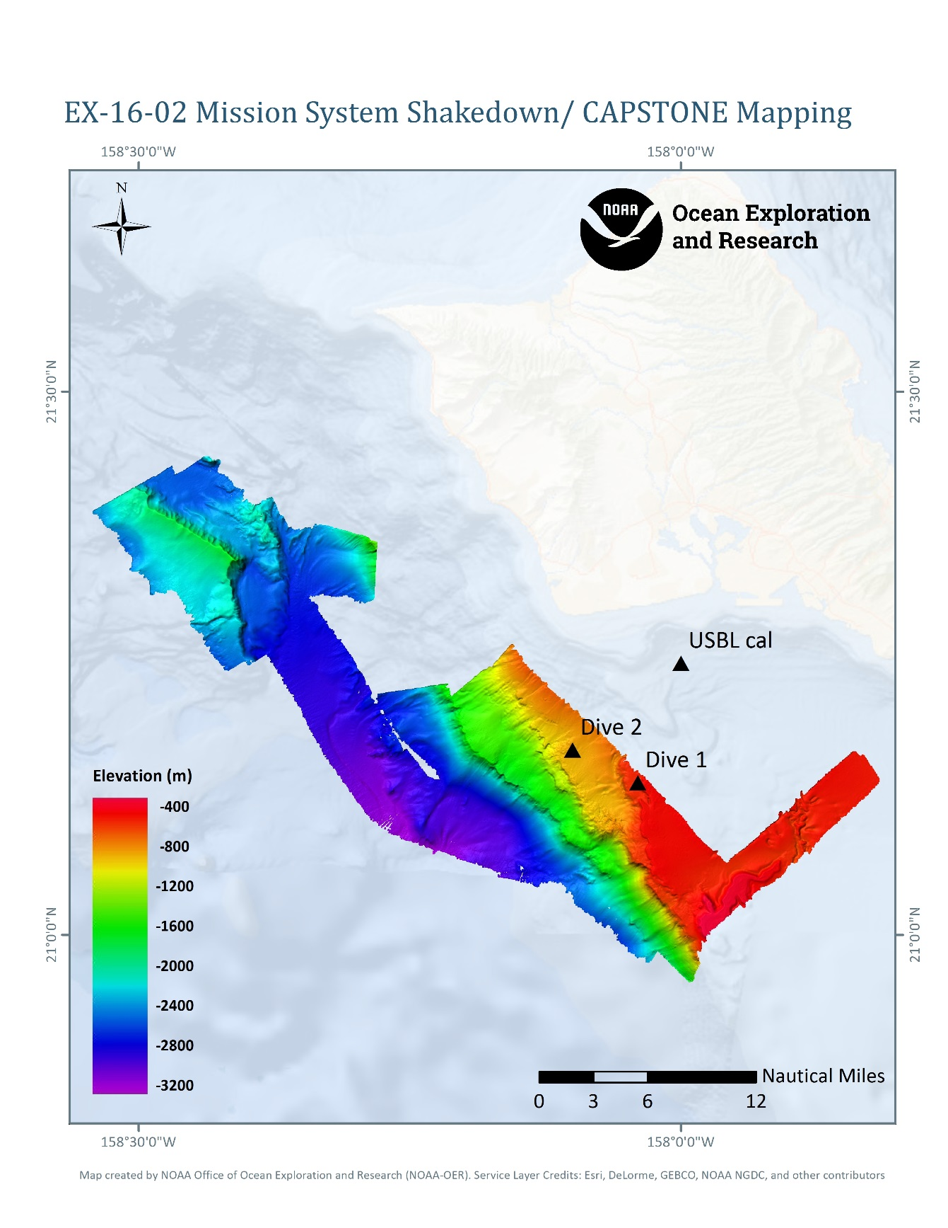

Figure 1: Summary map of EX-16-02 operations.

## Operations Overview

Operations on *Okeanos Explorer* are conducted 24 hours-a-day. During EX-16-02, ROV operations were conducted during the daylight hours, with mapping operations conducted during non-ROV hours. During EX-16-02, the vehicles conducted 2 of 4 planned dives at depths ranging from 450 to 1000 meters. The ROVs spent a collective 11.5 hours in the water and approximately 10 hours on the seafloor. No physical samples were collected on this expedition. Non- ROV operations included EM 302 multibeam, EK 60 singlebeam, Knudsen subbottom profile, and limited ADCP data collection. Mapping operations were conducted overnight and when the ROV was on-deck during the day. 400 linear kilometers and 1050 square kilometers were mapped with the EM302 multibeam. Five XBT casts were conducted.

Following the second ROV dive, there was a critical failure with the ship’s dynamic positioning system that prevented safe ROV operations. After a full day of troubleshooting the system on February 14th, the decision was made to return to port to await a technician to repair the system.

Mapping operations were initiated as soon as the ROV was recovered each day and continued throughout the night until ROV deployment the following day. Simrad EK60 split-beam, and Knudsen 3260 sub-bottom profiler sonar data were collected simultaneously during the first night of mapping operations. The Kongsberg EM302 multibeam was run simultaneously to the EK60 split-beam and Knudsen sub-bottom profiler sonars on the second and third days of the cruise. To ensure high quality multibeam data, sound speed profiles of the water column were obtained using expendable bathythermographs (XBTs) every few hours during mapping operations. Five XBT casts were completed during the expedition.

## Calendar of Events

|  |  |  |  |  |  |  |
| --- | --- | --- | --- | --- | --- | --- |
| **February** | | | | | | |
| Sunday | Monday | Tuesday | Wednesday | Thursday | Friday | Saturday |
| **7**  Mission personnel being arriving | **8**  Begin mobilization; Mission personnel arrive | **9**  Mobilization;  Mission personnel arrive | **10**  Mobilization | **11**  Mobilization; Ships tours | **12**  Departed at 1030; Dive01 conducted; overnight mapping with EK60 suite, Knudsen, and 300 kHz ADCP | **13**  Dive02 conducted; problems with DP experience during vehicle launch and recovery; overnight mapping with EK60 suite, Knudsen, and EM302 |
| **14**  Dive canceled; conducted at sea DP testing; afternoon and overnight mapping operations with EK60 suite, Knudsen, and EM302 | **15**  Pulled into port in the morning; ROV team conducted training and cruise wrap up; all sonars secured for alongside | **16**  Dockside emergency and regular recovery practice; EM302 troubleshooting, replaced dead CPU board battery | **17**  Dynamic Positioning Technician arrived and began troubleshooting the system. Mission personnel begin to depart |  |  |  |

## Expedition Daily Log

All times are listed in local ship time, which was - 10 hours from UTC.

**February 12, 2016** –

A number of repairs and preparations for the shakedown were made during the inport period. The ROV team and ship also spent time training new personnel**.**  The ship departed at 1030 and steamed for the first dive site. Dive 01 was an overall success with most systems passing shakedown tests. Systems with errors were troubleshot overnight and will be tested tomorrow. Overnight mapping was conducted with only EK60s and SBP due to an issue with the Multibeam. Priority mapping objective to remap the S-28 target site was not accomplished and will be attempted again tomorrow night.

**February 13, 2016** -

Dive 02 was conducted to allow the engineering team additional shakedown time and new personnel training. During launch and recovery the ship experienced significant issues with the DP system due to the unreliable response of the system communications between the bridge and the aft station. The vehicles were recovered safely and troubleshooting on the system began. Troubleshooting the EM302 continued, with the issue of unresponsive TRU seemingly resolved although one of the status lamps still red.

**February 14, 2016** –

ROV Dive 03 was canceled due to continued problems with the DP system. We spent the day troubleshooting the DP system and completing mapping objectives. Once the Chief ET had exhausted all possible solutions while still on the ship and confirmed with Kongsberg, the decision was made to return to port in the morning as the current status of the DP system poses a significant risk to the vehicles if used for launch and recovery.

**February 15, 2016** -

The ship pulled into port in the morning as the status of the DP system compromised the safety of ROV operations. Once inport, the ROV team conducted pilot training on the manipulator arm and cruise wrap up. Mapping operations were conducted overnight prior to returning to port.

**February 16, 2016** -

Dockside emergency and regular recovery practice with the entire deck crew and ROV team was carried out in the morning. We ran through the entire emergency recovery process and successfully recovered D2. Mapping Lead and CET spent the day troubleshooting the EM3012. The problems with the TRU were diagnosed to be a dying BIOS battery in the CPU board. After installing replacement boards and updating the configurations in SIS, we successfully connected the TRU and pinged at the dock.

## ROV Dive Table

|  |  |  |  |  |  |  |  |
| --- | --- | --- | --- | --- | --- | --- | --- |
| **Dive #** | **Site Name** | **Date** | **Region** | **Location \*\*** | **Approximate depth (m)** | **Approximate Length (HH:MM:SS)** | **Focus** |
| 01 | Engineering 1 | 2/12/2016 | South Oahu | 21.14 N, -158.04 W | 400 | 03:30:00 | System Shakedown Tests |
| 02 | Engineering 2 | 2/13/2016 | South Oahu | 21.17 N, 158.10 W | 1000 | 08:00:00 | System Shakedown Tests |

\*\* Note – Position, dive time, and depth information is approximate as there was a failure with the ROV data acquisition and recording system. Additional information about this malfunction can be found in the dive summary forms in Appendix B.

# Summary of Findings

**Dive 01**

Dive site was rippled sand with few surface falls (leaves, wood). Biological observations included a few fish (including Ophichthyidae), an asteroid, broken urchin test, and a worm. A strong current prevailed throughout the dive.

**Dive 02**

Dive 02 was conducted over what looked like weathered or eroded carbonate with soft sediment built up in between outcrops. Biological observations included solitary hydroids, siphonophores, octocorals, sponges, brisingid sea stars, a sea pen, crinoids on a chrysogorgid octocoral, fish in the water column, anemones, a shrimp, a rattail, and eels. Relative abundance was highest for the solitary hydroids or all organisms observed during this dive. Despite availability of hard substrate, and a good depth for deep sea corals and sponges, encrusting biota was observed only occasionally. This is potentially due to the low slope of the area surveyed.

# Summary of Mapping

Mapping operations were conducted in the region of the dive sites. The primary objective was collecting high resolution backscatter over an area where the S-28 wreck might have occurred and expanding EM302 coverage of the I23 site to the south, edge matching existing multibeam data collected on the R/V *Falkor*. There was an issue with the EM302, so only two days of multibeam data were collected. Mapping data was collected with the EK60 sonars and the subbottom profile throughout the cruise during mapping operations. Figure 2 shows the tracklines of each sonar.

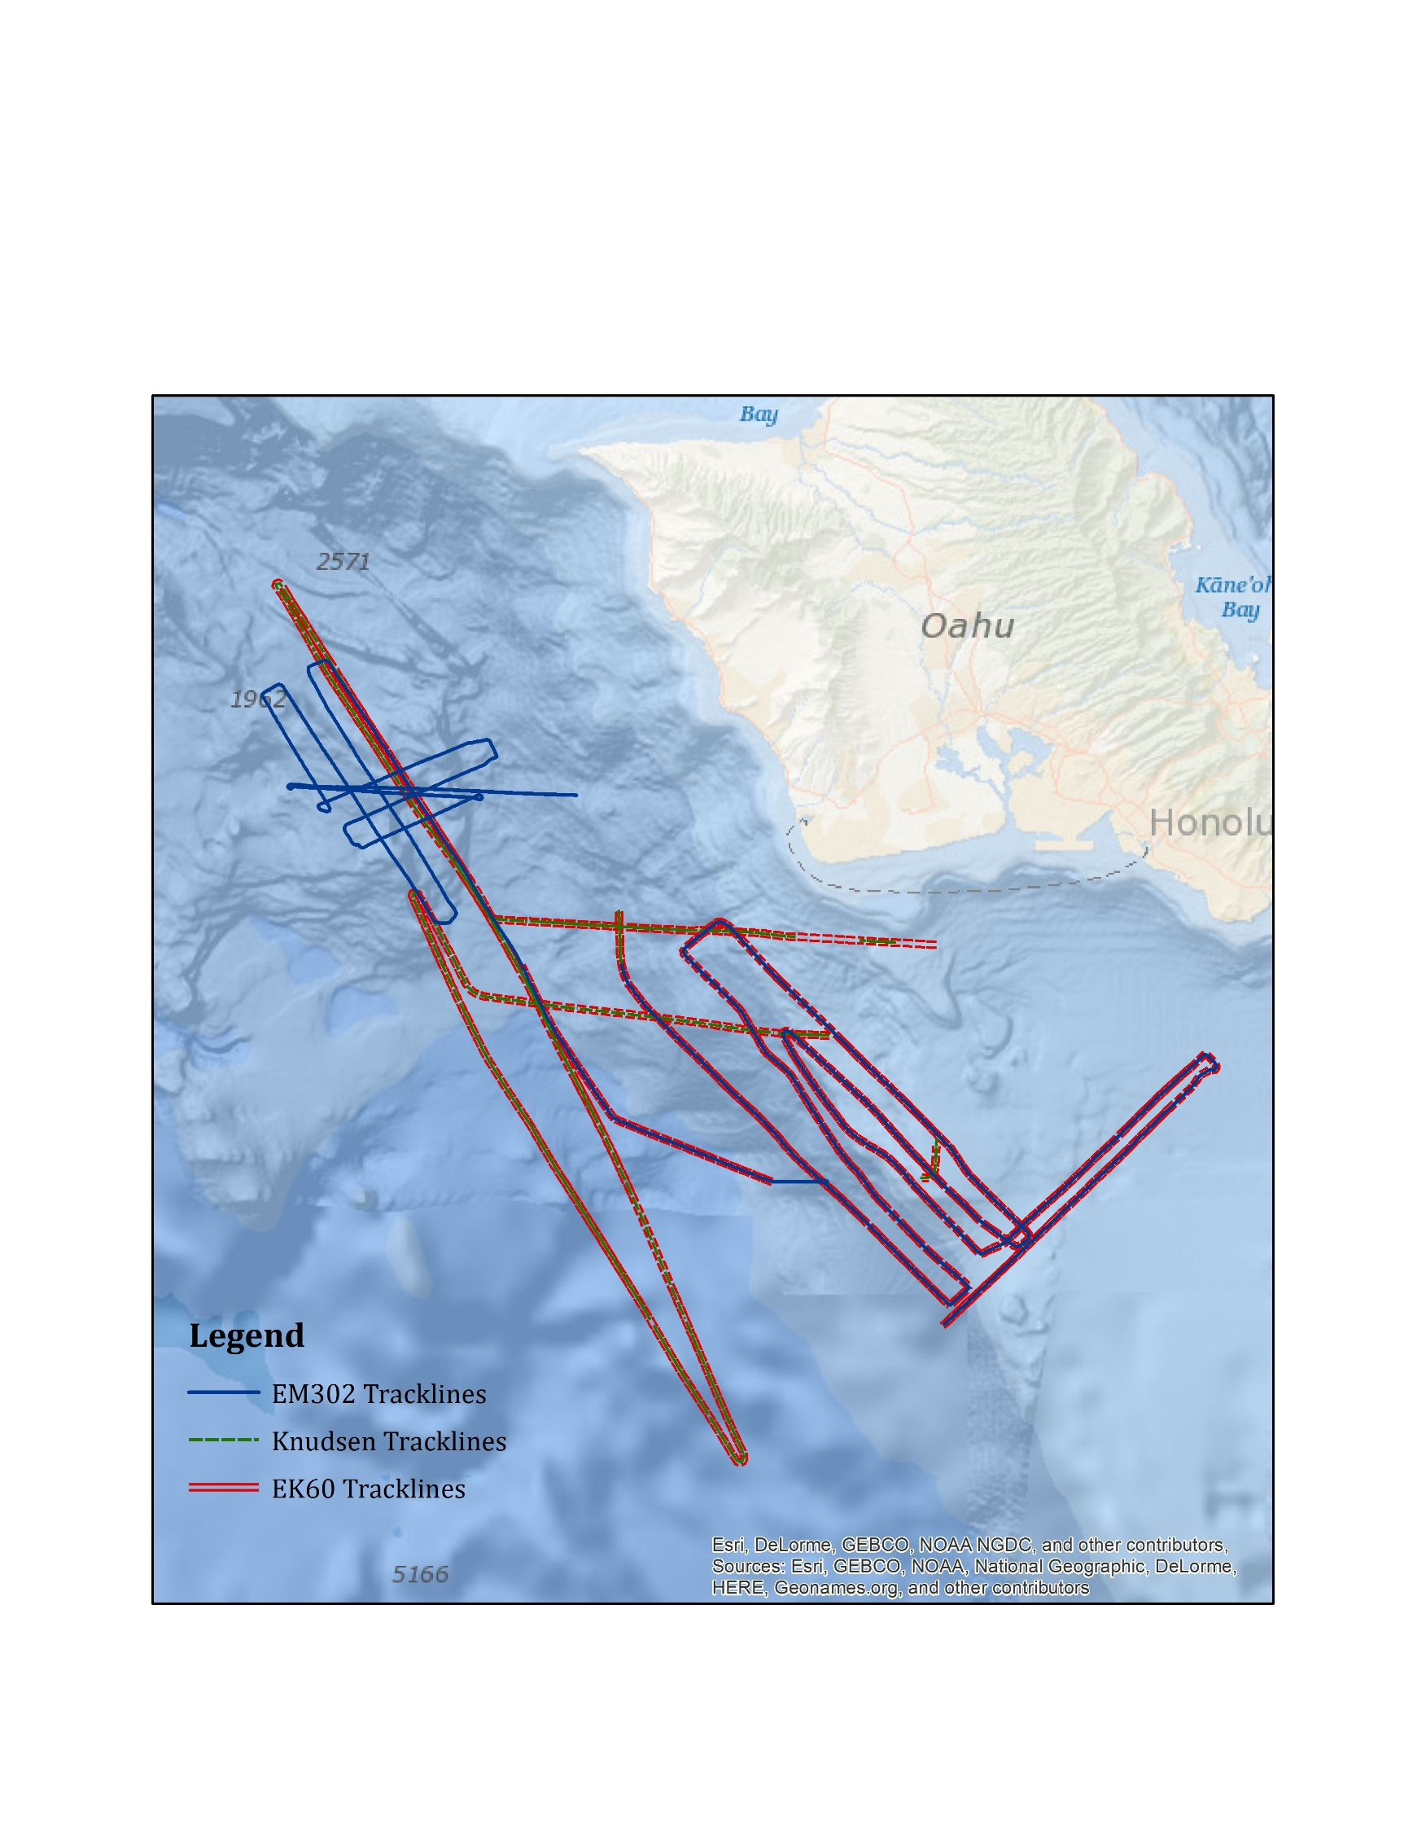

Figure 2. Tracklines from the EM302 multibeam, Knudsen subbottom profiler, and EK60 fisheries sonars.

## A. Sonar Data Quality Assessment

The first evening of the cruise, the EM302 Transreceive Unit (TRU) would not connect to the data acquisition software, Seafloor Information Systems (SIS), so no multibeam data collected. The TRU and SIS did connect on the second evening, but there was a warning light about the transmit boards illuminated. The data quality looked high, so the system was left running to collect data. The connection and warning light problems were later diagnosed as a dead bios battery in the central processing unit (CPU) board. The board was replaced with a spare and then ran as expected with the newly installed board.

Bathymetry and backscatter data quality from the EM302 were high. Data quality from the other sonars was also high during the cruise. Raw data and select data products are achieved with NCEI (Appendix C).

***Crosslines***

Crossline analysis was conducted using surface differencing in Caris. Two reference surfaces were computed, the first using multibeam line 0017, run in the E/W direction. The second using line 0006 oriented N/S, Figure 3. The two surfaces were differenced, and statistics were computed based on the differences. The attribute value bin sized used for the differencing was 1 m. The elevation ranges of the surfaces were -1,700 to -2,700 m.

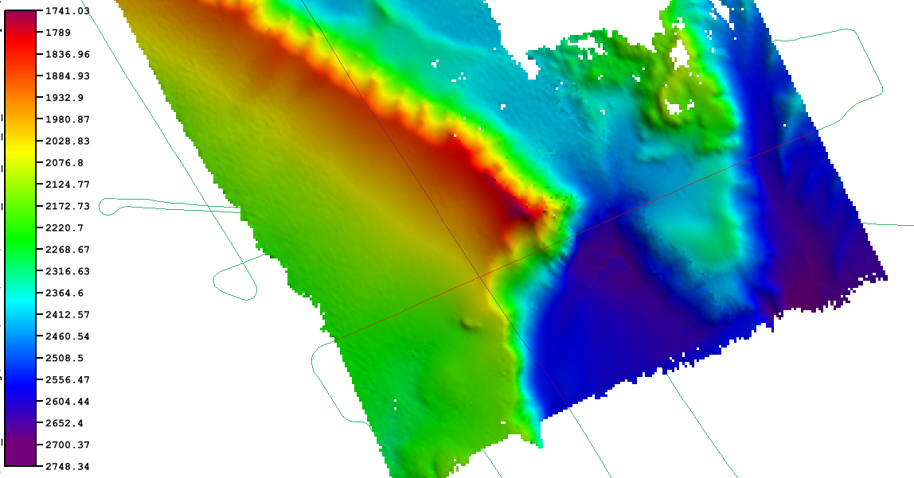

**Figure 3. Reference surface used in cross-line analysis. Lines used for analysis are shown in brown. Depths are in meters.**

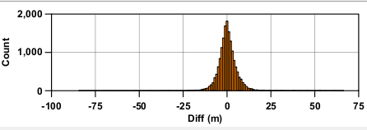

**Figure 4. Difference histogram. The water depth of the cross-line analysis ranged from 1700 m to 2700 m. Statistics of the differencing are shown below.**

**Crossline Statistics**

Minimum: -84.4 m

Maximum: 66.4 m

Mean: 0.2 m

Area: N/A

Standard Deviation: 5.4 m

Total count: 16,291

## B. Mapping Statistics

|  |  |
| --- | --- |
| Dates | Feb 12-15, 2016 |
| Line kilometers of survey with EM302 | 404 |
| Square kilometers mapped with EM302 | 1,050 |
| Number / Data Volume of EM 302 raw bathymetric / bottom backscatter files | 49 files/ 2.48 GB |
| Number / Data Volume of EM 302 water column multibeam files | 49 files / 9.05 GB |
| Number / Data Volume of EK 60 water column singlebeam files | 511 files / 3.10GB |
| Number / Data Volume of subbottom sonar files | 36 files / 637 MB |
| Number of XBT casts | 5 |
| Number of CTD casts (including test casts) | 0 |

# Data Deposition and Archival

The complete 2016 Field Season *Okeanos Explorer* Data Management Plan can be found in the Data Management Report, accessible through <http://service.ncddc.noaa.gov/rdn/oer-waf/media/docs/EX_FY16_DMP.pdf> . The EX-16-02 Data Management Plan can be found in Appendix A.

## OER Data Discoverability Tools

All data collected by *Okeanos Explorer* are archived and publically available within 90 days of the end of each cruise via the National Center for Environmental Intelligence (NCEI, formerly NGDC) online archives. Data can be accessed via the following websites:

OER Digital Atlas at <http://www.ncddc.noaa.gov/website/google_maps/OE/mapsOE.htm>

OER ROV Data Archives at <http://service.ncddc.noaa.gov/rdn/oer-rov-cruises>

Additional data requests are handled through the NOAA Ocean Exploration and Research Program Data Access Request Form which can be found here: <https://docs.google.com/a/noaa.gov/forms/d/1pU3jbcV5ffunMKUbYgnA2OK-ZT9qj2Dh6JgZ79TTORM/viewform?formkey=dHAycC1MYndJb0hTdGRaYXAzVTVBdWc6MA&fromEmail=true>

## B. Sonar Data

Sonar data collected onboard *Okeanos Explorer* undergoes QA/QC after a cruise and is then made publicly available through the OER Data Discoverability Tools, the National Archives, and the following websites:

* NGDC Interactive Bathymetry Data Viewer at <http://maps.ngdc.noaa.gov/viewers/bathymetry/>
* NGDC Interactive Multibeam Data Viewer at <http://maps.ngdc.noaa.gov/viewers/multibeam/>
* NGDC Interactive Water Column Data Viewer at <http://maps.ngdc.noaa.gov/viewers/water_column_sonar/>

## C. Physical Samples

No physical samples were collected on this cruise.

# Additional Information

Daily Situation Reports, internal operational records, are also on file with OER. For questions, please contact OER.

# Appendices

## APPENDIX A: Data Management Plan

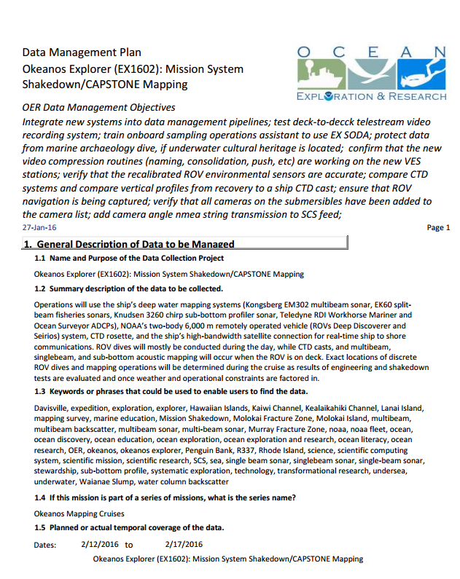

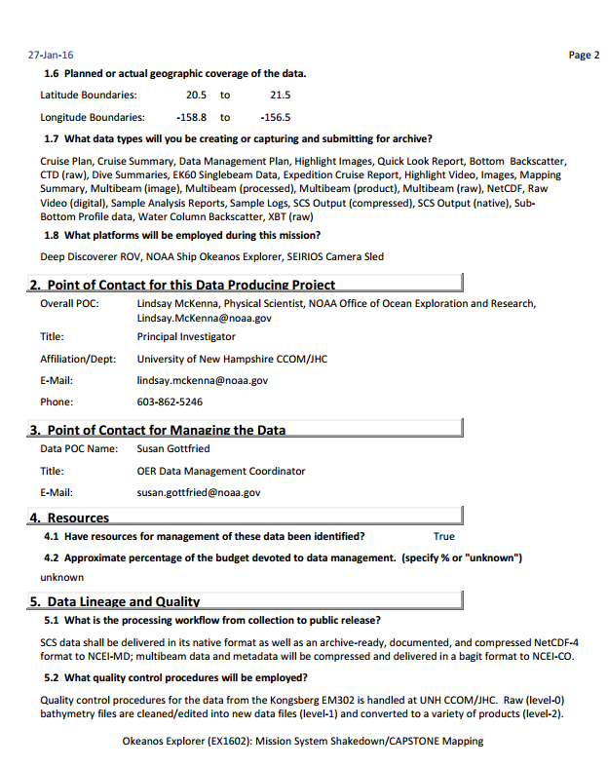

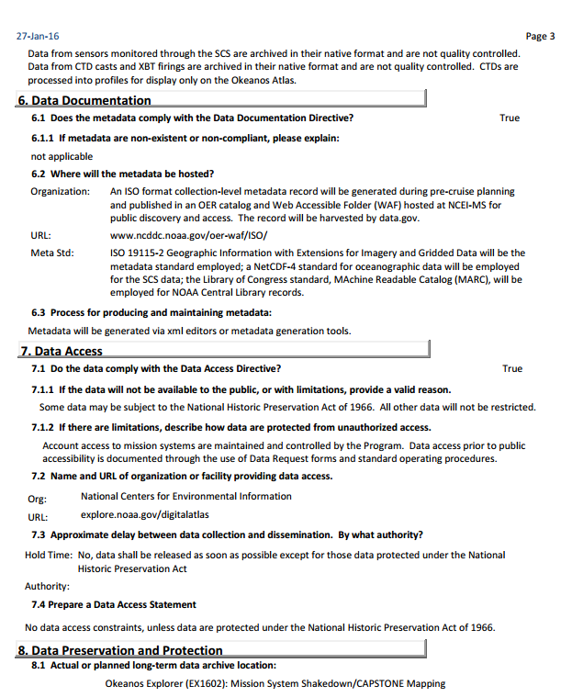

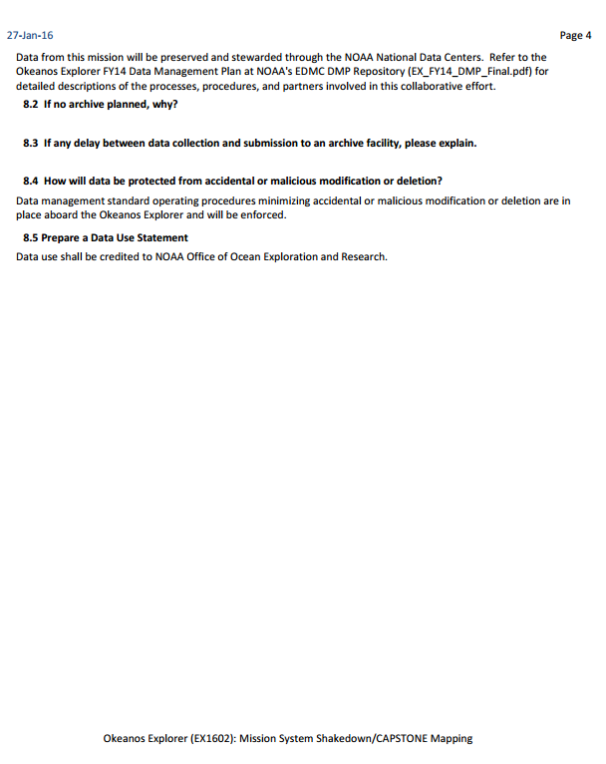

## APPENDIX B: ROV Dive Summary Forms

Okeanos Explorer ROV Dive Summary

|  |  |  |  |  |  |  |
| --- | --- | --- | --- | --- | --- | --- |
| **Site Name** | Engineering 1 | | | |  | |
| **ROV Lead/Expedition Coordinators** | Karl McLetchie/  Kasey Cantwell & Lindsay McKenna | | | |
| **Science Team Leads** | Chris Kelley (pre-cruise and onshore) | | | |
| **General Area Descriptor** | Main Hawaiian Islands | | | |
| **ROV Dive Name** | Cruise | | Leg | | | Dive Number |
| EX-16-02 | | N/A | | | DIVE01 |
| **Equipment Deployed** | ROV: | | Deep Discoverer | | | |
| Camera Platform: | | Seirios | | | |
| **ROV Measurements** | CTD\* | | Depth\* | | | Altitude |
| Scanning Sonar | | USBL Position\* | | | Heading |
| Pitch | | Roll | | | HD Camera 1 |
| HD Camera 2 | | Low Res Cam 1 | | | Low Res Cam 2 |
| Low Res Cam 3 | | Low Res Cam 4 | | | Low Res Cam 2 |
|  | \* This equipment was functioning, but was not recording information as the computer that stores and automates dive products was not functional. See “Equipment Malfunctions” section for more information. | | | | | |
| **Equipment Malfunctions** | Prior to the start of EX-16-02, there was a catastrophic failure of the computer system that records ROV position information, dive track data, dive depth and duration, and ROV CTD data. This computer underwent troubleshooting throughout the cruise to return functionality, but these efforts were unsuccessful. The computer was replaced, however all of the automated scripts and data pathways needed to be rewritten, so no position information or ROV CTD data was recorded during the two ROV dives of this cruise. | | | | | |
| **ROV Dive Summary**  **(From processed ROV data)** | Date: 2/12/2016  Approximate ROV dive location: 21.14 N, 158.04 W\*\*  Approximate dive duration: 3.5 hours  Approximate max depth: 400 m  \*\* *Please note: No ROV position information collected. See information about equipment malfunction under “Equipment Malfunctions” section.* | | | | | |
| **Special Notes** |  | | | | | |
| **Scientists Involved**  ***(please provide name / location / affiliation / email)*** | Chris Kelley, EX, UH, [ckelley@hawaii.edu](mailto:ckelley@hawaii.edu) | | | | | |
| **Purpose of the Dive**  The main objective of this dive was to 1) familiarize new pilots and deck personnel with launch and recovery operations; 2) to train new ROV personnel on dive operations including navigation responsibilities, flying the ROVs, and the use of the manipulator arms; and 3) to check all equipment for functionality and readiness for the rest of the field season. | | | | | | |
| **Description of the Dive:** | | | | | | |
| Dive site was rippled sand with few surface falls (leaves, wood). Biological observations included a few fish (including Ophichthyidae), an asteroid, broken urchin test, and a worm. A strong current prevailed throughout the dive. | | | | | | |
| **Overall Map of ROV Dive Area** | | | | | | |
| **C:\Users\kasey.cantwell\Downloads\EX1602_SummaryMap.jpg** | | | | | | |
| **Representative Photos of the Dive** | | | | | | |
| **C:\Users\kasey.cantwell\Documents\FY16\Expeditions\EX\EX1602\Imagery\EX1602_DIVE01_20160212\EX1602_IMG_20160213T013216Z_ROVHD_ARM_TEST.jpg** | | | | C:\Users\kasey.cantwell\Documents\FY16\Expeditions\EX\EX1602\Imagery\EX1602_DIVE01_20160212\EX1602_IMG_20160213T014516Z_ROVHD_SEA_STAR_WORM.jpg | | |
| ROV pilots practice using the manipulator arm over a rippled, sedimented bottom. | | | | A sea star observed towards the end of the dive. | | |
| **Samples Collected** | | | | | | |
| No samples were collected during this dive. | | | | | | |
| **Please direct inquiries to:** | | NOAA Office of Ocean Exploration & Research 1315 East-West Highway (SSMC3 10th Floor)  Silver Spring, MD 20910  (301) 734-1014 | | | | |

Okeanos Explorer ROV Dive Summary

|  |  |  |  |  |  |  |
| --- | --- | --- | --- | --- | --- | --- |
| **Site Name** | Engineering 2 | | | |  | |
| **ROV Lead/Expedition Coordinators** | Karl McLetchie/  Kasey Cantwell & Lindsay McKenna | | | |  | |
| **Science Team Leads** | Chris Kelley (pre-cruise and onshore) | | | |  | |
| **General Area Descriptor** | Main Hawaiian Islands | | | |  | |
| **ROV Dive Name** | Cruise | | Leg | | | Dive Number |
|  | EX-16-02 | | N/A | | | DIVE02 |
| **Equipment Deployed** | ROV: | | Deep Discoverer | | | |
|  | Camera Platform: | | Seirios | | | |
| **ROV Measurements** | CTD\* | | Depth\* | | | Altitude |
|  | Scanning Sonar | | USBL Position\* | | | Heading |
|  | Pitch | | Roll | | | HD Camera 1 |
|  | HD Camera 2 | | Low Res Cam 1 | | | Low Res Cam 2 |
|  | Low Res Cam 3 | | Low Res Cam 4 | | | Low Res Cam 2 |
|  | \* This equipment was functioning, but was not recording information as the computer that stores and automates dive products was not functional. See “Equipment Malfunctions” section for more information. | | | | | |
| **Equipment Malfunctions** | Prior to the start of EX-16-02, there was a catastrophic failure of the computer system that records ROV position information, dive track data, dive depth and duration, and ROV CTD data. This computer underwent troubleshooting throughout the cruise to return functionality, but these efforts were unsuccessful. The computer was replaced, however all of the automated scripts and data pathways needed to be rewritten, so no position information or ROV CTD data was recorded during the two ROV dives of this cruise. | | | | | |
| **ROV Dive Summary**  **(From processed ROV data)** | Date: 2/13/2016  Approximate ROV dive location: 21.14 N, 158.04 W\*\*  Approximate dive duration: 3.5 hours  Approximate max depth: 400 m  \*\* *Please note: No ROV position information collected. See information about equipment malfunction under “Equipment Malfunctions” section.* | | | | | |
| **Special Notes** |  | | | | | |
| **Scientists Involved**  ***(please provide name / location / affiliation / email)*** |  | | | | | |
| **Purpose of the Dive**  The main objective of this dive was to 1) familiarize new pilots and deck personnel with launch and recovery operations; 2) to train new ROV personnel on dive operations including navigation responsibilities, positioning the vehicles during ascent and descent, flying the ROVs, and the use of the manipulator arms; and 3) to check all equipment for functionality and readiness for the rest of the field season. | | | | | | |
| **Description of the Dive:** | | | | | | |
| Dive 02 was conducted over what looked like weathered or eroded carbonate with soft sediment built up in between outcrops. Biological observations included solitary hydroids, siphonophores, octocorals, sponges, brisingid sea stars, a sea pen, crinoids on a chrysogorgid octocoral, fish in the water column, anemones, a shrimp, and an eel. Relative abundance was highest for the solitary hydroids of all organisms observed during this dive. Despite availability of hard substrate, and a good depth for deep sea corals and sponges, encrusting biota was only occasional. This is potentially due to the low slope of the area surveyed. | | | | | | |
| **Overall Map of ROV Dive Area** | | | | | | |
| **C:\Users\kasey.cantwell\Downloads\EX1602_SummaryMap.jpg** | | | | | | |
| **Representative Photos of the Dive** | | | | | | |
| **C:\Users\kasey.cantwell\Documents\FY16\Expeditions\EX\EX1602\Imagery\EX1602_DIVE02_20160213\EX1602_IMG_20160214T010417Z_ROVHD_HYD_FSH_NUD.jpg** | | | | C:\Users\kasey.cantwell\Documents\FY16\Expeditions\EX\EX1602\Imagery\EX1602_DIVE02_20160213\EX1602_IMG_20160214T011028Z_ROVHD_COR.jpg | | |
| Solitary hydroids were the most common organism observed. | | | | Two crinoids are perched on a *Chrysogorgia* sp. surrounded by apparent weathered carbonate. | | |
| **Samples Collected** | | | | | | |
| No samples were collected during this dive. | | | | | | |
| **Please direct inquiries to:** | | NOAA Office of Ocean Exploration & Research 1315 East-West Highway (SSMC3 10th Floor)  Silver Spring, MD 20910  (301) 734-1014 | | | | |

## APPENDIX C: Mapping Files/Tables

Data files can be downloaded or obtained from the following links:

Single beam and subbottom data at --*http://www.ngdc.noaa.gov/trackline/request/?surveyIds=EX1602*

Multibeam data and associated products and ancillary files at –

*http://www.ngdc.noaa.gov/nndc/struts/results?op\_0=eq&t=101378&s=8&d=70&d=75&d=76&d=91&d=74&d=73&d=72&d=81&d=82&d=85&d=86&d=79&no\_data=suppress&v\_0=NEW2465*