Okeanos Explorer ROV Dive Summary
Site Name |  | Karin Ridge Top |  |  |  | 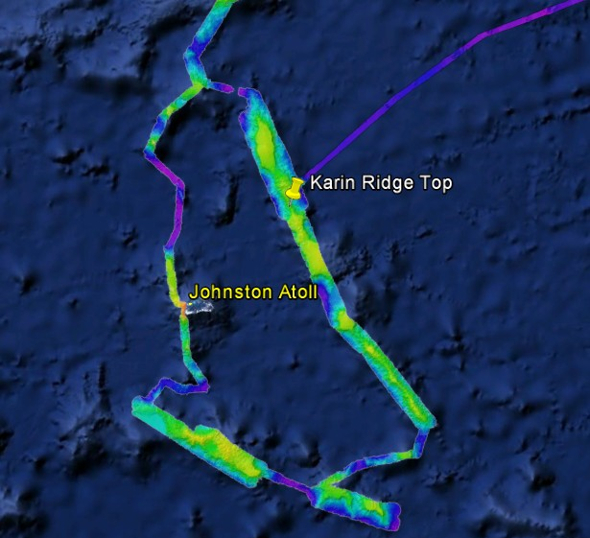
ROV Lead/Expedition Coordinator |  | Karl Mcletchie/ Brian RC Kennedy
Science Team Leads |  | Scott France and Mackenzie Gerringer
General Area Descriptor |  | Johnston Atoll Pacific Remote Islands Marine National Monument
ROV Dive Name |  | Cruise Season |  | Leg |  |  | Dive Number
 |  | EX1504 |  | 4 |  |  | DIVE11
Equipment Deployed |  | ROV: |  | Deep Discoverer
 |  | Camera Platform: |  | Seirios
ROV Measurements |  | D2 CTD |  | Depth |  |  | Altitude
 |  | Scanning Sonar |  | USBL Position |  |  | Heading
 |  | Pitch |  | Roll |  |  | HD Camera 1
 |  | HD Camera 2 |  | ROV HD 2 |  |  | Seirios CTD
 |  | Temperature Probe |  | D2 DO Sensor |  |  | Seirios DO sensor
Equipment Malfunctions |  | VSAT continues to underperform
ROV Dive Summary  (From processed ROV data) |  | Dive Summary: EX1504L4_DIVE11  ^^^^^^^^^^^^^^^^^^^^^^^^^^^^^^^^^^^^^^^^^^^^^^^^^^^  In Water: 2015-09-24T18:11:30.906000  17°, 29.956' N ; 168°, 44.685' W  Out Water: 2015-09-25T02:29:22.890000  17°, 30.357' N ; 168°, 44.238' W  Off Bottom: 2015-09-25T01:21:52.468000  17°, 30.296' N ; 168°, 44.666' W  On Bottom: 2015-09-24T19:29:46.703000  17°, 29.933' N ; 168°, 44.448' W  Dive duration: 8:17:51  Bottom Time: 5:52:5  Max. depth: 2173.0 m
Special Notes
Scientists Involved  (please provide name / location / affiliation / email) |  | Name Institution Email Address  Abby Lapointe University of Hawaii Zoology abbylap@hawaii.edu  Amy Baco-Taylor FSU abacotaylor@fsu.edu  Andrea Quattrini USGS aquattrini@usgs.gov  Asako Matsumoto University of Tokyo amatsu@gorgonian.jp  Bruce Mundy NOAA NMFS Pacific Islands Fisheries Science Center bruce.mundy@noaa.gov  Chris Kelley University of Hawaii ckelley@hawaii.edu  Chris Mah Smithsonian brisinga@gmail.com  Dennis Hanisak FAU/HBOI dhanisak@fau.edu  Jeff Drazen University of Hawaii jdrazen@hawaii.edu  John Smith University of Hawaii jrsmith@hawaii.edu  Mackenzie Garringer University of Hawaii mgerring@hawaii.edu  Scott France University of Louisiana at Lafayette france@louisiana.edu  Steve Haddock MBARI haddock@mbari.org  Steve Auscavitch Temple steven.auscavitch@temple.edu  Tina Molodtsova P.P.Shirshov Institute of Oceanology tina.molodtsova@gmail.com tina@ocean.ru  Rachael Bassett NOAA rachel.bassett@noaa.gov  John Reed FAU Harbor Branch Oceanographic jreed12@fau.edu  Jim Masterson FAU Harbor Branch Oceanographic jmaster7@fau.edu  Kimberly Galvez University of Miami - RSMAS CSL-Center for Carbonate Research kgalvez@rsmas.miami.edu  Bill Clancey IHMC wclancey@ihmc.us  Josh Voss HBOI Jvoss2@fau.edu
Purpose of the Dive
To explore the bathyal community of a hard bottom on crest of a ridge extending south from the same seamount feature as did the ridge explored on dive 3 in the Pacific Remote Islands Marine National Monument
Description of the Dive:
Upon arrival on bottom, there was considerable rubble over the visible seafloor. Along the dive transect the bottom alternated from fields of small rubble in the saddle features, to several large pillow lava flows with towering boulders. There was also a stretch of sediment that had a light thin layer of manganese crusting. When this was disturbed by the ROV skis, it was apparent that there was a fine-grain sediment below. This appeared to stretch over a considerable area. It appeared that more manganese encrustation was present at the latter portion of the dive. Two rocks were collected, from 2168 m and 2106 m.
As with previous dive sites, the community was extremely patchy. Sponge diversity changed dramatically as we followed along the ridge. As seen on the 3000+ m depth dive about 8 nautical miles northeast of this dive site, we saw an abundance of hexactinellid sponges. These were the most abundant metazoa seen throughout the dive by far. There were many large sponges, likely Poliopogon and Semperella where we started the dive. Interspersed along the transect were a fair number of stalked sponges – Caulophacus and Bolosoma. An impressive field of ?Monorhaphis sponges was imaged, with hundreds of individuals at around 2077 m depth. A bit further up the ridge, the flabellate branched-sponges collected on Dive 9 were in highest abundance. An unknown hexactinellid sponge was sampled from 2084 m. The high abundance of sponges may also explain the presence of a known sponge predator, the asteroid seastar Pteraster reticulatus.
At about 2130 m, there was another community transition, with more corals present. At the peak of the local summit on the ridge, coral densities were low. But just below the summit on the southwest slope were many coral colonies. This may suggest long-term current flows moving up the SW slope of the feature. Octocorals observed here included Isididae (?Eknomisis, Keratoisis, Isidella trichotoma, and a Lepidisis-like [unbranched] colony), Primnoidae (?Calytrophora angularis, Narella macrocalyx,?Candidella gigantea), and Chrysogorgiidae (Chrysogorgia chryseis, Chrysogorgia averta, Iridigorgia magnispiralis). Two bamboo corals were sampled, a Lepidisis-like colony from 2064 m, and an Eknomisis-like colony from 2062 m. Although the first collection fell out of the manipulator arm claw onto the deck and could not be recovered on the bottom, it was collected by the ROV team during ascent of the vehicle.
A notably high abundance of anemones was seen on this dive (Actinostolidae, Exocoelactis). As seen on previous dives, hydroid colonies were in relatively high abundance on many of the larger rocks. Several galatheid crabs were imaged, as were many acorn barnacles, and chirostylid squat lobsters (Uroptychus) associated with Chrysogorgia coral colonies. A few fish were seen, including one cutthroat eel (Synaphobranchidae), two Coryphaenoides longicirrhus, and two Kumba hebetate. Two of the macrourids had, as seen before, very large isopod parasites.
Other Metazoa observed
Echinoderms: Crinoids, Lophaster, Pteraster reticulatus
Cnidarians: “Dandelion” siphonophore (?Thermopalia), cup coral (Scleractinia)
Crustaceans: Nematocarcinus shrimp, amphipods, shrimp (Plesiopenaeus armatus)
Sponges: Poecilastra, Tretopleura, Farrea nr. Occa errecta, small cladorhizid, unknown Pheronematidae
Other: polychaete fan worm, arboreal foraminifera, snail

Overall Map of ROV Dive Area |  |  |  |  | Close-up Map of Main Dive Site
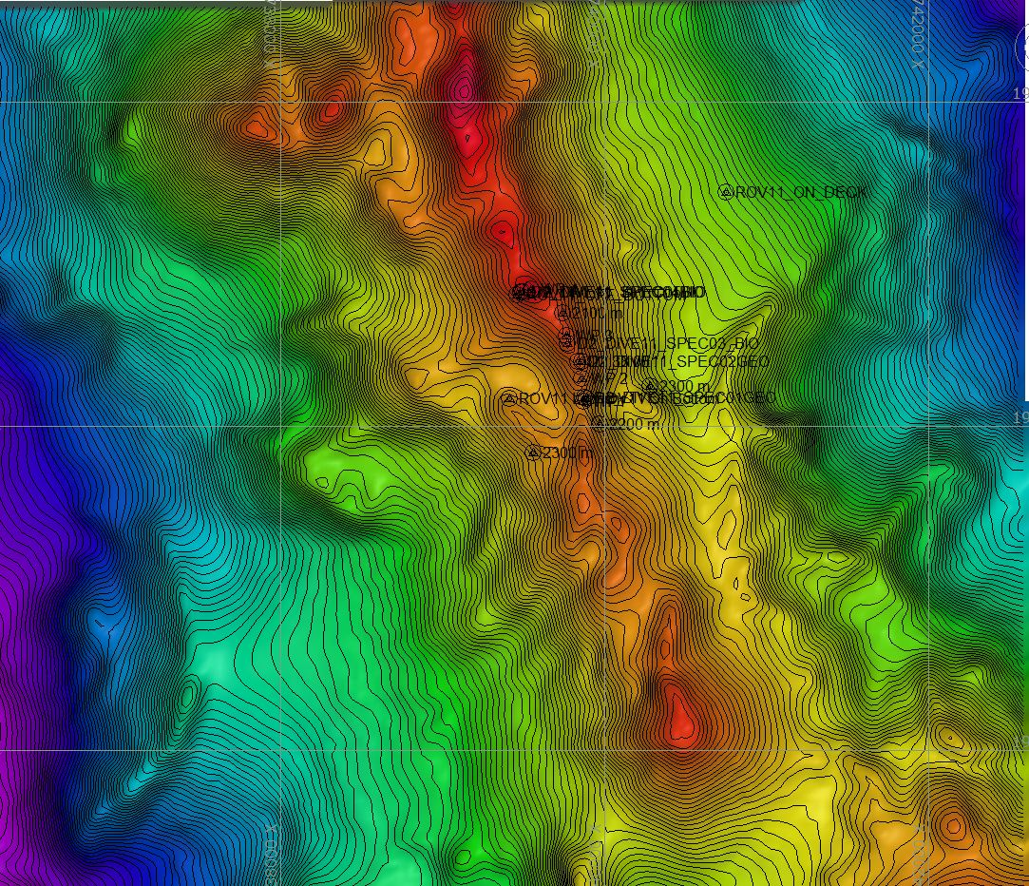 |  |  |  |  | 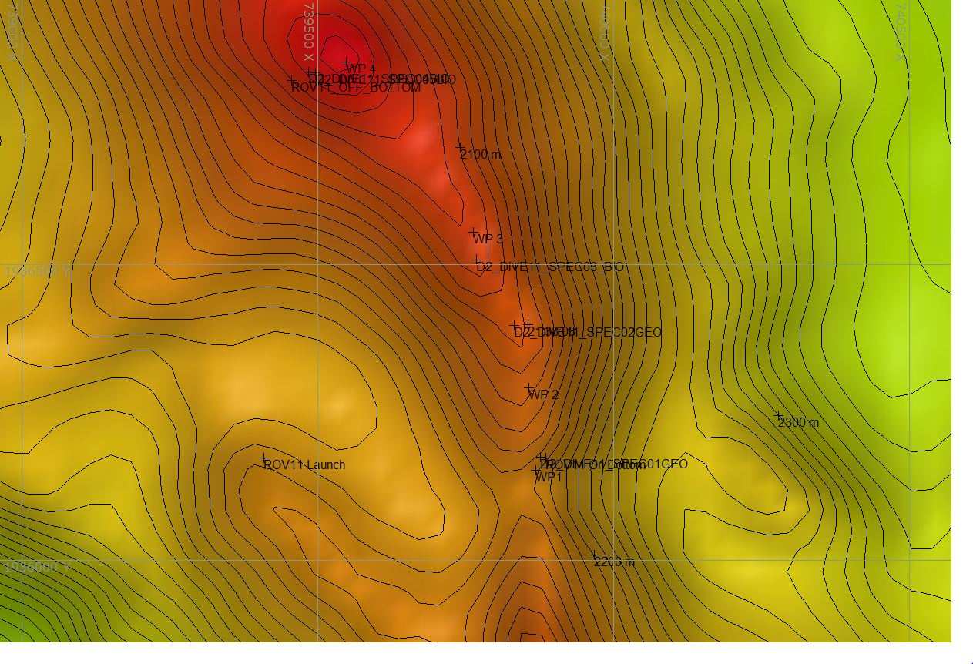
Representative Photos of the Dive
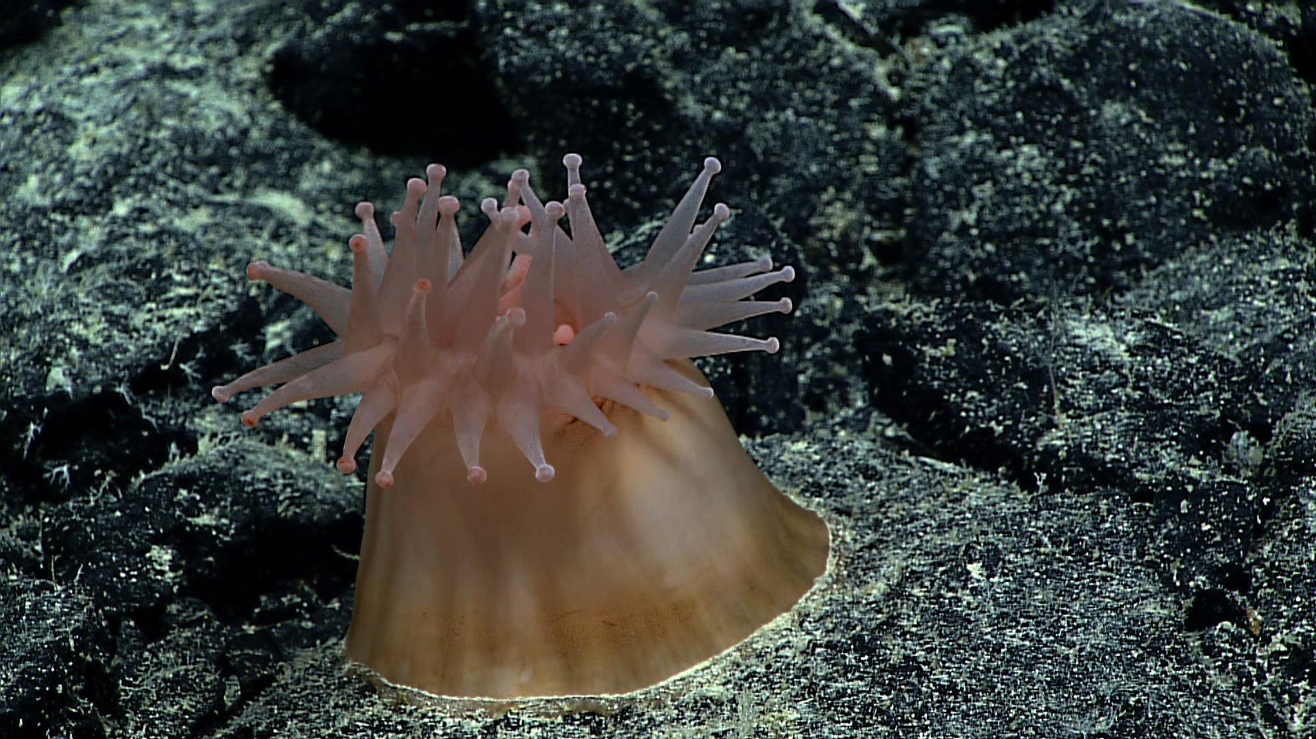 |  |  |  | 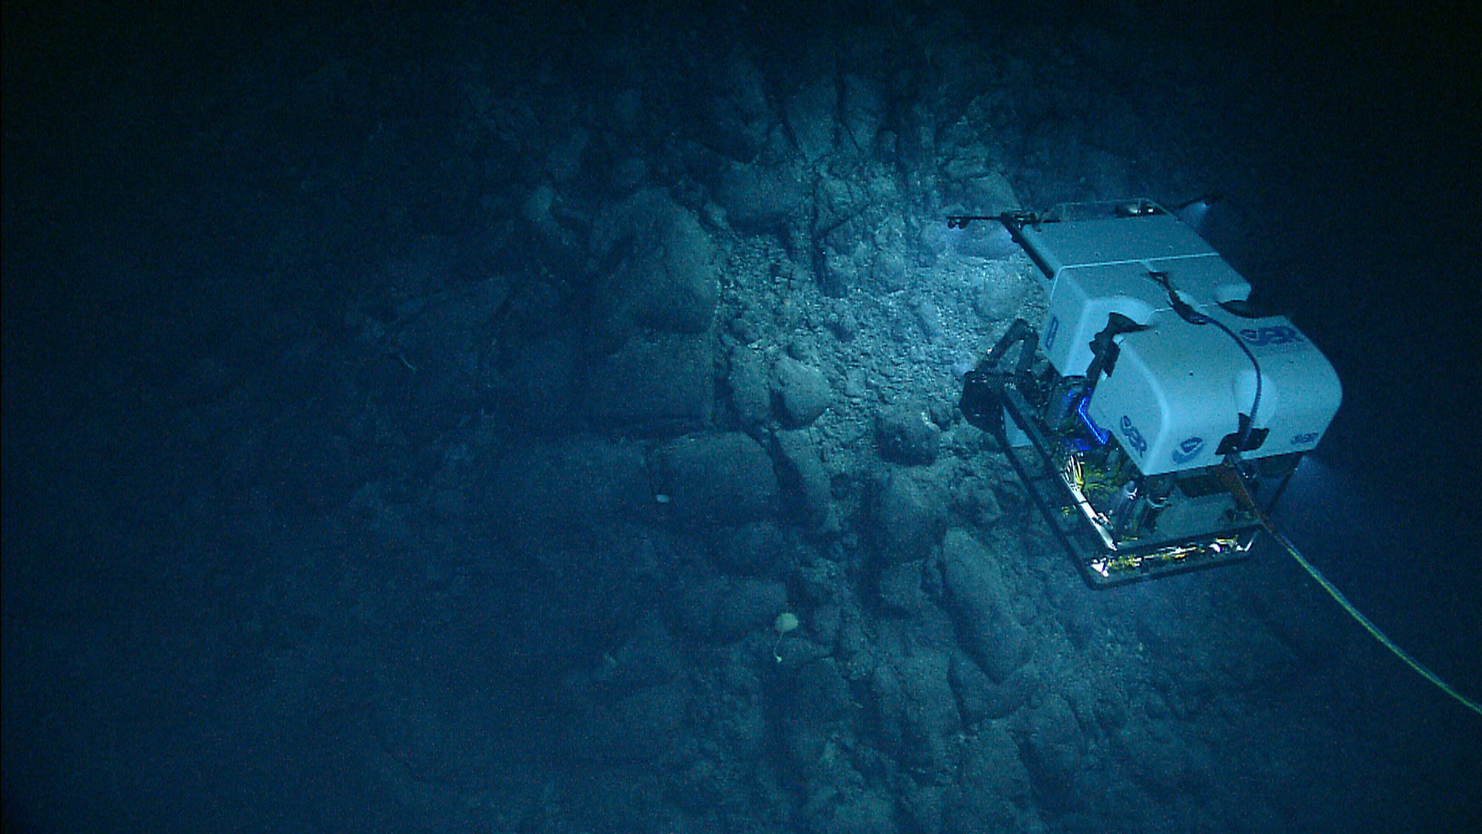
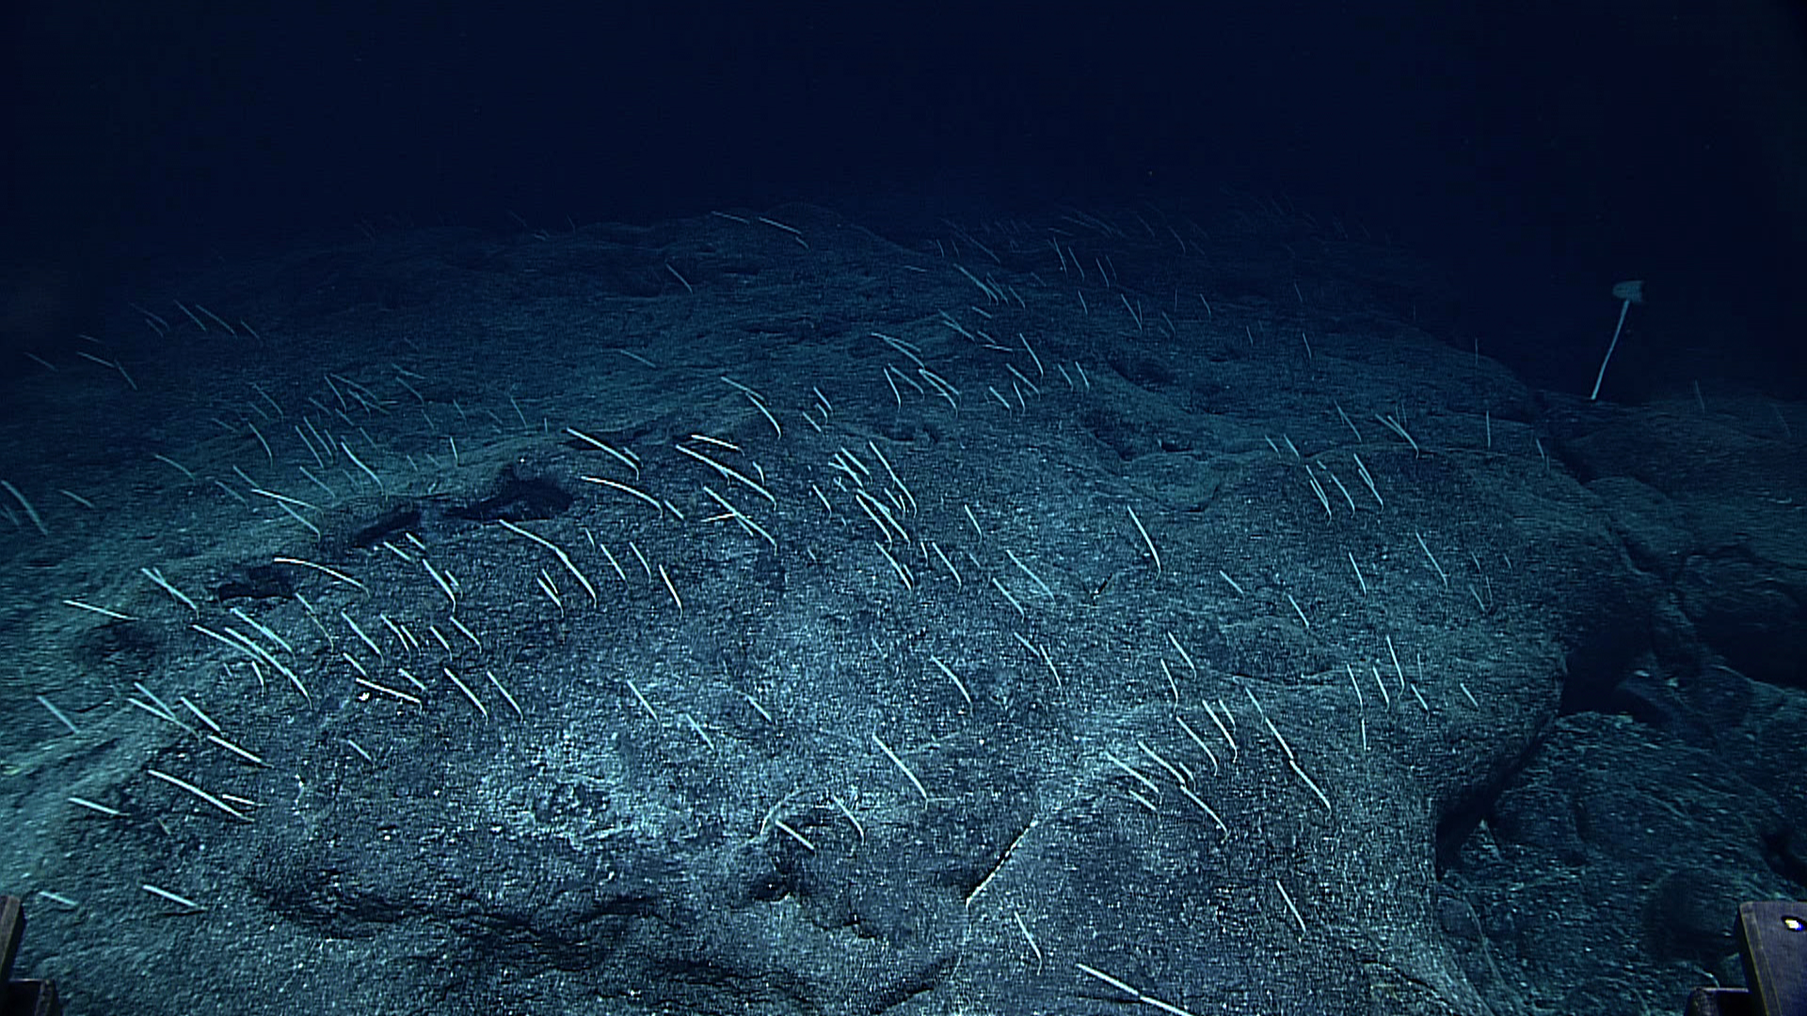 |  |  |  | 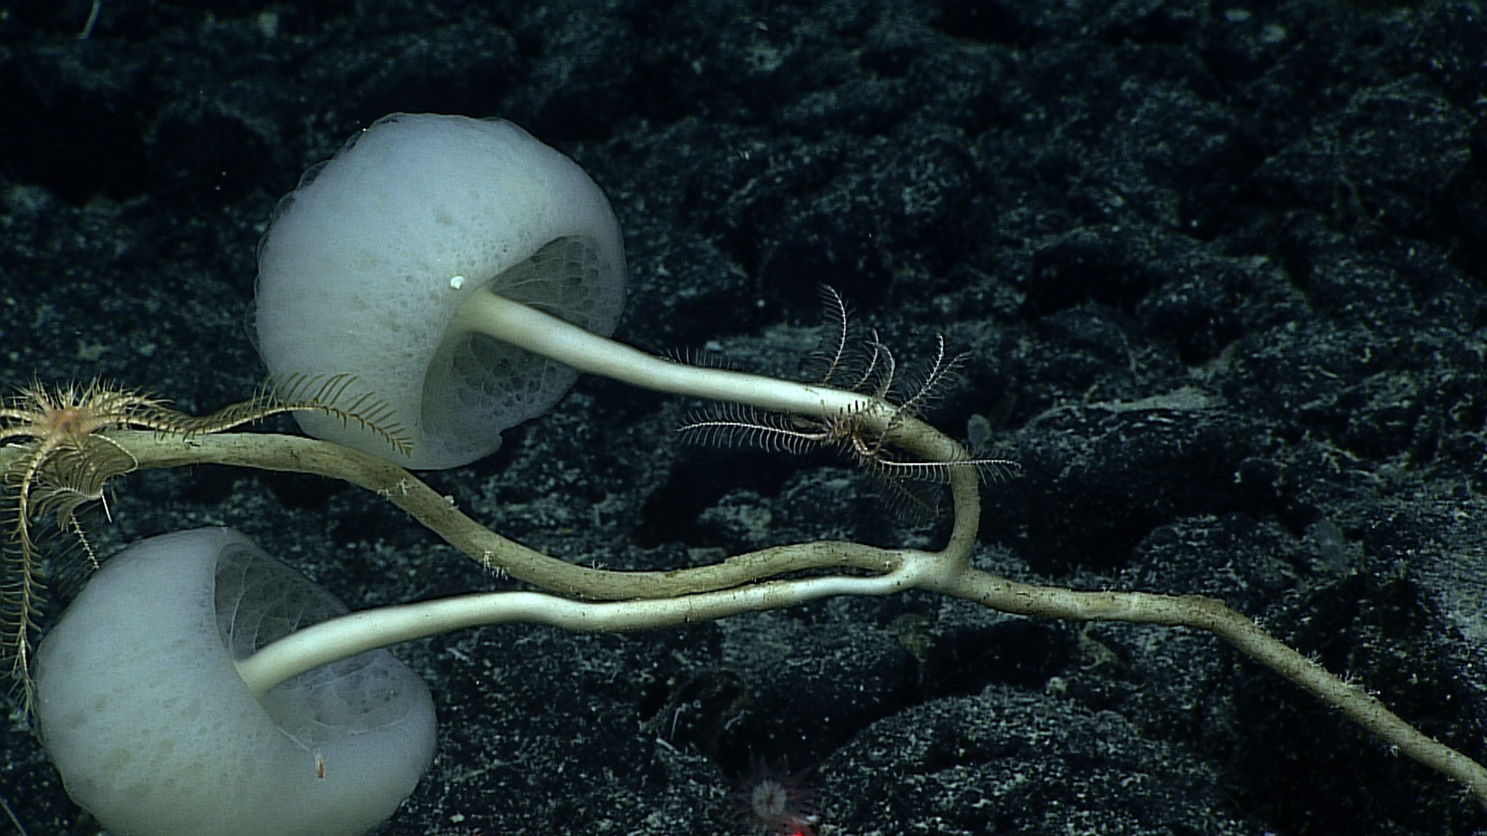
Samples Collected
Sample ID | EX1504L4_20150924T194238_D2_DIVE11_SPEC01GEO |  |  |  | 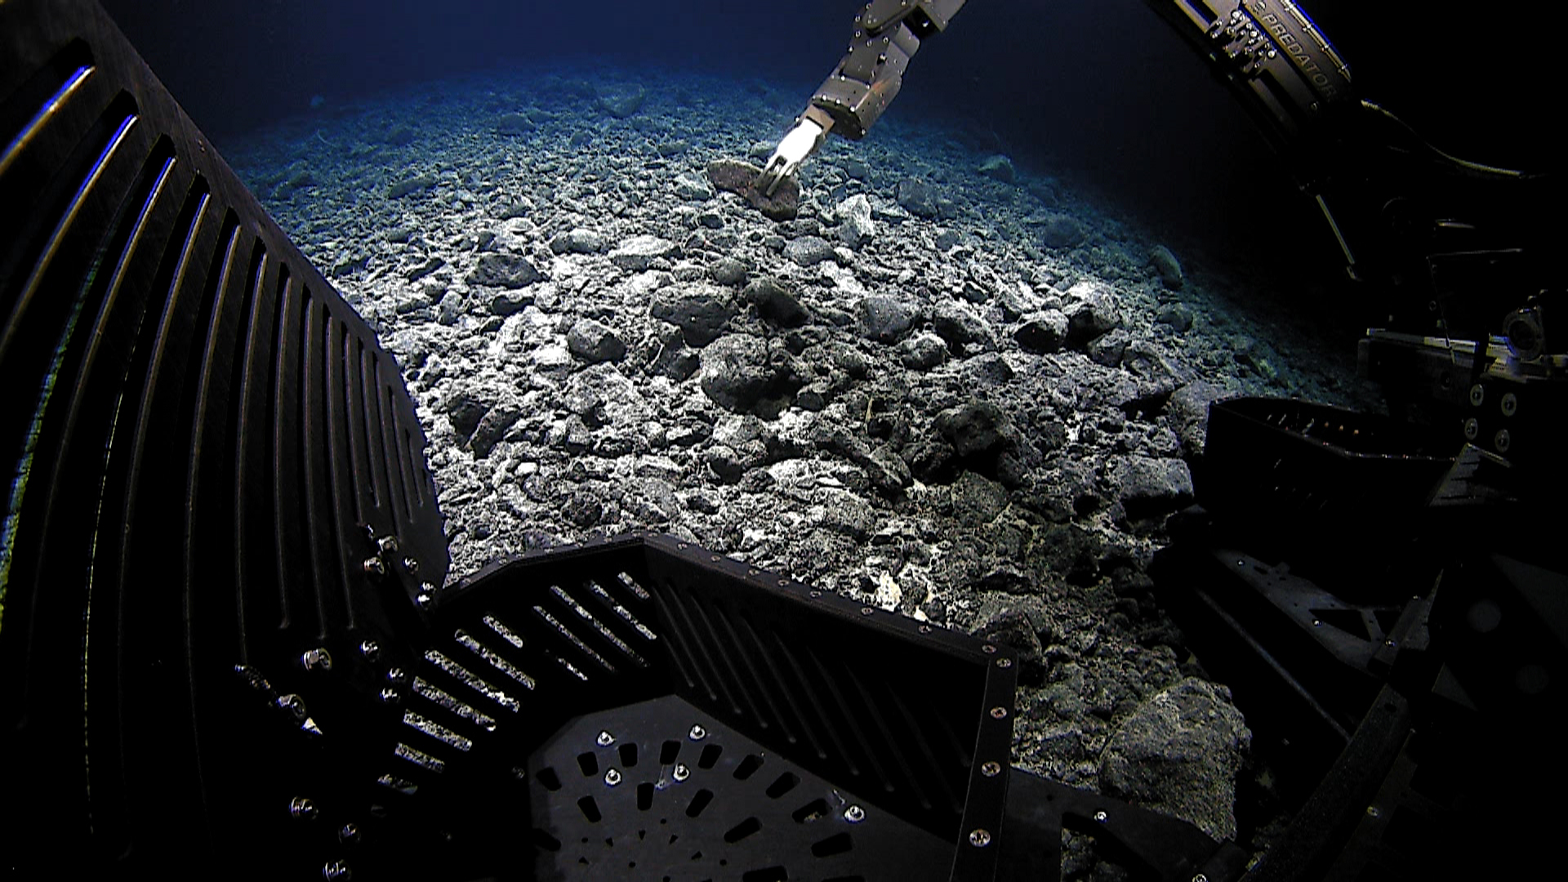
Date (UTC) | 20150924
Time (UTC) | 194238
Depth (m) | 2168.45
Temperature (ºC) | 1.88
Field ID(s) | Mn-encrusted basalt
Comments
Sample ID | EX1504L4_20150924T214653_D2_DIVE11_SPEC02GEO |  |  |  | 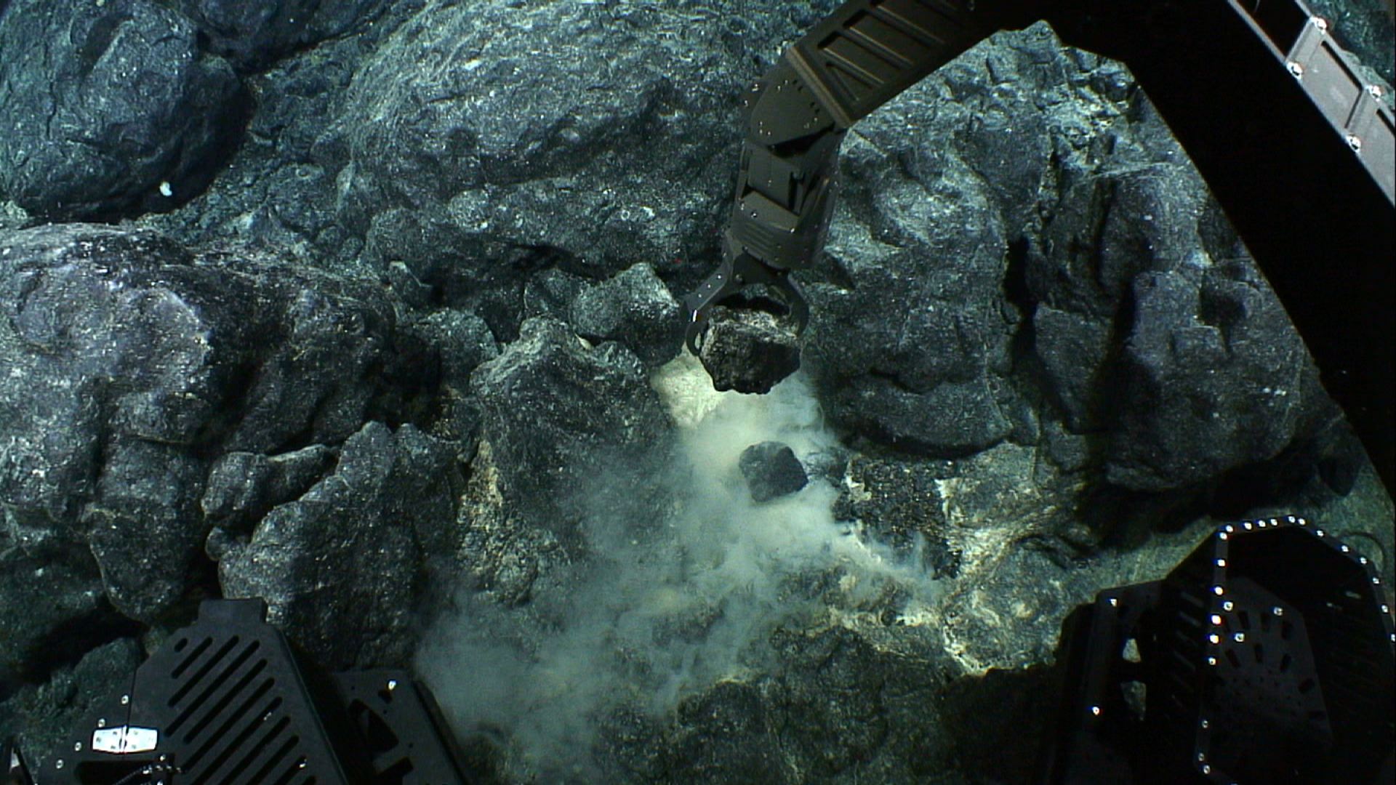
Date (UTC) | 20150924
Time (UTC) | 214653
Depth (m) | 2106.37
Temperature (ºC) | 2.11
Field ID(s) | Basalt
Comments
Sample ID | EX1504L4_20150924T222851_D2_DIVE11_SPEC03BIO |  |  |  | 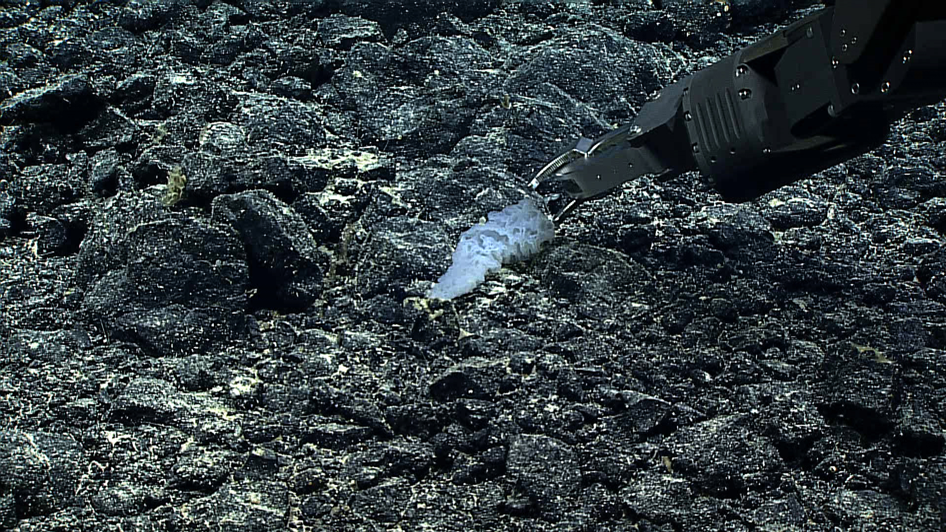
Date (UTC) | 20150924
Time (UTC) | 222851
Depth (m) | 2084.21
Temperature (ºC) | 2.05
Field ID(s) | Hexactinellida
Comments | Another sponge growing on specimen.
Sample ID | EX1504L4_20150925T010032_D2_DIVE11_SPEC04BIO |  |  |  | 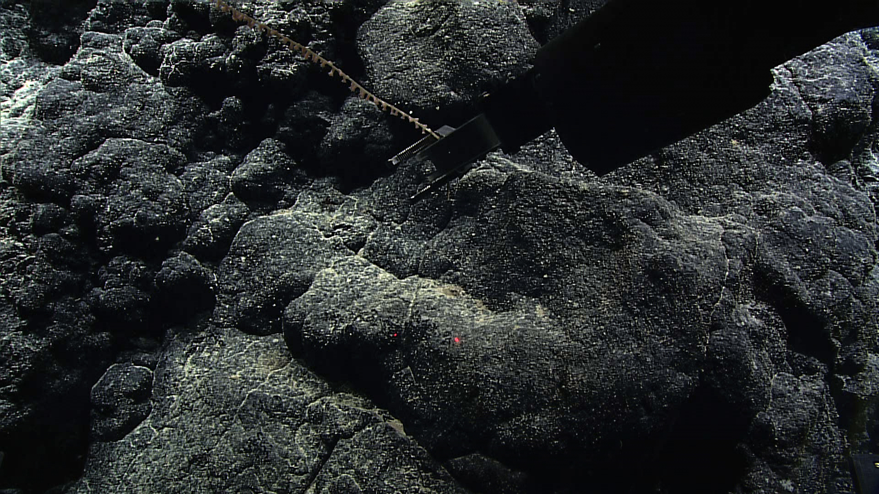
Date (UTC) | 20150925
Time (UTC) | 010032
Depth (m) | 2063.74
Temperature (ºC) | 1.98
Field ID(s) | Lepidisis sp.
Comments
Sample ID | EX1504L4_20150925T012012_D2_DIVE11_SPEC05BIO |  |  |  | 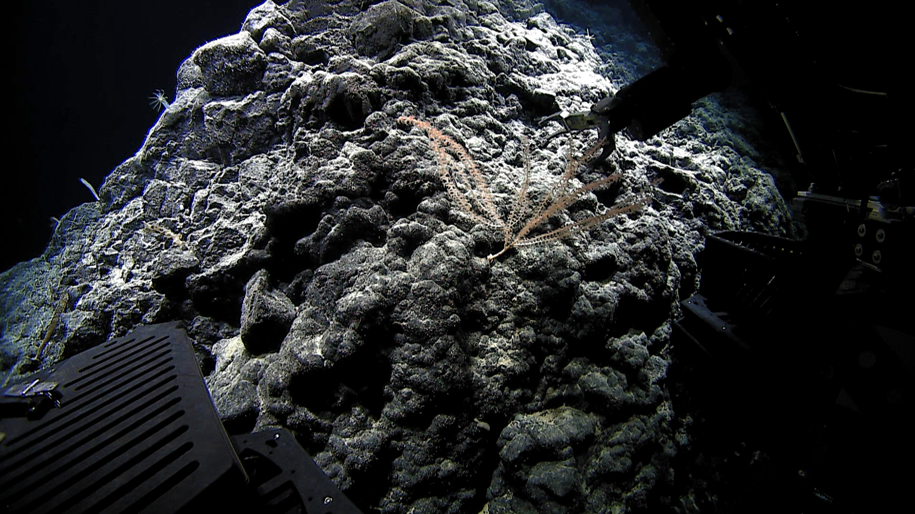
Date (UTC) | 20150925
Time (UTC) | 012012
Depth (m) | 2061.54
Temperature (ºC) | 1.95
Field ID(s) | Eknomisis sp.
Comments
Please direct inquiries to: |  |  | NOAA Office of Ocean Exploration & Research  1315 East-West Highway (SSMC3 10th Floor)  Silver Spring, MD 20910  (301) 734-1014

