Okeanos Explorer ROV Dive Summary
Site Name |  | Lone Cone |  |  |  | 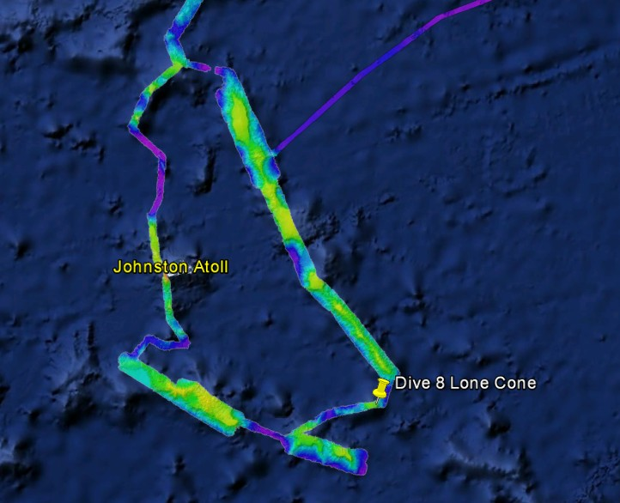
ROV Lead/Expedition Coordinator |  | Karl Mcletchie/ Brian RC Kennedy
Science Team Leads |  | Scott France and Mackenzie Gerringer
General Area Descriptor |  | Johnston Atoll Pacific Remote Islands Marine National Monument
ROV Dive Name |  | Cruise Season |  | Leg |  |  | Dive Number
 |  | EX1504 |  | 4 |  |  | DIVE08
Equipment Deployed |  | ROV: |  | Deep Discoverer
 |  | Camera Platform: |  | Seirios
ROV Measurements |  | D2 CTD |  | Depth |  |  | Altitude
 |  | Scanning Sonar |  | USBL Position |  |  | Heading
 |  | Pitch |  | Roll |  |  | HD Camera 1
 |  | HD Camera 2 |  | ROV HD 2 |  |  | Seirios CTD
 |  | Temperature Probe |  | D2 DO Sensor |  |  | Seirios DO sensor
Equipment Malfunctions |  | VSAT continues to underperform
ROV Dive Summary  (From processed ROV data) |  | Dive Summary: EX1504L4_DIVE08  ^^^^^^^^^^^^^^^^^^^^^^^^^^^^^^^^^^^^^^^^^^^^^^^^^^^  In Water: 2015-09-21T18:17:38.062000  15°, 35.929' N ; 167°, 44.950' W  Out Water: 2015-09-22T02:28:48.250000  15°, 35.011' N ; 167°, 44.680' W  Off Bottom: 2015-09-22T01:32:33.468000  15°, 35.247' N ; 167°, 44.894' W  On Bottom: 2015-09-21T19:26:40.265000  15°, 35.727' N ; 167°, 44.687' W  Dive duration: 8:11:10  Bottom Time: 6:5:53  Max. depth: 2116.4 m
Special Notes
Scientists Involved  (please provide name / location / affiliation / email) |  | Name Institution Email Address  Abby Lapointe University of Hawaii Zoology abbylap@hawaii.edu  Amy Baco-Taylor FSU abacotaylor@fsu.edu  Asako Matsumoto University of Tokyo amatsu@gorgonian.jp  Astrid Leitner University of Hawaii aleitner@hawaii.edu  Bruce Mundy NOAA NMFS Pacific Islands Fisheries Science Center bruce.mundy@noaa.gov  Chris Kelley University of Hawaii ckelley@hawaii.edu  Chris Mah Smithsonian brisinga@gmail.com  Dennis Hanisak FAU/HBOI dhanisak@fau.edu  Les Watling University of Hawaii watling@hawaii.edu  Mackenzie Garringer University of Hawaii mgerring@hawaii.edu  Mary Wicksten Texas A&M University, College Station wicksten@bio.tamu.edu  Santiago Herrera University of Toronto / WHOI sherrera@alum.mit.edu  Scott France University of Louisiana at Lafayette france@louisiana.edu  Steve Auscavitch Temple steven.auscavitch@temple.edu  Tina Molodtsova P.P.Shirshov Institute of Oceanology tina.molodtsova@gmail.com tina@ocean.ru  Andrew Shuler NOAA/NOS/NCCOS andrew.shuler@noaa.gov  John Reed FAU Harbor Branch Oceanographic jreed12@fau.edu  Jim Masterson FAU Harbor Branch Oceanographic jmaster7@fau.edu  Kimberly Galvez University of Miami - RSMAS CSL-Center for Carbonate Research kgalvez@rsmas.miami.edu  Bill Clancey IHMC wclancey@ihmc.us
Purpose of the Dive
To explore the bathyal community of a hard bottom on a cone feature that rises ≈400 m above the surrounding seamount plateau in the Pacific Remote Islands Marine National Monument
Description of the Dive:
The landing site on the gradual slope near the base of the cone showed much sediment accumulation with some outcrops of rock or thick manganese pavement. Some octocorals, black corals, sponges and lepaedomorph barnacles were seen attached to the small outcrops, and a rooted (rhizophorous) stalked crinoid was observed (and collected) in the sediment. As we ascended the cone feature, exposed manganese pavement and possible pillow lavas became more common than the sediment patches, and density and diversity of sessile fauna increased. The sediment was very fine grain and silt-like at times. The top of the cone contained more large boulders with very little sedimentation. Two rock samples were collected, one at 2074 m and one at 1832 m.
Overall, densities of sessile fauna were not very high, certainly when compared to the dives on Leg 2 of this expedition in the Northwestern Hawaiian Islands. Perhaps this relates to low productivity in the overlying surface waters. In the deeper half of the dive, the coral community was dominated by black coral (Bathypathes), but closer to the summit the octocoral Metallogorgia was most abundant. Anthomastus were present from depths around 1800 m to the summit. Evidence suggestive of recent recruitment was seen in the form of a colony of Anthomastus with only 2 polyps. Other corals observed included bamboo corals (Jasonisis, Lepidisis), primnoid corals (Candidella gigantea), chrysogorgiid corals (Chrysogorgia, Iridigorgia, Metallogorgia), scleraxonian corals (Hemicorallium cf. lauense, Paragorgiidae, Victorgorgia), Plexauridae and black corals (Heteropathes, Umbellapathes, Trissopathes, Stauropathes). A high number of dead coral and sponge skeletons were seen on this dive, many of them colonized by other fauna, such as barnacles and zoanthids, or overrun with ophiuroids and crinoids. We also observed several incidences of predation on coral by asteroid sea stars.
Very few sponges were seen on this dive, particularly in comparison to some of the densities seen on previous dives. Several dead sponge stalks were present at the base of the feature. One living Walteria sponge was seen, as was a Bolosoma. A few small sponges were seen, including one thought to be a demosponge (?Cladorhizidae). An unrecognized sponge, possibly a euplectellid, was collected from a depth of 1924 m.
Echinoderm diversity was high. Many ophiuroids were seen, both on rocks and associated with the sessile fauna, including the characteristic Ophiocreas oedipus that makes its home on Metallogorgia. A Circeaster sea star was seen feeding on what was thought to be a Victorgorgia colony and a Hippasterid sea star was seen feeding on the coral Jasonisis. Other seastars seen included Acthenactis papyraceus, what may have been a second Asthenactis species, and a brisingid. A few urchins were seen, including Araeosoma and Aspiodiadema hawaiiensis. Crinoids increased in density as we approached the summit, although not in the densities seen for Commatulina crinoids on Dive 7. Several stalked crinoids (Proisocrinus ruberrimus) were seen near the summit, as was a Bathycrinus, and another stalked crinoid that was not recognized, possibly of the genus Naumachocrinus; the latter was collected from 2083 m.
Among the fish observed, one of the highlights was the sighting of what is believed to be a juvenile Synaphobranchus brevidorsalis near the summit of the cone feature. Other fish encountered included a cusk eel (Ophidiidae: Bassozetus?), a relative of the tripod fish (Bathytyphops marionae), and an adult Synaphobranchus brevidorsalis.
Other notable observations recorded in some detail on this dive included a chaetognath apparently caught on a filament near a sponge stalk, perhaps a tentacle of a benthic ctenophore (Platyctenida) on the far side of the sponge; a second sighting of the evidently rare, spiky-legged squat lobster (Chirostylidae) seen on dive 6 to Two Cones that possibly represents a new genus; a hermit crab (Parapaguridae) with attached anemone; a sea pen (?Kophobelemnon); several solitary corallimorphs (Corallimorphus pilatus), and a pelagic ctenophore.

Overall Map of ROV Dive Area |  |  |  |  | Close-up Map of Main Dive Site
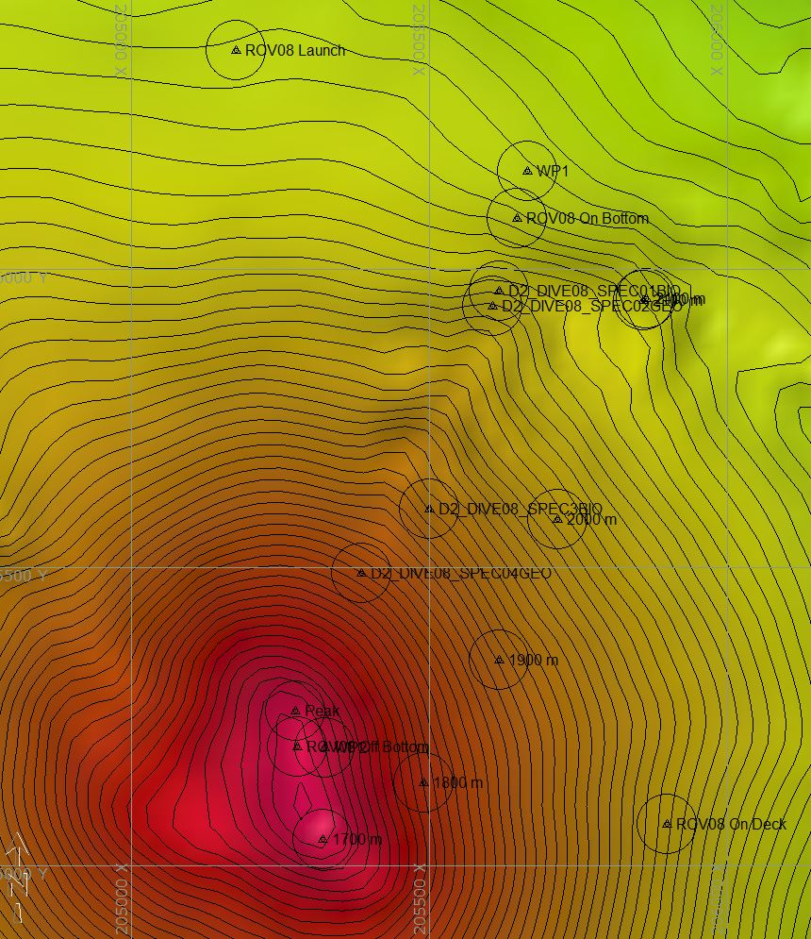 |  |  |  |  | 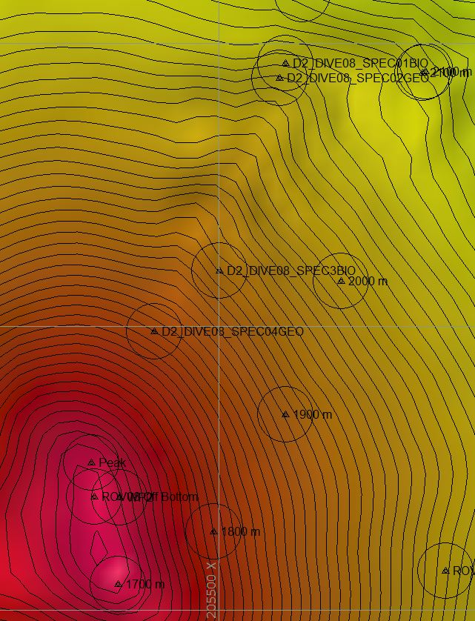
Representative Photos of the Dive
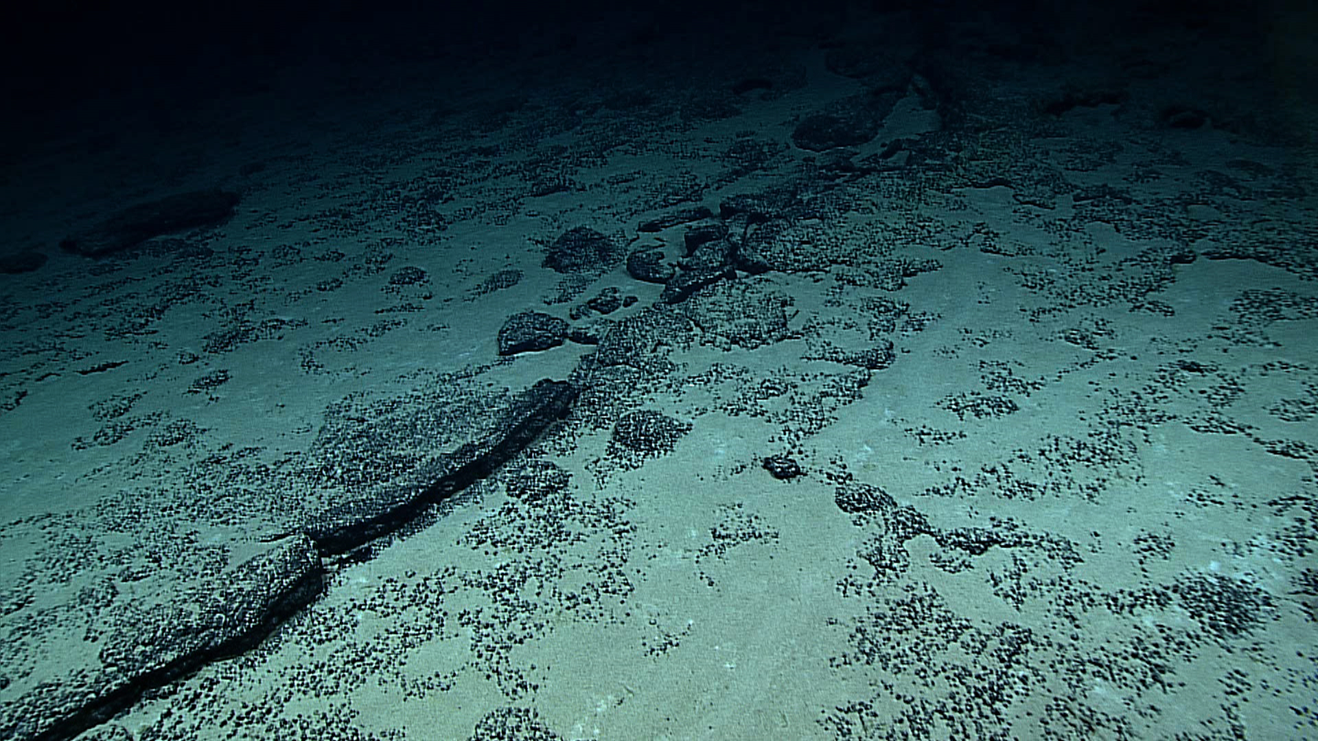 |  |  |  |  | 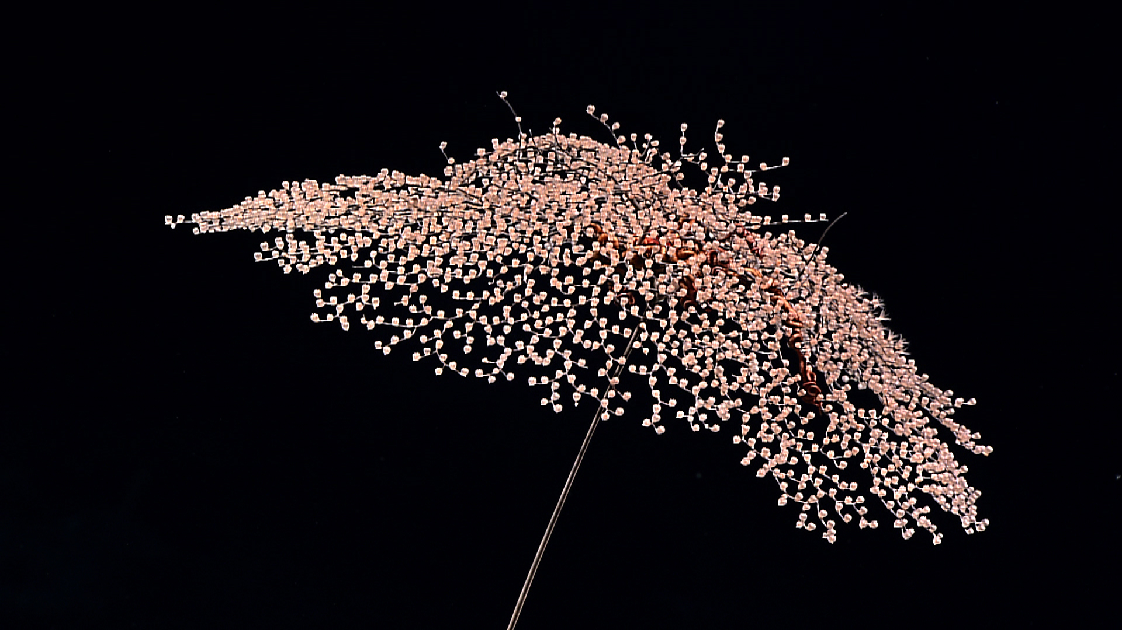
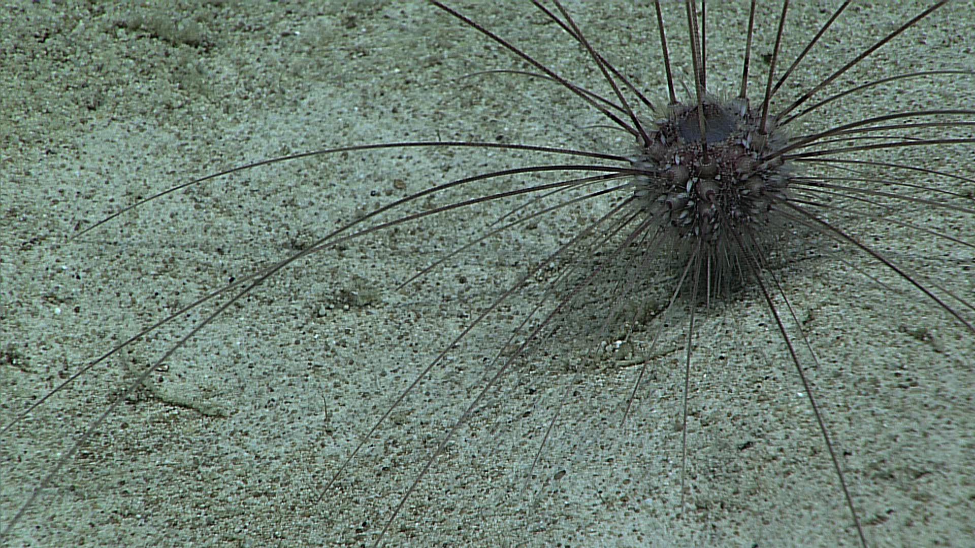 |  |  |  |  | 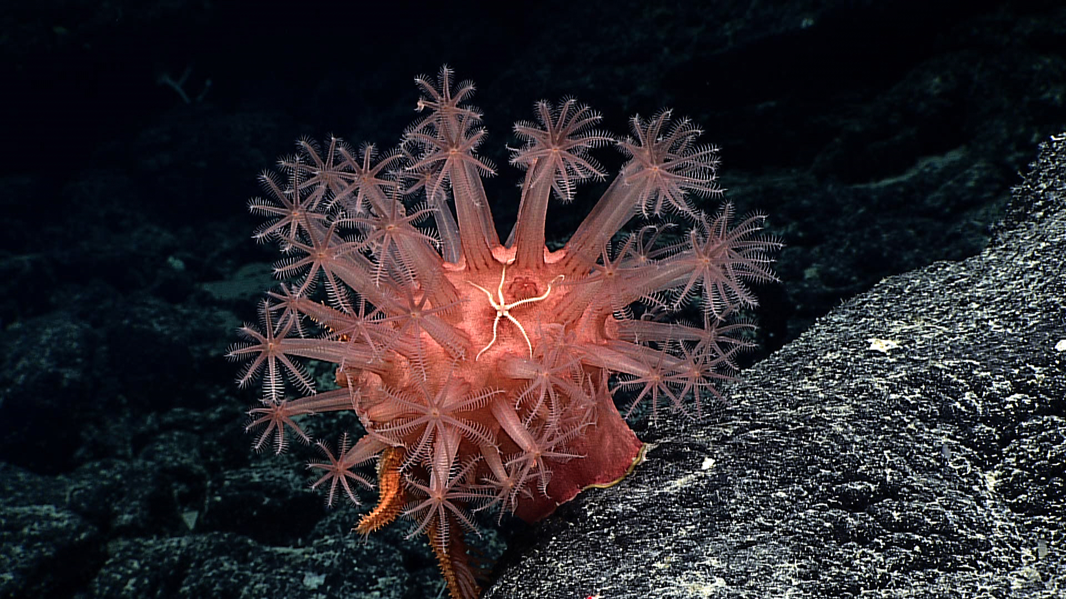
Samples Collected
Sample ID | EX1504L4_20150921T202731_D2_DIVE08_SPEC01BIO |  |  |  | 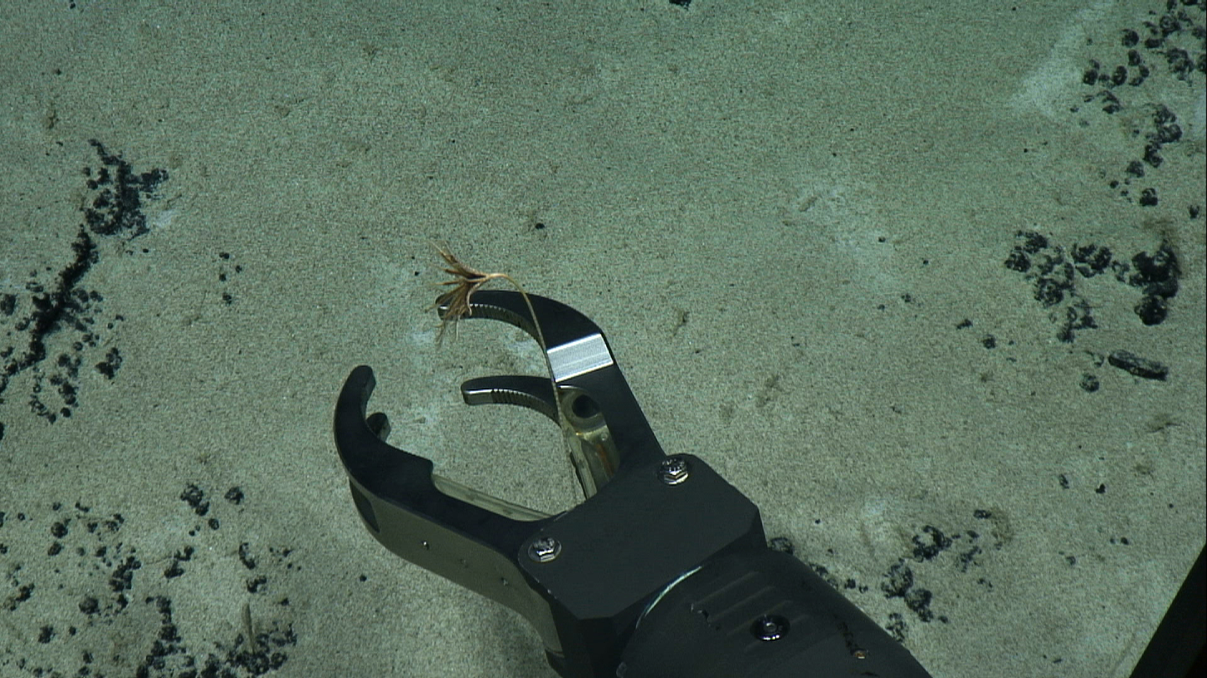
Date (UTC) | 20150921
Time (UTC) | 202731
Depth (m) | 2083.53
Temperature (ºC) | 2.2
Field ID(s) | Stalked Crinoid (Naumachocrinus)
Comments
Sample ID | EX1504L4_20150921T204528_D2_DIVE08_SPEC02GEO |  |  |  | 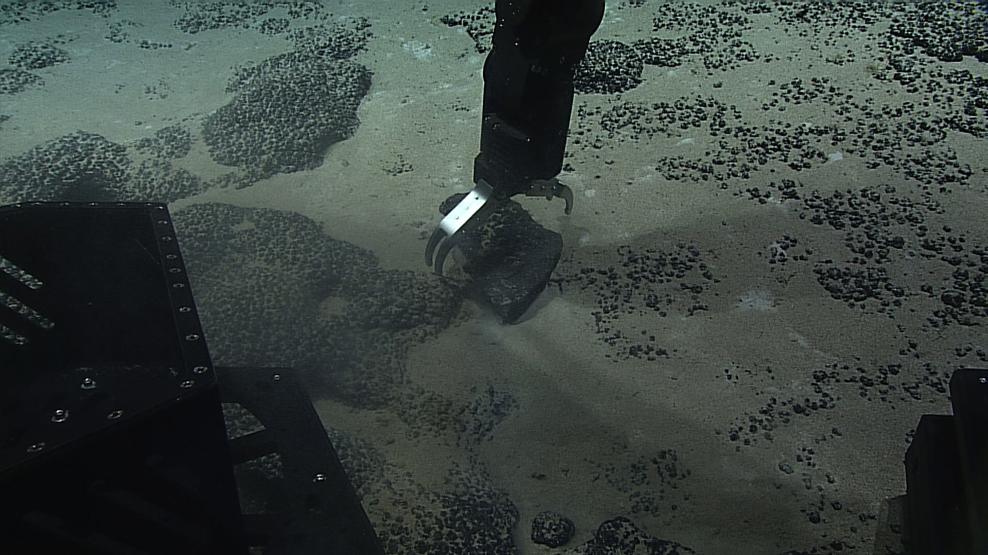
Date (UTC) | 20150921
Time (UTC) | 204528
Depth (m) | 2074.5
Temperature (ºC) | 2.18
Field ID(s) | Mn-encrusted basalt
Comments
Sample ID | EX1504L4_20150921T225230_D2_DIVE08_SPEC03BIO |  |  |  | 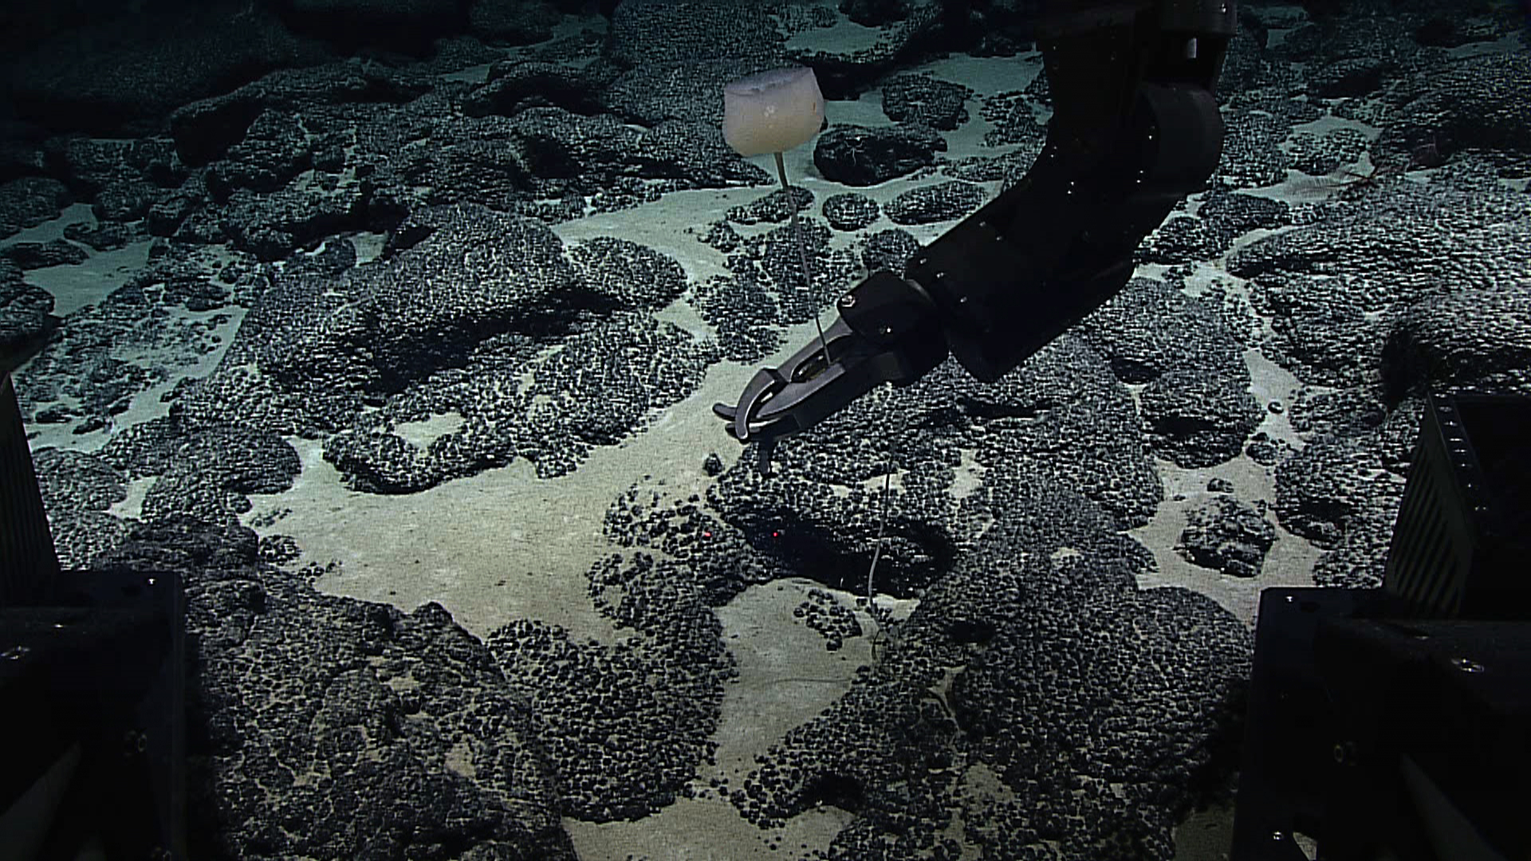
Date (UTC) | 20150921
Time (UTC) | 225230
Depth (m) | 1922.97
Temperature (ºC) | 2.31
Field ID(s) | Bolosominae
Comments
Sample ID | EX1504L4_20150921T234946_D2_DIVE08_SPEC04GEO |  |  |  | 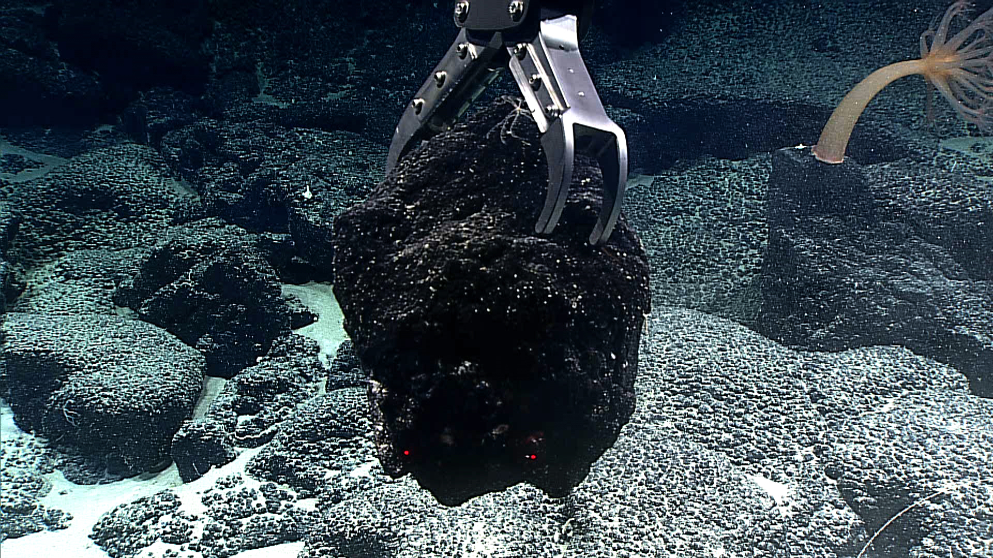
Date (UTC) | 20150921
Time (UTC) | 234946
Depth (m) | 1832.53
Temperature (ºC) | 2.37
Field ID(s) | Mn-encrusted basalt
Comments
Please direct inquiries to: |  |  | NOAA Office of Ocean Exploration & Research  1315 East-West Highway (SSMC3 10th Floor)  Silver Spring, MD 20910  (301) 734-1014

