Okeanos Explorer ROV Dive Summary
Site Name |  | Southernmost Cone |  |  |  | 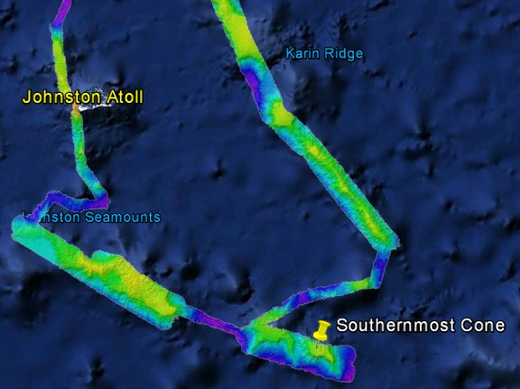
ROV Lead/Expedition Coordinator |  | Karl Mcletchie/ Brian RC Kennedy
Science Team Leads |  | Scott France and Mackenzie Gerringer
General Area Descriptor |  | Johnston Atoll Pacific Remote Islands Marine National Monument
ROV Dive Name |  | Cruise Season |  | Leg |  |  | Dive Number
 |  | EX1504 |  | 4 |  |  | DIVE07
Equipment Deployed |  | ROV: |  | Deep Discoverer
 |  | Camera Platform: |  | Seirios
ROV Measurements |  | D2 CTD |  | Depth |  |  | Altitude
 |  | Scanning Sonar |  | USBL Position |  |  | Heading
 |  | Pitch |  | Roll |  |  | HD Camera 1
 |  | HD Camera 2 |  | ROV HD 2 |  |  | Seirios CTD
 |  | Temperature Probe |  | D2 DO Sensor |  |  | Seirios DO sensor
Equipment Malfunctions |  | VSAT continues to underperform
ROV Dive Summary  (From processed ROV data) |  | Dive Summary: EX1504L4_DIVE07  ^^^^^^^^^^^^^^^^^^^^^^^^^^^^^^^^^^^^^^^^^^^^^^^^^^^  In Water: 2015-09-20T18:23:47.125000  15°, 12.532' N ; 168°, 03.960' W  Out Water: 2015-09-21T02:33:25.406000  15°, 12.227' N ; 168°, 03.187' W  Off Bottom: 2015-09-21T01:31:36.250000  15°, 12.291' N ; 168°, 03.507' W  On Bottom: 2015-09-20T19:29:46.515000  15°, 12.553' N ; 168°, 03.766' W  Dive duration: 8:9:38  Bottom Time: 6:1:49  Max. depth: 1950.7 m
Special Notes
Scientists Involved  (please provide name / location / affiliation / email) |  | Name Institution Email Address  Abby Lapointe University of Hawaii Zoology abbylap@hawaii.edu  Amy Baco-Taylor FSU abacotaylor@fsu.edu  Asako Matsumoto University of Tokyo amatsu@gorgonian.jp  Chris Kelley University of Hawaii ckelley@hawaii.edu  Mackenzie Garringer University of Hawaii mgerring@hawaii.edu  Scott France University of Louisiana at Lafayette france@louisiana.edu  Steve Auscavitch Temple steven.auscavitch@temple.edu  Tina Molodtsova P.P.Shirshov Institute of Oceanology tina.molodtsova@gmail.com tina@ocean.ru  Andrew Shuler NOAA/NOS/NCCOS andrew.shuler@noaa.gov  Robert McGuinn NOAA - DSCRTP robert.mcguinn@noaa.gov
Purpose of the Dive
To explore the bathyal community of a hard bottom on a pair of joined cone features, with the summit of the second ≈200 m above the plateau the plateau of an unnamed seamount in the Pacific Remote Islands Marine National Monument
Description of the Dive:
The landing site on the lower broad slope of the cone was well sedimented and with rubble and Mn-encrusted plate-like rock. As we worked up slope, prominent pillow lavas and large, isolated boulders were seen, particularly near the peak of the first cone. Three rocks were collected, from depths 1893, 1843, and 1747 m. The last rock was thin, and may be entirely manganese crust.
Density of sessile fauna was low at the landing site. Abundances of sessile organisms increased as we approached both cone peaks, but particularly at the summit of the taller cone. Overall, the most abundant fauna were crinoids, both stalked (red Proisocrinus, other unidentified yellow, which was collected at 1894 m) and unstalked forms (Glyptometra, plus likely second species). At one point on the dive we observed a rock that held all five classes of echinoderms: comatulid crinoids, a holothurian (synallactallid), ophiuroids, an urchin (Echinosteridae), and a slime star (Hymenaster). Other echinoderms on this cone included asteroids (Benthopectinidae: Chiraster sp., Myxaster, Hymenaster, Henricia, Brisingida), holothurians (Benthodytes, synallactalids, Amperima), and several ophiuroids.
Coral abundances were lower than observed on the previous cone dive (Dive 6), though diversity was still relatively high. Corals seen include black corals Stauropathes, Umbellapathes helioanthes, Bathypathes, Trissopathes, Heteropathes/Hexapathes and octocorals Lepidisis, Keratoisis, Candidella, Paragorgia, Hemicorallium, Umbellula, Chrysogorgia, Metallogorgia, Paragorgiidae overgrown with zoanthids and with a euryalinid ophiuroid, Victorgorgia, Plexauridae and a rock pen, Anthoptilum. Another predatory interaction directed at octocorals was observed and recorded: a molluscan aplacophoran feeding on a bamboo coral polyp. Other cnidarians encountered included the anemone Exocoelactis, cup corals, Hydrodendron or other hydroid fan, and corallimorpharians. One coral sample was collected (Lepidisis) in order to get the chirostylid crab on it. Although the crab swam away and the coral drifted away as they were being placed into the Bio Box, both were recovered, the crab was coaxed back onto the branch held in the manipulator arm claw.
A few Caulophacus and Walteria sponges were seen, but overall sponge abundance and diversity was low. Some interesting associations were again observed during this dive. For example, Walteria sponges housing a large number of associates, including a high abundance of ctenophores (Ptatyctenidae), several crinoids (Glyptometra and other morph), and gastropods.
Other interesting observations of fauna included a carnivorous tunicate (Octanemidae) with a polychaete inside, a pelagic ctenophore, polynoid polychaetes, isopods (Munopsidae), a number of squat lobsters, and a pagurid hermit crab with associated carcinoecium –forming anemone. A few fish were encountered on this dive, including the cutthroat eel (Synaphobranchus brevidorsalis), a lophiiform anglerfish (Chaunocops melanostomus cf), and a small brown cusk eel that no one immediately recognized (Ophidiidae), as well as another ophidiid, potentially Bassozetus.

Overall Map of ROV Dive Area |  |  |  |  | Close-up Map of Main Dive Site
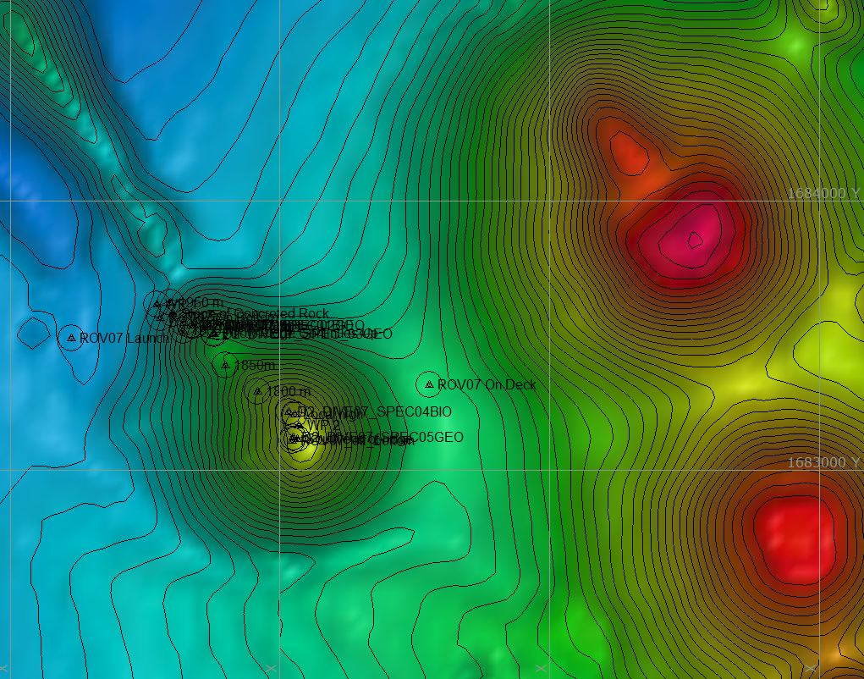 |  |  |  |  | 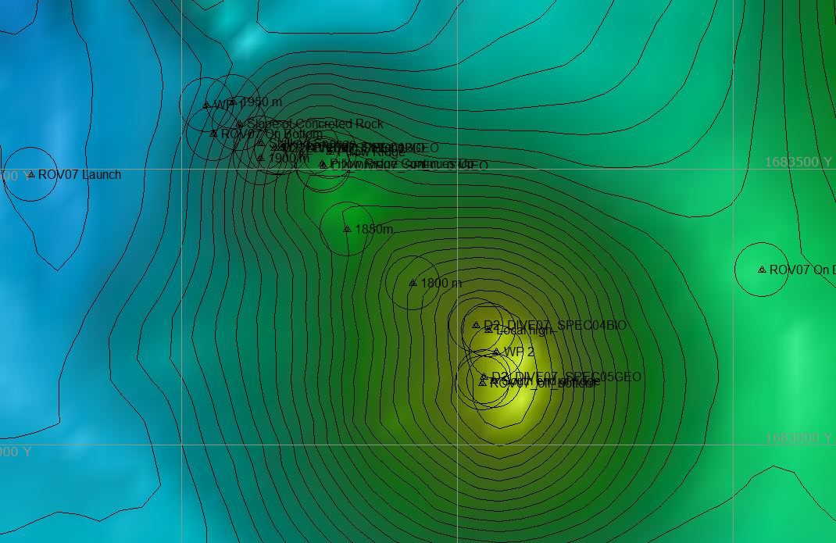
Representative Photos of the Dive
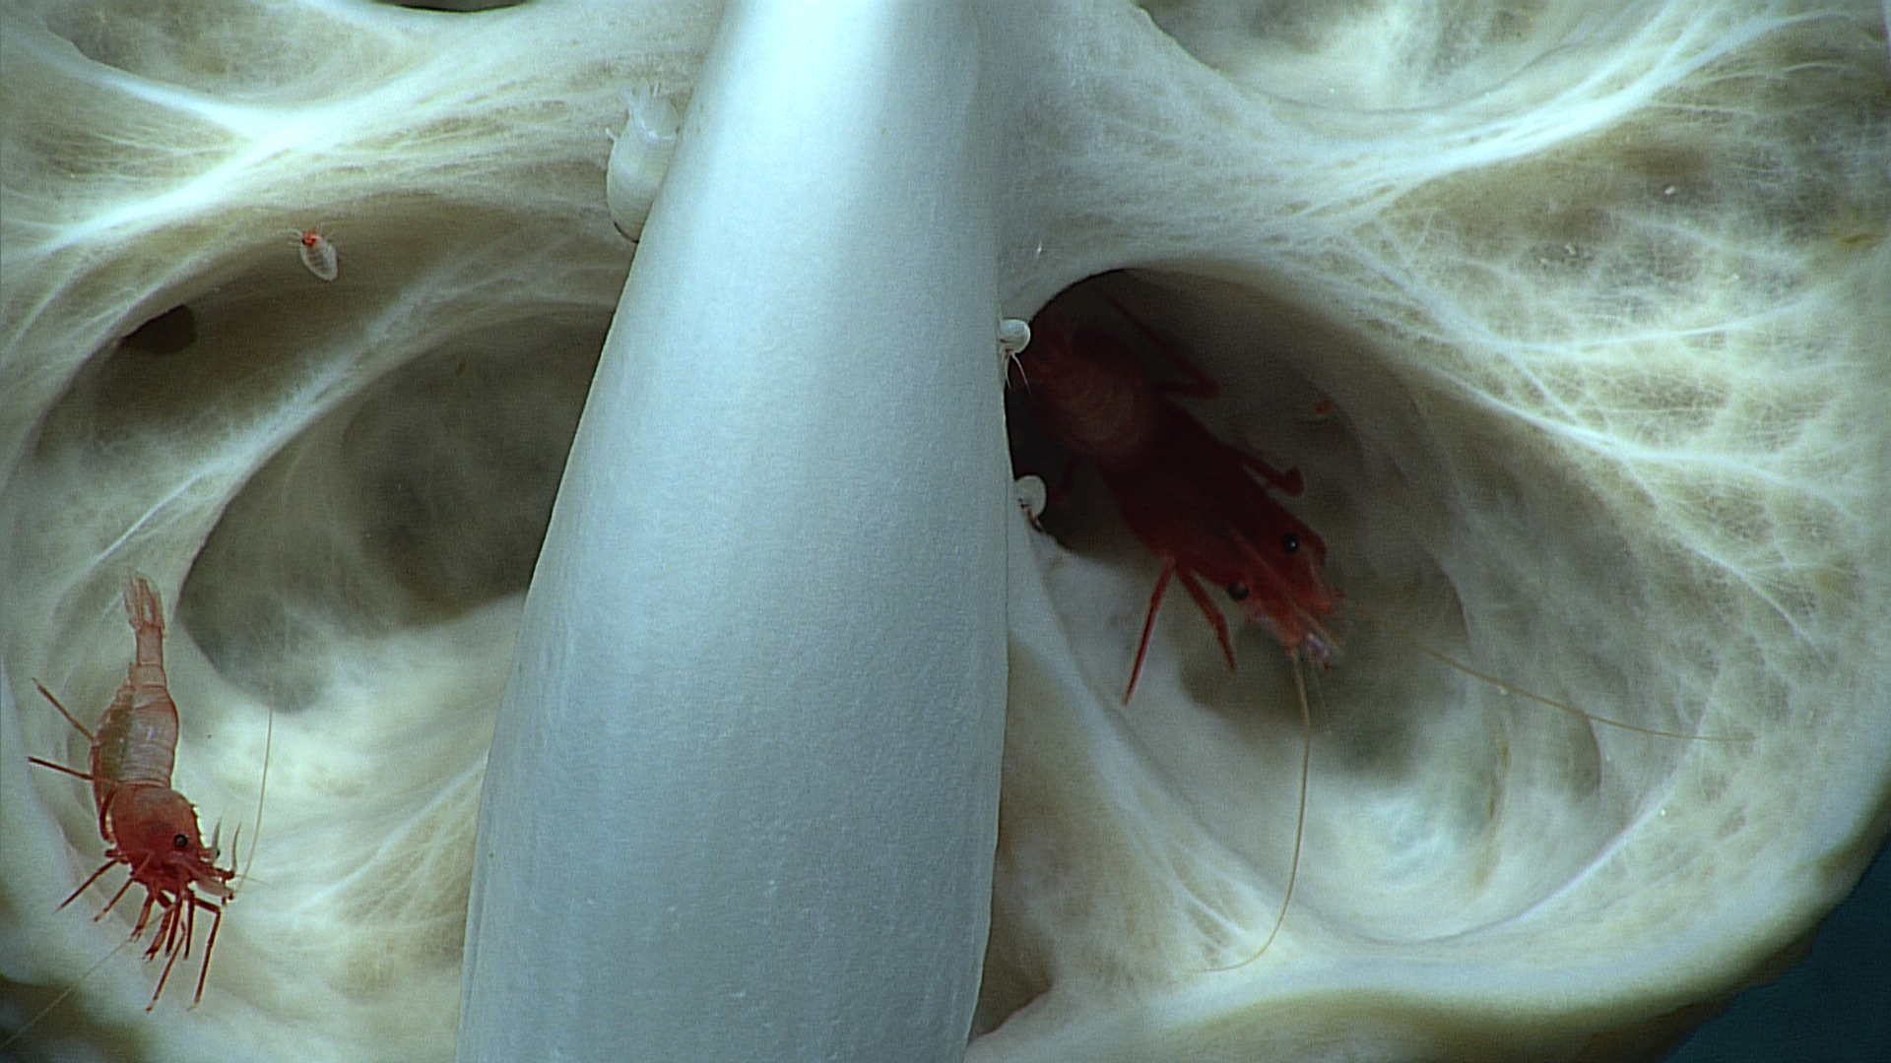 |  |  |  |  | 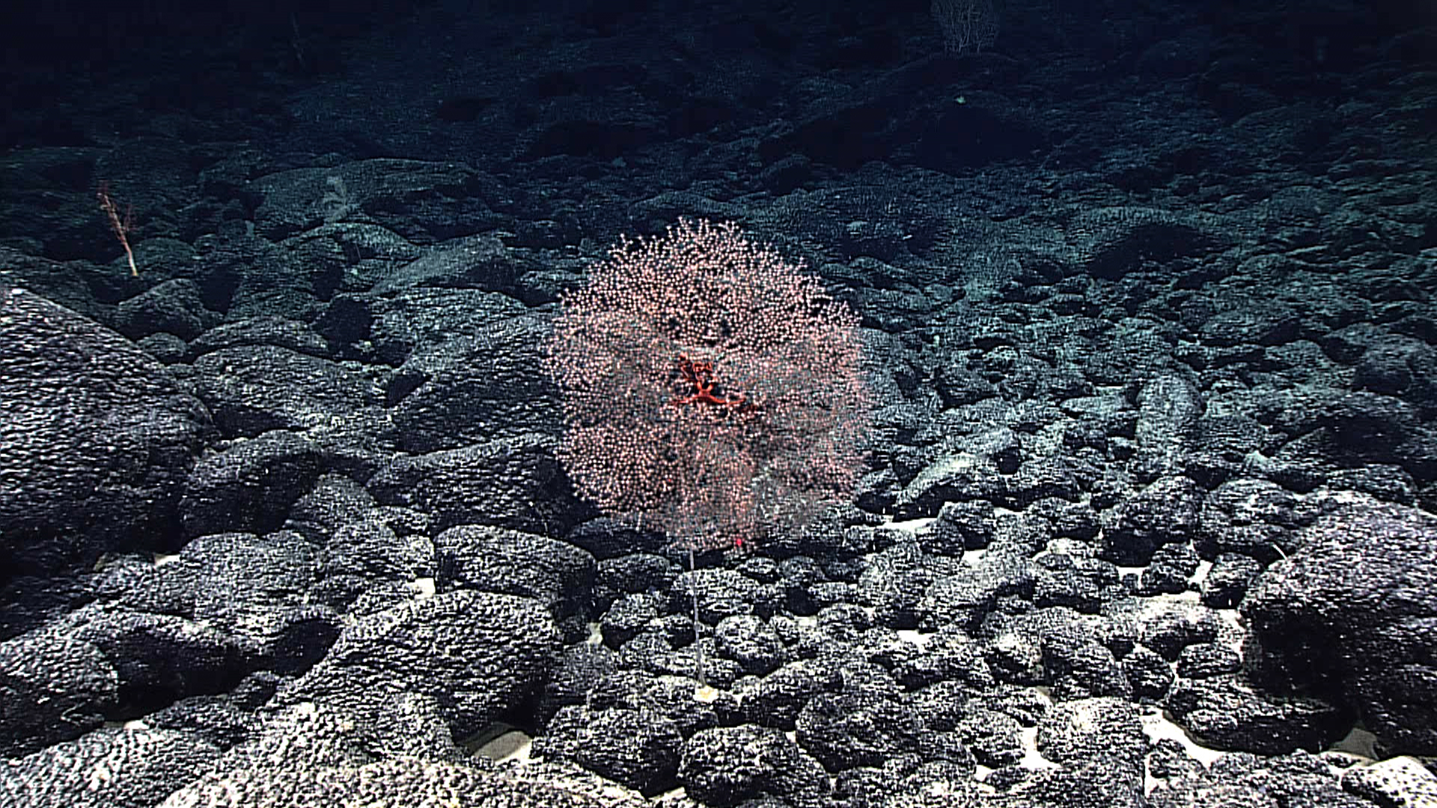
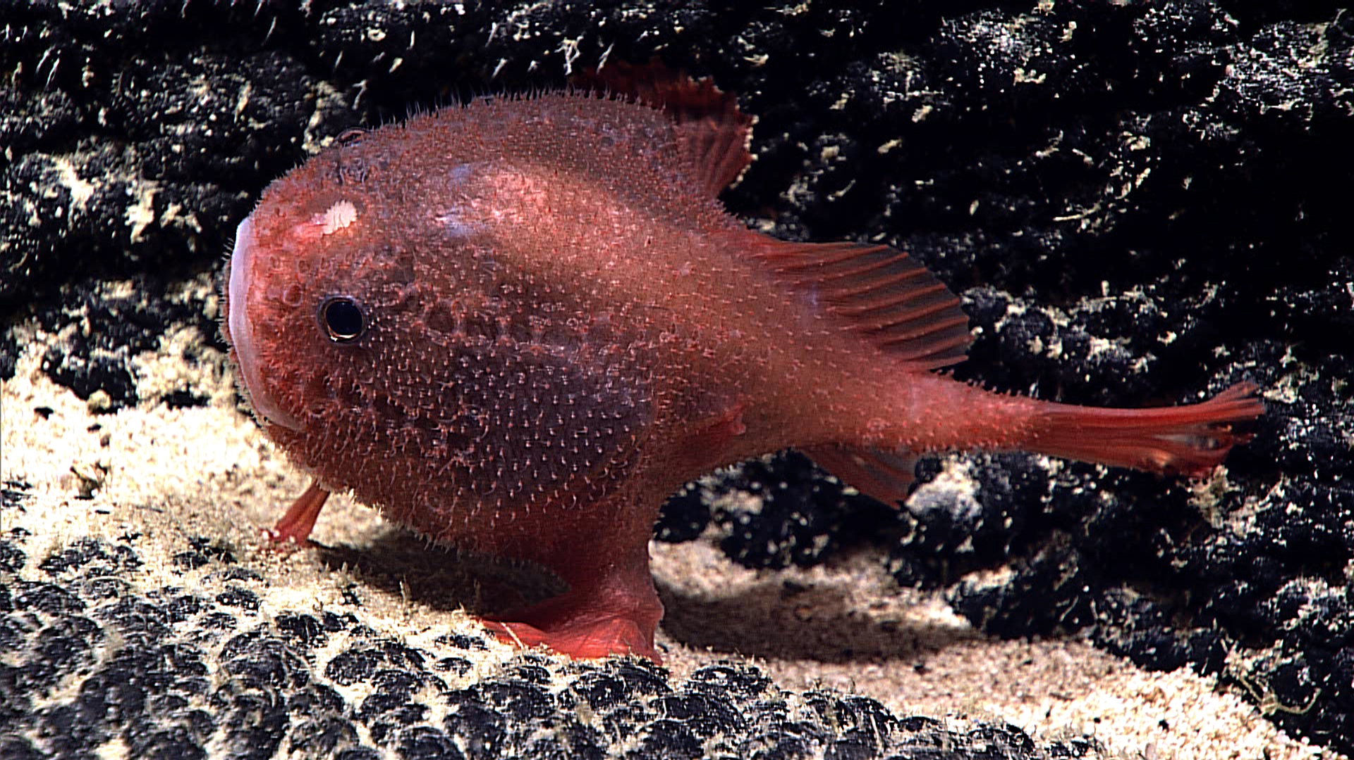 |  |  |  |  | 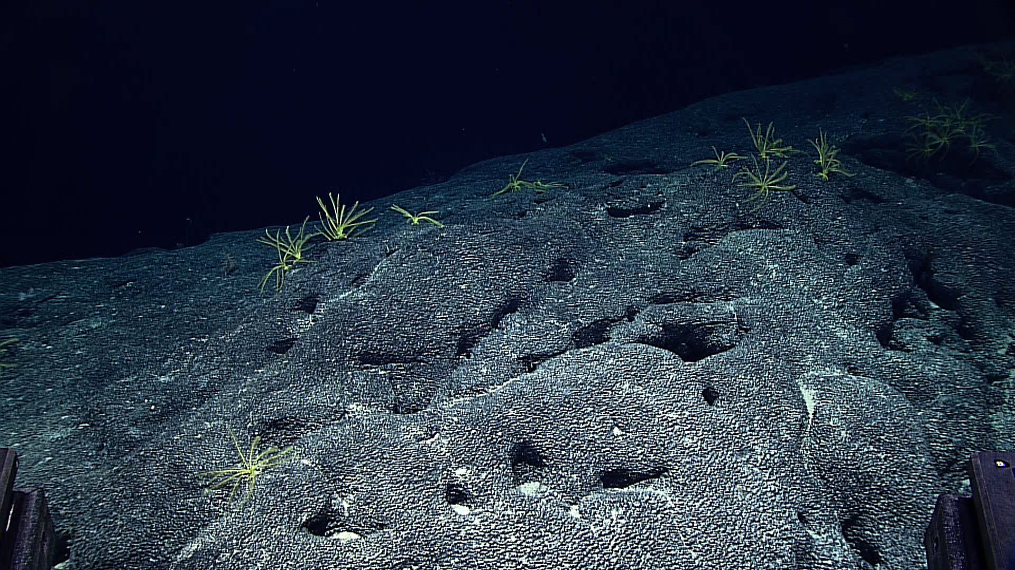
Samples Collected
Sample ID | EX1504L4_20150920T204336_D2_DIVE07_SPEC01BIO |  |  |  | 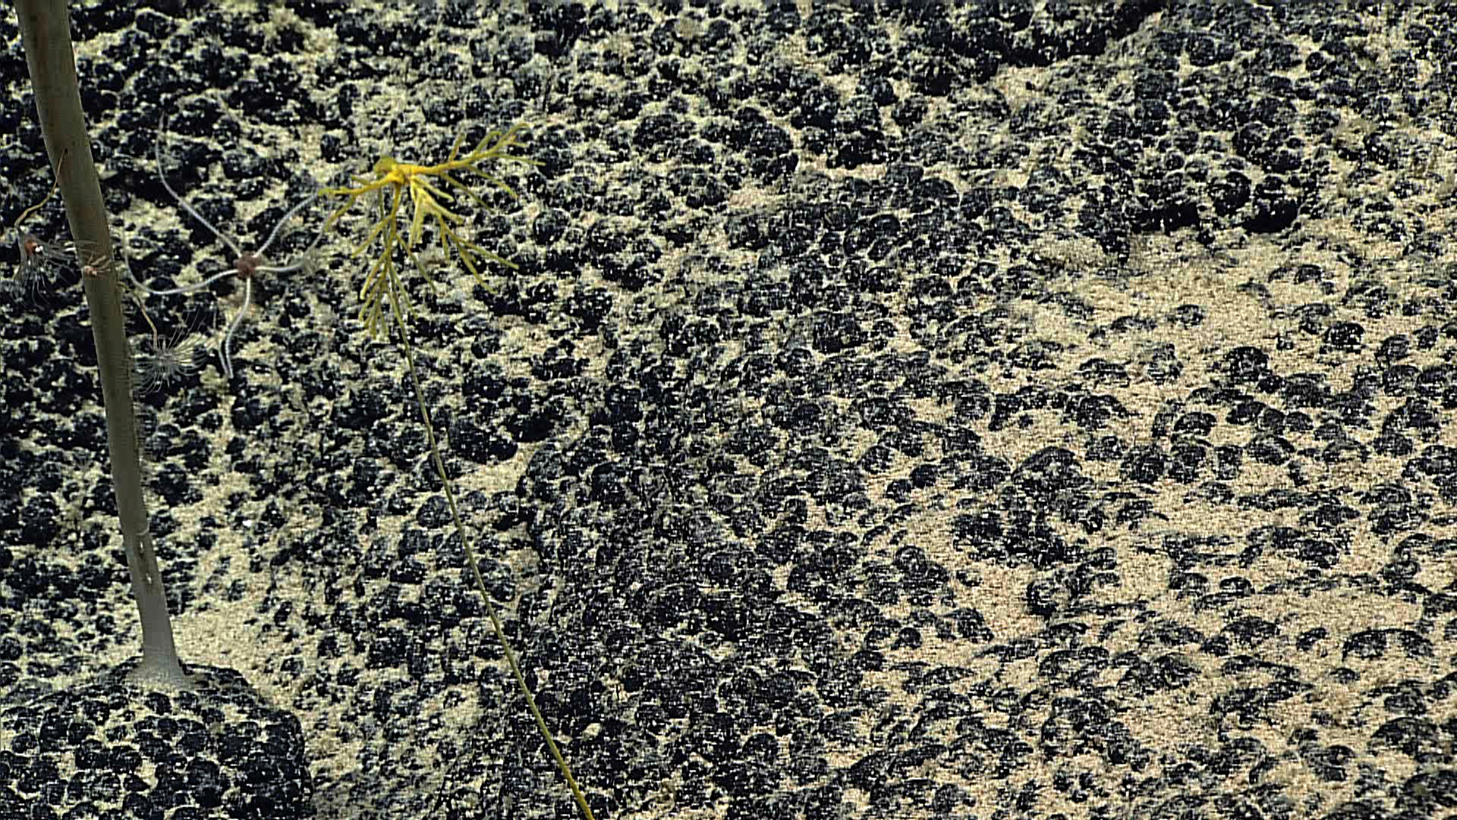
Date (UTC) | 20150920
Time (UTC) | 204336
Depth (m) | 1894.39
Temperature (ºC) | 2.32
Field ID(s) | Stalked crinoid
Comments
Sample ID | EX1504L4_20150920T210406_D2_DIVE07_SPEC02GEO |  |  |  | 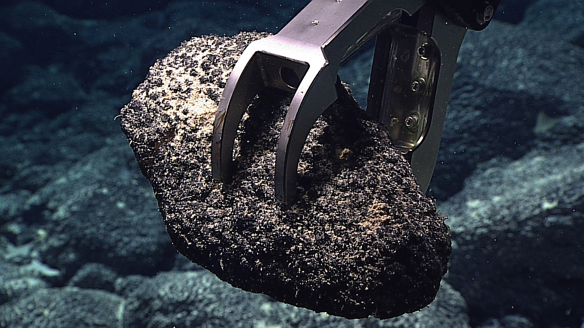
Date (UTC) | 20150920
Time (UTC) | 210406
Depth (m) | 1893.92
Temperature (ºC) | 2.31
Field ID(s) | Mn-encrusted basalt
Comments
Sample ID | EX1504L4_20150920T221401_D2_DIVE07_SPEC03GEO |  |  |  | 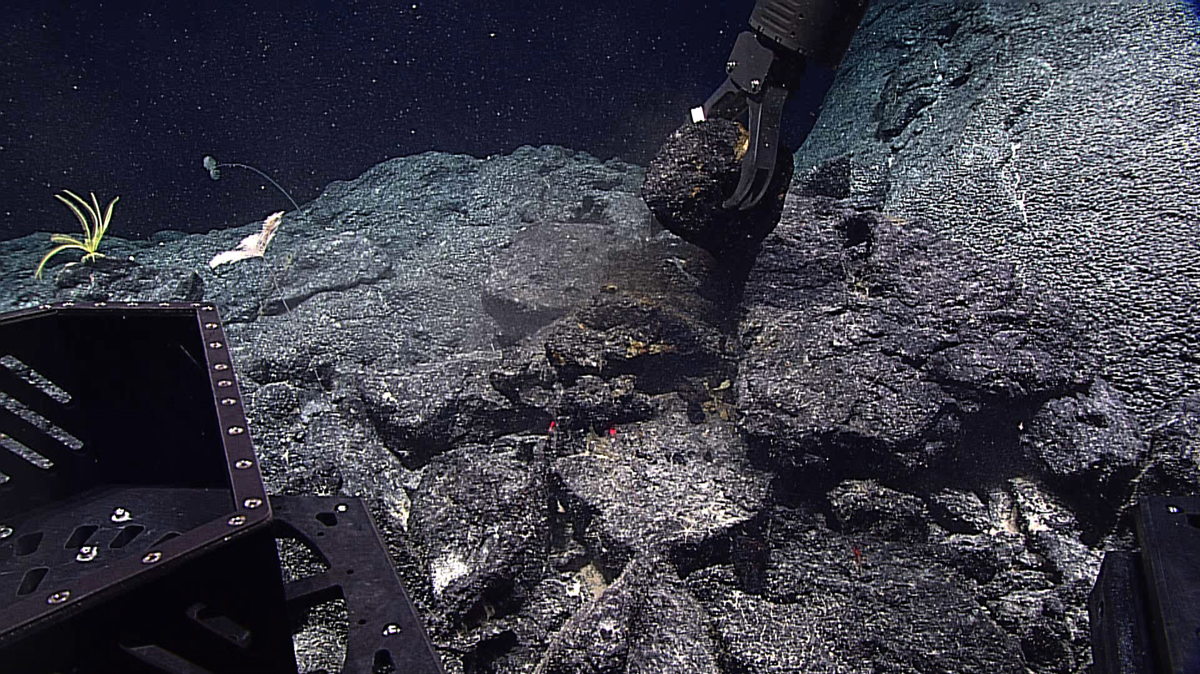
Date (UTC) | 20150920
Time (UTC) | 221401
Depth (m) | 1843.43
Temperature (ºC) | 2.34
Field ID(s) | Mn-encrusted basalt
Comments
Sample ID | EX1504L4_20150920T235711_D2_DIVE07_SPEC04BIO |  |  |  | 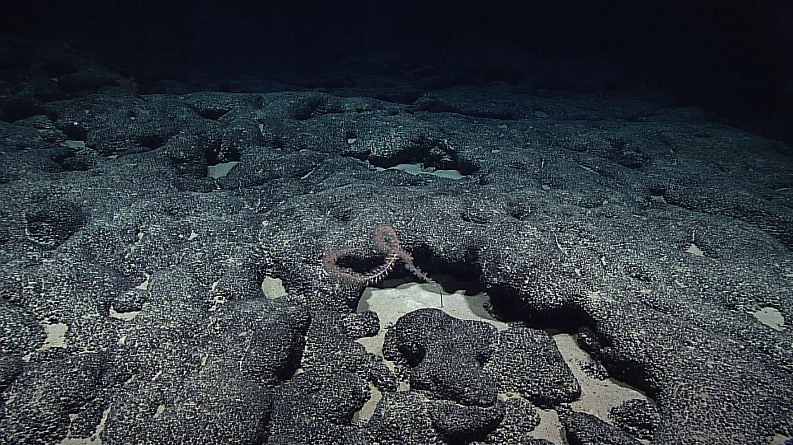
Date (UTC) | 20150920
Time (UTC) | 235711
Depth (m) | 1744.66
Temperature (ºC) | 2.6
Field ID(s) | Lepidisis
Comments
Sample ID | EX1504L4_20150921T010732_D2_DIVE07_SPEC05GEO |  |  |  | 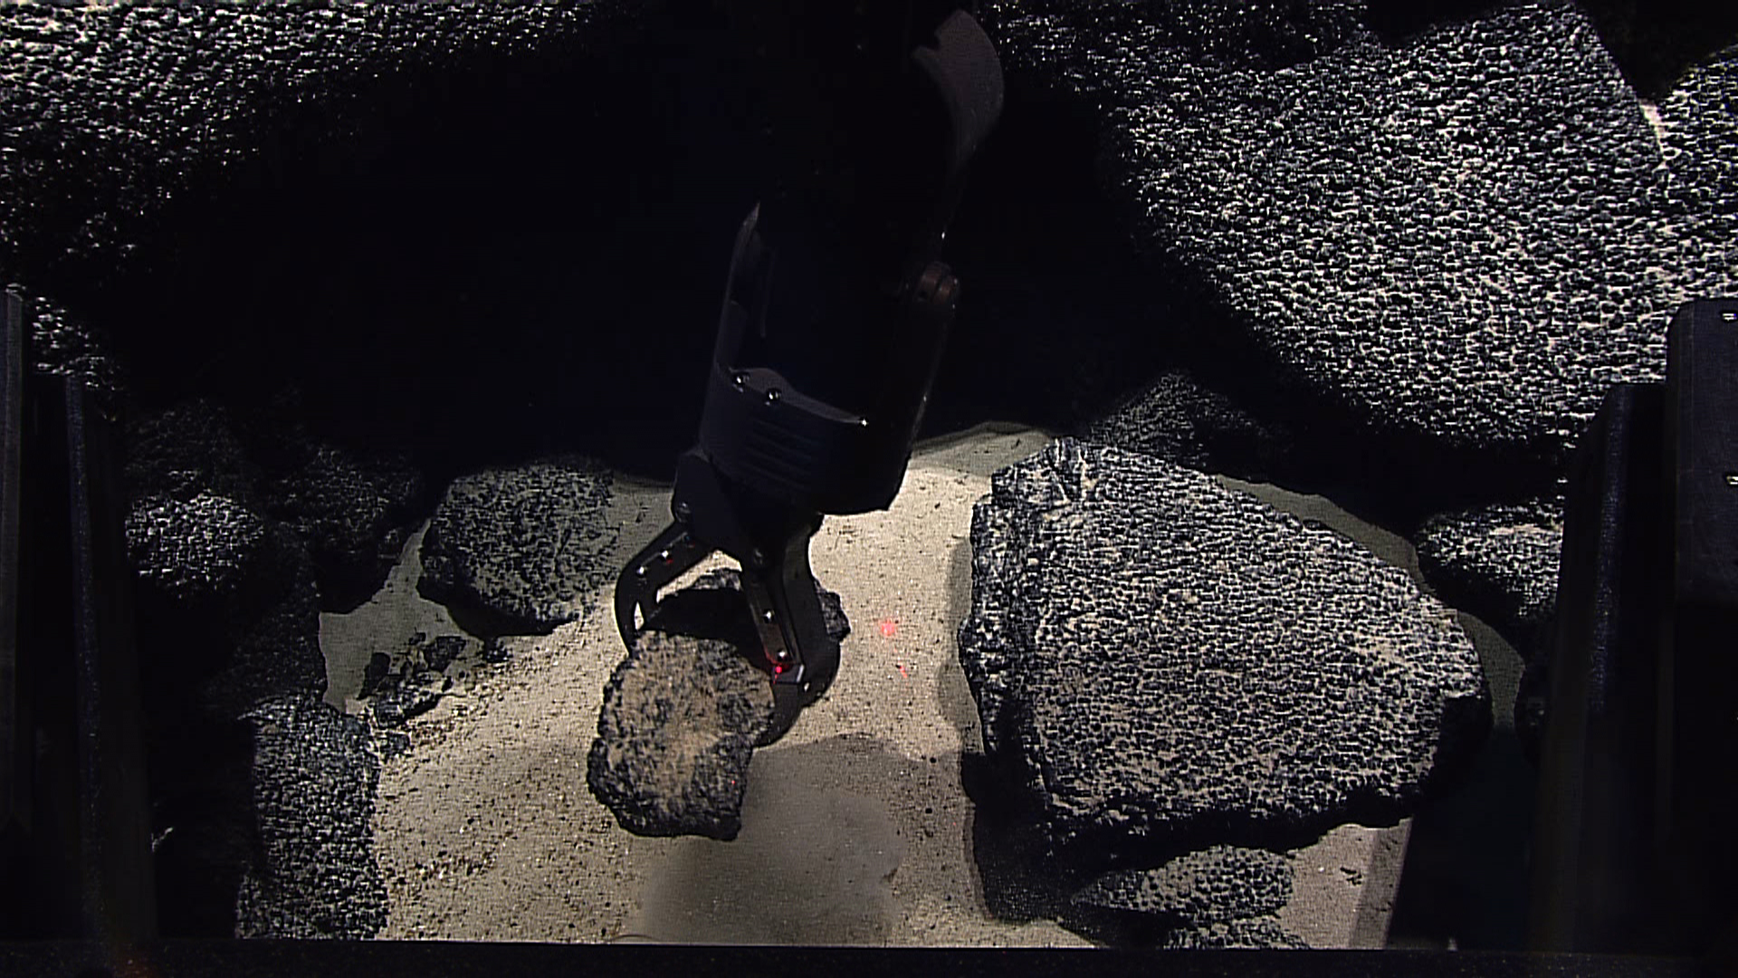
Date (UTC) | 20150921
Time (UTC) | 010732
Depth (m) | 1747.09
Temperature (ºC) | 2.53
Field ID(s) | Mn-encrusted basalt
Comments | Broken during transport to surface.
Please direct inquiries to: |  |  | NOAA Office of Ocean Exploration & Research  1315 East-West Highway (SSMC3 10th Floor)  Silver Spring, MD 20910  (301) 734-1014

