Okeanos Explorer ROV Dive Summary
Site Name | S19 Submarine Site |  |  |  | 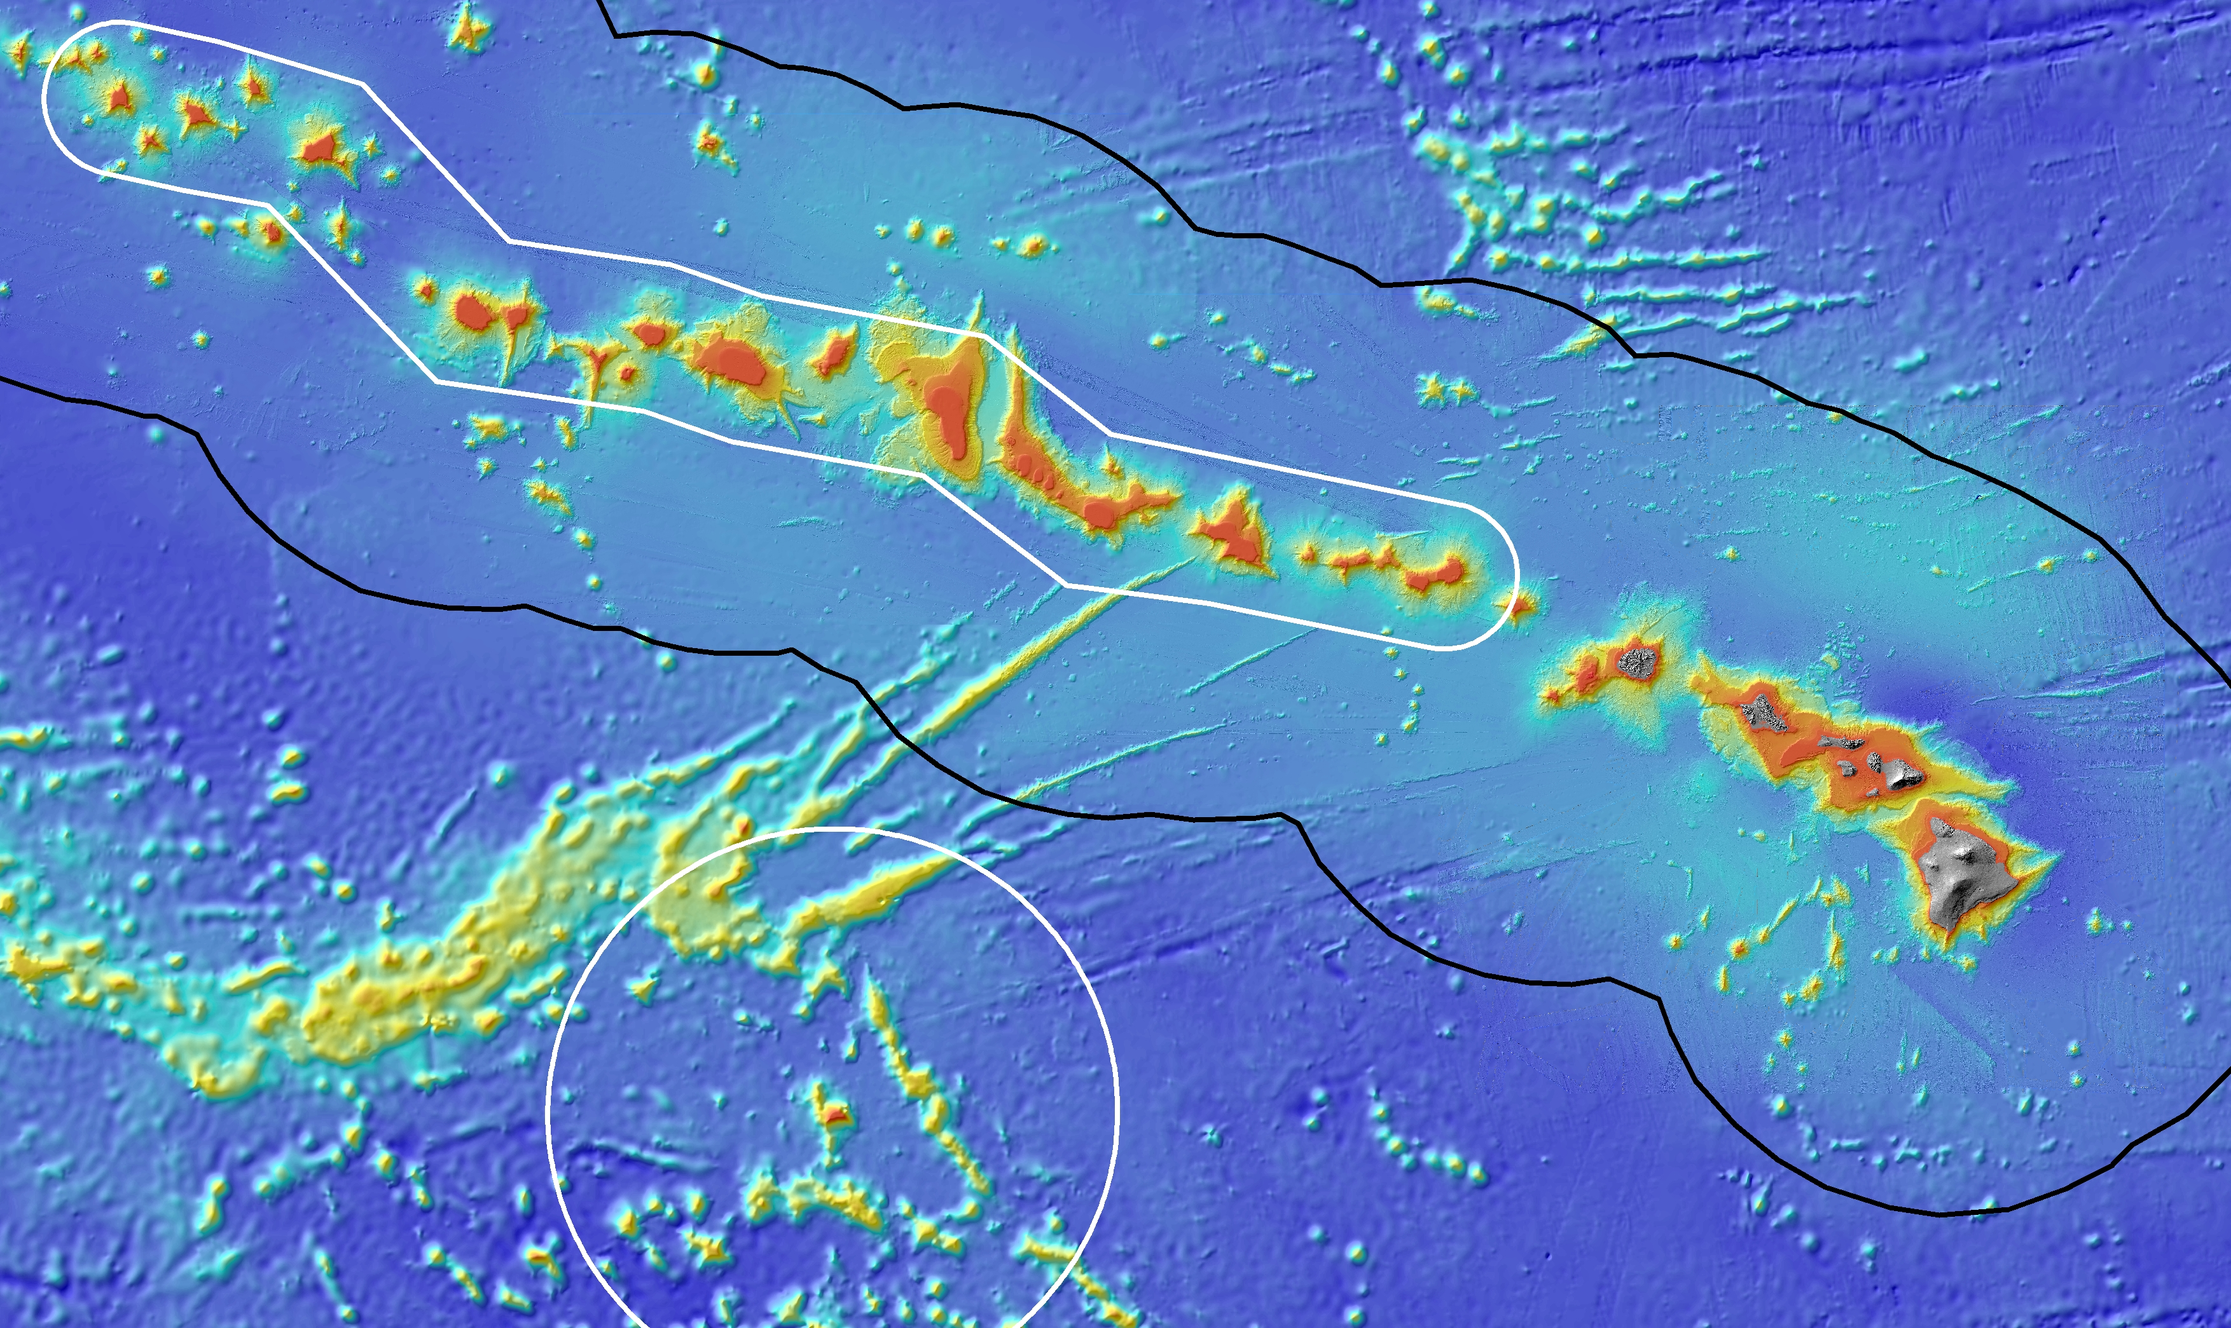
ROV Lead/Expedition Coordinator | Brian Bingham  Kelley Elliott
Science Team Leads | Frank Parrish (Biology)  Christopher Kelley (Biology)  Hans Von Tilburg (Archaeology)
General Area Descriptor | Main Hawaiian Islands
ROV Dive Name | Cruise Season |  | Leg |  |  | Dive Number
 | EX1504 |  | 3 |  |  | DIVE07
Equipment Deployed | ROV: |  | Deep Discoverer
 | Camera Platform: |  | Seirios
ROV Measurements | CTD |  | Depth |  |  | Altitude
 | Scanning Sonar |  | USBL Position |  |  | Heading
 | Pitch |  | Roll |  |  | HD Camera 1
 | HD Camera 2 |  | Low Res Cam 1 |  |  | Low Res Cam 2
 | Low Res Cam 3 |  | Low Res Cam 4 |  |  | Low Res Cam 2
Equipment Malfunctions | N/A
ROV Dive Summary  (From processed ROV data) | Dive Summary: EX1504L3_DIVE07  ^^^^^^^^^^^^^^^^^^^^^^^^^^^^^^^^^^^^^^^^^^^^^^^^^^^  In Water: 2015-09-03T19:00:12.265000  21°, 14.411' N ; 158°, 00.326' W  Out Water: 2015-09-03T22:33:55.328000  21°, 14.363' N ; 158°, 00.199' W  Off Bottom: 2015-09-03T22:11:20.718000  21°, 14.378' N ; 158°, 00.185' W  On Bottom: 2015-09-03T19:19:43.562000  21°, 14.409' N ; 158°, 00.182' W  Dive duration: 3:33:43  Bottom Time: 2:51:37  Max. depth: 402.9 m
Special Notes
Scientists Involved  (please provide name / location / affiliation / email) | Frank Parrish, EX, NOAA, Frank.Parrish@noaa.gov  Chris Kelley, EX, UH, ckelley@hawaii.edu  Hans Van Tilburg, EX, ONMS, hans.vantilburg@noaa.gov  Rachel Bassett, SC, DSCRTP, rachel.bassett@noaa.gov  Andrea Quatrini, CA, USGS, aquattrini@usgs.gov  Amy Baco-Taylor, FL, FSU, abacotaylor@fsu.edu  Asako Matsumoto, Japan, CIT, amatsu@gorgonian.jp  Chris Mah, DC, SI, mahch@si.edu  Scott France, LA, ULL, france@louisiana.edu  Brendan Roark, TX, TAMU, broark@geos.tamu.edu  Bruce Mundy, IRC ECC, PIFSC, bruce.mundy@noaa.gov  Mary Wicksten, TX, TAMU, wicksten@bio.tamu.edu  Michael Parke, IRC ECC, PIFSC, Michael.Parke@noaa.gov  John R. Smith, UH ECC, UH, jrsmith@hawaii.edu  Daniel Warren, TX, C&C Technologies, dan.warren@cctechnol.com  Jennifer McKinnon, NC, ECU, mckinnonje@ecu.edu  Melanie Damour, LA, BOEM, Melanie.Damour@boem.gov  Frank Cantelas, SS ECC, OER, frank.cantelas@noaa.gov  Kim Faulk, TX, GEMS/ACUA, Kim.Faulk@f-e-t.com
Purpose of the Dive
This dive will visit the hull of the World War I submarine S-19 which now rests on the bottom at 414 m in the middle of a sand expanse. After service in World War I the vessel was no longer needed and was intentionally scuttled by the Navy in 1938 and now serves as a relatively new feature of hard bottom habitat (~75 yrs old) for deep corals to colonize. The hull, which is intact, provides a unique glimpse of a community of pioneer settlement in deep corals. The objectives of the dive are to (1) recover a flow meter placed on the stern of the S-19, (2) to make observations on the condition of the vessel to support information on submerged cultural resources and (3) practice deploying and recovering a mock-up of a tilt meter instrument.

Description of the Dive:
All of the dive objectives were completed. The flowmeter was successfully recovered from the stern section of the S-19 hull. A complete survey of the of the full deck area of the S-19 hull was conducted with attention to the deep coral community looking for any evidence of recent arrival of the parasitic gold coral to resident host population growing on the S-19 hull. The practice deployment and recovery of the mock-up tilt meter indicated there would likely be few problems with the future deployment and recovery of the actual instruments. Observations on the condition of the S-19 itself indicate the submarine is relatively intact, aside from features removed prior to disposal, and resting on its midship section. Scour craters exist beneath both the unsupported bow and stern. Deterioration, flexing, and active corrosion of the hull and weather deck is very low compared to other sunken submarines. The survey was particularly useful for understanding the salvage operations completed prior to sinking. Diesel engines, superstructure, anchor, rudder and stern dive planes, propellers and shafts, and rotating bow planes had all been removed before the sub was scuttled.

Animals observed during the dive are listed below.

Cnidarians:
Thouarella hilgendorfi
Paracalyptrophora sp
Narella sp
Anthothela sp white
Gardineria hawaiiensis?
Lepidisis sp
Corallium sp
Acanella dispar
Madrepora oculata
Bathypathes sp
Stichopathes sp white
Callogorgia gilberti
Acanthogorgia sp
Plexauridae
Stoloniferous octocoral
Actinostolidae
Hormathiidae
Hydrodendron gorgonoide
Isadella sp
Paracalyptrophora sp
tubulariid hydrozoans

Sponges
Regadrella sp

Echinoderms
Ophiuroids
Stereocidaris hawaiiensis
Antedon sp yellow
Histocidaris variabilis
Astroceramus eldridgei
Charitometridae/Thalassometridae
Gorgonicephalidae

Arthropods
Heterocarpus ensifer
Plesionika pacifica
Plesionika edwardsii
Gooseneck barnacles
Munida sp

Fishes
Polymixia sp
Chrionema chryseres
Laemonema rhodochir
Pontinus macrocephalus
Hollardia goslinei
Moridae
Chaunax umbrinus
Epigonus sp

Other
Lyrocteis sp
Overall Map of ROV Dive Area |  |  |  | Close-up Map of Main Dive Site
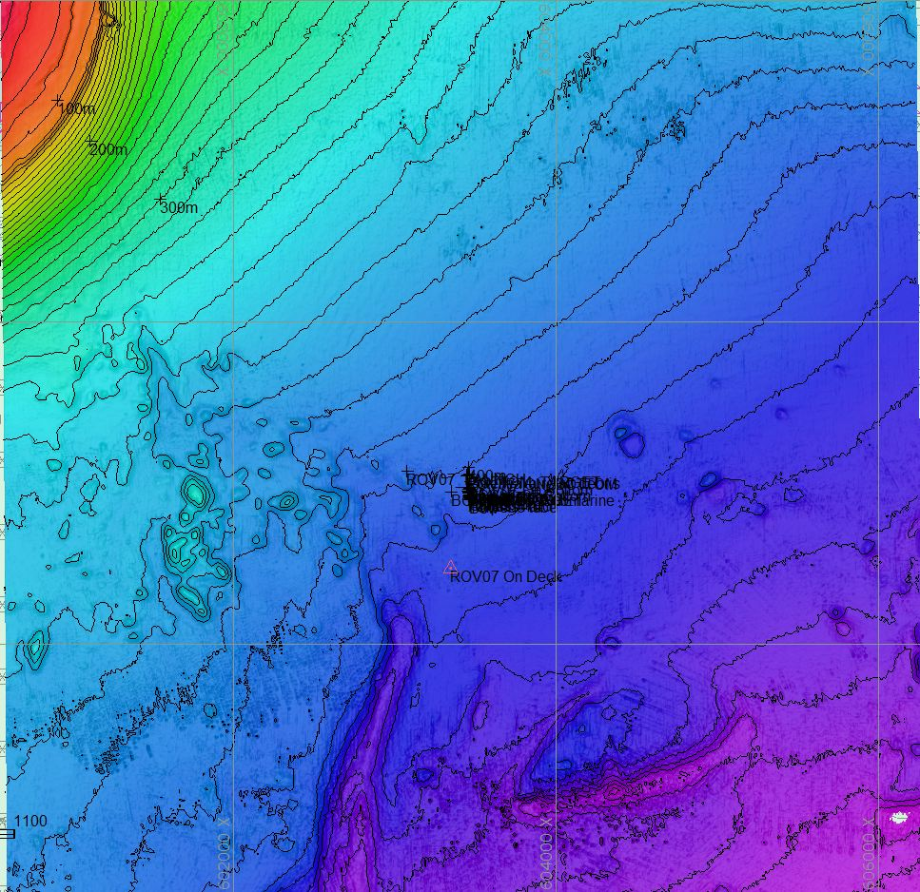 |  |  |  | 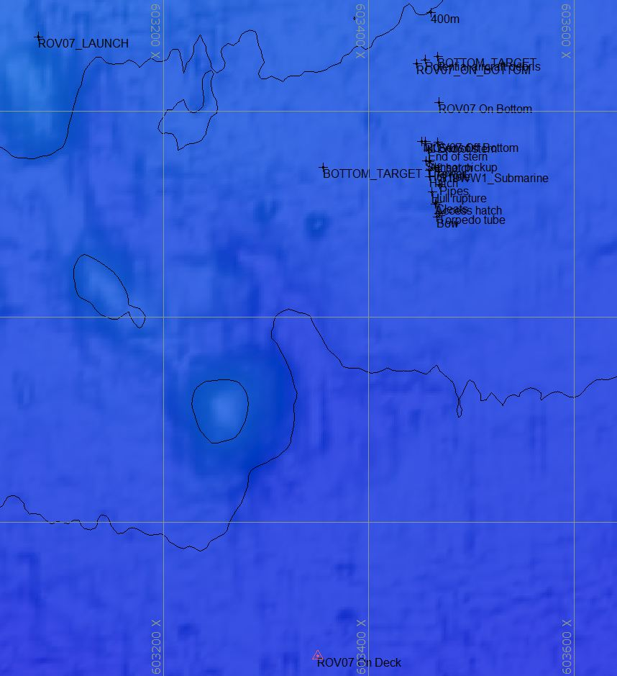
Hypack screen grab showing bathymetry data for the dive site. |  |  |  | Close up view of Hypack screen grab showing waypoints dropped during actual ROV dive.
Representative Photos of the Dive
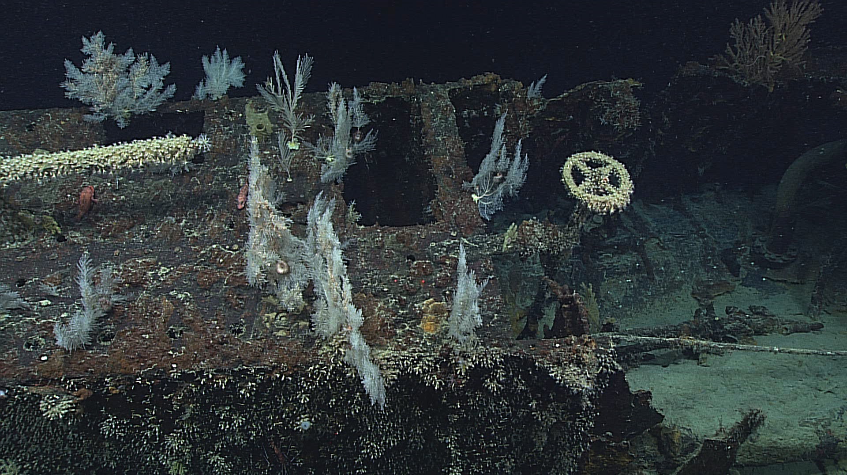 |  |  |  | 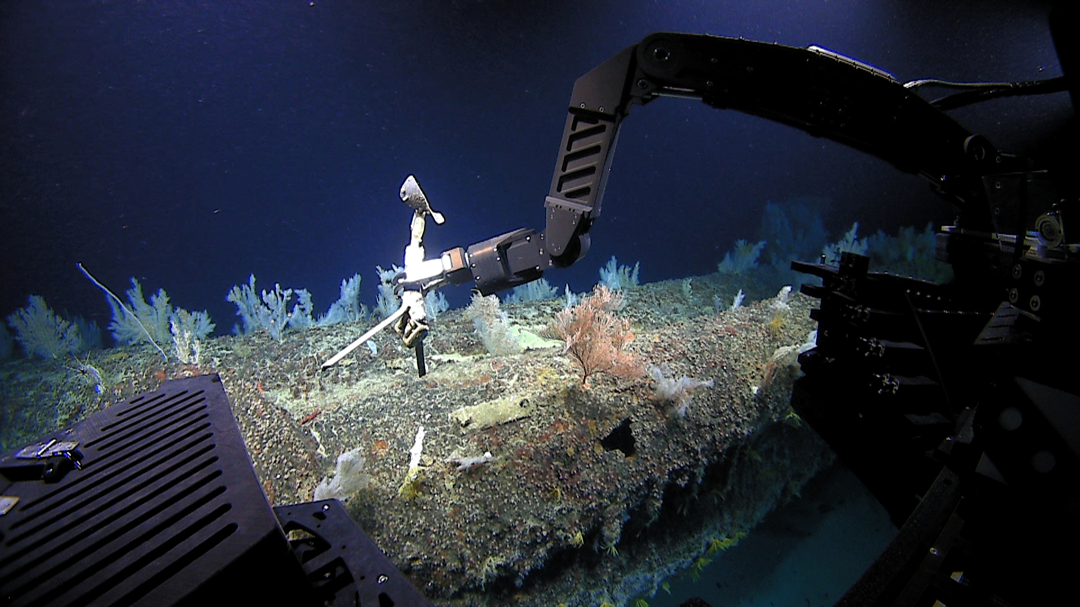
[Descriptive caption here] |  |  |  | [Descriptive caption here]
Please direct inquiries to: |  | NOAA Office of Ocean Exploration & Research  1315 East-West Highway (SSMC3 10th Floor)  Silver Spring, MD 20910  (301) 734-1014

