Okeanos Explorer ROV Dive Summary
Site Name |  | South Kona transect of 1868 lava flow |  |  |  | 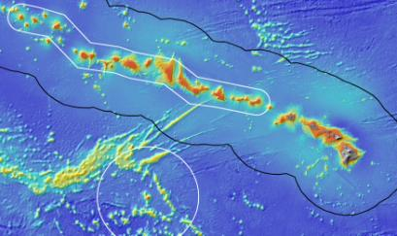
ROV Lead/Expedition Coordinator |  | Brian Bingham  Kelley Elliott
Science Team Leads |  | Frank Parrish (Biology)  Christopher Kelley (Biology)
General Area Descriptor |  | Main Hawaiian Islands
ROV Dive Name |  | Cruise Season |  | Leg |  |  | Dive Number
 |  | EX1504 |  | 3 |  |  | DIVE03
Equipment Deployed |  | ROV: |  | Deep Discoverer
 |  | Camera Platform: |  | Seirios
ROV Measurements |  | CTD |  | Depth |  |  | Altitude
 |  | Scanning Sonar |  | USBL Position |  |  | Heading
 |  | Pitch |  | Roll |  |  | HD Camera 1
 |  | HD Camera 2 |  | Low Res Cam 1 |  |  | Low Res Cam 2
 |  | Low Res Cam 3 |  | Low Res Cam 4 |  |  | Low Res Cam 2
Equipment Malfunctions |  | N/A
ROV Dive Summary  (From processed ROV data) |  | Dive Summary: EX1504L3_DIVE03  ^^^^^^^^^^^^^^^^^^^^^^^^^^^^^^^^^^^^^^^^^^^^^^^^^^^  In Water at: 2015-08-30T18:59:35.515000  18°, 57.592' N ; 155°, 43.940' W  Out Water at: 2015-08-31T02:27:22.250000  18°, 56.614' N ; 155°, 42.752' W  Off Bottom at: 2015-08-31T02:11:38.890000  18°, 56.741' N ; 155°, 42.804' W  On Bottom at: 2015-08-30T19:17:36.187000  18°, 57.535' N ; 155°, 43.901' W  Dive duration: 7:27:46  Bottom Time: 6:54:2  Max. depth: 454.9 m
Special Notes
Scientists Involved  (please provide name / location / affiliation / email) |  | Frank Parrish, EX, PIFSC/PSD, Frank.Parrish@noaa.gov  Chris Kelley, EX, UH, ckelley@hawaii.edu  Amy Baco-Taylor, FL, FSU, abacotaylor@fsu.edu  Asako Matsumoto, Japan, CIT, amatsu@gorgonian.jp  Chris Mah, DC, SI, mahch@si.edu  Michael Parke, HI, PIFSC, Michael.Parke@noaa.gov  Nicole Morgan, FL, FSU, nbmorgan11@gmail.com  Scott France, LA, ULL, france@louisiana.edu  Tina Molodtsova, Portugal, PPSIO, tina@ocean.ru  Rachel Bassett, SC, CCEHBR, Rachel.bassett@noaa.gov  Jonathan Tree, UH ECC, UH, jtree@hawaii.edu  Daniel Wagner, UH, PMNM, daniel.wagner@noaa.gov  Sam Kahng, UH ECC, HPU Skahng@HPU.edu  Meagan Putts, UH ECC, HPU, Mputts@HPU.edu  Brendan Roark, TX, TAMU-CC, broark@geos.tamu.edu  Michael Garcia, UH ECC, UH, mogarcia@hawaii.edu  Andrea Quattrini, CA, USGS, aquattrini@usgs.gov  Bruce Mundy, HI, IRC ECC, bruce.mundy@noaa.gov
Purpose of the Dive
This dive was the first use of the D2 to conduct a standardized survey of corals along a 450 contour at the southern end of the Kona Coast of the Big Island of Hawaii. The intent was survey a lava flow of a known age (1868) and see what coral community had grown in the years since the flow had formed. The objectives were to (1) travel a 2000 meter distance with the video recording a fixed wide frame with occasional snap zooms to verify coral taxa, (2) to use the laser scale to estimate the size frequency of the coral colonies encountered on the transect, and (3) to collect two basalt samples to verify the material and the age of the lava flow.
Description of the Dive:
All of the dive objectives were completed. The full 2000 m distance was covered completing the planned transect. Colonies of Hemicorallium sp, Kulamanamana haumeaae, Antipatharians and other coral were verified with a quick snap zoom of the camera to ensure progress on the transit was maintained and the full distance was covered. The dive did collect two basalt samples one at the beginning of the transect (near the edge of the flow) and one at the midpoint of the transect (the center of the flow).

Animals observed during the dive are listed below.

Cnidarians:
Acanthogorgia sp.
Corallium sp.
Hemicorallium cf. lauense
Isididae
Keratoisis sp.
Plexauridae
Callogorgia gilberti
Kulamanamana haumeae
Trissopathes pseudotristicha?
Calibelemnon symmetricum
Pennatula pearceyi
Hydrodendron gorgonoide
Stylobates aenaeus
Single polyp scleractinian
Chrysogorgia stellata
Acanthogorgia sp.
Anthomastus fisheri?
Anthomastus robustum
Primnoidae
Corallimorphus pileatus
Antipatharian
Umbellapathes helioanthes
Acanthogorgia striata
Swiftia sp.
Stichopathes sp
Bathypathes conferta
Chrysogorgia geniculata

Sponges
Regadrella sp
Poecillastra sp.
Uncinateridae new genus?

Echinoderms
Stereocidaris hawaiiensis
Sphaeriodiscus ammophilus
Starfish
Hippasteria municepula
Astroceramus eldridgei
Pedinidae
Atelocrinus conifer?

Arthropods
Paromola sp
Squat lobster
Gooseneck barnacles
Plesionika sp
Sympagurus dofleini
Crab
Indosquilla manihinei

Fishes
Chrionema chryseres
Chlorophthalmus proridens
Hollardia goslinei
Ophichthid eel
Epigonus glossodontus
Hoplostethus crassispinus
Scorpaenidae
Satyrichthys engyceros
Grammicolepis brachiusculus
Randallichthys filamentosus
Polymixia sp
Myctophidae
Beryx sp.
Malthopsis sp?
Eumegistus sp
Chaunax umbrinus

Other
Ctenophore
Lyrocteis sp (benthic ctenophore)
Salp
Xenophyophore

Overall Map of Dive Area |  |  |  |  | Actual track of ROV dive
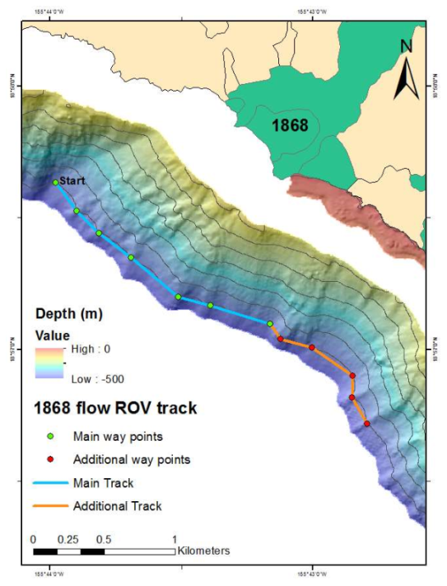 |  |  |  |  | 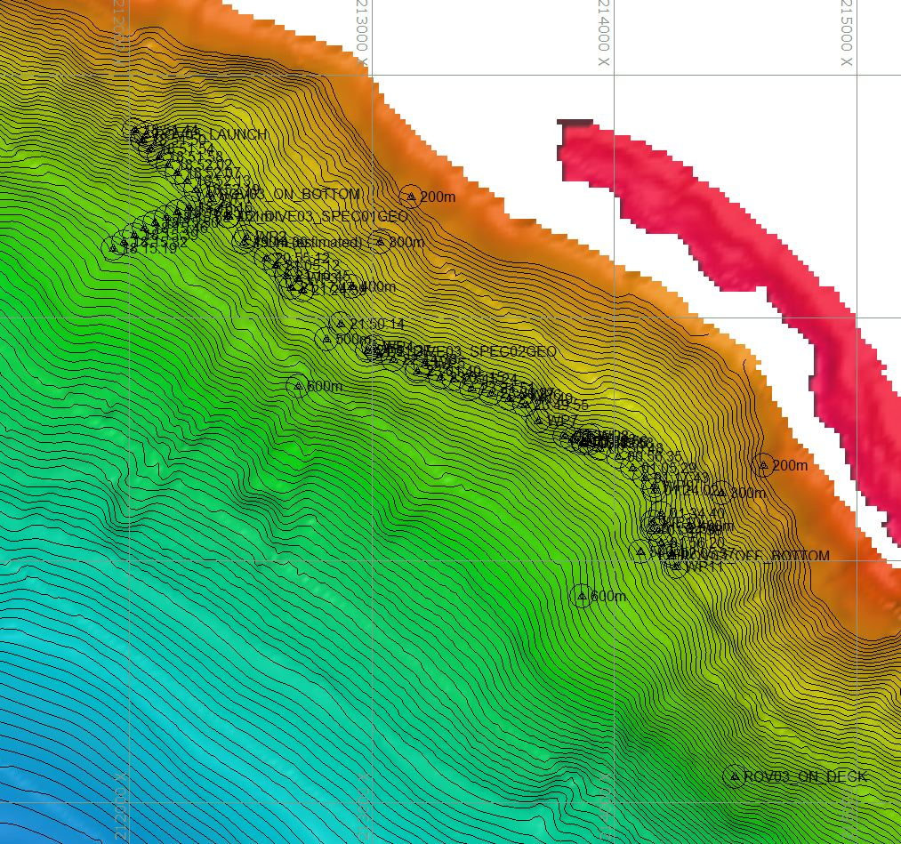
Bathymetry data for the dive site. Planned dive start and end points are at right and end of track lines. |  |  |  |  | Hypack screen grab showing waypoints dropped during actual ROV dive.
Representative Photos of the Dive
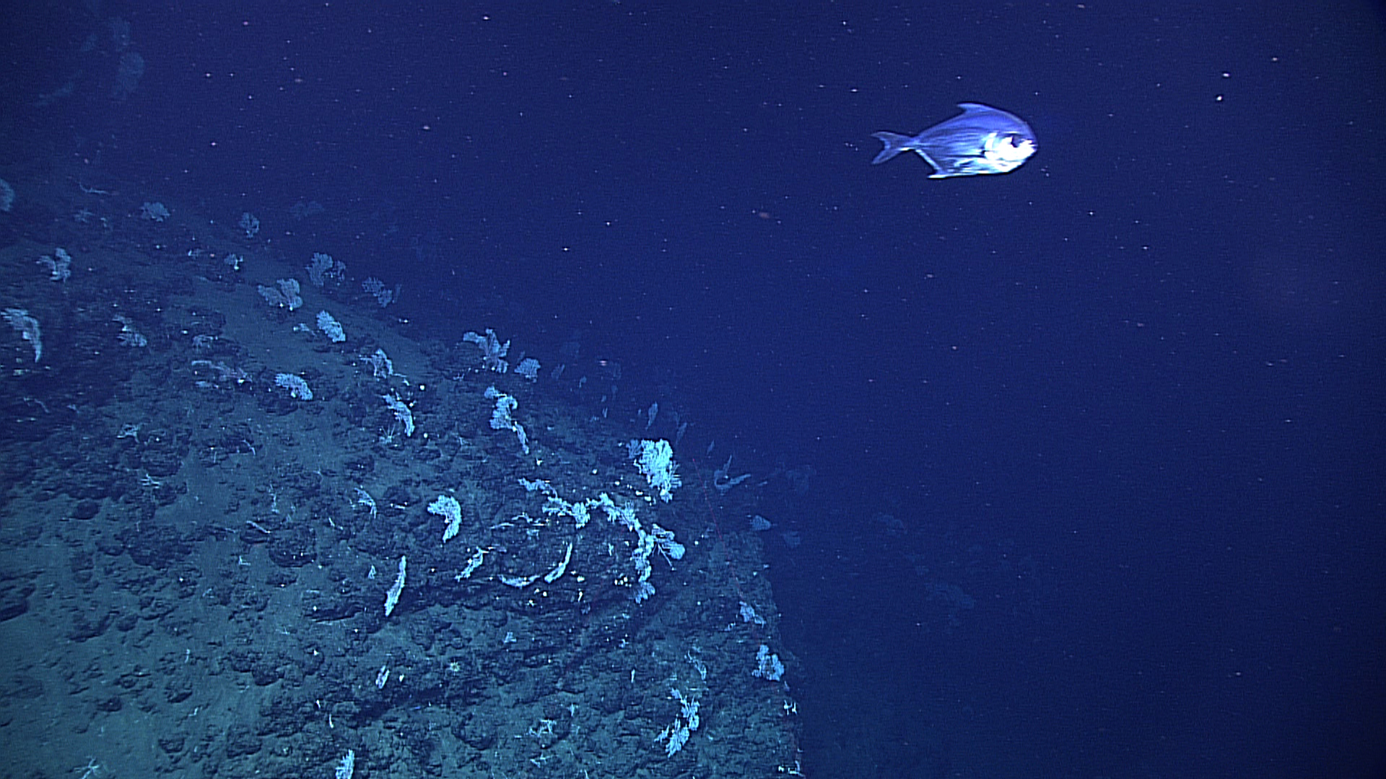 |  |  |  |  | 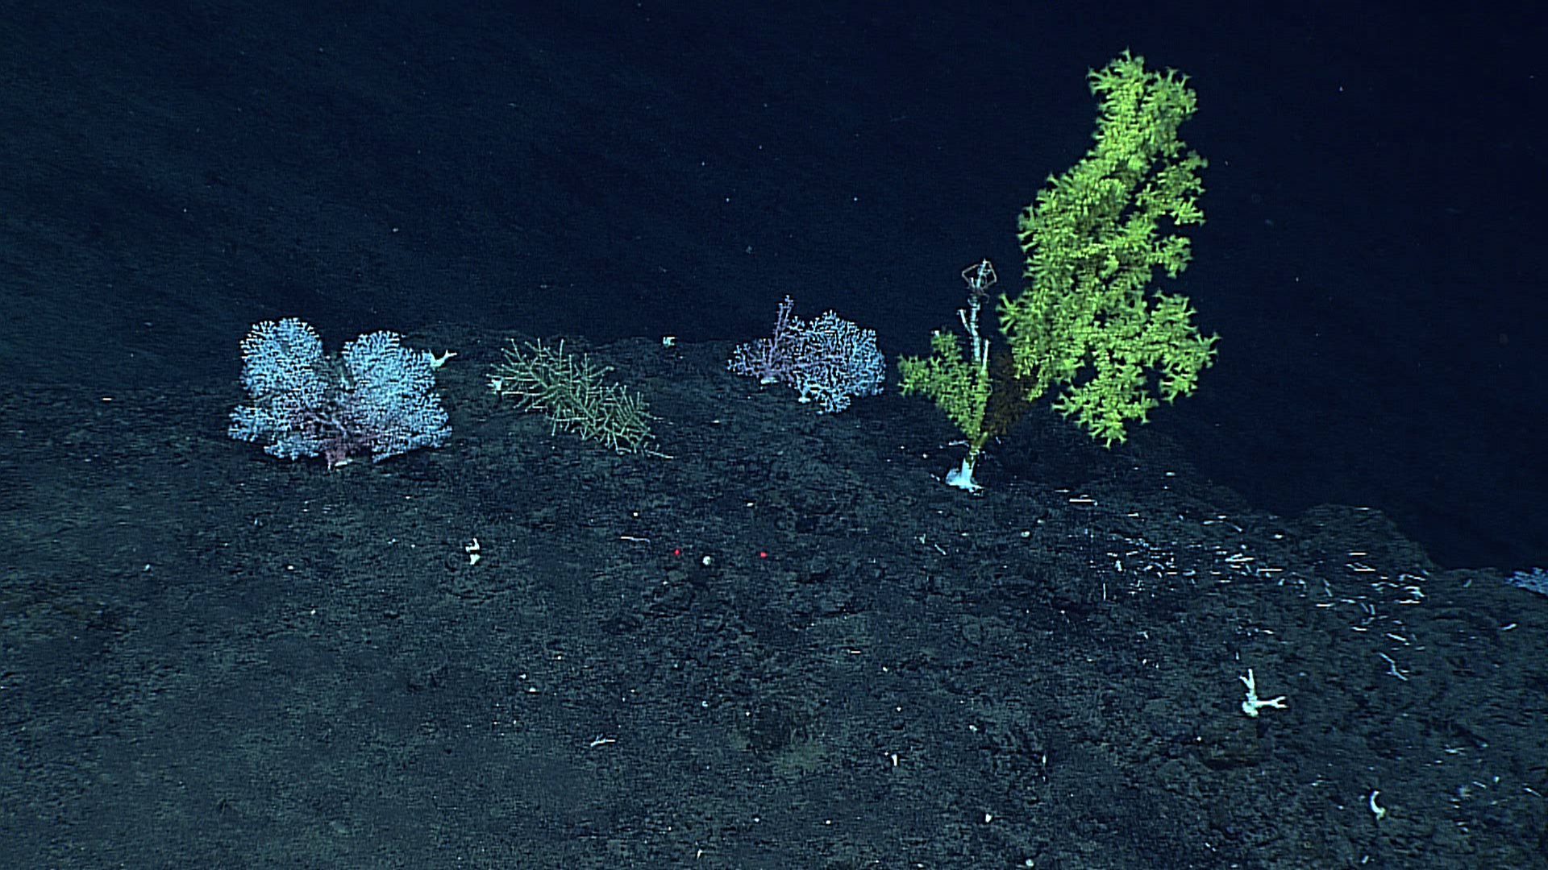
Precious coral in the family Coralliidae covering a ridge along the survey route. A deep water pomfret (Bramidae) swims by as the ROV approached. |  |  |  |  | Precious pink coral in the family Coralliidae (left) and gold coral (Kulamanamana haumeae, right) observed during the transect.
Samples Collected
Sample ID | EX1504L3_D2_DIVE03_SPEC01GEO |  |  |  | 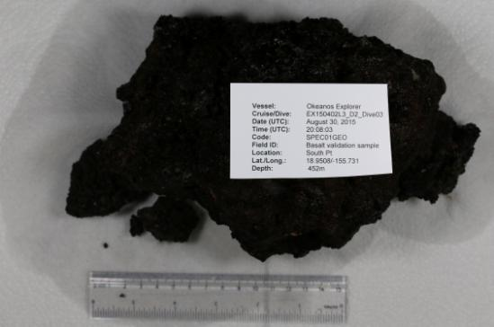
Date (UTC) | August 30, 2015
Time (UTC) | 20:08:03
Depth (m) | 452
Temperature (ºC) | 7.40
Oxygen (mL/L) | 1.90
Field ID(s) | Basalt validation sample
Comments
Sample ID | EX1504L3_D2_DIVE03__SPEC02GEO |  |  |  | 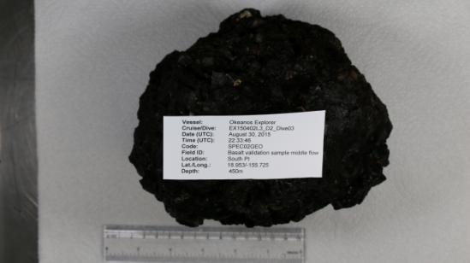
Date (UTC) | August 30, 2015
Time (UTC) | 22:33:46
Depth (m) | 450
Temperature (ºC) | 6.80
Oxygen (mL/L) | 1.60
Field ID(s) | Basalt valid. samp. middle flow
Comments
Please direct inquiries to: |  |  | NOAA Office of Ocean Exploration & Research  1315 East-West Highway (SSMC3 10th Floor)  Silver Spring, MD 20910  (301) 734-1014

