Okeanos Explorer ROV Dive Summary
Site Name |  | Makapuu Precious Coral Bed |  |  |  | 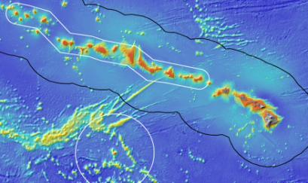
ROV Lead/Expedition Coordinator |  | Brian Bingham  Kelley Elliott
Science Team Leads |  | Frank Parrish (Biology)  Christopher Kelley (Biology)
General Area Descriptor |  | Main Hawaiian Islands
ROV Dive Name |  | Cruise Season |  | Leg |  |  | Dive Number
 |  | EX1504 |  | 3 |  |  | DIVE01
Equipment Deployed |  | ROV: |  | Deep Discoverer
 |  | Camera Platform: |  | Seirios
ROV Measurements |  | CTD |  | Depth |  |  | Altitude
 |  | Scanning Sonar |  | USBL Position |  |  | Heading
 |  | Pitch |  | Roll |  |  | HD Camera 1
 |  | HD Camera 2 |  | Low Res Cam 1 |  |  | Low Res Cam 2
 |  | Low Res Cam 3 |  | Low Res Cam 4 |  |  | Low Res Cam 2
Equipment Malfunctions |  | There was a problem with the A-frame immediately after the ROV was deployed which prompted its recovery. The dive was aborted at the surface without descending.
ROV Dive Summary  (From processed ROV data) |  | The dive was aborted at the surface immediately after deployment.
Special Notes
Scientists Involved  (please provide name / location / affiliation / email) |  | Frank Parrish, EX, NOAA, Frank.Parrish@noaa.gov  Chris Kelley, EX, UH, ckelley@hawaii.edu  Amy Baco-Taylor, FSU, abacotaylor@fsu.edu  John R Smith, UH, jrsmith@hawaii.edu  Mike Ford, NOAA, Michael.ford@noaa.gov
Purpose of the Dive
This dive will drop at the south edge of the Makapuu precious coral bed. The objectives are to (1) recover two flow meters placed at the edge of the bed and (2) to proceed into the bed and survey the community along the southern edge. Most of the Makapuu bed is a continuous, even carbonate pavement but roughly half a km inside the southern edge there is a spur of relief that contrasts the rest of the bed. The start position is the location of the flow meters and when instrument recovery is complete we will conduct the survey north into the bed for the remaining time available. Surveys at Makapuu are always of interest as this area has been the primary focus of the precious coral fishery throughout its history and the southern edge has received less attention than other areas of the bed.
Description of the Dive:
The dive was aborted at the surface immediately after deployment.

Overall Map of Dive Area |  |  |  |  | Actual track of ROV dive
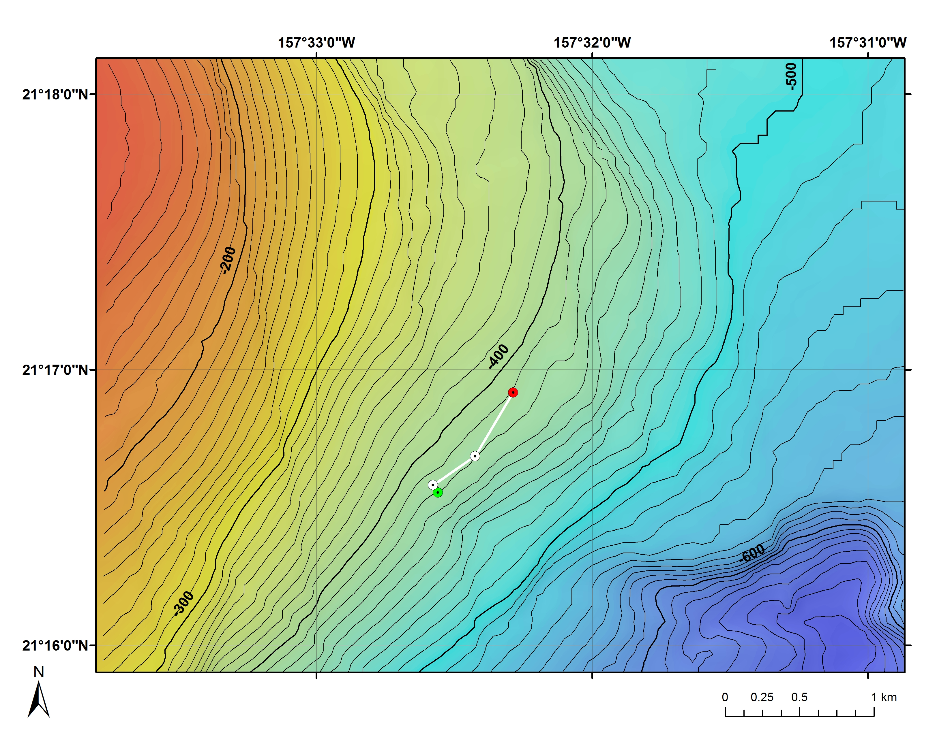
Bathymetry data for the dive site. Planned dive start and end points are shown as green and red dots, respectively. |  |  |  |  | Bathymetry data for the dive site showing tracking positions
Representative Photos of the Dive
Samples Collected
Sample ID
Date (UTC)
Time (UTC)
Depth (m)
Temperature (ºC)
Oxygen (mL/L)
Field ID(s)
Comments
Sample ID
Date (UTC)
Time (UTC)
Depth (m)
Temperature (ºC)
Oxygen (mL/L)
Field ID(s)
Comments
Please direct inquiries to: |  |  | NOAA Office of Ocean Exploration & Research  1315 East-West Highway (SSMC3 10th Floor)  Silver Spring, MD 20910  (301) 734-1014

