Okeanos Explorer ROV Dive Summary
Site Name |  | McCall Seamount |  |  |  | 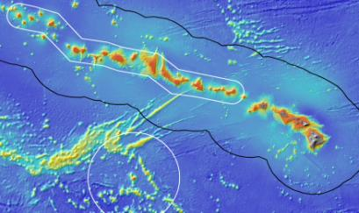
ROV Lead/Expedition Coordinator |  | Brian Bingham  Kelley Elliott
Science Team Leads |  | Frank Parrish (Biology)  Christopher Kelley (Biology)
General Area Descriptor |  | Main Hawaiian Islands
ROV Dive Name |  | Cruise Season |  | Leg |  |  | Dive Number
 |  | EX1504 |  | 3 |  |  | DIVE04
Equipment Deployed |  | ROV: |  | Deep Discoverer
 |  | Camera Platform: |  | Seirios
ROV Measurements |  | CTD |  | Depth |  |  | Altitude
 |  | Scanning Sonar |  | USBL Position |  |  | Heading
 |  | Pitch |  | Roll |  |  | HD Camera 1
 |  | HD Camera 2 |  | Low Res Cam 1 |  |  | Low Res Cam 2
 |  | Low Res Cam 3 |  | Low Res Cam 4 |  |  | Low Res Cam 2
Equipment Malfunctions |  | Onshore participants reported frequent transmission problems including periodic loss and freezing of video as well as periodic loss of the chat room and teleconference interface.
ROV Dive Summary  (From processed ROV data) |  | Dive Summary: EX1504L3_DIVE04  ^^^^^^^^^^^^^^^^^^^^^^^^^^^^^^^^^^^^^^^^^^^^^^^^^^^  In Water: 2015-08-31T18:42:14.156000  N/A ; N/A  Out Water: 2015-09-01T02:27:19.453000  18°, 58.959' N ; 157°, 06.310' W  Off Bottom: 2015-09-01T00:58:41.500000  18°, 58.616' N ; 157°, 06.651' W  On Bottom: 2015-08-31T20:03:54.390000  18°, 58.983' N ; 157°, 06.705' W  Dive duration: 7:45:5  Bottom Time: 4:54:47  Max. depth: 2715.0 m
Special Notes
Scientists Involved  (please provide name / location / affiliation / email) |  | Frank Parrish, EX, NOAA, Frank.Parrish@noaa.gov  Chris Kelley, EX, UH, ckelley@hawaii.edu  Amy Baco-Taylor, FL, FSU, abacotaylor@fsu.edu  Asako Matsumoto, Japan, CIT, amatsu@gorgonian.jp  Chris Mah, DC, SI, mahch@si.edu  Nicole Morgan, FL, FSU, nbmorgan11@gmail.com  Scott France, LA, ULL, france@louisiana.edu  Tina Molodtsova, Portugal, PPSIO, tina@ocean.ru  Rachel Bassett, SC, DSCRTP, rachel.bassett@noaa.gov  Meagan Putts, UH ECC, HPU, Mputts@HPU.edu  Brendan Roark, TX, TAMU, broark@geos.tamu.edu  Michael Garcia, UH ECC, UH, mogarcia@hawaii.edu  Bruce Mundy, IRC ECC, PIFSC, NOAA, bruce.mundy@noaa.gov
Purpose of the Dive
This dive was the first ever conducted on McCall Seamount in the group of topographic features referred to as the Geologist Seamounts. The dive surveyed the crest of a sharp ridge that extended north of the seamount at a depth of 2700 m. The survey employed the standard methodology of the D2 with the objectives of 1) making observations and collecting video and 2) collecting rock and biological samples.
Description of the Dive:
All of the dive objectives were completed. Nearly the full planned distance of the dive track was achieved. The ridge crest was covered with loose talus and was almost completely barren of animals, which was unexpected. This type of substrate continued throughout the dive except for a couple of small ledges consisting primarily of pillow lavas. Two basalt rocks were collected specifically for geology and one additional rock was collected as part of a coral sample. In total 4 coral samples (a stoloniferous hydrozoan, Stauropathes sp., a primnoid, and a Schizopathes sp?. were collected.

Animals observed during the dive are listed below.

Cnidarians:
Chrysogorgia pinnata
Primnoid
Isididae unbranched
Keratoisis sp
Hydrozoan stoloniferous
Stauropathes sp.
Narella dichotoma
Keratoisis sp.
Schizopathes sp?
Actinostolidae
Bathypathes sp

Sponges
Hexactinellida various unidentified
Farrea nr occa erecta?
Semperella sp.
Caulophacus (oxydiscus) sp
Caulophacus (Caulodiscus) sp
Rossellidae?
Corbitellinae?

Echinoderms
Holothuroidean
Deimatidae
Unidentified sea star
Stalked crinoid Hyacrinidae
Comatulina crinoid
Hymenaster sp
Glyptometra lateralis?

Arthropods
Nematocarcinus tenuirostris
Balanoid or verricid barnacles
Unidentified shrimp

Fishes
Ophidiidae

Other

Overall Map of ROV Dive Area |  |  |  |  | Close-up Map of Main Dive Site
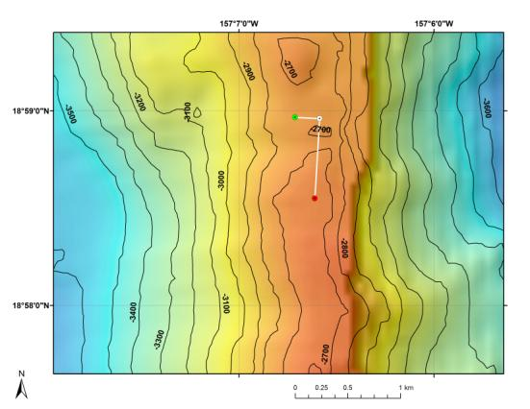 |  |  |  |  | 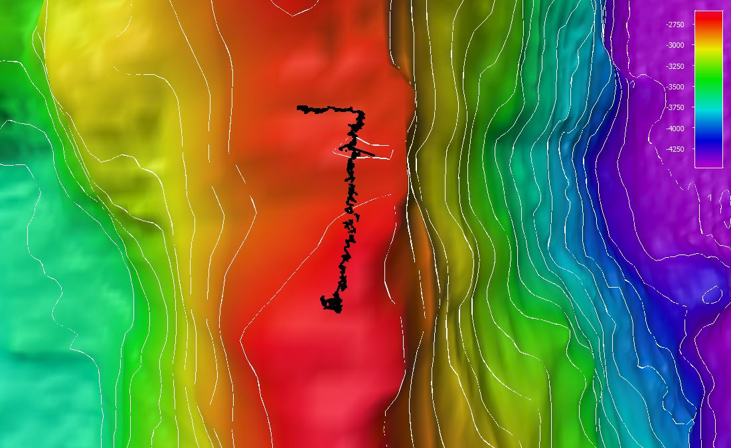
Bathymetry data for the dive site. Planned dive start and end points are shown as green and red dots, respectively. |  |  |  |  | Close-up showing actual ROV dive track as executed.
Representative Photos of the Dive
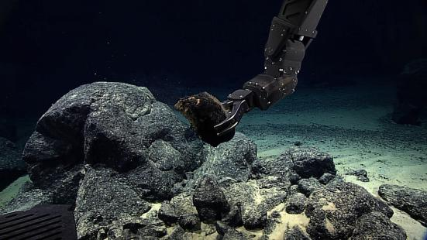 |  |  |  |  | 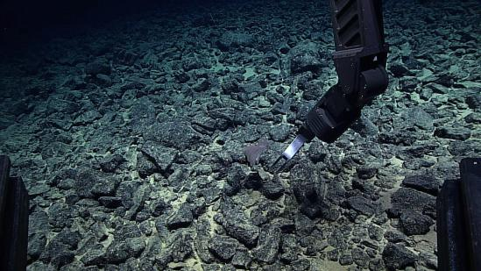
Collection of a vessiculated basalt sample from the crest of the ridge at the beginning of the dive. The expected thick Mn crusting was not observed at this site. |  |  |  |  | Collecting of a potential Schizopathes sp at the end of the dive. If the field identification is correct, this is either a new record or new species for Hawaii.
Samples Collected
Sample ID | D2_DIVE04_SPEC01GEO |  |  |  | 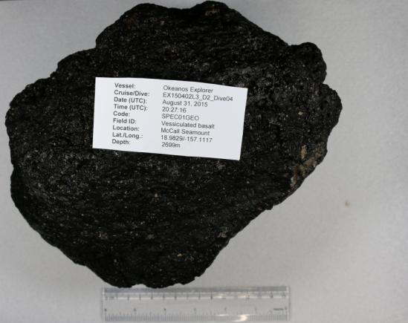
Date (UTC) | August 31, 2015
Time (UTC) | 20:27:16
Depth (m) | 2699
Temperature (ºF) | 1.67
Field ID(s) | Vessiculated basalt
Comments
Sample ID | D2_DIVE04_SPEC02BIO |  |  |  | 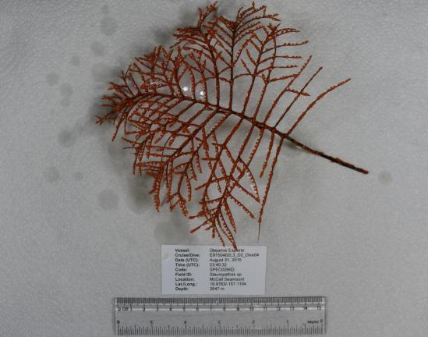
Date (UTC) | August 31, 2015
Time (UTC) | 23:40:32
Depth (m) | 2646
Temperature (ºF) | 1.58
Field ID(s) | Stauropathes sp.
Comments
Sample ID | D2_DIVE04_SPEC03GEO |  |  |  | 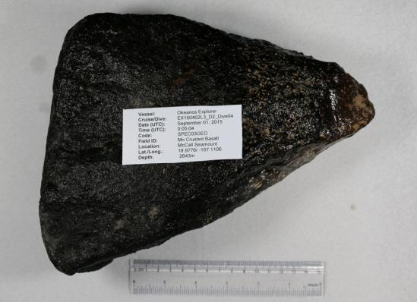
Date (UTC) | September 1, 2015
Time (UTC) | 0:05:04
Depth (m) | 2643
Temperature (ºF) | 1.57
Field ID(s) | Mn encrusted Basalt sample
Comments
Sample ID | D2_DIVE04_SPEC04GEO  D2_DIVE04_SPEC04GEO_C01  D2_DIVE04_SPEC04GEO_C02 |  |  |  | 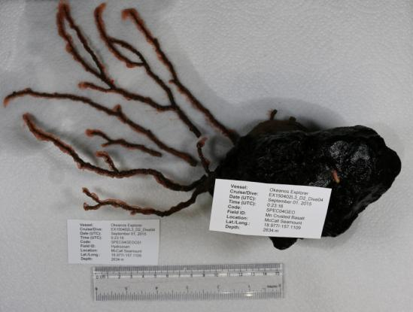
Date (UTC) | September 1, 2015
Time (UTC) | 0:23:16
Depth (m) | 2634
Temperature (ºF) | 1.57
Field ID(s) | Mn encrusted Basalt sample  Hydrozoan  Polychaete Worm
Comments
Samples Collected
Sample ID | D2_DIVE04_SPEC05BIO |  |  |  | 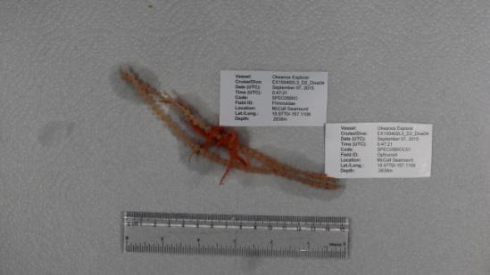
Date (UTC) | September 1, 2015
Time (UTC) | 0:47:21
Depth (m) | 2638
Temperature (ºF) | 1.58
Field ID(s) | Primnoid  Ophiuroid
Comments
Sample ID | D2_DIVE04_SPEC06BIO |  |  |  | 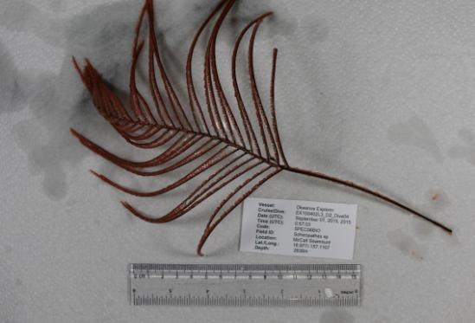
Date (UTC) | September 1, 2015
Time (UTC) | 0:57:03
Depth (m) | 2638
Temperature (ºF) | 1.58
Field ID(s) | Schizopathes sp
Comments
Please direct inquiries to: |  |  | NOAA Office of Ocean Exploration & Research  1315 East-West Highway (SSMC3 10th Floor)  Silver Spring, MD 20910  (301) 734-1014

