Okeanos Explorer ROV Dive Summary
Site Name |  | Kona Precious Coral Bed |  |  |  | 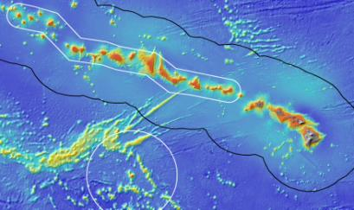
ROV Lead/Expedition Coordinator |  | Brian Bingham  Kelley Elliott
Science Team Leads |  | Chris Kelley (Biology)  Frank Parrish (Biology)
General Area Descriptor |  | Main Hawaiian Islands
ROV Dive Name |  | Cruise Season |  | Leg |  |  | Dive Number
 |  | EX1504 |  | 3 |  |  | DIVE02
Equipment Deployed |  | ROV: |  | Deep Discoverer
 |  | Camera Platform: |  | Seirios
ROV Measurements |  | CTD |  | Depth |  |  | Altitude
 |  | Scanning Sonar |  | USBL Position |  |  | Heading
 |  | Pitch |  | Roll |  |  | HD Camera 1
 |  | HD Camera 2 |  | Low Res Cam 1 |  |  | Low Res Cam 2
 |  | Low Res Cam 3 |  | Low Res Cam 4 |  |  | Low Res Cam 2
Equipment Malfunctions |  | Some audio problems were reported by onshore participants. Teleconference was interrupted several times as well.
ROV Dive Summary  (From processed ROV data) |  | Dive Summary: EX1504L3_DIVE02  ^^^^^^^^^^^^^^^^^^^^^^^^^^^^^^^^^^^^^^^^^^^^^^^^^^^  In Water at: 2015-08-29T19:06:30.125000  19°, 48.194' N ; 156°, 07.643' W  Out Water at: 2015-08-30T02:25:52.859000  19°, 48.121' N ; 156°, 07.575' W  Off Bottom at: 2015-08-30T02:11:25.218000  19°, 48.094' N ; 156°, 07.560' W  On Bottom at: 2015-08-29T19:24:32.671000  19°, 48.299' N ; 156°, 07.547' W  Dive duration: 7:19:22  Bottom Time: 6:46:52  Max. depth: 393.7 m
Special Notes
Scientists Involved  (please provide name / location / affiliation / email) |  | Frank Parrish, EX, PIFSC/PSD, Frank.Parrish@noaa.gov  Chris Kelley, EX, UH, ckelley@hawaii.edu  Amy Baco-Taylor, FL, FSU, abacotaylor@fsu.edu  Asako Matsumoto, Japan, CIT, amatsu@gorgonian.jp  Chris Mah, DC, USMNH, mahch@si.edu  Michael Parke, HI, PIFSC, Michael.Parke@noaa.gov  Nicole Morgan, FL, FSU, nbmorgan11@gmail.com  Scott France, LA, ULL, france@louisiana.edu  Steve Auscavitch, PA, Temple, steven.auscavitch@temple.edu  Tina Molodtsova, Portugal, PPSIO, tina@ocean.ru  Rachel Bassett, SC, CCEHBR, Rachel.bassett@noaa.gov  Daniel Wagner, HI, PMNM, daniel.wagner@noaa.gov
Purpose of the Dive
This dive targeted the middle of the Keahole precious coral bed off the Kona Coast of the Big Island of Hawaii. The objectives were to (1) recover an acoustic current meter and three flow meters placed throughout the bed, (2) to make observations on nearby previously marked colonies, and (3) to spend the remaining time exploring the surrounding environment. Most of the Keahole bed is carbonate ledge habitat and this dive was intended to spend much of the dive time working the top edge of the drop off.
Description of the Dive:
All of the dive objectives were completed. The acoustic Doppler current meter and three flow meters were all found and recovered. Colonies of gold coral near these instruments or marked by flower pots at other locations were located and close-up imagery was acquired for comparison to photographs of the colonies taken over 3 years ago. In addition, time remained during the dive to collect two biological specimens, a black coral and a bamboo coral, as well as fossil coral branches.

Animals observed during the dive are listed below.

Cnidarians:
Acanthogorgia sp.
Corallium sp.
Hemicorallium cf. lauense
Isidella trichotoma?
Keratoisis sp. (collected)
Lepidisis olapa
Acanella dispar?
Paracis sp?
Plexauridae sp.
Callogorgia gilberti
Kulamanamana haumeae
Leiopathes annosa
Trissopathes pseudotristicha?
Chrysopathes sp (collected)
Calibelemnon symmetricum
Pennatula pearceyi
Hydrodendron gorgonoide
Stylobates aenaeus
Single polyp scleractinian

Sponges
Regadrella sp

Echinoderms
Stereocidaris hawaiiensis
Sphaeriocidaris ammophilis

Arthropods
Paromola sp
Squat lobster
Gooseneck barnacles
Plesionika sp
Sympagurus dofleini

Fishes
Chrionema chryseres
Chlorophthalmus proridens
Hollardia goslinei
Ophichthid eel
Lophioides miacanthus
Epigonus glossodontus
Hoplostethus crassispinus
Scorpaenid
Satyrichthys engyceros
Sphenanthias sp

Other
Lyrocteis sp (benthic ctenophore)

Overall Map of ROV Dive Area |  |  |  |  | Close-up Map of Main Dive Site
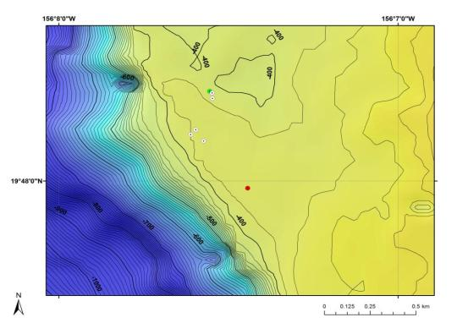 |  |  |  |  | 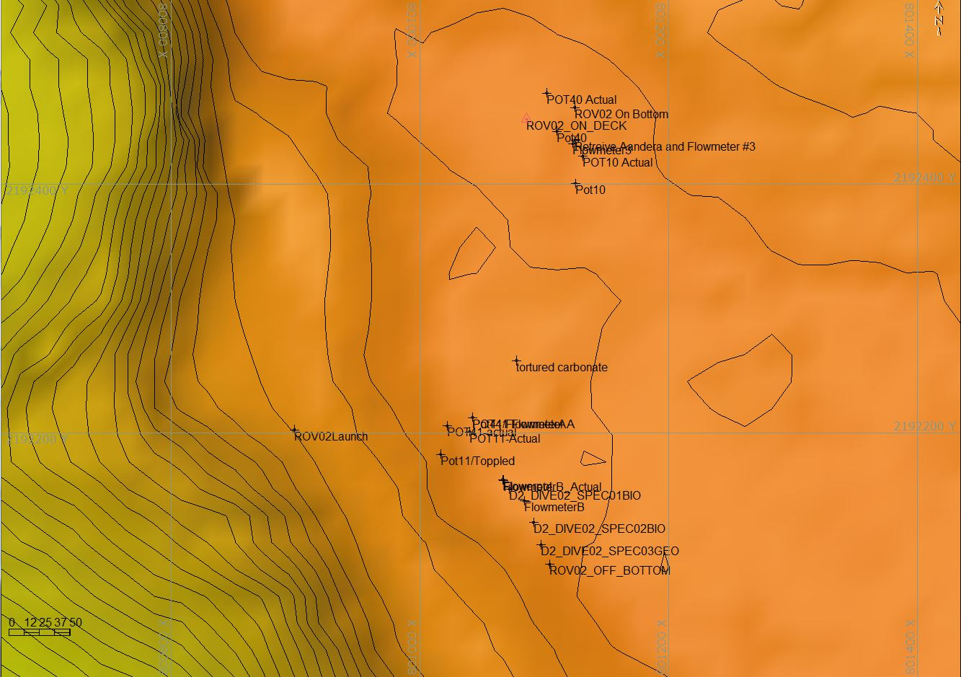
Bathymetry data for the dive site. Planned dive start and end points are shown as green and red dots, respectively. |  |  |  |  | Hypack screen grab showing waypoints dropped during the actual ROV dive.
Representative Photos of the Dive
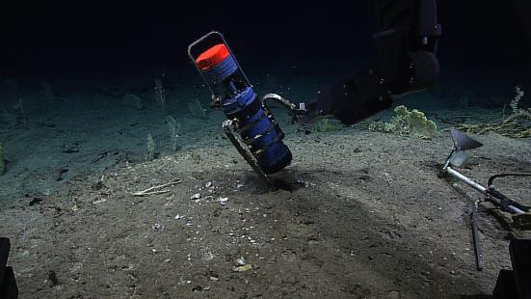 |  |  |  |  | 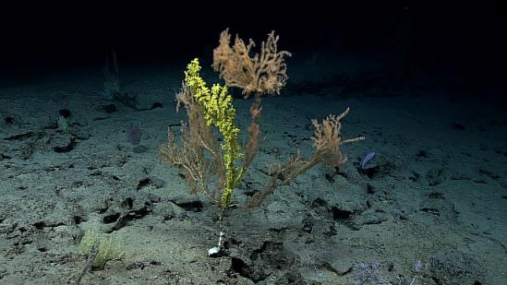
Recovery of the Andara ADCP that was placed on the site in 2012. |  |  |  |  | Gold coral (Kulamanamana haumeae (yellow) in the early stages of colonizing and overgrowing a bamboo coral.
Samples Collected
Sample ID | EX1504L3_D2_DIVE02_SPEC01BIO |  |  |  | 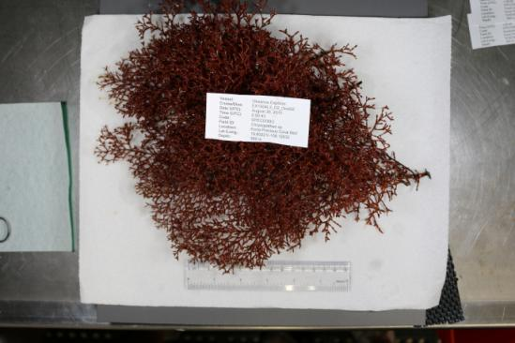
Date (UTC) | August 30, 2015
Time (UTC) | 0:50:43
Depth (m) | 389
Temperature (ºF) | 8.11
Field ID(s) | Chrysopathes sp
Comments
Sample ID | EX1504L3_D2_Dive02_SPEC02BIO |  |  |  | 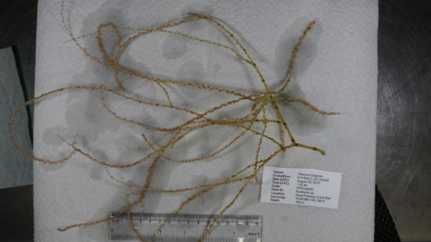
Date (UTC) | August 30, 2015
Time (UTC) | 1:43:45
Depth (m) | 393
Temperature (ºF) | 8.11
Field ID(s) | Keratoisis sp
Comments
Sample ID | EX1504L3_D2_Dive02_SPEC03GEO |  |  |  | 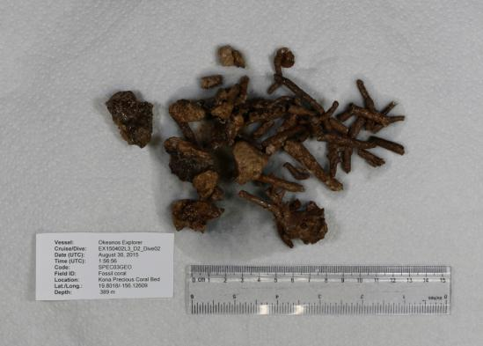
Date (UTC) | August 30, 2015
Time (UTC) | 1:56:56
Depth (m) | 389
Temperature (ºF) | 8.18
Field ID(s) | Fossil Coral
Comments
Please direct inquiries to: |  |  | NOAA Office of Ocean Exploration & Research  1315 East-West Highway (SSMC3 10th Floor)  Silver Spring, MD 20910  (301) 734-1014

