Okeanos Explorer ROV Dive Summary
Site Name |  | East North Gardner |  |  |  | 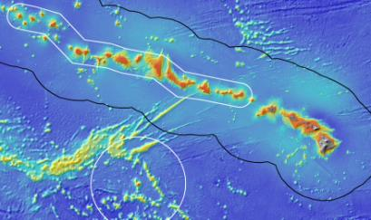
ROV Lead/Expedition Coordinator |  | Karl McLetchie  Kelley Elliott
Science Team Leads |  | Chris Kelley (Biology)  Daniel Wagner (Biology)
General Area Descriptor |  | Northwestern Hawaiian Islands
ROV Dive Name |  | Cruise Season |  | Leg |  |  | Dive Number
 |  | EX1504 |  | 2 |  |  | DIVE17
Equipment Deployed |  | ROV: |  | Deep Discoverer
 |  | Camera Platform: |  | Seirios
ROV Measurements |  | CTD |  | Depth |  |  | Altitude
 |  | Scanning Sonar |  | USBL Position |  |  | Heading
 |  | Pitch |  | Roll |  |  | HD Camera 1
 |  | HD Camera 2 |  | Low Res Cam 1 |  |  | Low Res Cam 2
 |  | Low Res Cam 3 |  | Low Res Cam 4 |  |  | Low Res Cam 2
Equipment Malfunctions |  | There were several communications issues between the shore-based and shipboard science team. The teleconference line was dropped for prolonged periods of time and the shore-based team reported that the video froze on multiple occasions.
ROV Dive Summary  (From processed ROV data) |  | Dive Summary: EX1504L2_DIVE17  ^^^^^^^^^^^^^^^^^^^^^^^^^^^^^^^^^^^^^^^^^^^^^^^^^^^  In Water at: 2015-08-18T18:08:49.468000  25°, 52.697' N ; 167°, 47.146' W  Out Water at: 2015-08-19T04:30:41.687000  25°, 53.459' N ; 167°, 46.252' W  Off Bottom at: 2015-08-19T01:56:27.203000  25°, 53.247' N ; 167°, 46.837' W  On Bottom at: 2015-08-18T19:27:46.015000  25°, 52.825' N ; 167°, 46.877' W  Dive duration: 10:21:52  Bottom Time: 6:28:41  Max. depth: 2085.9 m
Special Notes
Scientists Involved  (please provide name / location / affiliation / email) |  | Allen Collins, SI, SI, collinsa@si.edu  Amy Baco-Taylor, HBOI ECC, FSU, abacotaylor@fsu.edu  Asako Matsumoto, Tokyo, PERC/CIT, amatsu@gorgonian.jp  Bruce Mundy, IRC, NMFS, bruce.mundy@noaa.gov  Chris Kelley, EX, UH, ckelley@hawaii.edu  Chris Mah, SI, SI, mahch@si.edu  Daniel Wagner, EX, PMNM, daniel.wagner@noaa.gov  John R Smith, UH, UH, jrsmith@hawaii.edu  Jonathan Tree, UH, UH, jtree@hawaii.edu  Liz Shea, DE, DMNH, eshea@delmnh.org  Mary Wicksten, TX, TAMU, wicksten@bio.tamu.edu  Micheal Vecchione, SI, SI, VECCHIOM@si.edu  Rachel Clostio, ULL, ULL, rclostio@louisiana.edu  Santiago Herrera, Toronto, U. Toronto & WHOI, sherrera@alum.mit.edu  Scott France, ULL, ULL, france@louisiana.edu  Tim Shank, WHOI, WHOI, tshank@whoi.edu  Tina Molodtsova, Washington, DC, PPSIO, tina@ocean.ru
Purpose of the Dive
This dive site was located just outside the boundaries of the Monument on a ridge that extends north of Gardner Pinnacles. Its objectives were to survey a completely unexplored area for corals and sponges, testing the hypothesis that high density communities can be found on ridge topography. No previous dives have ever been conducted at this site. Discovery of high density communities will provide valuable information to NOAA’s Deep Sea Coral and Technology Program (DSCTP). The target start point was on the east slope of the ridge below the crest at 2108m. The plan was to survey up the slope of the ridge until reaching the ridge crest at 2053m. Then the ROV would move northeastward along the crest of the ridge to a final target depth of 1991m, documenting in particular the abundance of corals and sponges.
In addition to the surveying the seafloor, this dive would also include the second mid-water transects of the expedition, which would be carried out during the ROV’s ascent towards the surface. The objective of the mid-water transects was to explore depths between 800-1200 m in order to examine the potential prey field for deep-diving toothed whales, as well as documenting other nekton and gelatinous megaplankton. The mid-water transects were planned to begin after the ROV came up from the seafloor and ascended to 1200m. Five mid-water transects were planned, each conducted for 10 minutes at 100m depth increments between 1200 and 800m (10-minute transect at 1200m, 1100m, 1000m, 900m, and 800m). Additionally, a fifth 10 minute transect was planned for a depth to be determined to contain the thickest backscattering layer, as revealed by the EK60 sonar prior to the surveys. During each transect, the ROV would be below and in sight of Seirios, moving at ~0.5 knots or less. The ship would move stern-first using dynamic positioning. If the ROV encountered any large object during transects, the ROV would stop and image it.
Description of the Dive:
The ROV landed on the wall consisting of Mn-crusted dike rock and rubble at 2065m. The substrate did not contain any sediment and was overgrown by several fan-shaped bamboo corals. There was no current at the landing spot. A Mn-crusted dike rock and hexactinellid sponge sample was collected close to the landing spot at 2082m. As the ROV moved up the flank of the ridge, the density of animals increased, and included fan-shaped and unbranched corals. The substrate consisted of Mn-crusted pillows and rubble, which were free of sediment. There was a slight current from the northwest towards the southeast. Once the ROV reached the crest of the ridge, the substrate changed to hardpan, which was overgrown by fan-shaped and unbranched corals, mushroom corals and sponges. There was a strong current from the northwest towards the southeast. As the ROV moved northeastward along the crest of the ridge, it passed through several patches were the substrate consisted of smaller cobble, and there was a concomitant decrease in the density of animals. The ROV moved over to the northern end of the ridge and surveyed down the flank of the ridge, where the density of animals was moderate. A second Mn-crusted rock sample was collected on the northern flank of the ridge at 2041m, as well as a coral sample (Hemicoralliumsp.) at 2022m. The ROV then moved up towards the summit of the cone, where it collected a demosponge (Stelodoryx sp) and a mushroom coral (Pseudoanthomastus sp.) at 1980m. The ROV left the bottom at a depth of 1980m after a total bottom time of 6:33h, having covered a linear distance of 890m. Mid-water transects were conducted for 10 minutes each at 1200m, 1100m, 1000m, 900m, 800m and 550m, the latter being where the EK60 sonar showed the densest backscatter layer. A few animals were observed during the mid-water transects, including jellyfishes, ctenophores, siphonophores, shrimps, copepods, fishes, and a squid.

Animals observed during the bottom portion of the dive:
Phylum | Group | Species
Anellida | Polychaeta | Polychaete
Arthropod | Crab | Hermit crab with symbiotic anemone
Arthropod | Crab | Neolithidae sp.
Arthropod | Crab | Uroptychus sp.
Arthropods | Barnacles | Oxynaspis sp.
Arthropods | Barnacles | Poecilasmatidae
Arthropods | Barnacles | Scalpellidae
Arthropods | Pycnogonids | Pycnogonid
Arthropods | Amphipod | Amphipod
Arthropods | Amphipod | Caprellid amphipod
Arthropods | Shrimp | Mysid
Arthropods | Shrimp | Nematocarcinus tenuisrostris
Arthropods | Shrimp | Unidentified shrimp in water column
Arthropods | Squat lobsters | Uroptychus sp.
Arthropods | Squat lobsters | Munidopsis sp.
Bryozoans | Bryozoan | Bryozoan
Cnidarians | Actiniarians | Actinoscyphia sp.
Cnidarians | Actiniarians | Exocoelactis sp.
Cnidarians | Actiniarians | Hormathiidae
Cnidarians | Actiniarians | Unidentifed anemone
Cnidarians | Alcyonaceans | Pseudoanthomastus fisheri?
Cnidarians | Alcyonaceans | Pseudoanthomastus sp.
Cnidarians | Alcyonaceans | Anthomastus tahinodus
Cnidarians | Alcyonaceans | Stoloniferous octocoral
Cnidarians | Antipatharians | Bathypathes alternata
Cnidarians | Antipatharians | Bathypathes conferta
Cnidarians | Antipatharians | Stauropathes sp.
Cnidarians | Antipatharians | Trissopathes cf. pseudotristicha
Cnidarians | Gorgonians | Acanella weberi
Cnidarians | Gorgonians | Candidella gigantea
Cnidarians | Gorgonians | Chrysogorgia geniculata
Cnidarians | Gorgonians | Chrysogorgia sp.
Cnidarians | Gorgonians | Hemicorallium sp.
Cnidarians | Gorgonians | Iridogorgia bella
Cnidarians | Gorgonians | Iridogorgia magnispiralis
Cnidarians | Gorgonians | Isidella sp. lyrate
Cnidarians | Gorgonians | Jasonisis sp.
Cnidarians | Gorgonians | Keratoisis sp.
Cnidarians | Gorgonians | Lepidisis sp.
Cnidarians | Gorgonians | Metallogorgia melanotrichos
Cnidarians | Gorgonians | Narella alata?
Cnidarians | Gorgonians | Narella sp.
Cnidarians | Gorgonians | Paragorgia sp.
Cnidarians | Gorgonians | Pleurogorgia sp.
Cnidarians | Gorgonians | Unbranched isidid
Cnidarians | Hydrozoans | Anthecate hydroids
Cnidarians | Hydrozoans | Hydromedusae
Cnidarians | Hydrozoans | Solitary hydroid
Cnidarians | Hydrozoans | Unidentified hydroids
Cnidarians | Pennatulaceans | Anthoptilum sp.
Cnidarians | Pennatulaceans | Halipteris sp.
Cnidarians | Zoanthid | Corallizoanthus sp.
Cnidarians | Zoanthid | Bullagummizoanthus sp.
Cnidarians | Zoanthid | Unidentified zoanthid overgrowing bamboo coral
Cnidarians | Zoanthid | Unidentified zoanthid overgrowing Paragorgia
Echinoderms | Asteroids | Henricia sp.
Echinoderms | Crinoids | Comatulid crinoid
Echinoderms | Crinoids | Hyocrinidae?
Echinoderms | Ophiuroids | Asteroschema sp.
Echinoderms | Ophiuroids | Unidentified ophiuroids
Fishes | Eels | Synaphobranchus brevidorsalis
Fishes | Eels | Synaphobranchus sp.
Fishes | Eels | Lyophinae sp.
Fishes | Macrourids | Coryphaenoides longicirrhus
Fishes | Macrourids | Trachonurus/Malacocephalus sp.
Sponges | Demosponges | Stelodoryx sp
Sponges | Hexactinellids | Bolosoma sp.
Sponges | Hexactinellids | Caulophacus sp.
Sponges | Hexactinellids | Euretinae new genus sp.
Sponges | Hexactinellids | Farrrea nr occa erecta
Sponges | Hexactinellids | Poliopogon sp.
Sponges | Hexactinellids | Regadrella sp.
Sponges | Hexactinellids | Tretopleura sp.  Euretidae
Animals observed during the mid-water transect:
Group | Species
Arthropod | Shrimp
Arthropod | Copepod
Cephalopods | Walvisteuthis youngorum
Chaetognaths | Chaetognaths
Ctenophore | Bathocyroe sp.
Ctenophore | Cydippidae
Ctenophore | Ctenophore
Ctenophore | Lobate ctenophores
Fishes | Gonostomatidae
Fishes | Unidentified
Hydromedusae | Narcomedusae
Hydromedusae | Trachymedusae
Hydromedusae | Unidentified jellyfishes
Hydromedusae | Halicreas sp
Hydromedusae | Solmissus sp.
Polychaetes | Tomopteris sp.
Siphonophore | Siphonophore
Siphonophore | Calycophoran
Siphonophore | Physonect
Tunicate | Larvacean

Overall Map of Dive Area |  |  |  |  | Actual track of ROV dive
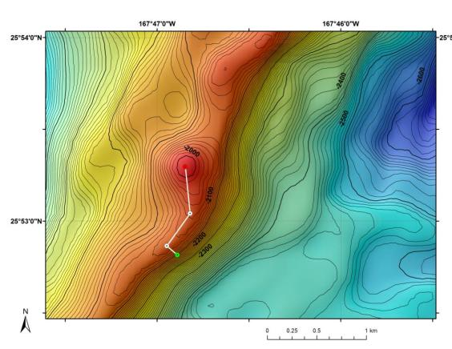 |  |  |  |  | 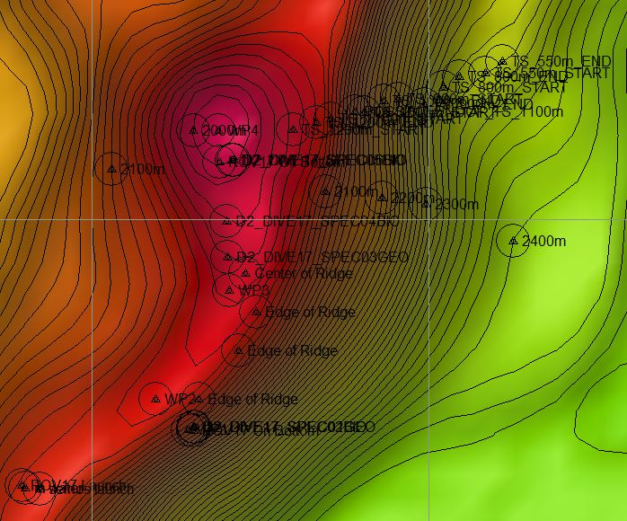
Bathymetry data for the dive site. Planned dive start and end points are shown as green and red dots, respectively. |  |  |  |  | Hypack screen grab showing waypoints dropped during actual ROV dive.
Representative Photos of the Dive
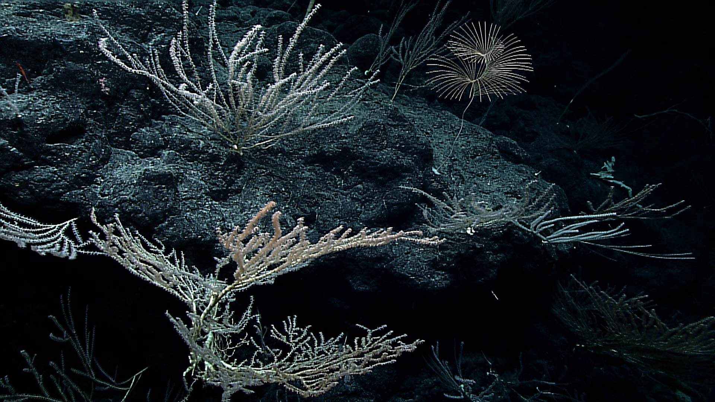 |  |  |  |  | 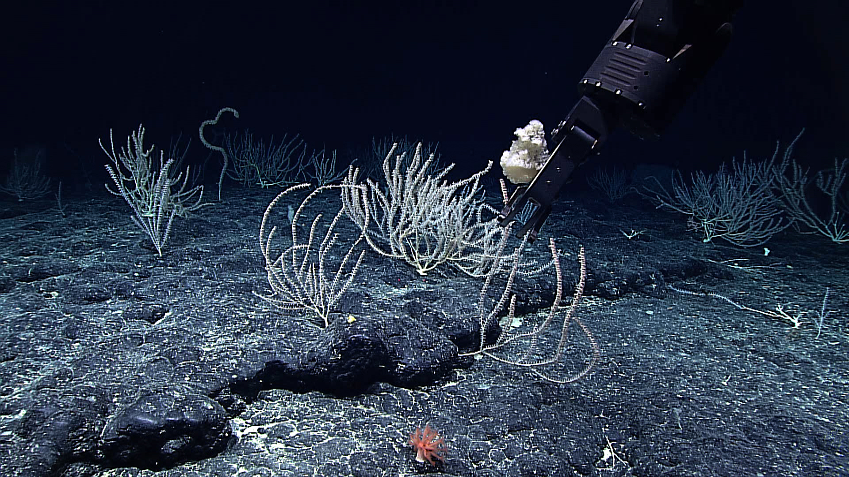
Large bamboo coral fans (Keratoisis sp.) observed at the beginning of the dive. Many were oriented downslope indicating across ridge prevailing current flow. |  |  |  |  | Collection of a demosponge (Stelodoryx sp.) and a mushroom coral (Pseudoanthomastussp, lower center of photo) at the end of the dive.
Samples Collected
Sample ID | EX1504L2_20150818193756_D2_Dive17_SPEC01GEO |  |  |  | 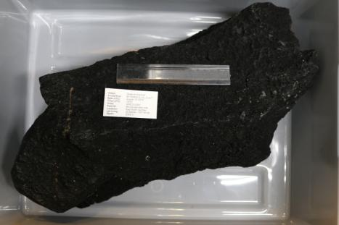
Date (UTC) | 2015/08/18
Time (UTC) | 19:37:56
Depth (m) | 2082
Temperature (ºC) | 1.90364
Oxygen (mL/L) | 3.00535
Field ID(s) | Mn-crsuted dike rock
Comments
Sample ID | EX1504L2_20150818194204_D2_Dive17_SPEC02BIO |  |  |  | 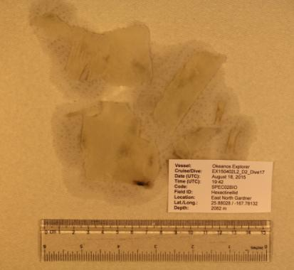
Date (UTC) | 2015/08/18
Time (UTC) | 19:42:04
Depth (m) | 2082
Temperature (ºC) | 1.88749
Oxygen (mL/L) | 3.00168
Field ID(s) | Hexactinellid sp.
Comments
Sample ID | EX1504L2_20150818234530_D2_Dive17_SPEC03GEO |  |  |  | 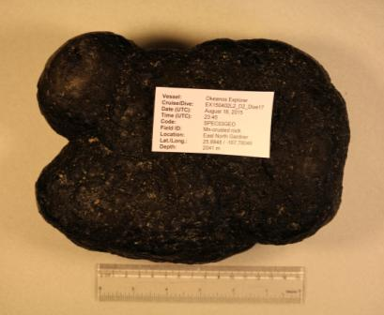
Date (UTC) | 2015/08/18
Time (UTC) | 23:45:30
Depth (m) | 2041
Temperature (ºC) | 1.86912
Oxygen (mL/L) | 2.99507
Field ID(s) | Mn-crusted rock
Comments
Sample ID | EX1504L2_20150819003422_D2_Dive17_SPEC04BIO |  |  |  | 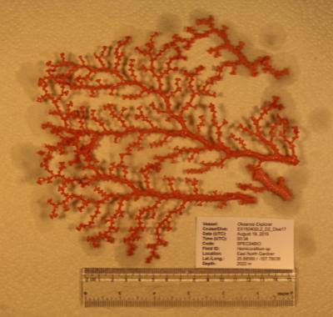
Date (UTC) | 2015/08/19
Time (UTC) | 00:34:22
Depth (m) | 2022
Temperature (ºC) | 1.88328
Oxygen (mL/L) | 2.95145
Field ID(s) | Hemicorallium sp.
Comments
Sample ID | EX1504L2_20150819013748_D2_Dive17_SPEC05BIO |  |  |  | 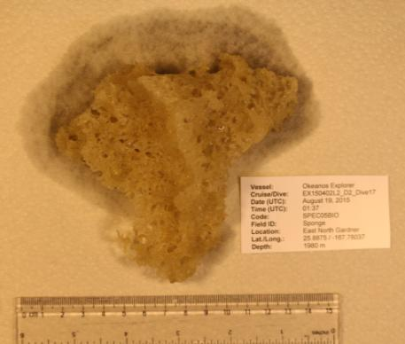
Date (UTC) | 2015/08/19
Time (UTC) | 01:37:48
Depth (m) | 1980
Temperature (ºC) | 1.91512
Oxygen (mL/L) | 2.90973
Field ID(s) | Sponge
Comments | Sponge was determined to be a demosponge based on preliminary examination of its spicules.
Sample ID | EX1504L2_20150819014542_D2_Dive17_SPEC06BIO |  |  |  | 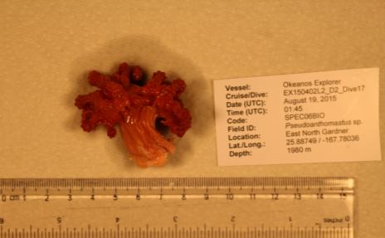
Date (UTC) | 2015/08/19
Time (UTC) | 01:45:42
Depth (m) | 1980
Temperature (ºC) | 1.93313
Oxygen (mL/L) | 2.85255
Field ID(s) | Pseudoanthomastus sp.
Comments
Sample ID | EX1504L2_20150819020000_D2_Dive17_SPEC07BIO |  |  |  | 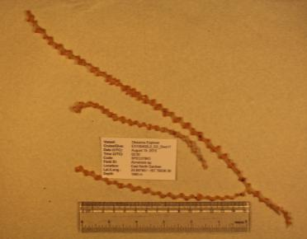
Date (UTC) | 2015/08/19
Time (UTC) | 02:00:00
Depth (m) | 1980
Temperature (ºC) | 1.93313
Oxygen (mL/L) | 2.85255
Field ID(s) | Keratoisis sp.
Comments | Coral came up attached to ROV. The environmental and position information was estimated based on where the last specimen was collected.
Sample ID | EX1504L2_20150819??????_D2_Dive17_SPEC0?BIO_C01 |  |  |  | 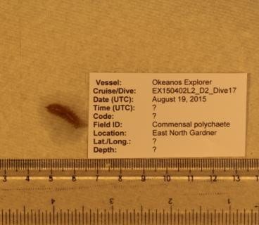
Date (UTC) | 2015/08/19
Time (UTC) | ?
Depth (m) | ?
Temperature (ºC) | ?
Oxygen (mL/L) | ?
Field ID(s) | Commensal polychaete
Comments | Commensal polychaete came up in bio box which contained multiple specimens. Thus, it is not possible to determine from which sample it originated, and no metadata is available for the specimen.
Please direct inquiries to: |  |  | NOAA Office of Ocean Exploration & Research  1315 East-West Highway (SSMC3 10th Floor)  Silver Spring, MD 20910  (301) 734-1014

