Okeanos Explorer ROV Dive Summary
Site Name |  | Unnamed Seamount east of Pearl &Hermes |  |  |  | 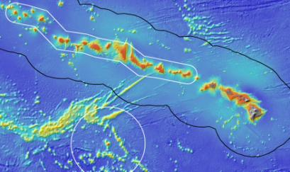
ROV Lead/Expedition Coordinator |  | Karl McLetchie  Kelley Elliott
Science Team Leads |  | Chris Kelley (Biology)  Daniel Wagner (Biology)
General Area Descriptor |  | Northwestern Hawaiian Islands
ROV Dive Name |  | Cruise Season |  | Leg |  |  | Dive Number
 |  | EX1504 |  | 2 |  |  | DIVE13
Equipment Deployed |  | ROV: |  | Deep Discoverer
 |  | Camera Platform: |  | Seirios
ROV Measurements |  | CTD |  | Depth |  |  | Altitude
 |  | Scanning Sonar |  | USBL Position |  |  | Heading
 |  | Pitch |  | Roll |  |  | HD Camera 1
 |  | HD Camera 2 |  | Low Res Cam 1 |  |  | Low Res Cam 2
 |  | Low Res Cam 3 |  | Low Res Cam 4 |  |  | Low Res Cam 2
Equipment Malfunctions |  | There were only few communications issues between the shore-based and shipboard science team. Only 1 feed was available to the ECCs, however other than that, all other equipment worked properly.
ROV Dive Summary  (From processed ROV data) |  | Dive Summary: EX1504L2_DIVE13  ^^^^^^^^^^^^^^^^^^^^^^^^^^^^^^^^^^^^^^^^^^^^^^^^^^^  In Water at: 2015-08-14T18:13:07.609000  27°, 51.135' N ; 175°, 10.007' W  Out Water at: 2015-08-15T00:41:11.125000  27°, 50.958' N ; 175°, 09.555' W  Off Bottom at: 2015-08-14T23:29:45.515000  27°, 51.293' N ; 175°, 10.200' W  On Bottom at: 2015-08-14T19:38:52.640000  27°, 51.199' N ; 175°, 09.775' W  Dive duration: 6:28:3  Bottom Time: 3:50:52  Max. depth: 2306.0 m
Special Notes
Scientists Involved  (please provide name / location / affiliation / email) |  | Allen Andrews, IRC, NMFS, Allen.Andrews@noaa.gov  Amy Baco-Taylor, HBOI ECC, FSU, abacotaylor@fsu.edu  Andrea Quattrini, Pasadena, CA, USGS, aquattrini@usgs.gov  Asako Matsumoto, Tokyo, PERC/CIT, amatsu@gorgonian.jp  Brendan Roark, TX, TAMU-CC, broark@geos.tamu.edu  Bruce Mundy, IRC, NMFS, bruce.mundy@noaa.gov  Chris Kelley, EX, UH, ckelley@hawaii.edu  Chris Mah, SI, SI, mahch@si.edu  Daniel Wagner, EX, PMNM, daniel.wagner@noaa.gov  Espirit Saucier, LSU, LSU, heestand.saucier@louisiana.edu  John R Smith, UH, UH, jrsmith@hawaii.edu  Jonathan Tree, UH, UH, jtree@hawaii.edu  Les Watling, Maine, UH, watling@hawaii.edu  Mackenzie Garringer, UH, UH, mgerring@hawaii.edu  Mary Wicksten, TX, TAMU, wicksten@bio.tamu.edu  Michael Parke, IRC, NMFS, Michael.Parke@noaa.gov  Scott France, ULL, ULL, france@louisiana.edu  Tina Molodtsova, Washington, DC, PPSIO, tina@ocean.ru
Purpose of the Dive
This dive was on a ridge that extends to the southeast of an unnamed seamount east of Pearl and Hermes Atoll. The objectives of the dive were to explore the ridge for high density communities of deep-sea corals and sponges. The target start point of the dive was on the crest of the ridge at a depth of 2300m. The plan was to then head up the ridge crest until reaching a depth of 2120m, documenting in particular the abundance of corals and sponges.
Description of the Dive:
The ROV landed close to the edge of the ridge at 2305m. The substrate consisted of heavily Mn-crusted and broken pillow lava that was covered with mostly planar bamboo corals (genus Keratoisis sp) and a few Chrysogorgia sp, and mushroom corals (Anthomastus sp). There was a moderate current from the south towards the north. As the ROV moved up along the crest of the ridge, it became evident that the bamboo corals were all densely aggregated on the narrow ridge crest, oriented perpendicular to the current which was moving across the ridge. A Mn-crusted basalt sample was collected at 2286m. As the ROV continued moving upwards along the crest of the ridge, it passed through a couple of patches where the substrate consisted of cobble and did not contain any animals. At 2160m, the ROV collected a sample of the species of bamboo coral, which was the most dominant at the site. A second Mn-crusted basalt sample was collected at 2163m. Further up the ridge, the ROV collected a sea star (possible Pythonaster sp), which appeared to be feeding on a toppled over stalked sponge, at 2163m. The ROV left the bottom at a depth of 2118m after a total bottom time of 3:48h, having covered a linear distance of 700m.

Animals observed during the dive are listed below:
Phylum | Group | Species
Arthropod | Crab | Lithodes nintokuae
Arthropod | Crab | Unidentified crab
Arthropods | Amphipod | Amphipod
Arthropods | Shrimp | Aristopenaeus? sp.
Arthropods | Shrimp | Nematocarcinus tenuisrostris
Arthropods | Squat lobsters | Munidae
Arthropods | Squat lobsters | Munidopsis sp.
Cnidarians | Actiniarians | Actinostolidae
Cnidarians | Actiniarians | Exocoelactis sp.
Cnidarians | Alcyonaceans | Anthomastus sp.
Cnidarians | Antipatharians | Trissopathes sp.
Cnidarians | Corallimorpharian | Corallimorpharian?
Cnidarians | Ceriantharian | Ceriantharian?
Cnidarians | Gorgonians | Acanella weberi?
Cnidarians | Gorgonians | Chrysogorgia geniculata
Cnidarians | Gorgonians | Chrysogorgia sp.
Cnidarians | Gorgonians | Corallium sp.
Cnidarians | Gorgonians | Isidella trichotoma?
Cnidarians | Gorgonians | Jasonisis sp.
Cnidarians | Gorgonians | Keratoisis/Eknomisis sp.
Cnidarians | Gorgonians | Lepidisis sp.
Cnidarians | Gorgonians | Paragorgia sp.
Echinoderms | Asteroids | Henricia sp.
Echinoderms | Asteroids | Pythonaster sp. (collected)
Echinoderms | Crinoids | Unidentified comatulids
Echinoderms | Holothuria | Unidentified pink holothurian
Echinoderms | Holothuria | Unidentified purple holothurian
Fishes | Eels | Synaphobranchid
Fishes | Macrourids | Trachonurus/Malacocephalus sp.
Fishes | Ophidiidiformes | Ophidiidiformes
Sponges | Hexactinellids | Bolosoma sp.
Sponges | Hexactinellids | Caulophacus (Caulodiscus) sp.
Sponges | Hexactinellids | Caulophacus (Oxydiscus) sp.
Sponges | Hexactinellids | Euplectellidae sp.
Sponges | Hexactinellids | Farrrea nr occa erecta
Sponges | Hexactinellids | Uncinateridae new genus sp.
Sponges | Hexactinellids | Walteria cf. leukarti
Tunicate | Ascidacea | Culeolus sp.
Tunicate | Ascidacea | Larvacean

Overall Map of Dive Area |  |  |  |  | Actual track of ROV dive
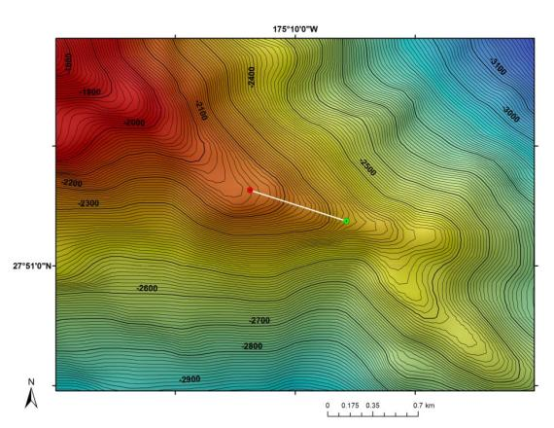 |  |  |  |  | 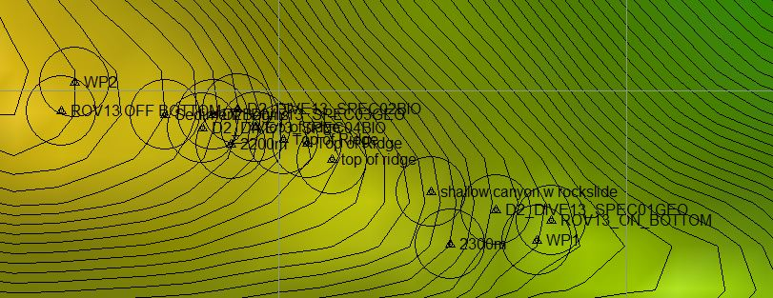
Bathymetry data for the dive site. Planned dive start and end points are shown as green and red dots, respectively. |  |  |  |  | Hypack screen grab showing waypoints dropped during actual ROV dive.
Representative Photos of the Dive
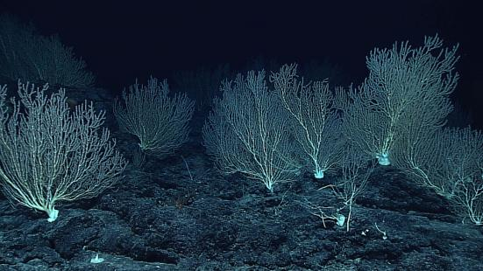 |  |  |  |  | 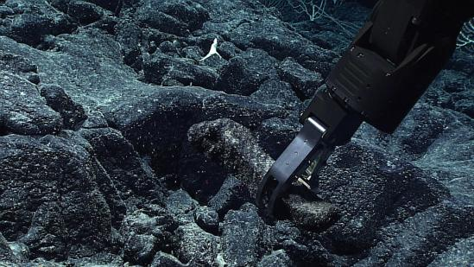
Dense forest of bamboo coral (Keratoisis sp) encountered at touchdown. The forest continued throughout the dive, diminishing only when in areas of sediment and cobbles. |  |  |  |  | Sample of what we suspect is very old basalt that will help determine if this seamount is Cretaceous or not.
Samples Collected
Sample ID | EX1504L2_20150814202148_D2_Dive13_SPEC01GEO |  |  |  | 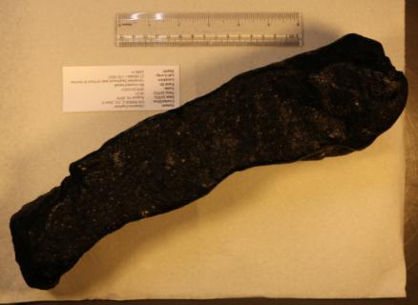
Date (UTC) | 2015/08/14
Time (UTC) | 20:21:48
Depth (m) | 2286
Temperature (ºC) | 1.80698
Oxygen (mL/L) | 2.99612
Field ID(s) | Mn-crusted basalt
Comments
Sample ID | EX1504L2_20150814215719_D2_Dive13_SPEC02BIO |  |  |  | 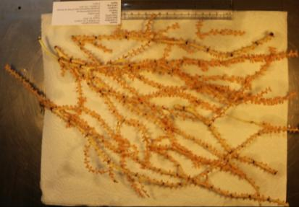
Date (UTC) | 2015/08/14
Time (UTC) | 21:57:19
Depth (m) | 2149
Temperature (ºC) | 1.86554
Oxygen (mL/L) | 2.88004
Field ID(s) | Keratoisis/Eknomisis sp.
Comments | This species was by far the most abundant at the dive site.
Sample ID | EX1504L2_20150814220810_D2_Dive13_SPEC03GEO |  |  |  | 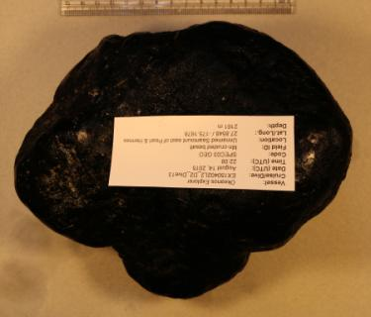
Date (UTC) | 2015/08/14
Time (UTC) | 22:08:10
Depth (m) | 2161
Temperature (ºC) | 1.88578
Oxygen (mL/L) | 2.87054
Field ID(s) | Mn-crusted basalt
Comments
Sample ID | EX1504L2_20150814223849_D2_Dive13_SPEC04BIO |  |  |  | 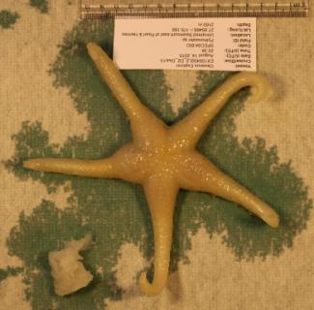
Date (UTC) | 2015/08/14
Time (UTC) | 22:38:49
Depth (m) | 2160
Temperature (ºC) | 1.76615
Oxygen (mL/L) | 2.97893
Field ID(s) | Pythonaster sp.
Comments | Specimen collected was feeding on a topped over Caulophacus (Oxydiscus) sp. sponge.
Please direct inquiries to: |  |  | NOAA Office of Ocean Exploration & Research  1315 East-West Highway (SSMC3 10th Floor)  Silver Spring, MD 20910  (301) 734-1014

