Okeanos Explorer ROV Dive Summary
Site Name |  | Bank 9 North |  |  |  | 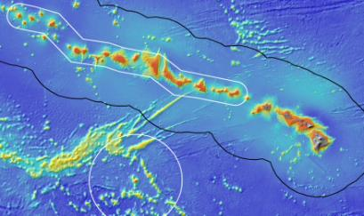
ROV Lead/Expedition Coordinator |  | Karl McLetchie  Kelley Elliott
Science Team Leads |  | Chris Kelley (Biology)  Daniel Wagner (Biology)
General Area Descriptor |  | Northwestern Hawaiian Islands
ROV Dive Name |  | Cruise Season |  | Leg |  |  | Dive Number
 |  | EX1504 |  | 2 |  |  | DIVE11
Equipment Deployed |  | ROV: |  | Deep Discoverer
 |  | Camera Platform: |  | Seirios
ROV Measurements |  | CTD |  | Depth |  |  | Altitude
 |  | Scanning Sonar |  | USBL Position |  |  | Heading
 |  | Pitch |  | Roll |  |  | HD Camera 1
 |  | HD Camera 2 |  | Low Res Cam 1 |  |  | Low Res Cam 2
 |  | Low Res Cam 3 |  | Low Res Cam 4 |  |  | Low Res Cam 2
Equipment Malfunctions |  | There were only few communications issues between the shore-based and shipboard science team. Other than that, all other equipment worked properly.
ROV Dive Summary  (From processed ROV data) |  | Dive Summary: EX1504L2_DIVE11  ^^^^^^^^^^^^^^^^^^^^^^^^^^^^^^^^^^^^^^^^^^^^^^^^^^^  In Water at: 2015-08-12T18:16:31.625000  27°, 08.103' N ; 175°, 34.514' W  Out Water at: 2015-08-13T02:17:58.421000  27°, 07.542' N ; 175°, 33.954' W  Off Bottom at: 2015-08-13T01:13:55.625000  27°, 07.699' N ; 175°, 34.242' W  On Bottom at: 2015-08-12T19:34:32.734000  27°, 07.982' N ; 175°, 34.251' W  Dive duration: 8:1:26  Bottom Time: 5:39:22  Max. depth: 2158.3 m
Special Notes
Scientists Involved  (please provide name / location / affiliation / email) |  | Abby Lapointe, UH, UH, abbylap@hawaii.edu  Amanda Ziegler, UH, UH, aziegler802@gmail.com  Amy Baco-Taylor, HBOI ECC, FSU, abacotaylor@fsu.edu  Andrea Quattrini, Pasadena, CA, USGS, aquattrini@usgs.gov  Astrid Leitner, UH, UH, aleitner@hawaii.edu  Brendan Roark, TX, TAMU-CC, broark@geos.tamu.edu  Bruce Mundy, IRC, NMFS, bruce.mundy@noaa.gov  Chris Kelley, EX, UH, ckelley@hawaii.edu  Chris Mah, SI, SI, mahch@si.edu  Daniel Wagner, EX, PMNM, daniel.wagner@noaa.gov  Diva Amon, UH, UH, divaamon@hawaii.edu  Espirit Saucier, LSU, LSU, heestand.saucier@louisiana.edu  Les Watling, UH, UH, watling@hawaii.edu  Mackenzie Garringer, UH, UH, mgerring@hawaii.edu  Mary Wicksten, TX, TAMU, wicksten@bio.tamu.edu  Michael Parke, IRC, NMFS, Michael.Parke@noaa.gov  Nicole Morgan, HBOI ECC, FSU, nbmorgan11@gmail.com  Randal Singer, FL, FLMNH, rsinger@flmnh.ufl.edu  Randall Kosaki, IRC, PMNM, Randall.kosaki@noaa.gov  Scott France, ULL, ULL, france@louisiana.edu  Steve Auscavitch, PA, Temple, steven.auscavitch@temple.edu  Tina Molodtsova, Washington, DC, PPSIO, tina@ocean.ru
Purpose of the Dive
This dive was located on a modest ridge that extends north from the northern half of Bank 9. The objectives of the dive were to explore for high density communities of deep-sea corals and sponges along the ridge. The target start point of the dive was the top of the ridge at 2201m. The plan was to survey over to the east side of the ridge top to the break in slope, then turn south and survey along the edge to a final target depth of approximately 2091m, documenting in particular the abundance of corals and sponges.
Description of the Dive:
The ROV landed very close to the western drop-off of the ridge at 2147m. The substrate consisted of well defined, Mn-crusted pillows, which were covered with a low density of sponges and corals. There was a strong current from the west towards the east. As a result, the ROV had to adjust its course moving up the slope of the ridge towards the south. A Mn-crusted rock sample was collected close to the ROV landing site at 2144m. As the ROV surveyed up the slope of the ridge, there were several patches that were dominated by sponges, others by stylasterid corals, and still others by bamboo corals. A second Mn-crusted rock sample was collected at 2120m and a stylasterid coral sample at 2117m. Shortly after collecting the stylasterid sample, the ROV encountered an enormous sponge that was over 3.5m long and 2.5m high. This was the same species as one collected two dives ago and its identity is still unknown. As the ROV continued its survey, a sample of another sponge was collected further up the ridge at 2112m, that similar to the sponge collected the day before, had a large number of commensal anemones living throughout its tissue. Towards the end of the dive, the ROV moved towards the east side of the ridge, where there was a marked increase in the density of corals and sponges close to the edge of the cliff. The ROV left the bottom at a depth of 2100m after a total bottom time of 5:49h, having covered a linear distance of 650m.

Animals observed during the dive are listed below:
Phylum | Group | Species
Arthropods | Barnacles | Scalpellidae
Arthropods | Barnacles | Poecilasmatidae
Arthropods | Shrimp | Amphipod
Arthropods | Shrimp | Nematocarcinus tenuisrostris
Arthropods | Polychelid | Polychelidae
Arthropods | Squat lobsters | Munidopsis sp.
Bryozoans | Bryozoan | Bryozoan
Cnidarians | Actiniarians | Actinernus nobilis
Cnidarians | Actiniarians | Actinoscyphia sp.
Cnidarians | Actiniarians | Exocoelactis sp.
Cnidarians | Actiniarians | Hormathiidae
Cnidarians | Alcyonaceans | Anthomastus sp.
Cnidarians | Alcyonaceans | Stoloniferous octocoral
Cnidarians | Antipatharians | Bathypathes alternata
Cnidarians | Antipatharians | Stauropathes staurocrada
Cnidarians | Antipatharians | Trissopathes sp.
Cnidarians | Gorgonians | Chrysogorgia geniculata
Cnidarians | Gorgonians | Chrysogorgia stellata
Cnidarians | Gorgonians | Corallium sp.
Cnidarians | Gorgonians | Iridogorgia magnispiralis
Cnidarians | Gorgonians | Isidella sp.
Cnidarians | Gorgonians | Isidella sp. lyrate
Cnidarians | Gorgonians | Isidella trichotoma
Cnidarians | Gorgonians | Jasonisis sp.
Cnidarians | Gorgonians | Keratoisis sp.
Cnidarians | Gorgonians | Narella sp.
Cnidarians | Hydrozoans | Hydromedusae
Cnidarians | Hydrozoans | Stylasterid
Cnidarians | Hydrozoans | Unidentified hydroids
Ctenophores | Ctenophores | Benthic ctenophore
Echinoderms | Asteroids | Brisingid
Echinoderms | Asteroids | Henricia sp.
Echinoderms | Asteroids | Hymenodiscus/Brisinga sp.
Echinoderms | Asteroids | Pteraster sp.
Echinoderms | Crinoids | Comatulid crinoid
Echinoderms | Holothuria | Holothurians
Echinoderms | Ophiuroids | Ophomusium? sp.
Fishes | Moridae | Antimora microlepis
Fishes | Eels | Synaptobranchid
Fishes | Macrourids | Trachonurus/Malacocephalus sp.
Mollusks | Aplocophoran | Solenogastres
Mollusks | Polycophora | Chiton
Mollusks | Gastropods | Gastropod
Sponges | Hexactinellids | Bathydorus? sp.
Sponges | Hexactinellids | Bolosoma sp.
Sponges | Hexactinellids | Caulophacus sp.
Sponges | Hexactinellids | Euretinae new genus sp.
Sponges | Hexactinellids | Euretinae sp.
Sponges | Hexactinellids | Farrea sp.
Sponges | Hexactinellids | Farrrea nr occa erecta
Sponges | Hexactinellids | Walteria cf. leukarti
Sponges | Demosponges | Poecillastra sp.

Overall Map of Dive Area |  |  |  |  | Actual track of ROV dive
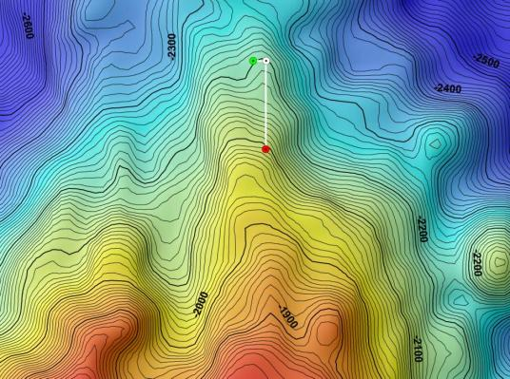 |  |  |  |  | 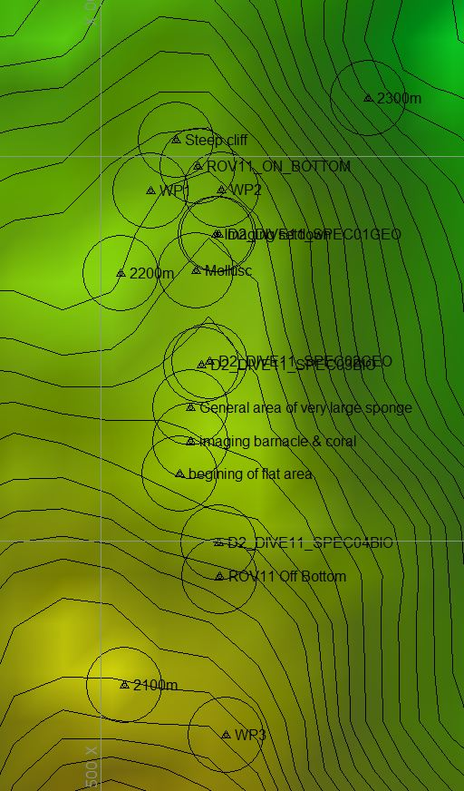
Bathymetry data for the dive site. Planned dive start and end points are shown as green and red dots, respectively. |  |  |  |  | Hypack screen grab showing waypoints dropped during actual ROV dive.
Representative Photos of the Dive
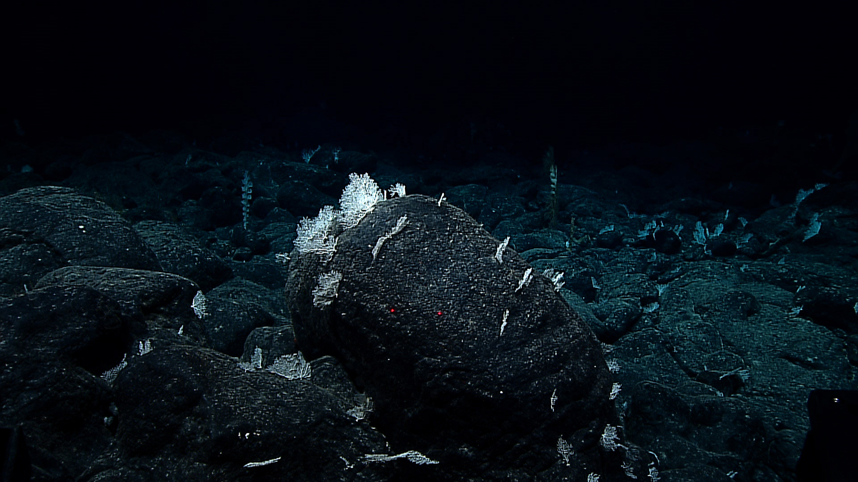 |  |  |  |  | 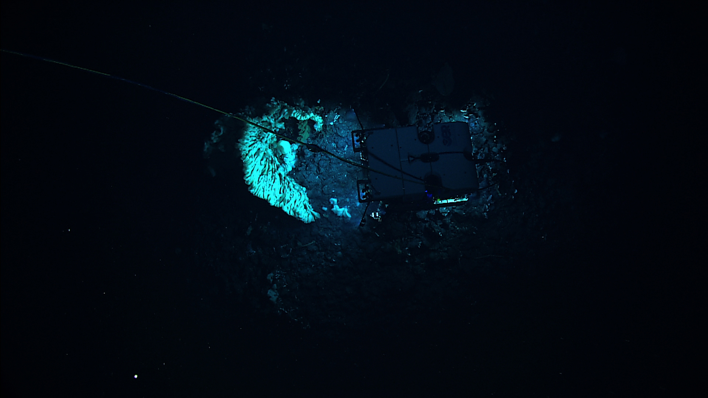
Stylasterid corals observed as soon as the ROV touched bottom. The species showed localized changes in abundance, disappearing in abundance then reappearing throughout the dive. |  |  |  |  | Gigantic hexactinellid sponge (either euplectellid or rossellid) that was encountered during the dive. This view is from the Seirios vehicle looking down at the ROV to show the size.
Samples Collected
Sample ID | EX1504L2_20150812205035_D2_Dive11_SPEC01GEO |  |  |  | 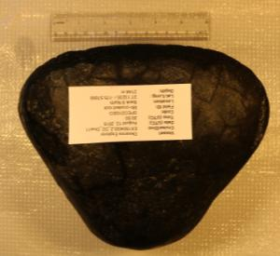
Date (UTC) | 2015/08/12
Time (UTC) | 20:50:35
Depth (m) | 2144
Temperature (ºC) | 1.72837
Oxygen (mL/L) | 3.15195
Field ID(s) | Mn-crusted rock
Comments
Sample ID | EX1504L2_20150812221207_D2_Dive11_SPEC02GEO |  |  |  | 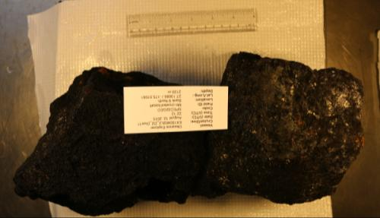
Date (UTC) | 2015/08/12
Time (UTC) | 22:12:07
Depth (m) | 2120
Temperature (ºC) | 1.75726
Oxygen (mL/L) | 3.05488
Field ID(s) | Mn-crusted basalt
Comments
Sample ID | EX1504L2_20150812223321_D2_Dive11_SPEC03BIO |  |  |  | 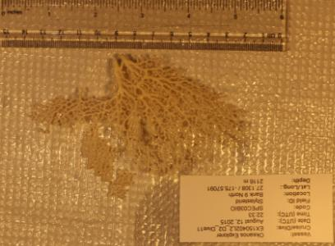
Date (UTC) | 2015/08/12
Time (UTC) | 22:33:21
Depth (m) | 2116
Temperature (ºC) | 1.794
Oxygen (mL/L) | 2.9719
Field ID(s) | Stylasterid
Comments | Species was very common at dive site
Sample ID | EX1504L2_20150813002031_D2_Dive11_SPEC04BIO |  |  |  | 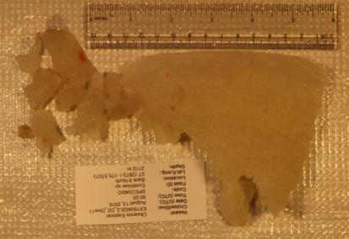
Date (UTC) | 2015/08/13
Time (UTC) | 00:20:31
Depth (m) | 2112
Temperature (ºC) | 1.80351
Oxygen (mL/L) | 2.9826
Field ID(s) | Euretiniae with commensal anemone
Comments | Sponge collected had commensal cnidarians which were also collected. The commensal cnidarians were not separated out; they were placed in same vial as sponge.
Please direct inquiries to: |  |  | NOAA Office of Ocean Exploration & Research  1315 East-West Highway (SSMC3 10th Floor)  Silver Spring, MD 20910  (301) 734-1014

