Okeanos Explorer ROV Dive Summary
Site Name |  | St. Rogatien Rift Zone Ridge |  |  |  | 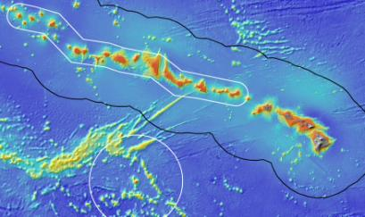
ROV Lead/Expedition Coordinator |  | Karl McLetchie  Kelley Elliott
Science Team Leads |  | Chris Kelley (Biology)  Daniel Wagner (Biology)
General Area Descriptor |  | Northwestern Hawaiian Islands
ROV Dive Name |  | Cruise Season |  | Leg |  |  | Dive Number
 |  | EX1504 |  | 2 |  |  | DIVE03
Equipment Deployed |  | ROV: |  | Deep Discoverer
 |  | Camera Platform: |  | Seirios
ROV Measurements |  | CTD |  | Depth |  |  | Altitude
 |  | Scanning Sonar |  | USBL Position |  |  | Heading
 |  | Pitch |  | Roll |  |  | HD Camera 1
 |  | HD Camera 2 |  | Low Res Cam 1 |  |  | Low Res Cam 2
 |  | Low Res Cam 3 |  | Low Res Cam 4 |  |  | Low Res Cam 2
Equipment Malfunctions |  | 30 minutes into the dive, the ship lost its dynamic positioning for ~15 minutes, during which the ROV had to come off the bottom. The teleconference call between the shore-based and shipboard science team was dropped on several occasions.
ROV Dive Summary  (From processed ROV data) |  | Dive Summary: EX1504L2_DIVE03  ^^^^^^^^^^^^^^^^^^^^^^^^^^^^^^^^^^^^^^^^^^^^^^^^^^^  In Water at: 2015-08-04T18:21:05.968000  25°, 37.592' N ; 167°, 14.682' W  Out Water at: 2015-08-05T02:28:55  25°, 37.765' N ; 167°, 13.771' W  Off Bottom at: 2015-08-05T01:19:43.093000  25°, 37.592' N ; 167°, 14.559' W  On Bottom at: 2015-08-04T19:33:23.812000  25°, 37.582' N ; 167°, 14.352' W  Dive duration: 8:7:49  Bottom Time: 5:46:19  Max. depth: 2155.6 m
Special Notes
Scientists Involved  (please provide name / location / affiliation / email) |  | Chris Kelley, EX, UH, ckelley@hawaii.edu  Daniel Wagner, EX, PMNM, Daniel.Wagner@noaa.gov  Diva Amon, UH, UH divaamon@hawaii.edu  Amy Baco-Taylor, HBOI ECC, FSU, abacotaylor@fsu.edu  Scott France, ULL, ULL, france@louisiana.edu  Santiago Herrera, UT & WHOI, sherrera@alum.mit.edu  Astrid Leitner, UH, UH, aleitner@hawaii.edu  Tina Molodtsova, SI (Washington, DC), PPSIO, tina@ocean.ru  Andrea Quattrini, Pasadena, CA, USGS, aquattrini@usgs.gov  John R Smith, UH, UH, jrsmith@hawaii.edu  Michael Garcia, UH, UH, mogarcia@hawaii.edu  Bruce Mundy, IRC, NOAA, bruce.mundy@noaa.gov  Jonathan Tree, UH, UH, jtree@hawaii.edu  Randal Singer, FLMNH, rsinger@flmnh.ufl.edu  Nicole Morgan, HBOI, FSU, nbmorgan11@gmail.com  Brendan Roark, TAMU-CC, TAMU, broark@geos.tamu.edu  Les Watling, UH, UH, watling@hawaii.edu  Mike Ford, SS, NOAA, Michael.ford@noaa.gov  Michael Parke, IRC, NOAA, Michael.Parke@noaa.gov  Charlotte Reid, NEU, c.seid@neu.edu  John Smith, UH, UH, jrsmith@hawaii.edu  Espirit Saucier, LSU, LSU, heestand.saucier@louisiana.edu
Purpose of the Dive
This dive was located on the east side of a large rift zone ridge north of St. Rogatien Bank. The objectives of the dive were to survey a completely unexplored area, testing the hypothesis that high density communities of corals and sponges can be found on ridge topography. No previous dives have ever been conducted on this site. Discovery of high density communities would provide valuable new information to NOAA’s Deep Sea Coral and Technology Program (DSCTP). The target start point of the dive was a relatively flat terrace located at a depth of 2168m, which transitioned into a steep slope at approximately 2100m. The plan was to survey up the steep slope to a final target depth of approximately 1900m, documenting in particular the abundance of corals and sponges.
Description of the Dive:
The ROV landed on a flat surface close to the slope at 2151m. The surface was covered by a dense aggregation of manganese nodules (2-5cm in diameter) that lay loosely on the bottom. Several unbranched corals, sponges and a stalked crinoid were observed at the landing site and there was no current. Approximately 30 minutes after the ROV reached the bottom, the ship lost its dynamic positioning and the ROV was pulled from the bottom for 15 minutes. Upon solving the problem, the ROV returned to the bottom and collected a sample of a possible cladorhizid sponge at 2152m. A field of manganese crusted boulders was observed upon moving up the slope, which was void of animals. Further up the slope at around 2100m, the density of animals increased somewhat and included corals, sponges and crinoids. A second biological sample, a black coral tentatively identified as Heteropathes cf. pacifica, was collected at 2128m. The density of animals remained moderately low until a depth of 2050m, when an increase of corals and sponges was observed. A manganese-crusted basalt was collected at 2050m. As the ROV moved up the slope, both the density and diversity of animals increased with decreasing depth and distance to the ridge crest, with numerous species of gorgonians, black corals and sponges being recorded. An isidid coral, tentatively identified as belonging to the genus Jasonisis was collected at 1982m. The ROV was not able to reach the target end point on the top of the ridge at 1900m and had to leave the bottom at 1958m. The dive covered a distance of roughly 280m in a total bottom time of 5:45. Only a handful of fishes were observed during the dive.

Animals observed during the dive are listed below:
Cnidarians | Gorgonians | Chrysogorgia geniculata
 |  | Chrysogorgia pinnata?
 |  | Chrysogorgiid sp. (unidentified)
 |  | Narella? sp.
 |  | Narella alata/musikae?
 |  | Narella bowersi?
 |  | Iridogorgia magnispiralis
 |  | Lepidisis sp.
 |  | Acanella weberi
 |  | Unidentified unbranched isidid
 |  | Unidentified branched isidids
 |  | Forked Lepidisis sp.
 |  | Isidella sp.?
 |  | Isidella sp. Lyrate?
 |  | Isidella trichotoma?
 |  | Jasonisis? sp. (collected)
 |  | Corallium spp.
 |  | Paragorgia sp.
 |  | Paragorgia coralloides
 | Alcyonaceans | Anthomastus fisheri?
 | Stoloniferans | Unidentified stoloniferan overgrowing sponge
 | Scleractinians | Unidentified cup coral
 | Antipatharians | Heteropathes cf. pacifica (collected)
 |  | Heteropathes sp
 |  | Bathypathes alternata
 |  | Umbellapathes sp.
 |  | Trissopathes sp.
 |  | Parantipathes sp.
 |  | Stauropathes sp.
 | Actiniarians | Sycionis? sp.
 | Ceriantharians | Unidentified ceriantharian
 | Corallimorpharians | Corallimorphus pilatus
 | Zoanthid | Zoanthid overgrowing Paragorgia coralloides
 | Hydrozoans | Hydromedusa
 |  | Hydroids (on crinoid)
Sponges | Hexactinellids | Walteria sp?.
 |  | Poliopogon sp. (various)
 |  | Tretopleura sp.
 |  | Farrrea nr occa erecta
 |  | Caulophacus sp.
 |  | Bolosoma sp.
 | Demosponges | Unidentified cladorhizid (collected)
 |  | Unidentified cladorhizid
Echinoderms | Asteroids | Hypasteria muscipula
 |  | Unidentified brisingid
 |  | Unidentified asteroid
 | Ophiuroids | Unidentified ophiuroids
 | Crinoids | Unidentified hyocrinid
 |  | Unidentified comatulid
 |  | Glyptometra lateralis
 |  | Proisocrinus ruberrimus
 |  | Bathycrinus? sp.
 |  | Sarametra triserialis
 | Holothuria | Unidentified holothurian
Arthropods | Shrimp | Nematocarcinus tenuirostris
 |  | Bathypalaemonella sp.
 | Squat lobsters | Unidentified squat lobster
 | Pycnogonids | Colossendeis sp. (with gastropods on arms)
Mollusks | Gastropods | Unidentified gastropods
Fishes | Macrourids | Nezumia sp.
 | Eels | Unidentified ophidiid

Overall Map of Dive Area |  |  |  |  | Actual track of ROV dive
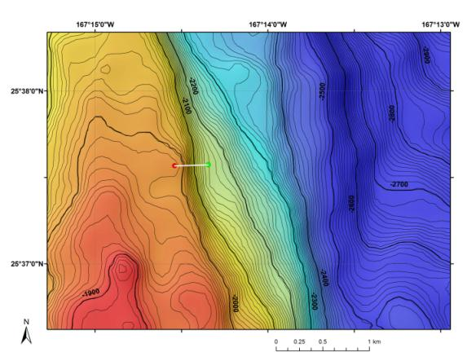 |  |  |  |  | 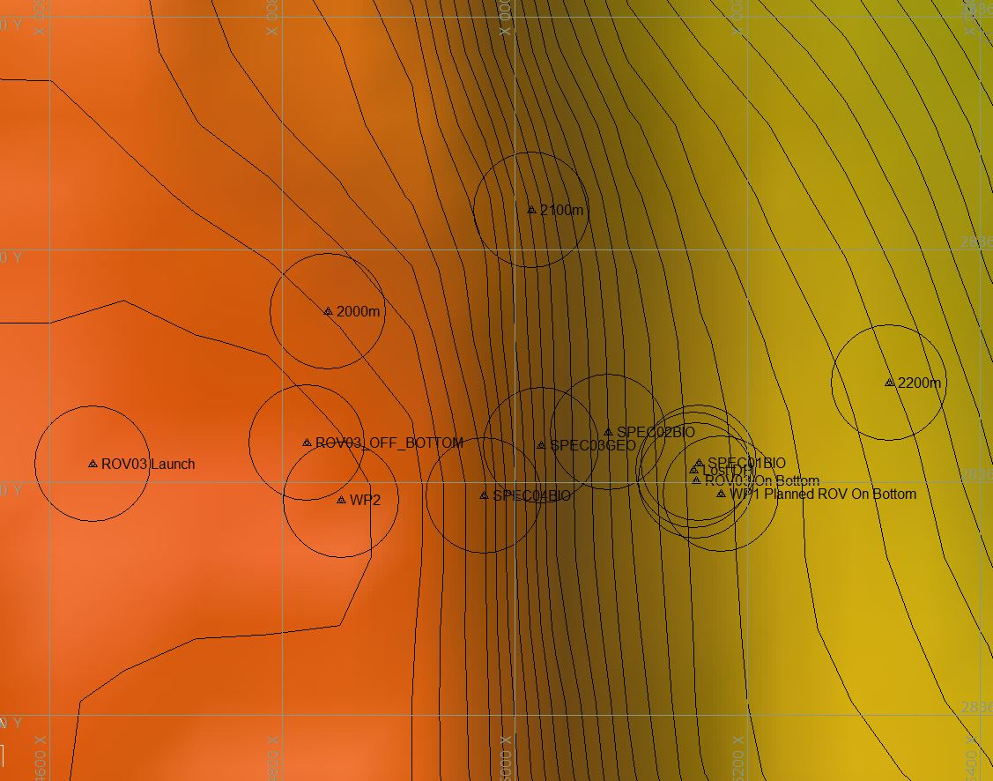
Bathymetry data for the dive site. Planned dive start and end points are shown as green and red dots, respectively. |  |  |  |  | Hypack screen grab showing waypoints dropped during the actual ROV dive track.
Representative Photos of the Dive
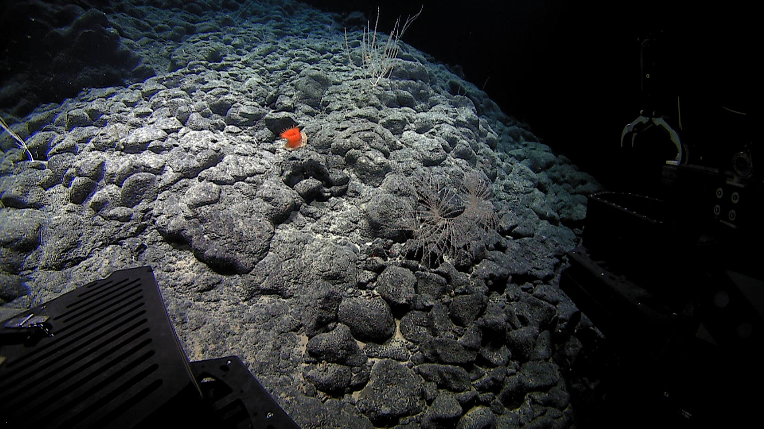 |  |  |  |  | 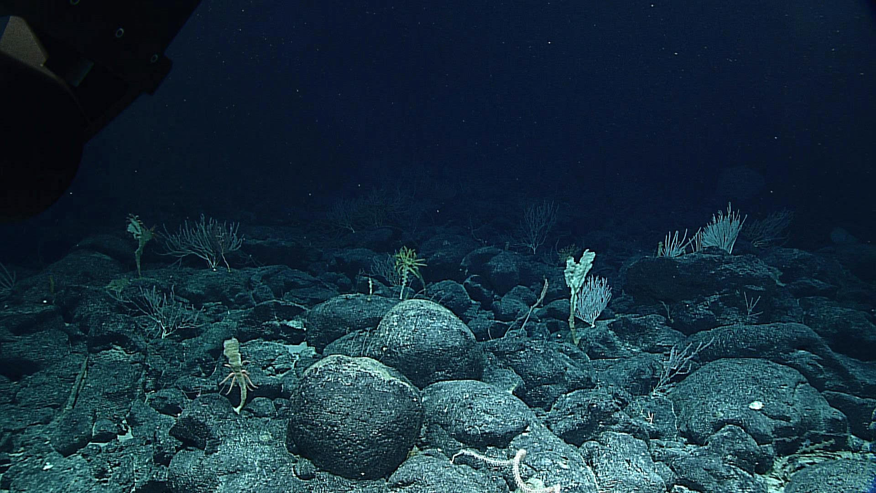
Anemone and corals observed on the survey up the slope of the ridge. |  |  |  |  | Coral and sponge community observed right at and over the ridge break in slope.
Samples Collected
Sample ID | EX1504L2_20150804203352_D2_Dive03_SPEC01BIO |  |  |  | 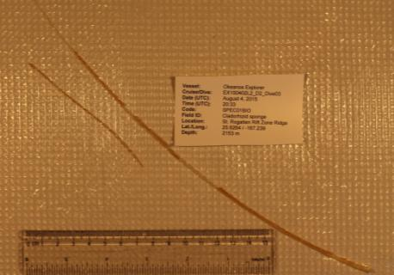
Date (UTC) | 2015/08/04
Time (UTC) | 20:33:52
Depth (m) | 2153
Temperature (ºC) | 1.83044
Oxygen (mL/L) | 3.11054
Field ID(s) | cladorhizid sponge
Comments | The fragile sponge specimen broke into several pieces in the laboratory.
Sample ID | EX1504L2_20150804220443_D2_Dive03_SPEC02BIO |  |  |  | 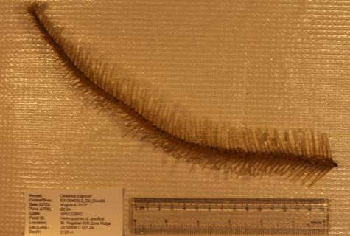
Date (UTC) | 2015/08/04
Time (UTC) | 22:04:43
Depth (m) | 2128
Temperature (ºC) | 1.87322
Oxygen (mL/L) | 3.04564
Field ID(s) | Heteropathes cf. pacifica
Comments | The sampled colony was branched, but the collected specimen does not contain any branches.
Sample ID | EX1504L2_20150804223938_D2_Dive03_SPEC03GEO |  |  |  | 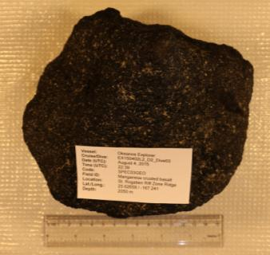
Date (UTC) | 2015/08/04
Time (UTC) | 22:39:38
Depth (m) | 2050
Temperature (ºC) | 1.88453
Oxygen (mL/L) | 2.96857
Field ID(s) | Mn-crusted basalt
Comments
Sample ID | EX1504L2_20150804232851_D2_Dive03_SPEC04BIO |  |  |  | 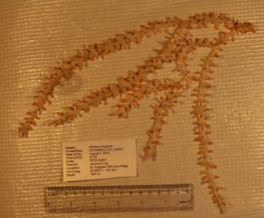
Date (UTC) | 2015/08/04
Time (UTC) | 23:28:51
Depth (m) | 1981
Temperature (ºC) | 2.00956
Oxygen (mL/L) | 2.78827
Field ID(s) | Jasonisis? sp.
Comments
Please direct inquiries to: |  |  | NOAA Office of Ocean Exploration & Research  1315 East-West Highway (SSMC3 10th Floor)  Silver Spring, MD 20910  (301) 734-1014

