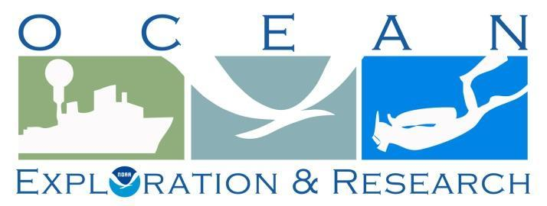

**DRAFT Project Instructions**

**Date Submitted:** May 18, 2015

**Platform:** NOAA Ship *Okeanos Explorer*

**Project Number:** EX-15-04 Leg I

**Project Title:** CAPSTONE NWHI Exploration Mapping

**Project Dates:** July 3 - 24, 2015

Prepared by: ________________________ Dated: __________________

Derek Sowers

Expedition Coordinator

Office of Ocean Exploration & Research

Approved by: ________________________ Dated: __________________

John McDonough

Deputy Director

Office of Ocean Exploration & Research

Approved by: ________________________ Dated: ________________

Captain Anne K. Lynch, NOAA

Commanding Officer

Marine Operations Center - Atlantic

**I.** Overview

A. Brief Summary and Project Period

The ocean is 95 percent unexplored, unknown, and unseen by human eyes. Resource managers cannot manage what they do not know. To understand, manage, and protect the ocean and its resources, NOAA believes it is critical to support a systematic program of ocean exploration, using the best of ocean technology to explore, discover, inform, educate, and motivate. Exploration of our largely unknown ocean supports key NOAA, national, and international goals related to a better understanding of the ocean that will benefit current and future generations. NOAA Ship *Okeanos Explorer* is helping us to better understand the unknown ocean by targeted mapping.

EX-15-04 Leg I is an exploratory mapping expedition, and is the first cruise of a two year major effort (2015-2016) in the Pacific by the Office of Ocean Exploration and Research, entitled CAPSTONE (Campaign to Address Pacific Monument Science, Technology, and Ocean NEeds). NOAA priorities for the 2015 CAPSTONE Expedition include a combination of science, education, outreach, and open data objectives that will support management decisions at multiple levels.

Understanding biogeographic patterns between and among the Pacific Monuments and Sanctuaries is a coordinating theme for 2015-17 CAPSTONE science priorities. Themes and objectives for the 2015 Expedition include:

* Acquire data to support priority Monument and Sanctuaries science and management needs, including habitat surveys in recently expanded boundary areas;
* Identification and characterization of vulnerable marine habitats - particularly high density deep sea coral and sponge communities;
* Characterization of seamounts within the Prime Crust Zone (PCZ). The PCZ is the area of the Pacific with the highest expected concentration of deep sea minerals, including rare metals and rare earth elements;
* Collect information on the geologic history of Central Pacific Seamounts, including those that are or may be relevant to our understanding of plate tectonics and subduction zone biology and geology; and
* Provide a foundation of publicly accessible data and information products to spur further exploration, research, and management activities.

Originally created by Presidential Proclamation 8336 of January 6, 2009, PRIMNM boundaries were expanded by Presidential Proclamation 9173, dated September 29, 2014. The expansion includes waters adjacent to Jarvis and Wake Islands, and Johnson Atoll.

This document contains project instructions for EX-15-04 Leg I, with operations expected to commence on July 3, 2015 at Honolulu, HI, and conclude on July 24, 2015 at Honolulu, HI. Multibeam and singlebeam mapping operations will be conducted 24 hours a day throughout the cruise. Sub-bottom profile mapping will be conducted 24 hours a day at the discretion of the CO. Most of the mapping areas to be pursued during this cruise have never been mapped with modern sonar before. Mapping activities will focus on two primary areas, (1) the Necker Island area within the Papahānaumokuākea Marine National Monument (PMNM), and (2) the Karin Seamount Chain near Johnson Atoll within the recently expanded Pacific Remote Islands Marine National Monument (PRIMNM).

B. Days at Sea (DAS)

Of the _22_ DAS scheduled for this project, _5_ DAS are funded by an OMAO allocation, _0_ DAS are funded by a Line Office Allocation, _17_ DAS are Program Funded, and _0_DAS are Other Agency funded. This project is estimated to exhibit a Medium Operational Tempo.

C. Operating Area (include optional map/figure showing op area)

Leg 1 is a mapping exploration cruise that will conduct 24 hour mapping operations, including during transit. The expedition will first focus on filling gaps in multibeam sonar coverage of mapping priority areas in PMNM, and then spend the majority of surveying time in the vicinity of Johnston Atoll PRIMNM. The ship will transit from Pearl Harbor, Oahu to PMNM and do a small amount of "patch mapping" around Necker, and then depart PMNM and proceed down to the Johnston atoll portion of PRIMNM. Mapping will take place along Horizon tablemount, down through the Karin seamount chain, then over to the Johnston seamount chain before transiting back to Pearl Harbor, Oahu. Opportunistic CTD rosette operations may also be conducted. All survey areas are in US and international waters.

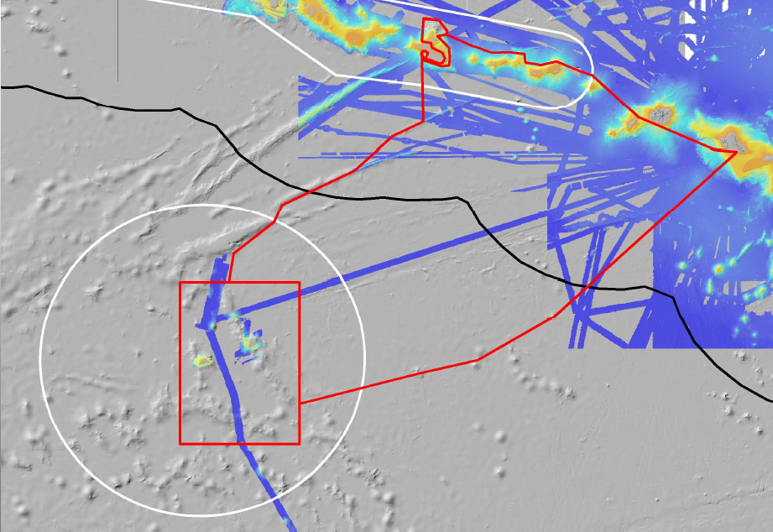

Oahu

Karin Ridge

Necker Island

*Figure 1: EX-15-04 Leg 1 Proposed transit lines and primary survey focus areas. The red lines show the draft cruise tracks, the red boxes and polygons show priority mapping areas for leg 1: vicinity of Necker Island and Karin Ridge region near Johnston Atoll. The white lines are the boundaries of PMNM and the Johnston Atoll portion of the PRIMNM. The black line is the U.S. EEZ. Color coded background bathymetry shows select multibeam coverage from various research expeditions, compiled by Dr. Chris Kelley.*

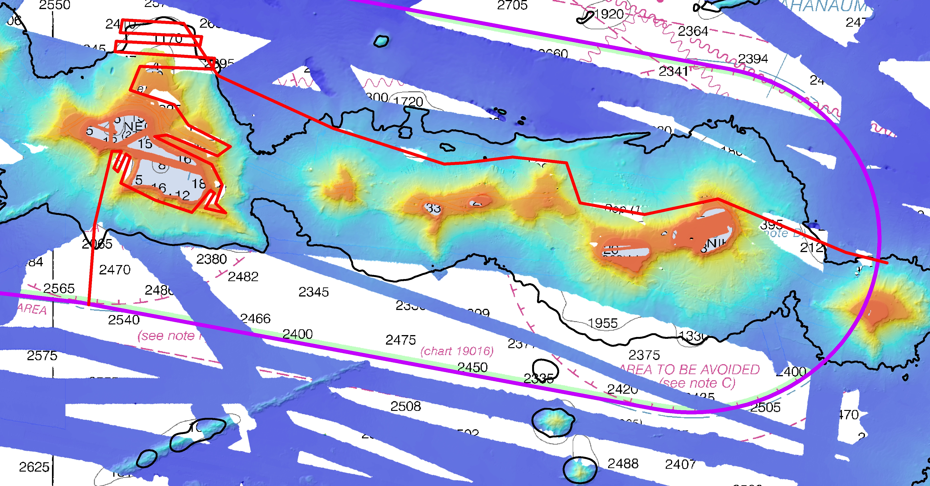

Necker Island

*Figure 2. Approximate survey line of ship to fill gaps in multibeam coverage in the vicinity of Necker Island within the Papahānaumokuākea Marine National Monument. The red line is the approximate proposed ship track line. Actual survey plan lines will be refined while underway. Color coded background bathymetry shows select multibeam coverage from various research expeditions, compiled by Dr. Chris Kelley.*

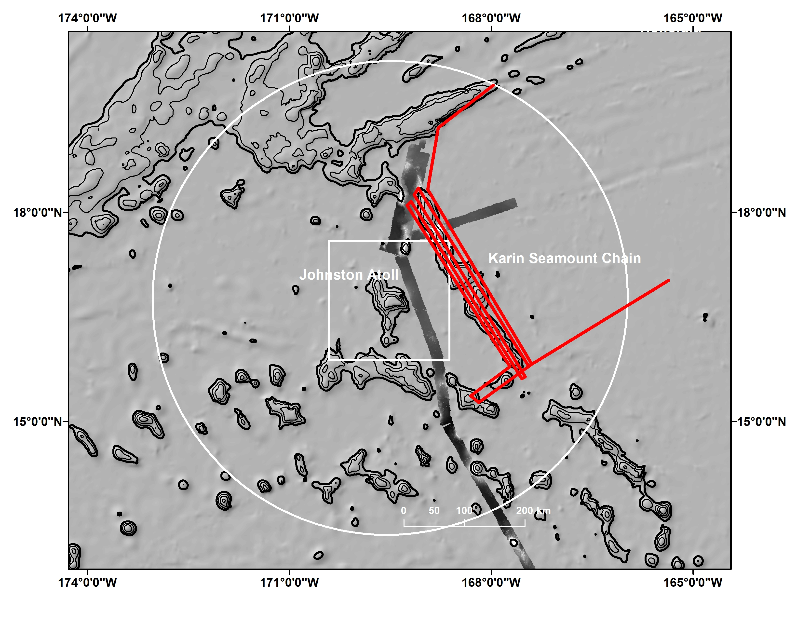

*Figure 3. Red lines show approximate survey line of ship to fill gaps in multibeam coverage in the vicinity of Johnston Atoll PRIMNM and the Karin Seamount Chain. Actual survey plan lines will be refined further prior to the expedition and while underway. Survey time allocated to this area will likely enable data to be gathered over a larger area than shown. Background multibeam data coverage shown is ECS data collected by Dr. James Gardner aboard the Kilo Moana.*

Table 1: Approximate transit waypoints to survey area within Papahānaumokuākea Marine National Monument (decimal minutes)

|  |  |  |
| --- | --- | --- |
| Remarks | Longitude | Latitude |
| Departing Pearl Harbor | 157 57.0 W | 21 16.8 N |
| Near SW corner of Oahu | 158 6.6 W | 21 15.6 N |
| S28 Wreck Site area | 158 22.67 W | 21 19.75 N |
| Just NE of Ni’ihau | 160 0.98 | 22 1.69 N |
| Gap filling during transit | 161 1.9 W | 22 57.2 N |
| Gap filling during transit | 161 1.54 W | 22 57.19 N |
| Gap filling during transit | 161 15.71 W | 23 1.68 N |
| Gap filling during transit | 161 35.87 W | 23 10.10 N |
| Gap filling during transit | 161 48.42 W | 23 15.27 N |
| Gap filling during transit | 161 52.9 W | 23 14.0 N |
| Gap filling during transit | 162 9.0 W | 23 10.74 N |
| Gap filling during transit | 162 28.84 W | 23 13.85 N |
| Gap filling during transit | 162 30.42 W | 23 25.34 N |
| Gap filling during transit | 162 50.33 W | 23 27.4 N |
| Gap filling during transit | 163 11.86 W | 23 26.93N |
| Gap filling during transit | 163 21.9 W | 23 29.9 N |
| Gap filling during transit | 163 32.54 W | 23 33.78N |
| Gap filling during transit | 163 38.93 W | 23 35.54 N |
| Arrival at survey area near Necker Island | 164 12.37 W | 23 50.6 N |

Table 2: Approximate transit waypoints from PMNM to Johnston Atoll PRIMNM survey area (decimal minutes)

|  |  |  |
| --- | --- | --- |
| Remarks | Longitude | Latitude |
| Start transit from Necker Island to Johnston | 164 43.92 W | 23 23.96 N |
| Transit mapping | 164 42.2 W | 21 56.2 N |
| Transit mapping | 165 22.5 W | 21 36.94 N |
| Starting point for surveying Tiru Seamount | 166 12.0 W | 20 52.85 N |
| Ending point for surveying Tiru Seamount | 167 46.63 W | 20 7.87 N |
| Horizon Tablemount | 167 57.12 W | 19 44.0 N |
| Transit Mapping | 168 49.6 W | 19 3.86 N |
| Start point for survey of Karin Ridge | 168 56.2 W | 18 27.5 N |

Table 3: Approximate transit waypoints from Johnston Atoll PRIMNM survey area to Pearl Harbor (decimal minutes)

|  |  |  |
| --- | --- | --- |
| Remarks | Longitude | Latitude |
| Begin transit to Pearl Harbor | 167 21.16 W | 15 48.5 N |
| Transit mapping | 164 47.55 W | 16 27.52 N |
| Transit mapping | 163 30.92 W | 16 45.01 N |
| Transit mapping | 161 51.65 W | 17 41.46 N |
| Entrance to Pearl Harbor | 157 57.0 W | 21 16.8 N |

D. Summary of Objectives

**JULY 3 – 24, 2015 (Honolulu HI - Honolulu HI)**

During EX-15-04 Leg I multibeam data will be collected 24 hours a day, largely over previously unexplored regions. Data will be used to better understand the seafloor characteristics of Papahānaumokuākea Marine National Monument and the Karin Seamount Chain within the recently expanded Pacific Remote Islands marine National Monument and allow reconnaissance of the region prior to Legs II and IV of CAPSTONE, which are both ROV cruises.

XBT casts will be conducted at an interval defined by prevailing oceanographic conditions, but not to exceed 6 hours. XBT data will be used to correct the sound velocity of the multibeam data. Additionally, EK 60 (single beam) and sub-bottom profile data will be collected 24 hours per day.

All multibeam data will be fully processed according to standard onboard procedures and will be archived with the National Geophysical Data Center. Splitbeam EK60 data will be archived at the National Oceanographic Data Center.

The following are cruise objectives for EX-15-04 Leg I:

1. Collect deep water multibeam bathymetry sonar data (MBES)

a. Conduct 24-hour mapping operations for the duration of the cruise

b. Collect bathymetric, seafloor backscatter, and water column backscatter data

c. Fill gaps in multibeam sonar coverage in the vicinity of Necker Island

d. Complement previously-gathered Extended Continental Shelf (ECS) surveying efforts around Johnston Atoll by mapping a key gap that may connect two ridge features

e. Map the majority of the Karin Ridge feature within the Johnston Atoll PRIMNM.

2. Collect ancillary sonar data

a. EK60 single beam sonar (24 hours/day)

b. Knudsen sub-bottom profiler (24 hours/day)

3. XBT operations

a. XBT casts will be collected at regular intervals of no more than 6 hours

5. Train new personnel in all data collection and processing procedures (continuous throughout cruise)

a. Training of new personnel in the Survey Department

b. Train UCAR Explorers-in-Training

c. Train UCAR mapping contractor new to the ship

d. Train EPP mapping intern and interested visiting scientists

6. Continue testing new or modified mission hardware, software, and the mission UPS system.

a. Mission computers recently upgraded to Windows 7

b. Continue testing upgrades to Caris, Fledermaus, Hypack

c. Assess performance of mission UPS following anticipated installation of new batteries

7. Telepresence (VSAT 5 mbps ship to shore; T1 shore to ship)

a. Maintain single live stream video from ship to shore with a focus on the multibeam mapping display.

8. CTD operations

a. CTD rosette operations may be requested to obtain sound velocity profiles as a back-up for XBT operations, or for the collection of water samples for shore-based scientists (TBD), and thus the CTD should be mission-ready prior to the start of the expedition.

9. The longstanding NASA marine aerosols network survey of opportunity will continue for the cruise.

10. Marine mammal observations

a. Richard Hall, Fishery Policy Analyst for NOAA’s NMFS Pacific Islands Region, will be onboard to lead marine mammal observations during the expedition. Data on observed marine mammal behavioral responses to the presence of the ship will be documented using the same methodology employed during the 2014 R/V Falkor expeditions within PMNM.

E. Participating Institutions

National Oceanic and Atmospheric Administration (NOAA) - Office of Ocean Exploration and Research (OER) - 1315 East-West Hwy, Silver Spring, MD 20910 USA

NOAA Fisheries, Pacific Islands Regional Office, NOAA Inouye Regional Center (IRC), 1845 Wasp Blvd., Building 176, Honolulu, HI 96818

NOAA, National Oceanographic Data Center, National Coastal Data Development Center, Stennis Space Center MS, 39529

NOAA, National Ocean Service (NOS) - 1305 East-West Hwy, Silver Spring, MD 20910 USA

NOAA, Office of Coast Survey, Hydrographic Surveys Division, Atlantic Hydrographic Branch, 439 W. York St., Bldg 2, Norfolk, VA 23510

University Corporation for Atmospheric Research Joint Office for Science Support (JOSS), PO Box 3000 Boulder, CO 80307 USA

University of Hawai`i at Manoa, 1000 Pope Road, Marine Sciences Building, Honolulu, HI 96822 USA

University of New Hampshire (UNH) Center for Coastal and Ocean Mapping (CCOM) Jere A. Chase Ocean Engineering Lab, 24 Colovos Road, Durham, NH 03824 USA

University of Rhode Island, Graduate School of Oceanography’s Inner Space Center, 215 South Ferry Rd. Narragansett, RI 02882 USA

F. Personnel/Science Party: name, title, gender, affiliation, and nationality

A full mapping complement is necessary for this cruise. Required mission personnel include a Mapping Lead/Expedition Coordinator as well as two qualified watchstanders for each of the three eight hour watches. The Mapping Lead is responsible for facilitating overall mapping operations, including participating in operational meetings, providing guidance for mapping/survey troubleshooting, and communicating status of mapping sensors to personnel on shore.

Table 4. List of Science Party personnel

| **Name (Last, First)** | **Title** | **Date Aboard** | **Date Depart** | **Gender** | **Affiliation** | **Nationality** |
| --- | --- | --- | --- | --- | --- | --- |
| Sowers, Derek | Expedition Coordinator/ Mapping Team Lead | 7/1/15 | 7/25/15 | M | OER/ERT Inc. | US Citizen |
| Self-Miller, Vanessa | Watch Lead | 7/1/15 | 7/24/15 | F | AHB | US Citizen |
| Bittinger, Amanda | Watch Lead | 7/1/15 | 7/24/15 | F | UCAR | US Citizen |
| Miller, Joyce | Watchstander | 7/2/15 | 7/24/15 | F | HI Mapping Research Group | US Citizen |
| Heywood, Luan | Watchstander | 7/1/15 | 7/24/15 | F | UCAR | US Citizen |
| Tauriello, Dan | Watchstander | 7/1/15 | 7/24/15 | M | UCAR | US Citizen |
| Veazey, Lindsay | Watchstander | 7/1/15 | 7/24/15 | F | UCAR | US Citizen |
| Baechler, Neah | Watchstander | 7/1/15 | 7/24/15 | F | UCAR | US Citizen |
| Cooksey, Maria | Watchstander | 7/1/15 | 7/24/15 | F | EPP | US Citizen |
| Hall, Richard | Mammal Observer | 7/2/15 | 7/24/15 | M | NMFS/PIRO | US Citizen |
| Lewis, Andrew | Journalist | 7/1/15 | 7/24/15 | M | Columbia University | US Citizen |

G. Administrative

1. Points of Contacts:

*Ship Operations*

|  |  |
| --- | --- |
| Marine Operations Center, Atlantic (MOA)  439 West York Street  Norfolk, VA 23510-1145 Telephone: (757) 441-6776  Fax: (757) 441-6495 | Chief, Operations Division, Atlantic (MOA)  LCDR Donald Beaucage  Telephone: (757) 441-6842  E-mail:chiefops.moa@noaa.gov |
|  |  |

### *Mission Operations*

|  |  |
| --- | --- |
| CDR Mark Wetzler, NOAA  Commanding Officer  NOAA Ship *Okeanos Explorer*  Phone: Iridium - (808) 659 9179  Email: [CO.Explorer@noaa.gov](mailto:CO.Explorer@noaa.gov)  LT Emily Rose, NOAA  Operations Officer  NOAA Ship *Okeanos Explorer*  Phone: (808) 659-9179  E-mail: [Ops.Explorer@noaa.gov](mailto:Ops.Explorer@noaa.gov) | Derek Sowers  Expedition Coordinator/Mapping Team Lead  NOAA Office of Ocean Exploration  and Research (ERT, Inc)  Phone : (603) 862-0369  Mobile: (714) 321-6084  E-mail : Derek.Sowers@noaa.gov |

### *Other Mission Contacts*

|  |  |
| --- | --- |
| John McDonough  Deputy Director  NOAA Ocean Exploration & Research  Phone: (301) 734-1023 / (240) 676-5206  E-mail: John.McDonough@noaa.gov | Kelley Elliott  Acting EX Program Manager  NOAA Office of Ocean Exploration  and Research  Phone : (301) 734-1024  Mobile: (703) 927-5449  E-mail :[Kelley.Elliott@noaa.gov](mailto:Kelley.Elliott@noaa.gov) |
| Jeremy Potter  Expeditions Director  NOAA Office of Ocean Exploration and Research  Phone: (301) 734-1145 / (240) 215-7101  E-mail: jeremy.potter@noaa.gov | Alan Leonardi, Director  NOAA Ocean Exploration & Research  Phone: 301-734-1016/ Mobile: 202-631-1790  E-mail: alan.leonardi@noaa.gov |

2. Diplomatic Clearances

None Required. All operations in US and International waters.

3. Licenses and Permits

See Appendix for Categorical Exclusion documentation.

**II. Operations**

The Expedition Coordinator is responsible for ensuring the scientific staff are trained in planned operations and are knowledgeable of project objectives and priorities. The Commanding Officer is responsible for ensuring all operations conform to the ship’s accepted practices and procedures.

A. Project Itinerary *(All times and dates are subject to prevailing conditions and the discretion of the commanding officer):*

*Wednesday, July 1*

* Most mission personnel arrive to ship throughout the day

*Thursday, July 2*

* Remaining mission personnel arrive to ship, mission orientation and safety talk

*Friday, July 3*

* Depart Pearl Harbor and begin transit to PMNM survey area, filling multibeam coverage gaps on the way

*Saturday, July 4*

* Continue transit towards Necker Island region of PMNM

*Sunday, July 5*

* Begin focused survey operations adjacent to Necker Island, filling large gaps in multibeam sonar coverage of the seafloor.

*Monday, July 6*

* Survey of area near Necker Island filling gaps in previously completed multibeam bathymetry coverage.

*Tuesday, July 7*

* Complete survey of Necker Island region, begin transit line to Karin Ridge in Johnston Atoll PRIMNM.

*Wednesday, July 8*

* Transit mapping, including ridgeline of Tiru Seamount

*Thursday, July 9th*

* Transit mapping of Horizon Tablemount, begin focused survey operations of Karin Ridge

*Friday July 10 – Tuesday, July 21*

* Focused survey mapping of Karin Ridge and other priority areas within Johnston Atoll PRIMNM
* Begin transit back to port early morning hours of July 21

*Friday, July 24*

* Arrive Pearl Harbor sea buoy in the morning
* Arrive in port
* Most mission personnel depart

*Saturday, July 25*

* Remaining mission personnel depart ship.

*Telepresence Events*

There are currently no telepresence events scheduled.

*In-Port Events*

There are currently no in-port events scheduled.

B. Staging and Destaging:

*Shipments*

Send an email to *Okeanos Explorer’s* Operations Officer at [OPS.Explorer@noaa.gov](mailto:OPS.Explorer@noaa.gov) indicating the size and number of items being shipped. All items should arrive to Honolulu, HI no later than **COB June 29, 2015**.

Vessel shipping address:

???

VOIP Ship: (301)-713-7772

C. Operations to be Conducted:

*Sonar Operations*

Multibeam, EK 60, and Knudsen sub-bottom profiler data acquisition is planned for this cruise. The mapping team will ensure that all the standard protocols, as laid out by the Commanding Officer and mapping lead directives will be followed for efficient and safe mapping operations. The final decision to operate and collect sub-bottom profiler data will be at the discretion of the Commanding Officer.

D. Dive Plan

All dives are to be conducted in accordance with the requirements and regulations of the NOAA Diving Program (<http://www.ndc.noaa.gov/dr.html>) and require the approval of the ship’s Commanding Officer.

Dives are not planned for this project.

E. Applicable Restrictions

Conditions which preclude normal operations: (1) XBTs will not be conducted in very rough sea states or when there is significant risk of lightning. (2) If rough sea state is resulting in very poor data quality, sonar data may not be collected for that period of time.

**III. Equipment**

1. Equipment and Capabilities provided by the ship (itemized)

* Kongsberg Simrad EM302 MultibeamEchosounder (MBES)
* Kongsberg Simrad EK60DeepwaterEchosounder
* Knudsen Chirp 3260 Sub-bottom profiler (SBP)
* LHM Sippican XBT (Deep Blue probes)
* Seabird SBE 911Plus CTD
* Seabird SBE 32 Carousel and 24 2.5 L Niskin Bottles
* Light Scattering Sensor (LSS)
* Oxidation – Reduction Potential (ORP)
* Dissolved Oxygen (DO) sensor
* Altimeter Sensor and battery pack
* CNAV GPS
* POS/MV
* Seabird SBE-45 (Micro TSG)
* Kongsberg Dynamic Positioning-1 System
* NetApps mapping storage system
* CARIS HIPS Software
* IVS Fledermaus Software
* SIS Software
* Hypack Software
* Scientific Computing System (SCS)
* ECDIS
* Met/Wx Sensor Package
* Telepresence System
* VSAT High-Speed link (Comtech5Mbps ship to shore; 1.54 Mbps shore to ship)
* Cruise Information Management System (CIMS)

1. Equipment and Capabilities provided by the scientists (itemized)

* Microtops II Ozone Monitor -Sunphotometer and handheld GPS required for NASA Marine Aerosols Network supplementary project.

**IV. Hazardous Materials**

A. Policy and Compliance

The Expedition Coordinator is responsible for complying with FEC 07 Hazardous Materials and Hazardous Waste Management Requirements for Visiting Scientific Parties (or the OMAO procedure that supersedes it). By Federal regulations and NOAA Marine and Aviation Operations policy, the ship may not sail without a complete inventory of all hazardous materials by name and quantity, MSDS, appropriate spill cleanup materials (neutralizing agents, buffers, or absorbents) in amounts adequate to address spills of a size equal to the amount of chemical brought aboard, and chemical safety and spill response procedures. Documentation regarding those requirements will be provided by the Chief of Operations, Marine Operations Center, upon request.

Per OMAO procedure, the scientific party will include with their project instructions and provide to the CO of the respective ship 30 days before departure:

* + - List of chemicals by name with anticipated quantity
    - List of spill response materials, including neutralizing agents, buffers, and absorbents
    - Chemical safety and spill response procedures, such as excerpts of the program’s Chemical Hygiene Plan or SOPs relevant for shipboard laboratories
    - For bulk quantities of chemicals in excess of 50 gallons total or in containers larger than 10 gallons each, notify ship’s Operations Officer regarding quantity, packaging and chemical to verify safe stowage is available as soon as chemical quantities are known.

Upon embarkation and prior to loading hazardous materials aboard the vessel, the scientific party will provide to the CO or their designee:

* An inventory list showing actual amount of hazardous material brought aboard
* An MSDS for each material
* Confirmation that neutralizing agents and spill equipment were brought aboard sufficient to contain and cleanup all of the hazardous material brought aboard by the program
* Confirmation that chemical safety and spill response procedures were brought aboard

Upon departure from the ship, scientific parties will provide the CO or their designee an inventory showing that all chemicals were removed from the vessel. The CO’s designee will maintain a log to track scientific party hazardous materials. MSDS will be made available to the ship’s complement, in compliance with Hazard Communication Laws.

Scientific parties are expected to manage and respond to spills of scientific hazardous materials. Overboard discharge of hazardous materials is not permitted aboard NOAA ships.

B. Inventory

Not applicable to this cruise.

1. Chemical safety and spill response procedures

Not applicable to this cruise.

1. Radioactive Materials

No Radioactive Isotopes are planned for this project

E. Inventory (itemized) of Radioactive Materials

Not applicable to this cruise.

**V. Additional Projects**

A. Supplementary (“Piggyback”) Projects

During the cruise the marine aerosol layer observations will be collected for the NASA Maritime Aerosol Network (MAN). Observations will be made by mission personnel (mapping interns) with a sun photometer instrument provided by the NASA MAN program. Resulting data will be delivered to the NASA MAN primary investigator Alexander Smirnov by the expedition coordinator. All collected data will be archived and publically available at: <http://aeronet.gsfc.nasa.gov/new_web/maritime_aerosol_network.html>. Equipment is stewarded by OER physical scientists. See Appendix C for full Survey of Opportunity Form.

B. NOAA Fleet Ancillary Projects

No NOAA Fleet Ancillary Projects are planned.

**VI. Disposition of Data and Reports**

Disposition of data gathered aboard NOAA ships will conform to NAO 216-101 *Ocean Data Acquisitions* and NAO 212-15 *Management of Environmental Data and Information.* To guide the implementation of these NAOs, NOAA’s Environmental Data Management Committee (EDMC) provides the *NOAA Data Documentation Procedural Directive* (data documentation) and *NOAA Data Management Planning Procedural Directive* (preparation of Data Management Plans). OMAO is developing procedures and allocating resources to manage OMAO data and Programs are encouraged to do the same for their Project data.

1. Data Classifications: *Under Development*
   1. OMAO Data

The Commanding Officer is responsible for all data collected for missions until those data have been transferred to mission party designees. Data transfers will be documented on NOAA Form 61-29. Reporting and sending copies of project data to NESDIS (ROSCOP form) is the responsibility of OER.

* 1. Program Data
     + At sea
       - Daily plans of the Day (POD)
       - Daily situation reports (SITREPS)
       - Daily summary bathymetry data files
     + Post cruise
       - Refined SOPs for all pertinent operational activities
       - Assessments of all activities
     + Science
       - Multibeam and XBT raw and processed data (see appendix B for the formal cruise data management plan)
       - EK 60 raw data
       - Knudsen 3260 sub-bottom profiler raw data
       - Mapping data report

1. Responsibilities: *Under Development*

**VII. Meetings, Vessel Familiarization,and Project Evaluations**

1. Pre-Project Meeting: The Expedition Coordinator and Commanding Officer will conduct a meeting of pertinent members of the scientific party and ship’s crew to discuss required equipment, planned operations, concerns, and establish mitigation strategies for all concerns. This meeting shall be conducted before the beginning of the project with sufficient time to allow for preparation of the ship and project personnel. The ship’s Operations Officer usually is delegated to assist the Expedition Coordinator in arranging this meeting.
2. Vessel Familiarization Meeting: The Commanding Officer is responsible for ensuring scientific personnel are familiarized with applicable sections of the standing orders and vessel protocols, e.g., meals, watches, etiquette, drills, etc. A vessel familiarization meeting shall be conducted in the first 24 hours of the project’s start and is normally presented by the ship’s Operations Officer.
3. Post-Project Meeting: The Commanding Officer is responsible for conducted a meeting no earlier than 24 hrs before or 7 days after the completion of a project to discuss the overall success and short comings of the project. Concerns regarding safety, efficiency, and suggestions for future improvements shall be discussed and mitigations for future projects will be documented for future use. This meeting shall be attended by the ship’s officers, applicable crew, the Expedition Coordinator, and members of the scientific party and is normally arranged by the Operations Officer and Expedition Coordinator.
4. Project Evaluation Report:Within seven days of the completion of the project, a Customer Satisfaction Survey is to be completed by the Expedition Coordinator. The form is available at <http://www.omao.noaa.gov/fleeteval.html> and provides a “Submit” button at the end of the form. Submitted form data is deposited into a spreadsheet used by OMAO management to analyze the information. Though the complete form is not shared with the ships’, specific concerns and praises are followed up on while not divulging the identity of the evaluator.

**VIII. Miscellaneous**

A. Meals and Berthing

The ship will provide meals for the scientists listed above. Meals will be served 3 times daily beginning one hour before scheduled departure, extending throughout the project, and ending two hours after the termination of the project. Since the watch schedule is split between day and night, the night watch may often miss daytime meals and will require adequate food and beverages (for example a variety of sandwich items, cheeses, fruit, milk, juices) during what are not typically meal hours. Special dietary requirements for scientific participants will be made available to the ship’s command at least seven days prior to the project.

Berthing requirements, including number and gender of the scientific party, will be provided to the ship by the Expedition Coordinator. The Expedition Coordinator and Commanding Officer will work together on a detailed berthing plan to accommodate the gender mix of the scientific party taking into consideration the current make-up of the ship’s complement. The Expedition Coordinator is responsible for ensuring the scientific berthing spaces are left in the condition in which they were received; for stripping bedding and linen return; and for the return of any room keys which were issued. The Expedition Coordinator ist is also responsible for the cleanliness of the laboratory spaces and the storage areas utilized by the scientific party, both during the project and at its conclusion prior to departing the ship.

All NOAA scientists will have proper travel orders when assigned to any NOAA ship. The Expedition Coordinator will ensure that all non NOAA or non-Federal scientists aboard also have proper orders. It is the responsibility of the Expedition Coordinator to ensure that the entire scientific party has a mechanism in place to provide lodging and food and to be reimbursed for these costs in the event that the ship becomes uninhabitable and/or the galley is closed during any part of the scheduled project.

All persons boarding NOAA vessels give implied consent to comply with all safety and security policies and regulations which are administered by the Commanding Officer. All spaces and equipment on the vessel are subject to inspection or search at any time. All personnel must comply with OMAO's Drug and Alcohol Policy dated May 17, 2000 which forbids the possession and/or use of illegal drugs and alcohol aboard NOAA Vessels.

B. Medical Forms and Emergency Contacts

The NOAA Health Services Questionnaire (NHSQ, NF 57-10-01 (3-14)) must be completed in advance by each participating scientist. The NHSQ can be obtained from the Expedition Coordinator or the NOAA website <http://www.corporateservices.noaa.gov/noaaforms/eforms/nf57-10-01.pdf>.

All NHSQs submitted after March 1, 2014, must be accompanied by [NOAA Form (NF) 57-10-02](http://www.moc.noaa.gov/all-ships/index.html)- Tuberculosis Screening Document in compliance with [OMAO Policy 1008](http://www.moc.noaa.gov/all-ships/index.html) (Tuberculosis Protection Program).

The completed forms should be sent to the Regional Director of Health Services at the applicable Marine Operations Center. The NHSQ and Tuberculosis Screening Document should reach the Health Services Office no later than 4 weeks prior to the start of the project to allow time for the participant to obtain and submit additional information should health services require it, before clearance to sail can be granted. Please contact MOC Health Services with any questions regarding eligibility or completion of either form. Ensure to fully complete each form and indicate the ship or ships the participant will be sailing on. The participant will receive an email notice when medically cleared to sail if a legible email address is provided on the NHSQ.

The participant can mail, fax, or email the forms to the contact information below. Participants should take precautions to protect their Personally Identifiable Information (PII) and medical information and ensure all correspondence adheres to DOC guidance (<http://ocio.os.doc.gov/ITPolicyandPrograms/IT_Privacy/PROD01_008240>).

The only secure email process approved by NOAA is [Accellion Secure File Transfer](https://sft2.doc.gov/courier/web/1000@/wmLogin.html) which requires the sender to setup an account. [Accellion’s Web Users Guide](https://sft2.doc.gov/courier/1000@/Accellion_Secure_Collaboration_Guide.pdf) is a valuable aid in using this service, however to reduce cost the DOC contract doesn’t provide for automatically issuing full functioning accounts. To receive access to a “Send Tab”, after your Accellion account has been established send an email from the associated email account to[accellionAlerts@doc.gov](mailto:accellionAlerts@doc.gov) requesting access to the “Send Tab” function. They will notify you via email usually within 1 business day of your approval. The ‘Send Tab” function will be accessible for 30 days.

Contact information:

|  |  |
| --- | --- |
| Regional Director of Health Services  Marine Operations Center – Atlantic  439 W. York Street  Norfolk, VA 23510  Telephone 757-441-6320  Fax 757-441-3760  Email[MOA.Health.Services@noaa.gov](mailto:MOA.Health.Services@noaa.gov) |  |

Prior to departure, the Expedition Coordinator must provide a listing of emergency contacts to the Operations Officer for all members of the scientific party, with the following information: name, address, relationship to member, and telephone number using the Google Form at

<https://docs.google.com/a/noaa.gov/forms/d/1pcoSgPluUVxaY64CM1hJ75l1iIYirTk48G-lv37Am_k/viewform>

C. Shipboard Safety

Hard hats are required when working with suspended loads.  Work vests are required when working near open railings and during small boat launch and recovery operations.  Hard hats and work vests will be provided by the ship when required.

Wearing open-toed footwear or shoes that do not completely enclose the foot (such as sandals or clogs) outside of private berthing areas is not permitted.  At the discretion of the ship CO, safety shoes (i.e. steel or composite toe protection) may be required to participate in any work dealing with suspended loads, including CTD deployment and recovery.  The ship does not provide safety-toed shoes/boots.  The ship’s Operations Officer should be consulted by the Expedition Coordinator to ensure members of the scientific party report aboard with the proper attire.

D. Communications

A progress report on operations prepared by the Expedition Coordinator may be relayed to the program office. Sometimes it is necessary for the Expedition Coordinator to communicate with another vessel, aircraft, or shore facility. Through various means of communications, the ship can usually accommodate the Expedition Coordinator. Special radio voice communications requirements should be listed in the project instructions. The ship’s primary means of communication with the Marine Operations Center is via email and the Very Small Aperture Terminal (VSAT) link. Standard VSAT bandwidth at 128kbs is shared by all vessels staff and the science team at no charge. Increased bandwidth in 30 day increments is available on the VSAT systems at increased cost to the scientific party. If increased bandwidth is being considered, program accounting is required and it must be arranged through the ship’s Commanding Officer at least 30 days in advance.

Specific information on how to contact NOAA Ship *Okeanos Explorer* and all other fleet vessels can be found at [http://www.moc.noaa.gov/MOC/phone.html#EXhttp://www.moc.noaa.gov/MOC/phone.html - EX](http://www.moc.noaa.gov/MOC/phone.html#EX)

Important Telephone and Facsimile Numbers and E-mail Addresses

Ocean Exploration and Research (OER):

Phone: (301) 734-1010

Fax: (301) 713-4252

#### University of New Hampshire, Center for Coastal and Ocean Mapping

Phone: (603) 862-3438

Fax: (603) 862-0839

#### NOAA Ship Okeanos Explorer - Telephone methods listed in order of increasing expense:

*Okeanos Explorer* Cellular: (401) 713-4114

*Okeanos Explorer* Iridium:(808) 659-9179

OER Mission Iridium (dry lab): (808) 851-3827

EX INMARSAT B

Line 1: 011-870-764-852-328

Line 2: 011-870-764-852-329

Voice Over IP (VoIP) Phone:

301-713-7772 (expect a delay once picked up by directory)

E-Mail: [Ops.Explorer@noaa.gov](mailto:Ops.Explorer@noaa.gov) - (mention the person’s name in SUBJECT field)

[expeditioncoordinator.explorer@noaa.gov](mailto:expeditioncoordinator.explorer@noaa.gov) - For dissemination of all hands emails by Expedition Coordinator while on board. See ET for password.

E. IT Security

Any computer that will be hooked into the ship's network must comply with the *OMAO Fleet IT Security Policy*1.1 (November 4, 2005) prior to establishing a direct connection to the NOAA WAN. Requirements include, but are not limited to:

(1) Installation of the latest virus definition (.DAT) file on all systems and performance of a virus scan on each system.   
(2) Installation of the latest critical operating system security patches.   
(3) No external public Internet Service Provider (ISP) connections.

Completion of the above requirements prior to boarding the ship is required.

Non-NOAA personnel using the ship's computers or connecting their own computers to the ship's network must complete NOAA’s IT Security Awareness Course within 3 days of embarking.

F. Foreign National Guests Access to OMAO Facilities and Platforms

All foreign national access to the vessel shall be in accordance with NAO 207-12 and RADM De Bow’s March 16, 2006 memo (<http://deemedexports.noaa.gov>). National Marine Fisheries Service personnel will use the Foreign National Registration System (FNRS) to submit requests for access to NOAA facilities and ships. The Departmental Sponsor/NOAA (DSN) is responsible for obtaining clearances and export licenses and for providing escorts required by the NAO. DSNs should consult with their designated Line Office Deemed Export point of contact to assist with the process.

Full compliance with NAO 207-12 is required.

Responsibilities of the Expedition Coordinator:

1. Provide the Commanding Officer with the email generated by the Servicing Security Office granting approval for the foreign national guest’s visit. (For NMFS-sponsored guests, this email will be transmitted by FNRS.)This email will identify the guest’s DSN and will serve as evidence that the requirements of NAO 207-12 have been complied with.
2. Escorts – The Expedition Coordinator is responsible to provide escorts to comply with NAO 207-12 Section 5.10, or as required by the vessel’s DOC/OSY Regional Security Officer.
3. Ensure all non-foreign national members of the scientific party receive the briefing on Espionage Indicators (NAO 207-12 Appendix A) at least annually or as required by the Servicing Security Office.
4. Export Control - Ensure that approved controls are in place for any technologies that are subject to Export Administration Regulations (EAR)*.*

The Commanding Officer and the Expedition Coordinator will work together to implement any access controls necessary to ensure no unlicensed export occurs of any controlled technology onboard regardless of ownership.

Responsibilities of the Commanding Officer:

1. Ensure only those foreign nationals with DOC/OSY clearance are granted access.
2. Deny access to OMAO platforms and facilities by foreign nationals from countries controlled for anti-terrorism (AT) reasons and individuals from Cuba or Iran without written approval from the Director of the Office of Marine and Aviation Operations and compliance with export and sanction regulations.
3. Ensure foreign national access is permitted only if unlicensed deemed export is not likely to occur.
4. Ensure receipt from the Expedition Coordinator or the DSN of the FNRS or Servicing Security Office email granting approval for the foreign national guest’s visit.
5. Ensure Foreign Port Officials, e.g., Pilots, immigration officials, receive escorted access in accordance with maritime custom to facilitate the vessel’s visit to foreign ports.
6. Export Control - 8 weeks in advance of the project, provide the Expedition Coordinator with a current inventory of OMAO controlled technology onboard the vessel and a copy of the vessel Technology Access Control Plan (TACP). Also notify the Expedition Coordinator of any OMAO-sponsored foreign nationals that will be onboard while program equipment is aboard so that the Expedition Coordinator can take steps to prevent unlicensed export of Program controlled technology. The Commanding Officer and the Expedition Coordinator will work together to implement any access controls necessary to ensure no unlicensed export occurs of any controlled technology onboard regardless of ownership.
7. Ensure all OMAO personnel onboard receive the briefing on Espionage Indicators (NAO 207-12 Appendix A) at least annually or as required by the Servicing Security Office.

Responsibilities of the Foreign National Sponsor:

1. Export Control - The foreign national’s sponsor is responsible for obtaining any required export licenses and complying with any conditions of those licenses prior to the foreign national being provided access to the controlled technology onboard regardless of the technology’s ownership.
2. The DSN of the foreign national shall assign an on-board Program individual, who will be responsible for the foreign national while on board. The identified individual must be a U.S. citizen and a NOAA or DOC employee. According to DOC/OSY, this requirement cannot be altered.
3. Ensure completion and submission of Appendix C (Certification of Conditions and Responsibilities for a Foreign National

**VIII. Appendices**

Appendix 1. Data Management Plan (In preparation)

Appendix 2. Categorical Exclusion (In preparation)

**Appendix 3. Survey of Opportunity**

**NASA Maritime Aerosols Network Survey of Opportunity**

**Survey or Project Name**

|  |
| --- |
| **Maritime Aerosol Network** |

**Points of Contact (POC): Dr. Alexander Smirnov**

**Activities Description(s)** *(Include goals, objectives and tasks)*

|  |
| --- |
| **The Maritime Aerosol Network (MAN) component of AERONET provides ship-borne aerosol optical depth measurements from the Microtops II sun photometers. These data provide an alternative to observations from islands as well as establish validation points for satellite and aerosol transport models. Since 2004, these instruments have been deployed periodically on ships of opportunity and research vessels to monitor aerosol properties over the World Oceans.** |