Okeanos Explorer ROV Dive Summary
Site Name | Engineering Dive |  |  |  | 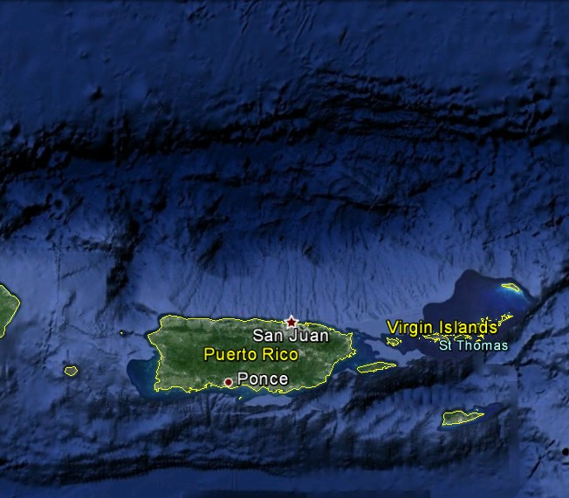
ROV Lead/Expedition Coordinator | Brian Bingham/  Brian Kennedy
Science Team Leads | Andrea Quattrini and Mike Cheadle
General Area Descriptor | Puerto Rico and US Virgin Islands
ROV Dive Name | Cruise Season |  | Leg |  |  | Dive Number
 | EX1502 |  | 3 |  |  | DIVE08
Equipment Deployed | ROV: |  | Deep Discoverer
 | Camera Platform: |  | Seirios
ROV Measurements | D2 CTD |  | Depth |  |  | Altitude
 | Scanning Sonar |  | USBL Position |  |  | Heading
 | Pitch |  | Roll |  |  | HD Camera 1
 | HD Camera 2 |  | ROV HD 2 |  |  | Seirios CTD
 | Temperature Probe |  | D2 DO Sensor |  |  | Seirios DO sensor
Equipment Malfunctions | Operating with a secondary DO sensor that was last calibrated in 2013. Error in Depth sensor in SCS for both vehicles during descent. ROV team rebooted system which fixed the problem.
ROV Dive Summary  (From processed ROV data) | Dive Summary: EX1502L3_DIVE08  ^^^^^^^^^^^^^^^^^^^^^^^^^^^^^^^^^^^^^^^^^^^^^^^^^^^  In Water at: 2015-04-25T17:06:35.984000  18°, 41.436' N ; 066°, 15.950' W  Out Water at: 2015-04-25T22:38:06.546000  18°, 41.603' N ; 066°, 15.405' W  Off Bottom at: 2015-04-25T21:41:53.921000  18°, 41.530' N ; 066°, 15.826' W  On Bottom at: 2015-04-25T18:01:04.656000  18°, 41.535' N ; 066°, 15.804' W  Dive duration: 5:31:30  Bottom Time: 3:40:49  Max. depth: 1678.1 m
Special Notes
Scientists Involved  (please provide name / location / affiliation / email) | Mike Cheadle University of Wyoming cheadle@uwyo.edu  Mike Ford NOAA Fisheries michael.ford@noaa.gov  Andrea Quanttrini USGS aquattrini@usgs.gov  Christopher Kelley University of Hawaii ckelley@hawaii.edu
Purpose of the Dive
The purpose of this engineering dive was to give ROV pilots time to train on the manipulators and to check white balance control had been restored to one of the Zeus Plus cameras that had failed during Dive 01.
Description of the Dive:
ROV Deep Discoverer landed on a soft sedimented bottom at a depth of 1678 m. ROV pilots spent time training with the manipulator arms, practicing with the SeaPoke, weights with different handles, the temperature probe, and setting up a remote GoPro camera stand. During the dive fauna observed included a few holothurians, shrimp, and a few fish. About half way through the dive, the manipulator was able to bring a “handful” of sediment to the camera for close inspection.
Overall Map of ROV Dive Area |  |  |  | Close-up Map of Main Dive Site
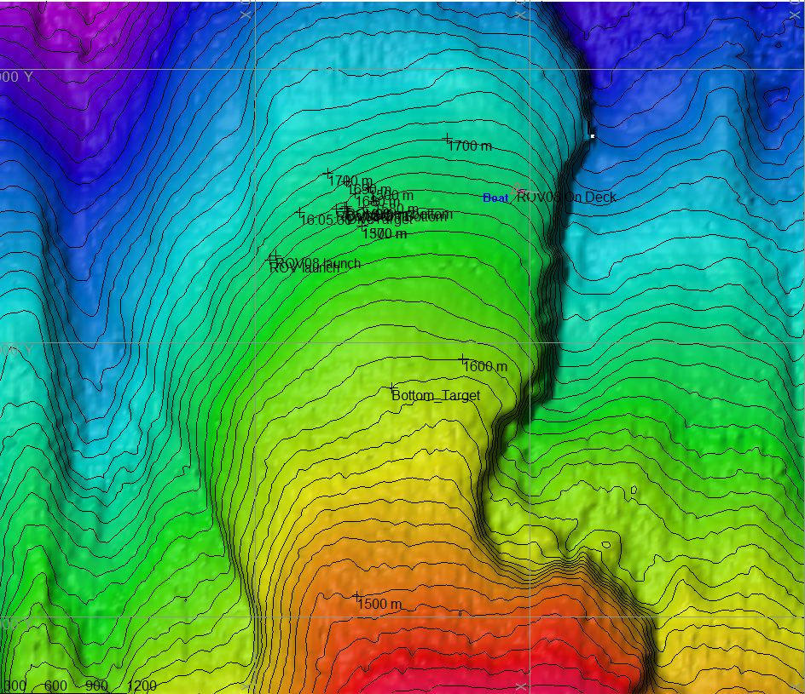 |  |  |  | 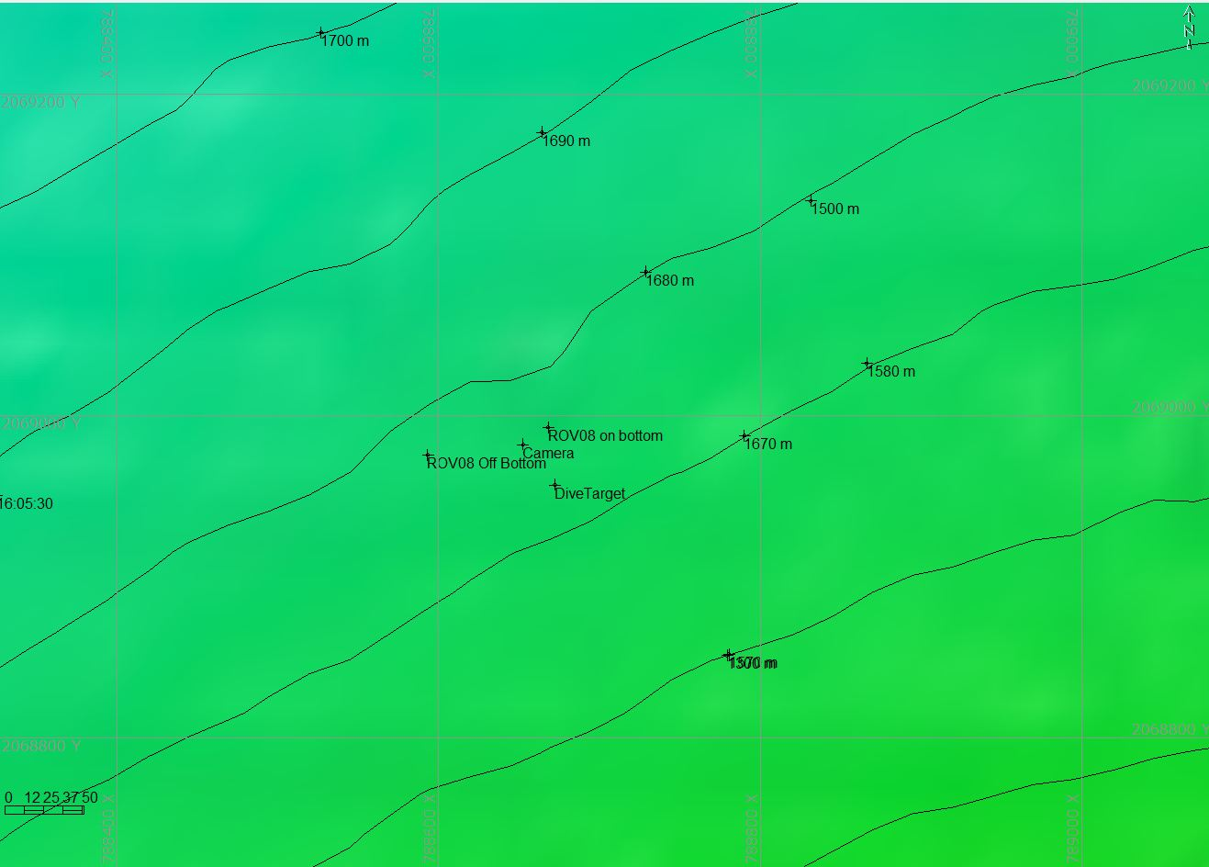
Representative Photos of the Dive
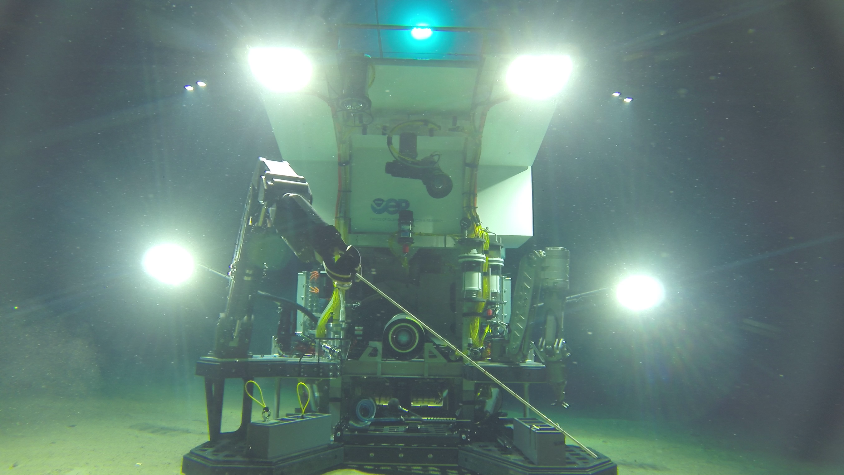 |  |  |  | 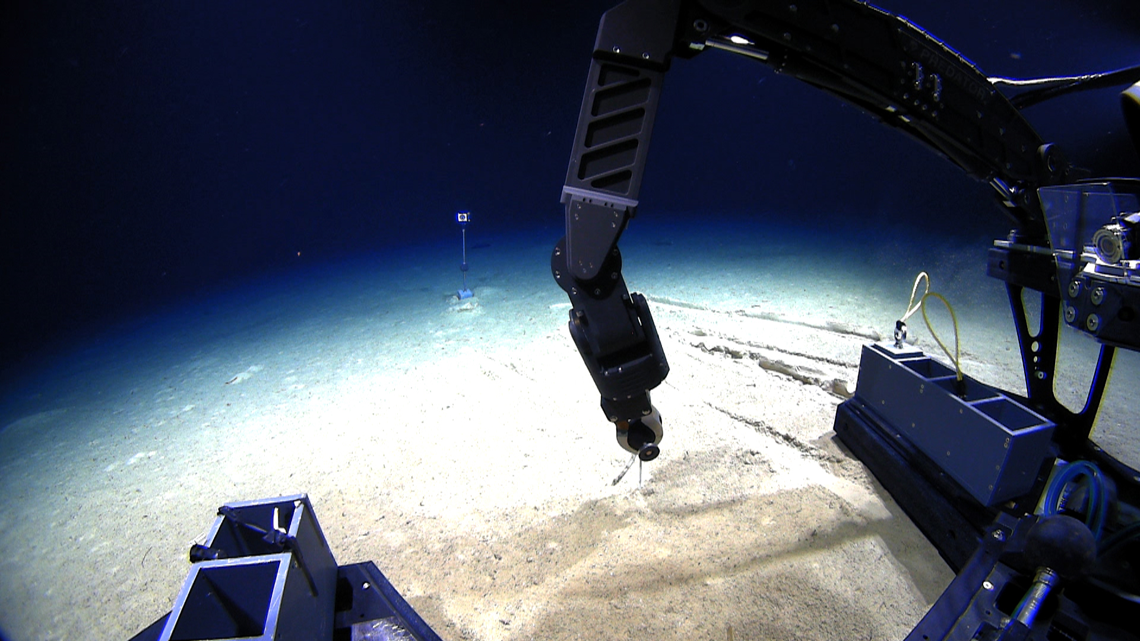
Please direct inquiries to: |  | NOAA Office of Ocean Exploration & Research  1315 East-West Highway (SSMC3 10th Floor)  Silver Spring, MD 20910  (301) 734-1014

