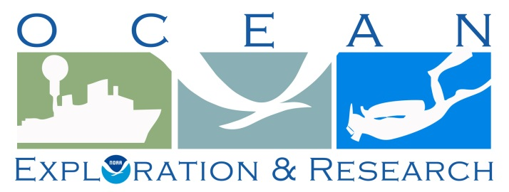

Project Instructions

Date Submitted:

Platform: NOAA Ship Okeanos Explorer

Project Number: EX-14-04 Leg II and III

Project Title: Our Deepwater Backyard: Exploring the Atlantic Canyons and Seamounts

Project Dates: Leg II (ROV and VIPs) September 4-10, 2014
Leg III (ROV, Mapping, CTD) September 16 – October 7, 2014

Prepared by: Brian Kennedy, NOAA
Expedition Coordinator
Office of Ocean Exploration & Research

Approved by: ________________________ Dated: __________________
Craig W. Russell
Program Manager
Office of Ocean Exploration & Research

Approved by: ________________________ Dated: __________________
Captain Anne K. Lynch, NOAA
Commanding Officer
Marine Operations Center - Atlantic
- OVERVIEW
A. Brief Summary and Project Period
NOAA’s Okeanos Explorer systematically explores the ocean every day of every cruise to maximize public benefit from the ship’s unique capabilities. With 95% of the ocean unexplored, we pursue every opportunity to map, sample, explore, and survey at planned destinations as well as during transits; “Always Exploring” is a guiding principle. An integral element of Okeanos Explorer’s “Always Exploring” model is the ship’s seafloor and water column mapping capabilities. All three mapping sonars (EM 302, EK 60, Knudsen subbottom) are operational on all transit cruises for 24-hour seabed, water column, and subbottom data collection and selected processing.

This document contains project instructions for EX-14-04 Leg II and Leg III, which are telepresence enabled ROV and mapping exploration cruises. Operations for Leg II are expected to commence on September 4, 2014 in North Kingstown, RI, and conclude on September 10, 2014 in Baltimore Maryland. Leg III operations are expected to commence on September 16, 2014 and conclude on October 7, 2014 in North Kingstown Rhode Island. ROV dives will mostly be conducted during the day, while CTD casts, and multibeam, singlebeam, and subbottom acoustic mapping will occur when the ROV is on deck. Exploration operations will focus on the New England Seamount Chain and the shelf break canyons between North Carolina and Lydonia Canyon.

Requests for information on priority exploration areas for 2014 mapping and ROV exploration resulted in general interest for exploration of the New England Seamount Chain. At the time of writing of this draft (August 20, 2014), identification of discrete ROV exploration targets was still in development, however preliminary plans indicate that the majority of the ROV dives will occur between Bear and Gregg Seamounts and between Norfolk and Lydonia Canyons.

Leg II will be a short seven-day cruise with 4 canyon or inter-canyon ROV dives planned. The ROV dives will focus on little or unknown areas of the continental slope between Rhode Island and Chesapeake Bay, with exact locations to be determined soon. The major driving objective during these dives will be conducting engineering trials of the ROV and focused outreach events. The first dive will be in the area of Lindenkohl canyons and will be devoted to ROV engineering trials. The second dive is currently planned for Washington Canyon will be an exploration dive if there are no engineering objectives remaining from dive 1. Dive 3 will be in the head of Norfolk Canyon and will be an outreach dive with several VIPs on board the ship observing the operations. Dive 4 will likely be at the mid-Atlantic gas seep site and will also be a VIP outreach dive. Both dive 3 and 4 will likely be evening dive with the ROV being deployed in the afternoon and recovered at night. All telepresence systems will be functioning for shore based science participation.

Leg III will depart Baltimore, MD and conduct several ROV dives along the continental slope submarine canyons, en route to and returning from the North Atlantic Seamount Chain. ROV operations on the seamounts will be conducted on seamounts both inside and outside the U.S. EEZ. Operations will focus on areas of high potential for discovery and of interest to the management community. The individual seamount that will be targeted is still TBD but for each seamount visited during the cruise we plan on conducting between 1 and 3 ROV dives. Full shore-based distributed science participation is expected. This cruise will operate very similarly to previous Okeanos Explorer expeditions.

B. Days at Sea (DAS)

Leg II:
Of the 7 DAS scheduled for this project, 7 DAS are funded by an OMAO allocation, 0 DAS are funded by a Line Office Allocation, 0 DAS are Program Funded, and 0 DAS are Other Agency funded. This project is estimated to exhibit a High Operational Tempo due to daily ROV operations, small boat transfers, and nighttime mapping.

Leg III:
Of the 22 DAS scheduled for this project, 15 DAS are funded by an OMAO allocation for FY14 and 7 DAS are funded by an OMAO allocation for FY15, 0 DAS are funded by a Line Office Allocation, 0 DAS are Program Funded, and 0 DAS are Other Agency funded. This project is estimated to exhibit a High Operational Tempo due to daily ROV operations, nighttime mapping, and evening CTD work.
C. Operating Area
The 2014 “Our Deepwater Backyard” Expedition will focus primarily on U.S. northeast Atlantic seamounts and canyons. Leg II will focus on the western portion of the canyons operating area, and Leg III will focus on the New England Seamount Chain, figure 1. The daily schedule for both cruises will usually be split between daytime ROV operations and evening/night CTD and mapping operations. The majority of CTD casts will be conducted during leg III, currently only one or two CTD casts are expected during leg II. ROV operations will focus in depths >500m and will include high-resolution visual surveys. Mapping operations will include overnight subbottom data collection over key features, multibeam data collection over canyon heads requiring coverage development, and re-mapping of recently discovered gaseous seeps.
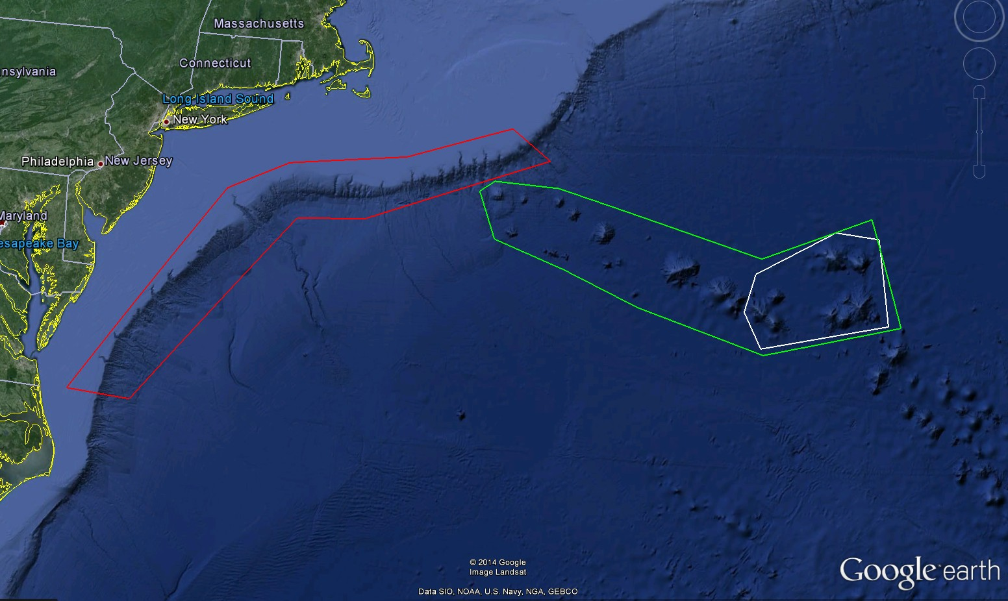
Figure 1: Approximate operating area of Okeanos Explorer for EX-14-04-Leg II and III. The red polygon is the operations area for leg II and the transit dives during leg III. The green polygon denotes the primary operating area for leg III. The white polygon is the area expected to be mapped on Leg I. Figure produced in Google Earth Pro.
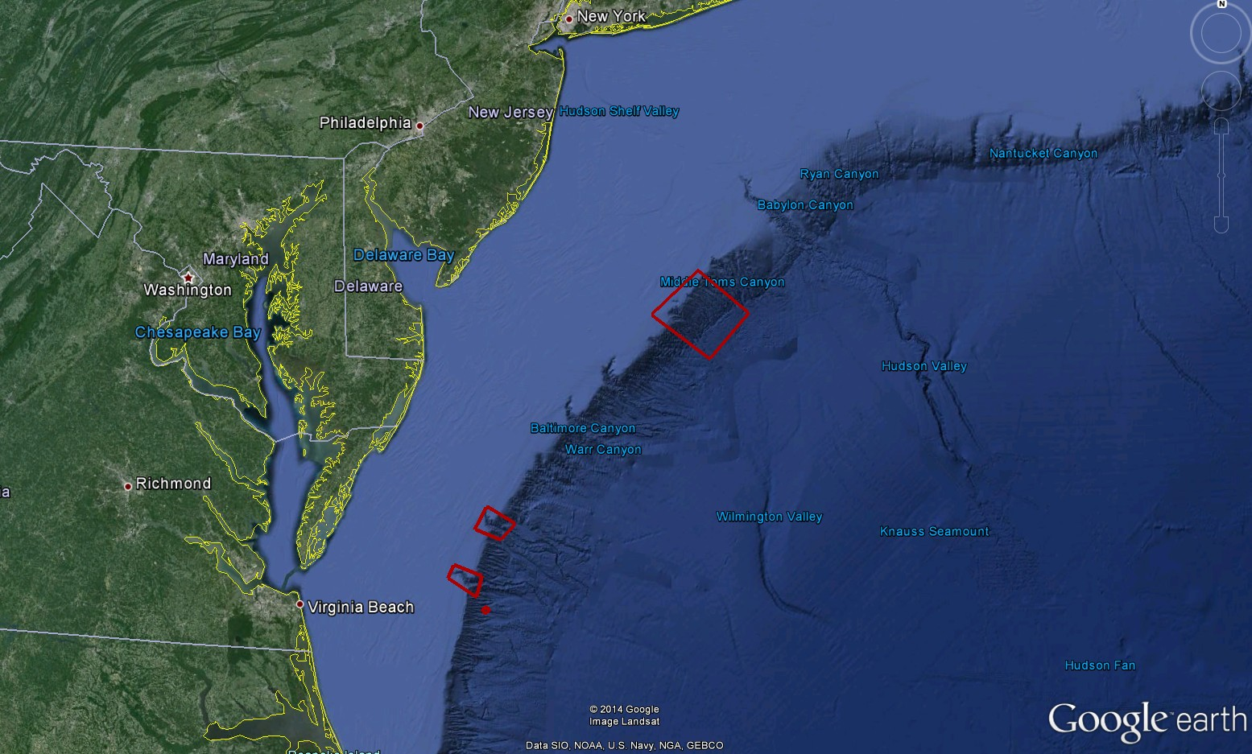
Figure 2: The red boxes denote the area for the expected dives during leg II. The boxes will be visited from north to south. Figure produced in Google Earth Pro.
D. Summary of Objectives
Leg II: SEPT 4 – SEPT 10 (North Kingstown, RI to Baltimore, MD) Telepresence enabled ROV cruise with VIP participation

EX-14-04 Leg II operations will focus on the western portion of the operating area shown in figure 1. Refined target areas for ROV dives are shown in figure 2. The primary goals for this cruise will be to conduct ROV shakedown activities, explore poorly known areas of the continental slope, and increase awareness of ocean exploration and OER through VIP interactions.

Leg III: SEPT. 16- OCT 7 (Baltimore, MD to North Kingstown, RI) Telepresence enabled ROV cruise with Mapping, and CTD operations

EX-14-04 Leg III operations will focus on the New England Seamount Chain shown in figure 1. The primary goals for this cruise include collecting baseline-characterization data of poorly known areas along the New England Seamount Chain and U.S. northeast continental shelf canyons.
Mission objectives for EX-14-04 Legs II and III include a combination of operational, science, education, outreach and data management objectives. They are:
- Science
  - Identify and explore the diversity and distribution of benthic habitats and features in the region (e.g., seeps, deep corals and related benthic ecosystems, canyons, and seamounts)
  - Ground-truth acoustic data using video imagery and characterize associated habitat
  - Collect baseline data for the areas visited
  - Create and provide input into standard science products

- Remote Science/Exploration Command Centers
  - Test and refine ship-to-shore communications and operations procedures that engage multiple ECCs and other remote participants
  - Test and refine operating procedures and products
  - Engage a broad spectrum of the scientific community and public in telepresence-based exploration

- ROV
  - Integrate ROV into ship systems
    - Load ROVs
    - Load ROV stores
    - Connect .68 cable to ROVs
    - Test all ROV systems while alongside
    - Possibly conduct alongside ROV dive
    - Conduct ROV launch and recovery training for new crew members
    - Test USBL alongside
  - Daytime ROV dives on exploration targets
  - Ongoing training of pilots
  - Ongoing system familiarization, documentation and training.
  - Test new ROV sub systems

- Telepresence (VSAT 20 mb/sec ship-to-shore; T1 shore-to-ship)
  - Turn on and test terrestrial and high-speed satellite links
  - Support telepresence-enabled ROV expedition
  - Collect/create all standard video products
  - Evaluate newly purchased video encoders
  - Test/implement new protocols for accessing the ship’s wireless internet
  - Work with NOAA NOC to harden the video network path
  - Work with MTN to harden the VSAT system
  - Facilitate live outreach events between ship and shore
  - Test new YouTube Live streaming encoder
  - Take new B-Roll shots of the ship from a small boat

- Mapping
  - Collect high resolution mapping data from all three sonars
  - Support ROV operations with mapping products and expertise
  - Conduct mapping operations during transit, with possible further development of exploration targets
  - Collect XBT cast at regular intervals no longer than 3-4 hours, as data quality requires, during mapping operations
  - Create daily standard mapping products

- CTD operations
  - Conduct CTD cast for comparison to ROV CTDs
  - Conduct CTDs with water sample collection as requested after ROV dives

- Data Management
  - Troubleshoot ROV CTD data
  - Train new data engineer
  - Provide a foundation of publicly accessible data and information products to spur further exploration, research, and management activities, as detailed in the 2013 post-cruise product list
  - Provide daily products to shore for operational decision making purposes, as detailed in the 2013 field products list
  - Test the ability to record high definition video footage of a dive onboard the ship

- Outreach
  - Engage the general public in ocean exploration through live video and timely content posted on the Ocean Explorer website
  - Conduct two 24hrs VIP trips
  - Host live events with information science centers
  - Host live events with VIPS
  - Participate in Google Hangout hosted by the National Aquarium
  - Participate in Star Spangled Spectacular (S3) and other NOAA organized outreach events en route, in, and departing from Baltimore, MD in port.

E. Participating Institutions
College of Earth, Ocean, and Atmospheric Sciences, Oregon State University,104 CEOAS Administration Building, Corvallis, OR 97331-5503

National Oceanic and Atmospheric Administration (NOAA) –Office of Ocean Exploration and Research (OER)–1315 East-West Hwy, Silver Spring, MD 20910 USA

NOAA, National Oceanographic Data Center, National Coastal Data Development Center, Stennis Space Center MS, 39529

NOAA, Office of Coast Survey, Hydrographic Surveys Division, Atlantic Hydrographic Branch, 439 W. York St., Bldg 2, Norfolk, VA 23510

Rockefeller University - Program for the Human Environment – 1230 York Ave, New York, NY 10021

University Corporation for Atmospheric Research Joint Office for Science Support (JOSS), PO Box 3000 Boulder, CO 80307 USA

University of New Hampshire (UNH)–Center for Coastal and Ocean Mapping (CCOM)–Jere A. Chase Ocean Engineering Lab, 24Colovos Road, Durham, NH 03824 USA

University of Louisiana at Lafayette- Biology Department – 300 E St. Mary Blvd., Lafayette, LA 70503 USA

The University of Texas at Austin, John A. and Katherine G. Jackson School of Geosciences, Institute for Geophysics, J.J. Pickle Research Campus, Building 196 (ROC), 10100 Burnet Road (R2200), Austin, TX 78758-0999

University of Rhode Island, Graduate School of Oceanography’s Inner Space Center – 215 South Ferry Rd. Narragansett, RI 02882 USA

F. Personnel (Mission Party)
Partial mapping teams are necessary for leg II. Leg III will have a normal ROV cruise mapping staff. Required mission personnel for leg II include a mapping lead and full ROV team. Required mission personnel for leg III include a mapping lead and one qualified watchstander and full ROV team.

Table 1: Leg II (First 4 days) Full list of the mission party members and their affiliation
Name  (Last, First) | Title | Date Aboard | Date Disembark | Gender | Affiliation | Nationality
Kennedy, Brian | Expedition Coordinator | 9/4/14 | 10/7/14 | M | NOAA OER | USA
Drewniak, Jared | Video Lead | 9/4/14 | 10/7/14 | M | NOAA OER (ERT) | USA
Lobecker, Elizabeth “Meme” | Mapping Lead | 9/4/14 | 9/11/14 | F | NOAA OER (ERT) | USA
Reser, Brendan | Data Lead | 9/2/14 | 9/11/14 | M | NOAA NCDDC (DGIT) | USA
Austin, Jamie | Science Co-Lead | 9/3/14 | 9/10/14 | M | UTIG | USA
Ausubel, Jesse | Scientist | 9/3/14 | 9/10/14 | M | Rockefeller University | USA
Lovalvo, David | ROV team Lead | 9/4/14 | 9/7/14 | M | NOAA OER (ERT) | USA
Wright, Dave | ROV Engineer | 9/2/14 | 10/8/14 | M | UCAR | USA
Williams, Jeff | ROV Engineer | 9/2/14 | 9/7/14 | M | UCAR | USA
Mohr, Bobby | ROV Engineer | 9/2/14 | 10/8/14 | M | UCAR | USA
Lanning, Jeff | ROV Engineer | 9/2/14 | 10/8/14 | M | UCAR | USA
McLetchie, Karl | ROV Engineer | 9/2/14 | 10/8/14 | M | UCAR | USA
Gregory, Todd | ROV Engineer | 9/2/14 | 10/8/14 | M | UCAR | USA
Carlson, Joshua | ROV Engineer | 9/2/14 | 10/8/14 | M | UCAR | USA
Rogers, Dan | ROV Engineer | 9/2/14 | 9/7/14 | M | UCAR | USA
Bingham, Brian | ROV Engineer | 9/2/14 | 10/8/14 | M | UCAR | USA
Brian, Roland | Video Engineer | 9/2/14 | 10/8/14 | M | UCAR | USA
Howard, Art | Video Editor | 9/2/14 | 9/7/14 | M | UCAR | USA
TBD | Video Engineer |  |  | M | UCAR | USA
TBD

Table 2: Leg II (First VIP trip) Full list of the mission party members and their affiliation
Name  (Last, First) | Title | Date Aboard | Date Disembark | Gender | Affiliation | Nationality
Kennedy, Brian | Expedition Coordinator | 9/4/14 | 10/7/14 | M | NOAA OER | USA
Drewniak, Jared | Video Lead | 9/4/14 | 10/7/14 | M | NOAA OER (ERT) | USA
Lobecker, Elizabeth “Meme” | Mapping Lead | 9/4/14 | 9/11/14 | F | NOAA OER (ERT) | USA
Austin, Jamie | Science Co-Lead | 9/3/14 | 9/10/14 | M | UTIG | USA
Ausubel, Jesse | Science Co-Lead | 9/3/14 | 9/10/14 | M | Rockefeller University | USA
Lovalvo, Dave | ROV Team Lead | 9/2/14 | 9/11/14 | M | UCAR | USA
Wright, Dave | ROV Engineer | 9/2/14 | 10/8/14 | M | UCAR | USA
Bingham, Brian | ROV Engineer | 9/2/14 | 9/11/14 | M | UCAR | USA
Mohr, Bobby | ROV Engineer | 9/2/14 | 10/8/14 | M | UCAR | USA
Wright, Dave | ROV Engineer | 9/2/14 | 10/8/14 | M | UCAR | USA
McLetchie, Karl | ROV Engineer | 9/2/14 | 10/8/14 | M | UCAR | USA
Gregory, Todd | ROV Engineer | 9/2/14 | 10/8/14 | M | UCAR | USA
Carlson, Joshua | ROV Engineer | 9/2/14 | 10/8/14 | M | UCAR | USA
Roland, Brian | Video Engineer | 9/2/14 | 10/8/14 | M | UCAR | USA
VIP |  |  |  |  |  | ?
VIP |  |  |  |  |  | ?
VIP |  |  |  |  |  | ?
VIP |  |  |  |  |  | ?
VIP |  |  |  |  |  | ?
VIP |  |  |  |  |  | ?

Table 3: Leg II (Second VIP trip) Full list of the mission party members and their affiliation
Name  (Last, First) | Title | Date Aboard | Date Disembark | Gender | Affiliation | Nationality
Kennedy, Brian | Expedition Coordinator | 9/4/14 | 10/7/14 | M | NOAA OER | USA
Drewniak, Jared | Video Lead | 9/4/14 | 10/7/14 | M | NOAA OER (ERT) | USA
Lobecker, Elizabeth “Meme” | Mapping Lead | 9/4/14 | 9/11/14 | F | NOAA OER (ERT) | USA
Austin, Jamie | Science Co-Lead | 9/3/14 | 9/10/14 | M | UTIG | USA
Ausubel, Jesse | Science Co-Lead | 9/3/14 | 9/10/14 | M | Rockefeller University | USA
Lovalvo, Dave | ROV Team Lead | 9/2/14 | 9/11/14 | M | NOAA OER (ERT) | USA
Wright, Dave | ROV Engineer | 9/2/14 | 10/8/14 | M | UCAR | USA
Bingham, Brian | ROV Engineer | 9/2/14 | 9/11/14 | M | UCAR | USA
Mohr, Bobby | ROV Engineer | 9/2/14 | 10/8/14 | M | UCAR | USA
Wright, Dave | ROV Engineer | 9/2/14 | 10/8/14 | M | UCAR | USA
McLetchie, Karl | ROV Engineer | 9/2/14 | 10/8/14 | M | UCAR | USA
Gregory, Todd | ROV Engineer | 9/2/14 | 10/8/14 | M | UCAR | USA
Carlson, Joshua | ROV Engineer | 9/2/14 | 10/8/14 | M | UCAR | USA
Roland, Brian | Video Engineer | 9/2/14 | 10/8/14 | M | UCAR | USA
Clark, Mike | Guest | 9/8/14 | 9/9/14 | M | OMB | USA
Miller, Kim | Guest | 9/8/14 | 9/9/14 | F | OMB | USA
Phelps, Michael | Guest | 9/8/14 | 9/9/14 | M | DOC | USA
Garneski, John | Guest | 9/8/14 | 9/9/14 | M | DOC | USA
Cruickshank, Walter | Guest | 9/8/14 | 9/9/14 | M | BOEM | USA
McDonough, John | Guest | 9/8/14 | 9/9/14 | M | NOAA OER | USA

Table 4: Leg III Full list of the mission party members and their affiliation
Name  (Last, First) | Title | Date Aboard | Date Disembark | Gender | Affiliation | Nationality
Kennedy, Brian | Expedition Coordinator | 9/4/14 | 10/7/14 | M | NOAA OER | USA
McKenna, Lindsay | Mapping Team Lead | 9/13/14 | 10/7/14 | F | NOAA OER  (ERT Inc) | USA
Reser, Brendan | Data Lead | 9/2/14 | 10/8/14 | M | NOAA NCDDC (DGIT) | USA
Drewniak, Jared | Video Lead | 9/4/14 | 10/7/14 | M |  | USA
France, Scott | Science Lead | 9/14/14 | 10/8/14 | M |  | US permanent resident (Canadian)
Schnur, Susan | Geologist | 9/14/14 | 10/8/14 | F | Oregon State University (UCAR) | USA
Gregory, Todd | ROV Team Lead | 9/2/14 | 10/8/14 | M | UCAR | USA
Wright, Dave | ROV Engineer | 9/2/14 | 10/8/14 | M | UCAR | USA
Williams, Jeff | ROV Engineer | 9/11/14 | 10/8/14 | M | UCAR | USA
Mohr, Bobby | ROV Engineer | 9/2/14 | 10/8/14 | M | UCAR | USA
Lanning, Jeff | ROV Engineer | 9/2/14 | 10/8/14 | M | UCAR | USA
McLetchie, Karl | ROV Engineer | 9/2/14 | 10/8/14 | M | UCAR | USA
TBD | ROV Engineer | 9/2/14 | 10/8/14 | M | UCAR | USA
Ritter, Chris | ROV Engineer | 9/10/14 | 10/8/14 | M | UCAR | USA
Carlson, Joshua | ROV Engineer | 9/2/14 | 10/8/14 | M | UCAR | USA
Rogers, Dan | ROV Engineer | 9/2/14 | 10/8/14 | M | UCAR | USA
Howard, Art | Video Editor | 9/2/14 | 10/8/14 | M | UCAR | USA
Brian, Roland | Video Engineer | 9/2/14 | 10/8/14 | M | UCAR | USA
TBD | Video Engineer | 9/14/14 | 10/8/14 | M | UCAR | USA
Miller, James | Mapping Watch lead | 9/15/14 | 10/8/14 | M | NOAA AHB | USA

Table 5: Leg II and III Shore Based Participants
Last Name | First Name | Organization | Area of interest or expertise. | Location
Martinez | Catalina | NOAA OER | Shore side OPS | ISC
Elliot | Kelley | NOAA OER (20/20) | Shore side OPS | SS ECC
Cantwell | Kasey | NOAA OER (20/20) | Web Coordinator | SS ECC
Graddy | Sarah | NOAA OER (20/20) | Web Coordinator | SS ECC
Heyl | Taylor | WHOI | Benthic biology | Redfield Building, WHOI
Shank | Timothy | WHOI | Benthic biology | Redfield Building, WHOI
Brooke | sandra | FSUCML | Coral and seep ecology | FSUCML
Cordes | Erik | Temple University | benthic biology | the EEC ECC at Temple University
White | Scott | University of South Carolina | geomorphology, volcanology, structure/tectonics | University of South Carolina, Columbia, SC
Ford | Mike | NOAA Fisheries | gelatinous zooplankton - oceanography | United States
Carney | Robert | Louisiana State Univ | benthic biology | United States
Cantwell | Kasey | NOAA OER |  | United States
Cordes | Erik | Temple University | benthic biology | Temple University, Philadelphia PA
Jann | Wendt | University of Kiel | Geomorphology | University of Kiel
Herrera | Santiago | WHOI | Biology | WHOI
Stevens | Brad | Univ of MD Eastern Shore | epibenthos, crustaceans | United States
James | Moore | BOEM | archaeology | BOEM Headquarters, Herndon, VA
Mayer | Larry | UNH CCOM | geomorphology - mapping | UNH when there
Baco-Taylor | Amy | Florida State University | Benthic Ecology and Genetics | Florida State University
Carney | Robert | LSU | benthic biology | Baton Rouge La, LSU
Clostio | Rachel | University of Louisiana at Lafayette | deep-sea corals | University of Louisiana at Lafayette
Nizinski | Martha | NOAA/NMFS | deep-sea corals, crustaceans | Smithsonian Institution/Silver Spring Command Center
Ball | Bernie | Duke University Marine Lab | chemosynthetic ecology and biology | Duke University Marine Lab, Beaufort NC
Ruppel | Carolyn | USGS | methane hydrate, methane, seeps, other geoscience | wherever I am on that day (home, MIT, USGS), but may got to URI ISC for any non-VIP seep dives
Pomponi | Shirley | Harbor Branch - FAU - CIOERT | benthic biology, sponges | HBOI ECC
Auster | Peter | UConn and SRF | benthic biology, deep sea fish, habitat | URI or SRF/MMA
Vecchione | Michael | NMFS Syatematics Lab | cephalopods, nekton, pelagic diversity | Silver Spring for pelagic obs, office or home otherwise; Can do public I2 presentation at National Museum of Natural History
Jordan | Brian | BOEM | archaeology | BOEM Herndon, VA or from home
Ritter | Thomas | Montana State University | Ichthyology | MSU - Bozeman
Quattrini | Andrea | USGS |  | home
Kris | Ohleth | Mid-Atlantic Regional Council on the Ocean (MARCO) |  | MARCO Office, New Jersey
Odell | Jay | The Nature Conservancy | benthic ecology, invertebrate zoology, conservation biology, regional ocean planning | TNC in Richmond or ?
Ticco | Paul | NOAA/ONMS | Marine Protected Area Management | Newport News, VA
Bohan | Margot | NOAA | geology, benthic biology | United States
Morgan | Nicole | Florida State university | benthic biology, octocorals | FSU, Tallahassee FL
Morrison | Cheryl | USGS | Benthic biology, corals and galatheoid crabs | USGS Leetown WV
Shea | Liz | Delaware Museum of Natural History | cephalopods | Delaware Musem of Natural History, Wilmington, DE USA
Ross | Steve | Univ. of NC at Wilmington | fishes, deep corals, seeps, water column and benthic ecology | my office at UNCW
Skarke | Adam | Mississippi State University | Marine Geology, Geophysics, Gas Seeps, Mapping | Stennis Space Center ECC
Hemphill | Arlo | MARCO - Mid-Atlantic Regional Council on the Ocean | communications, ichthyology | Ocean City, Maryland ; MARCO
Roark | Brendan | Texas A&M University | Deep sea coral and biogeochemistry | Office at Texas A&M
Gilbert | Lisa | Williams College | volcanology, geophysics, seafloor mapping | Williams-Mystic, Mystic, CT
Brooke | Sandra | FSUCML | Coral and seep ecology | FSUCML
Austin | James | University of Texas/Austin, Jackson School of Geosciences | marine geology | Institute for Geophysics, Austin, TX
Herter | Jeffrey | NYS Department of State, Office of Planning & Development | Offshore Planning | United States

G. Administrative

Points of Contact:

Ship Operations

Marine Operations Center, Atlantic (MOA)  439 West York Street  Norfolk, VA 23510-1145  Telephone: (757) 441-6776  Fax: (757) 441-6495 | Chief, Operations Division, Atlantic (MOA)  LT Laura Gibson, NOAA  Telephone: (757) 441-6842  E-mail: Chiefops.MOA@noaa.gov

Mission Operations

LTJG Brian Kennedy  Expedition Coordinator  NOAA Office of Ocean Exploration  and Research  Phone : 401-874-6150/ 706-540-2664  E-mail : Brian.Kennedy@noaa.gov  Elizabeth “Meme” Lobecker  Leg II Mapping Lead  NOAA Office of Ocean Exploration  and Research (ERT)  Phone : 401-874-6150/ 706-540-2664  E-mail : Elizabeth.Lobecker@noaa.gov  Lindsay Mckenna  Leg III Mapping Lead  NOAA Office of Ocean Exploration  and Research (ERT)  Phone : 603-862-5246 (o) / 518-669-2285 (c)  E-mail : Lindsay.Mckenna@noaa.gov  Jared Drewniak, Telepresence Lead  NOAA Office of Ocean Exploration & Research (ERT)  Phone: (401) 874-6250 (o) / (401) 330-9662 (c)  Email: jared.drewniak@noaa.gov | CDR Ricardo Ramos, NOAA  Commanding Officer  NOAA Ship Okeanos Explorer  Phone: (401) 378-8284  Email: CO.Explorer@noaa.gov  LT Emily Rose, NOAA  Operations Officer  NOAA Ship Okeanos Explorer  Phone: (808) 659-9197 (Ship’s Iridium)  E-mail: Ops.Explorer@noaa.gov  Dave Lovalvo  ROV Team Lead  NOAA Office of Ocean Exploration  and Research (ERT)  Phone : 401-874-6150/ 706-540-2664  E-mail : david.lovalvo@noaa.gov

Other Mission Contacts
Craig Russell, EX Program Manager  NOAA Ocean Exploration & Research  Phone: 206-526-4803 / 206-518-1068  E-mail: Craig.Russell@noaa.gov | LCDR Nicola VerPlanck, EX Deputy Program Manager  NOAA Ocean Exploration & Research  Phone: 206-526-4801  E-mail: Nicola.Verplanck@noaa.gov
John McDonough, Acting Director  NOAA Ocean Exploration & Research  Phone: 301-734-1023 / 240-676-5206  E-mail: John.McDonough@noaa.gov | Jeremy Potter, Expeditions Director  NOAA Ocean Exploration and Research  Phone: 301-734-1145 / 240-215-7101  Jeremy.Potter@noaa.gov

Vessel shipping address:

Shipments:
Send an email to the Okeanos Explorer Operations Officer at OPS.Explorer@noaa.gov indicating the size and number of items being shipped.

Leg II items should arrive at the below address prior to COB September 2, 2014.

NOAA Ship Okeanos Explorer
2578 Davisville Rd.
North Kingstown, RI 02852

Leg III items should arrive at the below address prior to COB September 11, 2014.

NOAA Ship Okeanos Explorer
2578 Davisville Rd.
North Kingstown, RI 02852

- Diplomatic Clearances
None Required.
- Licenses and Permits
See Appendix C for categorical exclusion documentation.

- OPERATIONS

The Expedition Coordinator is responsible for ensuring the scientific staff are trained in planned operations and are knowledgeable of project objectives and priorities. The Commanding Officer is responsible for ensuring all operations conform to the ship’s accepted practices and procedures.

- Project Itinerary(All times and dates are subject to prevailing conditions and the discretion of the Commanding Officer)

Table 3: Leg II Detailed Itinerary
Date | Activity | Notes and Requirements
8/30/2014 | Load ROVs and ROV stores | Crane operators and line handles for 2-3 hours after the ship is alongside. OER will arrange for a truck to move the ROVs from the port office to the ship. Use of the ship’s forklift and an operator would speed up the process.
8/31/2014 | Unpack ROV stores and re integrate ROV into ship systems | No ships force work will be necessary. The ROV engineers will need to work 12 hrs on board. The ability to do small hot work such as soldering would speed up the operation.
9/1/2014 | Unpack ROV stores and re integrate ROV into ship systems | No ships force work will be necessary. The ROV engineers will need to work 12 hrs on board. The ability to do small hot work such as soldering would speed up the operation.
9/2/14 | ROV mission personnel move on the ship | Mission personnel check in
9/2/2014 | Continue to re-integrate ROV | Crane operations and Hydraulics required assistance from the ETs to bring all additional ROV and Telepresence systems come online. Conduct over the ship USBL test
9/3/2014 | Practice ROV launch and recovery | Full deck department participation in launch and recovery walk through and alongside dive test dive.
9/3/2014 | Rest of the mission personnel move on the ship | Additional mission personnel check in
9/4/2014 | Depart Rhode Island 0900 hours
9/5/2014 | Engineering Shakedown Dive | ROV engineering dive. Following the ROV dive we will need to conduct a CTD to compare with the CTDs on the ROVs. The dive site will be a location of convenience in the area of Lindenkohl Canyon
9/6/2014 | Exploration Dive | Normal ROV dive day Washington Canyon. If there are engineering remaining from dive 1 they will be completed during this dive
9/7/2014 | VIP dive 1 | Pick up VIPs near shore ~0630 then steam to Norfolk Canyon. Deploy ROV dive approx. 1400 and Recover the ROV around 2200 then transit back to VIP pick location
9/8/2014 | VIP dive 2 | Pick up VIPs near shore ~0630 then steam to the Mid Atlantic seep site location. Deploy ROV approx. 1500. Recover the ROV around 2200 then transit back to VIP pick location
9/9/2014 | Transit Day | Drop off VIPs to small boat near shore ~0800. Then start transit up the Chesapeake
9/10/2014 | Arrival Baltimore | Arrive Annapolis in the morning pick up VIPs by small boat then transit to Baltimore Inner Harbor

Table 3: Leg III Detailed Itinerary
Date | Activity | Notes and Requirements
9/16/2014 | Depart Baltimore | Departure will be between 1000 and 1400 with a possible VIP/media drop-off at the Annapolis
9/17/2014 | Transit day | Transit day
9/18/2014 | Dive 1 Canyons | Normal ROV operations followed by transit mapping
9/19/2014 | Dive 2 Canyons | Normal ROV operations followed by transit mapping
9/20/2014 | Dive 3 Canyons | Normal ROV operations followed by transit mapping
9/21/2014 | Dive 4 Seamounts | Normal ROV operations followed by transit mapping
9/22/2014 | Dive 5 Seamounts | Normal ROV Operations followed by CTD and mapping operations
9/23/2014 | Dive 6 Seamounts | Normal ROV Operations followed by CTD and mapping operations
9/24/2014 | Dive 7 Seamounts | Normal ROV Operations followed by CTD and mapping operations
9/25/2014 | Dive 8 Seamounts | Normal ROV Operations followed by CTD and mapping operations
9/26/2014 | Dive 9 Seamounts | Normal ROV Operations followed by CTD and mapping operations
9/27/2014 | Dive 10 Seamounts | Normal ROV Operations followed by CTD and mapping operations
9/28/2014 | Dive 11 Seamounts | Normal ROV Operations followed by CTD and mapping operations
9/29/2014 | Dive 12 Seamounts | Normal ROV Operations followed by CTD and mapping operations
9/30/2014 | Dive 13 Seamounts | Normal ROV Operations followed by CTD and mapping operations
10/1/2014 | Dive 14 Seamounts | Normal ROV Operations followed by CTD and mapping operations
10/2/2014 | Dive 15 Seamounts | Normal ROV Operations followed by CTD and mapping operations
10/3/2014 | Dive 16 Seamounts | Normal ROV Operations followed by CTD and mapping operations
10/4/2014 | Dive 17 Seamounts | Normal ROV Operations followed by CTD and mapping operations
10/5/2014 | Dive 18 Canyons | Normal ROV operations followed by transit mapping
10/6/2014 | Dive 19 Canyons | Normal ROV operations followed by transit mapping
10/7/2014 | Arrival RI | Demob two containers and ROV’s

- Telepresence Events
  - Live interaction with Aquariums and possibly National Geographic
  - Mid-Atlantic Regional Ocean Council live interaction
  - USM Marine Science major interaction from Stennis ECC
  - Google hangout hosted by the National Aquarium

- In-Port Events
  - The Okeanos Explorer will be participating in the Star Spangled Spectacular festival in Baltimore, MD to commemorate the 200th anniversary of the National Anthem. This five-day in port will be heavy with VIP and public outreach events. Details are TBD and will be included in Appendix E.

- Staging and De-staging
The ROV and ROV stores will be loaded the day the ship returns to port from EX-14-04 Leg I. Please see the detailed schedule for more details. At the conclusion of Leg III OER will remove the ROV and containers details and times are TBD.
- Dive Plan
All dives are to be conducted in accordance with the requirements and regulations of the NOAA Diving Program (http://www.ndc.noaa.gov/dr.html) and require the approval of the ship’s Commanding Officer. No SCUBA dives are currently planned for this cruise.
- Sonar Operations
EM 302, EK 60, and subbottom profiler data acquisition is planned for this cruise. All data acquisition will be conducted in accordance with established standard operating procedures under the direction of the mapping team lead. The final decision to operate and collect 24 hour sub-bottom profiler data will be at the discretion of the Commanding Officer.

- Applicable Restrictions
NOT APPLICABLE TO THIS CRUISE

- EQUIPMENT
- Equipment and capabilities provided by the ship
- Kongsberg Simrad EM302 MultibeamEchosounder (MBES)
- Kongsberg Simrad EK60DeepwaterEchosounder
- Knudsen Chirp 3260 Sub-bottom profiler (SBP)
- LHM Sippican XBT (Deep Blue probes)
- Seabird SBE 911Plus CTD
- Seabird SBE 32 Carousel and 24 2.5 L Niskin Bottles
- Light Scattering Sensor (LSS)
- Oxidation – Reduction Potential (ORP)
- Dissolved Oxygen (DO) sensor
- Altimeter Sensor and battery pack
- CNAV GPS
- POS/MV
- Seabird SBE-45 (Micro TSG)
- Kongsberg Dynamic Positioning-1 System
- NetApps mapping storage system
- CARIS HIPS Software
- IVS Fledermaus Software
- SIS Software
- Hypack Software
- Scientific Computing System (SCS)
- ECDIS
- Met/Wx Sensor Package
- Telepresence System
- VSAT High-Speed link (Comtech 20Mbps ship to shore; 1.54 Mbps shore to ship)
- Cruise Information Management System (CIMS)
- Two VoIP telephone lines
- Equipment and capabilities provided by the scientists
- Microtops II Ozone Monitor Sunphotometer and handheld GPS required for NASA Marine Aerosols Network supplementary project.

- HAZARDOUS MATERIALS
- Policy and Compliance
- Inventory
- Chemical safety and spill response procedures.
- Radioactive Materials
NOT APPLICABLE TO THIS CRUISE

- ADDITIONAL PROJECTS
- Supplementary Projects
NASA Maritime Aerosol Network
During the cruise the marine aerosol layer observations will be collected for the NASA Maritime Aerosol Network (MAN). Observations will be made by mission personnel (mapping interns) with a sun photometer instrument provided by the NASA MAN program. Resulting data will be delivered to the NASA MAN primary investigator Alexander Smirnov by the expedition coordinator. All collected data will be archived and publically available at: http://aeronet.gsfc.nasa.gov/new_web/maritime_aerosol_network.html
Equipment resides on the ship and is stewarded by the Expedition Coordinator.
See Appendix D for full Survey of Opportunity Form.
- NOAA Fleet Ancillary Projects
NOT APPLICABLE TO THIS CRUISE

- DISPOSITION OF DATA AND REPORTS
- Data Responsibilities
All data acquired on Okeanos Explorer will be provided to the public archives without proprietary rights.All data management activities shall be executed in accordance with NAO 212-15, Management of Environmental and Geospatial Data and Information
[http://www.corporateservices.noaa.gov/ames/administrative_orders/chapter_212/212-15.html].

Ship Responsibilities
The Commanding Officer is responsible for all data collected for missions until those data have been transferred to mission party designees. Data transfers will be documented on NOAA Form 61-29. Reporting and sending copies of project data to NESDIS (ROSCOP form) is the responsibility of OER.

NOAA OER Responsibilities
The Expedition Coordinator will work with the Okeanos Explorer Operations Officer to ensure data pipeline protocols are followed for final archive of all data acquired on Okeanos Explorer without proprietary rights.

Deliverables
  - At sea
      - Daily plans of the Day (POD)
      - Daily situation reports (SITREPS)
      - Daily summary bathymetry data files
      - Summary forms for each ROV dive
      - Summary forms for each CTD rosette casts
  - Post cruise
      - Refined SOPs for all pertinent operational activities
      - Assessments of all activities
  - Science
- Multibeam and XBT raw and processed data (see appendix B for the formal cruise data management plan)
- EK 60 raw data
- Knudsen 3260 sub-bottom profiler raw data
- Mapping data report
- Cruise Report

Archive
- The Program and ship will work together to ensure documentation andstewardship of acquired data sets in accordance with NAO 212-15. The Cruise Information Management System is the primary tool used to accomplish this activity.
- Meetings, Vessel Familiarization, and Project Evaluations
  - Shipboard Meetings
Daily Operations Briefing meetings will be held at 1430 in the forward lounge to review the current day, and define operations, associated requirements, and staffing needs for the following day. A Plan of the Day (POD) will be posted each evening for the next day in specified locations throughout the ship. A safety brief and overview of POD will occur on the Bridge each morning at 0800. Daily Situation Reports (SITREPS) will be posted as well and shared daily through e-mail and/or the EX FTP site.
Pre-Project Meeting: The Expedition Coordinator and Commanding Officer will conduct a meeting of pertinent members of the scientific party and ship’s crew to discuss required equipment, planned operations, concerns, and establish mitigation strategies for all concerns. This meeting shall be conducted before the beginning of the project with sufficient time to allow for preparation of the ship and project personnel. The ship’s Operations Officer usually is delegated to assist the Expedition Coordinator in arranging this meeting.
Vessel Familiarization Meeting: The Commanding Officer is responsible for ensuring scientific personnel are familiarized with applicable sections of the standing orders and vessel protocols, e.g., meals, watches, etiquette, drills, etc. A vessel familiarization meeting shall be conducted in the first 24 hours of the project’s start and is normally presented by the ship’s Operations Officer.
Post-Project Meeting: The Commanding Officer is responsible for conducted a meeting no earlier than 24 hrs before or 7 days after the completion of a project to discuss the overall success and short comings of the project. Concerns regarding safety, efficiency, and suggestions for future improvements shall be discussed and mitigations for future projects will be documented for future use. This meeting shall be attended by the ship’s officers, applicable crew, the Expedition Coordinator, and members of the scientific party and is normally arranged by the Operations Officer and Expedition Coordinator.
  - Project Evaluation Report:
Within seven days of the completion of the project, a Customer Satisfaction Survey is to be completed by the Expedition Coordinator. The form is available at http://www.omao.noaa.gov/fleeteval.html and provides a “Submit” button at the end of the form. Submitted form data is deposited into a spreadsheet used by OMAO management to analyze the information. Though the complete form is not shared with the ships, specific concerns and praises are followed up on while not divulging the identity of the evaluator.

- MISCELLANEOUS
- Meals and Berthing
Meals and berthing are required for 20 scientists. Meals will be served 3 times daily beginning one hour before scheduled departure, extending throughout the cruise, and ending two hours after the termination of the cruise. Since the watch schedule is split between day and night, the night watch may often miss daytime meals and will require adequate food and beverages (for example a variety of sandwich items, cheeses, fruit, milk, juices) during what are not typically meal hours. Special dietary requirements for scientific participants will be made available to the ship’s command at least twenty-one days prior to the survey (e.g., Expedition Coordinator is allergic to fin fish).Berthing requirements, including number and gender of the scientific party, will be provided to the ship by the Expedition Coordinator. The Expedition Coordinator and Operations Officer will work together on a detailed berthing plan to accommodate the gender mix of the scientific party taking into consideration the current make-up of the ship’s complement. The Expedition Coordinator is responsible for ensuring the scientific berthing spaces are left in the condition in which they were received; for stripping bedding and linen return; and for the return of any room keys which were issued. The Expedition Coordinator is also responsible for the cleanliness of the laboratory spaces and the storage areas utilized by the scientific party, both during the cruise and at its conclusion prior to departing the ship.
All NOAA scientists will have proper travel orders when assigned to any NOAA ship. The Expedition Coordinator will ensure that all non NOAA or non Federal scientists aboard also have proper orders. It is the responsibility of the Expedition Coordinator to ensure that the entire scientific party has a mechanism in place to provide lodging and food and to be reimbursed for these costs in the event that the ship becomes uninhabitable and/or the galley is closed during any part of the scheduled project.
All persons boarding NOAA vessels give implied consent to comply with all safety and security policies and regulations which are administered by the Commanding Officer. All spaces and equipment on the vessel are subject to inspection or search at any time. All personnel must comply with OMAO's Drug and Alcohol Policy dated May 7, 1999 which forbids the possession and/or use of illegal drugs and alcohol aboard NOAA Vessels.
- Medical Forms and Emergency Contacts
The NOAA Health Services Questionnaire (NHSQ, NF 57-10-01 (3-14)) must be completed in advance by each participating scientist. The NHSQ can be obtained from the Expedition Coordinator or the NOAA website http://www.corporateservices.noaa.gov/noaaforms/eforms/nf57-10-01.pdf.
All NHSQs submitted after March 1, 2014 must be accompanied by NOAA Form (NF) 57-10-02 - Tuberculosis Screening Document in compliance with OMAO Policy 1008 (Tuberculosis Protection Program).
The completed forms should be sent to the Regional Director of Health Services at the applicable Marine Operations Center. The NHSQ and Tuberculosis Screening Document should reach the Health Services Office no later than 4 weeks prior to the start of the project to allow time for the participant to obtain and submit additional information should health services require it, before clearance to sail can be granted. Please contact MOC Health Services with any questions regarding eligibility or completion of either form. Ensure to fully complete each form and indicate the ship or ships the participant will be sailing on. The participant will receive an email notice when medically cleared to sail if a legible email address is provided on the NHSQ.
The participant can mail, fax, or email the forms to the contact information below. Participants should take precautions to protect their Personally Identifiable Information (PII) and medical information and ensure all correspondence adheres to DOC guidance (http://ocio.os.doc.gov/ITPolicyandPrograms/IT_Privacy/PROD01_008240).
The only secure email process approved by NOAA is Accellion Secure File Transfer which requires the sender to setup an account. Accellion’s Web Users Guide is a valuable aid in using this service, however to reduce cost the DOC contract doesn’t provide for automatically issuing full functioning accounts. To receive access to a “Send Tab”, after your Accellion account has been established send an email from the associated email account to accellionAlerts@doc.gov requesting access to the “Send Tab” function. They will notify you via email usually within 1 business day of your approval. The ‘Send Tab” function will be accessible for 30 days. Contact information:
Regional Director of Health Services
Marine Operations Center – Atlantic
439 W. York Street
Norfolk, VA 23510
Telephone 757.441.6320
Fax 757.441.3760
E-mail: MOA.Health.Services@noaa.gov
Please make sure the medical.explorer@noaa.gov email address is cc’d on all medical correspondence.
Prior to departure, the Expedition Coordinator must provide a listing of emergency contacts to the Operations Officer for all members of the scientific party, with the following information: name, address, relationship to member, and telephone number.
Emergency contact form is included as Appendix A.
- Shipboard Safety
Hard hats are required when working with suspended loads. Work vests are required when working near open railings and during small boat launch and recovery operations. Hard hats and work vests will be provided by the ship when required.
Wearing open-toed footwear or shoes that do not completely enclose the foot (such as sandals or clogs) outside of private berthing areas is not permitted. Steel-toed shoes are required to participate in any work dealing with suspended loads, including CTD deployments and recovery. The ship does not provide steel-toed boots. Hard hats are also required when working with suspended loads. Work vests are required when working near open railings and during small boat launch and recovery operations. Hard hats and work vests will be provided by the ship when required.
Operational Risk Management: For every operation to be conducted aboard the ship (NOAA-wide initiative), risk management procedures will be followed. For each operation, risks will be identified and assessed for probability and severity. Risk mitigation strategies / measures will be investigated and implemented where possible. After mitigation, the residual risk will have to be assessed to make Go-No Go decisions for the operations. Particularly with new operations, risk assessment will be ongoing and updated as necessary. This does not only apply to over-the-side operations, but to everyday tasks aboard the vessel that pose risk to personnel and property.
- CTD, ROV (and other pertinent) ORM documents will be followed by all personnel working on board Okeanos Explorer.
- All personnel on board are in the position of calling a halt to operations/activities in the event of a safety concern.
- Communications
A daily situation report (SITREP) on operations prepared by the Expedition Coordinator will be relayed to the program office. Sometimes it is necessary for the Expedition Coordinator to communicate with another vessel, aircraft, or shore facility. Through various modes of communication, the ship is able to maintain contact with the Marine Operations Center on an as needed basis. These methods will be made available to the Expedition Coordinator upon request, in order to conduct official business. The ship’s primary means of communication with the Marine Operations Center is via e-mail and the Very Small Aperture Terminal (VSAT) link. Standard VSAT bandwidth at 5Mbps is shared by all vessels staff and the science team at no charge. Increased bandwidth in 30 day increments is available on the VSAT systems at increased cost to the scientific party. If increased bandwidth is being considered, program accounting is required it must be arranged at least 30 days in advance.
Specific information on how to contact NOAA Ship Okeanos Explorer and all other fleet vessels can be found at http://www.moc.noaa.gov/MOC/phone.html#EX
Important Telephone and Facsimile Numbers and E-mail Addresses

Ocean Exploration and Research (OER):
OER Program Administration:
Phone: (301) 734-1010
Fax: (301) 713-4252
E-mail: Firstname.Lastname@noaa.gov

University of New Hampshire, Center for Coastal and Ocean Mapping
Phone: (603) 862-3438
Fax: (603) 862-0839

NOAA Ship Okeanos Explorer - Telephone methods listed in order of increasing expense:
Okeanos Explorer Cellular: (401) 713-4114
Okeanos Explorer Iridium:(808) 659-9179
OER Mission Iridium (dry lab): (808) 851-3827

EX INMARSAT B
Line 1: 011-870-764-852-328
Line 2: 011-870-764-852-329

Voice Over IP (VoIP) Phone:
301-713-7785
301-713-7791
301-713-7792

E-Mail: Ops.Explorer@noaa.gov - (mention the person’s name in SUBJECT field)

expeditioncoordinator.explorer@noaa.gov - For dissemination of all hands emails by Expedition Coordinator while on board. See ET for password.
- IT Security
Any computer that will be hooked into the ship's network must comply with the NMAO Fleet IT Security Policy prior to establishing a direct connection to the NOAA WAN. Requirements include, but are not limited to:
- Installation of the latest virus definition (.DAT) file on all systems and performance of a virus scan on each system.
- Installation of the latest critical operating system security patches.
- No external public Internet Service Provider (ISP) connections.
Completion of these requirements prior to boarding the ship is required.
Non-NOAA personnel using the ship's computers or connecting their own computers to the ship's network must complete NOAA’s IT Security Awareness Course within 3 days of embarking.

- Foreign National Guests Access to OMAO Facilities and Platforms
- Foreign National access to the NOAA ship or Federal Facilities is not required for this project.
Appendix A

EMERGENCY DATA SHEET

NOAA OKEANOS EXPLORER

Scientists sailing aboard the Okeanos Explorer should fill out the form found at the following link location: https://docs.google.com/a/noaa.gov/forms/d/1pcoSgPluUVxaY64CM1hJ75l1iIYirTk48G-lv37Am_k/viewformwith their emergency contact information

Appendix B:
EX-14-04 Data Management Plans 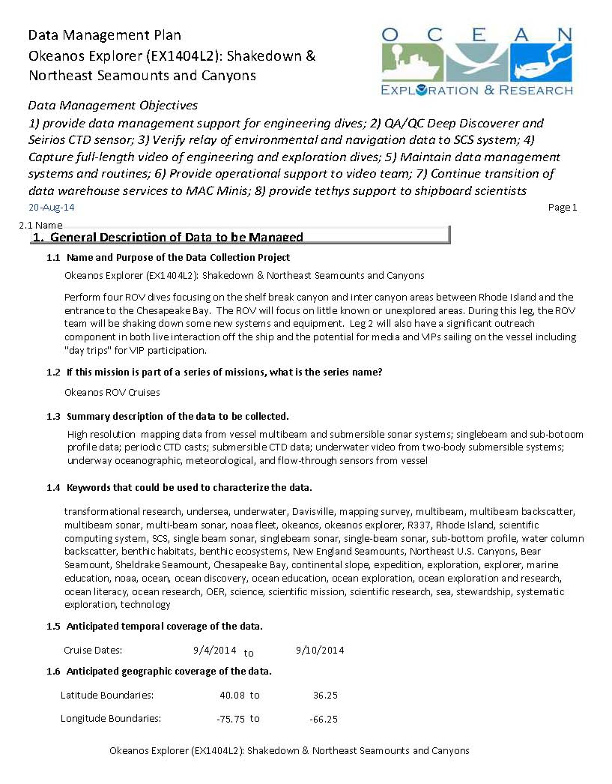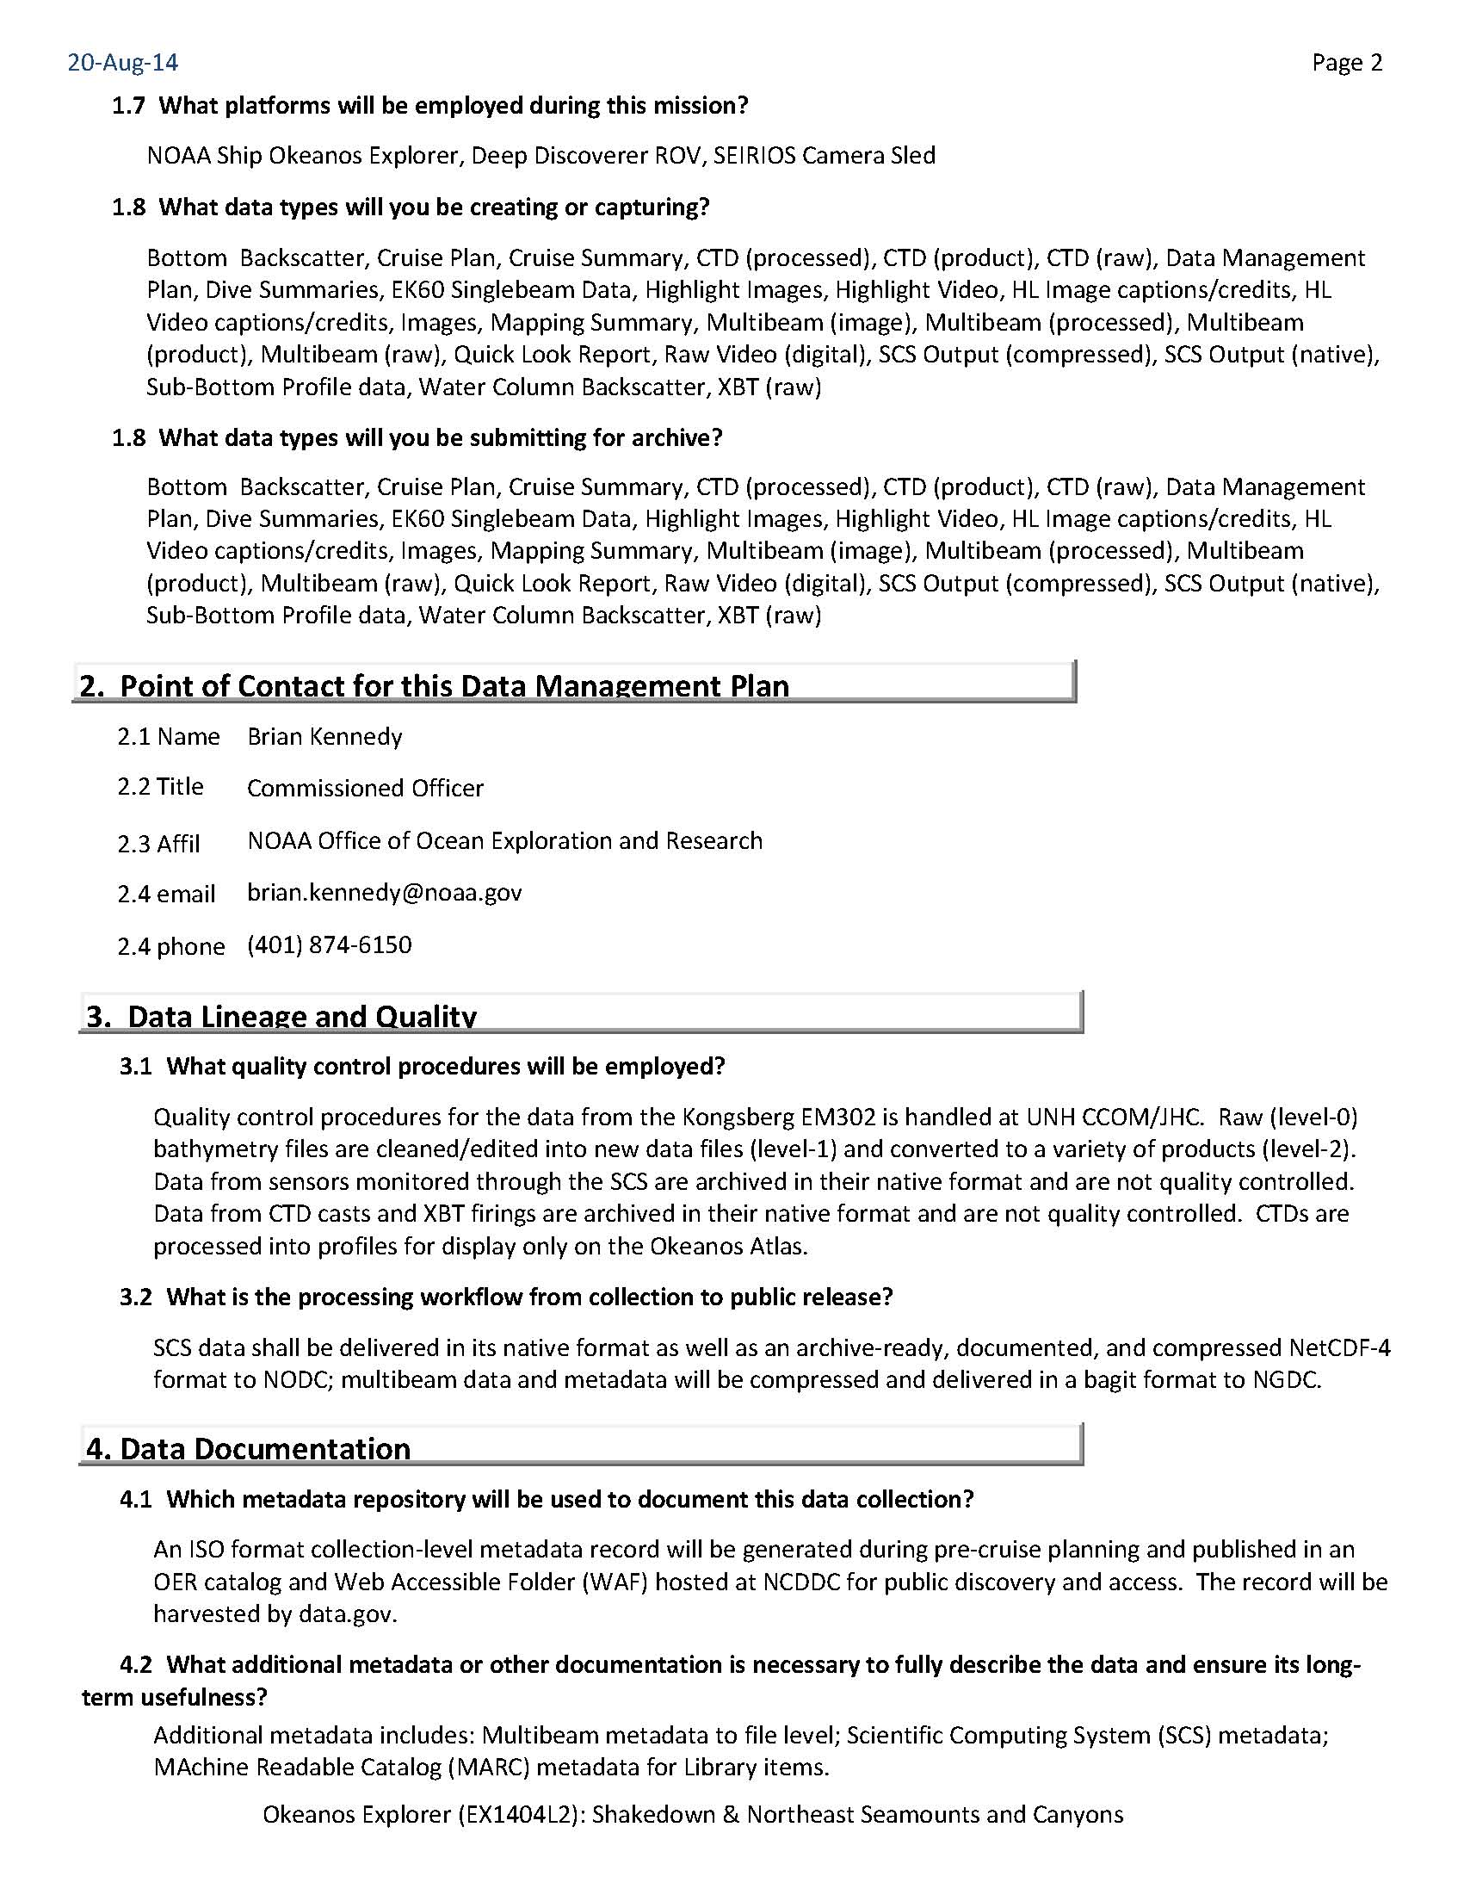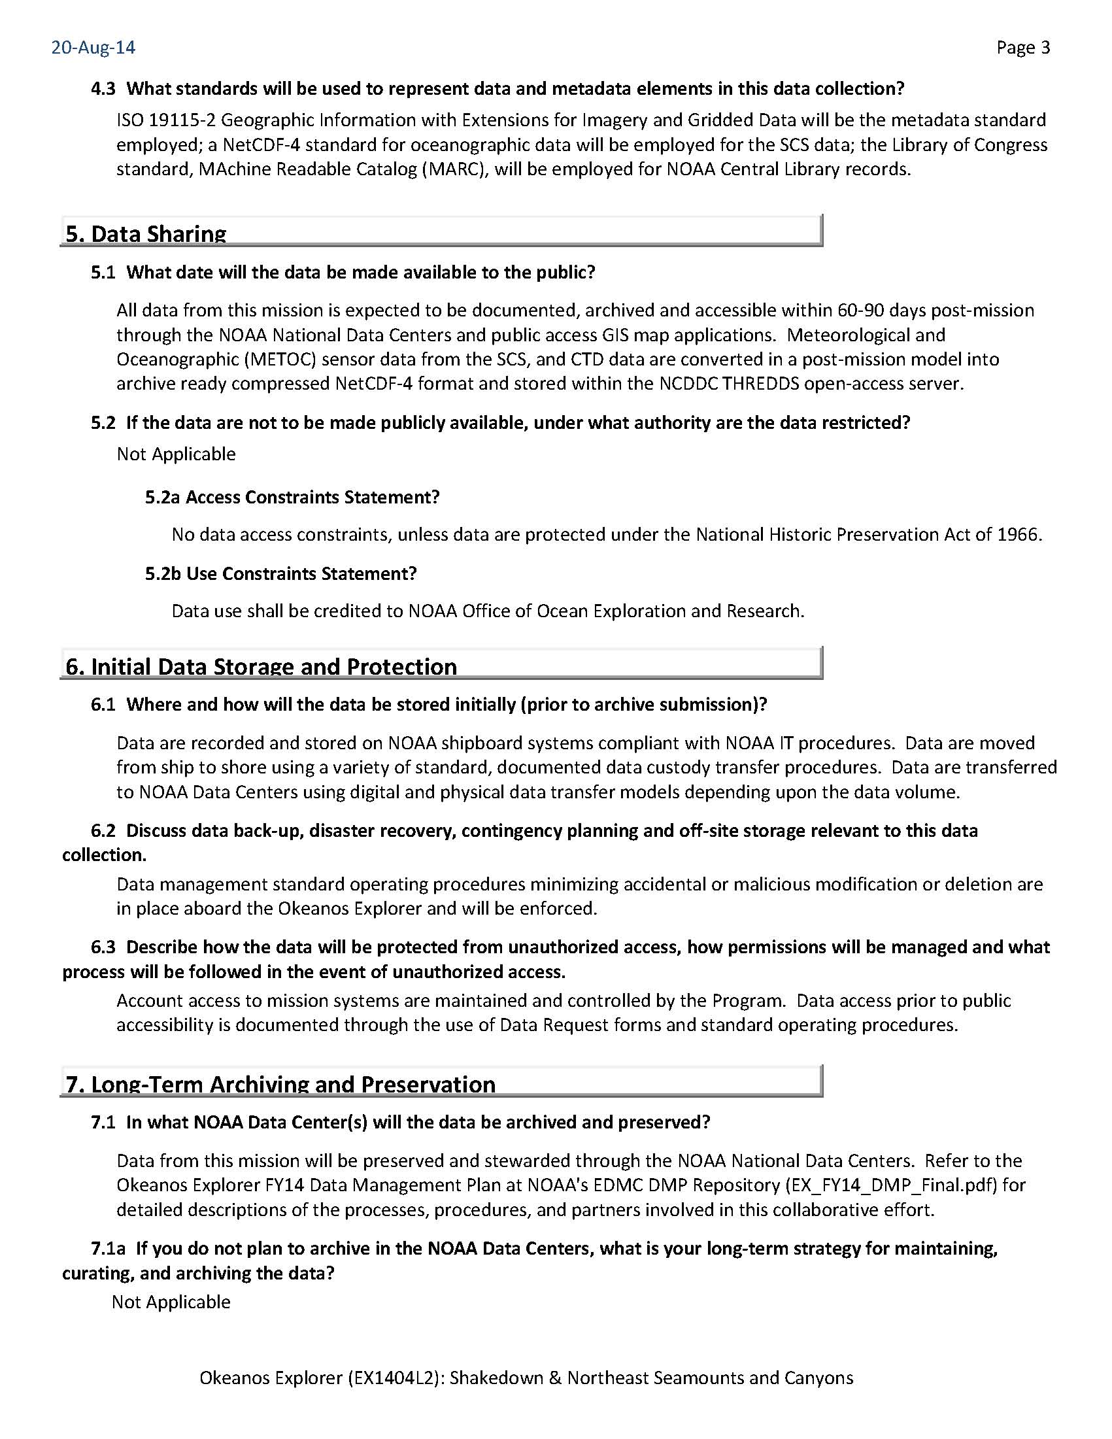

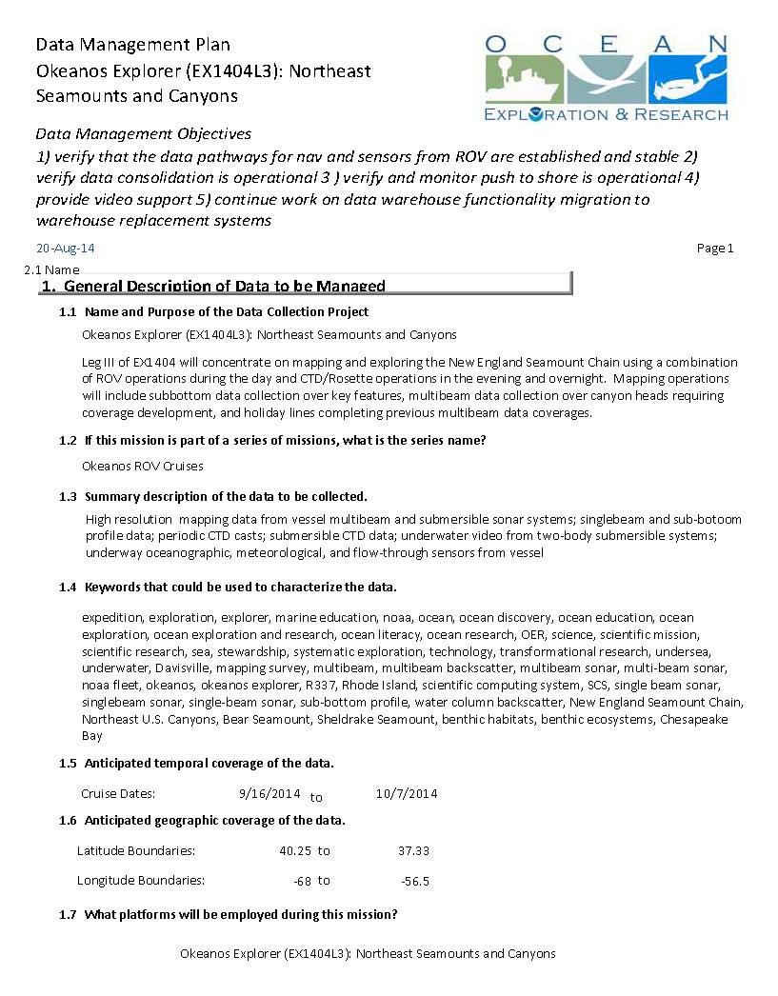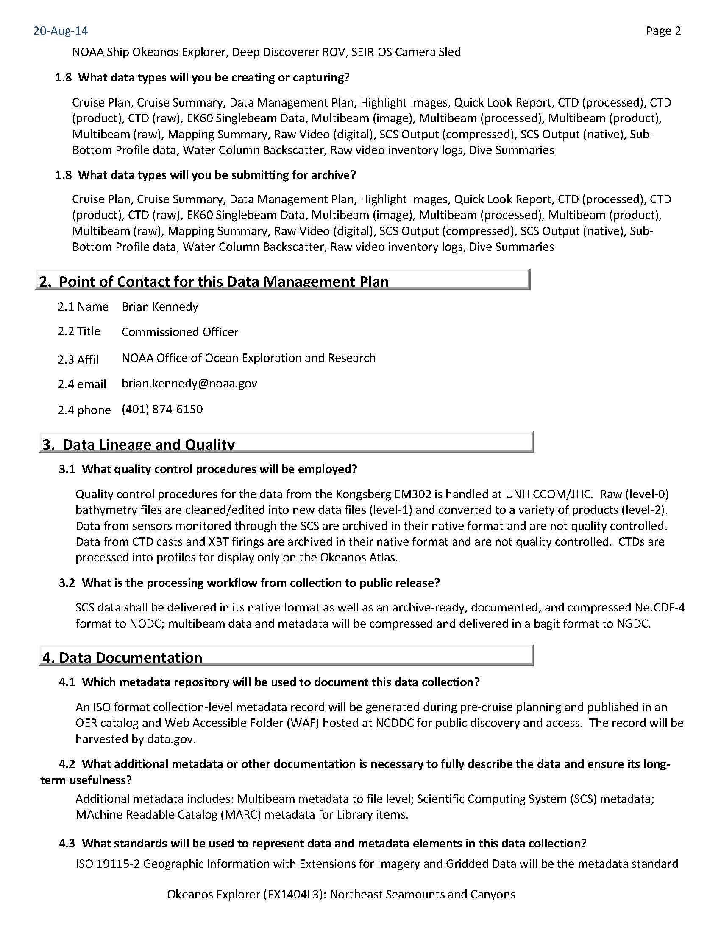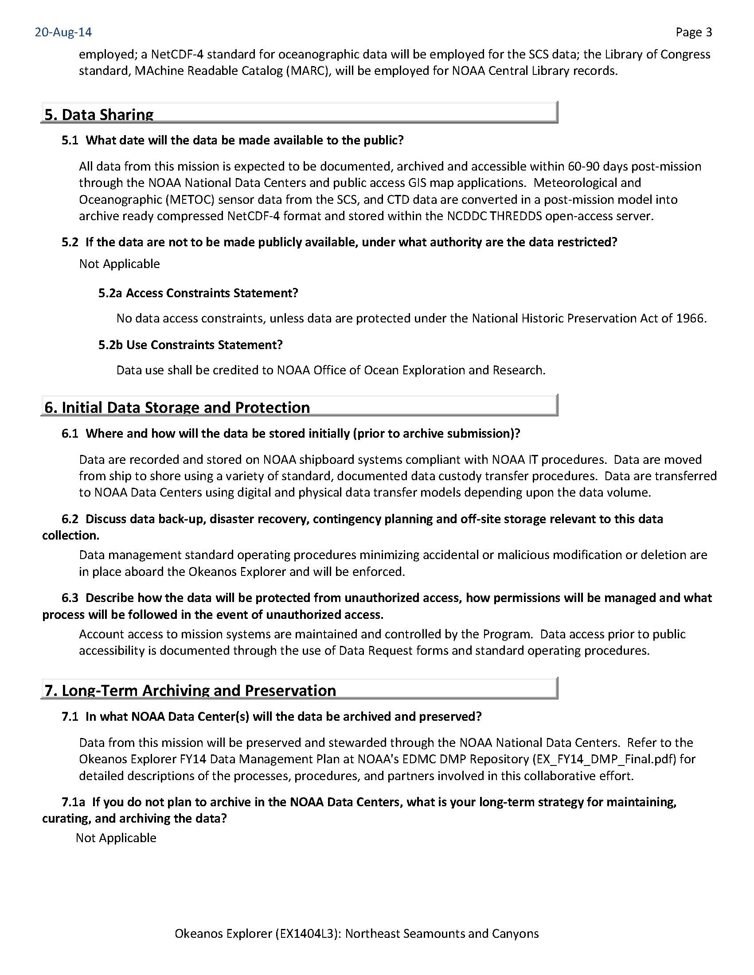
Appendix C: Categorical Exclusion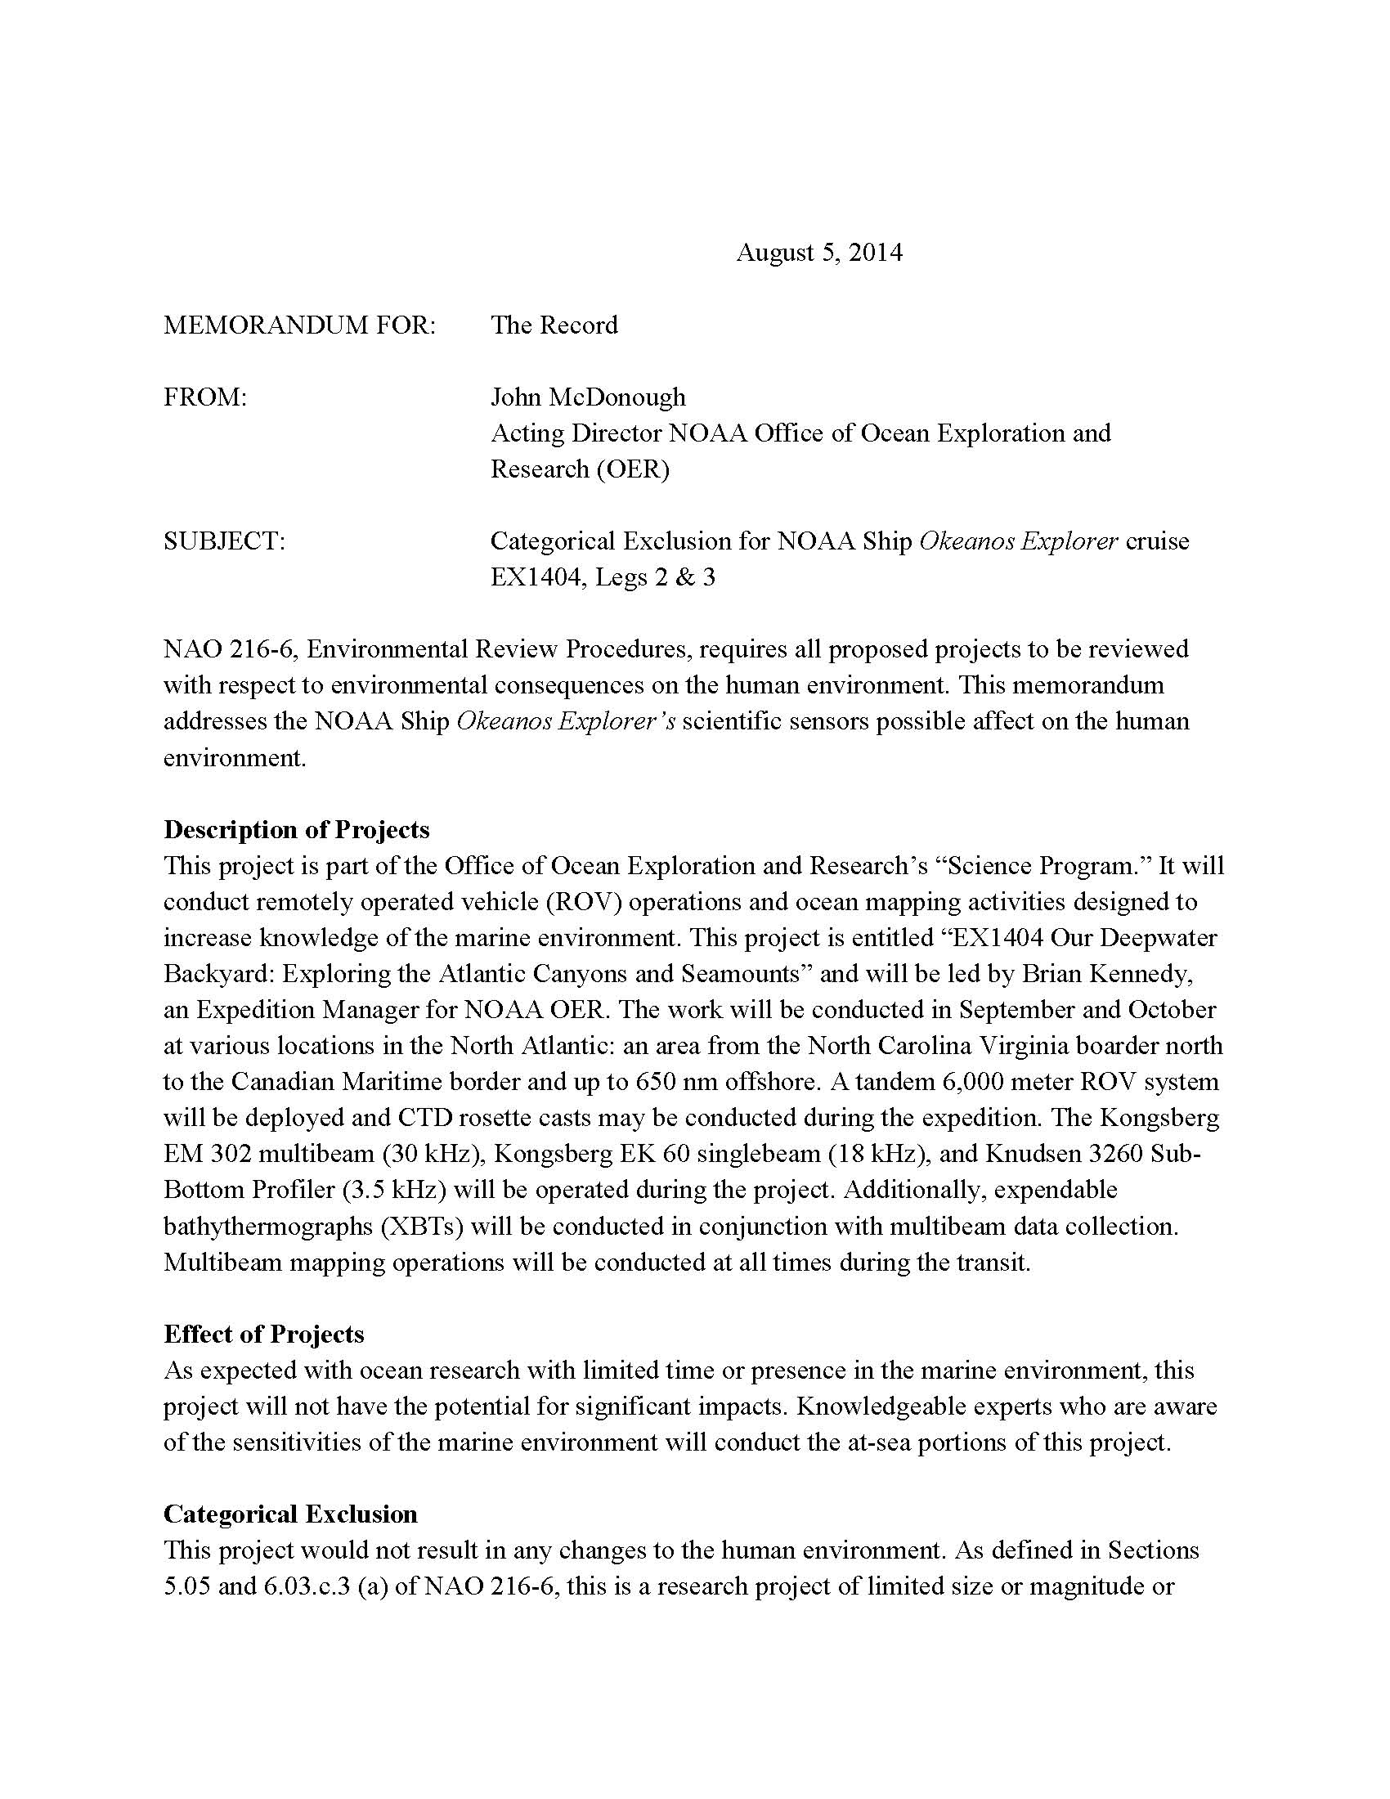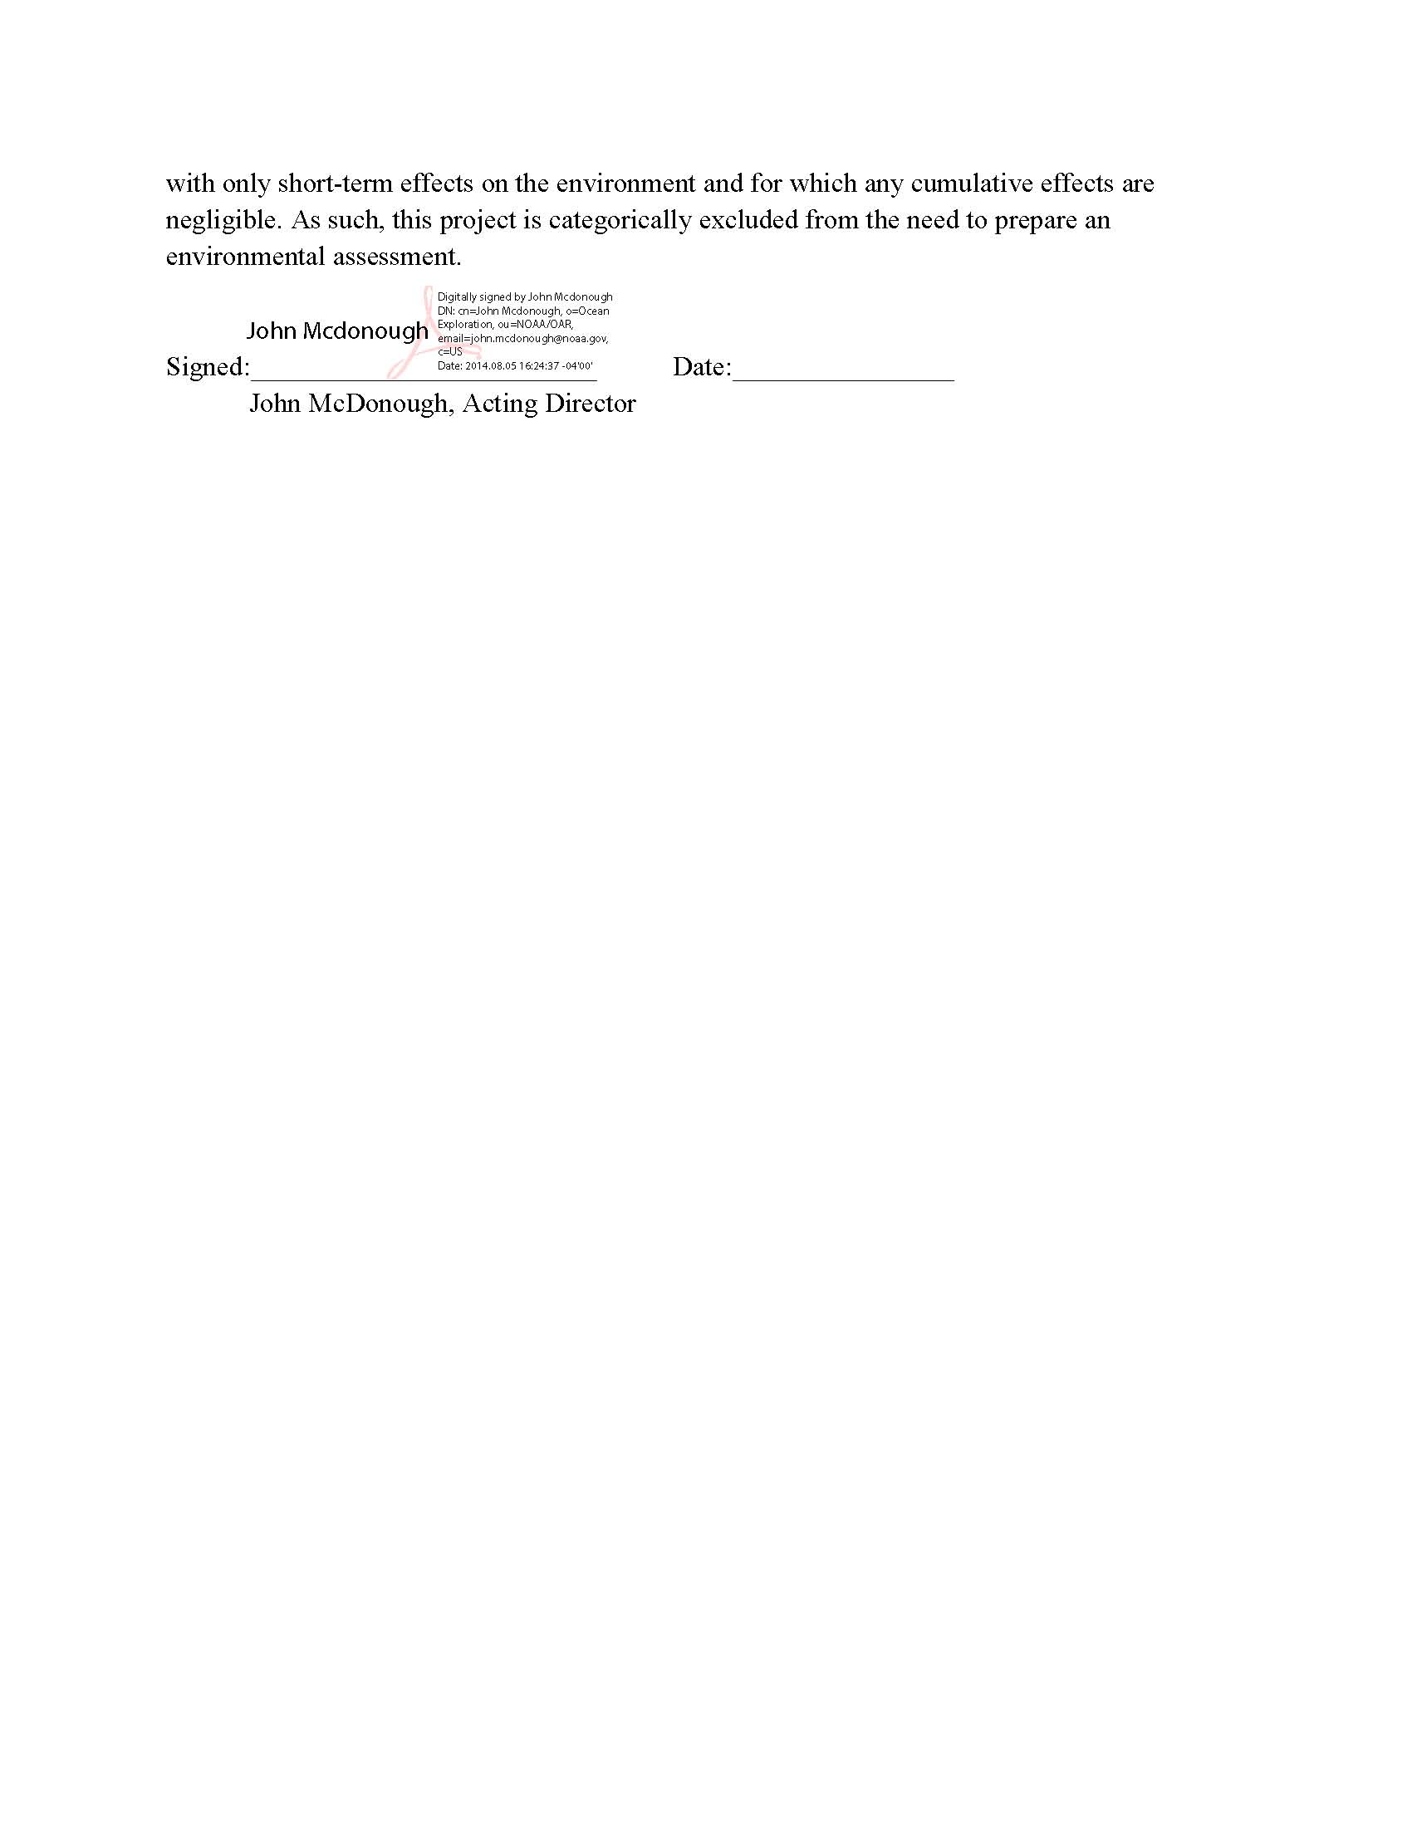
Appendix D. NASA Maritime Aerosols Network Survey of Opportunity

Survey or Project Name
Maritime Aerosol Network

Points of Contact (POC)
Lead POC or Principle Investigator (PI & Affiliation) | Supporting Team Members ashore
POC: Dr. Alexander Smirnov | Supporting Team Members aboard (if required)

Activities Description(s)(Include goals, objectives and tasks)
The Maritime Aerosol Network (MAN) component of AERONET provides ship-borne aerosol optical depth measurements from the Microtops II sun photometers. These data provide an alternative to observations from islands as well as establish validation points for satellite and aerosol transport models. Since 2004, these instruments have been deployed periodically on ships of opportunity and research vessels to monitor aerosol properties over the World Oceans.

Appendix E: Baltimore Event Schedule

Appendix F: Memo for the Record on Sonars 