Okeanos Explorer ROV Dive Summary
Site Name | Ryan Canyon |  |  |  | 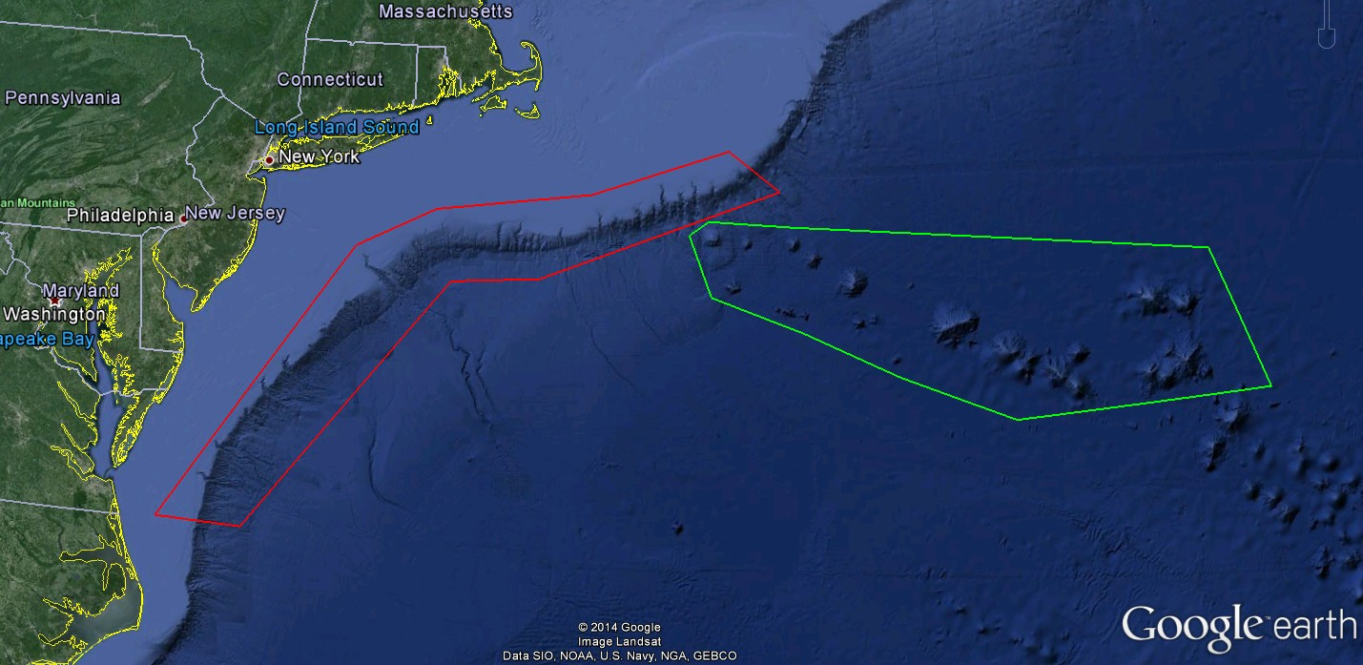
ROV Lead/Expedition Coordinator | Todd Gregory/  Brian Kennedy
Science Team Leads | Scott France and Susan Schnur
General Area Descriptor | Northwest Atlantic Ocean;  Mid Atlantic U.S. Canyons
ROV Dive Name | Cruise Season |  | Leg |  |  | Dive Number
 | EX1404 |  | 3 |  |  | DIVE12
Equipment Deployed | ROV: |  | Deep Discoverer
 | Camera Platform: |  | Seirios
ROV Measurements | CTD |  | Depth |  |  | Altitude
 | Scanning Sonar |  | USBL Position |  |  | Heading
 | Pitch |  | Roll |  |  | HD Camera 1
 | HD Camera 2 |  | Low Res Cam 1 |  |  | Low Res Cam 2
 | Low Res Cam 3 |  | Low Res Cam 4 |  |  | Low Res Cam 2
Equipment Malfunctions | None
ROV Dive Summary  (From processed ROV data) | Dive Summary: EX1404L3_Dive12  ^^^^^^^^^^^^^^^^^^^^^^^^^^^^^^^^^^^^^^^^^^^^^^^^^^^  In Water at: 2014-10-04T12:20:21.541000  39°, 40.093' N ; 071°, 37.940' W  Out Water at: 2014-10-04T17:46:03.189000  39°, 40.388' N ; 071°, 37.563' W  Off Bottom at: 2014-10-04T16:50:15.773000  39°, 40.616' N ; 071°, 37.821' W  On Bottom at: 2014-10-04T13:12:03.102000  39°, 40.116' N ; 071°, 37.778' W  Dive duration: 5:25:41  Bottom Time: 3:38:12  Max. depth: 1524.4 m
Special Notes | Dive was shortened due to weather
Scientists Involved  (please provide name / location / affiliation / email) | Peter Auster UConn and SRF peter.auster@uconn.edu  Robert Carney LSU rcarne1@lsu.edu  Jason Chaytor USGS jchaytor@usgs.gov  Mike Ford NOAA Fisheries michael.ford@noaa.gov  Taylor Heyl WHOI theyl@whoi.edu  Thomas Ritter Montana State University thomas.ritter@msu.montana.edu  Tim Shank WHOI tshank@whoi.edu  Liz Shea Delaware Museum of Natural History eshea@delmnh.org  Randy Singer University of Alabama Ichthyology Collection randal.a.singer@as.ua.edu  Brad Stevens Univ of MD Eastern Shore bgstevens@umes.edu  Michael Vecchione NMFS Syatematics Lab vecchiom@si.edu  Scott France University of Louisiana at Lafayette france@louisiana.edu  Susan Schnur Oregan State University sschnur@coas.oregonstate.edu  Ellie Bors WHOI ekbors@gmail.com  Emily Duwan University of Connecticut emilyduwan@gmail.com  Steve Auscavitch University of Maine steven.auscavitch@maine.edu
Purpose of the Dive
Explore the biology and geomorphology of Ryan Canyon
Description of the Dive:
Setting: Dive 12 took place in Ryan Canyon, which neighbors the previously-visited McMaster Canyon. Ryan is a slope-sourced canyon (it does not extend shoreward of the shelf break). The dive site was located about 13 miles down slope from the shelf break, about two miles further along the canyon than the McMaster dive site. The planned dive track began at the edges of a current scour pit spanning the width of the canyon, then led up a slope to the canyon floor and finally up the main canyon walls.

Exploration: The ROV touched down at 1524 m on a broad plain of soft sediments. There was a fair amount of fish activity at the landing site, with many synaphobranchid eels swimming in the area, witch flounder on the sediments, and myctophids in the water column. The first half of the dive consisted of a rapid transit over these fine, silt-rich, nutrient-rich sediments, only occasionally stopping to examine organisms in more detail. Hygrosoma urchins (without juvenile cusk eels, although some had a small ophiuroid on the surface of the test or a mysid swimming among the spines) and buried asteroid seastars (only the upper parts of the dorsal surface and arm tips visible) were common; occasional ?Flabellum cup corals were also observed. At one point we saw a neolithoidid crab feeding on a Hygrosoma. At 1515 m (1327 UTC) we observed two parallel sets of scrape tracks in the sediment. These appeared to have been made by currents dragging the two handles of a plastic bag along the ground. Overall, we observed several instances of garbage in the canyon, including plastic bags, tangled fishing gear and a lobster fishing bait bag. The canyon floor was highly bioturbated and thousands of very small elasipodid holothurians (?Amperima) were scattered across the soft sediments, and many were also seen swimming. In places small pits with steep walls were observed. One of these provided a cross-section through the sediment, revealing an upper 3 cm-thick yellow-red silt (perhaps oxidized) and a lower layer of grey silt (perhaps hypoxic).

At 1388 m, the ROV began moving up a slightly steeper slope, but there was no sign of the chalk cliffs we expected to see here based on the bathymetry and previous dives over similar scour features. We did not see any hard rock surfaces until reaching the main wall of the canyon at 1376 m. The walls of the canyon appeared to be composed of the same chalk unit seen at similar depths in other canyons. However, the large amount of sediment covering even nearly-vertical surfaces made it hard to examine the texture more closely. Overall the canyon seemed undisturbed by any major or minor collapse features. Continuing up the wall we encountered several overhangs and terraced surfaces, reflecting more resistant layers within the carbonate. Despite the similar geomorphology, we saw far fewer of the characteristic cup coral-Acesta bivalve-Solenosmilia clumps and associated communities than observed in other canyons, and these were mostly restricted to a narrow band between 1341-1320 meters depth (a second aggregation were seen under an overhand at 1290 m depth). This may be due to the higher sediment loads on the wall or likely a lack of strong current flow (as reflected by the increased sedimentation). Also seen on the wall in small numbers were octocorals Anthomastus (single sighting of 3 colonies that appeared to be connected by stolons; 1551 UTC), a single bamboo coral (?Keratoisis), Clavularia, Acanthogorgia, zoanthids, and a second species of cup coral.

Following an ascent of about 85 vertical meters, we reached the top of the cliff at 1290 m. At this point the deteriorating weather situation forced us to end the dive. Fortunately we had maintained a good pace and were able to cover most of the planned dive track.

Other biological observations: Shore-based scientist Peter Auster provided a count (113 individuals) and species list of fish observed: Witch flounder, Cutthroat eel, Halosaur (Aldrovandia sp), Zoarcid (Lycenchelys sp.; one was observed curled in small depression on sedimented seafloor), Blue hake (Antimora), Grenadier (Nezumia), Chimaera (Harriotta sp), Black dogfish, Ophidiid cusk eel (Dicrolene), Ophidiid cusk eel (unknown sp), False boarfish (Neocyttus helgae).

Other species:
Cnidaria: Actiniaria Hormathiidae; Ceriantharia tube anemone
Pycnogonida: Colossendeis sp. (individual at 1509 UTC was “grooming,” wiping mucus off of proboscis and pedipalps using oviparous legs)
Crustacea: caridean shrimp (benthic), red crab (Chaceon)
Echinodermata: Asteroidea Asteropectinidae (?Plutonaster), Brisingidae; Holothuroidea Elasipodida - ?Amperima); Echinoidea Echinus-like
Enteropneusta: mound topped by fresh fecal strings with two closely-space distinct grooves, possibly from an enteropneust acorn worm (1523 UTC)

Interesting highlights: Blanket of fine, nutrient-rich sediment on almost all surfaces, High abundance and diversity of fish (13 species identified), thousands of small elasipodid holothurians (?Amperima) covering canyon floor.

Overall Map of ROV Dive Area |  |  |  | Close-up Map of Main Dive Site
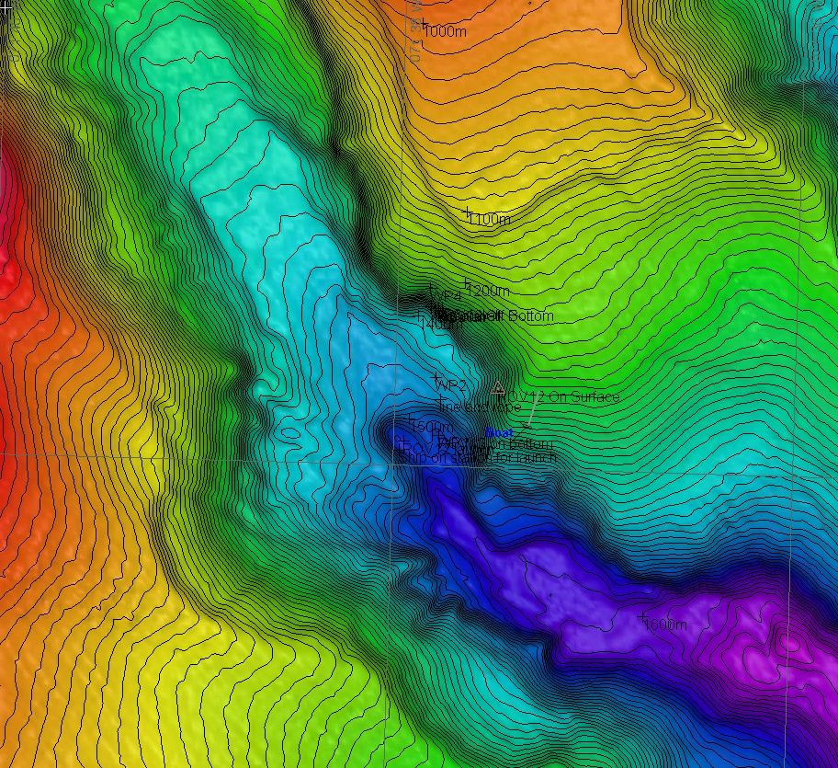 |  |  |  | 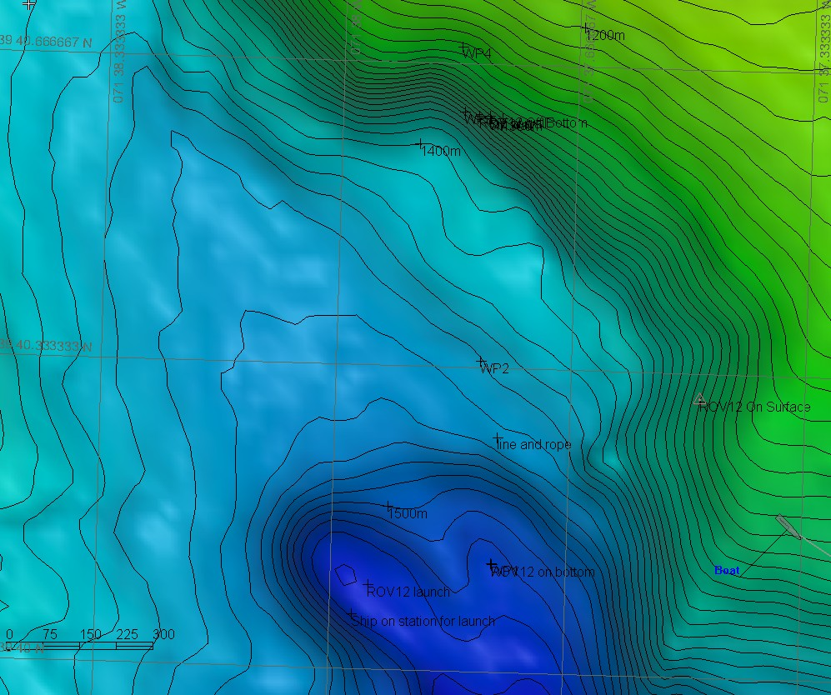
Representative Photos of the Dive
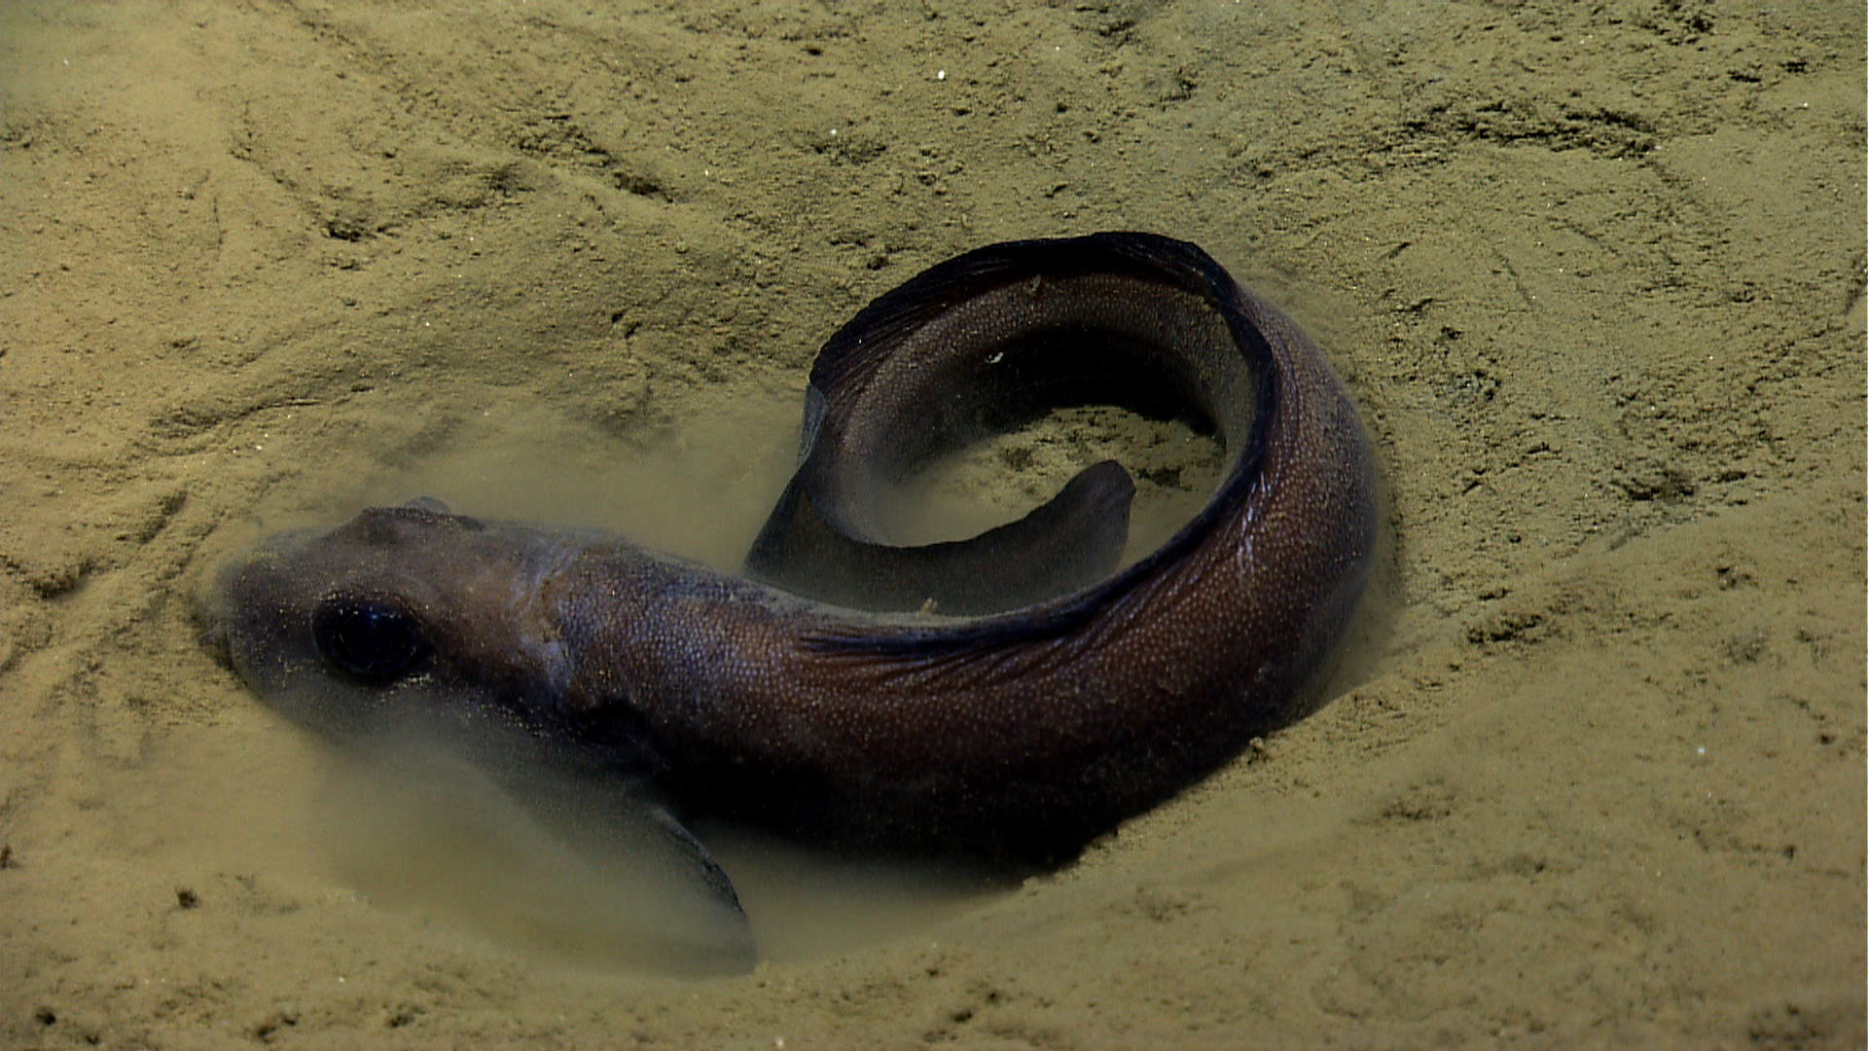 |  |  |  | 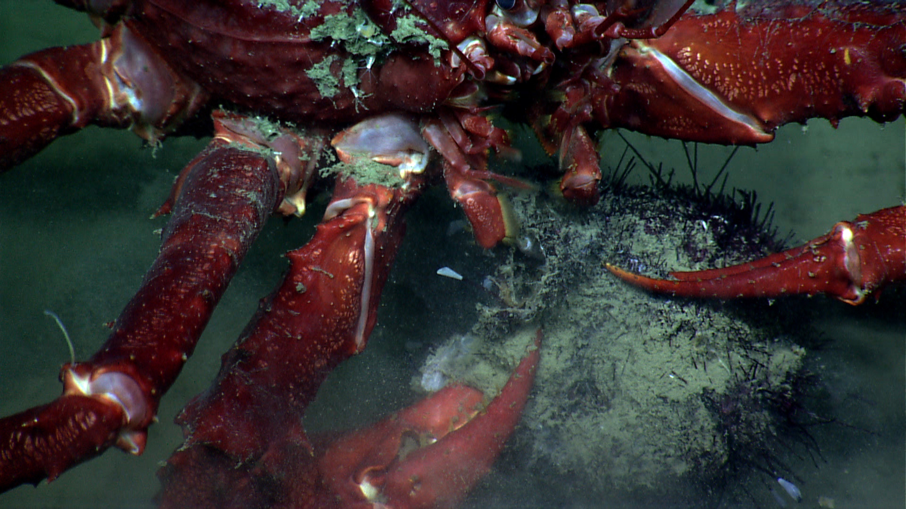
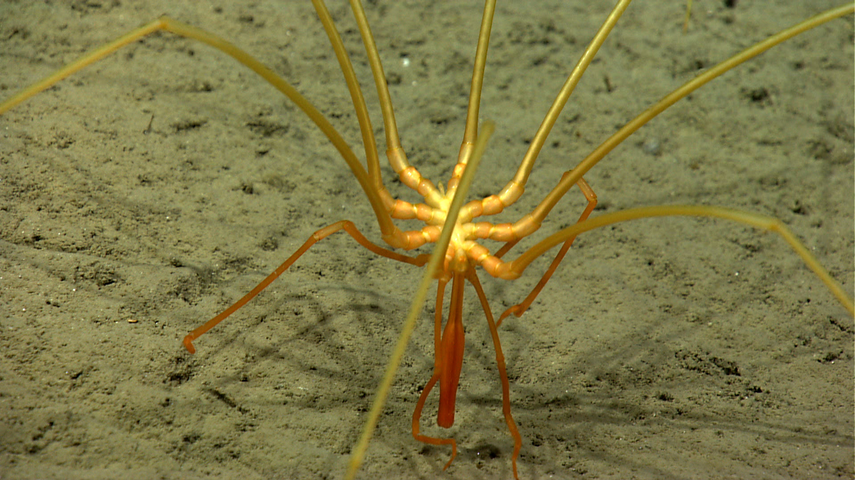 |  |  |  | 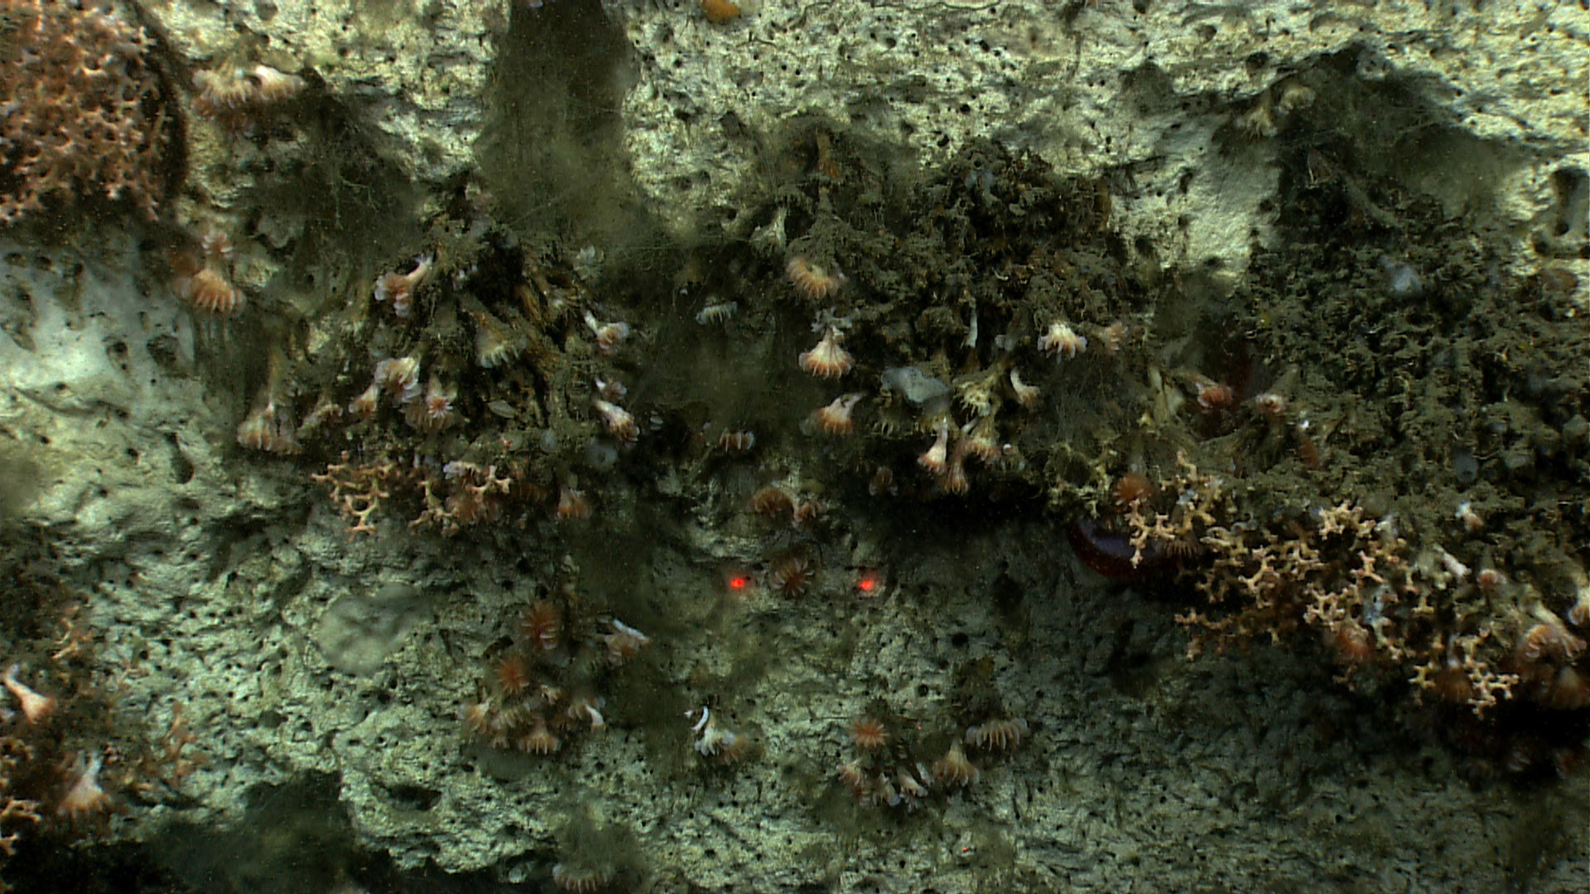
Please direct inquiries to: |  | NOAA Office of Ocean Exploration & Research  1315 East-West Highway (SSMC3 10th Floor)  Silver Spring, MD 20910  (301) 734-1014

