Okeanos Explorer ROV Dive Summary
Site Name | Physalia Seamount |  |  |  | 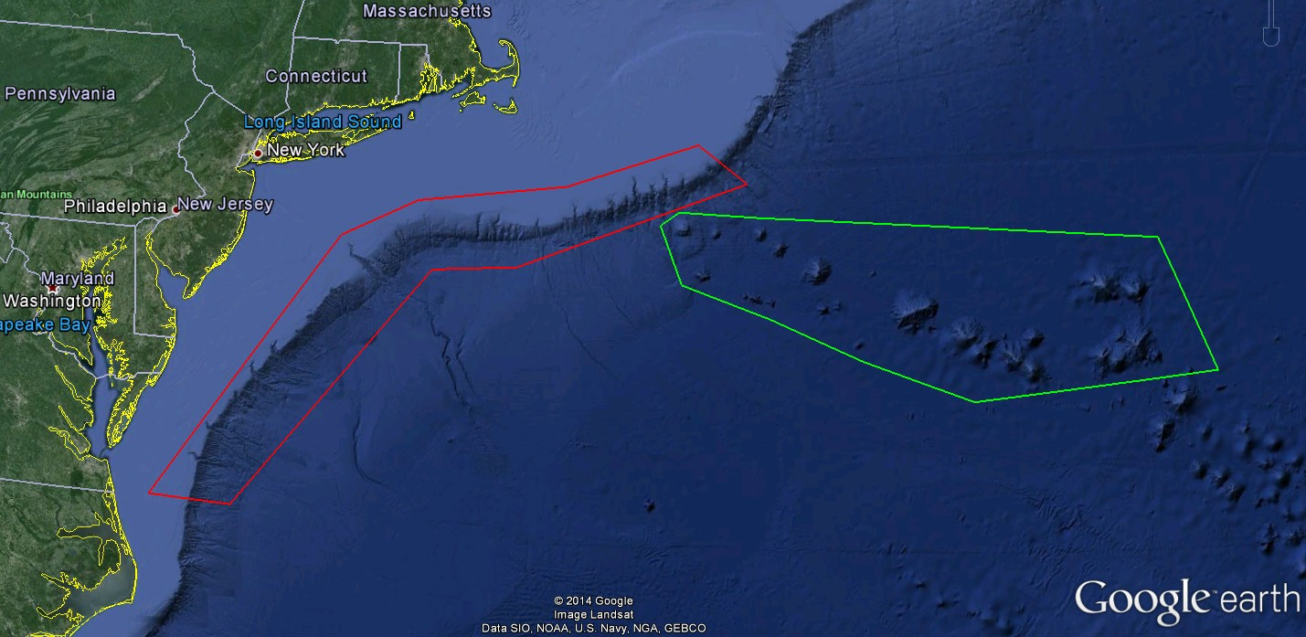
ROV Lead/Expedition Coordinator | Todd Gregory/  Brian Kennedy
Science Team Leads | Scott France and Susan Schnur
General Area Descriptor | Northwest Atlantic Ocean;  Mid Atlantic U.S. Canyons
ROV Dive Name | Cruise Season |  | Leg |  |  | Dive Number
 | EX1404 |  | 3 |  |  | DIVE11
Equipment Deployed | ROV: |  | Deep Discoverer
 | Camera Platform: |  | Seirios
ROV Measurements | CTD |  | Depth |  |  | Altitude
 | Scanning Sonar |  | USBL Position |  |  | Heading
 | Pitch |  | Roll |  |  | HD Camera 1
 | HD Camera 2 |  | Low Res Cam 1 |  |  | Low Res Cam 2
 | Low Res Cam 3 |  | Low Res Cam 4 |  |  | Low Res Cam 2
Equipment Malfunctions | None
ROV Dive Summary  (From processed ROV data) | Dive Summary: EX1404L3  ^^^^^^^^^^^^^^^^^^^^^^^^^^^^^^^^^^^^^^^^^^^^^^^^^^^  In Water at: 2014-10-01T12:28:04.434000  39°, 48.878' N ; 066°, 55.934' W  Out Water at: 2014-10-01T19:39:06.975000  39°, 49.144' N ; 066°, 52.896' W  Off Bottom at: 2014-10-01T18:01:52.238000  39°, 48.868' N ; 066°, 55.711' W  On Bottom at: 2014-10-01T13:57:04.783000  39°, 48.651' N ; 066°, 55.922' W  Dive duration: 7:11:2  Bottom Time: 4:4:47  Max. depth: 2588.5 m
Special Notes
Scientists Involved  (please provide name / location / affiliation / email) | Peter Auster UConn and SRF peter.auster@uconn.edu  Amy Baco-Taylor Florida State University abacotaylor@fsu.edu  Robert Carney LSU rcarne1@lsu.edu  Jason Chaytor USGS jchaytor@usgs.gov  Rachel Clostio University of Louisiana at Lafayette rclostio@louisiana.edu  Erik Cordes Temple University ecordes@temple.edu  Mike Ford NOAA Fisheries michael.ford@noaa.gov  Lisa Gilbert Williams College lgilbert@williams.edu  Christopher (Chris) Mah Invertebrate Zoology, NMNH, Smithsonian brisinga@gmail.com  Shirley Pomponi Harbor Branch - FAU - CIOERT spomponi@fau.edu  Andrea Quattrini USGS andrea.quattrini@temple.edu  Brendan Roark Texas A&M University broark@geos.tamu.edu  Liz Shea Delaware Museum of Natural History eshea@delmnh.org  Randy Singer University of Alabama Ichthyology Collection randal.a.singer@as.ua.edu  Brad Stevens Univ of MD Eastern Shore bgstevens@umes.edu  Alice Stratton NOAA/NOS/ONMS/SBNMS alice.stratton@noaa.gov  Michael Vecchione NMFS Syatematics Lab vecchiom@si.edu  Scott France University of Louisiana at Lafayette france@louisiana.edu  Susan Schnur Oregan State University sschnur@coas.oregonstate.edu  Ellie Bors WHOI ekbors@gmail.com  Emily Duwan University of Connecticut emilyduwan@gmail.com  Steve Auscavitch University of Maine steven.auscavitch@maine.edu  Stephanie Farrington HBOI sfarrington@fau.edu  John Reed HBOI jreed12@hboi.fau.edu  Josh Voss HBOI Jvoss2@fau.edu
Purpose of the Dive
Explore the biology and geomorphology of Physalia Seamount
Description of the Dive:
Setting: Dive 11 took place on the upper flanks of Physalia Seamount. Physalia is a small (1750 m tall, 10 km diameter), circular seamount within the US EEZ. It is close enough to the continental shelf to be within range of sediments delivered from the shelf down onto the abyssal plain. The dive path ascended a steep slope on the southern side of the seamount.

Exploration: The ROV reached the seafloor at a depth of about 2588 m and began moving across a sandy gravel-covered slope. Traveling diagonally upward, we occasionally crossed small areas of hard rock outcrop, all of which were heavily eroded. The slope seemed very unstable. Poorly-sorted multi-color gravel deposits provided evidence of periodic downslope transport of material. This continuous movement of sediment may have reduced Mn-crust formation, as most Mn-covered surfaces seemed to lack well-developed crust surface morphologies. Occasionally we observed debris cobbles of what appeared to be limonite (Fe-oxyhydroxide, a common basalt alteration product). Sea urchins (Echinus like) and brittle stars (Ophiuroidea) were abundant on these gentle slopes. In addition to the many live urchins, there were many empty tests suggesting significant predation. In one location at the base of a ledge (1453 UTC) there were at least a dozen empty tests. We also saw two heart urchin tests (but no live individuals, which typically live buried in soft sediments).

At 2564 m a small landslide headwall scarp exposed a cross-section through the upper 30 cm of the underlying slope. The top 10 cm of the exposure were coated in mn-crust but the lower, more-recently exposed face revealed a porous, highly-altered limonite matrix supporting several hard rock cobbles. A relatively large (cms) neomeniomorph aplacophoran (Solenogastres) was seen on the exposed face. A single pom-pom anemone (? Liponema brevicornis), >15 cm diameter, was seen in the adjacent sediment chute; this has been the only observation of this species on this cruise leg. At 2559 m depth (1458 UTC), a yellowish-green organism was discovered growing from a ledge face that was otherwise dominated by encrusting sponges and polychaete tubes. The organism had a reticulating mesh-like “body” (perhaps a colony), with the anastomosing branches forming closed hexagons; branches had small swellings reminiscent of retracted zooids, but also had “rootlets” extending from a main “branch” toward the ledge face. Consultation with various experts on bryozoans, sponges, hydroids, and corals has yet to reveal any familiarity with the organism.

At 2547 m we encountered a highly-altered matrix-supported volcaniclastic breccia. Overlying this was a thin (1-2 m) laterally-continuous carbonate layer, possibly indicating a hiatus of hundreds to thousands of years between formation of the underlying and overlying breccias and flows. Above the carbonates we observed an outcrop where pillows appeared to have been extruded into or under the surrounding breccias, as evidenced by brecciated material caught between the pillow lobes. However, no cooling margins could be observed to confirm this. At 2507 m, pillow lavas began to dominate, ranging in size from small (0.5-1 m) at first to large (1-2 m) higher in the section. At 2467 m the ROV began moving into a thick series of capping sedimentary layers. Even with close examination we could not determine if these were sandstones or fine volcaniclastic tuffs. We reached the top of the unit and also the cliff at about 2457 m and moved onto a more gently sloping sandy surface that we followed for the rest of the dive. Highlights of this transit were the discovery of two glass bottles, one clear and the other dark brown. The bottom of the clear bottle was filled with white shell fragments (pteropods?), as if an organism had used the bottle as a shelter to consume its prey. We also observed an unusually bright red rock that we could not identify. One of the shore-based scientists reported seeing this color in altered Archean carbonates.

Deteriorating sea state prompted the decision to recover the vehicles earlier than was planned. Our final bottom image was of an octopus (Muusoctopus johnsonianus) moving over a sedimented slope, jetting backward off the slope and settling down again to face the ROV as we began our ascent. Although the recovery was challenging, the vehicles were returned to deck safely thanks to the professionalism of the ROV and ship’s crew.

Other biological observations: A highlight of the dive was the unprecedented observation of a predation event by a large pycnogonid sea spider (Colossendeidae) on a corymorphid hydroid (giant solitary hydroid). It appeared the proboscis was specifically directed at the gonophores, suggesting feeding on reproductive tissue. A second colossendeid at 2419 m (1723 UTC) was observed holding something (barnacle?) into which the proboscis was inserted. A third individual was seen a short time later (1726 UTC) apparently manipulating something in a shallow pit, perhaps a burrowing anemone.

Corals were observed in low abundance and diversity, with Chrysogorgia sp. and sea pen Anthoptilum sp. being seen most commonly, and only occasional bamboo whips Lepidisis sp. Anthoptilum sp. were seen in typical sea pen habitus embedded in soft sediments but also on hard substrates in the manner of “rock pens.” As is often the case, a great diversity of hexactinellid sponge morphologies were on display, including some not previously observed during this cruise (eg. see 1610 UTC), although most could not be identified. Only 3 fish species were recorded in the eventlog during the dive: cusk eel, halosaur, grenadier. At least at least 4 observations were made of the red, spiny-armed asteroid seastar Benthopecten, about which very little is known. During ascent in the water column a pyrosome colony was imaged at ≈465 m depth.

Porifera: stick-like cladorhizids
Cnidaria: Hexacorallia: Actiniaria - burrowing anemones (Edwardsiidae), orange ?Edwardsiidae, orange Hormathiidae; Ceriantharia - tube anemones; Antipatharia - black coral Telopathes, Bathypathes; Scleractinia - cup coral; Zoanthinaria stoloniferous colony on rock at 1753 UTC; Octocorallia: Anthomastus
Annelida: many excellent images of polychaete fan worms (sabellids and serpulids)
Mollusca: Gastropoda (?Turridae)
Crustacea: nice video of a swimming mysid shrimp, barnacles (?Glyptelasma), squat lobsters, nematocarcind shrimp
Echinodermata: Asteroidea - slime star ?Hymenaster (purple membranous with osculum), ?Neomorphaster; Holothuroidea - ?Aspidochirota pink, Elasipodida long dorsal tentacles, Elasipodida pink ?Amperima; Crinoidea - comatulid feather stars and stalked crinoids

Interesting highlights: Complex collection of volcaniclastic pillow breccias and pillow lavas, thick section of sedimentary layers (possibly sandstone); feeding by pycnogonid sea spiders; a large neomeniomorph aplacophoran

Overall Map of ROV Dive Area |  |  |  | Close-up Map of Main Dive Site
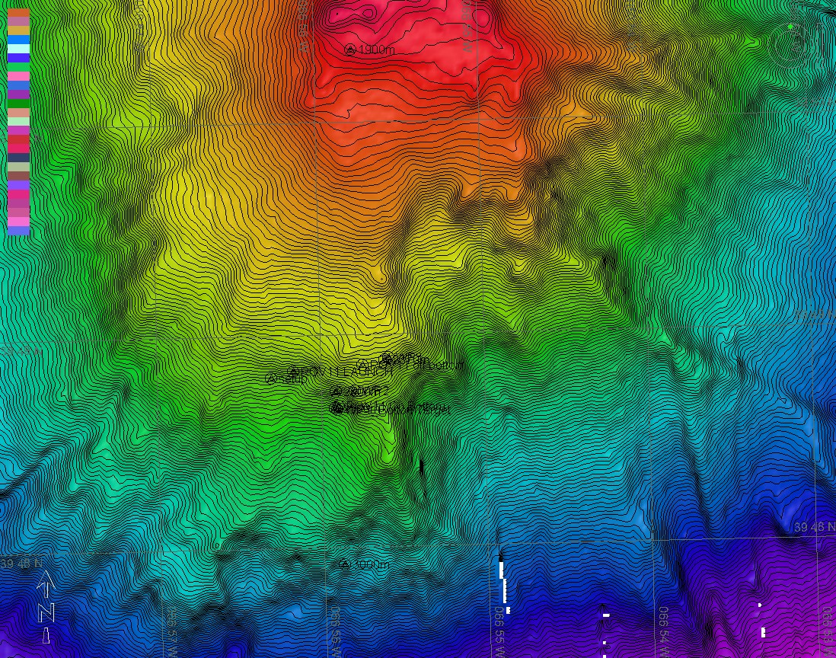 |  |  |  | 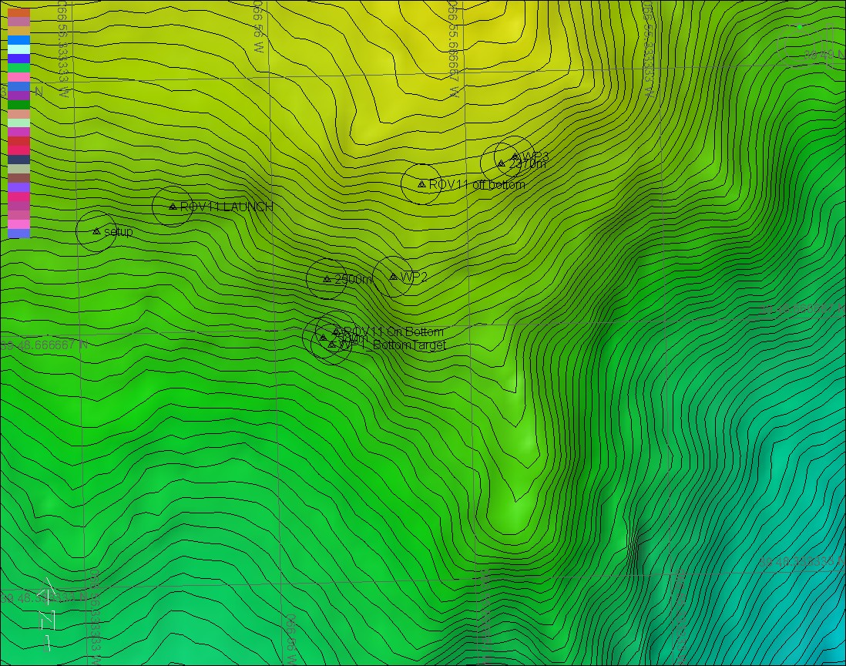
Representative Photos of the Dive
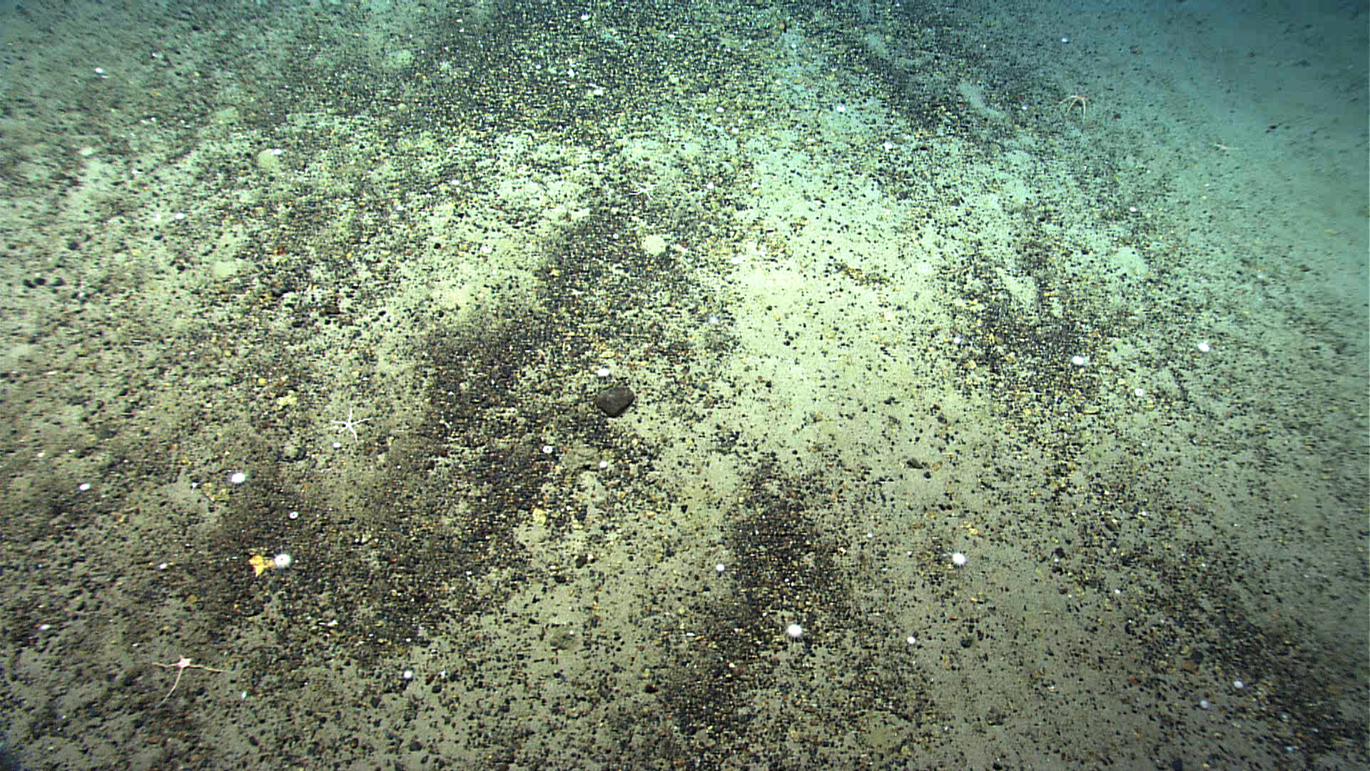 |  |  |  | 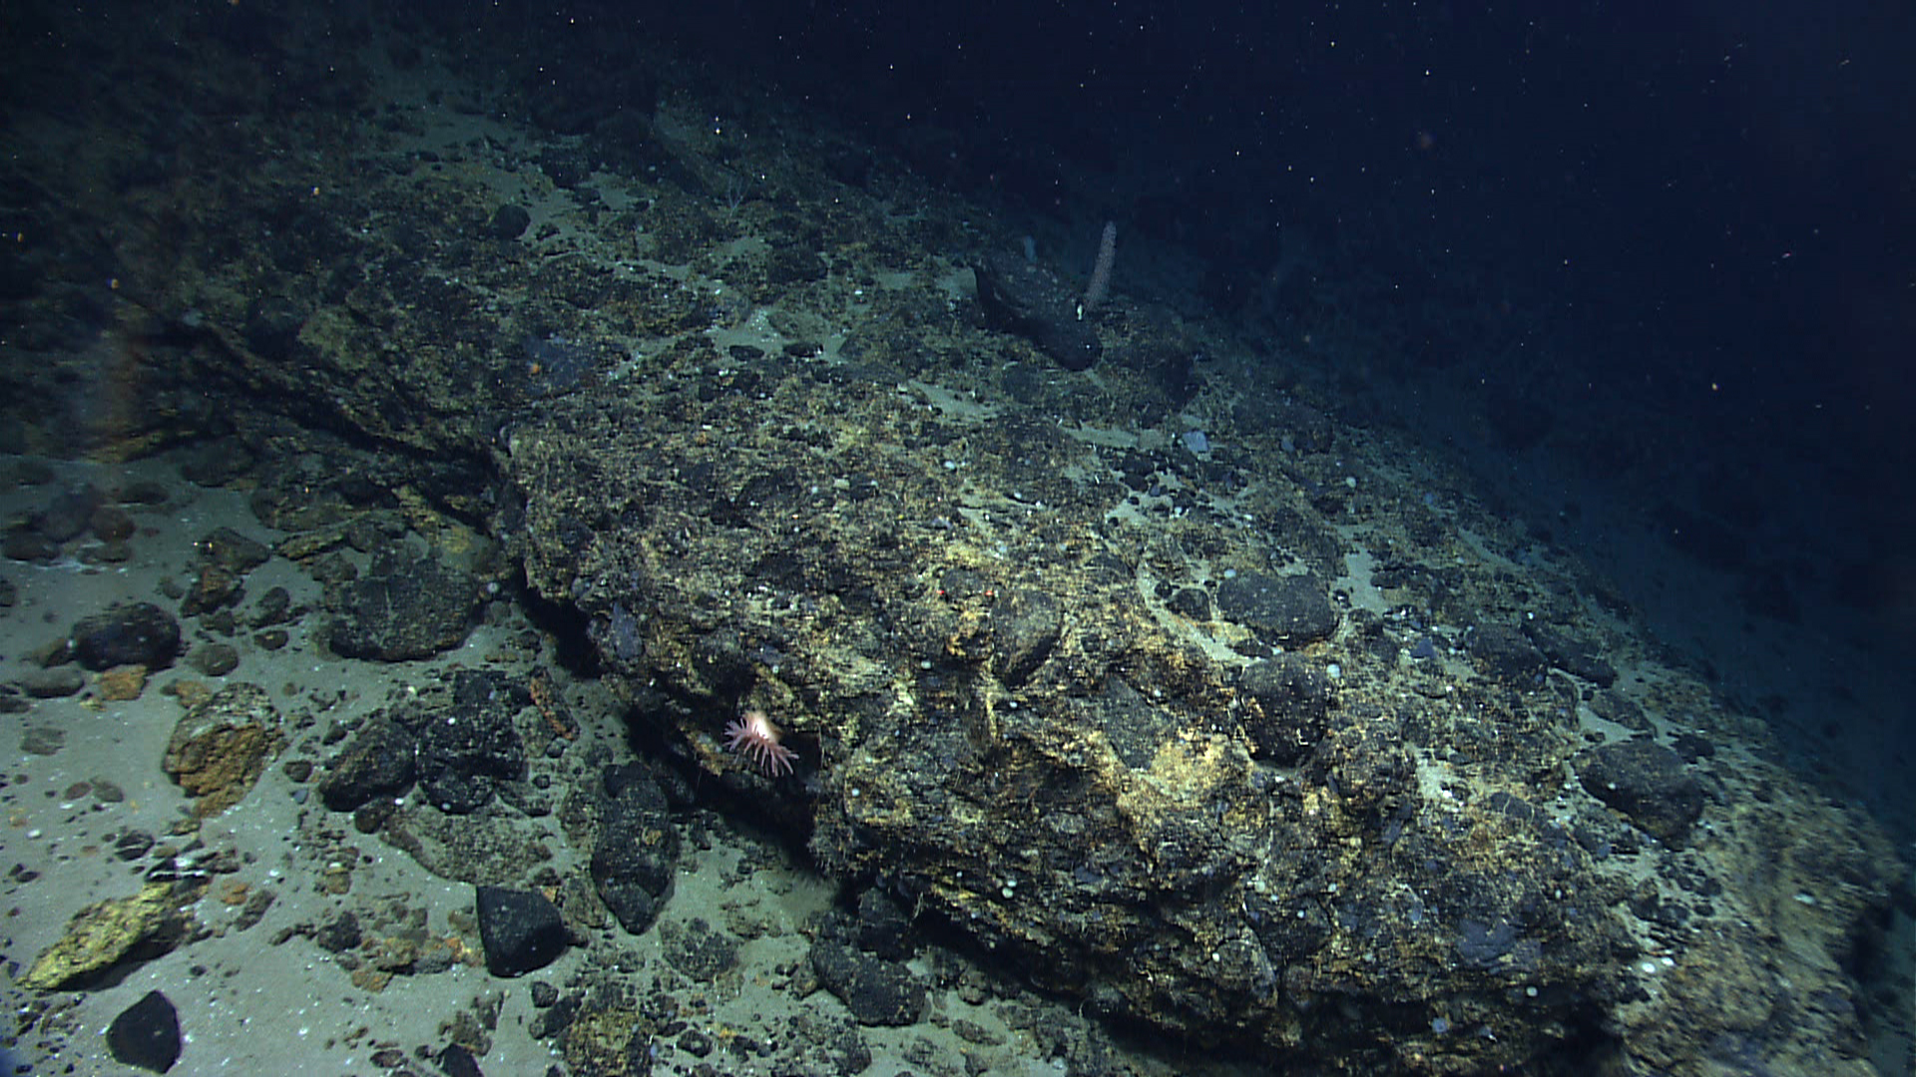
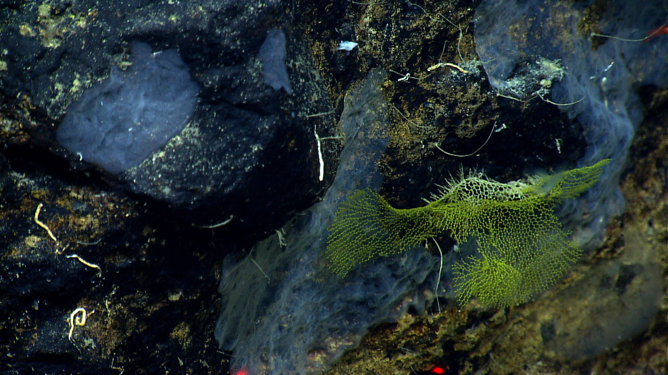 |  |  |  | 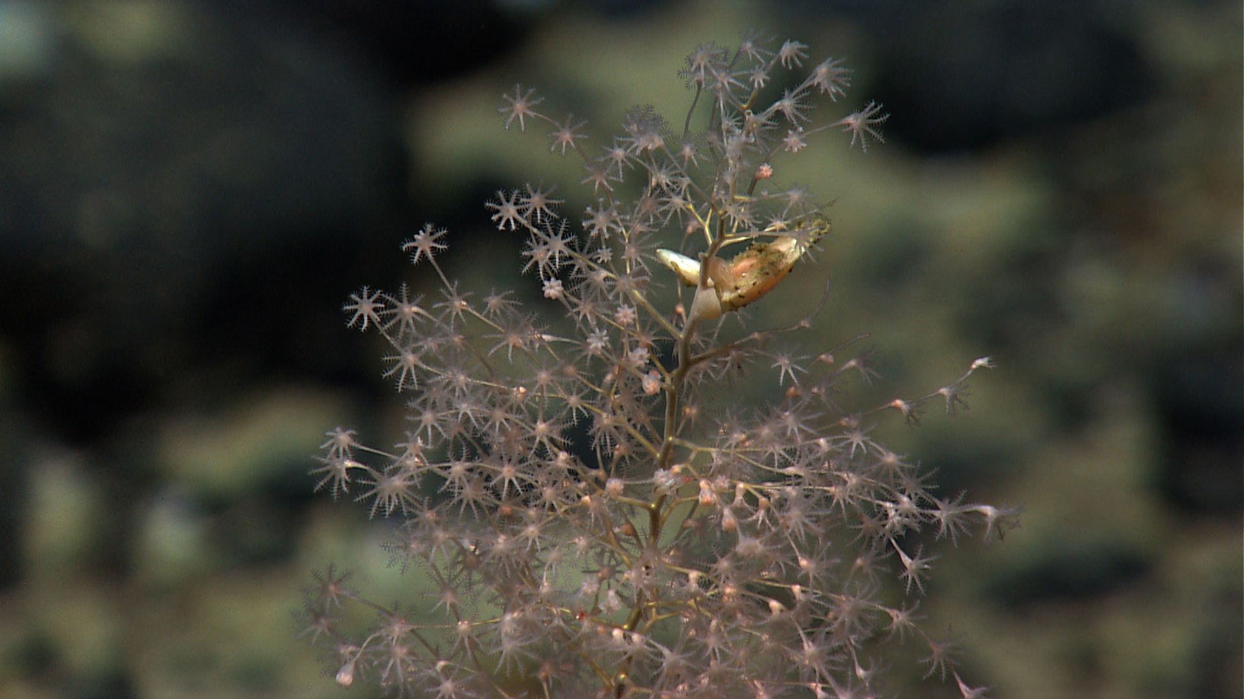
Please direct inquiries to: |  | NOAA Office of Ocean Exploration & Research  1315 East-West Highway (SSMC3 10th Floor)  Silver Spring, MD 20910  (301) 734-1014

