Okeanos Explorer ROV Dive Summary
Site Name | Kelvin Seamount |  |  |  | 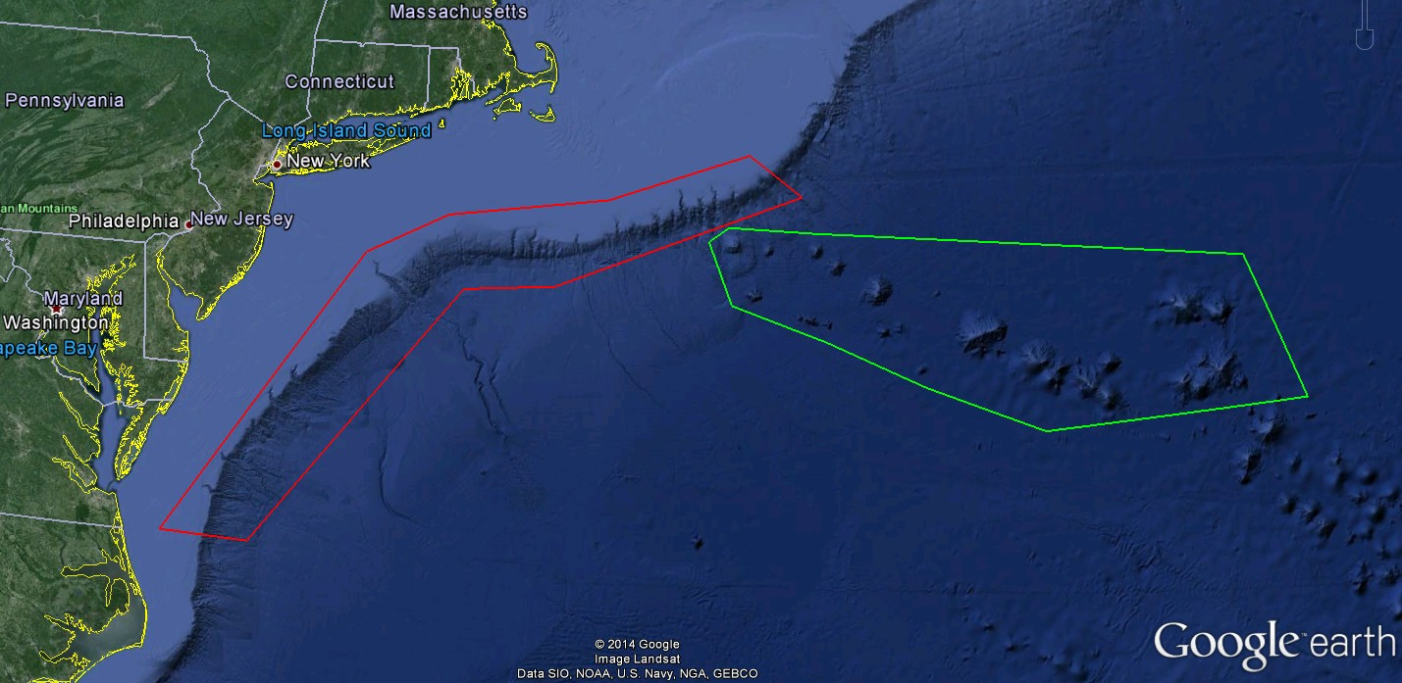
ROV Lead/Expedition Coordinator | Todd Gregory/  Brian Kennedy
Science Team Leads | Scott France and Susan Schnur
General Area Descriptor | Northwest Atlantic Ocean;  Mid Atlantic U.S. Canyons
ROV Dive Name | Cruise Season |  | Leg |  |  | Dive Number
 | EX1404 |  | 3 |  |  | DIVE09
Equipment Deployed | ROV: |  | Deep Discoverer
 | Camera Platform: |  | Seirios
ROV Measurements | CTD |  | Depth |  |  | Altitude
 | Scanning Sonar |  | USBL Position |  |  | Heading
 | Pitch |  | Roll |  |  | HD Camera 1
 | HD Camera 2 |  | Low Res Cam 1 |  |  | Low Res Cam 2
 | Low Res Cam 3 |  | Low Res Cam 4 |  |  | Low Res Cam 2
Equipment Malfunctions | The aft lateral thruster on D2 was secured for most of the dive after reposting an error. The lack of the thrusters did not have any significant impacts on the dive.
ROV Dive Summary  (From processed ROV data) | Dive Summary: EX1404l3_Dive09  ^^^^^^^^^^^^^^^^^^^^^^^^^^^^^^^^^^^^^^^^^^^^^^^^^^^  In Water at: 2014-09-29T16:58:56.248000  38°, 51.422' N ; 063°, 45.019' W  Out Water at: 2014-09-29T23:43:51.807000  38°, 51.358' N ; 063°, 44.048' W  Off Bottom at: 2014-09-29T22:35:09.564000  38°, 51.528' N ; 063°, 44.407' W  On Bottom at: 2014-09-29T18:07:43.183000  38°, 51.452' N ; 063°, 44.919' W  Dive duration: 6:44:55  Bottom Time: 4:27:26  Max. depth: 2075.6 m
Special Notes | Kelvin was a backup location for a dive that was scheduled to be on Atlantis II Seamount but was canceled due to strong currents.
Scientists Involved  (please provide name / location / affiliation / email) | Peter Auster UConn and SRF peter.auster@uconn.edu  Amy Baco-Taylor Florida State University abacotaylor@fsu.edu  Jason Chaytor USGS jchaytor@usgs.gov  Rachel Clostio University of Louisiana at Lafayette rclostio@louisiana.edu  Erik Cordes Temple University ecordes@temple.edu  Mike Ford NOAA Fisheries michael.ford@noaa.gov  Lisa Gilbert Williams College lgilbert@williams.edu  Tara Harmer Luke The RIchard Stockton College of New Jersey luket@stockton.edu  Christopher (Chris) Mah Invertebrate Zoology, NMNH, Smithsonian brisinga@gmail.com  Katie Musser ULL katie.musser@mail.wlc.edu  Andrea Quattrini USGS andrea.quattrini@temple.edu  Brendan Roark Texas A&M University broark@geos.tamu.edu  Liz Shea Delaware Museum of Natural History eshea@delmnh.org  Randy Singer University of Alabama Ichthyology Collection randal.a.singer@as.ua.edu  Brad Stevens Univ of MD Eastern Shore bgstevens@umes.edu  Alice Stratton NOAA/NOS/ONMS/SBNMS alice.stratton@noaa.gov  Michael Vecchione NMFS Syatematics Lab vecchiom@si.edu  Scott France University of Louisiana at Lafayette france@louisiana.edu  Susan Schnur Oregan State University sschnur@coas.oregonstate.edu  Emily Duwan University of Connecticut emilyduwan@gmail.com  Stephanie Farrington HBOI sfarrington@fau.edu  John Reed HBOI jreed12@hboi.fau.edu
Purpose of the Dive
To explore the biology and geomorphology of Kelvin Seamount
Description of the Dive:
Setting: Dive 9 took place on the southeastern summit of Kelvin Seamount. Kelvin is a large (3300 m tall), elongate, flat-topped guyot with evidence of massive failure and collapse of large parts of the edifice in some locations. Our goal was to explore an unusual bulls-eye or dome-shaped feature rising above the otherwise flat summit of the guyot. These shapes are sometimes indicative of volcanic deformation due to the inflation of a subsurface magma chamber. Alternately the dome could represent a constructional feature, formed by rejuvenated late-stage volcanism during the final cooling and subsidence of the volcano.

Exploration: The dive began at 2075 m on a broad, sandy, gently-sloping plain at the base of the low dome feature, estimated to be only about 150 m high. Well-developed, uniform bedforms in the sand indicated a strong, unidirectional current, with coarser material deposited on the lee slope of each ripple. In places large boulders lying in the sediment displayed a down-current ‘shadow’ of darker, coarser material. On the rippled sediments urchins (Echinus like) were common, but only a single holothurian was observed. Sea pens (Anthoptilum), cup corals (Caryophyllia?), and xenophyophores were also seen, with Anthomastus and sponges seen on the occasional boulders.

At about 2055 m, a sudden sharp incline led about one meter upward to a continuation of the flat, sandy plain. Based on the elongation direction of the ripples, the current below the incline was running parallel to the nearby dome, but above the incline the dominant current was running perpendicular to the dome. Overall, the bedforms above the incline were more chaotic and less unidirectional, perhaps indicating flow turbulence induced by the hill. Soon after climbing the incline, the ROV encountered hard rock lavas and began moving up the dome, which we were able to confirm was a volcanic feature with only patchy sediment cover. The lower reaches of the dome were dominated by lobate flows, with small pillowed zones encountered further up. Immediately upon encountering rocky outcrops at the base of the dome-like feature we observed a high diversity of octocorals, including Candidella, Calyptrophora ?microdentata and C. ?antilla, Lepidisis, Acanella, Isidella, Chrysogorgia, Iridogorgia magnispiralis and I. splendens (at least some with shrimp ?Bathypalaemonella serratipalma), Metallogorgia melanotrichos (with ophiuroid associate Ophiocreas oedipus), Clavularia, Cornularia-like stoloniferan octocoral, Paragorgia, Paramuricea sp. (with ophiuroid Asteroschema), Swiftia, Corallium ?niobe, and black corals (Stauropathes, Parantipathes). A large Calyptrophora ?microdentata appeared to have several parasitized polyps (visible as outsized polyps that upon first glance can be mistaken for lepadomorph barnacles). We saw a gorgonian-like skeleton that was populated by many red polyps; the question was whether these were anemones that had settled on a bare skeleton, or if this was a Swiftia octocoral that had had the coenenchyme removed between all the polyps. Either possibility is of interest. Anther interesting observation was of a shell hash-covered holothurian (?Meseres, suggests Dave Pawson) on the rocks.

Moving up the slope a pattern began to emerge of alternating lobate and pillowed zones, leading to the hypothesis that the dome is comprised of a series of stacked lobate sheet flows with pillowed edges. Numerous times during the dive we observed large (1-2 m) lobes that had cracked open to reveal empty interiors. These ‘skylights’ form when lava drains out from under the solidified crust of an inflated lobe. Near the summit of the dome the ROV encountered a large drainback feature. Hanging over a shallow, flat depression, we could look to either side and see where an inflated crust might have broken off. The orientation and tilt of the drainback features suggests there may indeed have been deformation at the dome. The drainbacks on the lower slopes seemed tilted away from the center of the dome, whereas the large drainback near the summit appeared almost level. No ‘bathtub rings’ of lava or other indicators of paleohorizontal were observed on the insides of the inflated lobes. Moving up towards the summit we observed a thin (5 cm) sheet flow. The sediment probe was deployed at the end of the dive, and revealed that the sediment pile covering the sheet flows at the summit was only about 25-35 cm thick.

Other biological observations: Only a handful of fish species were observed, including Cusk eel (Ophidiidae), grenadier (Macrouridae), Blue hake (Antimora rostrata), hatchetfish, and ?synaphobranchid eel.

According to Chuck Messing (Nova Southeastern), our observation of several of the purple comatulid crinoids Xenometra are the northernmost record for the species. Among the recorded sightings of asteroid seastars were a 6-armed star (?Ampheraster), a possible Coronaster ?briseus, Evoplosoma, ?Chondraster, ?Henricia, and a terrific video of the asteropectinid Plutonaster moving (“gliding”) across the sediments raised on pointed podia.

Porifera: Demospongiae Polymastia-like, plate sponge ?Pachastrellidae, cladorhizids, “grapefruit”; Hexactinellida Euplectella-like
Cnidaria: cup coral; anemones (burrowing Edwardsiidae); zoanthids; solitary hydroid (Corymorphidae)
Mollusca: gastropods, Pteropod Clio sp.
Crustacea: Aristaeopsis edwardsiana shrimp, nematocarcinid shrimp, red crab (Chaceon ?quinquedens), barnacles
Pycnogonida: Colossendeis sp.
Echinodermata: Ophiuroidea (many different types, including Asteroschema associated with Paragorgia); Crinoidea (comatulid); Holothuroidea; Echiuroidea including at least 2 heart urchin tests on sediments, but not living
Possible Brachipoda on rock at 2159 UTC

Interesting highlights:
• Drainback features in inflated lava lobes.
• observation and extended video of a pteropod Clio sp swimming from the a position at rest on the bottom into the water column.

Overall Map of ROV Dive Area |  |  |  | Close-up Map of Main Dive Site
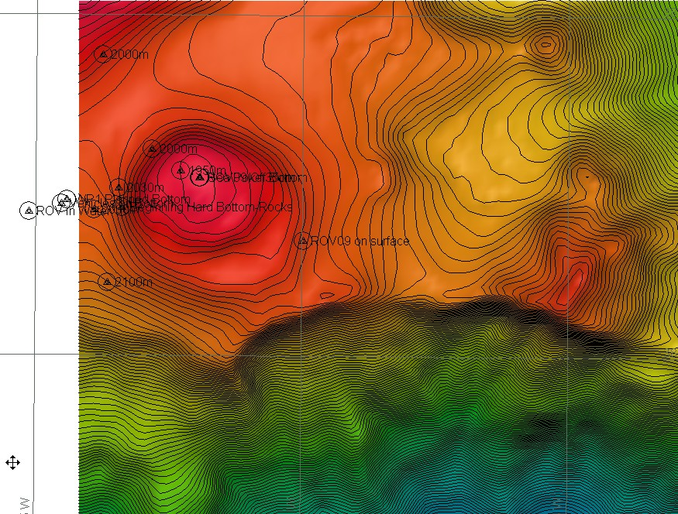 |  |  |  | 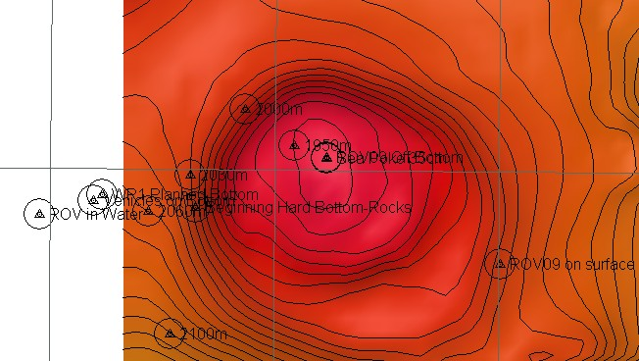
Representative Photos of the Dive
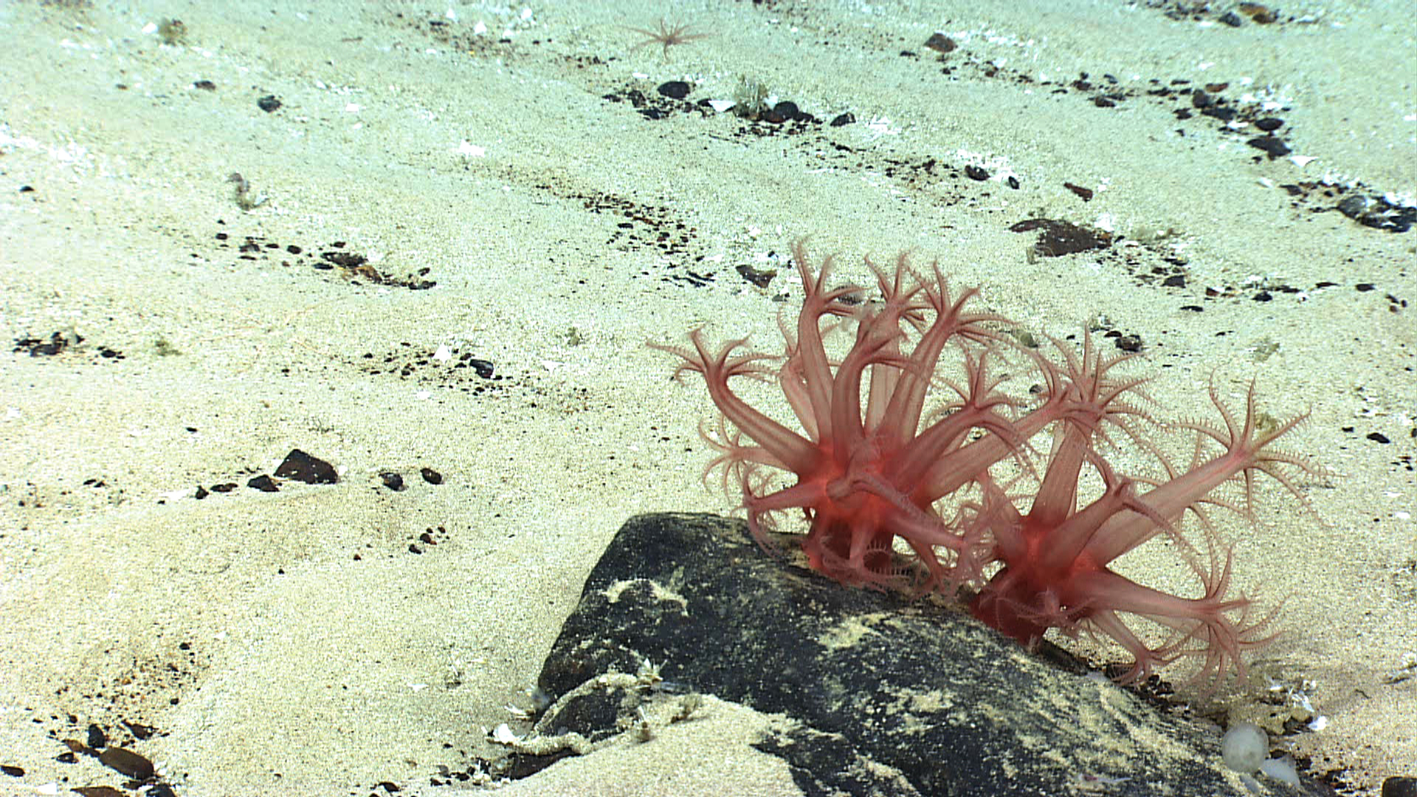 |  |  |  | 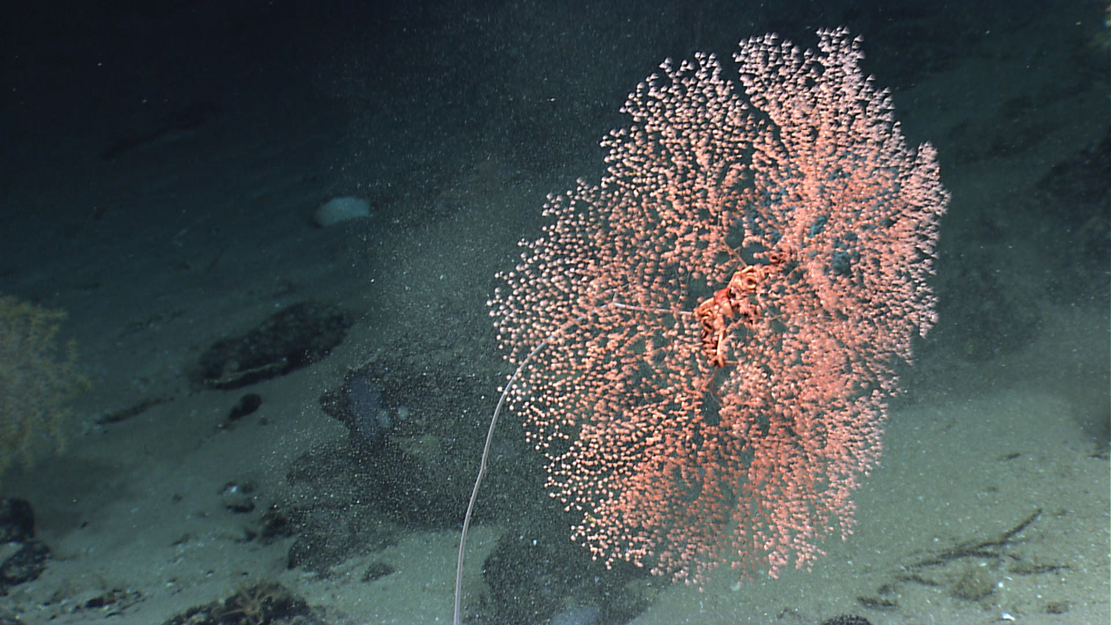
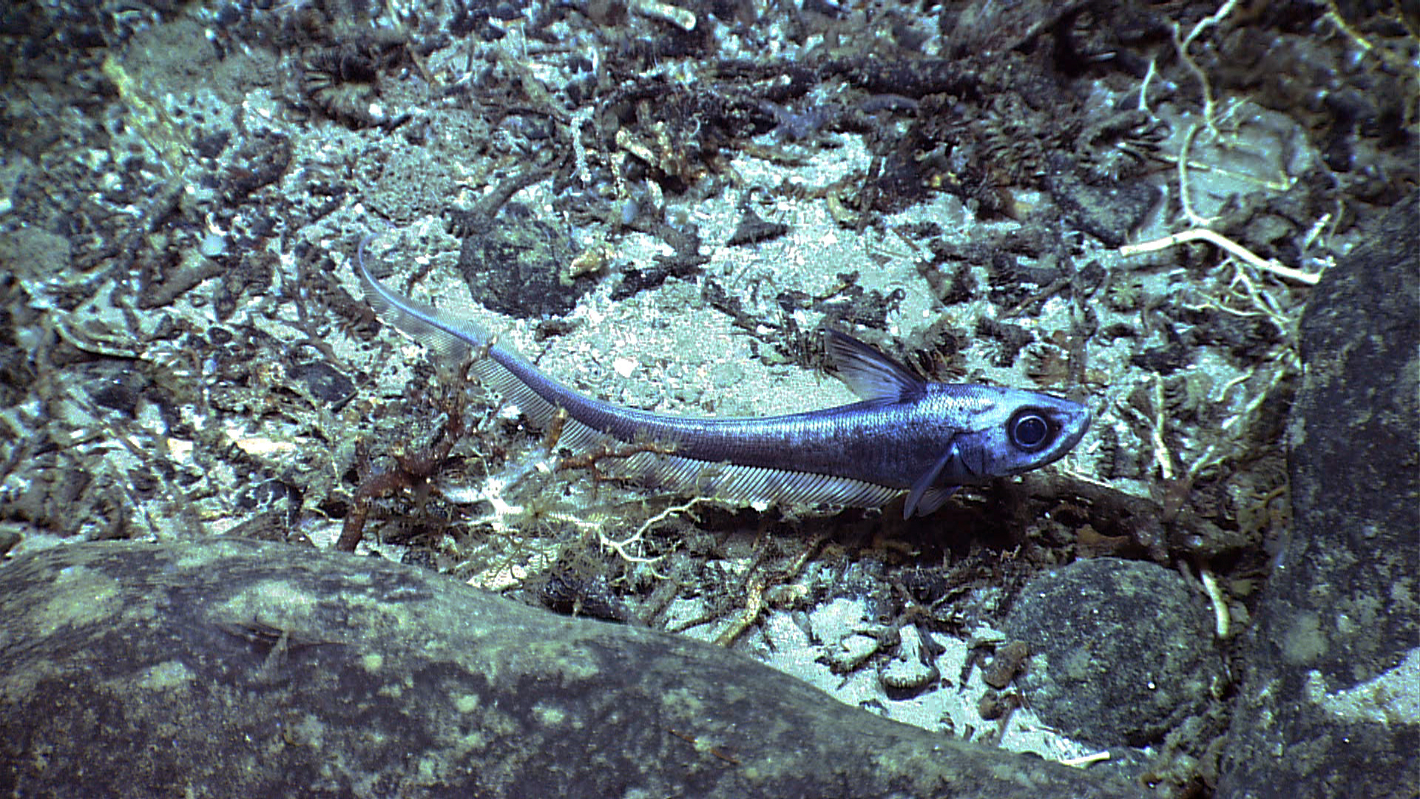 |  |  |  | 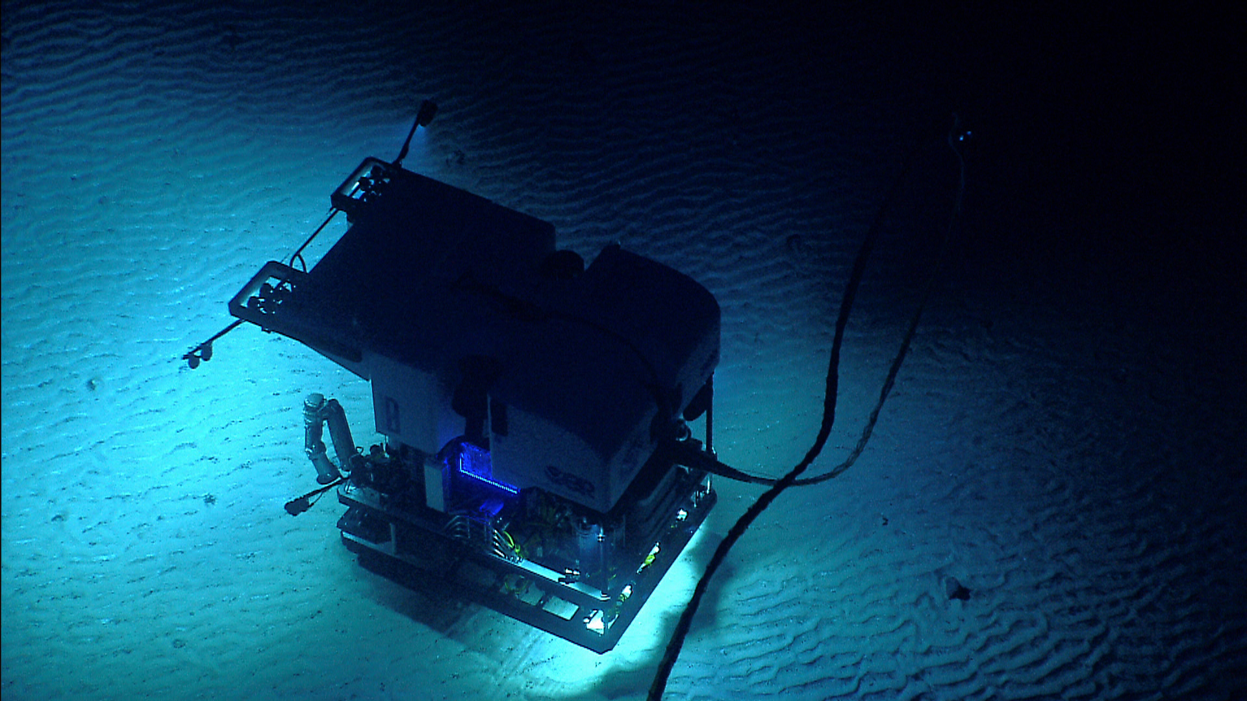
Please direct inquiries to: |  | NOAA Office of Ocean Exploration & Research  1315 East-West Highway (SSMC3 10th Floor)  Silver Spring, MD 20910  (301) 734-1014

