Okeanos Explorer ROV Dive Summary
Site Name | Gosnold Seamount |  |  |  | 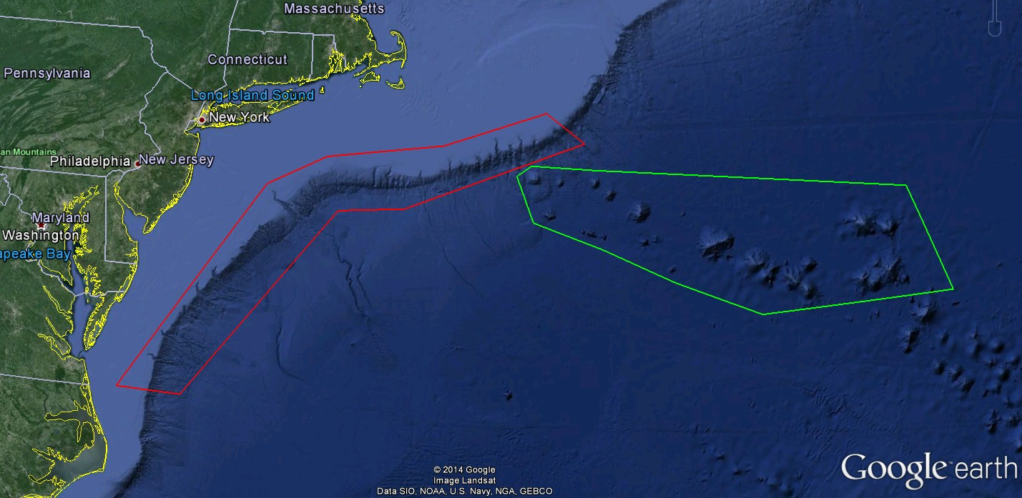
ROV Lead/Expedition Coordinator | Todd Gregory/  Brian Kennedy
Science Team Leads | Scott France and Susan Schnur
General Area Descriptor | Northwest Atlantic Ocean;  Mid Atlantic U.S. Canyons
ROV Dive Name | Cruise Season |  | Leg |  |  | Dive Number
 | EX1404 |  | 3 |  |  | DIVE08
Equipment Deployed | ROV: |  | Deep Discoverer
 | Camera Platform: |  | Seirios
ROV Measurements | CTD |  | Depth |  |  | Altitude
 | Scanning Sonar |  | USBL Position |  |  | Heading
 | Pitch |  | Roll |  |  | HD Camera 1
 | HD Camera 2 |  | Low Res Cam 1 |  |  | Low Res Cam 2
 | Low Res Cam 3 |  | Low Res Cam 4 |  |  | Low Res Cam 2
Equipment Malfunctions | None
ROV Dive Summary  (From processed ROV data) | Dive Summary: EX1404L3_DIVE08  ^^^^^^^^^^^^^^^^^^^^^^^^^^^^^^^^^^^^^^^^^^^^^^^^^^^  In Water at: 2014-09-28T12:44:04.765000  38°, 18.059' N ; 062°, 30.698' W  Out Water at: 2014-09-28T20:15:15.011000  N/A ; N/A  Off Bottom at: 2014-09-28T19:38:53.570000  38°, 17.855' N ; 062°, 31.120' W  On Bottom at: 2014-09-28T14:14:11.179000  38°, 18.143' N ; 062°, 30.643' W  Dive duration: 7:31:10  Bottom Time: 5:24:42  Max. depth: 2138.4 m
Special Notes
Scientists Involved  (please provide name / location / affiliation / email) | Peter Auster UConn and SRF peter.auster@uconn.edu  Amy Baco-Taylor Florida State University abacotaylor@fsu.edu  Robert Carney LSU rcarne1@lsu.edu  Jason Chaytor USGS jchaytor@usgs.gov  Mike Ford NOAA Fisheries michael.ford@noaa.gov  Christopher (Chris) Mah Invertebrate Zoology, NMNH, Smithsonian brisinga@gmail.com  Katie Musser ULL katie.musser@mail.wlc.edu  Andrea Quattrini USGS andrea.quattrini@temple.edu  Brendan Roark Texas A&M University broark@geos.tamu.edu  Tim Shank WHOI tshank@whoi.edu  Brad Stevens Univ of MD Eastern Shore bgstevens@umes.edu  Les Watling University of Hawaii at Manoa watling@hawaii.edu  Scott France University of Louisiana at Lafayette france@louisiana.edu  Susan schnur Oregan State University sschnur@coas.oregonstate.edu  Ellie Bors WHOI ekbors@gmail.com  Emily Duwan University of Connecticut emilyduwan@gmail.com  Steve Auscavitch University of Maine steven.auscavitch@maine.edu
Purpose of the Dive
To explore the biology and geomorpholy of the wholly unexplored Gosnold Seamount.
Description of the Dive:
Setting: Dive 8 took place on the northern flank of Gosnold Seamount. This seamount is a large (3400 m high) elongate guyot similar in size and shape to the main edifice of the nearby Atlantis II Seamounts. The dive track started on the upper flanks of the seamount and led upward along the top of a rift arm ridge to an unusual channel feature at the summit of the seamount.

Exploration: The ROV descended to a hard lava surface at 2138 m before proceeding up the slope to 2126 m to start the dive. Immediately seen in the area were several large Corallium ?niobe colonies that were extensively overgrown by zoanthids and held a variety of associates, including Ophiacantha-like brittlestars and a pycnogonid sea spider. For most of the dive the ROV traversed terrain dominated by jumbled sheet flows with small, irregular lobes. The flows were covered in a light dusting of sediment and large amounts of biological debris and overgrowth. Manganese-encrusted coral branches and cup coral skeletons mixed with shell fragments to form piles of debris between lobes. Especially striking were the large patches of bamboo coral bramble. Dense patches of fine intertwining coral branches covered most surfaces. These thickets were mixtures of live colonies of Keratoisis (possibly K. flexibilis) and many tissue-free branches. Some branches were heavily encrusted and stained, suggesting a long time period of being exposed, but others were relatively clean, suggesting recent stripping of the live tissue from the skeleton. A host of invertebrates were seen on or among the brambles, including hydroids, barnacles urchins and glass sponges (Hexactinellida), the latter of several morphs and colors (yellow-green, purple, white) that were very common all along the dive transect. White munidopsid(?) galatheoid crabs were common, and on at least two occasions individuals with very fuzzy antennae were seen.

Although the jumbled lava morphology was the dominant surface for most of the dive we did observe the broken off edges of several smoother sheet flows as we moved up the cliff. At about 2043 meters depth we first encountered the sharp edge of the ridge we had been following. A rounded promontory stretched out into the water column, with the slope dropping off vertically beneath it. Unfortunately no distinct lava forms were revealed in cross-section on this face. Large Corallium and Candidella colonies and sponges extended from the vertical face of the upper wall into the water column, with occasional Paragorgia colonies as well. We had a brief but interesting observation of what appeared to be a crab carrying a dead hexactinellid sponge skeleton at 1965 m depth. Post-dive input from Darryl Felder (UL Lafayette) suggested, based on the part of legs exposed, that this was a brachyuran crab in the family Homolidae (carrier crabs or porter crabs), a group rarely observed alive.

Further up on the seamount (1912 m) we observed the almost perfectly flat top of a thin (8 cm) sheet flow that had clearly broken off and crumbled near the cliff edge, likely due to the massive landslide that must have formed this sharp edge. At 1854 m we moved into an area with greater sediment cover and also observed a subtle shift in lava flow morphology. Isolated lava mounds stood out from alternating sheet and lobate flow terraces. Just above this we began to move onto the flatter canyon summit and into the channel feature identified in the bathymetry. Moving over the summit we crossed a large sand-filled depression characterized by ripple marks from strong currents and light-colored sediment. The depression did not continue further along the summit channel. Instead we observed a return to patchy sediment and lava flow surfaces. Even on these smaller outcrops in the channel a diverse collection of octocorals and sponges were seen. A test of the sediment probe revealed > 20 cm sediment thickness at one location and less than 5-10 cm in another. The sediment is generally covered by black debris, but is very white under this cover (predominantly pelagic calcareous ooze). These sediment thickness tests marked the end of the dive, and the ROV left bottom at 1851 m, shortly after reaching the summit of the seamount.

Other biological observations: At least 15 species of coral were observed on the transect, including bamboo corals Acanella, Keratoisis and Lepidisis, Paragorgia sp. - many overgrown by yellow zoanthids (presumptive Bullagummizoanthus), Chrysogorgia sp., Iridogorgia magnispiralis and I. splendens, Metallogorgia melanotrichos (with ophiuroid associate Ophiocreas oedipus), Acanthogorgia, Candidella imbricata (some with a zoanthid overgrowth, different looking from yellow Bullagummizoanthus), Clavularia, Paramuricea sp. (with ophiuroid Asteroschema), and black corals (Bathypathes, Stauropathes, Telopathes).

Among the 7 recorded sightings of asteroid seastars was an ususual “sunstar” that caught the attention of Chris Mah (NMNH), who noted it was in the genus Myxaster, and that “myxasterid species are rarely encountered and are known from very few specimens.”

Fish species diversity was fairly low, with 6 species observed. The following list was provided by shore-based scientist Peter Auster and follows: Halsosaur (Aldrovandia sp), Grenadier 1 (Coryphaenoides armatus?), Grenadier 2 (Malacocephalus?), Cusk eel 1 (Brotulataenia or Diplocanthopoma?) Cusk eel (3 other species ... who knows?), Blue hake (Antimora rostrata)

Porifera: Demospongiae Polymastia-like; “grapefruit”; Hexactinellida Euplectella-like
Cnidaria: cup coral; anemones (Actinerus, Hormathiidae)
Mollusca: gastropods
Crustacea: mysids; lepadomorph barnacles on octocoral skeletons (Glyptelasma); nematocarcinid shrimp; Aristaeopsis edwardsiana shrimp
Pycnogonida: Colossendeis sp.
Echinodermata: Ophiuroidea (many different types, including Asteroschema associated with Paragorgia); Crinoidea (stalked and comatulid); Holothuroidea (pink ?Aspidochirotida); Echiuroidea (Echinus-like).

Interesting highlights: Steep landslide headwall scarp dropping off to the west, rapid transition into patchy rippled sediments at seamount summit.

High densities of bramble bamboo coral colonies throughout the entirety of the dive transit over hard bottom on the ridge.

Overall Map of ROV Dive Area |  |  |  | Close-up Map of Main Dive Site
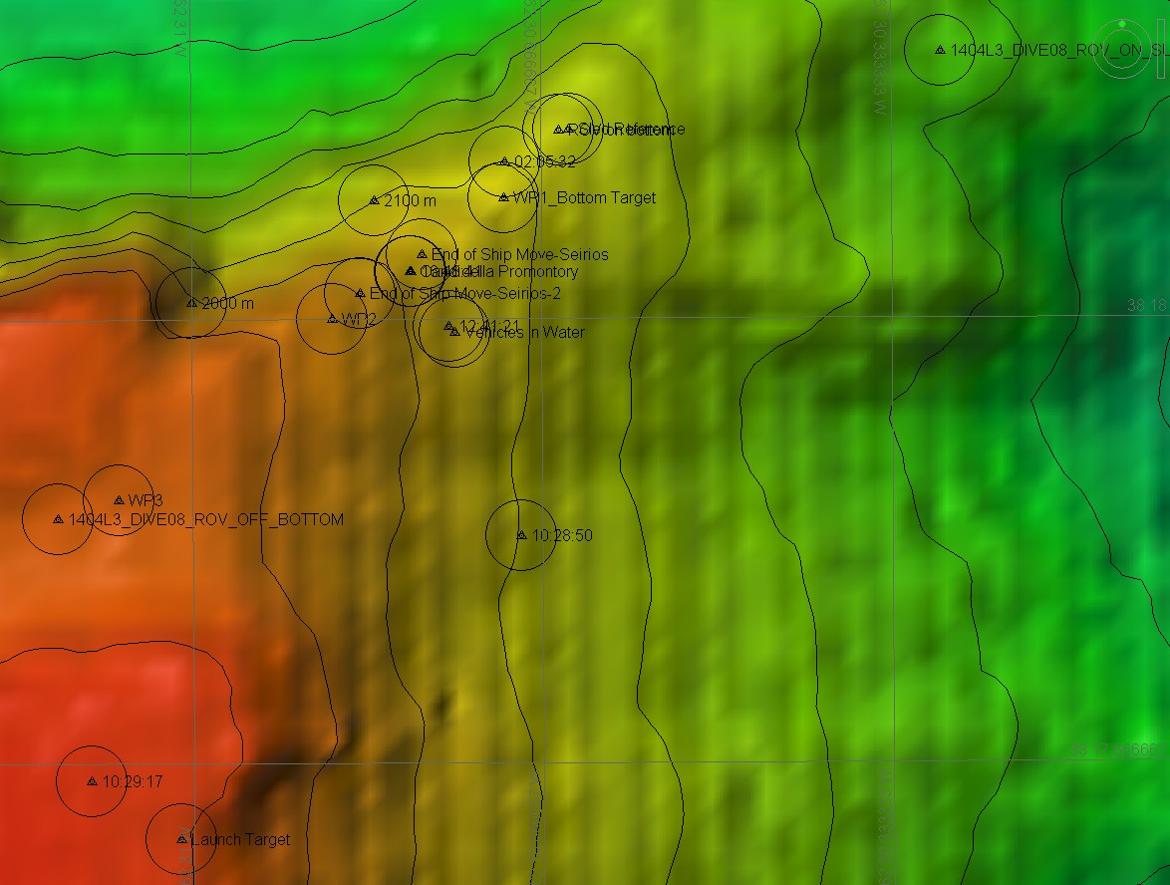 |  |  |  | 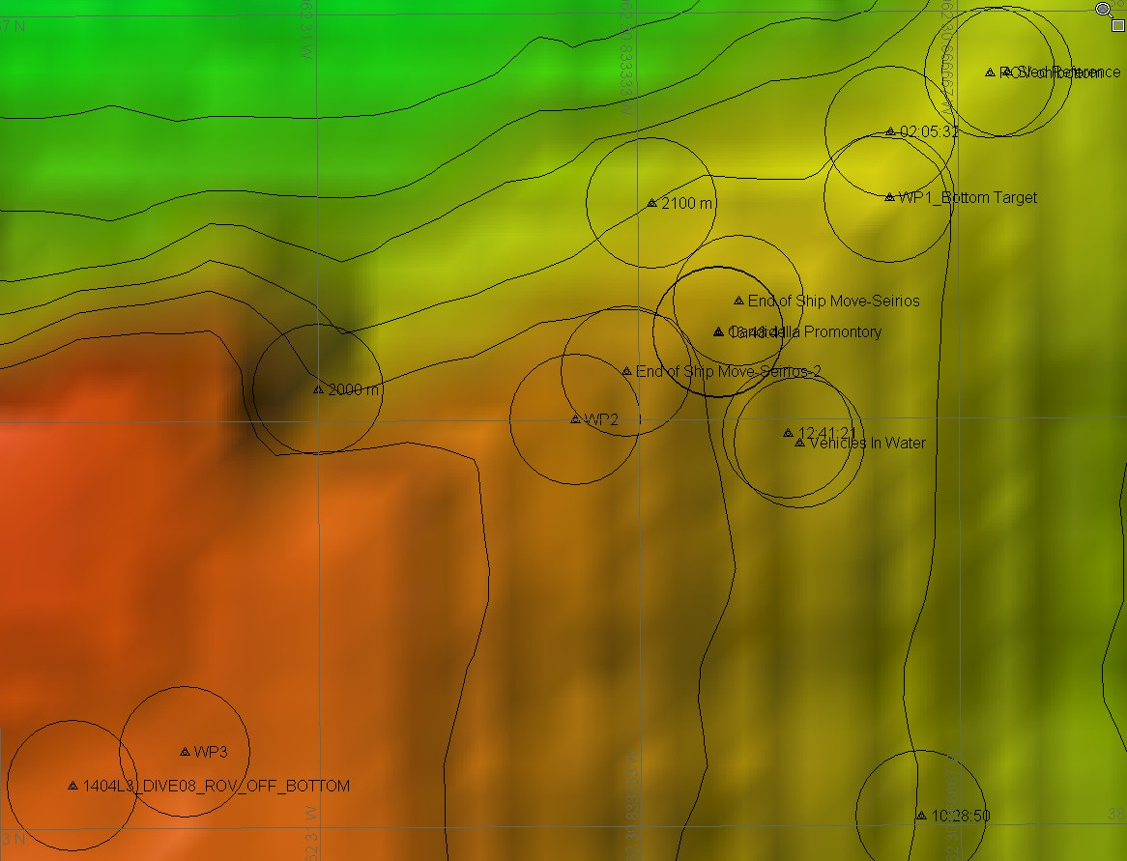
Representative Photos of the Dive
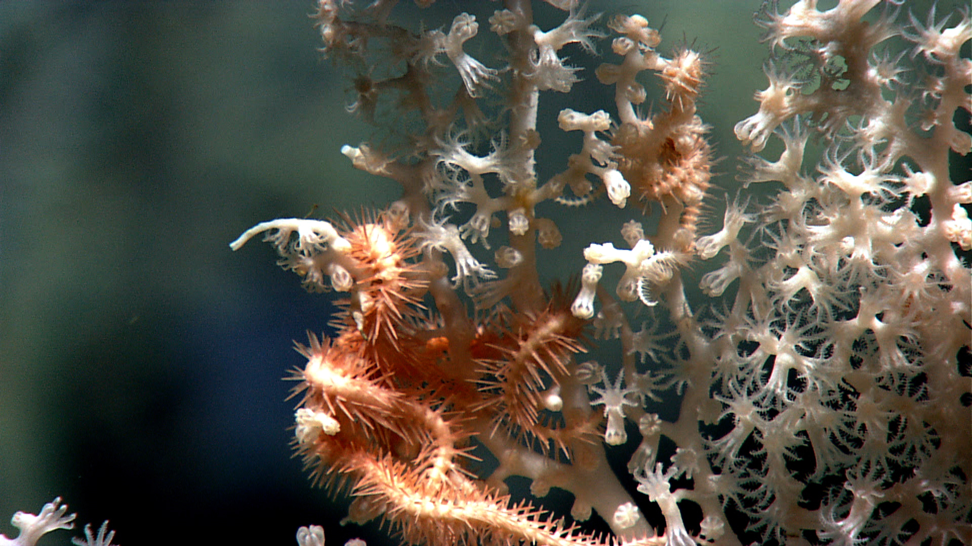 |  |  |  | 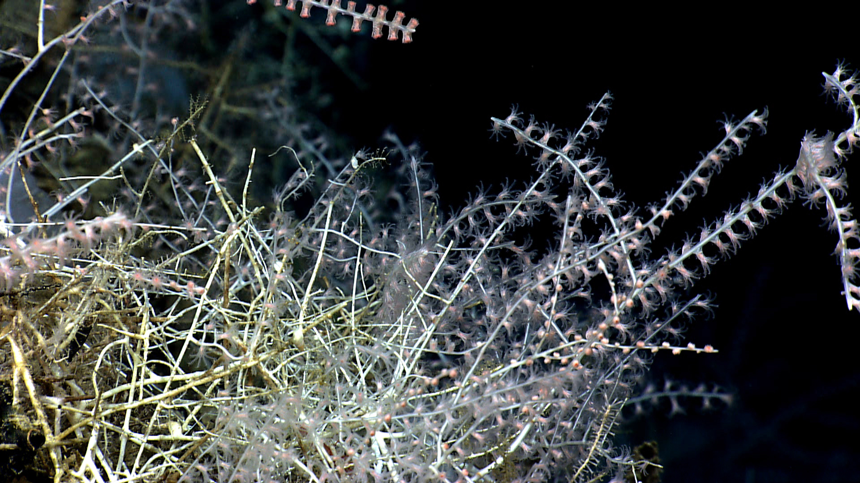
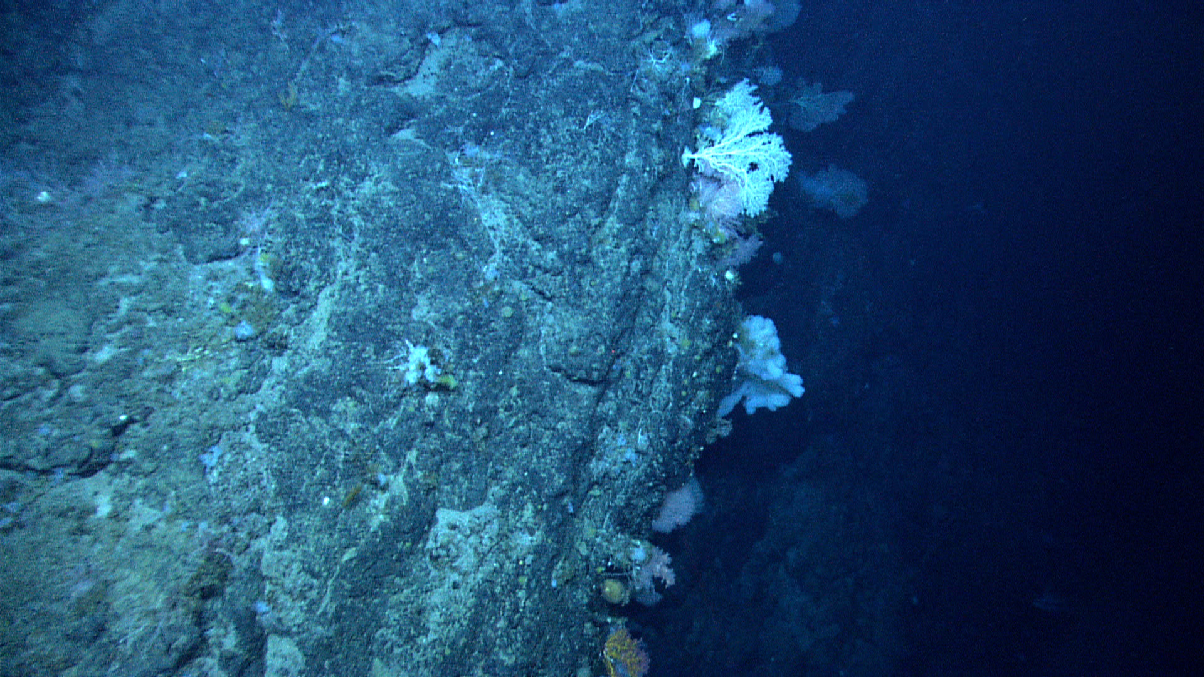 |  |  |  | 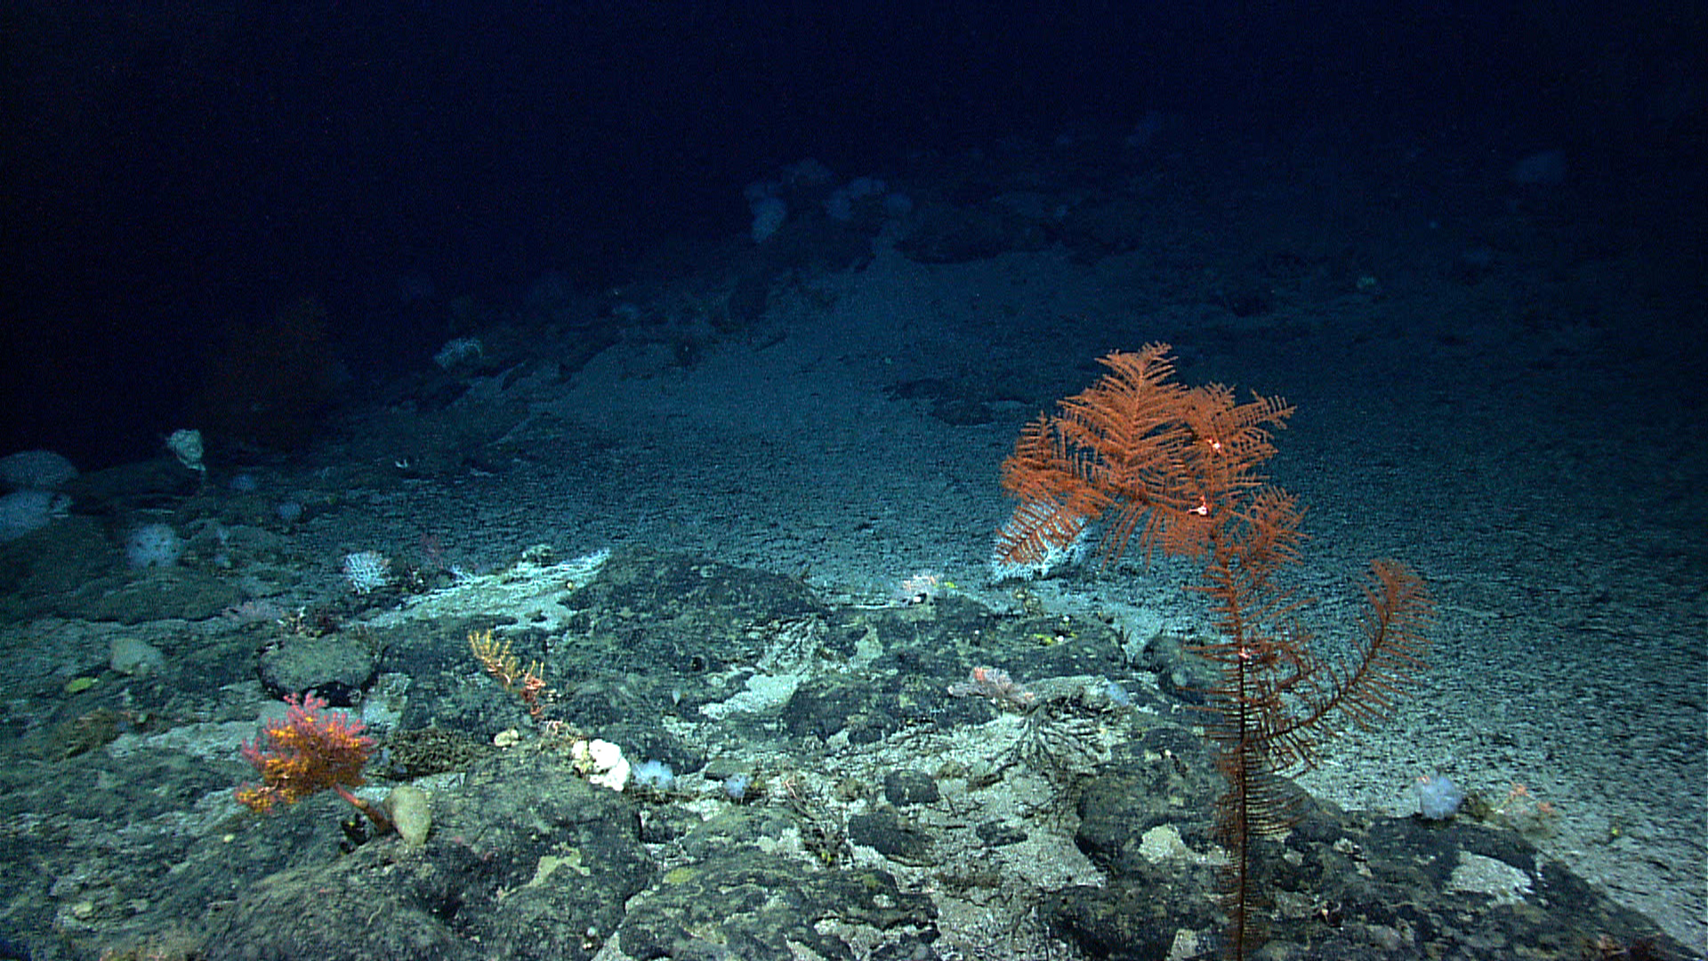
Please direct inquiries to: |  | NOAA Office of Ocean Exploration & Research  1315 East-West Highway (SSMC3 10th Floor)  Silver Spring, MD 20910  (301) 734-1014

