Okeanos Explorer ROV Dive Summary
Site Name | Atlantis II North West Slope |  |  |  | 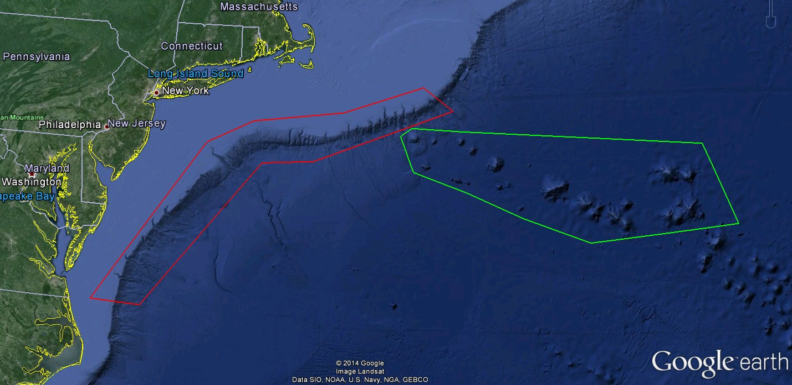
ROV Lead/Expedition Coordinator | Todd Gregory/  Brian Kennedy
Science Team Leads | Scott France and Susan Schnur
General Area Descriptor | Northwest Atlantic Ocean;  Mid Atlantic U.S. Canyons
ROV Dive Name | Cruise Season |  | Leg |  |  | Dive Number
 | EX1404 |  | 3 |  |  | DIVE07
Equipment Deployed | ROV: |  | Deep Discoverer
 | Camera Platform: |  | Seirios
ROV Measurements | CTD |  | Depth |  |  | Altitude
 | Scanning Sonar |  | USBL Position |  |  | Heading
 | Pitch |  | Roll |  |  | HD Camera 1
 | HD Camera 2 |  | Low Res Cam 1 |  |  | Low Res Cam 2
 | Low Res Cam 3 |  | Low Res Cam 4 |  |  | Low Res Cam 2
Equipment Malfunctions | none
ROV Dive Summary  (From processed ROV data) | Dive Summary: EX1404L3_Dive07  ^^^^^^^^^^^^^^^^^^^^^^^^^^^^^^^^^^^^^^^^^^^^^^^^^^^  In Water at: 2014-09-27T12:24:49.234000  38°, 36.096' N ; 063°, 19.479' W  Out Water at: 2014-09-27T23:35:39.506000  38°, 36.948' N ; 063°, 16.702' W  Off Bottom at: 2014-09-27T22:10:49.716000  38°, 35.920' N ; 063°, 18.830' W  On Bottom at: 2014-09-27T14:00:57.665000  38°, 36.180' N ; 063°, 19.351' W  Dive duration: 11:10:50  Bottom Time: 8:9:52  Max. depth: 2746.9 m
Special Notes
Scientists Involved  (please provide name / location / affiliation / email) | Peter Auster UConn and SRF peter.auster@uconn.edu  Amy Baco-Taylor Florida State University abacotaylor@fsu.edu  Robert Carney LSU rcarne1@lsu.edu  Jason Chaytor USGS jchaytor@usgs.gov  Mike Ford NOAA Fisheries michael.ford@noaa.gov  Christopher (Chris) Mah Invertebrate Zoology, NMNH, Smithsonian brisinga@gmail.com  Katie Musser ULL katie.musser@mail.wlc.edu  Andrea Quattrini USGS andrea.quattrini@temple.edu  Thomas Ritter Montana State University thomas.ritter@msu.montana.edu  Tim Shank WHOI tshank@whoi.edu  Brad Stevens Univ of MD Eastern Shore bgstevens@umes.edu  Michael Vecchione NMFS Syatematics Lab vecchiom@si.edu  Les Watling University of Hawaii at Manoa watling@hawaii.edu  Rhian Waller University of Maine rhian.waller@maine.edu  Scott France University of Louisiana at Lafayette france@louisiana.edu  Susan schnur Oregan State University sschnur@coas.oregonstate.edu  Ellie Bors WHOI ekbors@gmail.com  Emily Duwan University of Connecticut emilyduwan@gmail.com
Purpose of the Dive
Explore the biology and geomorphology of the Atlantis II seamount
Description of the Dive:
Setting: Dive 7 took place on the northwestern flank of the main edifice of the Atlantis II Seamounts. This seamount is a large (3200 m) guyot (flat-topped seamount), assumed to have reached above the ocean surface at some time in the past. The dive climbed the edge of a small mid-flank ridge feature then followed the top of the ridge towards the summit.

Exploration: The ROV touched down on a hard-bottom substrate composed of lava flows with minimal sediment coating. The dominant lava morphology appeared to be a lobate flow, although some large bulbous pillow-shaped features were also observed, draped over a break in the slope. Patchy sediment cover was observed in the valleys between the lava lobes. At the landing site a few fish were observed (ophidids and grenadiers), and the rocks had scattered hydroids, serpulid polychaetes and encrusting sponges. Very quickly we began to see red-pink colonies of Corallium ?bathyrubrum; this species proved to be the most abundant coral of the day, being seen throughout the dive along the entire depth range. Many other octocoral colonies were seen along the dive transect, including Chrysogorgia sp. (many with chirostylid squat lobsters), Anthomastus, Paragorgia, Corallium ?niobe (white morph), bamboo corals (Isidella sp. 1 and I. sp.2, Jasonisis, Lepidisis, and a node-less bramble); and black corals Bathypathes, and Stauropathes. Many rock sea pens (?Calibelemnon) were seen on hard bottoms during the first half of the dive. “Ring” anemones (those with pedal disc fused around a coral branch) were common on many coral colonies.

Continuing upward, we entered an area of broken stair-step terrain composed of the eroded platey remains of one or more thick (15 cm) sheet flows. One boulder revealed two sheet flows stacked on top of each other, although camera zoom was insufficient to confirm a cooling margin. The ROV then continued upwards and came out onto the flatter ridge top and an adjacent plateau. The dominant flow here was a sort of bulbous lobate flow, possibly intermediate between pillow lavas and a lobate morphology. Hexactinellid glass sponges became very abundant and diverse beginning around 2690 m depth and were the dominant taxon along with Corallium ?bathyrubrum. At 2546 m we observed a distinct carbonate layer with a thick blanket of sediment at its base. We followed this contact for some distance and the unit appeared to be laterally continuous. The layer appeared quite white, but coarser and more porous than the chalky unit observed at the base of the submarine canyons. One hypothesis is that this unit represents a drowned reef that formed in shallow waters at a time when the seamount was still active and reached above the surface. A number of cerianthid tube anemones were seen extending from burrows in the chalk-like wall at 2543 m.

At one point we also observed small areas of very shiny black manganese-encrusted lobate lava tongues. They appeared almost sand-blasted and very smooth. One hypothesis is that an eddy in the strong currents moving through this area may have scoured off this surface. The rest of the dive continued over a flatter surface, with a uniform lobate morphology. Further up on the slope we observed piles of mostly biological gravel-sized material in the valleys between lava lobes. This biological debris was dominated by Fe and Mn-stained coral remains and white pteropod shells. The small debris fans appear to have formed by creeping and tumbling of material from higher above.

Other species observations:
• At least 9 species of fish were observed and a list was provided by shore-based scientist Peter Auster and follows: Cutthroat eel (Synaphobranchidae), Cusk eels (Ophidiidae - 3 species); Grenadier (1 species); Blue hake (Antimora sp.); Hake (Lepidion); Anglerfish [sea toad] (Bathychaunax roseus); Snailfish (Liparidae)
• Two cephalopod sightings were made, one an extended view of a “dumbo” octopus (Grimpoteuthis), the other a view from the Seirios HD camera of a possible Vampyroteuthis (as noted by Mike Vecchione).
• Frequent observations of large ?Arcoscalpellum barnacles in clumps on the seafloor.
• Stoloniferous (ribbon growth) and Paralcyonium (or Ceeceenus)-like octocorals were very abundant encrusting the seafloor in many places throughout the dive (described in the eventlog by one scientist as a “carpet of octocorals”) as were arborescent foraminifera.
• A pycnogonid sea spider was observed carrying an egg mass, which was a highlight for several scientists who know males carry eggs but had not observed this in deep sea.

Other taxa:
- Porifera: stick-like cladorhizids
- Cnidaria: cup corals; dandelion siphonophore (?Thermopalia sp.); zoanthids; Corallimorpharia
- Mollusca: gastropods were seen on sponges, bamboo coral skeletons and the bare substratum.
- Crustacea: red crab (Chaceon quinquedens), Hermit Crab (Paguridae), barnacles (Glyptelasma) on coral colonies, squat lobsters, nematocarcind shrimp, Aristeopenaeus shrimp, caprellid amphipods, munid isopod (“water walker”), lophogastrid
- Pycnogonida: Colossendeis sp.
- Echinodermata: Asteroidea (?Ceramaster, Hymenaster, Evoplosoma, including some feeding on coral), brisingid; Ophiuroidea (many different types, including associates on corals); Crinoidea (both stalked and comatulid); Holothuroidea (?Aspidochirota and two species of Elasipodida).

Interesting highlights:
Distinct carbonate layer at 2546 m with thin overlying lobate sheet flow, very shiny black manganese-encrusted lobate lava tongues.
High abundance of Corallium ?bathyrubrum
Hexactinellid sponge “zone” of high abundance and diversity beginning around 2692 m depth

Overall Map of ROV Dive Area |  |  |  | Close-up Map of Main Dive Site
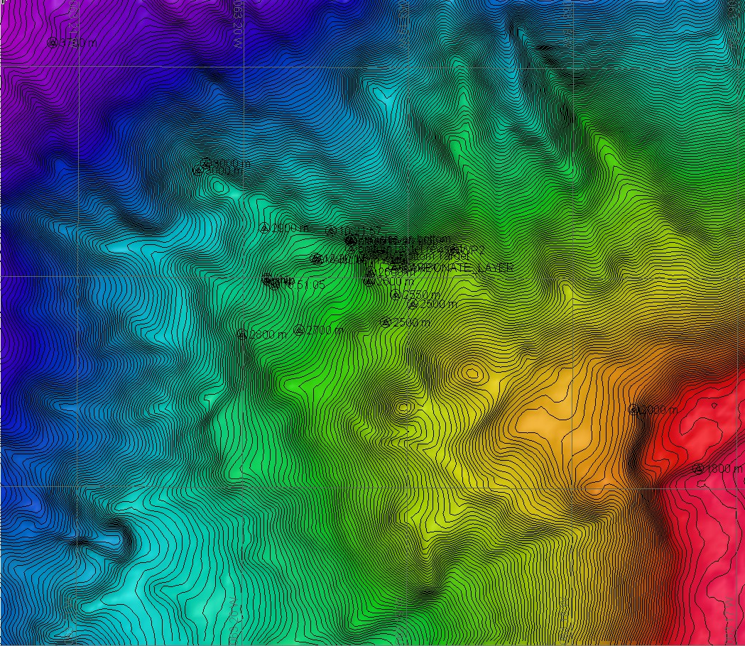 |  |  |  | 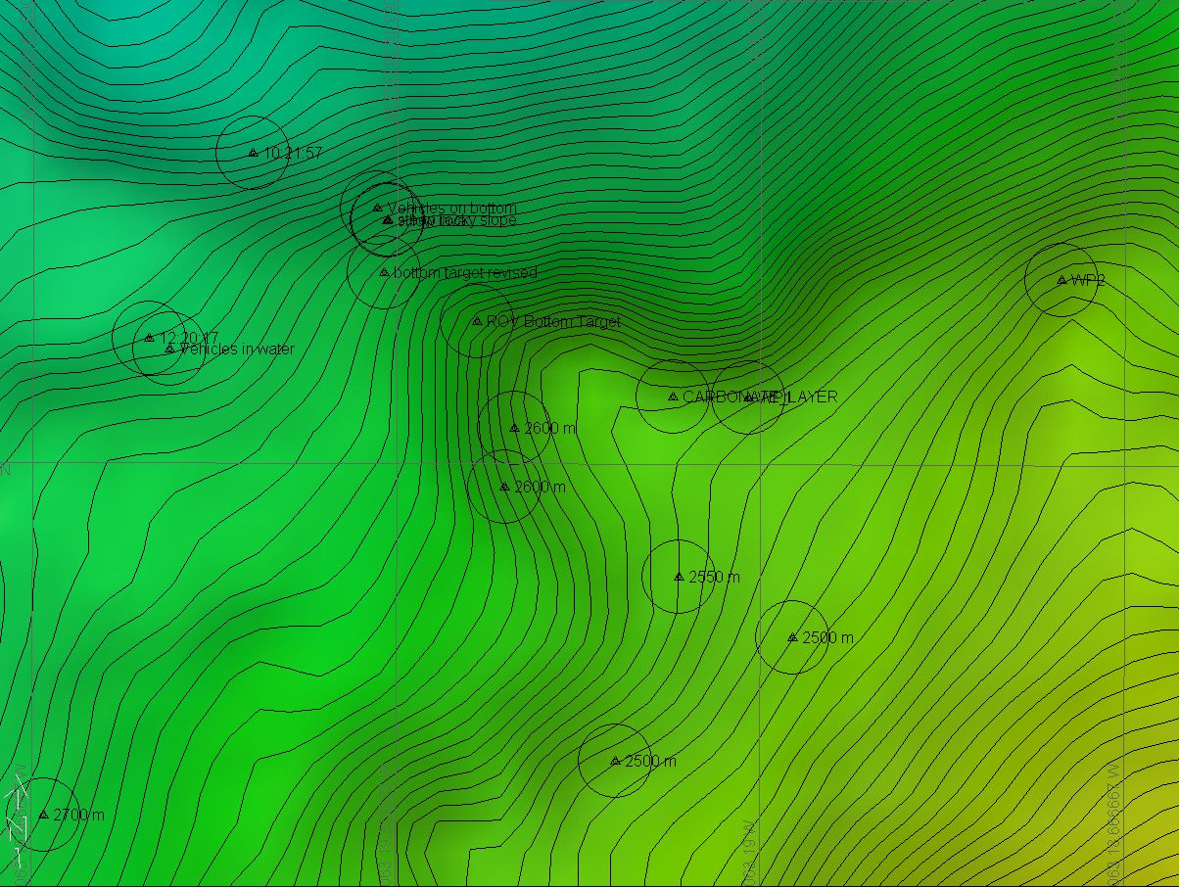
Representative Photos of the Dive
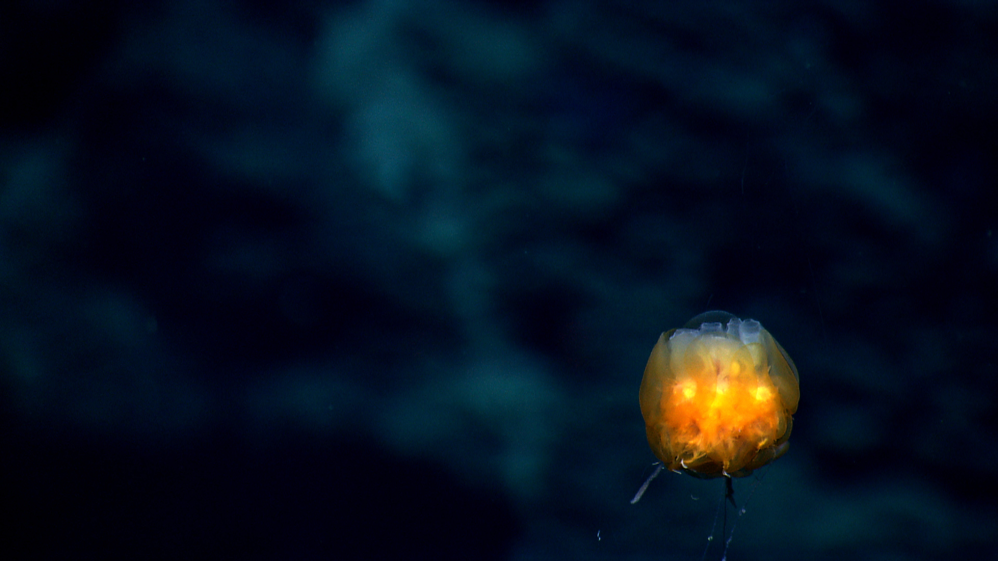 |  |  |  | 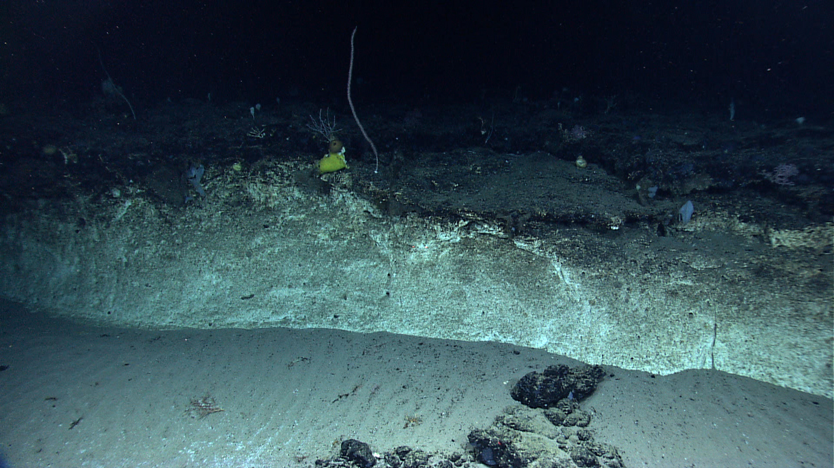
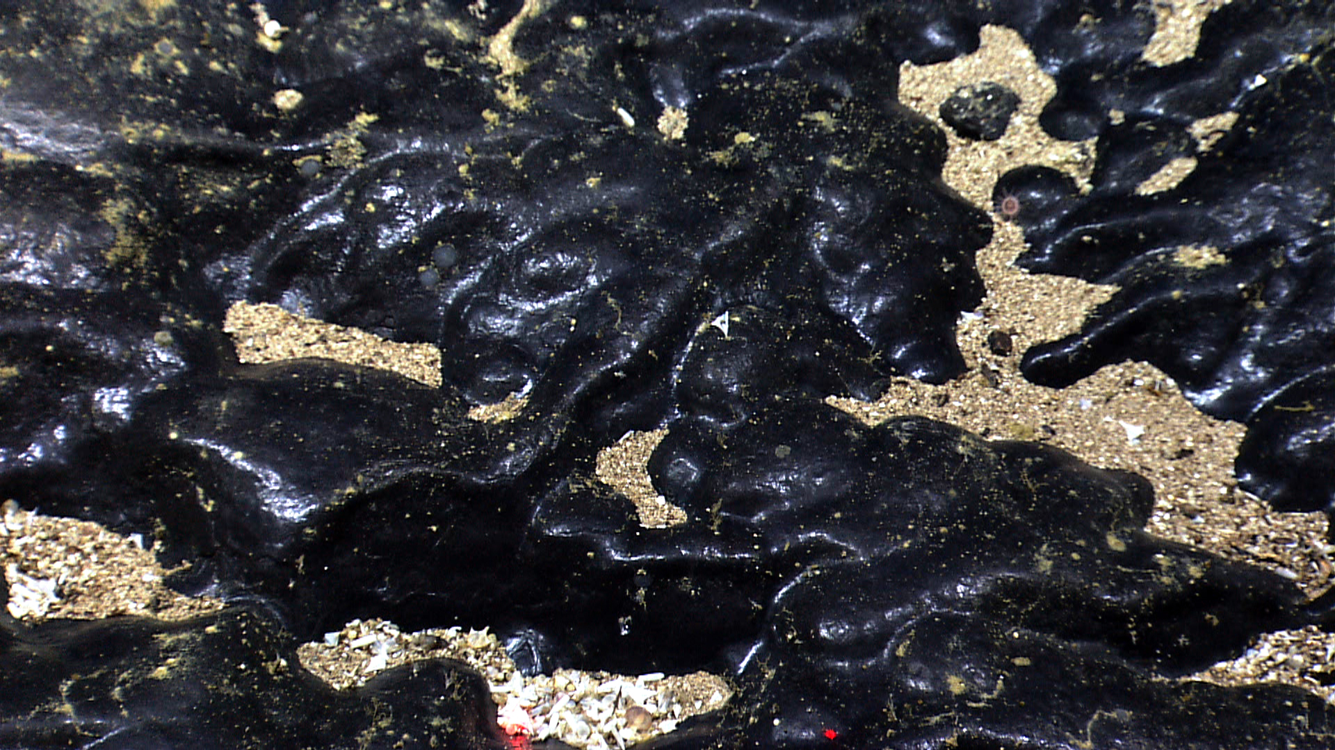 |  |  |  | 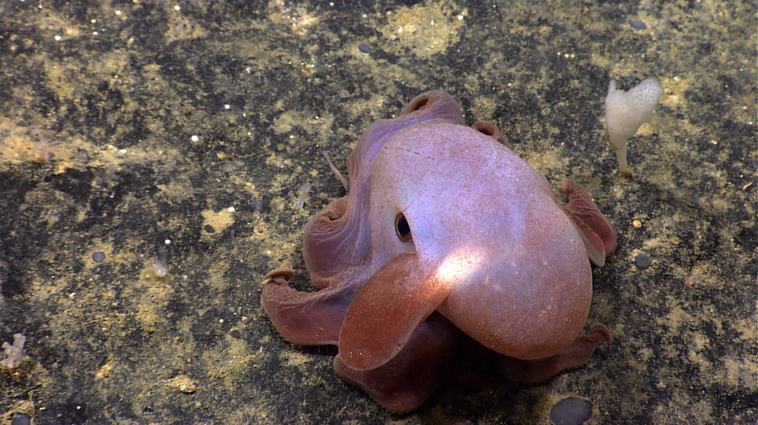
Please direct inquiries to: |  | NOAA Office of Ocean Exploration & Research  1315 East-West Highway (SSMC3 10th Floor)  Silver Spring, MD 20910  (301) 734-1014

