Okeanos Explorer ROV Dive Summary
Site Name | Asterias Seamount (Aborted) |  |  |  | 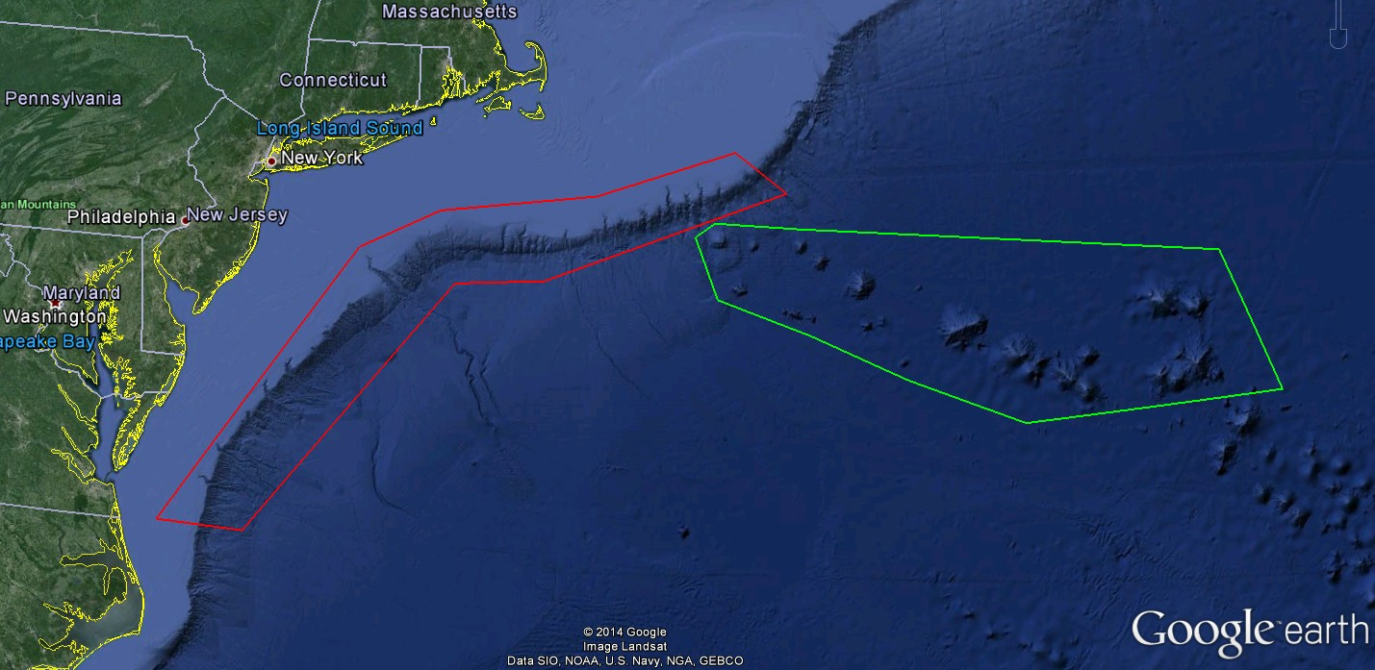
ROV Lead/Expedition Coordinator | Todd Gregory/  Brian Kennedy
Science Team Leads | Scott France and Susan Schnur
General Area Descriptor | Northwest Atlantic Ocean;  Mid Atlantic U.S. Canyons
ROV Dive Name | Cruise Season |  | Leg |  |  | Dive Number
 | EX1404 |  | 3 |  |  | DIVE06
Equipment Deployed | ROV: |  | Deep Discoverer
 | Camera Platform: |  | Seirios
ROV Measurements | CTD |  | Depth |  |  | Altitude
 | Scanning Sonar |  | USBL Position |  |  | Heading
 | Pitch |  | Roll |  |  | HD Camera 1
 | HD Camera 2 |  | Low Res Cam 1 |  |  | Low Res Cam 2
 | Low Res Cam 3 |  | Low Res Cam 4 |  |  | Low Res Cam 2
Equipment Malfunctions | none
ROV Dive Summary  (From processed ROV data) | Complete data set not available due to aborted dive.  In water at: 38.9295N, -65.3482W
Special Notes | The dive was aborted before the ROV reached the bottom due to weather.
Scientists Involved  (please provide name / location / affiliation / email) | Peter Auster UConn and SRF peter.auster@uconn.edu  Amy Baco-Taylor Florida State University abacotaylor@fsu.edu  Tara Harmer Luke The RIchard Stockton College of New Jersey luket@stockton.edu  Katie Musser ULL katie.musser@mail.wlc.edu  Brendan Roark Texas A&M University broark@geos.tamu.edu  Esprit Saucier University of Louisiana at Lafayette heestand.saucier@louisiana.edu  Tim Shank WHOI tshank@whoi.edu  Brad Stevens Univ of MD Eastern Shore bgstevens@umes.edu  Michael Vecchione NMFS Syatematics Lab vecchiom@si.edu  Les Watling University of Hawaii at Manoa watling@hawaii.edu  Rhian Waller University of Maine rhian.waller@maine.edu  Scott France University of Louisiana at Lafayette france@louisiana.edu  Adam Boyette NOAA NCDDC adam.boyette@noaa.gov  Susan Schnur Oregan State University sschnur@coas.oregonstate.edu  Ellie Bors WHOI ekbors@gmail.com  Emily Duwan University of Connecticut emilyduwan@gmail.com
Purpose of the Dive
To explore the biology and geomorphology of Asterias Seamount.
Description of the Dive:
The ROVs were deployed for the first ever exploration of Asterias Seamount. Once the ROV reached 2100 meters the decision was made to abort the dive due to deteriorating weather conditions. The ROV imaged numerous creatures in the water column during the dive but bottom contact was never made.
Overall Map of ROV Dive Area |  |  |  | Close-up Map of Main Dive Site
Not Available |  |  |  | Not Available
Representative Photos of the Dive
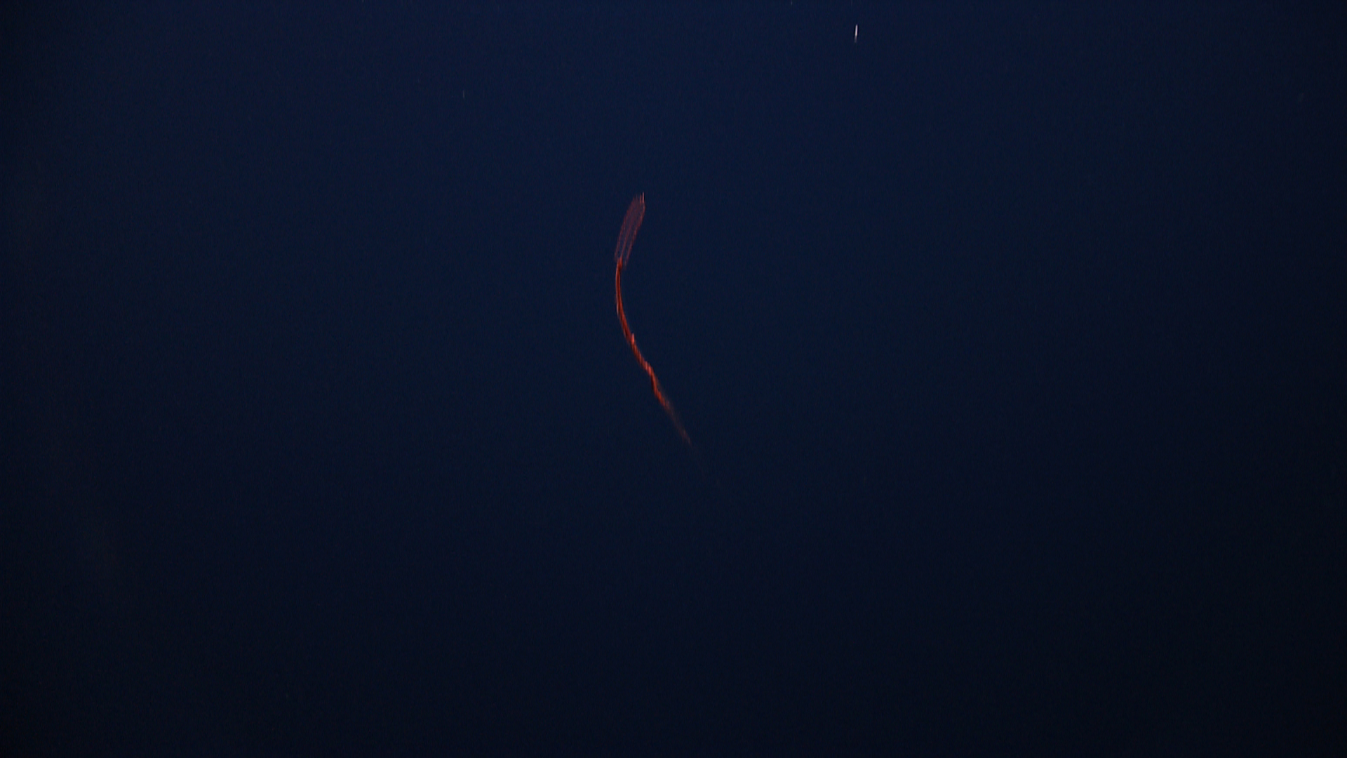 |  |  |  | 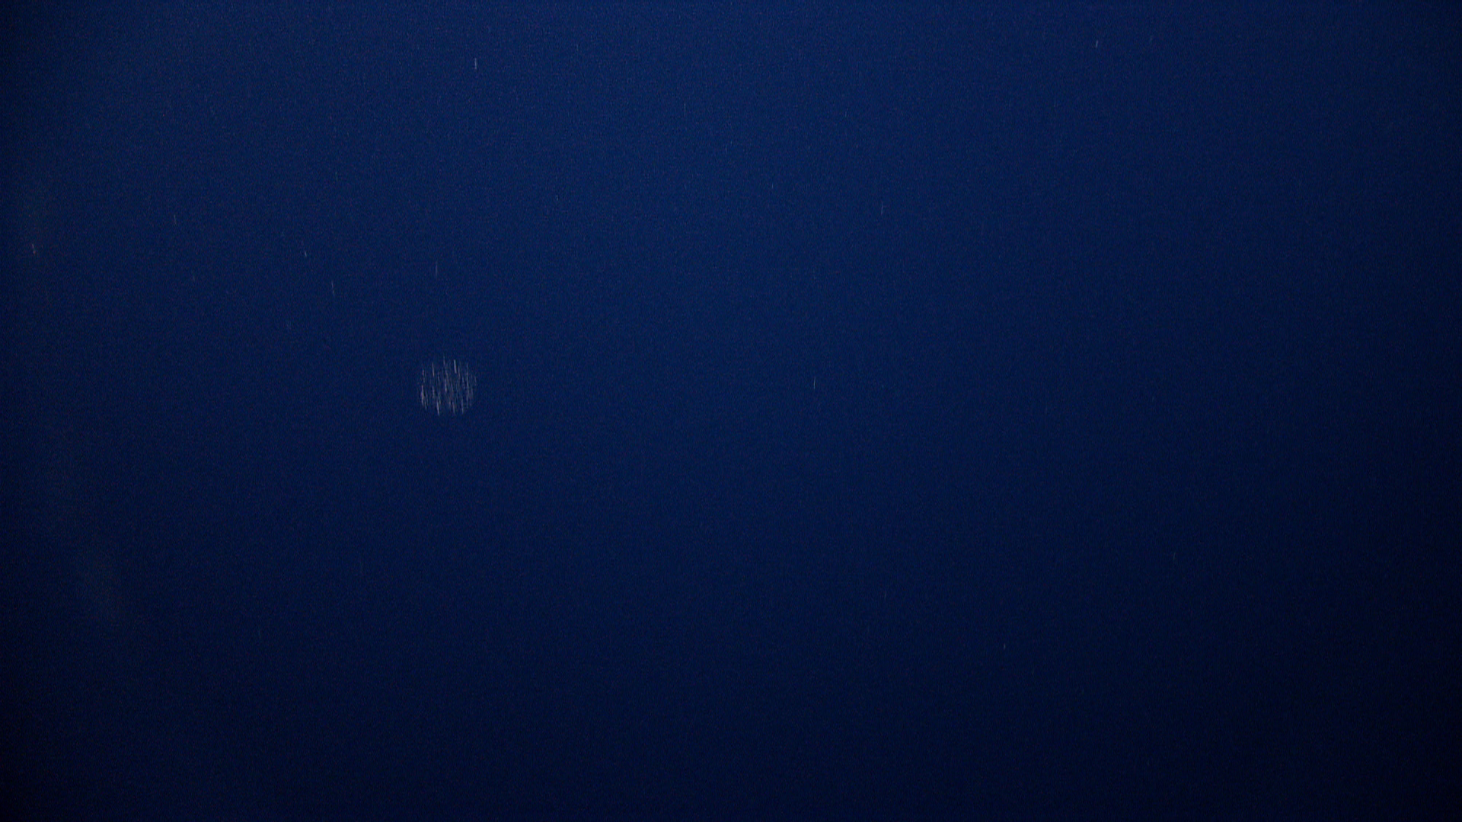
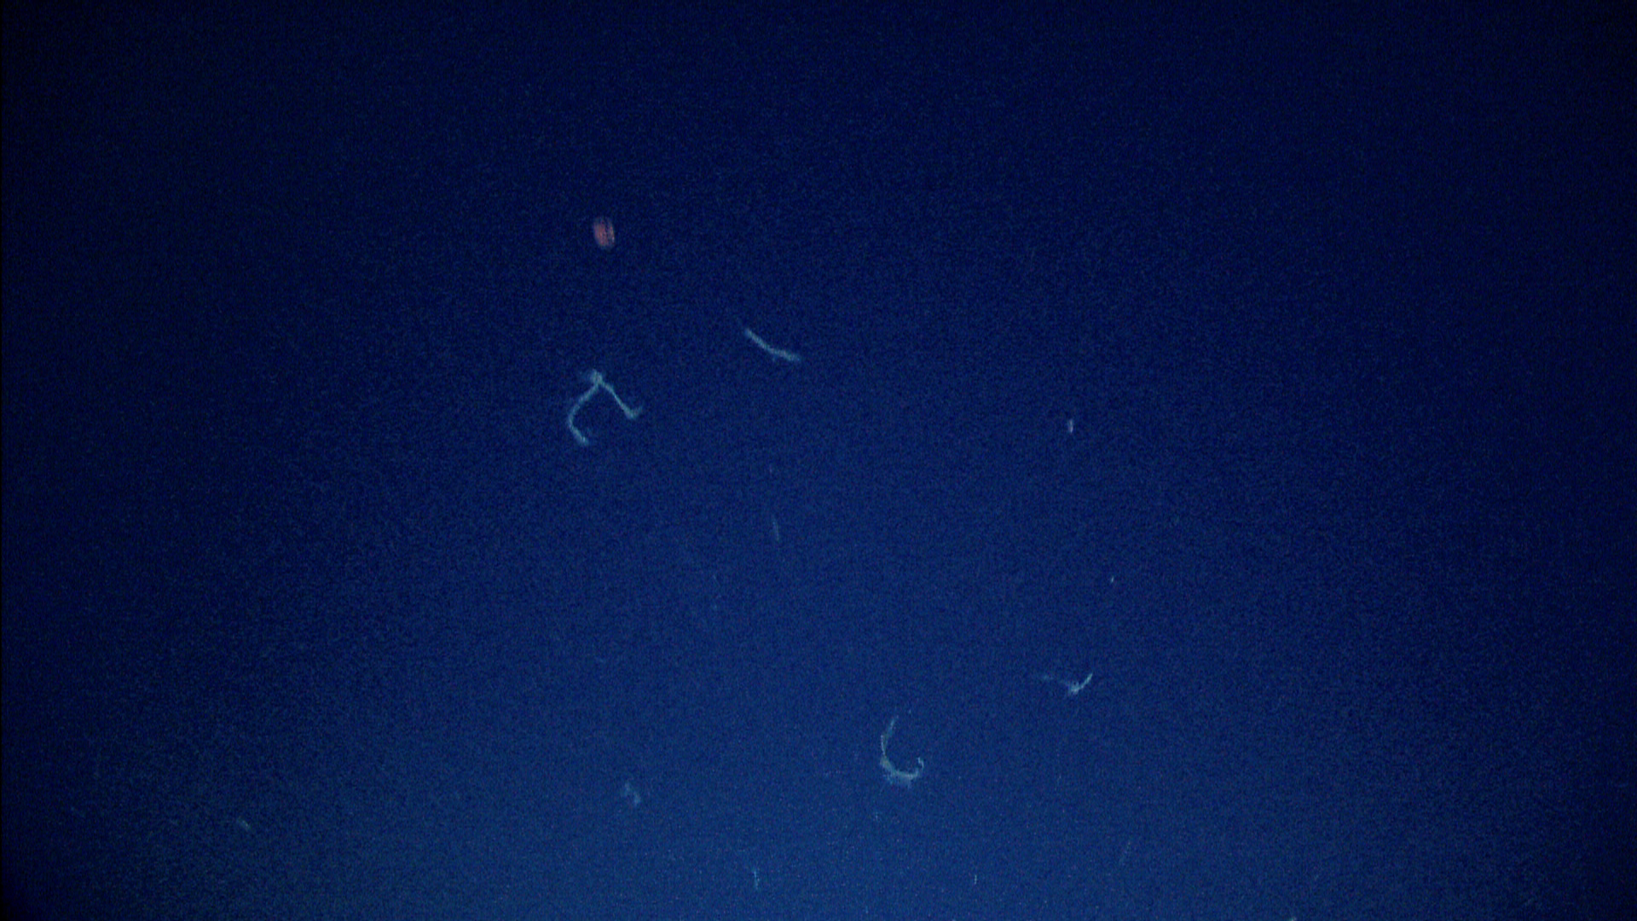 |  |  |  | 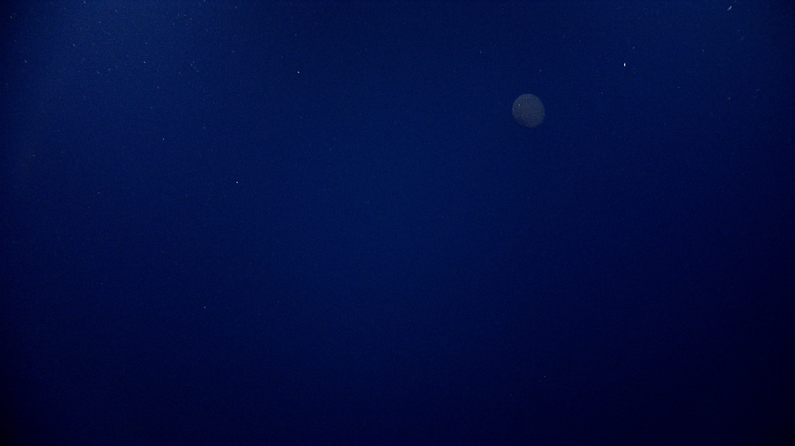
Please direct inquiries to: |  | NOAA Office of Ocean Exploration & Research  1315 East-West Highway (SSMC3 10th Floor)  Silver Spring, MD 20910  (301) 734-1014

