Okeanos Explorer ROV Dive Summary
Site Name | McMaster Canyon |  |  |  | 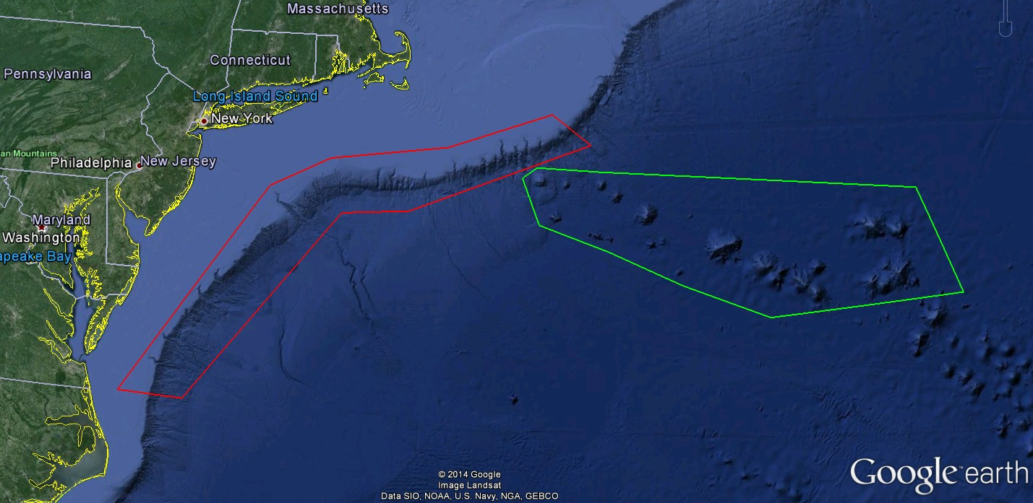
ROV Lead/Expedition Coordinator | Todd Gregory/  Brian Kennedy
Science Team Leads | Scott France and Susan Schnur
General Area Descriptor | Northwest Atlantic Ocean;  Mid Atlantic U.S. Canyons
ROV Dive Name | Cruise Season |  | Leg |  |  | Dive Number
 | EX1404 |  | 3 |  |  | DIVE03
Equipment Deployed | ROV: |  | Deep Discoverer
 | Camera Platform: |  | Seirios
ROV Measurements | CTD |  | Depth |  |  | Altitude
 | Scanning Sonar |  | USBL Position |  |  | Heading
 | Pitch |  | Roll |  |  | HD Camera 1
 | HD Camera 2 |  | Low Res Cam 1 |  |  | Low Res Cam 2
 | Low Res Cam 3 |  | Low Res Cam 4 |  |  | Low Res Cam 2
Equipment Malfunctions | None
ROV Dive Summary  (From processed ROV data) | Dive Summary: EX1404L3_DIVE03  ^^^^^^^^^^^^^^^^^^^^^^^^^^^^^^^^^^^^^^^^^^^^^^^^^^^  In Water at: 2014-09-21T12:19:07.584000  N/A ; N/A  Out Water at: 2014-09-21T20:37:58.083000  39°, 41.882' N ; 071°, 35.468' W  Off Bottom at: 2014-09-21T19:08:24.256000  39°, 42.072' N ; 071°, 35.787' W  On Bottom at: 2014-09-21T13:02:54.561000  39°, 42.414' N ; 071°, 35.914' W  Dive duration: 8:18:50  Bottom Time: 6:5:29  Max. depth: 1358.2 m
Special Notes | none
Scientists Involved  (please provide name / location / affiliation / email) | Peter Auster UConn and SRF peter.auster@uconn.edu  Amy Baco-Taylor Florida State University abacotaylor@fsu.edu  Jason Chaytor USGS jchaytor@usgs.gov  Santiago Herrera WHOI tiagohe@gmail.com  Taylor Heyl WHOI theyl@whoi.edu  Brian Kinlan NOAA/NOS/NCCOS Biogeography Branch brian.kinlan@NOAA.gov  Christopher (Chris) Mah Invertebrate Zoology, NMNH, Smithsonian brisinga@gmail.com  Esprit Saucier University of Louisiana at Lafayette heestand.saucier@louisiana.edu  Tim Shank WHOI tshank@whoi.edu  Michael Vecchione NMFS Syatematics Lab vecchiom@si.edu  Scott France University of Louisiana at Lafayette france@louisiana.edu  Adam Boyette NOAA NCDDC adam.boyette@noaa.gov  Susan Schnur Oregan State University sschnur@coas.oregonstate.edu  Ellie Bors WHOI ekbors@gmail.com  Emily Duwan University of Connecticut emilyduwan@gmail.com  Kiley Dancy Mid-Atlantic Fishery Management Council kdancy@mafmc.org
Purpose of the Dive
Explore the biology and geomorphology of McMaster Canyon.
Description of the Dive:
Setting: Dive 3 took place in McMaster Canyon, about halfway (12 miles) down the canyon from the shelf break. McMaster is a slope-sourced canyon and does not extend shoreward of the shelf break. The dive consisted of two transects up the nearly-vertical canyon walls.

Exploration: The ROV D2 was deployed at 1214 UTC to a depth of 1358 m in McMaster Canyon; D2 reached the bottom at 1307 UTC. The canyon floor was once again heavily sedimented, although the average grain size appeared coarser than observed in the previous two dives. This may reflect a greater sand fraction as well as an abundance of pebbles (~25 mm diameter) eroded from the nearby chalk cliff. Based on previous work, white specks in the sand may be large foraminifera of the species Globorotalia menardii. As we approached the landing site we observed swimming holothurians (?Peniagone), and many individuals were observed in water column throughout the dive. A purple Hygrosoma urchin with hoof-like caps on the spines was observed ambling across the bottom with a juvenile Cusk Eel (Barathrites) tucked among the spines of the urchin; several more Hygrosoma were seen at various times on the dive, but no additional Barathrites juveniles were seen. On the sedimented area before reaching the wall we noted several items of trash, including plastic bags and discarded fishing line, and it was suggested in the eventlog this was a result of diving under vessel approach lanes to NYC. At about 1326 m, the ROV began ascending the nearby canyon wall. Exposed in the canyon walls was a chalk unit similar to that observed in Hendrickson Canyon. Given that the McMaster dive spanned a shallower depth range (1324-1217 m) than the Hendrickson dive (1670-1465 m), and the top of the Hendrickson section was a red-brown siltstone layer, the McMaster cliff may have been a different chalk unit. Compared to Hendrickson this chalk unit seemed to have a thicker sediment coating (perhaps due to more gentle slopes). Cracks and undulations in the cliff surface were also smoother and more sculpted, with no sharp break-off edges. These observations indicate that the canyon walls are evolving by slow bioerosion and small-scale pebble falls rather than brittle failure. In places, spallation of the outer burrowed layer of the wall was also observed. In terms of lithology (carbonate) the chalk unit appeared fairly homogenous throughout the dive. However, the hardness of the chalk seemed to vary through the section, resulting in frequent narrow terraces. At 1301 m the ROV encountered a distinct white layer in the wall. There was no change in lithology, but a sharp overhang and accumulation of sediment at the base of the layer made it stand out more sharply to the eye. This layer may have been softer and more porous. The overhang was also characterized by fine-scale layering. At 1220 m the ROV reached an intermediate flat terrace top covered in a thin layer of sediment. Large (1-3 m) tabular blocks of debris sourced from the overhanging chalk cliff hosted a variety of organisms. After a brief exploration of the terrace, the decision was made to descend to the base of the cliff and ascend the wall again; the water column transit and re-setting of the vehicles took approx. 1 hour. Transect 2 started several hundred meters southeast of Transect 1, and about 36 m lower in the stratigraphy. The softer, overhung layer previously observed at 1301 m continued laterally into the 2nd transect. No major differences were observed in the lithology of the chalk unit during Transect 2.

Biological observations: We observed many clumps of cup corals (Desmophyllum) and limid bivalves, often arranged in linear fashion across the wall and hanging down from the underside of overhanging ledges, although not as consistently as in Hendrickson Canyon; smaller numbers of ?Javania cup corals were also seen. Various invertebrates were seen among the Desmophyllum clumps, including edwardsiid anemones, brisingid asteroids, crinoids, ophiuroids and hydroids. Occasional colonies of the scleractinian coral Solenosmilla were also seen mixed with some Desmophyllum clumps. A brown-green floc and matrix of mucus strings was observed associated with burrows and pits on the wall, although not to the extent seen in Hendrickson Canyon. Many pink sea urchins (cf Echinus), several octopi (Graneledone verrucosa - including brooding females, Muusoctopus johnsonianus), and glass sponges (Hexactinellida) were observed in various places on the vertical wall.

We saw multiple species of bamboo corals (2x Keratoisis spp., possible Eknomisis, Acanella), and one species of Keratoisis was particularly abundant, especially on the canyon wall on the second transect between about 1330 - 1290 m depth. Other octocoral species observed and identified were Anthomastus, Anthothela, Acanthogorgia, Thouarella ?grasshoffi, Swiftia, Paragorgia ?johnsoni, Paramuricea, and an unidentified primnoid, for a total species richness of 12. We observed several black coral colonies (Parantipathes, Telopathes), primarily on the second transect.

Fish were not abundant in number, but 12 demersal/semi-demersal species were observed, in addition to myctophids, Cyclothone and barracudina in the water column. A species list of fish observations was provided by shore-based scientist Peter Auster: Halosaur (Aldrovandia sp), Cutthroat eel (Synaphobranchus sp. - also several seen in water column during transit to waypoint 4), Cat shark (Apristurus sp), Witch flounder (Glyptocephalus), Black dogfish (Centroscyllium), Cusk eel (Ophidiid sp.1), Cusk eel (Barathrites), Cusk eel (Dicrolene), Blue hake (Antimora rostrata), False boarfish (Neocyttus helgae), Skate (Rajidae), Blackspot seasnail (Paraliparis copei)

Other species observations:
Cnidaria: “dandelion” siphonophore (?Thermopalia); Edwardsiidae, Actinernus sp. and venus fly trap (?Actinoscyphia or Paraphelliactis) anemones
Mollusca: shortfin squid (Illex illecebrosus)
Crustacea: red crab (Chaceon), king crab (Neolithodes)
Echinodermata: asteroids (Chondraster grandis, Neomorphaster, cf Henricia); ophiuroids (many different types, including associates on corals).

Interesting highlights:
• Stair-step terrain with differential erosion of harder and softer layers within the main chalk unit.
• Five or more sightings of red pagurid crabs with gastropod shells (i.e. hermit crabs) on both the canyon wall itself and on corals.

The ROV left the bottom at 1949 UTC from 1280 m.

Overall Map of ROV Dive Area |  |  |  | Close-up Map of Main Dive Site
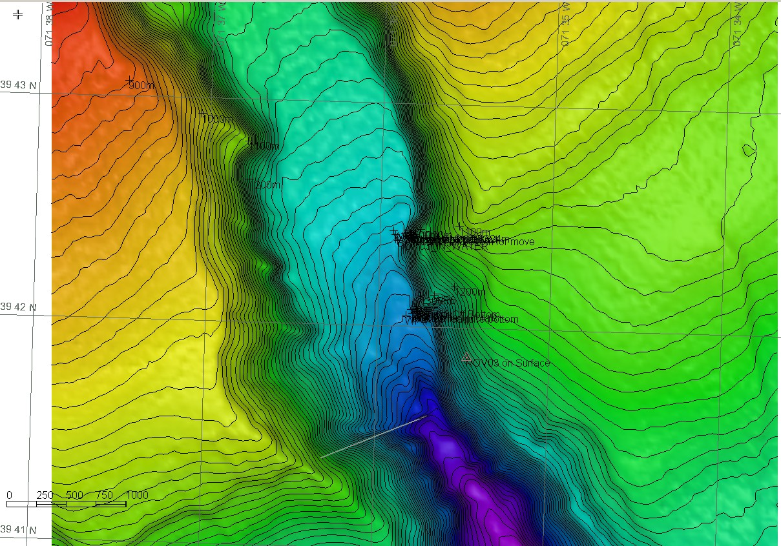 |  |  |  | 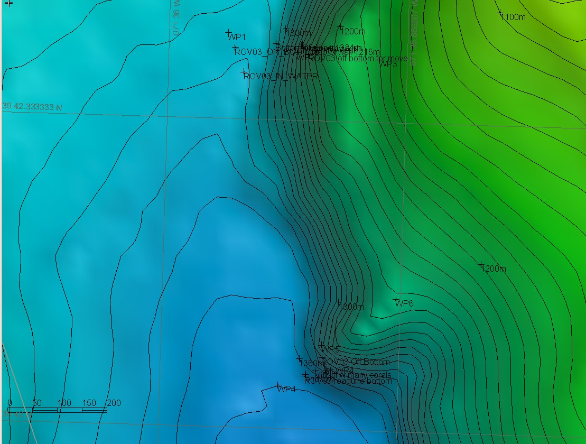
Representative Photos of the Dive
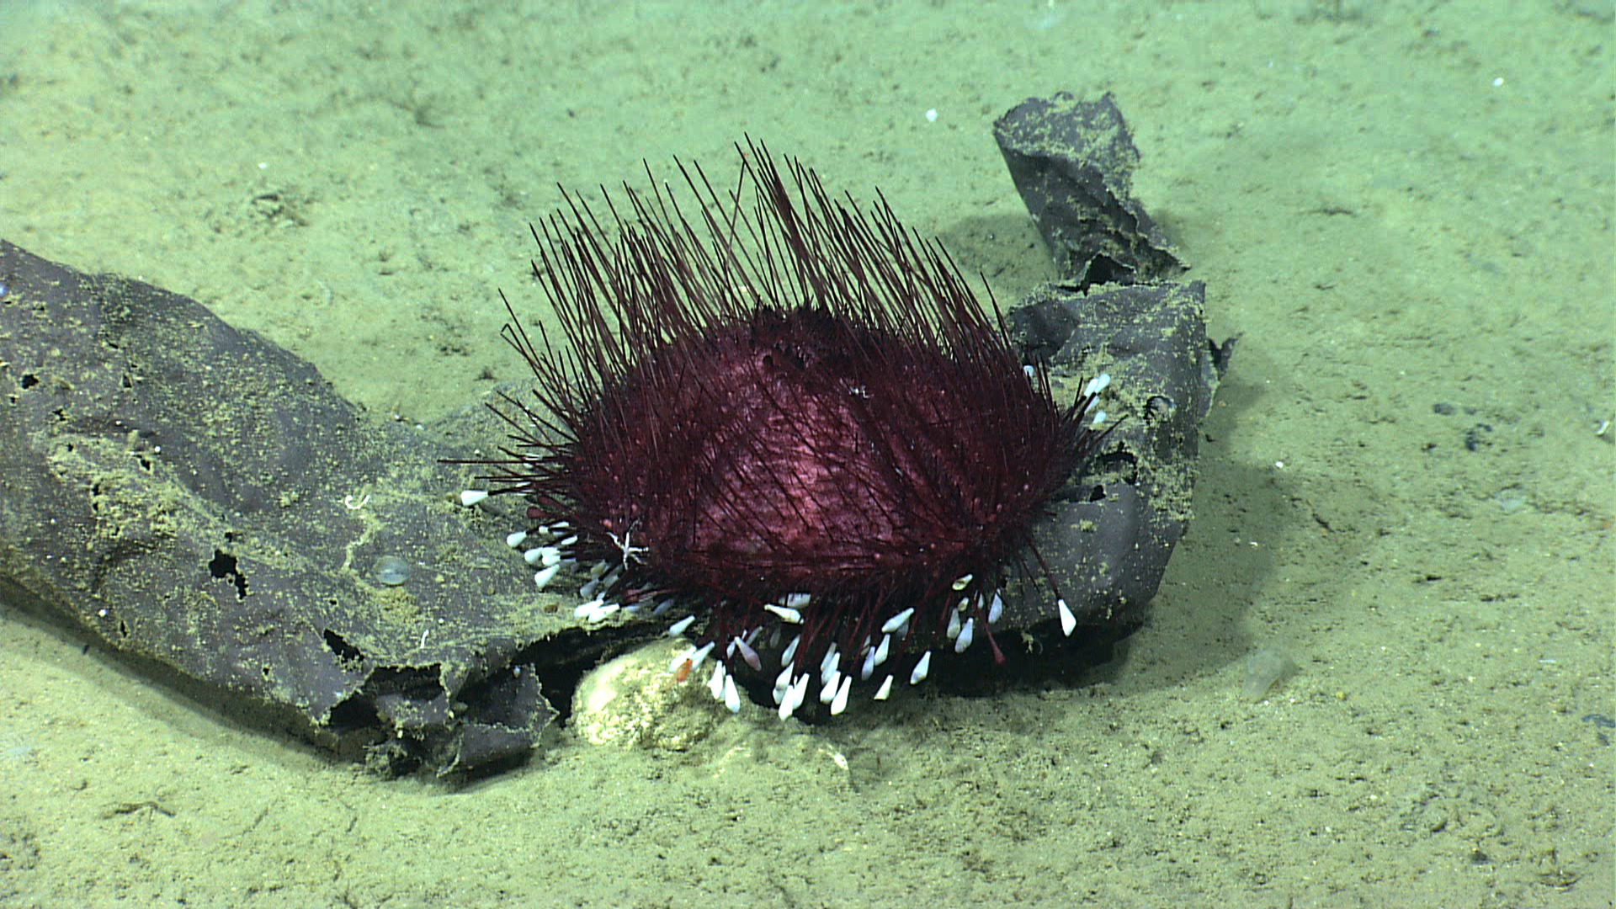 |  |  |  | 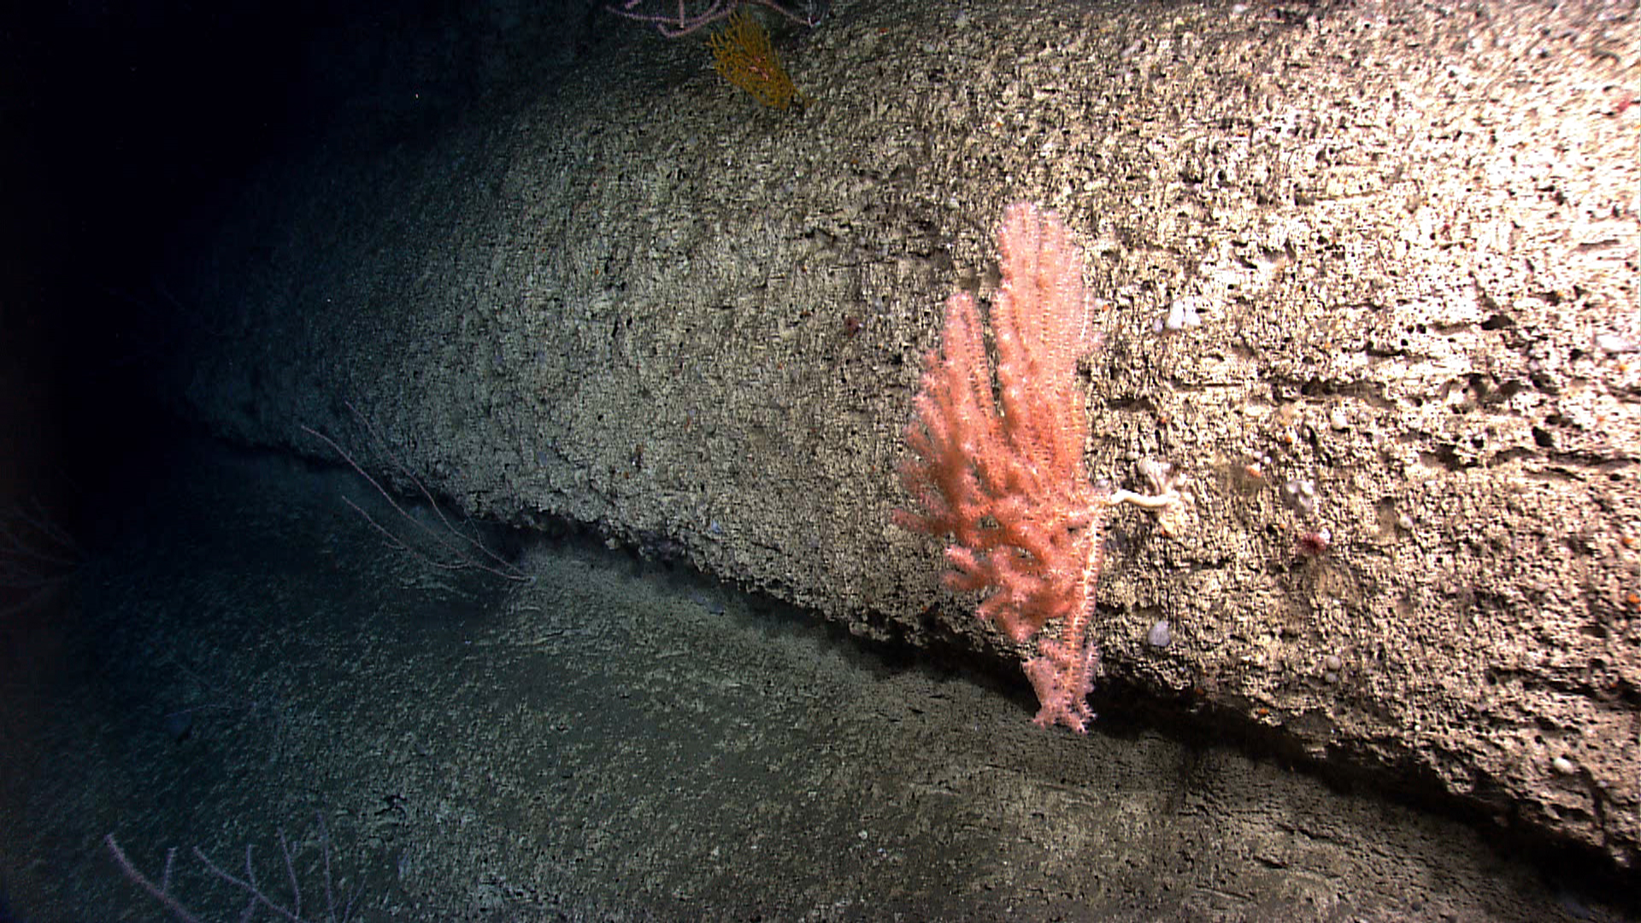
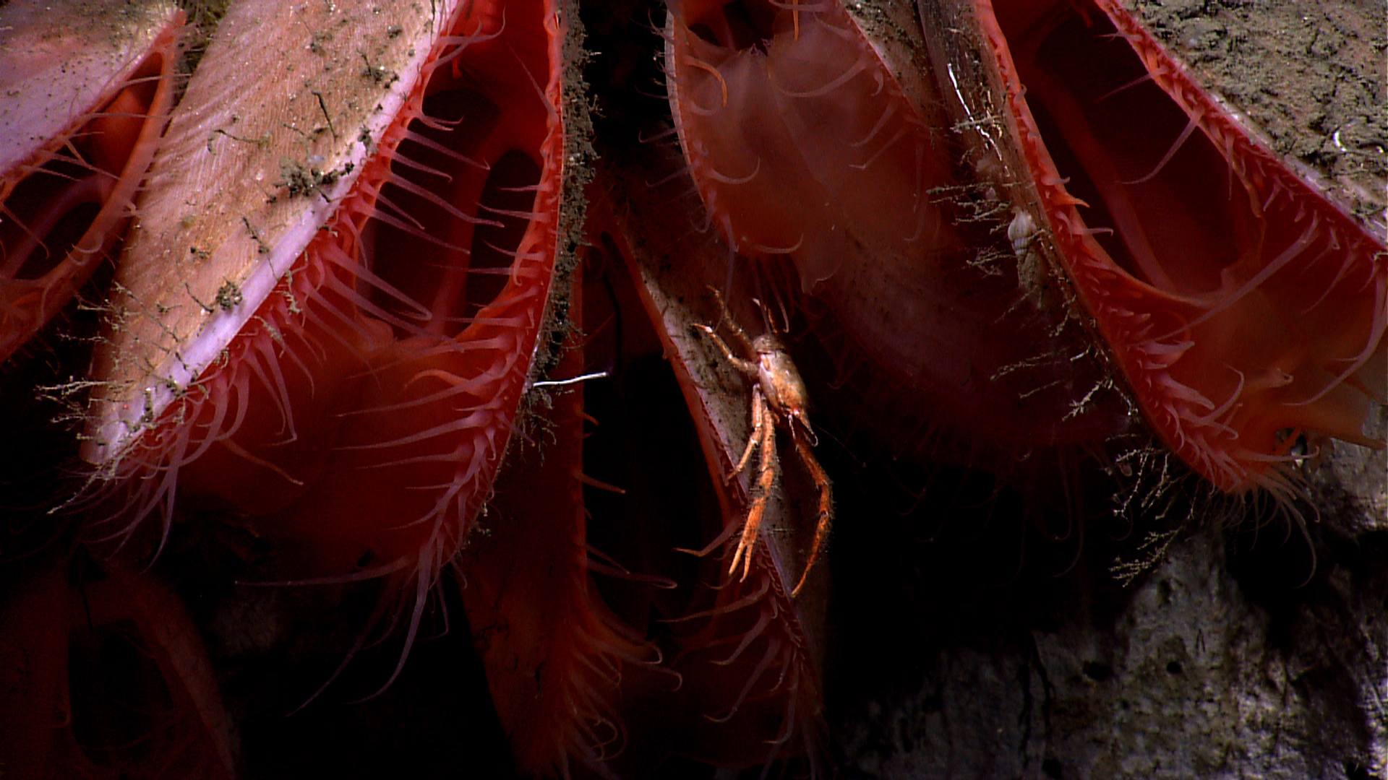 |  |  |  | 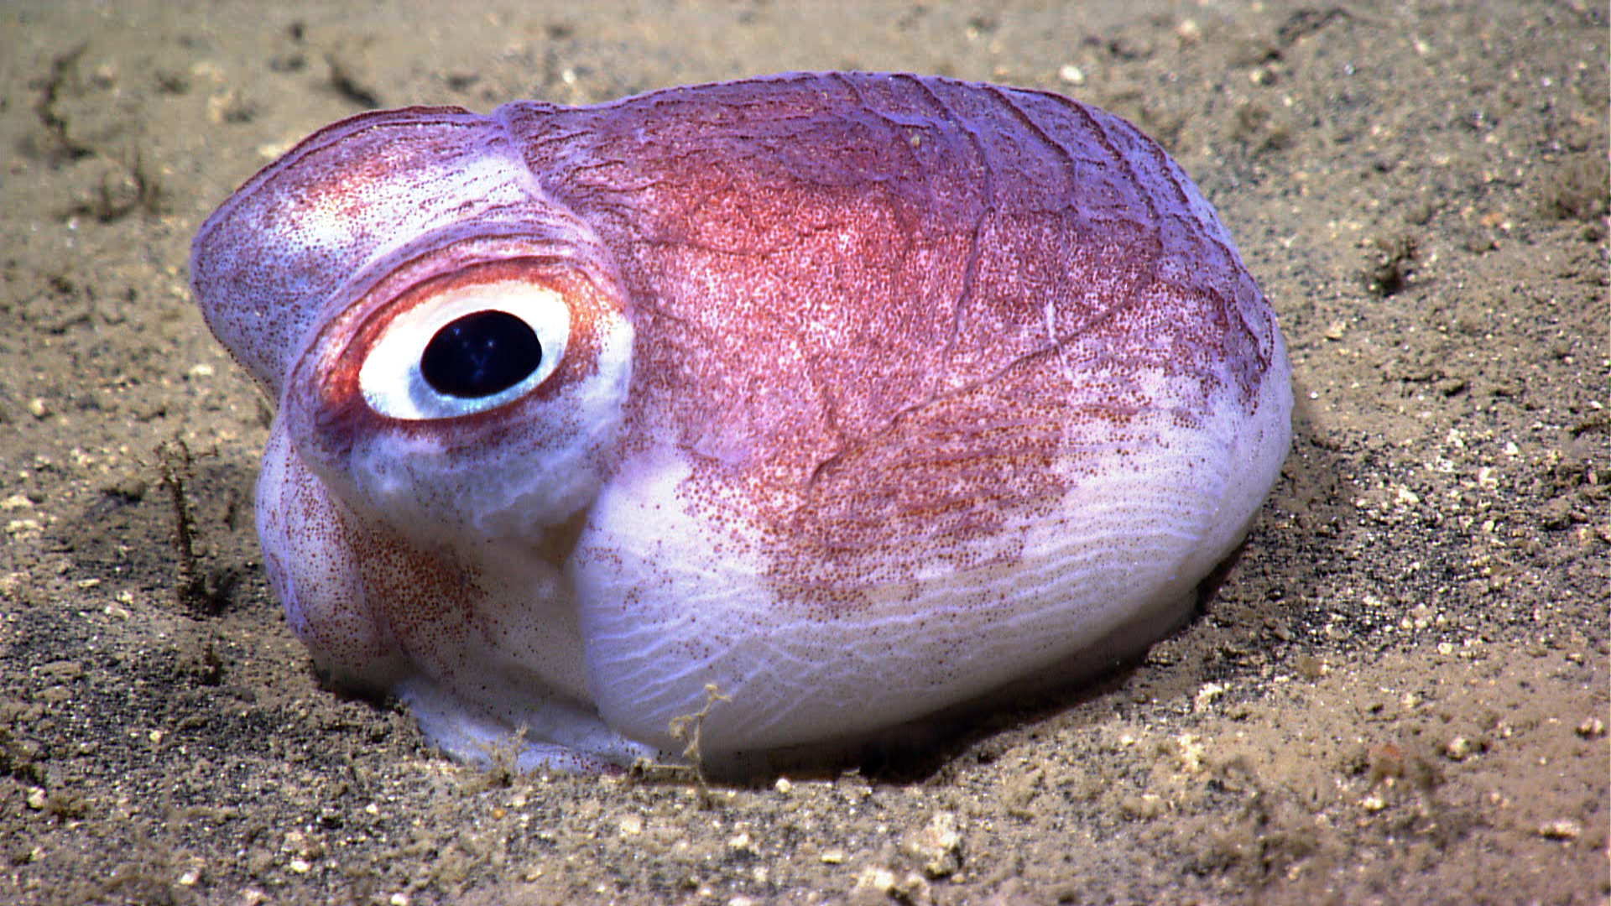
Please direct inquiries to: |  | NOAA Office of Ocean Exploration & Research  1315 East-West Highway (SSMC3 10th Floor)  Silver Spring, MD 20910  (301) 734-1014

