Okeanos Explorer ROV Dive Summary
Site Name | Hendrickson Canyon |  |  |  | 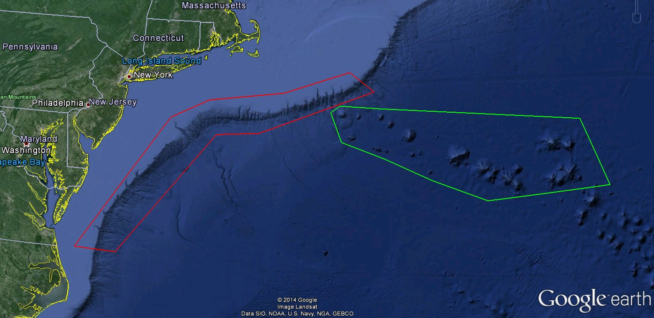
ROV Lead/Expedition Coordinator | Todd Gregory/  Brian Kennedy
Science Team Leads | Scott France and Susan Schnur
General Area Descriptor | Northwest Atlantic Ocean;  Mid Atlantic U.S. Canyons
ROV Dive Name | Cruise Season |  | Leg |  |  | Dive Number
 | EX1404 |  | 3 |  |  | DIVE02
Equipment Deployed | ROV: |  | Deep Discoverer
 | Camera Platform: |  | Seirios
ROV Measurements | CTD |  | Depth |  |  | Altitude
 | Scanning Sonar |  | USBL Position |  |  | Heading
 | Pitch |  | Roll |  |  | HD Camera 1
 | HD Camera 2 |  | Low Res Cam 1 |  |  | Low Res Cam 2
 | Low Res Cam 3 |  | Low Res Cam 4 |  |  | Low Res Cam 2
Equipment Malfunctions | During the dive the ship’s rudder stopped responding to commands from the ship’s DP system. This problem did not seriously affect the ship’s ability to maneuver.
ROV Dive Summary  (From processed ROV data) | Dive Summary: EX1404L3_DIVE02  ^^^^^^^^^^^^^^^^^^^^^^^^^^^^^^^^^^^^^^^^^^^^^^^^^^^  In Water at: 2014-09-20T12:22:21.386000  39°, 01.428' N ; 072°, 27.122' W  Out Water at: 2014-09-20T20:30:48.959000  39°, 01.201' N ; 072°, 26.837' W  Off Bottom at: 2014-09-20T19:44:40.068000  39°, 01.398' N ; 072°, 27.027' W  On Bottom at: 2014-09-20T13:36:18.460000  39°, 01.409' N ; 072°, 26.906' W  Dive duration: 8:8:27  Bottom Time: 6:8:21  Max. depth: 1669.0 m
Special Notes
Scientists Involved  (please provide name / location / affiliation / email) | Peter Auster UConn and SRF peter.auster@uconn.edu  Jason Chaytor USGS jchaytor@usgs.gov  Rachel Clostio University of Louisiana at Lafayette rclostio@louisiana.edu  Mike Ford NOAA Fisheries michael.ford@noaa.gov  Tara Harmer Luke The RIchard Stockton College of New Jersey luket@stockton.edu  Santiago Herrera WHOI tiagohe@gmail.com  Taylor Heyl WHOI theyl@whoi.edu  Brian Kinlan NOAA/NOS/NCCOS Biogeography Branch brian.kinlan@NOAA.gov  Christopher (Chris) Mah Invertebrate Zoology, NMNH, Smithsonian brisinga@gmail.com  Nicole Morgan Florida State university nbmorgan11@gmail.com  Tim Shank WHOI tshank@whoi.edu  Michael Vecchione NMFS Syatematics Lab vecchiom@si.edu  Scott France University of Louisiana at Lafayette france@louisiana.edu  Susan Schnur Oregan State University sschnur@coas.oregonstate.edu  Ellie Bors WHOI ekbors@gmail.com  Emily Duwan University of Connecticut emilyduwan@gmail.com
Purpose of the Dive
To explore the geomorphology and biology of the previously unexplored Hendrickson Canyon
Description of the Dive:
Setting: Dive 2 took place in Hendrickson Canyon, about half way (13 miles) down the canyon from the shelf break. Hendrickson is a smaller canyon that does not extend shoreward of the shelf break. The dive site was located at the edge of an approximately 1.6 mile-wide landslide scar and consisted of a 220 m transect up the near vertical walls of the headwall scarp.

Exploration: The ROV D2 was deployed at 1216 UTC to a depth of 1669 meters in Hendrickson Canyon; D2 reached the bottom at 1333 UTC. The canyon floor was dominated by thick sediment, darker than that seen at Phoenix Canyon. This difference can be attributed to finer grain size or higher organic content, likely related to the sediment source region for the canyon. Many ophiuroids (?Ophiomusium) were observed on the sediments at the landing site. The ROV followed a series of debris boulders to a massive chalk wall and began ascending the cliff from a depth of about 1656 m. Previous work suggests this may be an Eocene (34 - 56 Ma) chalk layer found deep in the stratigraphy of nearby canyons. A sediment coating on the base of the wall indicated that about one meter of sediment had been removed from the adjacent pile and carried down slope. The wall was characterized by abundant burrow holes and scratch marks, and deep horizontal streaks that may represent bedding planes. A scrape test of the wall, exerting what the ROV team estimated to be 5 lbs of pressure, easily removed the Mn-stained surface, revealing much whiter rock behind. The degree of Mn staining varied across the wall, with some faces appearing whiter and others having a deep purple or orange stain. In many places fresher surfaces indicated relatively recent collapse of both small blocks and larger pinnacles. Dark sediment and dead cup corals had accumulated on all horizontal surfaces. Half way up the wall the ROV reached a deep cleft with flat planar sides, cutting vertically through the wall. Following this cleft upwards, the ROV reached what appeared to be a major failure scarp at 1540 m, stretching across the entire field of view. This area was characterized by a fresh white, uncolonized surface in the failure zone, and a darker unmodified face above that was covered in cup corals. At 1465 m the ROV encountered a very distinct contact between the underlying chalk layer and a darker red-brown siltstone layer. Soft sediment deformation structures such as undulating and folded horizons were evident in this layer. At 1455 m the ROV reached the top of the cliff and emerged onto a heavily-sedimented plateau. A rod inserted into the sediment recorded a thickness of about 35-43 cm at a distance of several meters from the edge of the cliff. Traces of mud recovered from the ROV on deck suggest the dark sediment consists of about 10% sand, 10% clay and 80% silt.

In terms of the biology, we observed many clumps of cup corals (Desmophyllum), often hanging down from the underside of overhanging ledges. Various invertebrates were seen among these clumps, including edwardsiid anemones, brisingid asteroids, crinoids, and hydroids; however, no limid bivalves were observed today, despite previously been seen in these Desmophyllum biotopes and under ledges (CanEx 2013), perhaps a function of the depth. Many of the burrows and pits on the wall as well as the Desmophyllum corals were strewn with a brown-green floc caught in a matrix of mucus strings; it is unclear if the mucus is derived from the corals or another source. Many pink sea urchins (cf Echinus), several Graneledone verrucosa octopi (including brooding females), black corals (Bathypathes, Parantipathes, Telopathes)and glass sponges (Hexactinellida) were observed in various places on the vertical wall.

Across the upper third of the vertical wall octocoral colonies became more abundant and diverse. We saw multiple colonies of bamboo corals (Lepidisis sp., Keratoisis spp.), Swiftia, Paragorgia ?johnsoni, Paramuricea, stoloniferan Clavularia, and Anthomastus. Many of the colonies had ophiuroid or anemone associates, but very few galatheid/chirostylid crabs were seen. At the top of the ridge, several colonies of chrysogorgiid whips (Radicipes gracilis), bamboo coral bushes (Acanella sp.) and sea pens (?Anthoptilum) were seen anchored in sediment.

Although the diversity of fish species observed (n=12) was about equal to that observed on the shallower Phoenix Canyon dive, the overall the abundance of fish observed today was far less, perhaps due to the steep topography traversed. A species list of fish observations was provided by shore-based scientist Peter Auster: Ophidiid cusk eel sp. 1, Ophidiid cusk eel sp 3 (Luciobrotula), Halosaur (Aldrovandia sp.), Black dogfish (Centroscyllium fabricii), Grenadier (Nezumia sp), False boarfish (Neocyttus helgae), Chimaera (Hydrolagus sp), Cutthroat eel (Synaphobranchus sp), Duck-billed Eel (Nettastoma sp.), Catshark (Apristurus sp), Skate (Rajidae), Blue hake (Antimora rostrata)

Other species observations:
Cnidaria: solitary hydroid (?Branchiocerianthus sp.); corallimorpharian; Edwardsiidae, Actinernus sp. and venus fly trap (Actinoscyphia) anemones; scleractinian coral Solenosmilla; octocorals Anthothela and Acanthogorgia.
Mollusca: octopus Muusoctous johnsonianus (including brooding female)
Echinodermata: asteroids (Neomorphaster, Evoplosoma [feeding on a bamboo coral], cf Henricia); ophiuroids (many different types, including associates on corals), and several holothurians (?Peniagone) that were observed “swimming” though none were seen during our brief time on sedimented bottom.

Interesting highlights: Distinct contact between two sedimentary units (chalk and siltstone) at about 1465 m depth; close-up observation of a benthic “dandelion” siphonophore (?Thermopalia), which released a polyp bearing one of the anchoring tendrils, causing the colony to float upwards until snagged by the remaining anchored tendrils.

The ROV left the bottom at 1943 UTC

Overall Map of ROV Dive Area |  |  |  | Close-up Map of Main Dive Site
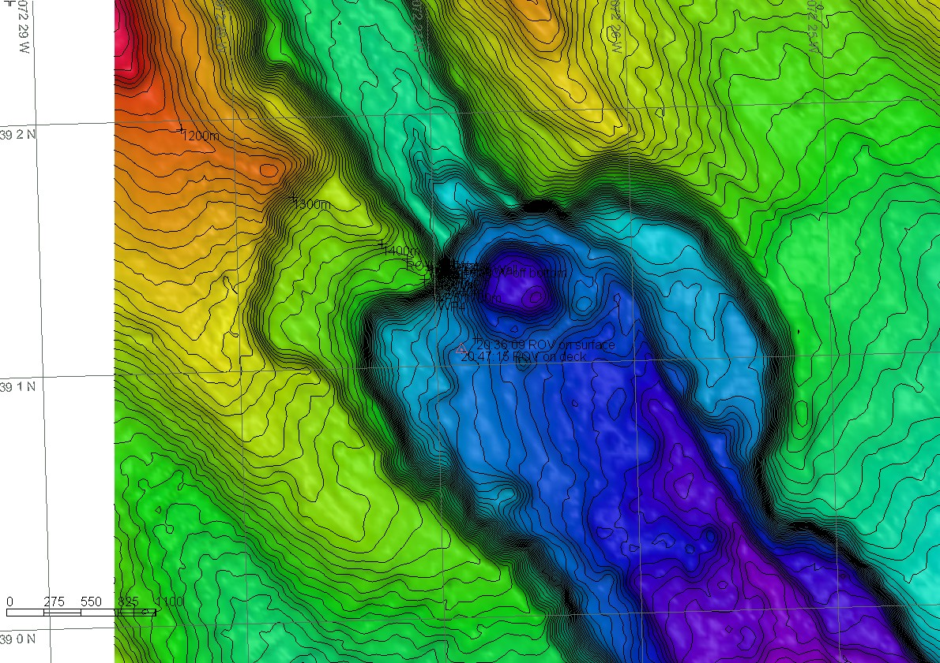 |  |  |  | 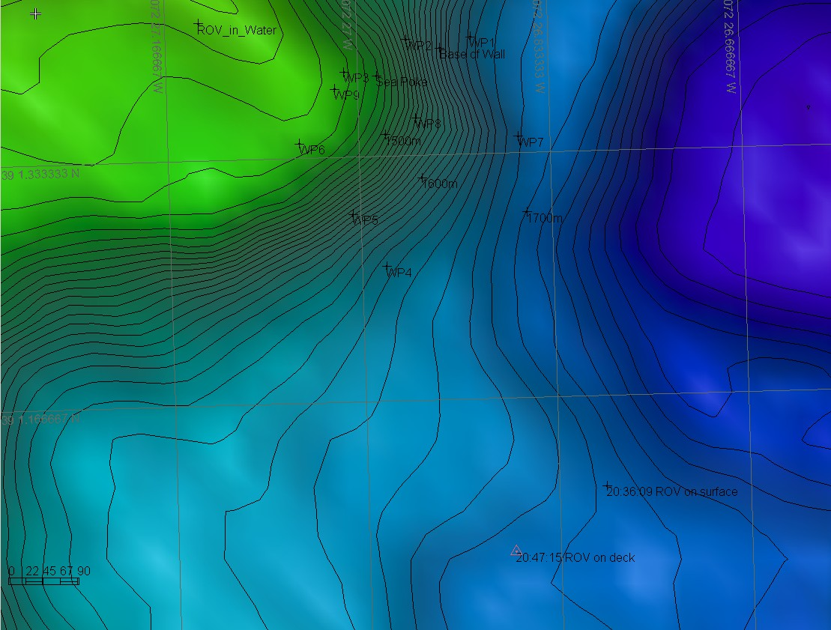
Representative Photos of the Dive
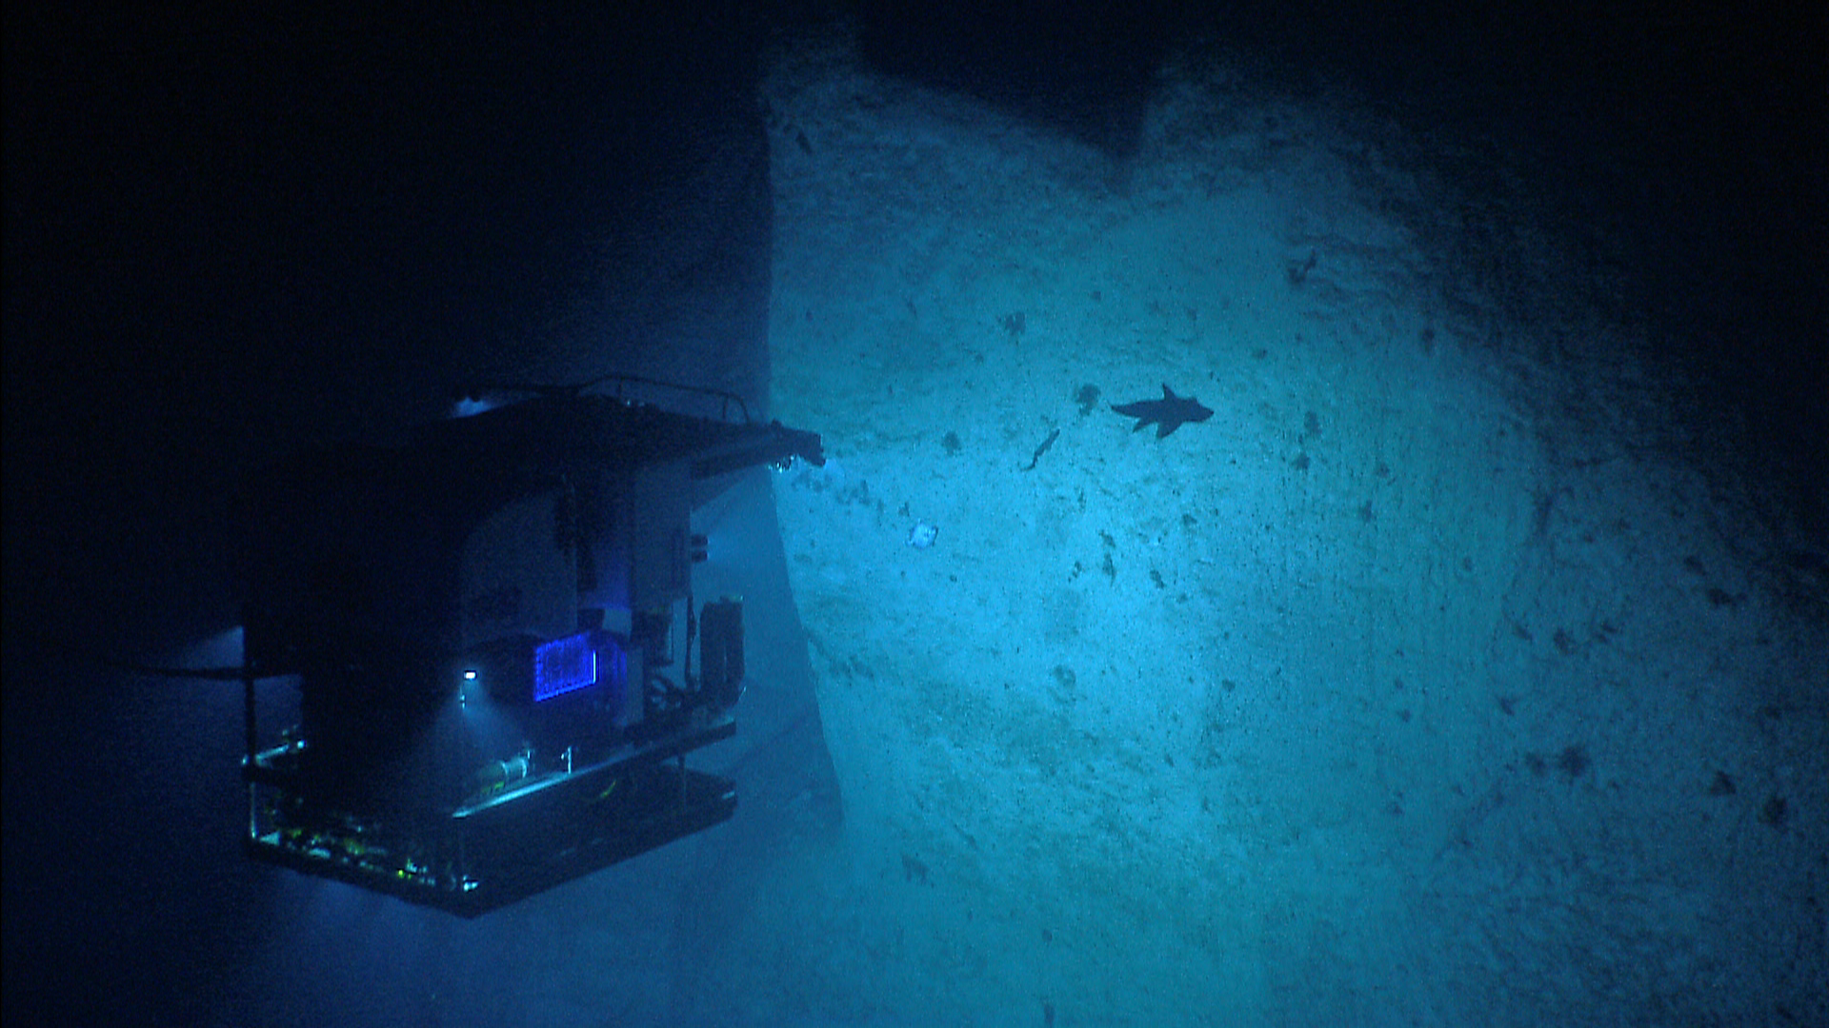 |  |  |  | 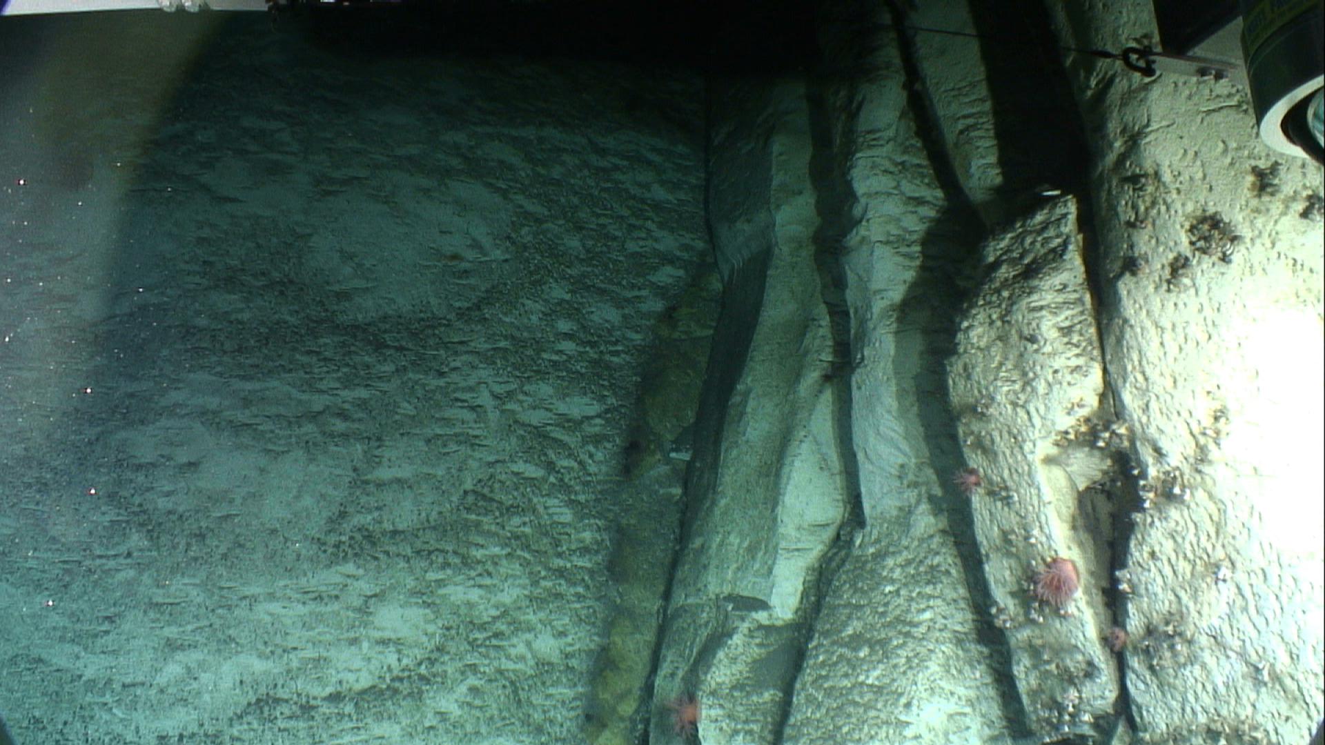
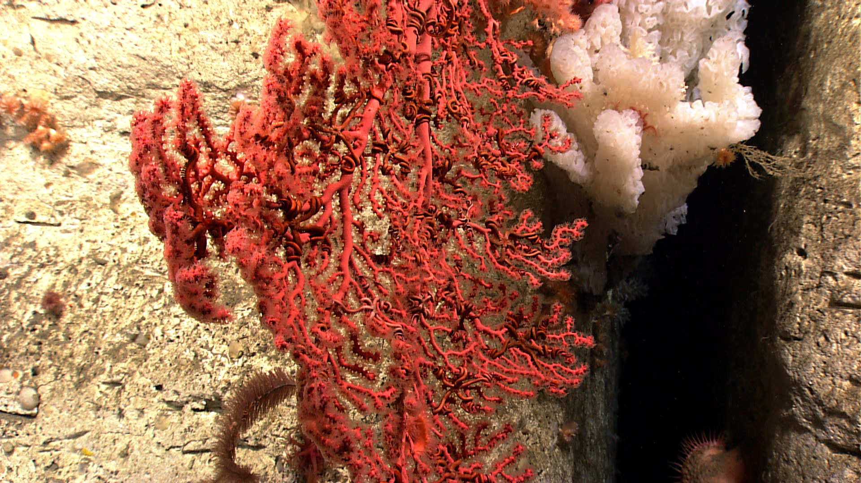 |  |  |  | 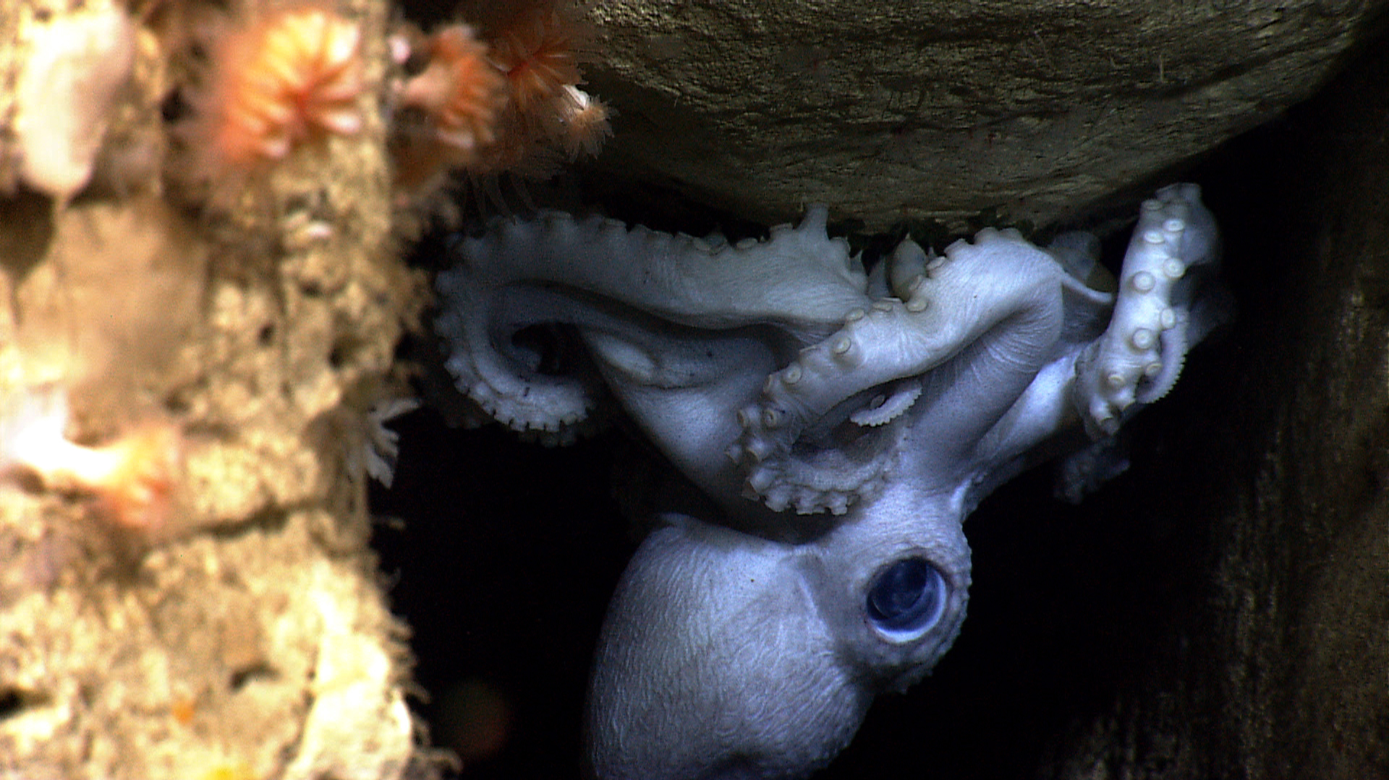
Please direct inquiries to: |  | NOAA Office of Ocean Exploration & Research  1315 East-West Highway (SSMC3 10th Floor)  Silver Spring, MD 20910  (301) 734-1014

