Okeanos Explorer ROV Dive Summary
Site Name | Phoenix Canyon |  |  |  | 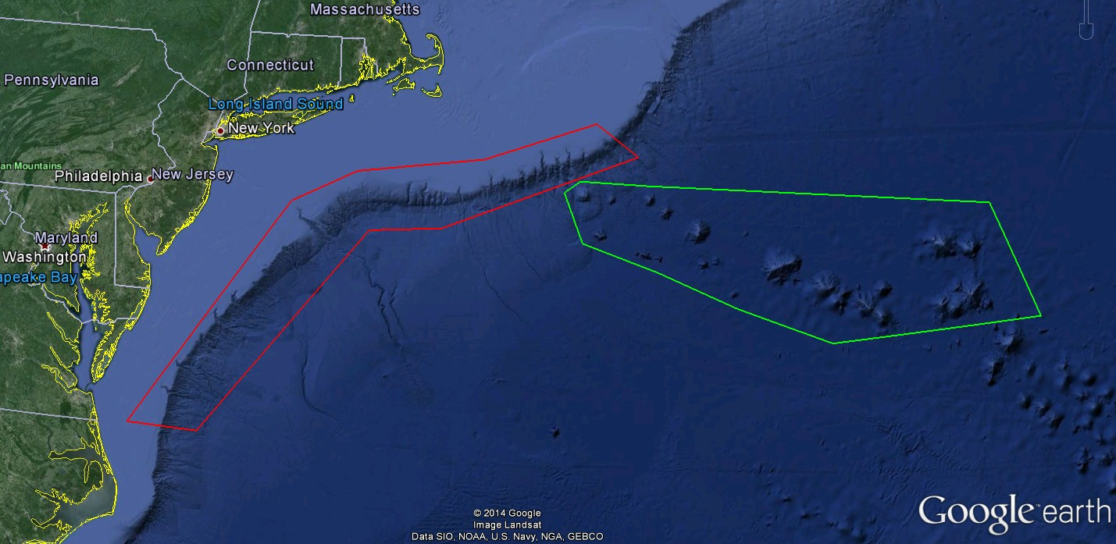
ROV Lead/Expedition Coordinator | Todd Gregory/  Brian Kennedy
Science Team Leads | Scott France and Susan Schnur
General Area Descriptor | Northwest Atlantic Ocean;  Mid Atlantic U.S. Canyons
ROV Dive Name | Cruise Season |  | Leg |  |  | Dive Number
 | EX1404 |  | 3 |  |  | DIVE01
Equipment Deployed | ROV: |  | Deep Discoverer
 | Camera Platform: |  | Seirios
ROV Measurements | CTD |  | Depth |  |  | Altitude
 | Scanning Sonar |  | USBL Position |  |  | Heading
 | Pitch |  | Roll |  |  | HD Camera 1
 | HD Camera 2 |  | Low Res Cam 1 |  |  | Low Res Cam 2
 | Low Res Cam 3 |  | Low Res Cam 4 |  |  | Low Res Cam 2
Equipment Malfunctions | None
ROV Dive Summary  (From processed ROV data) | Dive Summary: EX1404L3_DIVE01  ^^^^^^^^^^^^^^^^^^^^^^^^^^^^^^^^^^^^^^^^^^^^^^^^^^^  In Water at: 2014-09-19T12:29:39.755000  N/A ; N/A  Out Water at: 2014-09-19T20:31:22.141000  37°, 53.433' N ; 073°, 54.804' W  Off Bottom at: 2014-09-19T19:34:13.316000  37°, 53.359' N ; 073°, 54.877' W  On Bottom at: 2014-09-19T13:21:06.373000  37°, 53.468' N ; 073°, 54.740' W  Dive duration: 8:1:42  Bottom Time: 6:13:6  Max. depth: 1172.3 m
Special Notes | None
Scientists Involved  (please provide name / affiliation / email) | Peter Auster UConn and SRF peter.auster@uconn.edu  Robert Carney LSU rcarne1@lsu.edu  Jason Chaytor USGS jchaytor@usgs.gov  Rachel Clostio University of Louisiana at Lafayette rclostio@louisiana.edu  Erik Cordes Temple University ecordes@temple.edu  Amanda Demopoulos USGS ademopoulos@usgs.gov  Mike Ford NOAA Fisheries michael.ford@noaa.gov  Tara Harmer Luke The RIchard Stockton College of New Jersey luket@stockton.edu  Santiago Herrera WHOI tiagohe@gmail.com  Brian Kinlan NOAA/NOS/NCCOS Biogeography Branch brian.kinlan@NOAA.gov  Christopher (Chris) Mah Invertebrate Zoology, NMNH, Smithsonian brisinga@gmail.com  Nicole Morgan Florida State university nbmorgan11@gmail.com  Martha Nizinski NOAA/NMFS nizinski@si.edu  Esprit Saucier University of Louisiana at Lafayette heestand.saucier@louisiana.edu  Tim Shank WHOI tshank@whoi.edu  Liz Shea Delaware Museum of Natural History eshea@delmnh.org  Randy Singer University of Alabama Ichthyology Collection randal.a.singer@as.ua.edu  Brad Stevens Univ of MD Eastern Shore bgstevens@umes.edu  Michael Vecchione NMFS Syatematics Lab vecchiom@si.edu  Scott France University of Louisiana at Lafayette france@louisiana.edu  Wilmelie Cruz University of Maryland Eastern Shore wilmelie@hotmail.com  Susan Schnur Oregan State University sschnur@coas.oregonstate.edu  Ellie Bors WHOI ekbors@gmail.com  Emily Duwan University of Connecticut emilyduwan@gmail.com  Kiley Dancy Mid-Atlantic Fishery Management Council kdancy@mafmc.org
Purpose of the Dive
To explore the geomorphology and biology of the previously unexplored Phoenix Canyon
Description of the Dive:
The ROV D2 was deployed at 1225 UTC to a depth of 1172 meters in Phoenix Canyon; D2 reached the bottom at 1322 UTC. The dive began on a flat, sandy-silty, heavily-bioturbated bottom just south of the main canyon thalweg. One or two debris boulders embedded in the thick sand preserved the layering of strata that was later observed higher up on the cliff walls. Several cutthroat eels (Synaphobranchus sp.) and northern shortfin squid (Illex illecebrosus) were observed at the start site. We made our way toward the south wall of the canyon, continuing to cross soft sediment bottom. We observed several fish, including witch flounder (Glyptocephalus), blue hake (Antimora rostrata) and black dogfish (Centroscyllium fabricii), two species of squid (Mastigoteuthis magna and Brachioteuthis beanii) and one individual of the solitary scleractinian cup coral Flabellum. We encountered a rock on which a hydroid colony was been preyed upon by 5 or more aeolid nudibranchs. The slope transitioned to steeper terrain with tall, laterally-continuous outcrops of siltstone/mudstone hosting abundant biology. Outcrops showed distinct seaward-dipping bedding planes, differential erosion of less resistant layers and iron-staining. Abundant small caves and slide chutes were likely initiated by burrowing, but micro-scale fractures were frequently observed as well. Some overhangs on these walls were densely populated by Desmophyllum cup corals, along with occasional colonies of the scleractinian coral Solenosmilla, the octocoral Acanthogorgia, and scattered individuals of the limid bivalve Acesta (or relative).

Above the outcrops the ROV moved into a sandier, flatter area, also highly bioturbated but with isolated larger burrow holes and in places a white veneer thought to be fresher sand ejected from within the cliff by burrowing. In places we observed sharp headwall scarps where thin (~10 cm) slabs of siltstone had detached and slid downslope, leaving behind a fresh surface with exposed burrow casts. After reaching the top of the section the decision was made to move northwestward into a side-canyon, most likely a landslide valley. This area was dominated by a sloped, sandy-silty bottom and minimal in-situ outcrop, especially higher in the section. Overall, there was little evidence of recent major mass movement events on the southern walls and floor of Phoenix canyon, at least away from the thalweg; small-scale progressive erosion seemed the dominant physical process modifying the canyon. Throughout the dive we observed many pink sea urchins (cf Echinus), several Graneledone verrucosa octopi, many xenophyophores, and many skates (Bathyraja sp.).

Other species observations: Neolithodes sp. king crabs and Chaceon red crabs; fish: long-finned hake (Urophycis chesteri), roundnose grenadier (Coryphaenoides) and marlinspike grenadiers (Nezumia), long-finned hake (Urophycis chesteri), ghost cat shark (Apristurus?) and a cat shark egg case on an Acanthogorgia coral, cusk eels (Ophidiidae), fathead (Cottunculus) and dragonfish (Stomiidae);

Interesting highlights: an attack by a cutthroat eel (Synaphobranchus sp.) on a cranchiid squid, Teuthowenia megalops; a marlinspike grenadier (Nezumia sp.) infested with parasitic copepods; and an aeolid nudibranch crawling across the muddy seafloor in front of a resting bobtail squid (Rossia sp.).

The ROV left the bottom at 1956 UTC from 1035 m.
Overall Map of ROV Dive Area |  |  |  | Close-up Map of Main Dive Site
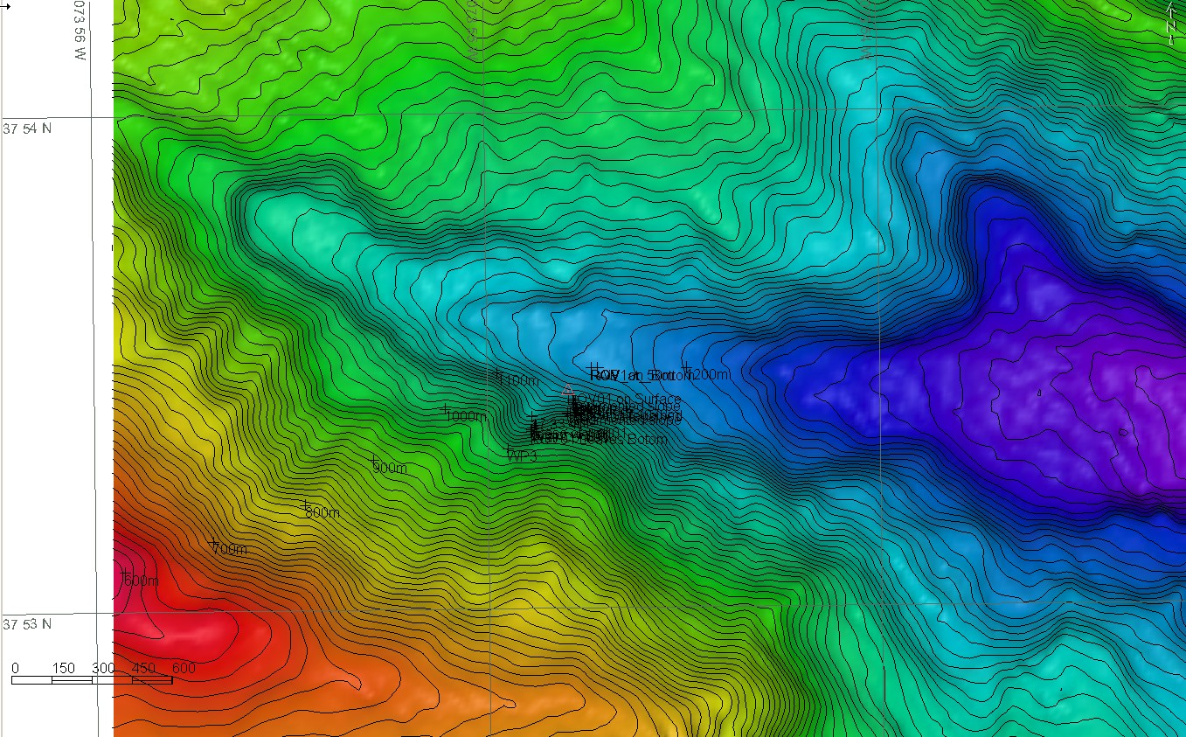 |  |  |  | 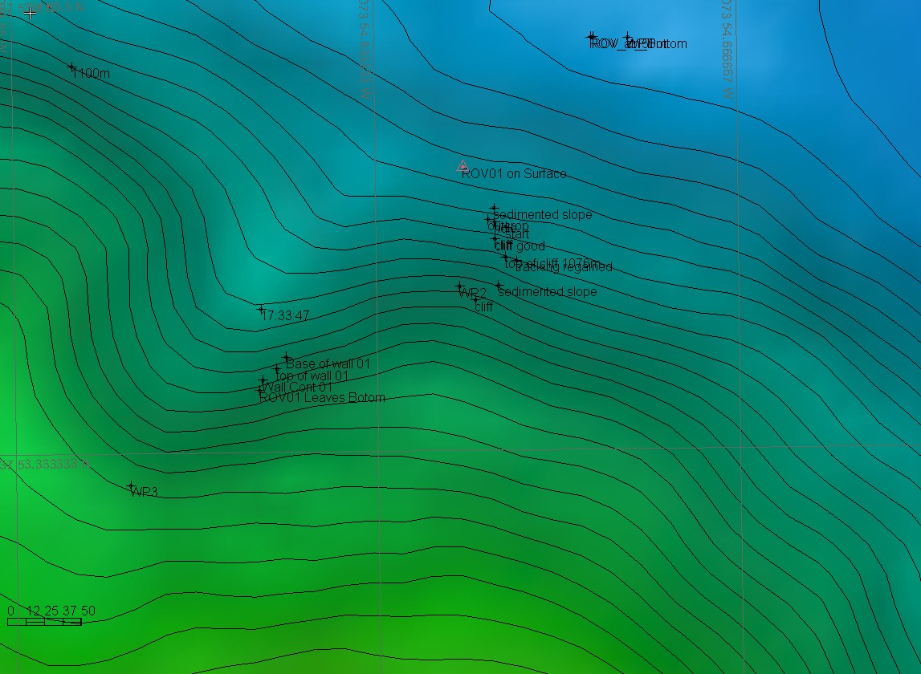
Representative Photos of the Dive
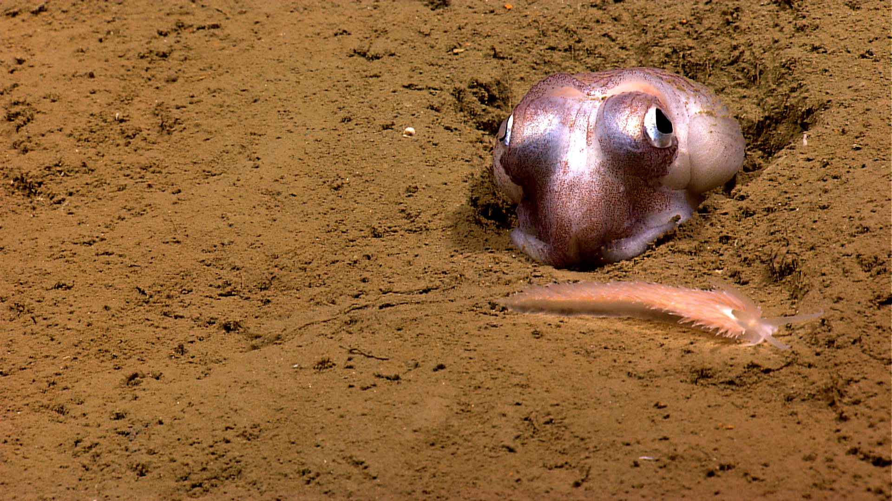 |  |  |  | 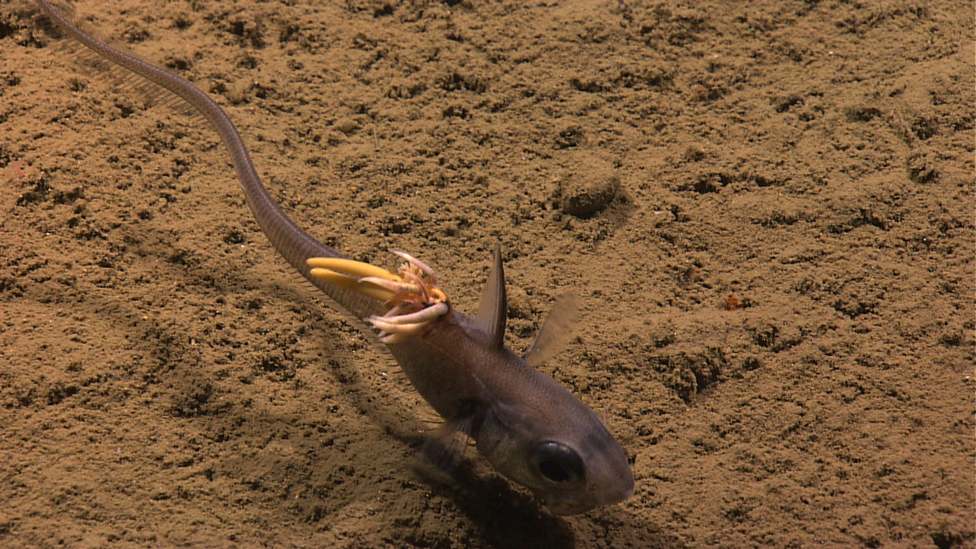
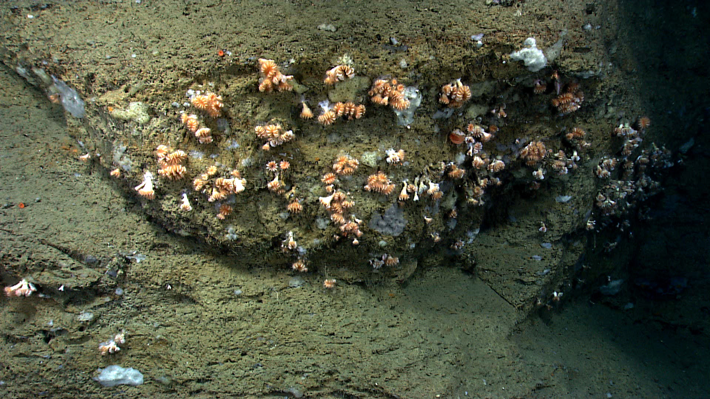 |  |  |  | 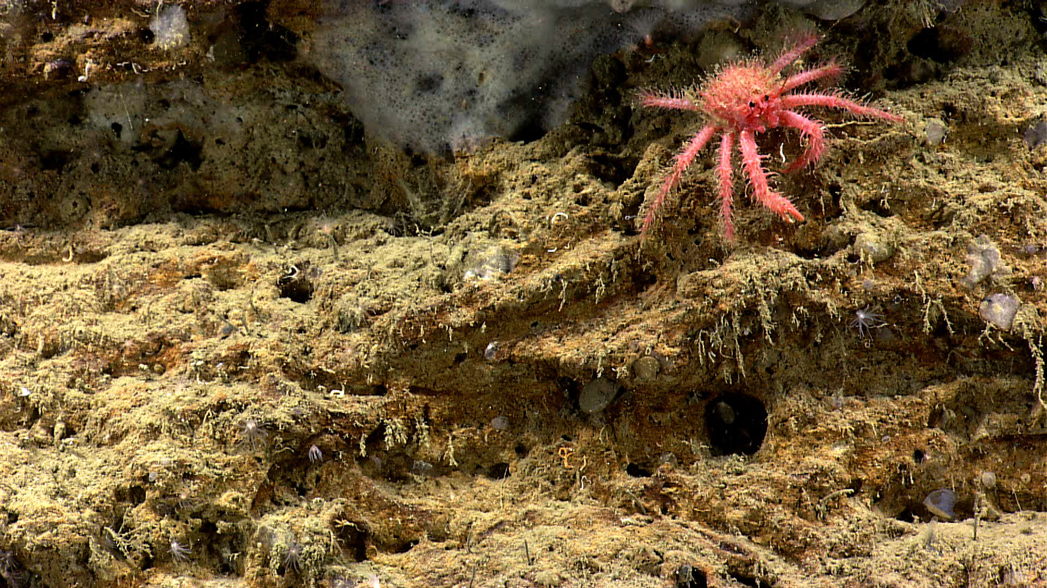
Please direct inquiries to: |  | NOAA Office of Ocean Exploration & Research  1315 East-West Highway (SSMC3 10th Floor)  Silver Spring, MD 20910  (301) 734-1014

