Okeanos Explorer ROV Dive Summary
Site Name | Washington Canyon |  |  |  | 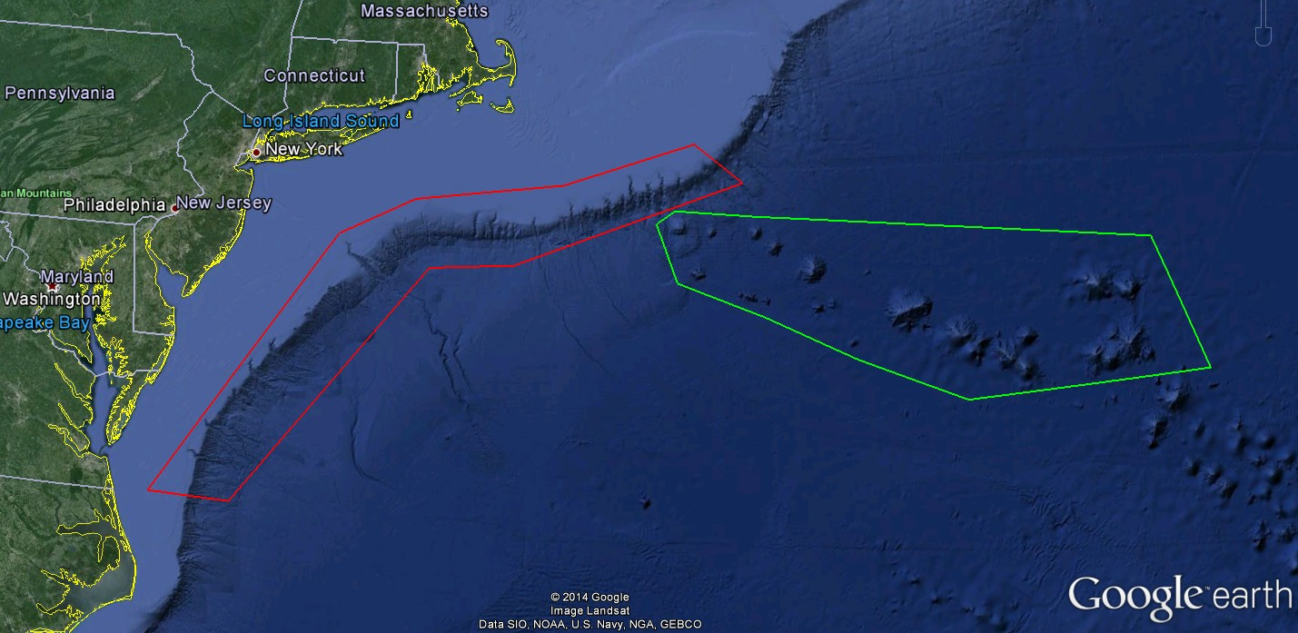
ROV Lead/Expedition Coordinator | David Lovalvo/  Brian Kennedy
Science Team Leads | Jamie Austin Jesse Ausubel
General Area Descriptor | Northwest Atlantic Ocean;  Mid Atlantic U.S. Canyons
ROV Dive Name | Cruise Season |  | Leg |  |  | Dive Number
 | EX1404 |  | 2 |  |  | DIVE02
Equipment Deployed | ROV: |  | Deep Discoverer
 | Camera Platform: |  | Seirios
ROV Measurements | CTD |  | Depth |  |  | Altitude
 | Scanning Sonar |  | USBL Position |  |  | Heading
 | Pitch |  | Roll |  |  | HD Camera 1
 | HD Camera 2 |  | Low Res Cam 1 |  |  | Low Res Cam 2
 | Low Res Cam 3 |  | Low Res Cam 4 |  |  | Low Res Cam 2
Equipment Malfunctions | none
ROV Dive Summary  (From processed ROV data) | Dive Summary: EX1404L2_DIVE02  ^^^^^^^^^^^^^^^^^^^^^^^^^^^^^^^^^^^^^^^^^^^^^^^^^^^  In Water at: 2014-09-06T12:27:53.214000  37°, 24.741' N ; 074°, 27.750' W  Out Water at: 2014-09-06T20:06:57.660000  37°, 24.494' N ; 074°, 28.536' W  Off Bottom at: 2014-09-06T18:57:44.224000  37°, 24.513' N ; 074°, 28.239' W  On Bottom at: 2014-09-06T13:00:50.318000  37°, 24.611' N ; 074°, 27.873' W  Dive duration: 7:39:4  Bottom Time: 5:56:53  Max. depth: 643.7 m
Special Notes | The ship experienced a steering causality that resulted in an electrical fire causing the dive to be ended early.
Scientists Involved  (please provide name / location / affiliation / email) | James Austin University of Texas/Austin, Jackson School of Geosciences jamie@utig.ig.utexas.edu  Robert Carney LSU rcarne1@lsu.edu  Jesse Ausubel Rockfeller university ausubel@mail.rockefeller.edu  Scott France University of Louisiana at Lafayette france@louisiana.edu
Purpose of the Dive
Explore the biology and geomorphology of Washington Canyon
Description of the Dive:
Dive 2 took place up the south flank of Washington Canyon. Seirios and D2 were both in the water by ~0820 hrs. The vehicles landed on a gentle, sedimented seafloor at 0900 hrs. Water depth at the landing site was 644 m.
The first part of the dive was spent angling up a slope to the SW. Step-like outcrops, some benches with near vertical walls facing the canyon axis, characterized this lower slope. Occasional fresh fractures with plumose textures were observed, but most of these outcrops were covered with soft sediment and heavily encrusted with sponges, antipatharians and anemones. Burrows in these steep exposures were common. In one cavern (created by spring sapping?) at 602 m, a small number of octocorals (“bubble gum” corals, both pink and white varieties) were observed; 6 colonies in total. Symbionts associated with these colonies were not apparent. A waypoint was dropped at this location. At 560 m, another amphitheater created by erosion was observed.
Life, both in the water column and on the sediment surface, was abundant from the start of the dive. At times, swarms of amphipods/euphausids (krill) and small fish were drawn to the D2 lights in sufficient quantities that illumination of the seafloor was significantly reduced. Siphonophores and a variety of other soft-bodied organisms including salps and medusas were abundant as well. Hake were often observed, as were long-nosed eels, eel pouts and halosaurs. A pair of large goose fish/monk fish were found well camouflaged in the mud, as well as some rays or skates and rosefish. Squid also occurred in large numbers, sometimes flying in schools, particularly higher on the slope. Quill worms littered in the surface in some areas. On the seafloor, red crabs were common; Jonah crabs were also observed as well as squat lobsters (galatheids, probably several species) and hermit crabs. Anemones, stalked and unstalked, were common. A number of small octopods were also observed. Behaviors included mating of crabs and predation (of a squid by a trio of red crabs).
The first transect, involving 5 waypoints, ended at 1400 hrs. at a water depth of ~440 m. Above the lower slope, no steep rock exposures were observed. Sedimented seafloor characterized the majority of this first transect. A mid-water transit brought the vehicles back down the slope ~700 m to a water depth of ~560 m, slightly up-canyon of the first transect. This second up-slope transect was terminated at 1450 hrs. a depth of ~520 m by a fire emergency on the vessel. Both vehicles were brought to a depth of 100 m until the emergency was contained, at 1535 hrs. Both vehicles were back on deck by 1620 hrs.

Overall Map of ROV Dive Area |  |  |  | Close-up Map of Main Dive Site
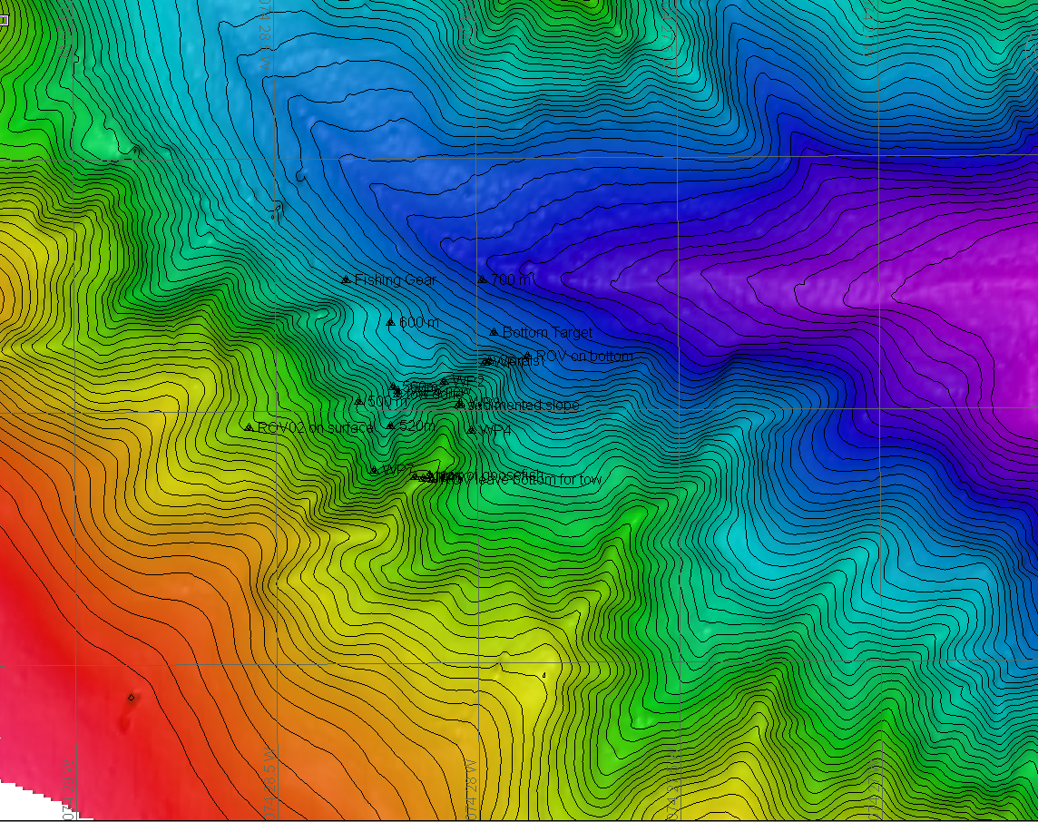 |  |  |  | 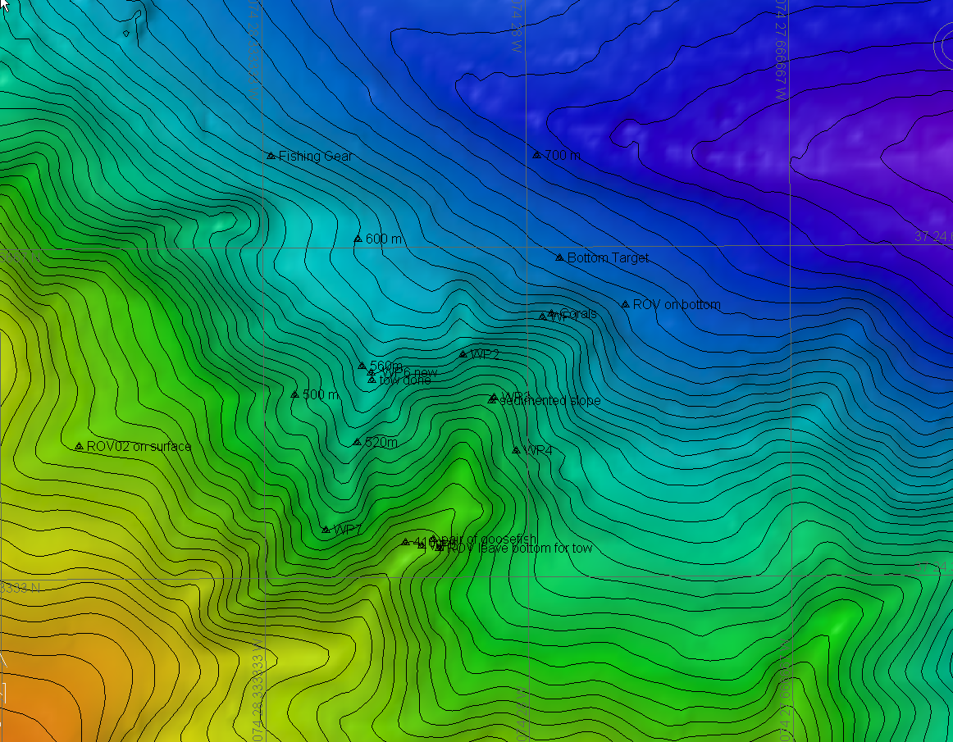
Representative Photos of the Dive
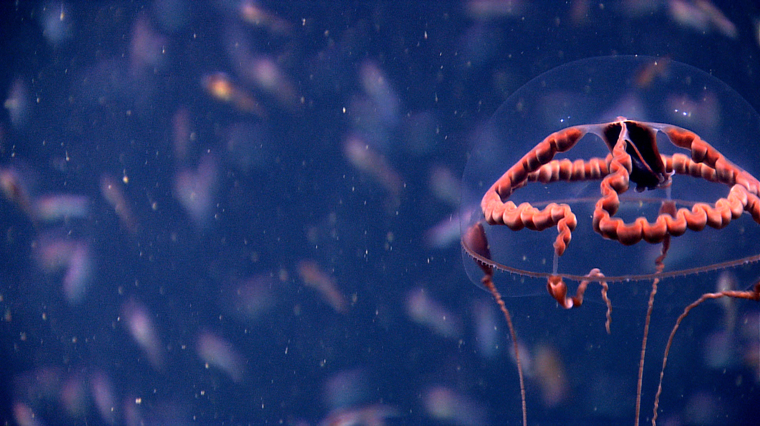 |  |  |  | 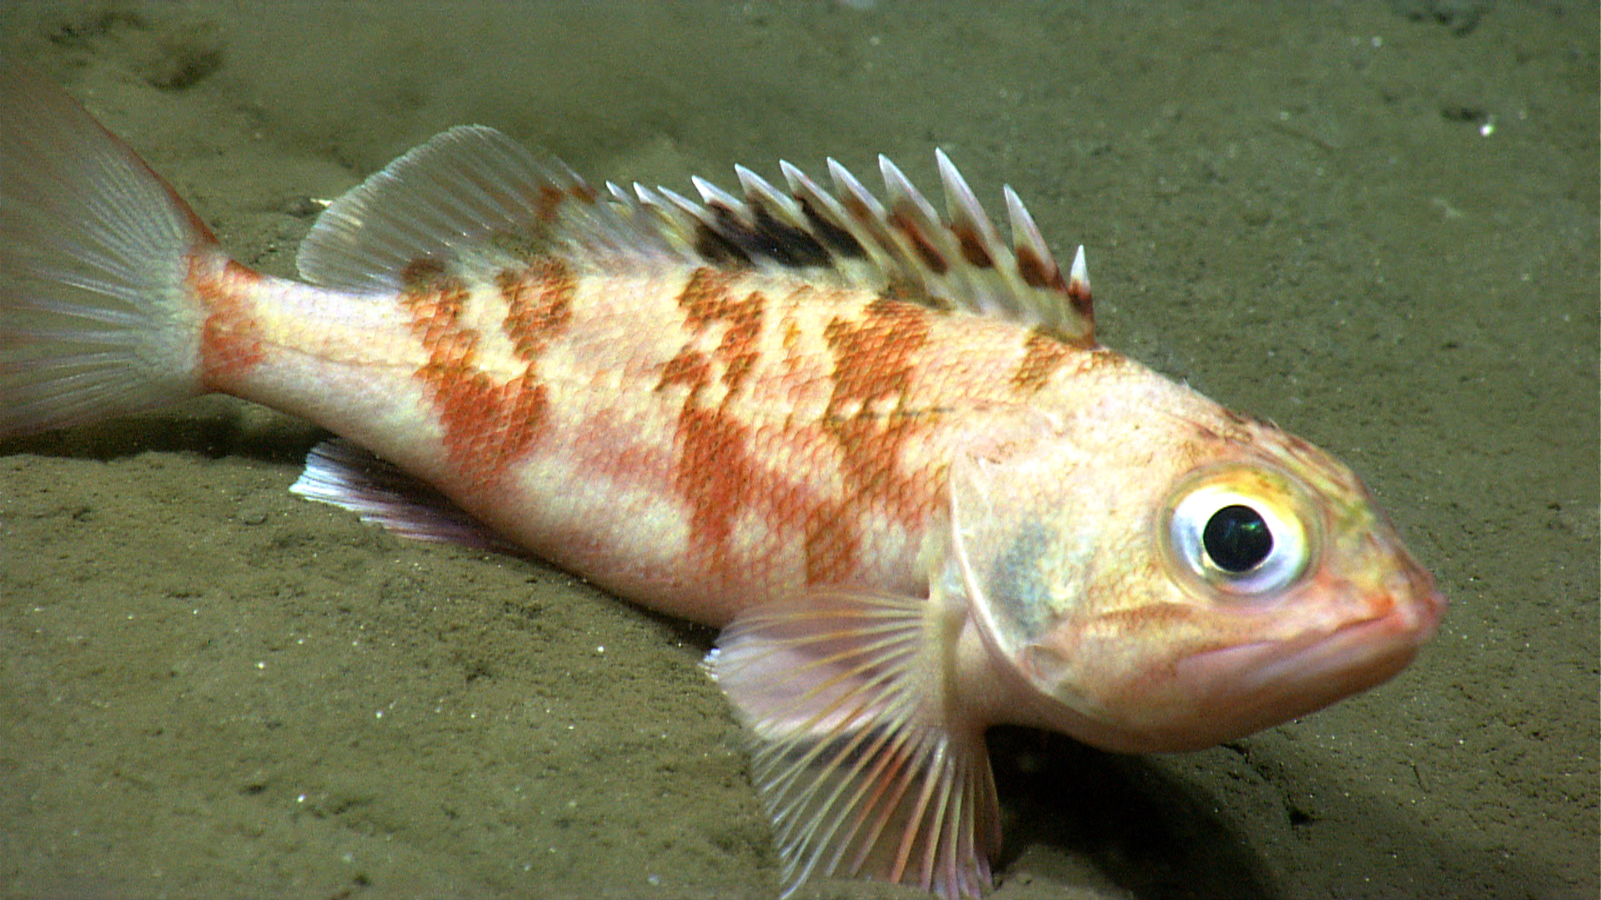
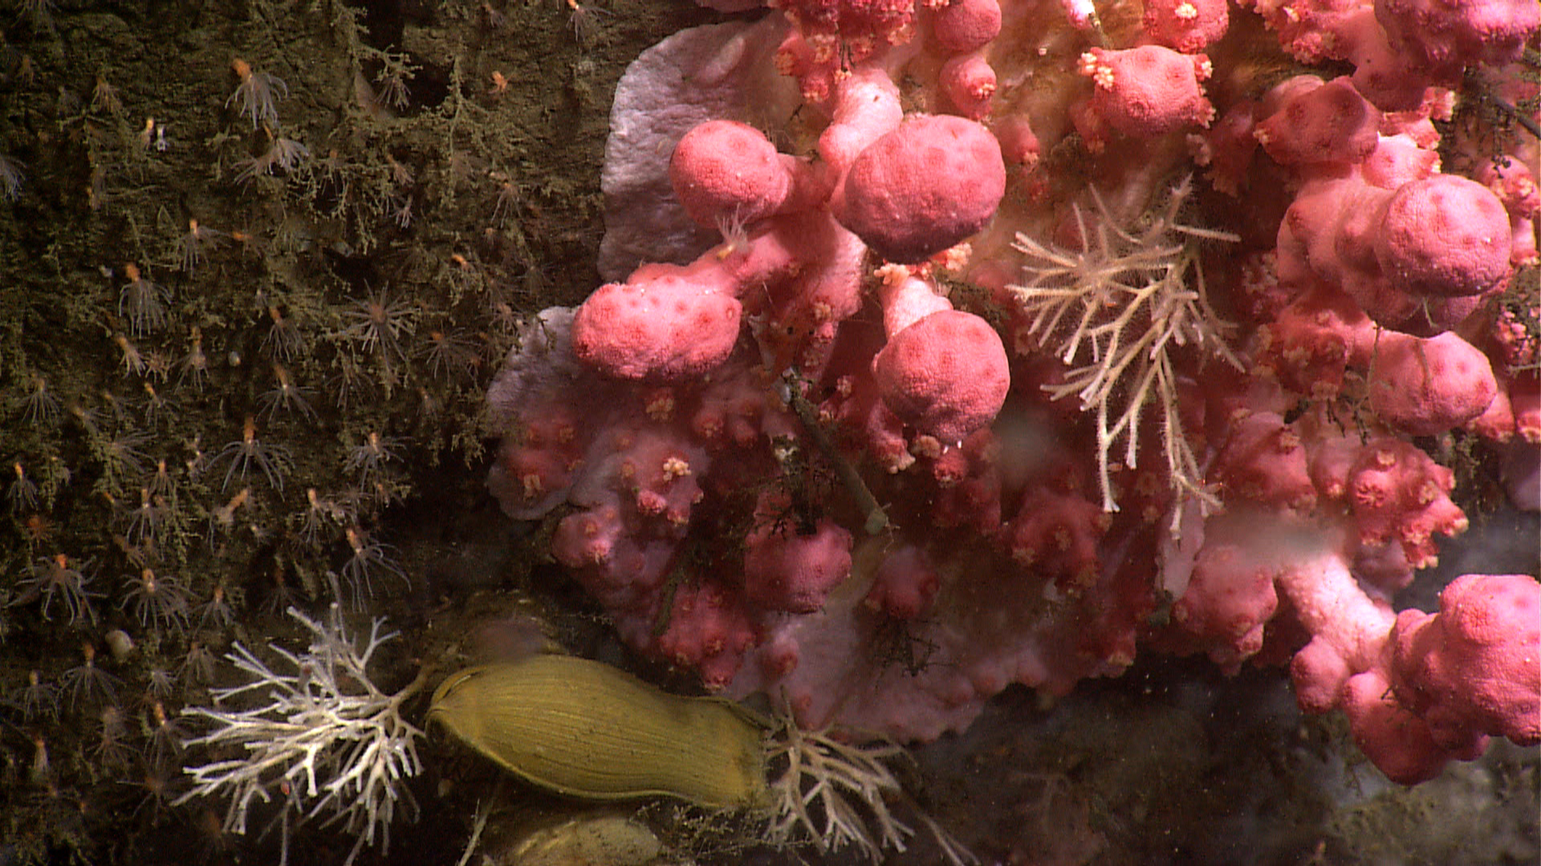 |  |  |  | 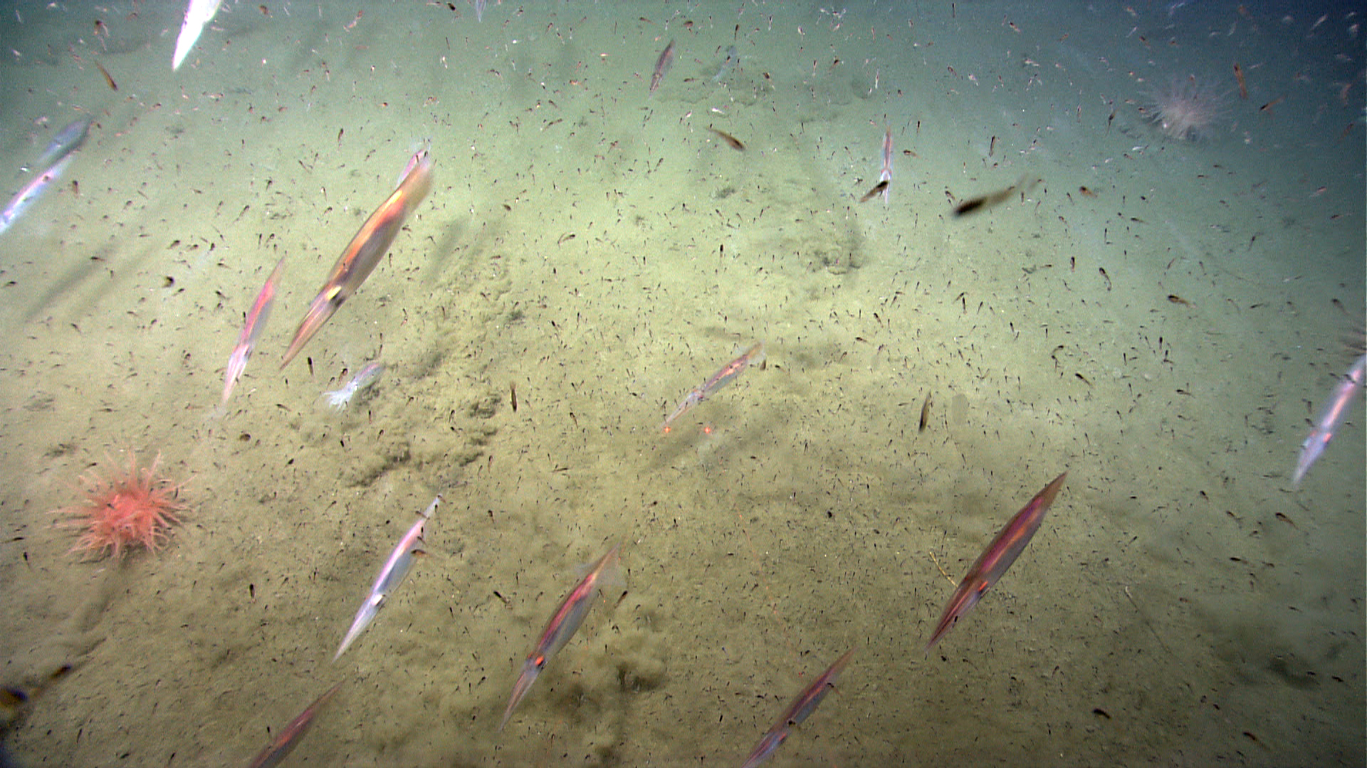
Please direct inquiries to: |  | NOAA Office of Ocean Exploration & Research  1315 East-West Highway (SSMC3 10th Floor)  Silver Spring, MD 20910  (301) 734-1014

