Okeanos Explorer ROV Dive Summary
Site Name | Lindenkohl Canyon |  |  |  | 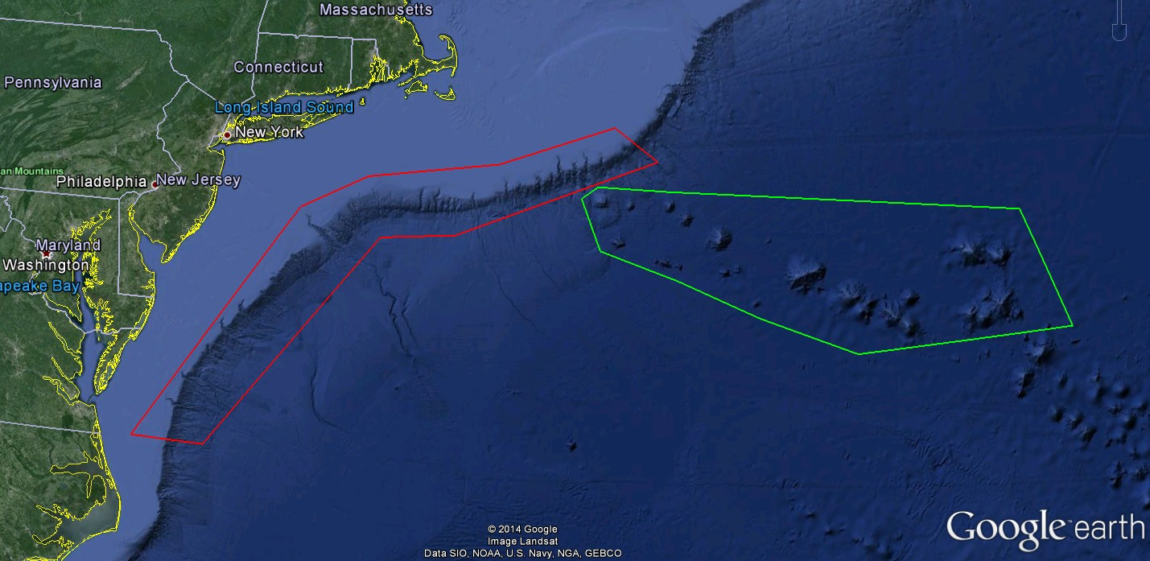
ROV Lead/Expedition Coordinator | David Lovalvo/  Brian Kennedy
Science Team Leads | Jamie Austin Jesse Ausubel
General Area Descriptor | Northwest Atlantic Ocean;  Mid Atlantic U.S. Canyons
ROV Dive Name | Cruise Season |  | Leg |  |  | Dive Number
 | EX1404 |  | 2 |  |  | DIVE01
Equipment Deployed | ROV: |  | Deep Discoverer
 | Camera Platform: |  | Seirios
ROV Measurements | CTD |  | Depth |  |  | Altitude
 | Scanning Sonar |  | USBL Position |  |  | Heading
 | Pitch |  | Roll |  |  | HD Camera 1
 | HD Camera 2 |  | Low Res Cam 1 |  |  | Low Res Cam 2
 | Low Res Cam 3 |  | Low Res Cam 4 |  |  | Low Res Cam 2
Equipment Malfunctions
ROV Dive Summary  (From processed ROV data) | Dive Summary: EX1404L2_DIVE01  ^^^^^^^^^^^^^^^^^^^^^^^^^^^^^^^^^^^^^^^^^^^^^^^^^^^  In Water at: 2014-09-05T13:16:06.820000  38°, 47.241' N ; 072°, 59.717' W  Out Water at: 2014-09-05T22:14:09.724000  38°, 47.462' N ; 072°, 59.533' W  Off Bottom at: 2014-09-05T21:41:53.453000  38°, 47.619' N ; 072°, 59.431' W  On Bottom at: 2014-09-05T13:52:22.323000  38°, 47.585' N ; 072°, 59.552' W  Dive duration: 8:58:2  Bottom Time: 7:49:31  Max. depth: 669.5 m
Special Notes | This dive’s primary objective was to conduct engineering trials of the ROV
Scientists Involved  (please provide name / location / affiliation / email) | James Austin University of Texas/Austin, Jackson School of Geosciences jamie@utig.ig.utexas.edu  Robert Carney LSU rcarne1@lsu.edu  Katharine Coykendall USGS dcoykendall@usgs.gov  Tara Harmer Luke The Richard Stockton College of New Jersey luket@stockton.edu  Santiago Herrera WHOI tiagohe@gmail.com  Esprit Saucier University of Louisiana at Lafayette heestand.saucier@louisiana.edu  Tim Shank WHOI tshank@whoi.edu  Brad Stevens Univ of MD Eastern Shore bgstevens@umes.edu  Jesse Ausubel Rockfeller university ausubel@mail.rockefeller.edu  Scott France University of Louisiana at Lafayette france@louisiana.edu
Purpose of the Dive
Conduct engineering trials of new ROV systems
Description of the Dive:
Science Summary:
The primary purpose of Dive 1 was to perform a series of engineering tests on the Deep Discoverer ROV (see Engineering Summary below), on a ~flat bench at a depth ~650 m along the northern flank of Lindenkohl Canyon. D2 and Seirios were deployed at ~0845 EDT. The vehicles were held at ~35-27 m while a noise issue with the A-frame shive was investigated (which turned out to be new parts in need if lubrication). The vehicles began decent at ~0910, while the ship moved to the NE, back towards our original deployment point. Descent was stopped at 550 m, while that transit was completed. Seafloor was sighted at a depth of ~667 m at 0952.
The entire dive was spent on parts of this bench, which was sedimented, characterized by occasional burrows and small-scale topography. The water column was full of marine snow and small organisms – amphipods, euphausiids, squid, halosaurs, and other small fish. Chaceon crabs, including one mating pair, were common.
The vehicles left the seafloor at 1738. Dive time was extended to accommodate additional engineering testing.
Engineering summary:
Tests were performed to characterize the operational bounds of the digital still camera (used to create mosaics) and the new strobe lights. Camera settings were managed and image quality was assessed at a fixed position for a series of elevations from 2 m to 5 m using both ambient ROV and strobe lighting. Transects were performed at several speeds and using different camera settings (as determined in the fixed-position tests) to obtain moasic image sequences for both ambient and strobe illuminated scenes. Strobe-illuminated transects were performed at 2, 3, and 4 m elevation. Transects were performed using both autopilot and manual flight control. These tests have resulted in series of images which can now be used to determine best practices for the operation of the DSC and strobes. (4 hours)
The D2 pilot camera was evaluated for zoom and focus capability from the nearest ROV-mounted device to the far field. The use of manual focus was validated as a means to compensate for the inadequate auto-focus feature of the camera. This test confirmed that the pilot camera can be used as intended for vehicle and manipulator observation. (15 minutes)
All hydraulic functions of the manipulator arms were tested using the pilot joyboxes. These tests confirmed the correct and improved operation produced by new joybox communications software and hardware, and confirmed the correct adjustments of the hydraulic control valves. The swingarm functions were tested using the GUI to confirm the correct adjustments of their control valves. (30 minutes)
In an attempt to exacerbate a previously-observed CTD data corruption event, all of the ROV devices and systems were exercised while simultaneously monitoring the CTD data stream. No corruption events were observed during this test, nor at any time prior to this test on this dive. (30 minutes)
The PHINS inertial navigation system was measured to determine inertial drift under three conditions: surface alignment, coarse subsea alignment, coarse and fine subsea alignment. Using each alignment method, the ROV was driven in a simple 20-minute box pattern. Position drift was measured by comparing the pre-box and post-box positions reported by the PHINS, having returned the ROV to the same location at the end of each box. The tests showed 7939 m, 10.5 m, and 6.5 m respectively. This suggests that a quick (coarse only) alignment is adequate for operations. (2 hours)

Overall Map of ROV Dive Area |  |  |  | Close-up Map of Main Dive Site
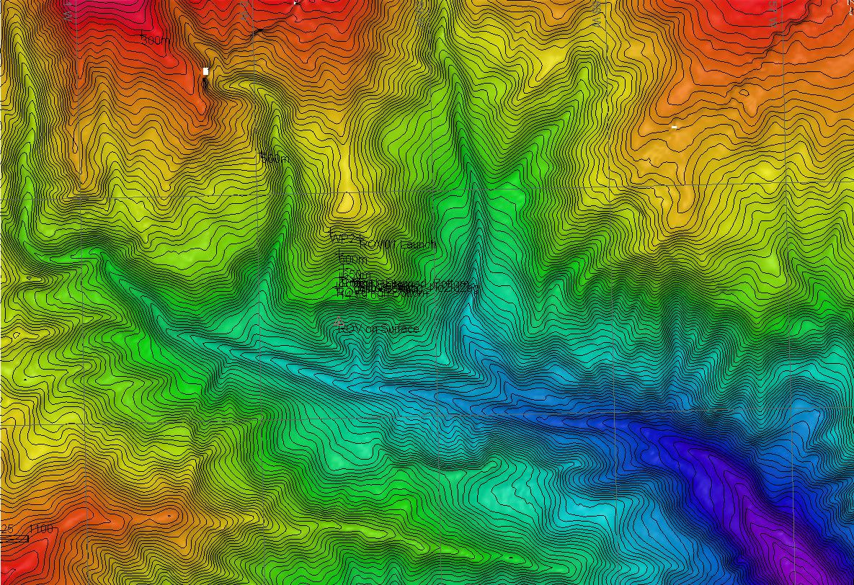 |  |  |  | 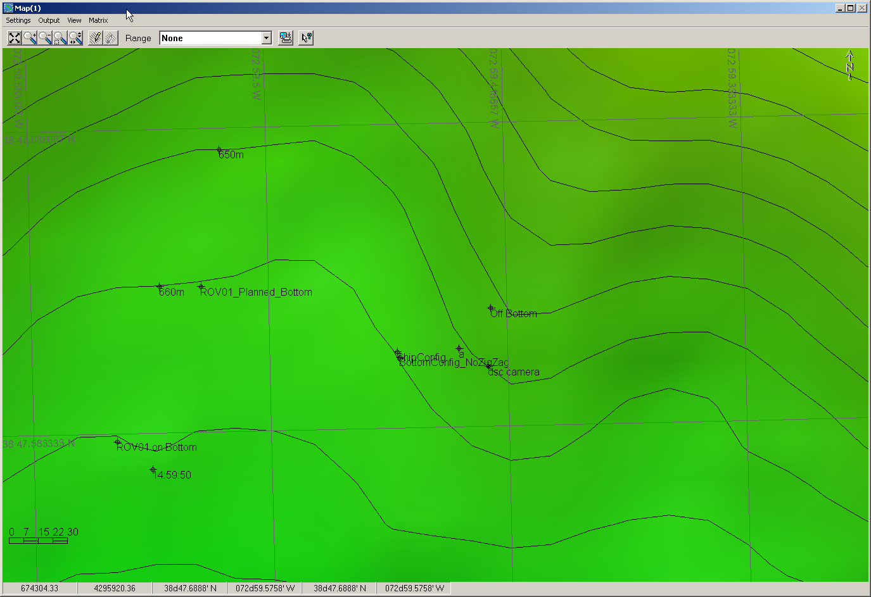
Representative Photos of the Dive
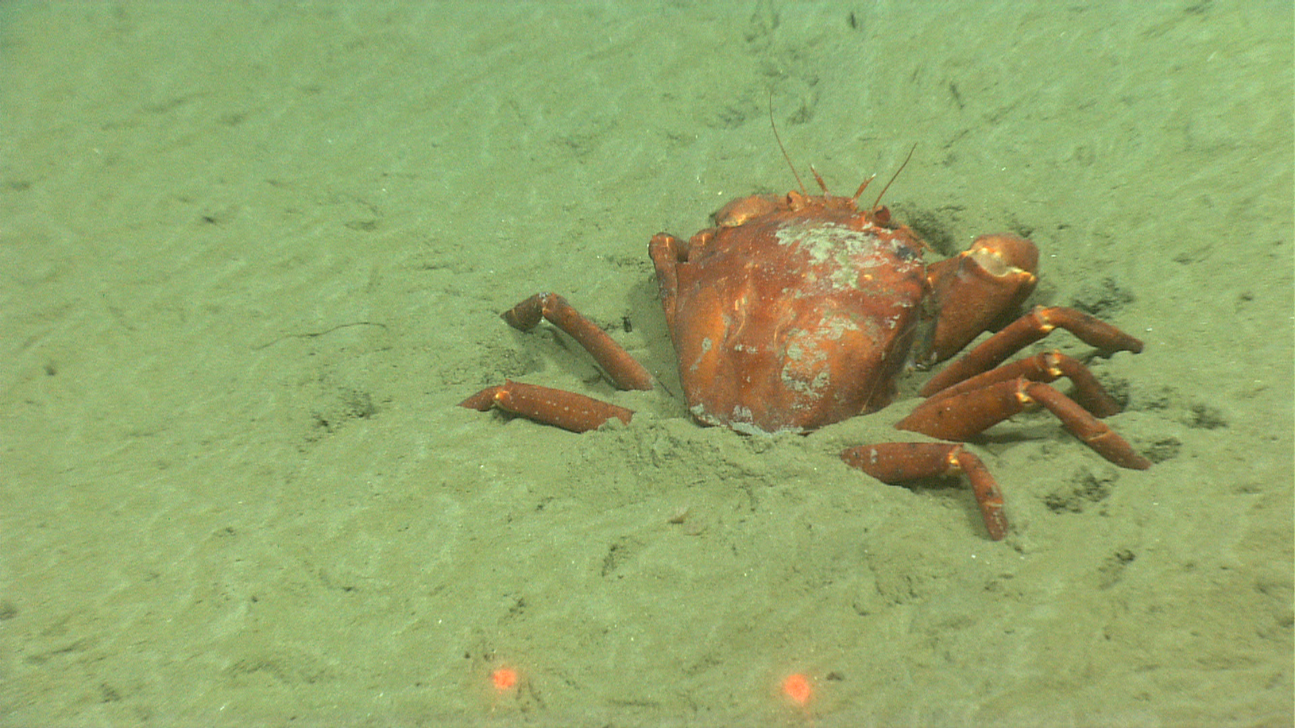 |  |  |  | 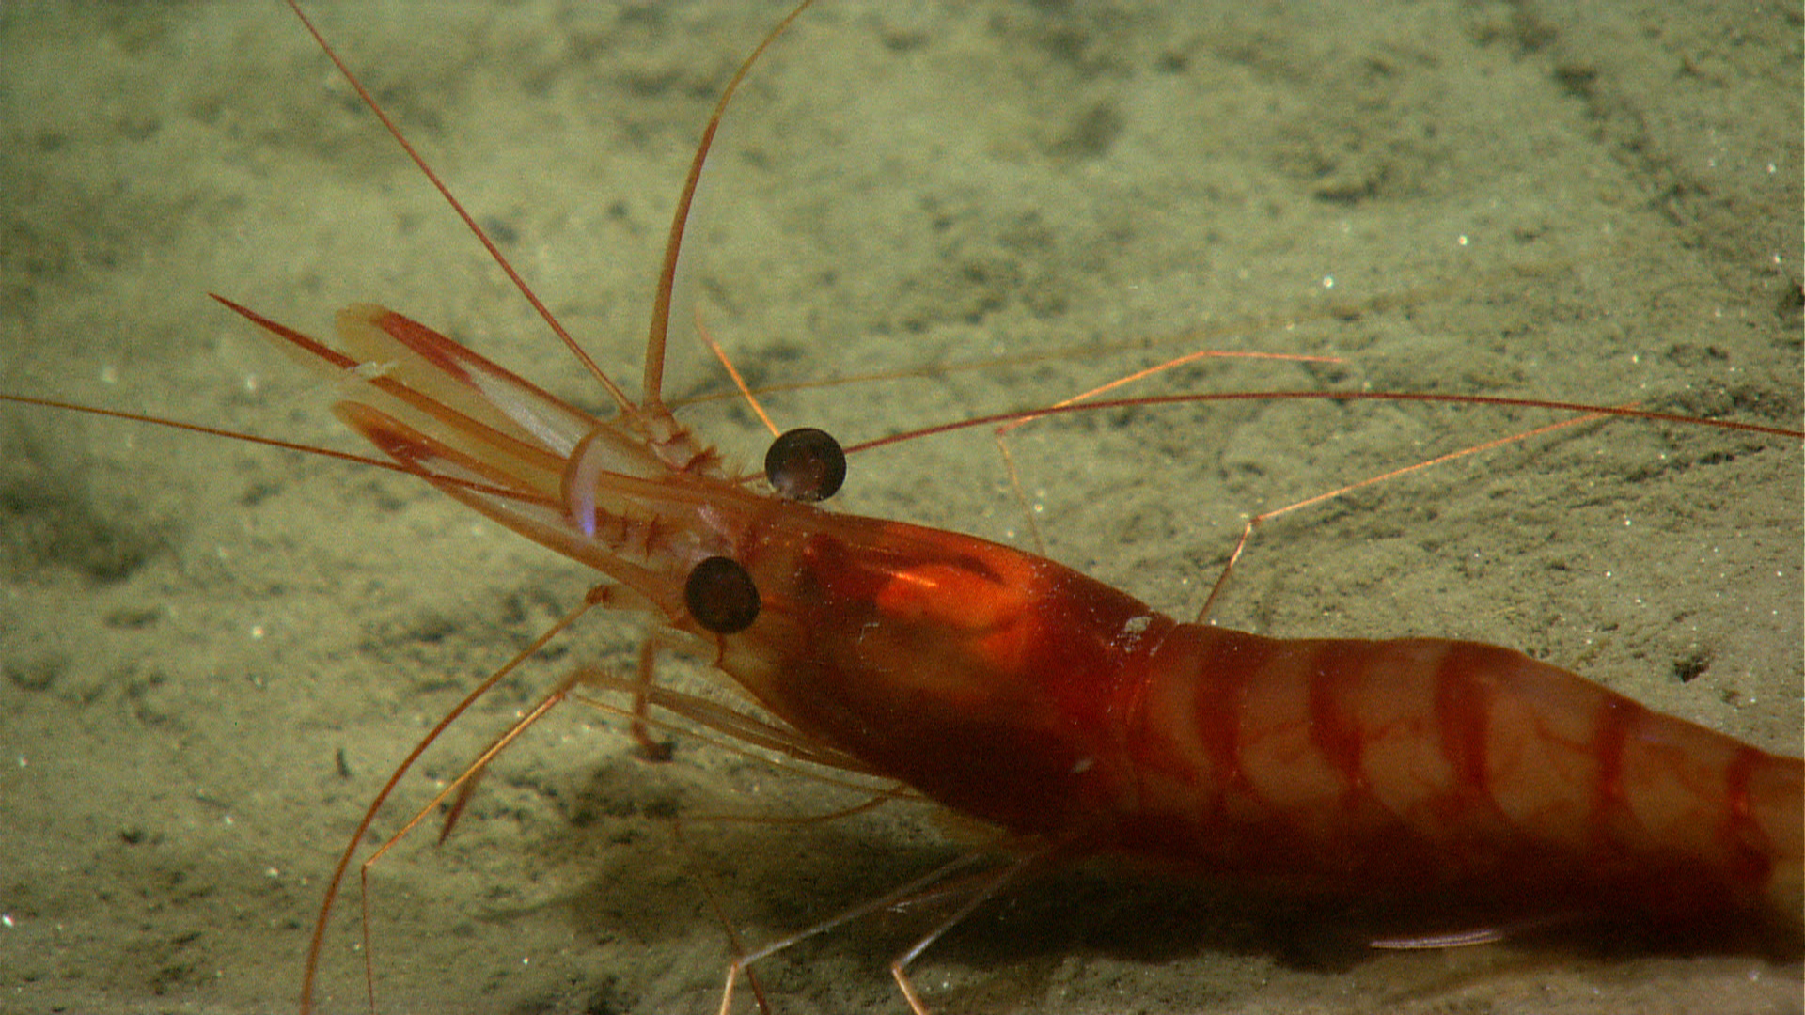
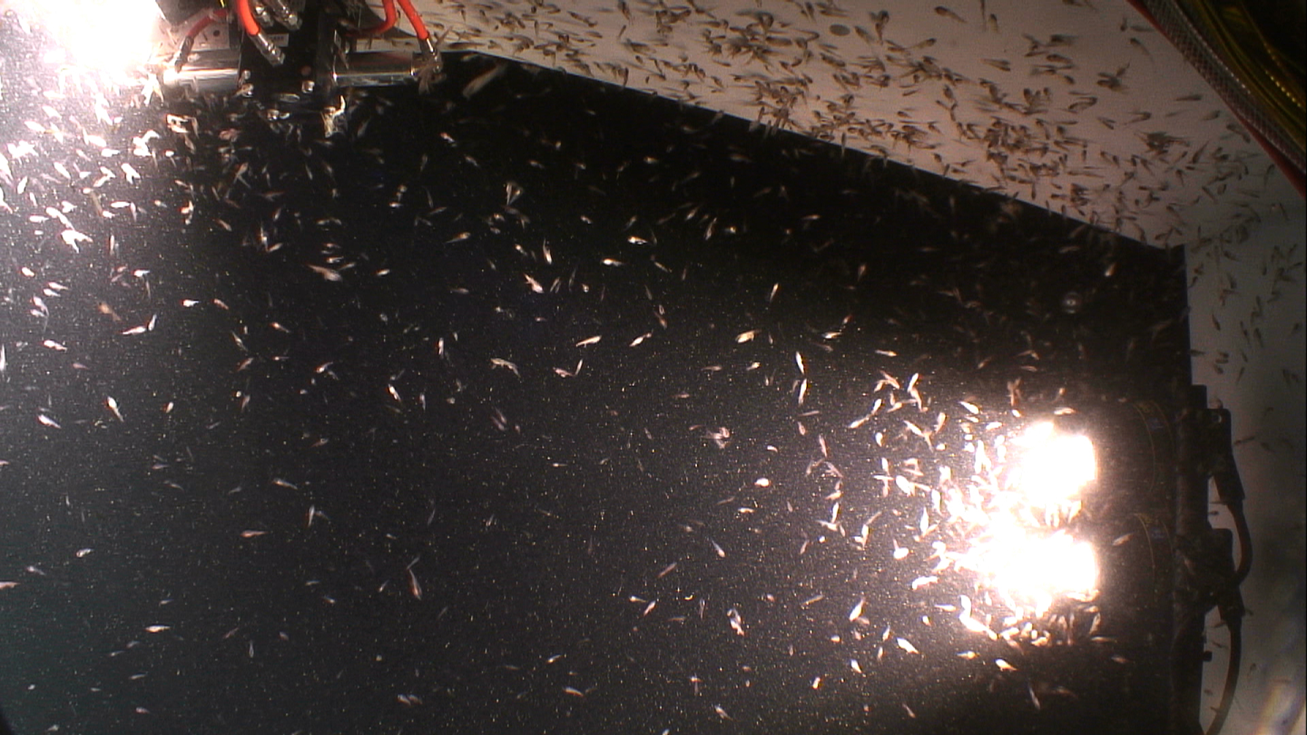 |  |  |  | 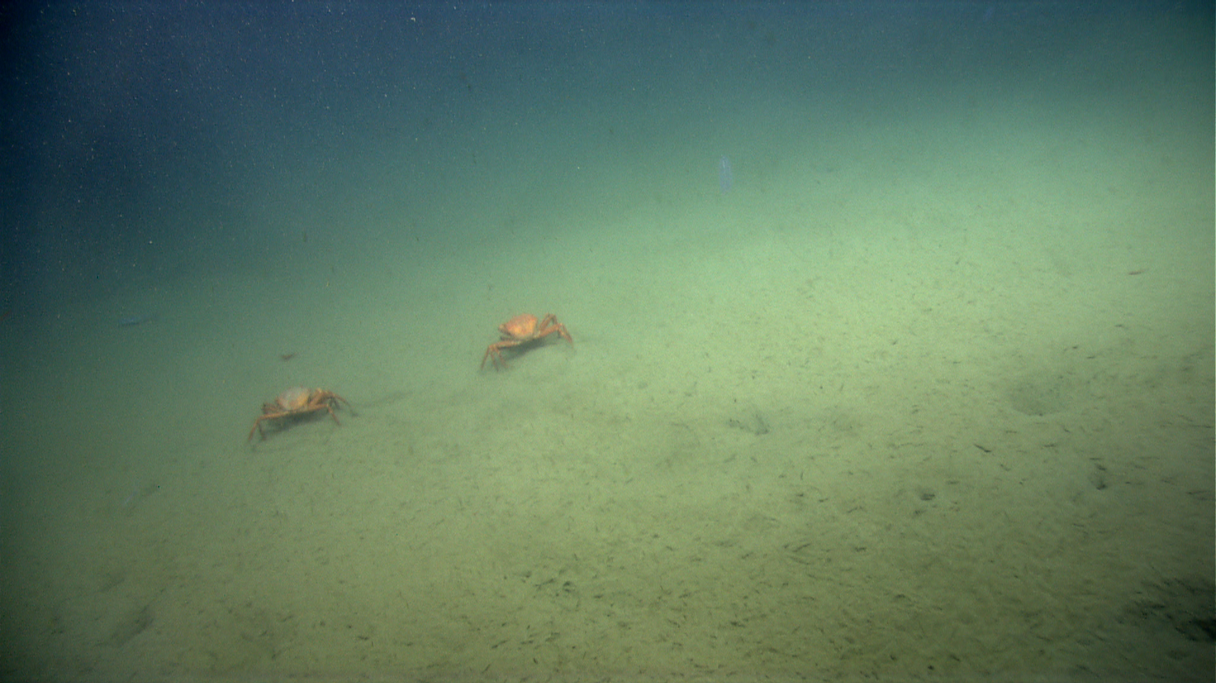
Please direct inquiries to: |  | NOAA Office of Ocean Exploration & Research  1315 East-West Highway (SSMC3 10th Floor)  Silver Spring, MD 20910  (301) 734-1014

