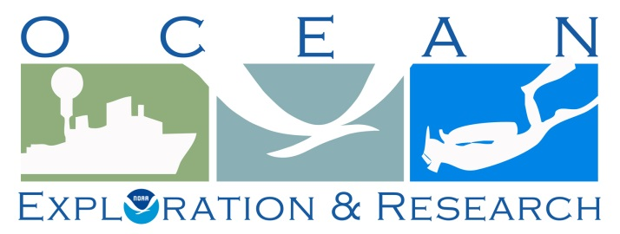

Project Instructions

Date Submitted: TBD

Platform: NOAA Ship Okeanos Explorer

Project Number: EX-14-02 LEG III

Project Title: Exploration, Gulf of Mexico (ROV/Mapping)

Project Dates: April 10 – May 1, 2014

Prepared by: Kelley Elliot, NOAA
Expedition Manager
Office of Ocean Exploration & Research

Approved by: ________________________ Dated: __________________
Craig W. Russell
Program Manager
Office of Ocean Exploration & Research

Approved by: ________________________ Dated: __________________
Captain Anne Lynch, NOAA
Commanding Officer
Marine Operations Center - Atlantic
- OVERVIEW
- Brief Summary and Project Period
This document contains project instructions for EX-14-02 LEG 3. EX-14-02 LEG 3 operations are expected to commence on April 10, 2014 at Pascagoula, MS and conclude on May 1, 2014 at St. Petersburg, FL. Daily daytime ROV dives are expected with full shore-based science participation; evening/night mapping and CTD operations. Focused operations will be conducted in deep water areas south and southeast of the Flower Garden Banks National Marine Sanctuary, and limited operations on the west Florida shelf and adjacent Escarpment.

- Days at Sea (DAS)

Of the 22 DAS scheduled for this project, 22 DAS are funded by an OMAO allocation, 0 DAS are funded by a Line Office Allocation, 0 DAS are Program Funded, and 0 DAS are Other Agency funded. This project is estimated to exhibit a High Operational Tempo.
C. Operating Area
There are two general operating areas planned for leg 3, both in the Gulf of Mexico. Operations will focus primarily on: 1) The area to the south and southeast of Flower Garden Banks National Marine Sanctuary (FGNMS), including Keathley Canyon and adjacent parts of the Sigsbee Escarpment, and 2) areas in on the West Florida Escarpment southwest of Tampa. ROV and most mapping operations will focus in depths >500 m. All operations including transit will be conducted mostly within the 200nm exclusive economic zone (EEZ) maritime boundary of the United States of America; however, several dives may be conducted in international waters south of FGNMS.

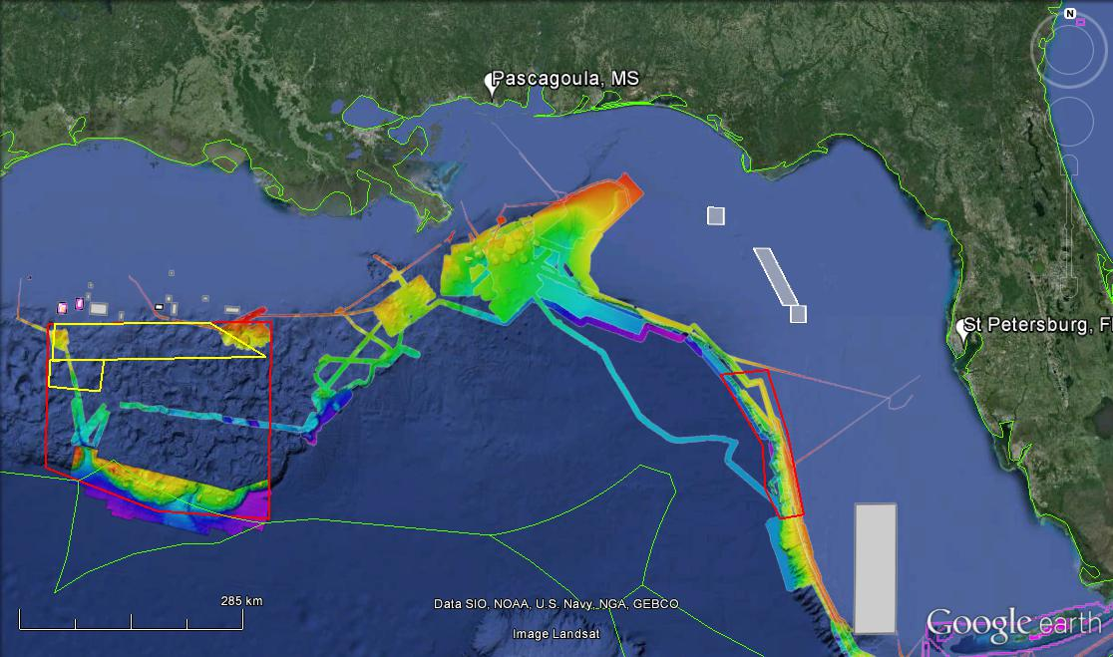Figure 1: Overview map showing priority exploration areas for leg 3 of the 2014 Gulf of Mexico Expedition. Red boxes are general operating areas for ROV, CTD and mapping operations. Yellow boxes are areas planned to be mapped during EX1402 Leg 2. White boxes are marine protected areas, and the green line is the U.S./Mexico Exclusive Economic Zone. Bathymetry shown is from 2011-2012 Okeanos cruises, and Extended Continental Shelf data (courtesy UNH CCOM).
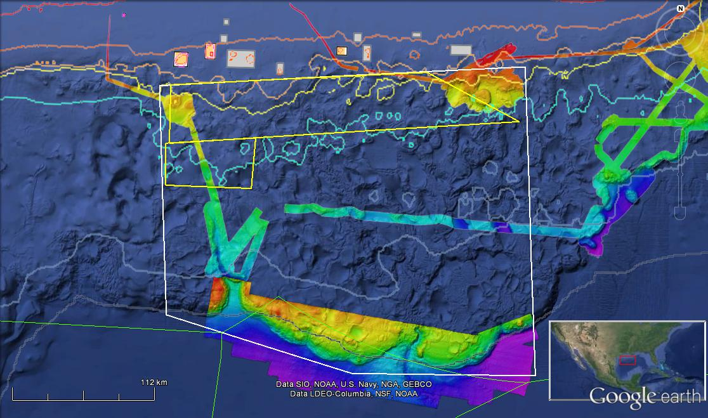
3000m
2000m
50m
250m
1000m
500m
100m
Figure 2: Close-up map showing the general operating area outlined in white for focused exploration activities during leg 3 of the 2014 Gulf of Mexico Expedition. Yellow boxes are areas planned to be mapped during EX1402 Leg 2. White-filled boxes are marine protected areas, and the green line is the U.S./Mexico Exclusive Economic Zone. Bathymetry show is from 2011-2012 Okeanos cruises, and Extended Continental Shelf data (courtesy UNH CCOM).

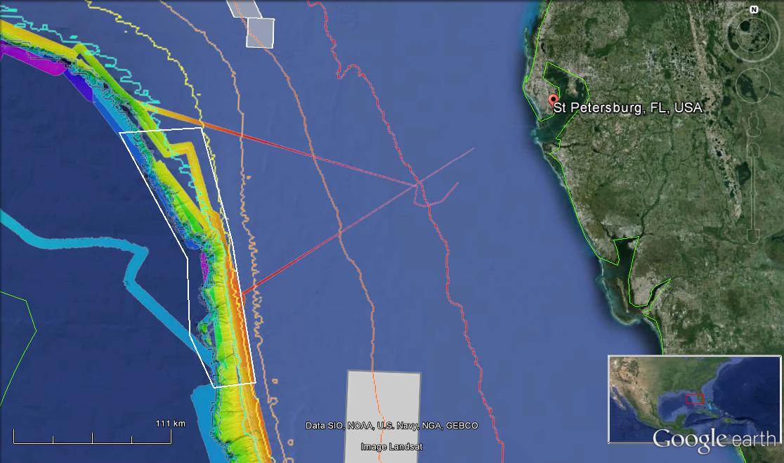
50m
100m
250m
500m
1000m
2000m
3000m
Figure 3: Close-up map showing the general operating area outlined in white for limited exploration activities during leg 3 of the 2014 Gulf of Mexico Expedition, as the ship makes her way into port in St. Petersburg, FL. White-filled boxes are marine protected areas, and the green line is the U.S./Mexico Exclusive Economic Zone. Bathymetry show is from 2011-2012 Okeanos Explorer cruises.

D. Summary of Objectives
EX-14-02 Leg 3 operations will focus within the two Gulf of Mexico polygons shown in figures 1 to 3 above. The overall goal of this cruise is to collect data to aid the development of a baseline characterization of the operating areas. Daytime operations will focus on ROV dives, while evening and night operations will be focused on CTD and Mapping operations.
Mission objectives for EX-14-02 Leg 3 include a combination of operational, science, education, outreach, surveys of opportunity, and data management objectives. They are:
- Science
  - Identify and explore the diversity and distribution of benthic habitats and features in the region (e.g., seeps, deep corals and related benthic ecosystems, canyons).
  - Conduct ROV dives along the Sigsbee Escarpment and in adjacent deep-water canyons.
  - Locate and characterize underwater cultural heritage e.g., shipwrecks (data will be used to assess their eligibility for the National Register of Historic Places).
  - Ground-truth acoustic seep data and characterize associated habitat.
  - Recover long deployment experiments from the seafloor if requested (See appendix F for more instructions.).
  - Deploy Argo Floats (See appendix G for more instructions.).

- ROV
  - Re-integrate the ROV into the ship’s systems.
  - Test and use the ROV for telepresence-enabled exploration.
  - Daytime ROV dives on exploration targets; and
  - Ongoing training of pilots; and
  - Ongoing system familiarization, documentation and training.
  - Train pilots to take high quality images and navigate the new ROV.
  - Continue to apply, develop and/or refine system checklists, SOPs, spares lists, etc.
  - Continue training in ROV launch and recovery operations.
  - Continue to train bridge crew on ROV operations and use of dynamic positioning system (DP).

- Telepresence (VSAT 20 mb/sec ship-to-shore; T1 shore-to-ship)
  - Test terrestrial and high-speed satellite links; and
  - Test and refine ship-to-shore communications and operations procedures that engage multiple ECCs during the course of each cruise; and
  - Engage new ECC located at Harbor Branch Oceanographic Institution, and ECCs new to Okeanos Explorer telepresence operations (TAMU Galveston, Meadows Center at Texas State University); and
  - Test and refine operating procedures and products; and
  - Engage a broad spectrum of the scientific community and public in telepresence-based exploration; and
  - Test/implement new protocols for accessing the ship’s wireless internet.
  - Work with NOAA NOC to harden the video network path.
  - Test new pathways for the Internet 1 accessible video stream.
  - Continue to use the real-time RSS feed to general public engagement.
  - Support live interaction between ship and shore for education and media events.

- ECCs
  - Prepare for and assess expectation of distributed participation from science community at multiple shore-side locations through telepresence; and
  - Train scientists on how to use online collaboration tools and technologies to conduct remote science; and
  - Refine/update SOPs; and
  - Ongoing system familiarization and training.
  - Test new online collaboration tools SOPs.

- Mapping Operations
- Support night time mapping operations and holiday filling.
- Support ROV dive planning by producing mapping products.
- Acquire water-column data with EK 60 and EM 302; and
- Acquire sub-bottom data; and
- Conduct mapping operations during transit, with possible further development of exploration targets; and
- Conduct training of new mapping watchstanders.
- Create daily standard mapping products.

- CTD operations
- Conduct CTD/rosette casts or tow-yo operations as needed to guide science operations; and

- XBT operations
  - During mapping operations, XBT casts will be collected at regular intervals of 2-4 hours or more often as data quality requires.

- Data Management
  - Provide a foundation of publicly accessible data and information products to spur further exploration, research, and management activities,
  - Provide daily cumulative multibeam products to shore for operational decision making purposes, as detailed in the 2013 field products list; and
  - Record 2 channels of streamed video footage of a ROV dive onboard the ship.
  - Prepare for data warehouse upgrades.
E. Participating Institutions
National Oceanic and Atmospheric Administration (NOAA) - Office of Ocean Exploration and Research (OER) - 1315 East-West Hwy, Silver Spring, MD 20910 USA

University of New Hampshire (UNH) - Center for Coastal and Ocean Mapping (CCOM) –
Jere A. Chase Ocean Engineering Lab, 24 Colovos Road, Durham, NH 03824 USA

University of Rhode Island, Graduate School of Oceanography, Inner Space Center, Narragansett, Rhode Island, 02882

NOAA, National Oceanographic Data Center, National Coastal Data Development Center, Stennis Space Center MS, 39529

University Corporation for Atmospheric Research (UCAR), Joint Office for Science Support (JOSS) PO Box 3000 Boulder, CO 80307

NOAA Pacific Marine Environmental Lab 7600 Sand Point Way NE, Seattle, WA 98115

U.S. Geological Survey, Woods Hole Science Center, 384 Woods Hole Road, Quissett Campus, Woods Hole, MA 02543-1598

The University of Texas at Austin, John A. and Katherine G. Jackson School of Geosciences, Institute for Geophysics, J.J. Pickle Research Campus, Building 196 (ROC), 10100 Burnet Road (R2200), Austin, TX 78758-0999
Cooperative Institute for Ocean Exploration, Research and Technology, Harbor Branch Oceanographic Institute at Florida Atlantic University, 5600 US 1 North, Fort Pierce, FL 34946

F. Personnel (Science Party)
A full mission complement is necessary for this cruise.

Table 2: Full list of the mission personnel afloat and their affiliation
Name  (Last, First) | Title | Date Aboard | Date Disembark | Gender | Affiliation | Nationality
Elliott, Kelley | Expedition Coordinator |  |  | F | NOAA OER (20/20) | US Citizen
Austin, James | Science Co-Lead |  |  | M | UT | US Citizen
Stephanie Farrington | Science Co-Lead |  |  | F | HBOI | US Citizen
Drewniak, Jared | Telepresence Video Lead |  |  | M | NOAA OER (ERT) | US Citizen
Reser, Brendan | Telepresence Data Lead |  |  | M | NOAA NCDDC (GDIT) | US Citizen
Lobecker, Elizebeth “Meme” | Mapping Team Lead |  |  | F | NOAA OER (ERT) | US Citizen
Miller, James | Mapping Watch Lead |  |  | M | NOAA AHB | US Citizen
Bingham, Brian | Dive Supervisor |  |  | M | UCAR | US Citizen
Wright, Dave | ROV Engineer |  |  | M | UCAR | US Citizen
Williams, Jeff | ROV Engineer |  |  | M | UCAR | US Citizen
Mohr, Bobby | ROV Engineer |  |  | M | UCAR | US Citizen
Lanning, Jeff | ROV Engineer |  |  | M | UCAR | US Citizen
Mcletchie, Karl | ROV Engineer |  |  | M | UCAR | US Citizen
Gregory, Todd | ROV Engineer |  |  | M | UCAR | US Citizen
Carlson, Joshua | ROV Engineer |  |  | M | UCAR | US Citizen
Ritter, Chris | ROV Engineer |  |  | M | UCAR | US Citizen
Rogers, Dan | ROV Engineer |  |  | M | UCAR | US Citizen
TBD | ROV Engineer |  |  |  | UCAR
McNicol, Ed | Telepresence Engineer |  |  | M | UCAR | US Citizen
Brian, Roland | Telepresence Engineer |  |  | M | UCAR | US Citizen

Shore-side Participants (Location and duration of participation will vary)
REMOTE | NAME | INSTITUTION | ROLE | INTEREST | PARTICIPATION LEVEL
URI | LTJG Brian Kennedy | NOAA OER | Operations Support | N/A | Core
URI | Dwight Coleman | URI/ISC | Marine Geologist/  Technical support | Marine Geology | Core
Laptop only | John Snedden | UTIG | Science | Marine Geology | Core for Submitted Dives
Laptop only | Jed Damuth | UT/Arlington |  | Marine Geology | Core for Submitted Dives
Stennis? | Bill Shedd | BOEM |  | Geophysicist | Core for Submitted Dives
CHAS | Peter Etnoyer | NOAA NCCOS |  | Deepwater Corals | Core
SS | Brian Kinlan | NOAA NCCOS |  | Deepwater Corals/ Geospatial Modelling | Partial
HBOI | John Reed | HBOI CIOERT |  | Marine Ecology | Distributed
SS | Mike Vecchione | NOAA NMFS |  | Cephalopods | Distributed
Remote/ URI? | Cindy Van Dover | Duke |  | Seep Ecology | Core for Seep Dives
TAMUG | William Keine | NOAA FGNMS |  | Interdisciplinary | Core
SS | Frank Cantelas | NOAA OER |  | Archaeology |  | Core for Archaeology
SS | Jim Delgado | NOAA NMS |  | Archaeology | Core for Archaeology
Stennis | Jack Irion | BOEM |  | Archaeology | Core for Archaeology
Stennis | Chris Horrell | BSEE |  | Archaeology | Core for Archaeology
Meadows | Fritz Handelmann | TSU |  | Archaeology | Core for Monterrey
LSU | Bob Carney | LSU |  | bBiology/Geology | Intermittent
? | Andrea Quatrrini | Temple |  | Deepwater Coral and fish | Intermittent
TAMU | Bredan Roak | UT |  | Deepwater Corals | Intermittent
WHOI? | Carolyn Ruppel | USGS |  | Methane Hydrates | Intermittent
Temple? | Erik Cordes | Temple |  | Deepwater Corals/Seeps | Intermittent
Tampa? | Morgan Kilgour | UCONN |  | Deepwater Ecosystems | Intermittent
 | Scott France |  |  | Deepwater Corals | Intermittent
UNH | Larry Mayer | UNH CCOM | Science | Marine Geology | Intermittent

G. Administrative

Points of Contact:

Ship Operations

Marine Operations Center, Atlantic (MOA)  439 West York Street  Norfolk, VA 23510-1145  Telephone: (757) 441-6776  Fax: (757) 441-6495 | Chief, Operations Division, Atlantic (MOA)  LT Laura Gibson, NOAA  Telephone: (757) 441-6842  E-mail: Laura.Gibson@noaa.gov

Mission Operations

Kelley Elliott  Expedition Manager  NOAA Office of Ocean Exploration  Phone: (301) 734-1024/ (703) 927-5449  Email: Kelley.Elliott@noaa.gov  Meme Lobecker, Mapping Lead  NOAA Ocean Exploration & Research (ERT, Inc.)  Phone: 603-862-1475/ 401-662-9297  E-mail: elizabeth.lobecker@noaa.gov | CDR Ricardo Ramos, NOAA  Commanding Officer  NOAA Ship Okeanos Explorer  Phone: (401) 378-8284  Email: CO.Explorer@noaa.gov  LT Emily Rose, NOAA  Operations Officer  NOAA Ship Okeanos Explorer  Phone: (307) 287-2005 (c)  E-mail: Ops.Explorer@noaa.gov

Other Mission Contacts
Craig Russell, EX Program Manager  NOAA Ocean Exploration & Research  Phone: 206-526-4803 / 206-518-1068  E-mail: Craig.Russell@noaa.gov | LCDR Nicola VerPlanck,NOAA  NOAA Ocean Exploration & Research  Phone: 206-526-4801  E-mail: Nicola.Verplanck@noaa.gov
John McDonough, Deputy Director  NOAA Ocean Exploration & Research  Phone: 301-734-1023 / 240-676-5206  E-mail: John.McDonough@noaa.gov  LTJG Brian Kennedy, ECC Coordinator  NOAA Ocean Exploration & Research  Phone: 401-874-6150 / 706-540-2664  E-mail: Brian.Kennedy@noaa.gov | Jared Drewniak, Telepresence Video Lead  NOAA Office of Ocean Exploration & Research (ERT)  Phone: (401) 874-6250 (o) / (401) 330-9662 (c)  Email: jared.drewniak@noaa.gov  Brendan Reser, Telepresence Data Lead  NOAA NCDDC  Phone: 228-688-3516 (o)/ 503-886-9705  E-mail: Brendan.Reser@noaa.gov

Shipments:

Send an email to the Okeanos Explorer Operations Officer at OPS.Explorer@noaa.gov indicating the size and number of items being shipped. All items should arrive at Pascagoula prior to COB TBD

Vessel shipping address at the Gulf Marine Support Facility:
NOAA Gulf Marine Support Facility
ATTN: LT Emily Rose, NOAA
NOAA Ship Okeanos Explorer
151 Watts Ave
Pascagoula, MS 39567-4102

The Gulf Marine Support Facility's telephone numbers are:
- 228-769-0307 (Voice)
- 228-769-9529 (Fax)

- Diplomatic Clearances
None Required.
- Licenses and Permits
See Appendix C for categorical exclusion documentation.

- OPERATIONS
- Project Itinerary(All times and dates are subject to prevailing conditions and the discretion of the Commanding Officer)
April 3: ROV team arrives in Pascagoula

April 4: ROV team arrives on ship. As many members of the ROV team as can be accommodated will stay onboard the ship starting April 4.

April 4: Truck arrives with container; Crane arrives at dock. ROV, camera sled, equipment and container all to be loaded on ship. Argo floats to be loaded onto ship (stored in container). Mobilization and interfacing of equipment. During this time the ROV team will require access to support from the engineering, ET and Bosun department.

April 5 – 9: Continued mobilization and interfacing of equipment. During this time the ROV team will require access to support from the engineering, ET and Bosun department. Weekend staffing/support from the ship will be required.

April 8: other mission personnel arrive

April 10: underway from Pascagoula

April 11: First ROV Dive in the western operating area. Depending on departure time and transit, the first dive may be en route to the western operating area.

April 24-27?: Depart western operating area

April 26-29?: first dive eastern operating area

April ??: Live interaction with Smithsonian

April ??: Live interview with NPR

May 1: Arrive St Petersburg, FL

May 2 or 3?: Inport event St Petersburg FL.
- Telepresence Events
Smithsonian Natural History Museum- TBD
NPR Cape Cod- TBD
- In-Port Events
St. Petersburg, Florida- details TBD
- Staging and De-staging
Staging:
A truck with OER’s 20’ container and a crane paid for by OER will arrive at the dock on April 4. The ROV, Camera Sled, additional equipment and the 20’ container will be loaded onto the ship on April 4. Argo floats will be loaded onto ship during this time (and stored in the second 20’ container).

Mobilization and interfacing of equipment will commence on April 4 and continue through the inport period to April 9. During this time the ROV team will require access to support from the engineering, ET and Bosun department. OER will work with the ship on a daily basis to determine support needed each day. Weekend staffing/support from the ship will be required.

Dates | ROV Operations | Remarks
4/4/14 | ROV team arrives in Pascagoula, MS | Team will stay onboard the ship starting April 4 through departure and require berthing and meals.
4/4/14 | Load ROV and camera sled | Crane support required
4/4/14 | Loading 20ft container | Crane support required
4/4/14 | Rigging block/winch wire | - The A-Frame block with the winch wire will be installed by ship crew and ROV team
4/4 - 4/9 | Begin set up control room and ROV workshop | - ROV team will require ET support and the ability to conduct hot work
4/4 - 4/9 | ROV integration and termination of vehicle. | - High Voltage testing  - Test ROV support systems  - Support ROV integration and testing  - Shifting to ships power will be required
4/4 | Load ARGO floats | Crane support requested. The Argo floats will be stored in the 20 ft container until they are deployed.
April 9 | Ship Fueling | NO crane activities.
Table1: Draft table of activities for ROV Staging and Integration.
All dates are approximate and can still change
De-staging
No de-staging required. The ROV D2, camera sled Seirios and second 20’ container will remain onboard until the ship pulls into port in North Kingstown, RI.
- Dive Plan
All dives are to be conducted in accordance with the requirements and regulations of the NOAA Diving Program (http://www.ndc.noaa.gov/dr.html) and require the approval of the ship’s Commanding Officer.
- Sonar Operations
Continuous nighttime EM 302, EK 60, and subbottom profiler data acquisition is planned for this cruise. All data acquisition will be conducted in accordance with established standard operating procedures under the direction of the mapping team lead. The final decision to operate and collect sub-bottom profiler data will be at the discretion of the Commanding Officer.

- Applicable Restrictions
NOT APPLICABLE TO THIS CRUISE

- EQUIPMENT
- Equipment and capabilities provided by the ship
- Kongsberg Simrad EM302 MultibeamEchosounder (MBES)
- Kongsberg Simrad EK60DeepwaterEchosounder
- Knudsen Chirp 3260 Sub-bottom profiler (SBP)
- LHM Sippican XBT (Deep Blue probes)
- Seabird SBE 911Plus CTD
- Seabird SBE 32 Carousel and 24 2.5 L Niskin Bottles
- Light Scattering Sensor (LSS)
- Oxidation – Reduction Potential (ORP)
- Dissolved Oxygen (DO) sensor
- Altimeter Sensor and battery pack
- CNAV GPS
- POS/MV
- Seabird SBE-45 (Micro TSG)
- Kongsberg Dynamic Positioning-1 System
- NetApps mapping storage system
- CARIS HIPS Software
- IVS Fledermaus Software
- SIS Software
- Hypack Software
- Scientific Computing System (SCS)
- ECDIS
- Met/Wx Sensor Package
- Telepresence System
- VSAT High-Speed link (Comtech5Mbps ship to shore; 1.54 Mbps shore to ship)
- Cruise Information Management System (CIMS)
- Equipment and capabilities provided by the scientists
- Microtops II Ozone Monitor –Sun photometer and handheld GPS required for NASA Marine Aerosols Network supplementary project.

- HAZARDOUS MATERIALS
- Policy and Compliance
The Expedition Coordinator is responsible for complying with FEC 07 Hazardous Materials and Hazardous Waste Management Requirements for Visiting Scientific Parties (or the OMAO procedure that supersedes it). By Federal regulations and NOAA Marine and Aviation Operations policy, the ship may not sail without a complete inventory of all hazardous materials by name and quantity, MSDS, appropriate spill cleanup materials (neutralizing agents, buffers, or absorbents) in amounts adequate to address spills of a size equal to the amount of chemical brought aboard, and chemical safety and spill response procedures. . Documentation regarding those requirements will be provided by the Chief of Operations, Marine Operations Center, upon request.
Per OMAO procedure, the scientific party will include with their project instructions and provide to the CO of the respective ship 30 days before departure:
    - List of chemicals by name with anticipated quantity
    - List of spill response materials, including neutralizing agents, buffers, and absorbents
    - Chemical safety and spill response procedures, such as excerpts of the program’s Chemical Hygiene Plan or SOPs relevant for shipboard laboratories
    - For bulk quantities of chemicals in excess of 50 gallons total or in containers larger than 10 gallons each, notify ship’s Operations Officer regarding quantity, packaging and chemical to verify safe stowage is available as soon as chemical quantities are known.
Upon embarkation and prior to loading hazardous materials aboard the vessel, the scientific party will provide to the CO or their designee:
- An inventory list showing actual amount of hazardous material brought aboard
- An MSDS for each material
- Confirmation that neutralizing agents and spill equipment were brought aboard sufficient to contain and cleanup all of the hazardous material brought aboard by the program
- Confirmation that chemical safety and spill response procedures were brought aboard
Upon departure from the ship, scientific parties will provide the CO or their designee an inventory showing that all chemicals were removed from the vessel. The CO’s designee will maintain a log to track scientific party hazardous materials. MSDS will be made available to the ship’s complement, in compliance with Hazard Communication Laws.
Scientific parties are expected to manage and respond to spills of scientific hazardous materials. Overboard discharge of hazardous materials is not permitted aboard NOAA ships.
- Inventory
Common Name of Material | Qty | Notes | Trained Individual | Spill  control
Alcohol (70-90%) | ½ gallon | Flammable | Stephanie Farrington | A
- Spill Response
  - Alcohol-
Small Spill:
Dilute with water and mop up, or absorb with an inert dry material and place in an appropriate waste disposal container.
Large Spill:
Flammable liquid. Keep away from heat. Keep away from sources of ignition. Stop leak if without risk. Absorb with DRY earth, sand or other non-combustible material. Do not touch spilled material. Prevent entry into sewers, basements or confined areas; dike if needed. Be careful that the product is not present at a concentration level above TLV. Check TLV on the MSDS
- Radioactive Materials
NOT APPLICABLE TO THIS CRUISE

- ADDITIONAL PROJECTS
- Supplementary Projects
NASA Maritime Aerosol Network
During the cruise the marine aerosol layer observations will be collected for the NASA Maritime Aerosol Network (MAN). Observations will be made by mission personnel (mapping interns) with a sun photometer instrument provided by the NASA MAN program. Resulting data will be delivered to the NASA MAN primary investigator Alexander Smirnov by the expedition coordinator. All collected data will be archived and publically available at: http://aeronet.gsfc.nasa.gov/new_web/maritime_aerosol_network.html
Equipment resides on the ship and is stewarded by ENS Pawlenko.
See Appendix D for full Survey of Opportunity Form.
- NOAA Fleet Ancillary Projects
NOT APPLICABLE TO THIS CRUISE

- DISPOSITION OF DATA AND REPORTS
- Data Responsibilities
All data acquired on Okeanos Explorer will be provided to the public archives without proprietary rights. All data management activities shall be executed in accordance with NAO 212-15, Management of Environmental and Geospatial Data and Information[http://www.corporateservices.noaa.gov/ames/administrative_orders/chapter_212/212-15.html].

Ship Responsibilities
The Commanding Officer is responsible for all data collected for missions until those data have been transferred to mission party designees. Data transfers will be documented on NOAA Form 61-29. Reporting and sending copies of project data to NESDIS (ROSCOP form) is the responsibility of OER.

NOAA OER Responsibilities
The Expedition Coordinator will work with the Okeanos Explorer Operations Officer to ensure data pipeline protocols are followed for final archive of all data acquired on Okeanos Explorer without proprietary rights.

Deliverables
  - At sea
      - Daily plans of the Day (POD)
      - Daily situation reports (SITREPS)
      - Daily summary bathymetry data files
  - Post cruise
      - Refined SOPs for all pertinent operational activities
      - Assessments of all activities
  - Science
- Multibeam and XBT raw and processed data (see appendix B for the formal cruise data management plan)
- EK 60 raw data
- Knudsen 3260 sub-bottom profiler raw data
- Mapping data report
- Cruise report

Archive
- The Program and ship will work together to ensure documentation and stewardship of acquired data sets in accordance with NAO 212-15. The Cruise Information Management System is the primary tool used to accomplish this activity.
- Meetings, Vessel Familiarization, and Project Evaluations
  - Shipboard Meetings
Daily Operations Briefing meetings will be held at 1430 in the forward lounge to review the current day, and define operations, associated requirements, and staffing needs for the following day. A Plan of the Day (POD) will be posted each evening for the next day in specified locations throughout the ship. A safety brief and overview of POD will occur on the Bridge each morning at 0800. Daily Situation Reports (SITREPS) will be posted as well and shared daily through e-mail and the EX operations folder on Google Drive.
Pre-Project Meeting: The Chief Scientist and Commanding Officer will conduct a meeting of pertinent members of the scientific party and ship’s crew to discuss required equipment, planned operations, concerns, and establish mitigation strategies for all concerns. This meeting shall be conducted before the beginning of the project with sufficient time to allow for preparation of the ship and project personnel. The ship’s Operations Officer usually is delegated to assist the Chief Scientist in arranging this meeting.
Vessel Familiarization Meeting: The Commanding Officer is responsible for ensuring scientific personnel are familiarized with applicable sections of the standing orders and vessel protocols, e.g., meals, watches, etiquette, drills, etc. A vessel familiarization meeting shall be conducted in the first 24 hours of the project’s start and is normally presented by the ship’s Operations Officer.
Post-Project Meeting: The Commanding Officer is responsible for conducted a meeting no earlier than 24 hrs before or 7 days after the completion of a project to discuss the overall success and short comings of the project. Concerns regarding safety, efficiency, and suggestions for future improvements shall be discussed and mitigations for future projects will be documented for future use. This meeting shall be attended by the ship’s officers, applicable crew, the Chief Scientist, and members of the scientific party and is normally arranged by the Operations Officer and Chief Scientist.
  - Project Evaluation Report:
Within seven days of the completion of the project, a Customer Satisfaction Survey is to be completed by the Chief Scientist. The form is available at http://www.omao.noaa.gov/fleeteval.html and provides a “Submit” button at the end.
The Customer Satisfaction Survey is one of the primary methods OMAO and Marine Operations (MO) utilize to improve ship customer service. Information submitted through the form is automatically input into a spreadsheet accessible to OMAO and MO management for use in preparing quarterly briefings. Marine Operations Centers (MOC) address concerns and praise with the applicable ship. Following the quarterly briefings the data are briefed to the Deputy Director of OMAO.

- MISCELLANEOUS
- Meals and Berthing
Meals and berthing are required for up to 10 scientists. Meals will be served 3 times daily beginning one hour before scheduled departure, extending throughout the cruise, and ending two hours after the termination of the cruise. Since the watch schedule is split between day and night, the night watch may often miss daytime meals and will require adequate food and beverages (for example a variety of sandwich items, cheeses, fruit, milk, juices) during what are not typically meal hours. Special dietary requirements for scientific participants will be made available to the ship’s command at least twenty-one days prior to the survey (e.g., Expedition Coordinator is allergic to fin fish). Berthing requirements, including number and gender of the scientific party, will be provided to the ship by the Expedition Coordinator. The Expedition Coordinator and Operations Officer will work together on a detailed berthing plan to accommodate the gender mix of the scientific party taking into consideration the current make-up of the ship’s complement. The Expedition Coordinator is responsible for ensuring the scientific berthing spaces are left in the condition in which they were received; for stripping bedding and linen return; and for the return of any room keys which were issued. The Expedition Coordinator is also responsible for the cleanliness of the laboratory spaces and the storage areas utilized by the scientific party, both during the cruise and at its conclusion prior to departing the ship.
All NOAA scientists will have proper travel orders when assigned to any NOAA ship. The Expedition Coordinator will ensure that all non NOAA or non Federal scientists aboard also have proper orders. It is the responsibility of the Expedition Coordinator to ensure that the entire scientific party has a mechanism in place to provide lodging and food and to be reimbursed for these costs in the event that the ship becomes uninhabitable and/or the galley is closed during any part of the scheduled project.
All persons boarding NOAA vessels give implied consent to comply with all safety and security policies and regulations which are administered by the Commanding Officer. All spaces and equipment on the vessel are subject to inspection or search at any time. All personnel must comply with OMAO's Drug and Alcohol Policy dated May 7, 1999 which forbids the possession and/or use of illegal drugs and alcohol aboard NOAA Vessels.
- Medical Forms and Emergency Contacts
The NOAA Health Services Questionnaire (NHSQ, Revised: 02 JAN 2012) must be completed in advance by each participating scientist. The NHSQ can be obtained from the Chief Scientist or the NOAA website http://www.corporateservices.noaa.gov/~noaaforms/eforms/nf57-10-01.pdf. The completed form should be sent to the Regional Director of Health Services at Marine Operations Center. The participant can mail, fax, or scan and send via secure e-mail the form using the contact information below; participants should take precautions to protect their Personally Identifiable Information (PII) and medical information. The NHSQ should reach the Health Services Office no later than 4 weeks prior to the project to allow time for the participant to obtain and submit additional information that health services might require before clearance to sail can be granted. Please contact MOC Health Services with any questions regarding eligibility or completion of the NHSQ. Be sure to include proof of tuberculosis (TB) testing, sign and date the form, and indicate the ship or ships the participant will be sailing on. The participant will receive an email notice when medically cleared to sail if a legible email address is provided on the NHSQ. Contact information:
Regional Director of Health Services
Marine Operations Center – Atlantic
439 W. York Street
Norfolk, VA 23510
Telephone 757.441.6320
Fax 757.441.3760
E-mail: MOA.Health.Services@noaa.gov
Please make sure the medical.explorer@noaa.gov email address is cc’d on all medical correspondence.
Prior to departure, the Expedition Coordinator must provide a listing of emergency contacts to the Operations Officer for all members of the scientific party, with the following information: name, address, relationship to member, and telephone number.
Emergency contact form is included as Appendix A.
- Shipboard Safety
Hard hats are required when working with suspended loads. Work vests are required when working near open railings and during small boat launch and recovery operations. Hard hats and work vests will be provided by the ship when required.
Wearing open-toed footwear or shoes that do not completely enclose the foot (such as sandals or clogs) outside of private berthing areas is not permitted. Steel-toed shoes are required to participate in any work dealing with suspended loads, including CTD deployments and recovery. The ship does not provide steel-toed boots. Hard hats are also required when working with suspended loads. Work vests are required when working near open railings and during small boat launch and recovery operations. Hard hats and work vests will be provided by the ship when required.
Operational Risk Management: For every operation to be conducted aboard the ship (NOAA-wide initiative), risk management procedures will be followed. For each operation, risks will be identified and assessed for probability and severity. Risk mitigation strategies / measures will be investigated and implemented where possible. After mitigation, the residual risk will have to be assessed to make Go-No Go decisions for the operations. Particularly with new operations, risk assessment will be ongoing and updated as necessary. This does not only apply to over-the-side operations, but to everyday tasks aboard the vessel that pose risk to personnel and property.
- CTD, ROV (and other pertinent) ORM documents will be followed by all personnel working on board Okeanos Explorer.
- All personnel on board are in the position of calling a halt to operations/activities in the event of a safety concern.
- Communications
A daily situation report (SITREP) on operations prepared by the Expedition Coordinator will be relayed to the program office. Sometimes it is necessary for the Expedition Coordinator to communicate with another vessel, aircraft, or shore facility. Through various modes of communication, the ship is able to maintain contact with the Marine Operations Center on an as needed basis. These methods will be made available to the Expedition Coordinator upon request, in order to conduct official business. The ship’s primary means of communication with the Marine Operations Center is via e-mail and the Very Small Aperture Terminal (VSAT) link. Standard VSAT bandwidth at 5Mbps is shared by all vessels staff and the science team at no charge. Increased bandwidth in 30 day increments is available on the VSAT systems at increased cost to the scientific party. If increased bandwidth is being considered, program accounting is required it must be arranged at least 30 days in advance.
Specific information on how to contact NOAA Ship Okeanos Explorer and all other fleet vessels can be found athttp://www.moc.noaa.gov/MOC/phone.html#EX
Important Telephone and Facsimile Numbers and E-mail Addresses

Ocean Exploration and Research (OER):
OER Program Administration:
Phone: (301) 734-1010
Fax: (301) 713-4252
E-mail: Firstname.Lastname@noaa.gov

University of New Hampshire, Center for Coastal and Ocean Mapping
Phone: (603) 862-3438
Fax: (603) 862-0839

NOAA Ship Okeanos Explorer - Telephone methods listed in order of increasing expense:
Okeanos Explorer Cellular: (401) 713-4114
Okeanos Explorer Iridium:(808) 659-9179
OER Mission Iridium (dry lab): (808) 851-3827

EX INMARSAT B
Line 1: 011-870-764-852-328
Line 2: 011-870-764-852-329

Voice Over IP (VoIP) Phone:
301-713-7772 (expect a delay once picked up by directory)
301-713-7785
301-713-7791
301-713-7792

E-Mail: Ops.Explorer@noaa.gov - (mention the person’s name in SUBJECT field)

expeditioncoordinator.explorer@noaa.gov - For dissemination of all hands emails by Expedition Coordinator while on board. See ET for password.
- IT Security
Any computer that will be hooked into the ship's network must comply with the NMAO Fleet IT Security Policy prior to establishing a direct connection to the NOAA WAN. Requirements include, but are not limited to:
- Installation of the latest virus definition (.DAT) file on all systems and performance of a virus scan on each system.
- Installation of the latest critical operating system security patches.
- No external public Internet Service Provider (ISP) connections.
Completion of these requirements prior to boarding the ship is required.
Non-NOAA personnel using the ship's computers or connecting their own computers to the ship's network must complete NOAA’s IT Security Awareness Course within 3 days of embarking.

- Foreign National Guests Access to OMAO Facilities and Platforms
All foreign national access to the vessel shall be in accordance with NAO 207-12 and RADM De Bow’s March 16, 2006 memo.
The following are basic requirements. Full compliance with NAO 207-12is required.
Responsibilities of the Expedition Coordinator:
- Provide the Commanding Officer with the e-mail generated by the FRNS granting approval for the foreign national guest’s visit. This e-mail will identify the guest’s DSN and will serve as evidence that the requirements of NAO 207-12have been complied with.
- Escorts – The Expedition Coordinator is responsible to provide escorts to comply with NAO 207-12Section 5.10, or as required by the vessel’s DOC/OSY Regional Security Officer. Ensure all non-foreign national members of the scientific party receive the briefing on Espionage Indicators NAO 207-12) at least annually or as required by the servicing Regional Security Officer.
- Export Control - The NEFSC currently neither possesses nor utilizes technologies that are subject to Export Administration Regulations (EAR).
The Commanding Officer and the Expedition Coordinator will work together to implement any access controls necessary to ensure no unlicensed export occurs of any controlled technology onboard regardless of ownership.
Responsibilities of the Commanding Officer:
- Ensure only those foreign nationals with DOC/OSY clearance are granted access.
- Deny access to OMAO platforms and facilities by foreign nationals from countries controlled for anti-terrorism (AT) reasons and individuals from Cuba or Iran without written NMAO approval and compliance with export and sanction regulations.
- Ensure foreign national access is permitted only if unlicensed deemed export is not likely to occur.
- Ensure receipt from the Expedition Coordinator or the DSN of the FRNS e-mail granting approval for the foreign national guest’s visit.
- Ensure Foreign Port Officials, e.g., Pilots, immigration officials, receive escorted access in accordance with maritime custom to facilitate the vessel’s visit to foreign ports.
- Export Control - 8 weeks in advance of the cruise, provide the Expedition Coordinator with a current inventory of OMAO controlled technology onboard the vessel and a copy of the vessel Technology Access Control Plan (TACP). Also notify the Expedition Coordinator of any OMAO-sponsored foreign nationals that will be onboard while program equipment is aboard so that the Expedition Coordinator can take steps to prevent unlicensed export of Program controlled technology. The Commanding Officer and the Expedition Coordinator will work together to implement any access controls necessary to ensure no unlicensed export occurs of any controlled technology onboard regardless of ownership.
- Ensure all OMAO personnel onboard receive the briefing on Espionage Indicators NAO 207-12) at least annually or as required by the servicing Regional Security Officer.
Responsibilities of the Foreign National Sponsor:
- Export Control - The foreign national’s sponsor is responsible for obtaining any required export licenses and complying with any conditions of those licenses prior to the foreign national being provided access to the controlled technology onboard regardless of the technology’s ownership.
- The DSN of the foreign national shall assign an on-board Program individual, who will be responsible for the foreign national while on board. The identified individual must be a U.S. citizen, NOAA (or DOC) employee. According to DOC/OSY, this requirement cannot be altered.
- Ensure completion and submission of the Certification of Conditions and Responsibilities for a Foreign National Guest as required byNAO 207-12 Section 5.03.h.
Appendix A

EMERGENCY DATA SHEET

NOAA OKEANOS EXPLORER

Scientists sailing aboard the Okeanos Explorer should fill out the form found at the following link location: https://docs.google.com/a/noaa.gov/forms/d/1pcoSgPluUVxaY64CM1hJ75l1iIYirTk48G-lv37Am_k/viewform with their emergency contact information

Appendix B DMP

Appendix C Categorical Exclusion

Appendix D Marine Archeology SOP

Appendix E. NASA Maritime Aerosols Network Survey of Opportunity

Survey or Project Name
Maritime Aerosol Network

Points of Contact (POC)
Lead POC or Principle Investigator (PI & Affiliation) | Supporting Team Members ashore
POC: Dr. Alexander Smirnov | Supporting Team Members aboard (if required)

Activities Description(s)(Include goals, objectives and tasks)
The Maritime Aerosol Network (MAN) component of AERONET provides ship-borne aerosol optical depth measurements from the Microtops II sun photometers. These data provide an alternative to observations from islands as well as establish validation points for satellite and aerosol transport models. Since 2004, these instruments have been deployed periodically on ships of opportunity and research vessels to monitor aerosol properties over the World Oceans.

Appendix F Wood preservation experiment recovery

The ROV may recover two long-term wood preservation experiments from the Monterrey Shipwreck site. The experiments were place in 2013 by the E/V Nautilus. The experiments will be observed during and ROV dive, and based on observation a decision made whether or not to recover them. If they are to be collected, Deep Discover will collect the samples and bring them to the surface in the ROVs sample tray. Once on deck a member of the mission crew will:

1. Once the arrays are on deck, to remove them from our bag (details will be sent as soon as they are complete) along with any loose critters.
2. Cut the four PVC pipes at their base ends with a hacksaw and unbolt just the oak boards from the pipes.
3. Place each pipe with attached samples in a plastic bag (we will supply) with any loose critters. There would be 8 pipes (about 12 inches long) with samples and two oak boards 15 x 3 inches.
4. Add enough 70%-90% alcohol to cover the samples. 1 or 2 gallons will be supplied, but it will probably only take about a 1/2 gallon max to ad to bags.
5. Place these bags in a bucket with a sealed lid (FGBNMS will supply).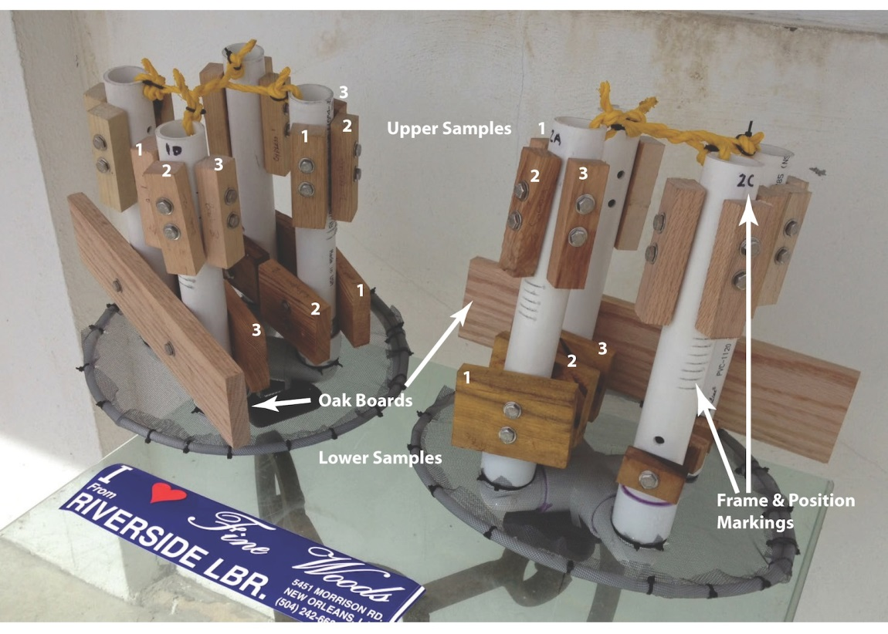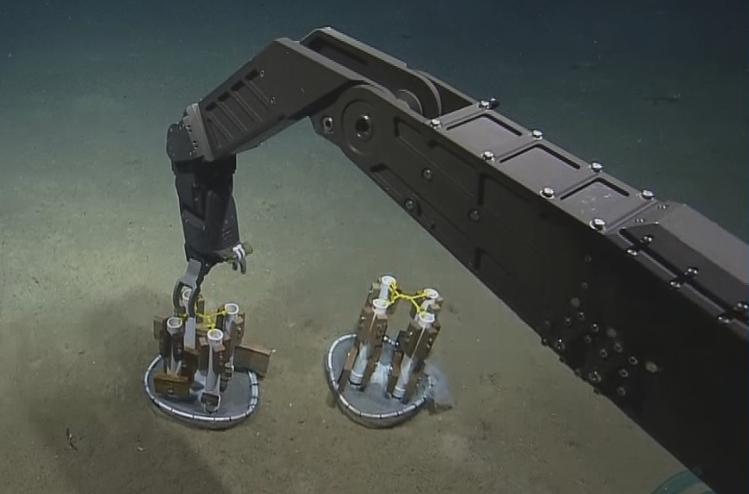

Appendix G Argo Float Deployment
Below is a proposal for Argo float deployments. The deployment locations will be modified to fit the ship’s cruise track.

Surveys of Opportunity - Initial Request Form

A surveys of opportunity is a small, exploratory expedition that takes advantage of the elastic schedules of ocean-going, research vessels, - in this case, the Okeanos Explorer - by maximizing transit times between ports or projects, or by filling smalls gaps in the ship’s calendar.
Given the ship’s unique technology and capabilities, NOAA’s Office of Ocean Exploration and Research (OER) invites regional researchers to help acquire additional data within the vessel’s operating areas to assess specific but poorly known sites, adding to an inventory of submerged resources. In circumstances where individuals cannot serve on a “survey of opportunity”, then OER ensures that acquired data and any other pertinent information are transferred to the appropriate researchers after the expedition. Previously successful surveys of opportunity have included mapping geological features, locating and characterizing shipwrecks, and defining marine protected areas. Some surveys are completed in only a few hours, while others last a couple days.
Although exploration potential and scientific merit plays a role in which opportunistic surveys are conducted, they are not chosen through a peer-reviewed process. Rather, their selection is based more on the vessel operating in the right place with the right equipment at the right time, and the ship’s calendar and on-board resources allow for the added work. All requests for a survey of opportunity are archived with OER and the ship, and expire only when the survey work is completed. There is no guarantee that any request for a survey will be accomplished, nor is there any system of prioritization or ranking. Keep in mind that this proposal may be available to the public upon request except for privileged information and material that is personal, proprietary or otherwise exempt from disclosure under law.

Survey or Project Name
U.S. Argo

Points of Contact (POC)
Lead POC or Principle Investigator (PI & Affiliation)  Molly Baringer – NOAA/AOML molly.baringer@noaa.gov  Tel: 305-361-4345 | Supporting Team Members ashore  Zach Barton – NOAA/AOML -zach.barton@noaa.gov – Tel: 305-361-4548  Pelle Robbins – WHOI - probbins@whoi.edu  Tel: 508 289 4917
 | Supporting Team Members aboard (if required)

Activities Description(s) (Include goals, objectives and tasks)
The objective of this activity is to deploy a number of Argo profiling floats into previously unreachable areas of the gulf of Mexico. To complete this objective, a representative from either the scientific group on board or from the vessel will need to deploy the float from the back of the vessel using a rope and a davit to lower the float into the water while the ship is underway. The goal will be to place floats in areas outside of the loop current so that the floats are able to stay in the waters of the Gulf and not be quickly advected into the Florida Current.

List of Participating Organizations
NOAA/AOML
WHOI

Duration (specific start and end dates, or expected length of survey)
Duration will be roughly 30 minutes per float, counting for mass startup time in the beginning and for deployment.

Area of Survey and Cruise Track Descriptions (please attach appropriate charts and include chart reference numbers)
Area of survey would be approximately 26°N, 85°W and 26°N, 90°W.

Conditions and Dependencies (e.g. water depths, special sea conditions, time constraints, sample storage, etc.)
Required water depths are at 2000m or greater. Also required would be storage for the floats which are 1x1x5 feet each, weighing approximately 50 Lbs each.

Procedures (e.g. deployment & recovery of instrument, required ship speed, instrument max depth, etc.)
Starting up of the floats will require a clear view of the sky, and for the floats to be put almost upright. (Can be leaned against the rail of a ship, for instance) a magnet swipe in the appropriate, labeled area will start the float. The starter will need to check the ballast bladders to ensure inflation and deflation. The floats will send messages to WHOI confirming proper startup. The starter will need to have access to e-mail or phone to be notified by WHOI or NOAA personnel as to status of float startup to ensure that no floats that may have malfunctioned will be deployed.
Deployment would be from rear of vessel, lowered into the water by rope until a starch disk releases and the deployment tethers are free of the box. Only one person is required for this, though more can make the deployment easier. Ship speed can be anything less than 20knots.

Sample Daily Operations Schedule (e.g. deployments per day, time per deployment, data recorded, etc.)
No specific daily operations are necessary. Deployments are based on location of vessel, so there may be more than one deployment per day based on ship speed and course.

Equipment/Systems Needed
Dynamic Positioning  A-Frame  J-Frame  Multibeam (EM302)  EK60 (ES18)  Sub-Bottom Profiler (Chirp 3260)  Seawater flow-through system  CTD Rosette  XBT launcher  SCS Outputs | Telepresence  ROV Sled  Hazardous Storage  Describe:  Other ship’s equipment(s):  Describe All:

Special Equipment (identify any PI-supplied gear that the ship will be requested to deploy)
Gear required to deploy floats (rope, releases, etc) will be supplied with shipment of floats or will be already attached to floats awaiting deployment.

Lead Time and Long Lead Time Items (e.g., permits, foreign nationals participation, etc)
The deployments are planned for US and international waters only. No foreign clearances are required. However, if another group were requesting foreign clearance for other purposes, we would consider modifying our deployment positions and the clearance request.

Shore-side support (besides staffing, what other coordination is needed, e.g. telepresence center)
n/a

Data, Products and Outputs (requested shipboard data processing, archiving and product generation, such as sonar processing, GIS layer creation, mosaic, video archiving, etc)
Only necessary data is time and position at deployment.

QUALITATIVE PARAMETERS

Why is this project considered “exploration”?
This project is considered exploration because historically, few deployments in this area of the gulf have occurred. This is due partly to ships not crossing the areas of depth required regularly. It is also due to the past floats not being able to handle areas of much less that 2000m. The newer floats are able to handle distance to bottom better.

How is this survey multidisciplinary? (Will various types of data be acquired by different user groups during the survey? Will the data products will be used by different users after the survey?)
The data for this survey is sent by the float to AOML where it is processed and then sent to the WMO Global Telecommunication System (GTS) which can be accessed by a number of institutions.

What is the public outreach potential for this project?
There are many avenues for public outreach, such as adopting a float where a school group can pick, or adopt, a specific float by its identifying numbers and track it over the course of their class. There are educational classroom materials available at http://www.argo.ucsd.edu/Educational_use.html via groups that participate in Argo around the world. There are also Google Earth overlays that can be used to track and view specific floats as well as the entire float array.

What will become of the data, imagery, information and samples after this survey? (Who is responsible for data archiving? How will the information be archived? Are there any intended publications from this survey? Will this data be used as leverage for follow-up investigation?)
The data will be sent to the GTS as noted before and also to the National Oceanographic Data Center (NODC) and to Coriolis, the official Argo data global data assembly center. The NODC will also archive the data. The data will be used by investigators worldwide, resulting in more than 100 publications each year.

What restrictions of confidentiality are placed on this request? (Can this request be shared with OER partners operating in the area who might be able to acquire these data? Is any part of this intended dataset sensitive and restricted? Are you willing to work with NOAA public affairs officials to report any discoveries made by this survey?
None.

If this project is maritime archeologically focused, what is the site’s archaeological or historical importance?
N/A

If this project is maritime archeologically focused, who has jurisdiction over the site, and have the appropriate agencies been contacted?
N/A

