Please use this as a template for documenting your recommendations for high-priority dive targets. Be sure to include a rationale for the dive as well as specific protocols (if applicable), and any known previous work or potential hazards at the site. Please include only generalized location information for any marine archaeology sites.
The form also includes fields for mapping targets and CTD cast locations.
Please send the completed form to Kelley.Elliott@noaa.gov and Jamie Austin (Jamie@utig.ig.utexas.edu)
Site Name: Many Mounds Shallow South
Approximate Location: 26.18592447; -84.73514218, 579m
Dive Date (local): 04/27/2014
Site maps:
Figure 1. Waypoints for dive (dots) overlaid on 5m multibeam bathymetry 3D view:
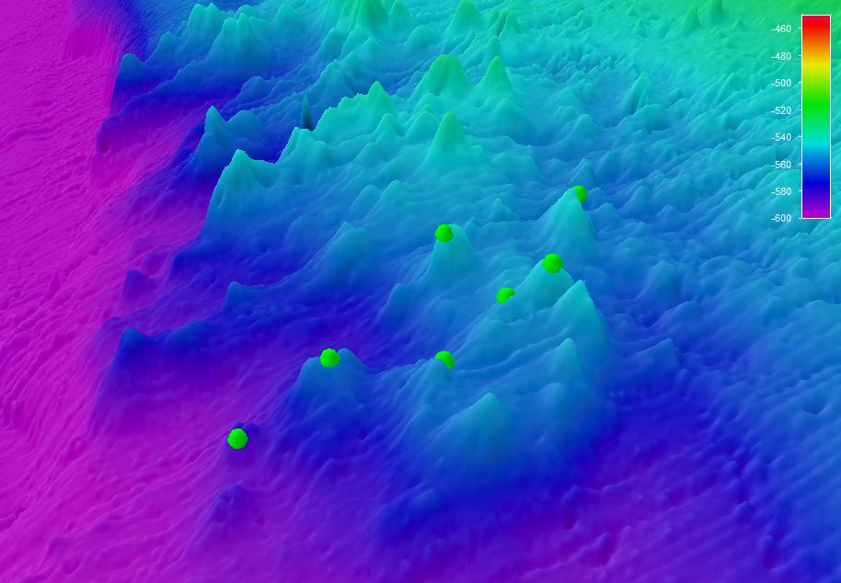
WP7
WP6
WP4
WP5
WP3
WP2
WP1

Figure 2. Waypoints for dive (dots) overlaid on 5m multibeam bathymetry (top) and slope (bottom) -- PLAN VIEW
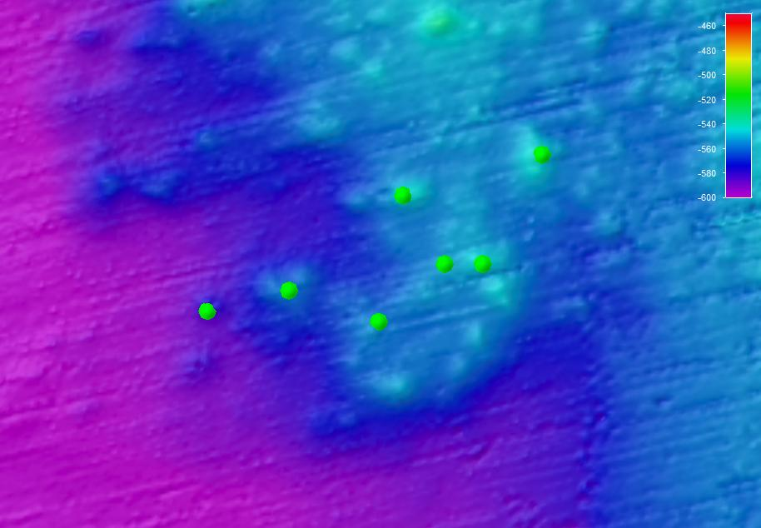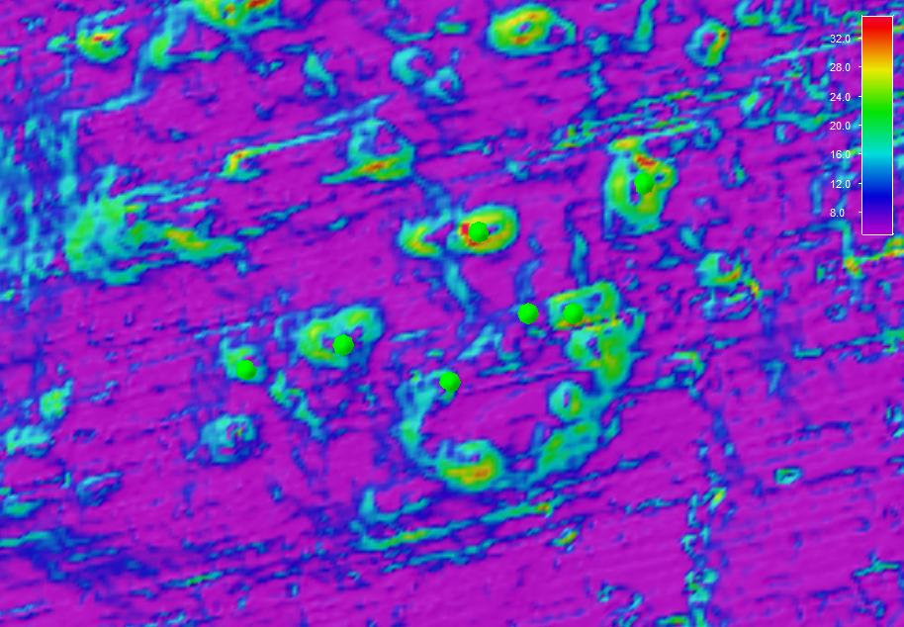
WP1
WP2
WP3
WP5
WP4
WP6
WP7
WP2
WP1
WP7
WP6
WP5
WP4
WP3

Figure 3. Waypoints for dive (dots) overlaid on 5m multibeam backscatter drape
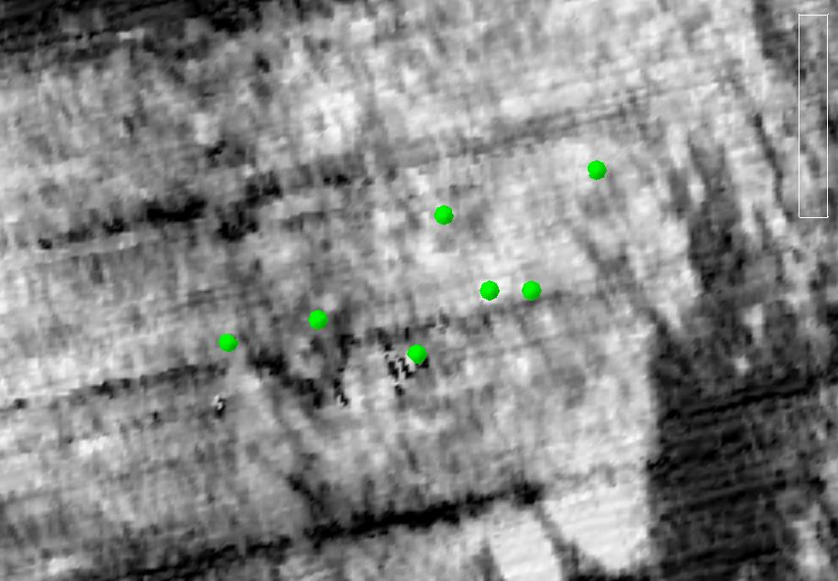
WP1
WP2
WP3
WP5
WP4
WP6
WP7
Waypoints for Bryant Canyon Shallow B (orange dots) overlaid on multibeam bathymetry (CCOM Law of the Sea 100m bathy dataset).
Brief Explanation of Exploration Objectives and Rationale for the Desired Dive Track:

The rationale for the dive track is that the high relief features in the 300-600 m depth range of the West Florida Escarpment are known and expected to support aggregations of Lophelia pertusa stony corals and Leiopathes sp. black corals within the depth range of bottom contact fisheries in the region.

The objective for the dive track is to estimate coral density, extent, diversity, and condition including the abundance and frequency of associated species and fishing debris. Lophelia pertusa, Leiopathes black corals, Paramuricea sea fans, golden crabs, and fishing gear are the primary subjects of interest.

The preferred methods are for the ROV to move along seafloor from Waypoint 1 to Waypoint 7 at a height of 0.25 to 1.0 meters (whatever is normal) and a speed of approximately 0.25 - 0.33 knots. The transect length is approximately 1 km linear distance. Lasers should be on and in view at all times, unless these are requested to be turned off for imaging. Two different colored sets of lasers are preferred if they are available, one set (red) at 10 cm and another set (green) at 1 m.

Large (> 50 cm) black corals and sea fans are primary imaging targets. These should be closely observed using a forward looking camera for associated invertebrates, health and condition, measures of colony height and width, and for Leiopathes and Paramuricea colonies, close inspection of the width of the primary axis at the holdfast for estimates of colony age.

Before and following the dive, the region indicated below should be mapped using multibeam sonar to achieve the highest possible resolution and accuracy of topography and backscatter.

Has previous work been conducted here? Are there potential hazards in the area?
Yes, there have been some dives in the vicinity. No hazards have been reported. Fishermen and fishing gear have been observed on nearby sites.

ROV Track Waypoints Table:
DESIRED WAYPOINTS TO EXPLORE -  (COMPLETED BY SHORE-SIDE SCIENTIST)  (not including launch) |  |  |  | ACTUAL WAYPOINTS TO EXPLORE-  (COMPLETED BY SHIPBOARD EXPEDITION LEADER)
WAYPOINT NAME/SEQUENCE | LATITUDE | LONGITUDE | APPROX DEPTH | WAYPOINT NAME/SEQUENCE | LATITUDE | LONGITUDE | APPROX  DEPTH
Launch |  |  |  | Launch
WP1 | -84.73514218 | 26.18592447 | -579.39 | WP1
WP2 | -84.73382084 | 26.18625481 | -561.90 | WP2
WP3 | -84.73236737 | 26.18574828 | -558.73 | WP3
WP4 | -84.73129928 | 26.18668424 | -554.24 | WP4
WP5 | -84.73068266 | 26.18668424 | -545.09 | WP5
WP6 | -84.73197097 | 26.18779636 | -546.06 | WP6
WP7 | -84.72972469 | 26.18845703 | -544.35 | WP7
Recovery |  |  |  | Recovery

ANCILLARY INFORMATION:

mapping operations REQUEST / Recommended operations in the target area prior to or after ROV dive

 | LATITUDE | LONGITUDE | APPROX DEPTH
MULTIBEAM BOUNDING COORDINATES
Upper left | 26.21667 | -84.74167 | -600
Lower right | 26.17917 | -84.69167 | -300

