Please use this as a template for documenting your recommendations for high-priority dive targets. Be sure to include a rationale for the dive as well as specific protocols (if applicable), and any known previous work or potential hazards at the site. Please include only generalized location information for any marine archaeology sites.
The form also includes fields for mapping targets and CTD cast locations.
Please send the completed form to Kelley.Elliott@noaa.gov and Jamie Austin (Jamie@utig.ig.utexas.edu)

Site Name: CIOERT Request Site 2: Large Mound
Approximate Location: 26°22'39.615"N, 84°46'27.087"W; 550-450 m
Dive Date (local): DATE (YYYY/MM/DD)
Site map:
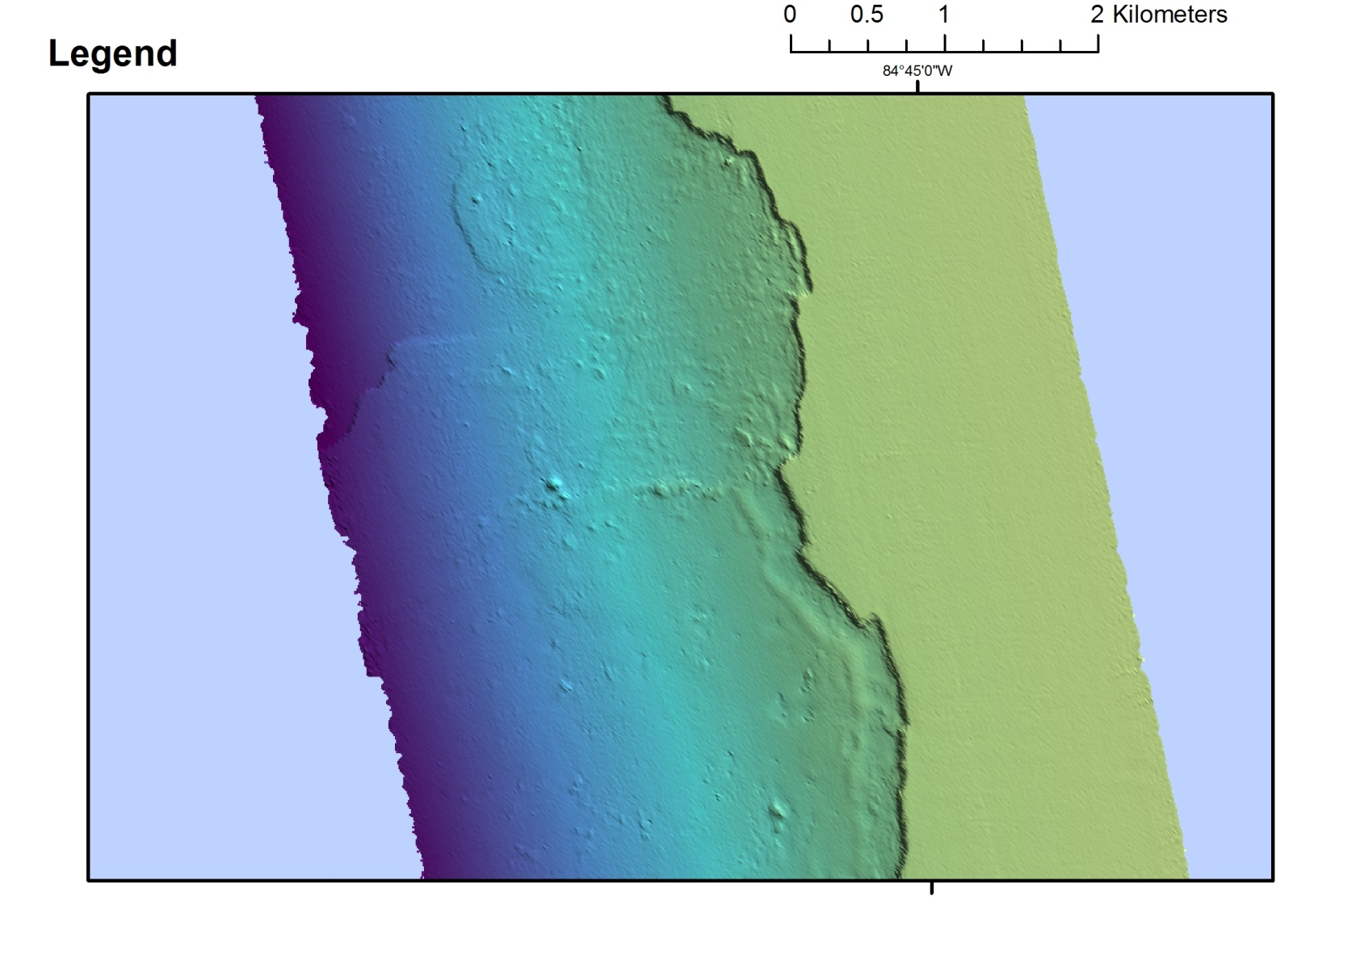

Brief Explanation of Exploration Objectives and Rationale for the Desired Dive Track:
This region is largely unexplored. There have been limited ROV/HOV dives, these dives showing large Lophelia bioherms that are currently unprotected and open to fishing and crabbing. The golden crab (Chaceon fenneri) fishery could decimate the fragile Lophelia reefs very quickly. More research in the area could lead to a protection status.

Has previous work been conducted here? Are there potential hazards in the area?
We have some very limited data regarding the 500 m escarpment region about 10 nmi north of Etnoyer’s ‘Many Mounds’. Our sites included a few Innovator ROV dives we made from the Ron Brown in 2003, and Johnson-Sea-Link Submersible dives in August 2010. In addition, JASON ROV Dive 542 was made (November 2010; S. Ross) in the region of ‘Many Mounds’.
The rock and Lophelia mounds are scattered on the terrace at the base of the escarpment and are not easily distinguishable from each other in the available multibeam.

Known Lophelia Mound Sites:
19-VII-10-3: 26 20.159’N, 84 45.356’W; 501-485; 15 m relief; dense live Lophelia pertusa = 3788
3-VIII-10-1: 26 20.0901’N, 84 45.5702’W; 516-474 m; 40 m relief; dense live Lophelia pertusa = JSL 3809

Suggested waypoints below were selected based on the unexplored mounds 4 km north of previously dived sites. Each waypoint is the center of a supposed mound on multibeam. Total transect length: 0.75 km.
The multibeam suggestion is a small area surrounding the mounds- As high resolution as possible is requested.

ROV Track Waypoints Table:
DESIRED WAYPOINTS TO EXPLORE -  (COMPLETED BY SHORE-SIDE SCIENTIST)  (not including launch) |  |  |  | ACTUAL WAYPOINTS TO EXPLORE-  (COMPLETED BY SHIPBOARD EXPEDITION LEADER)
WAYPOINT NAME/SEQUENCE | LATITUDE | LONGITUDE | APPROX DEPTH | WAYPOINT NAME/SEQUENCE | LATITUDE | LONGITUDE | APPROX  DEPTH
Launch |  |  |  | Launch
WP1 | 26°22'39.615"N | 84°46'27.087"W | 450-550 | WP1
WP2 | 26°22'36.912"N | 84°46'24.603"W |  | WP2
WP3 | 26°22'38.836"N | 84°46'1.53"W |  | WP3
WP4 |  |  |  | WP4
WP5 |  |  |  | WP5
Recovery |  |  |  | Recovery

ANCILLARY INFORMATION:

mapping and CTD operations REQUEST / Recommended operations in the target area prior to or after ROV dive
Please include requests for in situ sensors (LSS, DO, ORP) to be added to the CTD cast here, and specifics on the type of mapping operation requested (multibeam, subbottom, single beam).

 | LATITUDE | LONGITUDE | APPROX DEPTH
CTD CASTS
1
2
3
4
MULTIBEAM BOUNDING COORDINATES
North | 26°23'4.32"N
East |  | 84°46'1.327"W | 450-500 m
South | 26°22'14.779"N
West |  | 84°46'47.292"W

