Please send the completed form to Kelley.Elliott@noaa.gov and Jamie Austin (Jamie@utig.ig.utexas.edu)

Site Name: Monterrey Shipwreck B
Approximate Locations: 26.9°N, -92.9°W, 1330 meters
Dive Date (local): TBD
Site map:
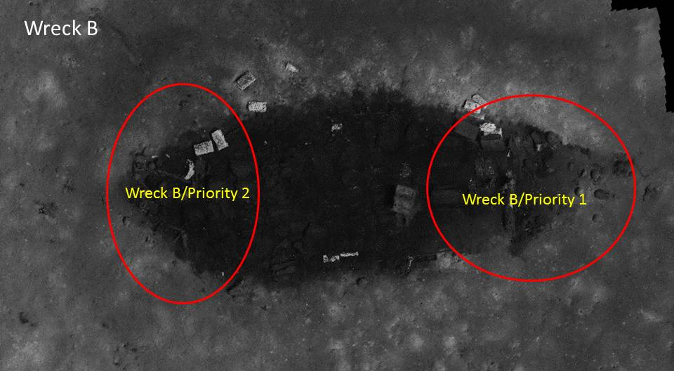
Locations of priority areas for biological documentation in stern (1) and bow (2) areas of Shipwreck B.

Brief Explanation of Exploration Objectives and Rationale for the Desired Dive Track:

Initial visits in 2013 by E/V Nautilus to Monterrey Shipwreck B revealed a concentrated microcosm of hard bottom species inhabiting a variety of substrate types created by the shipwreck. Many of these species are likely to be found elsewhere on hard surfaces in the western Gulf of Mexico, but some have rarely been seen in the past, and others are likely to be new species. There is also evidence that chemosynthesis may be supporting some species in conditions uniquely established by the contents and materials of the shipwreck itself. To explore the species present, the distribution of biological communities and the ecological processes functioning on the shipwreck, ROV surveys are proposed for this and the two other shipwrecks in the vicinity.
The first visit to Monterrey Shipwreck B in 2013 lasted approximately two hours. Its unique cargo, dominated by hides and tallow, also including a variety of ceramic and glass containers, navigational instruments, plates, cups, intact wooden boxes, and hardware, make this site particularly interesting for an assessment of biological assemblages. This visit will allow us to do a more comprehensive biological survey of the shipwreck. It will also provide an opportunity to further document the extraordinary artifacts at the site. Of particular interest is the artifacts in Priority Area 1 as viewed from the port side of the vessel, detailed imagery of the sides and edges of the hide rolls and tallow blocks, and documentation of the corrosion on the stove. There is also a need to map the sediments underlying the shipwreck to better understand the subsurface extent of the site, and the physical controls on biological community development and preservation of the shipwreck itself. Therefore, sub-bottom profile mapping in addition to ROV surveys is proposed for the shipwreck site. No artifact collection will occur on this mission.

Has previous work been conducted here? Are there potential hazards in the area?

E/V Nautilus used ROVs to explore Monterrey Shipwreck B briefly in 2013. The primary purpose of the 2014 mission is to more fully document fauna on the shipwreck using high-quality video imagery. Documentation will include close-up imagery of sessile and mobile fauna. Communities are likely to consist of sea anemones, hydroids, octocorals, solitary hard corals, sponges, barnacles, shipworms, crustaceans (primarily squat lobsters, shrimp, and crabs), and fish. Some locations (e.g., hide rolls) may also contain bacterial mats or small numbers of chemosynthetic tubeworms. Our goal is to document fauna on as many types of material as possible at the shipwreck site, as well as those with no clear affinities to shipwreck materials (fish, crabs, and water column species). High-resolution imagery of organisms in all these groups will help biologists identify them and compare assemblages on different substrates, compare shipwrecks, and compare these assemblages to those on natural other man-made hard surfaces in the region (e.g., deep oil and gas installations).

ROV Track Waypoints Table: (see images above for priority areas for documentation at each wreck site)
DESIRED WAYPOINTS TO EXPLORE -  (COMPLETED BY SHORE-SIDE SCIENTIST)  (not including launch) |  |  |  | ACTUAL WAYPOINTS TO EXPLORE-  (COMPLETED BY SHIPBOARD EXPEDITION LEADER)
WAYPOINT NAME/SEQUENCE | LATITUDE | LONGITUDE | APPROX DEPTH | WAYPOINT NAME/SEQUENCE | LATITUDE | LONGITUDE | APPROX  DEPTH
Launch |  |  |  | Launch
WP1 |  |  |  | WP1
WP2 |  |  |  | WP2
WP3 |  |  |  | WP3
WP4 |  |  |  | WP4
WP5 |  |  |  | WP5
Recovery |  |  |  | Recovery

mapping and CTD operations REQUEST / Recommended operations in the target area prior to or after ROV dive
Please include requests for in situ sensors (LSS, DO, ORP) to be added to the CTD cast here, and specifics on the type of mapping operation requested (multibeam, subbottom, single beam).

 | LATITUDE | LONGITUDE | APPROX DEPTH
CTD CASTS
1
2
3
4
MULTIBEAM BOUNDING COORDINATES
North
East
South
West

