Please send the completed form to Kelley.Elliott@noaa.gov and Jamie Austin (Jamie@utig.ig.utexas.edu)

Site Name: Monterrey Shipwreck A
Approximate Locations: 26.8°N -93.5°W, Depth 1330 meters
Dive Date (local): TBD
Site map:
Location of wood experiment arrays off the stern of Monterrey Shipwreck A. Yellow ovals are areas of the vessel with a variety of substrate types containing fauna slated for further documentation. Green ovals are priority sites for archaeological follow-up surveys. See below for image of stern area, showing the location of wood experimental arrays.

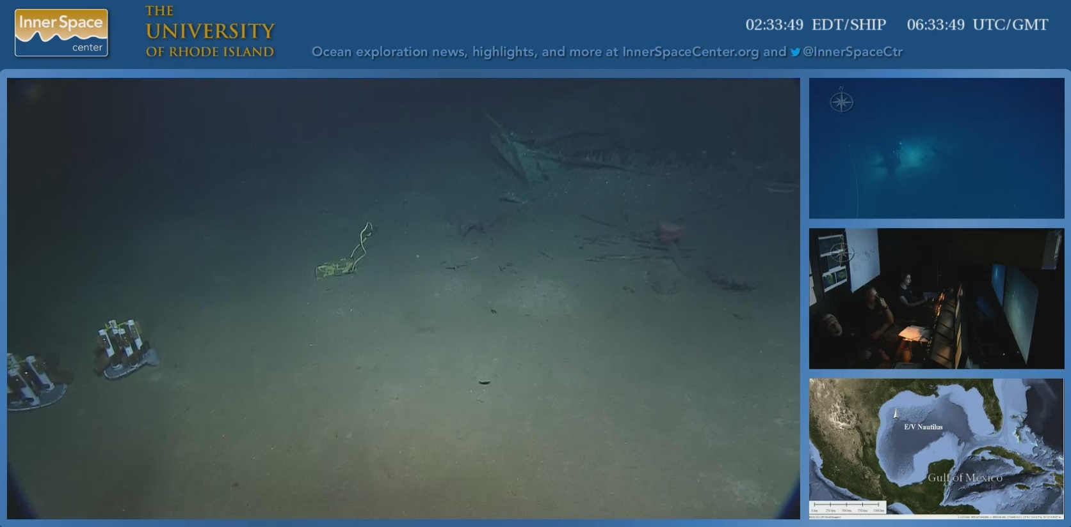

Brief Explanation of Exploration Objectives and Rationale for the Desired Dive Track:

Initial visits in 2013 by E/V Nautilus to Monterrey Shipwreck A found a well preserved mix of containers, plates, cups, navigational instruments, medical supplies, anchors, muskets, guns, hardware, copper sheathing, and wood. Many of these artifacts harbored hard-bottom species that are likely to be found elsewhere in the western Gulf of Mexico, including sea anemones, hydroids, octocorals, solitary hard corals, sponges, shipworms, barnacles, crustaceans (primarily squat lobsters, shrimp, and crabs), and fish. Some locations also contain bacterial mats or small numbers of chemosynthetic tubeworms. Some species have rarely been seen in the past, and others are likely to be new species. There is also evidence that chemosynthesis may be supporting some species in conditions uniquely established by the contents and materials of the shipwreckitself. To further explore the species present, the distribution of biological communities and the ecological processes functioning on the shipwreck, ROV surveys are proposed for this and two other shipwrecks found in the vicinity.
The first visits to the shipwreck were primarily for archaeological survey, though some documentation of fauna was conducted. There is also a need to map the sediments underlying the shipwreck to better understand the subsurface extent of the site, as well as the physical controls on biological community development and preservation of the shipwreck itself. Therefore, sub-bottom profile mapping in addition to ROV surveys is proposed for the shipwreck site. No artifact collection will occur on this mission.

In 2013, two experimental arrays were deployed at Monterrey Shipwreck A. These experiments are investigating the processes of degradation on different wood types used in the construction of early 19th century vessels. A goal of the 2014 mission is to observe these experiments and potentially collect the arrays if ROV observations determine that deterioration of the wood has been extensive. It is requested that the ROV collect the arrays, which are 15 inches in diameter and 15 inches tall, and have a 5 lb weight on the bottom of each array. Covers are being constructed to place over each array before collection to ensure samples are not lost during ascent. If deterioration of the wood has not advanced, the experiments will not be collected and will remain for a future mission to the site.
Regarding priorities, the highest priority for Shipwreck A is to evaluate the condition of the wood experimental arrays and decide whether to retrieve them or leave them in place. The second level priority is documentation of fauna in the yellow ovals on the map above by collecting close-up, high-definition imagery. The third level priority is imagery of “heavy” artifacts for the subsequent development of lift-rig scenarios including the pivot gun/carronade/anchor concreted assemblage, stove, and “printer” (green ovals on map). If time is limited, the second and third level priorities are lower than documenting the priority areas shown in the dive plans for Shipwreck B and Shipwreck C. If time allows, however, it is expected that adequate documentation would require 3-4 hours on Shipwreck A before transiting to the other shipwrecks.

Has previous work been conducted here? Are there potential hazards in the area?

Okeanos Explorer used an ROV to explore Monterrey Shipwreck A in 2012. The shipwreck was visited again in 2013 using ROV surveys by E/V Nautilus. The primary purpose of the 2014 mission is to more fully document fauna on the shipwreck using high-quality video imagery. Documentation will include close-up imagery of sessile and mobile fauna. High-resolution imagery of organisms in all these groups will help biologists identify them and compare assemblages on different substrates, compare shipwrecks, and compare these assemblages to those on natural other man-made hard surfaces in the region (e.g., deep oil and gas installations).

ROV Track Waypoints Table: (see images above for priority areas for documentation)
DESIRED WAYPOINTS TO EXPLORE -  (COMPLETED BY SHORE-SIDE SCIENTIST)  (not including launch) |  |  |  | ACTUAL WAYPOINTS TO EXPLORE-  (COMPLETED BY SHIPBOARD EXPEDITION LEADER)
WAYPOINT NAME/SEQUENCE | LATITUDE | LONGITUDE | APPROX DEPTH | WAYPOINT NAME/SEQUENCE | LATITUDE | LONGITUDE | APPROX  DEPTH
Launch |  |  |  | Launch
WP1 |  |  |  | WP1
WP2 |  |  |  | WP2
WP3 |  |  |  | WP3
WP4 |  |  |  | WP4
WP5 |  |  |  | WP5
Recovery |  |  |  | Recovery

mapping and CTD operations REQUEST / Recommended operations in the target area prior to or after ROV dive
Please include requests for in situ sensors (LSS, DO, ORP) to be added to the CTD cast here, and specifics on the type of mapping operation requested (multibeam, subbottom, single beam).

 | LATITUDE | LONGITUDE | APPROX DEPTH
CTD CASTS
1
2
3
4
MULTIBEAM BOUNDING COORDINATES
North
East
South
West

