Okeanos Explorer ROV Dive Summary
Site Name | GB907 |  |  |  | 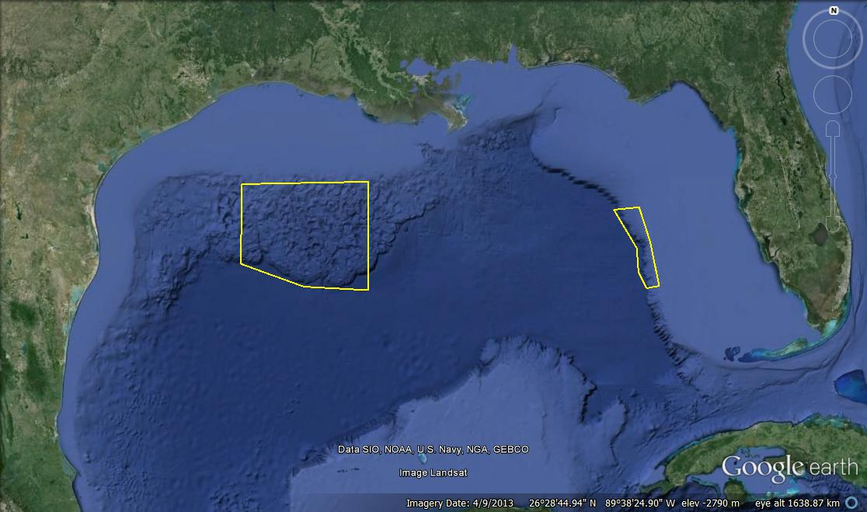
Expedition Coordinator/  ROV Lead | Kelley Elliott/  Brian Bingham
Science Team Leads | Stephanie Farrington (Biology)  Jamie Austin (Geology)
General Area Descriptor | Gulf of Mexico
ROV Dive Name | Cruise Season |  | Leg |  |  | Dive Number
 | EX1402 |  | 3 |  |  | DIVE02
Equipment Deployed | ROV: |  | Deep Discoverer
 | Camera Platform: |  | Seirios
ROV Measurements | CTD |  | Depth |  |  | Altitude
 | Scanning Sonar |  | USBL Position |  |  | Heading
 | Pitch |  | Roll |  |  | HD Camera 1
 | HD Camera 2 |  | Low Res Cam 1 |  |  | Low Res Cam 2
 | Low Res Cam 3 |  | Low Res Cam 4 |  |  | Low Res Cam 2
Equipment Malfunctions | N/A
ROV Dive Summary  (From processed ROV data) | Dive Summary: EX1402L3_DIVE02  ^^^^^^^^^^^^^^^^^^^^^^^^^^^^^^^^^^^^^^^^^^^^^^^^^^^  In Water at: 2014-04-13T13:45:38.439000  27°, 05.899' N ; 092°, 37.310' W  Out Water at: 2014-04-13T19:12:34.841000  27°, 05.096' N ; 092°, 36.588' W  Off Bottom at: 2014-04-13T18:24:04.035000  27°, 05.455' N ; 092°, 36.956' W  On Bottom at: 2014-04-13T14:31:16.507000  27°, 05.519' N ; 092°, 37.099' W  Dive duration: 5:26:56  Bottom Time: 3:52:47  Max. depth: 1266.7 m
Special Notes
Scientists Involved  (please provide name / location / affiliation / email) | Primary  Jamie Austin, EX, UT Austin, jamie@utig.ig.utexas.edu  Stephanie Farrington, EX, HBOI/FAU, sfarrington@fau.edu  Andrea Quattrini, Temple, Temple, andrea.quattrini@temple.edu  Bernie Ball, Duke, Duke, bernieb@duke.edu  Brian Kinlan, NOAA NMFS, Brian.Kinlan@noaa.gov  Carolyn Ruppel, Woods Hole, USGS, cruppel@usgs.gov  Erik Cordes, Temple, Temple, erik.cordes@temple.edu  Larry Mayer, UNH, UNH CCOM, lmayer@ccom.unh.edu  Michael Vecchione, Washington, DC, NOAA NMFS, VecchioneM@si.edu  Robert Carney, LSU, LSU, rcarne1@lsu.edu
Purpose of the Dive
The geological objectives of dive 2, the second dive proposed by the Bureau of Ocean Energy Management (BOEM), involved: 1) the search for cold seeps, escape of bubbles/oil from the seafloor as indicated by multibeam bathymetry “bubble stream anomalies”, and 2) confirmation that high backscatter returns from the bathymetric high/ridge on which this dive was conducted correlated with (carbonate) hardgrounds on or near the seafloor. Both objectives were confirmed.

Description of the Dive:
Geological Summary
The dive began in ~1260 m of water, and water depth barely varied throughout the dive. A total of four suspected seep locations were investigated before the dive was cut short (by several hours) by an intake water issue (i.e., clogging with seaweed) with the ship’s main engines.
The first spectacular discovery was an encounter (en route from the first waypoint, near the first suspected seep locale, to the second) with an irregularly shaped brine pool, complete with evidence for tributaries. Such brine accumulations were expected by BOEM, as there was (commercial) seismic evidence for surfacing of evaporites at or near the seafloor in this vicinity. The pool was tens of meters long, with an irregular “shoreline”. Scattered carbonate hardgrounds marked its periphery, encrusted by a variety of biological organisms (see biological summary). Depth of the pool was undetermined. However, the D2 temperature probe was inserted into the pool (no temperature anomaly above ambient, ~4.5 degrees C), and its 3 cm length appeared to reach the bottom of the brine. The bottom of the pool was black in color; orange staining generally marked its periphery. At one location, gas was observed escaping directly from the bottom of the pool through the brine/seawater interface, without apparently disturbing that interface.
The second discovery occurred mid-way between the second and third suspected seep localities. Associated with a small carbonate hardground outcrop, multiple streams of escaping oil droplets (escaping at varying rates, but at rates of multiple droplets/min) were observed emanating from a living mussel bed. A gas stream was also observed. A variety of encrusting biology was associated with this and neighboring outcrops (see biological summary).
As D2 was leaving the seafloor at the premature termination of the dive, another closed depression which could at one time have held brine (discolored base, staining around the periphery) was observed. No brine was observed in this depression, but a complete inspection of this depression could not be made in the time available.
Biological Summary
The brine pool was a unique habitat on this dive. There were many white/pink unidentified Sagartiid-like anemones; Clavularia sp. (Octocorallia) were rare, and a Chaceon-like unidentified, brachyuran crab. The Brisingidae asteroid appeared again on this dive near the brine pool along with Chrysogorgia sp. (Octocorallia). A few fish species including: Urophycis sp. and eelpout fish were also sighted here. The Polychaete- Lamellibranchia sp. were very common appearing on most of the rock structures around the brine pool and were 10-30 cm long indicating they were 100+ years old. Alvinocaris shrimp were common. Interestingly a few Pogonophora sp. (beard worms) were seen sticking out of the surface of the brine pool, possibly showing the brine pool may fluctuate in depth (like a tide pool). There were also tiny “fuzzy-tree” foraminiferans sitting on the rocks around the pool. There was nothing macrobiotic living under the “surface” of the brine pool however, there was a dead pycnogonid and pyrosoma identified.
In the sediment areas between hardbottom, the swimming holothurian- Paelopatides sp. was common, often leaving the benthos when disturbed. Otherwise it was fairly barren with light Bioturbation.
The hardbottom area associated with seep sites (oil and gas bubbles were sighted) had the usual fauna including: buccinid muscles, chitons, Alvinocaris sp. shrimp, an unidentified, white urchin was common, Lamellibranchia sp. and Chrysogorgia sp. also appeared on the hard bottom. Stoloniferous octocorals were first sighted here. The unidentified white sponge, seen previously, was rare but present. There was a cluster of not previously seen small, white, unidentified ophioroids living between the muscles as well as venus fly trap anemones. A few cusk eel were also sighted.
Overall Map of ROV Dive Area |  |  |  | Close-up Map of Main Dive Site
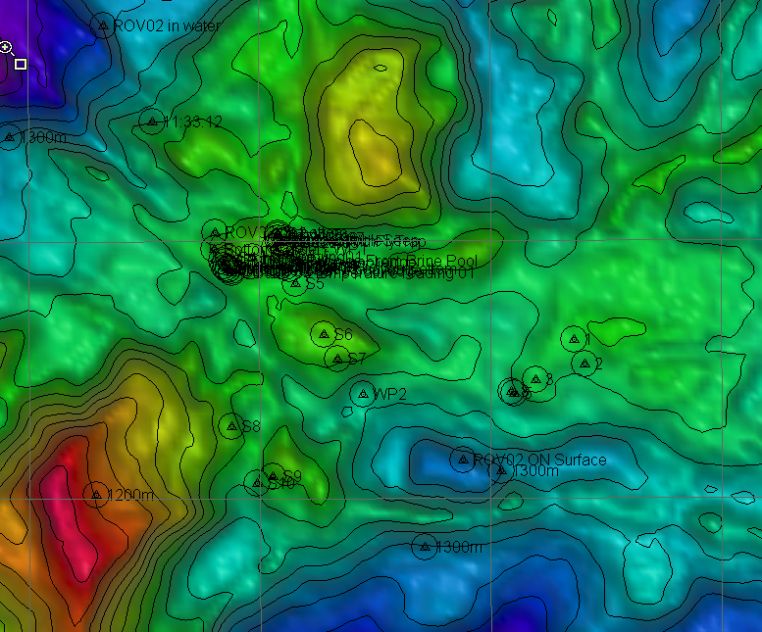 |  |  |  | 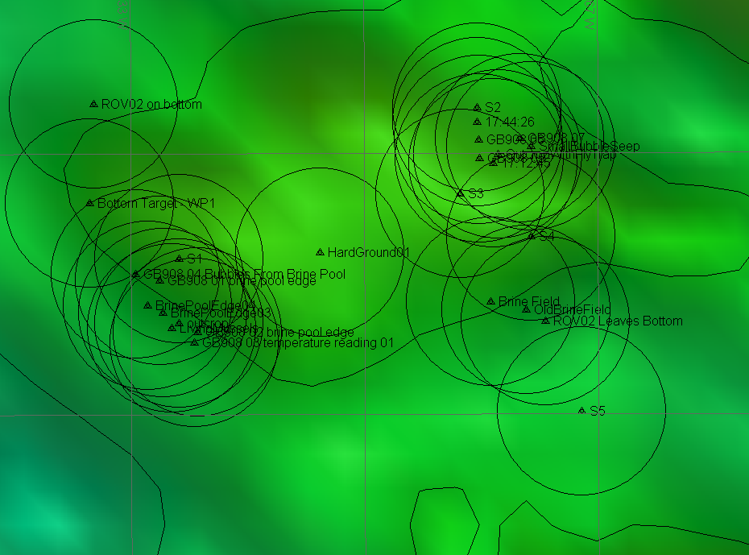
Representative Photos of the Dive
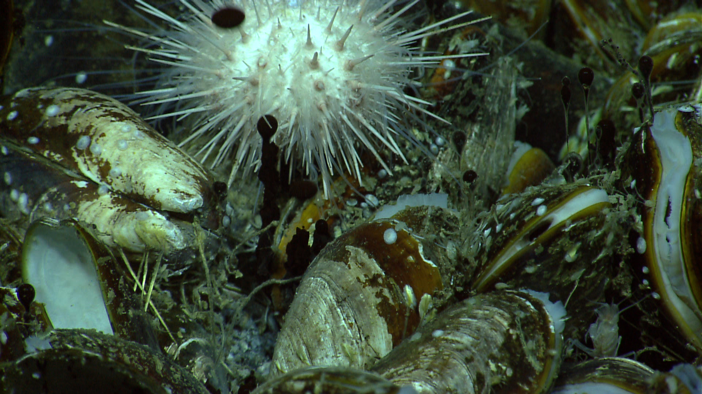 |  |  |  | 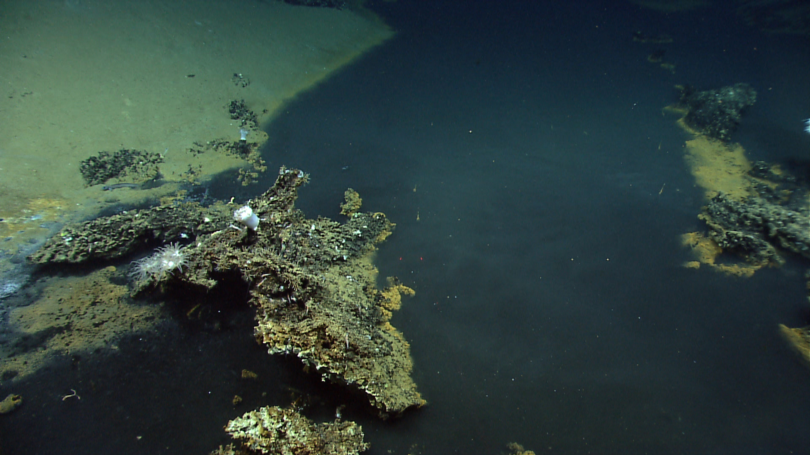
Oil droplets bubbling out of between buccinid muscles in front of a white unidentified urchin, |  |  |  | The ‘shoreline’ of the brine pool.
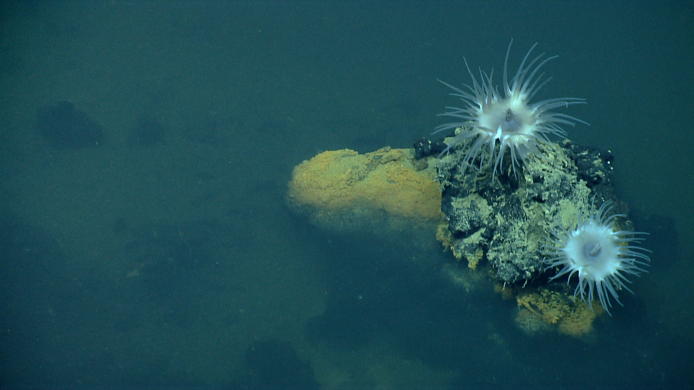 |  |  |  | 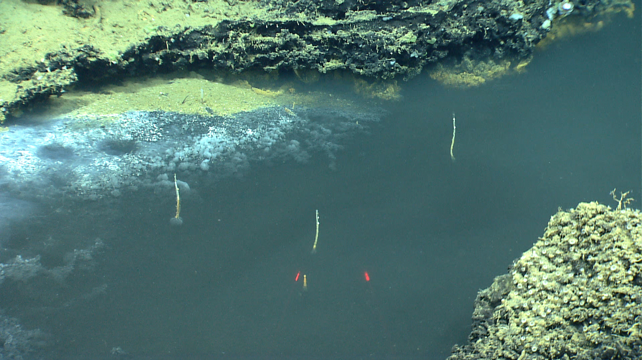
Unidentified anemones on an island in the brine pool |  |  |  | Pogonophora sp. (beard worms) were seen sticking out of the surface of the brine pool.
Please direct inquiries to: |  | NOAA Office of Ocean Exploration & Research  1315 East-West Highway (SSMC3 10th Floor)  Silver Spring, MD 20910  (301) 734-1014

