**NOAA *Okeanos Explorer* Program**

**MAPPING DATA REPORT**

**CRUISE EX1305**

Summer Ecosystem Monitoring Survey

August 2 – September 5, 2013

North Kingstown, RI to North Kingstown, RI

Report Contributors:

Mashkoor Malik, Jacklyn James, Jerry Prezioso

5 September, 2013

NOAA Office of Ocean Exploration and Research Northeast Fisheries Science Center

1315 East-West Hwy, SSMC3, #10210 National Marine Fisheries Service

Silver Spring, MD 20910 28 Tarzwell Drive, Narragansett, RI 02882



# Introduction



**The *Okeanos Explorer* Program**

Commissioned in August 2008, the NOAA Ship *Okeanos Explorer* is the nation’s only federal vessel dedicated to ocean exploration. With 95% of the world’s oceans left unexplored, the ship’s combination of scientific and technological tools uniquely positions it to systematically explore new areas of our largely unknown ocean. These exploration cruises are explicitly designed to generate hypotheses and lead to further investigations by the wider scientific community.

Using a high-resolution multibeam sonar with water column capabilities, a deep water remotely operated vehicle, and telepresence technology, *Okeanos Explorer* provides NOAA the ability to foster scientific discoveries by identifying new targets in real time, diving on those targets shortly after initial detection, and then sending this information back to shore for immediate near-real-time collaboration with scientists and experts at Exploration Command Centers around the world. The subsequent transparent and rapid dissemination of information-rich products to the scientific community ensures that discoveries are immediately available to experts in relevant disciplines for research and analysis

Through the *Okeanos Explorer* Program, NOAA’s Office of Ocean Exploration and Research (OER) provides the nation with unparalleled capacity to discover and investigate new oceanic regions and phenomena, conduct the basic research required to document discoveries, and seamlessly disseminate data and information-rich products to a multitude of users. The program strives to develop technological solutions and innovative applications to critical problems in undersea exploration and to provide resources for developing, testing, and transitioning solutions to meet these needs.

***Okeanos Explorer* Management – a unique partnership within NOAA**

The *Okeanos Explorer* Program combines the capabilities of the NOAA Ship *Okeanos Explorer* with shore-based high speed networks and infrastructure for systematic telepresence-enabled exploration of the world ocean. The ship is operated, managed and maintained by NOAA’s Office of Marine and Aviation Operations, which includes commissioned officers of the NOAA Corps and civilian wage mariners. OER owns and is responsible for operating and managing the cutting-edge ocean exploration systems on the vessel (ROV, mapping and telepresence) and ashore including Exploration Command Centers and terrestrial high speed networks. The ship and shore-based infrastructure combine to be the only federal program dedicated to systematic telepresence-enabled exploration of the planet’s largely unknown ocean.

Table of Contents

1. Introduction 2

2. Report Purpose 4

3. Cruise Objectives 4

4. Participating Personnel 5

5. Summary of Results 6

a. EK 60 operations 7

b. Jordan Basin Mapping 7

c.Schoodic Ridge mapping 7

d.Wilkinson basin focused mapping areas 7

6. Mapping Statistics 7

7. Mapping Sonar Setup 7

8. Data Acquisition and processing summary 8

9. Data Archival Procedures 8

10. Cruise Calendar 13

11. References 13

12. Appendices 14

Appendix A: Tables of data files collected 14

Appendix B: EM302 description and operational specs 17

Appendix C: Acronyms and abbreviations 20

# Report Purpose

The purpose of this report is to briefly describe the mapping data collection and processing methods, and to report the major results of the cruise. For a detailed description of the *Okeanos Explorer* mapping capabilities, see Appendix B as well as the ship’s readiness report, which can be obtained by contacting the ships Operations Officer ([ops.explorer@noaa.gov](mailto:ops.explorer@noaa.gov)).

This report focuses on mapping activities during EX1305 only.

# Cruise Objectives

The cruise had numerous objectives to address research goals of several programs within the Ecosystem Process Division of the NEFSC and outside collaborators including: climate research program, Ocean acidification program, ecosystem science in support of stock assessments program, science in support of ecosystem assessments program, development of new technologies to support ecosystem studies, habitat mapping and NEFSC outreach and education objectives. The specific objectives included [1]:

1) Assess changing biological and physical conditions which influence the sustainable productivity of the living marine resources of the northeast continental shelf ecosystem using CTD’s and bongo nets at stations located at predetermined randomly stratified locations. CTD will collect electronic data on temperature, salinity, density, and oxygen.

2) Trends in ocean acidification and nutrient levels will be determined by collecting water samples using a rosette sampler at predetermined fixed locations.

3) Detail incursion of Labrador Current water into the Gulf of Maine by conducting CTD casts in deep basin areas.

4) Collect samples for the Census of Marine Zooplankton Project by the use of 20-cm bongos piggybacked above the 61-cm bongos.

5) Analyze the size spectrum of water column particles using the Laser In-Situ Scattering and Transmissometry (LISST) instrument.

6) Determine the abundance and distribution of larval and juvenile yellowtail flounder (*Limanda* *ferruginea*) in the survey areas surveyed.

7) Report northern right whale and other marine mammal bird and turtle sightings.

8) Collect acoustic data using the EK60 single beam unit from along the cruise track, as well as SCS data.

9) Collect data with new optical plankton equipment, the Imaging FlowCytobot plumbed into the Scientific Seawater System

10) Conduct sea floor mapping in the Wilkinson and Georges Basin areas of the Gulf of Maine.

11) Conduct opportunistic Isaacs-Kidd midwater trawls near areas of puffin habitat that are near our planned cruise track in the Gulf of Maine.

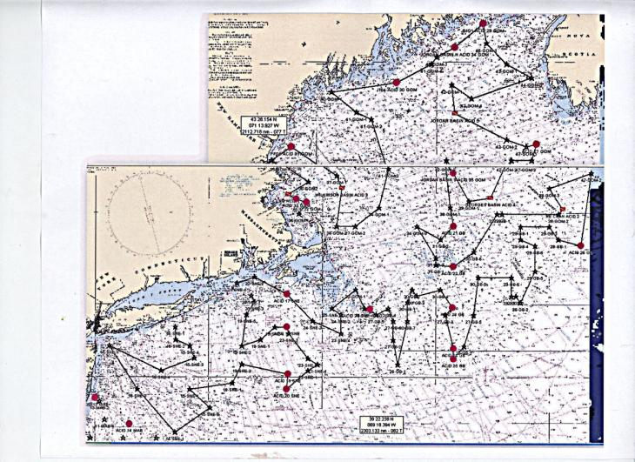

Figure 1. Proposed cruise track for *Okeanos Explorer* Summer Ecosystems Monitoring Survey, during 23 August – 4 September 2013. (Image from [1])

***Note: Objectives # 8 and 10 are addressed in this report.***

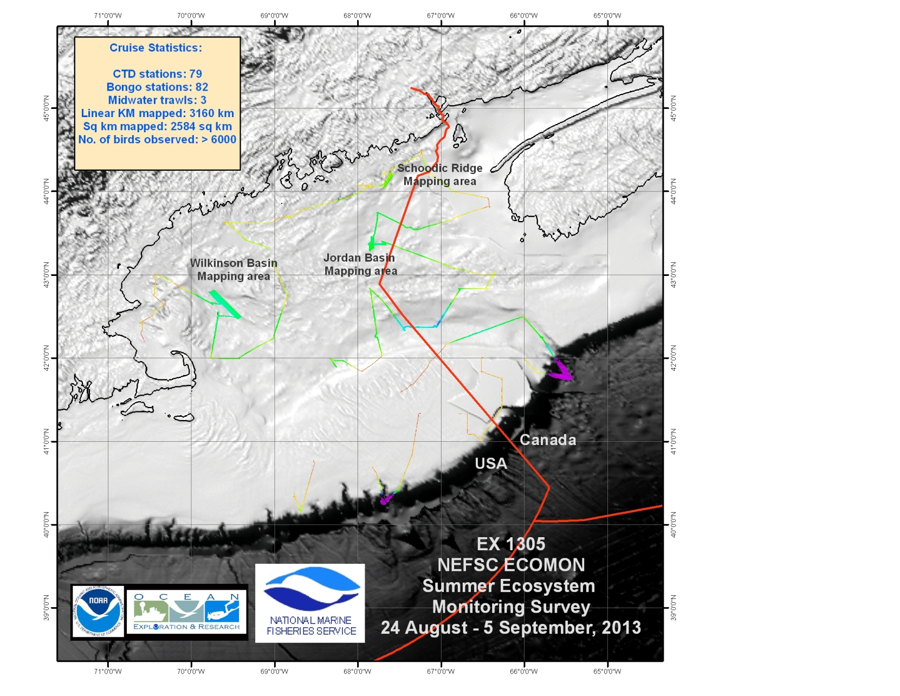

Figure 2: Multibeam data collected during EX1305.

# Participating Personnel

|  |  |  |
| --- | --- | --- |
| **NAME** | **ROLE** | **AFFILIATION** |
| CDR Ricardo Ramos | Commanding Officer | NOAA Corps |
| ENS Kasey Sims | Field Operations Officer | NOAA Corps |
| Jerry Prezioso | Chief Scientist | NOAA/NMFS Narragansett, RI |
| Tamara Holzwarth-Davis | Oceanography operations | NOAA/NMFS Woods Hole, MA |
| Cristina Bascunan | Oceanography operations | NOAA/NMFS Woods Hole, MA |
| Liwei Zhu | Student volunteer | URI / GSO Narragansett, RI |
| Jenna Martin-Fisher | Student volunteer | University of Maine |
| Patrick Bledsoe | Student volunteer | URI/GSO Narragansett, RI |
| Jacklyn James | Suvery technician | NOAA OMAO |
| Mashkoor Malik | Mapping Specialist | NOAA OER Silver Spring, MD |
| Emily Brownlee | FlowCytobot Specialist | WHOI Woods Hole, MA |
| Nicholas Metheny | Marine mammal/bird observer | CUNY Staten Island, NY |
| Glen Davis | Marine mammal/bird observer | CUNY Staten Island, NY |
|  |  |  |

# 

# Summary of Results

The cruise included EK60 single beam mapping through out the cruise. While, EM 302 data collection was attempted round the clock, the sound speed profiles were not collected regularly as the cruise was not staffed for 24 hours of multibeam operations. However, the bongo stations and CTD cast stations provided opportunistic sound speed casts for multibeam sonar. The frequency of these available sound speed casts, however, varied between 4-12 hours. At times, the system would loose the bottom tracking and was not able to regain the bottom without user intervention.

An example of such a case is included below:

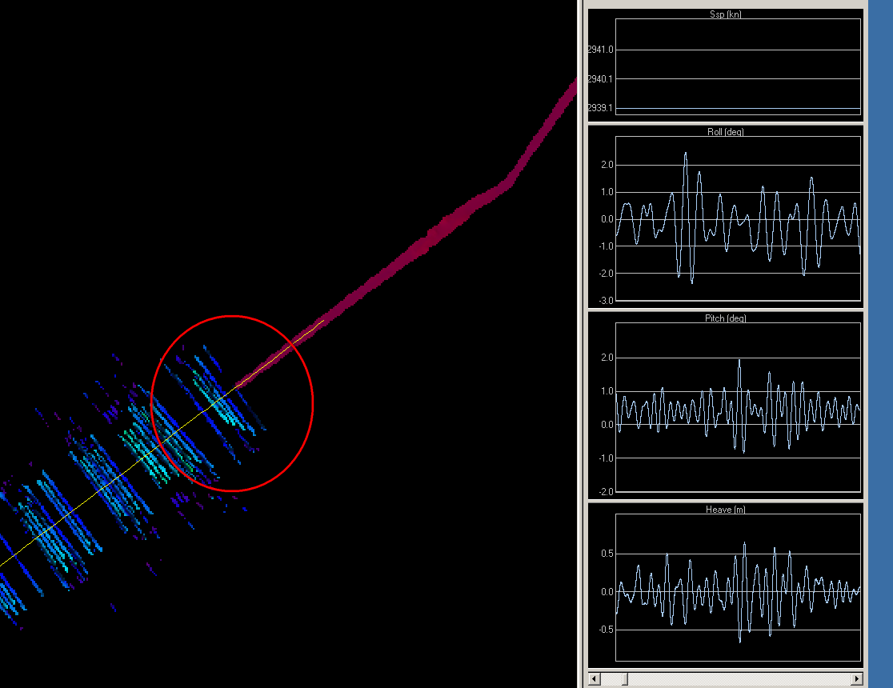

Figure 3: An example of EM 302 lossing bottom. The red circle denotes where the bottom was lost. The panel on the right shows the ship’s attitude at the time. Image from CARIS HIPS.

Besides opportunistic data collection round the clock, three sites were mapped during this cruise. These sites included Jordan basin, Schoodic Ridge and Wilkinson Basin. These sites were chosen based on feed back from several scientists including Dr. Peter Auster (Univ. of Conn.), Andy Armstrong (JHC/UNH) and assessment of the previsouly unmapped areas in the Gulf of Maine based on data held at NGDC.

## EK 60 operations

A team of scientists from NEFSC carried out calibration of EK 60 using a standard sphere method on 24 August 2013. The calibration report is included as Appendix E.

Round the clock EK 60 operations were conducted. Most of times, the system was not monitored during real time. The EK 60 data were visually inspected for any distinct features/ failures daily but detailed analysis of the EK 60 data was not performed onboard.

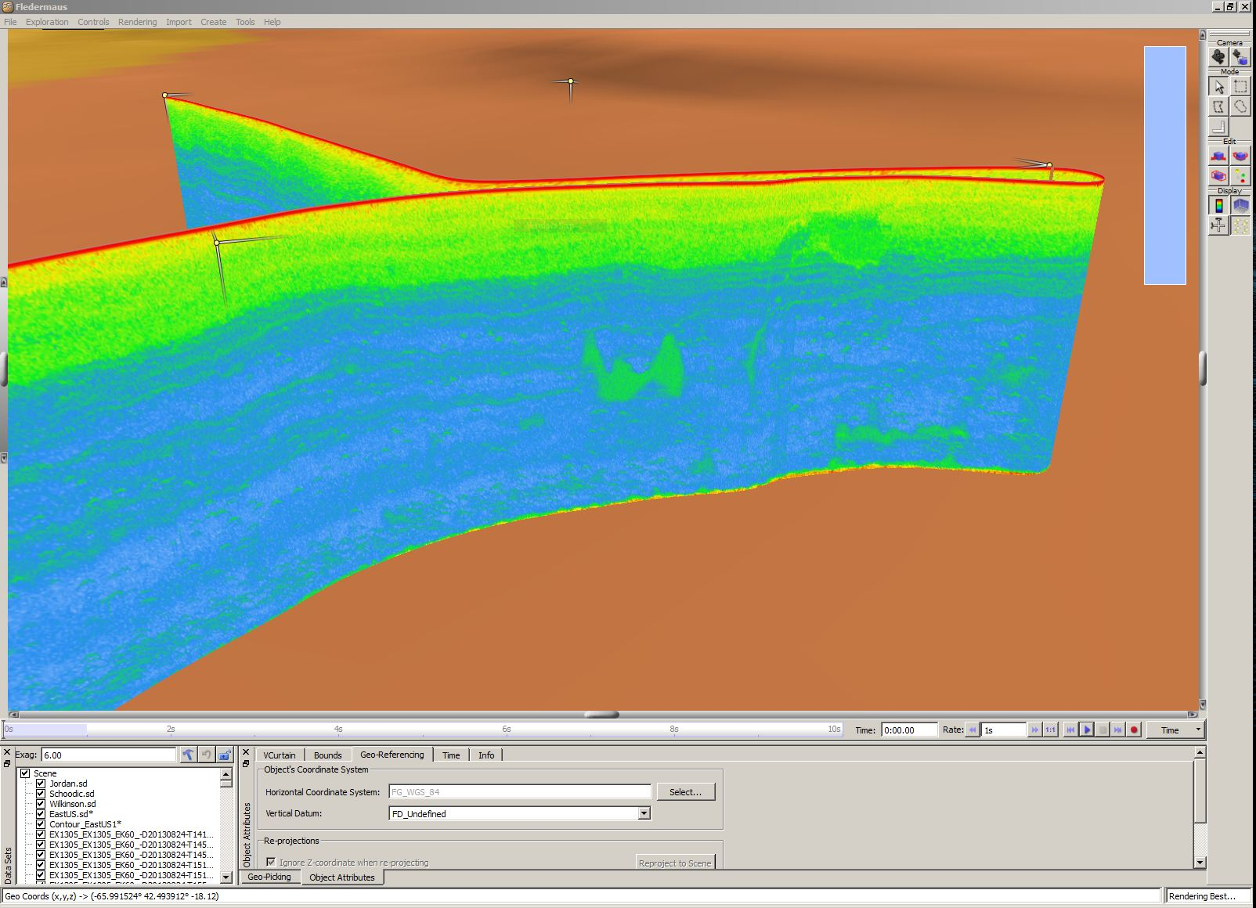

Figure 4: Examples of EK 60 curtain displayed in the QPS Fledermaus. A large fish school is visible in the middle of the image.

## Jordan Basin Mapping

The resulting map in the Jordan basin is shown below:

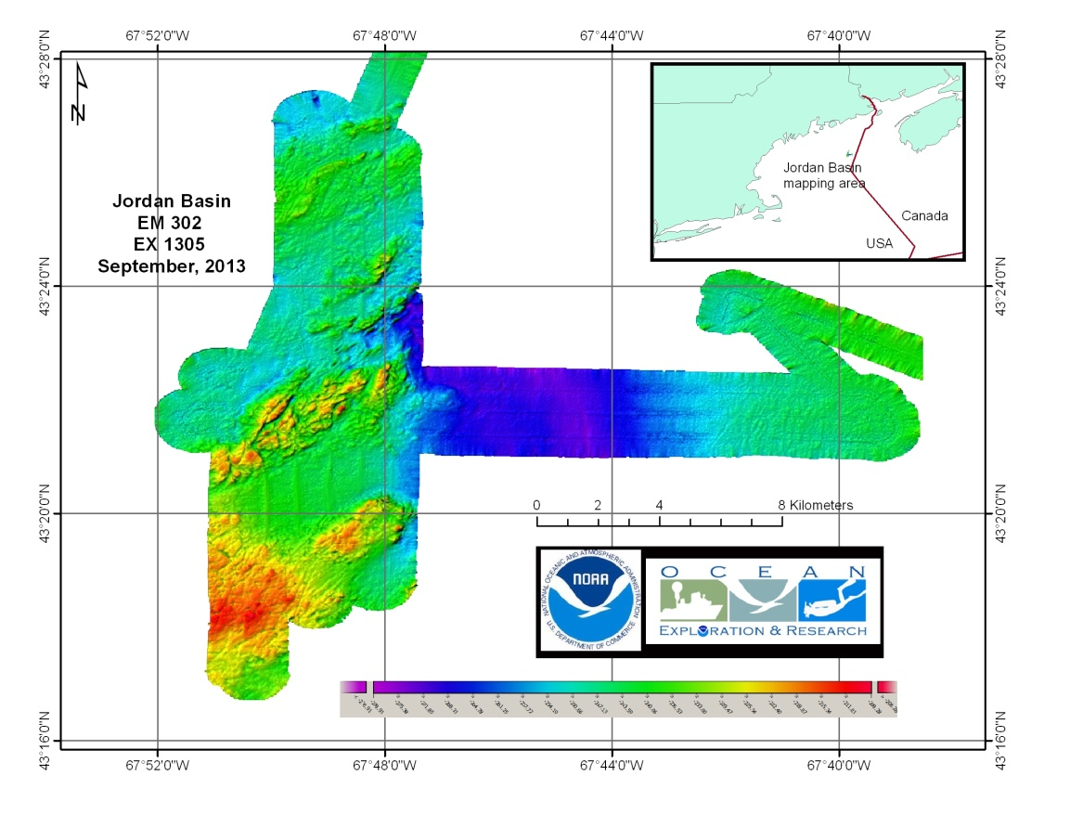

Figure 5: Bathymetric data collected in vicinity of Jordan Basin.

## Schoodic Ridge mapping

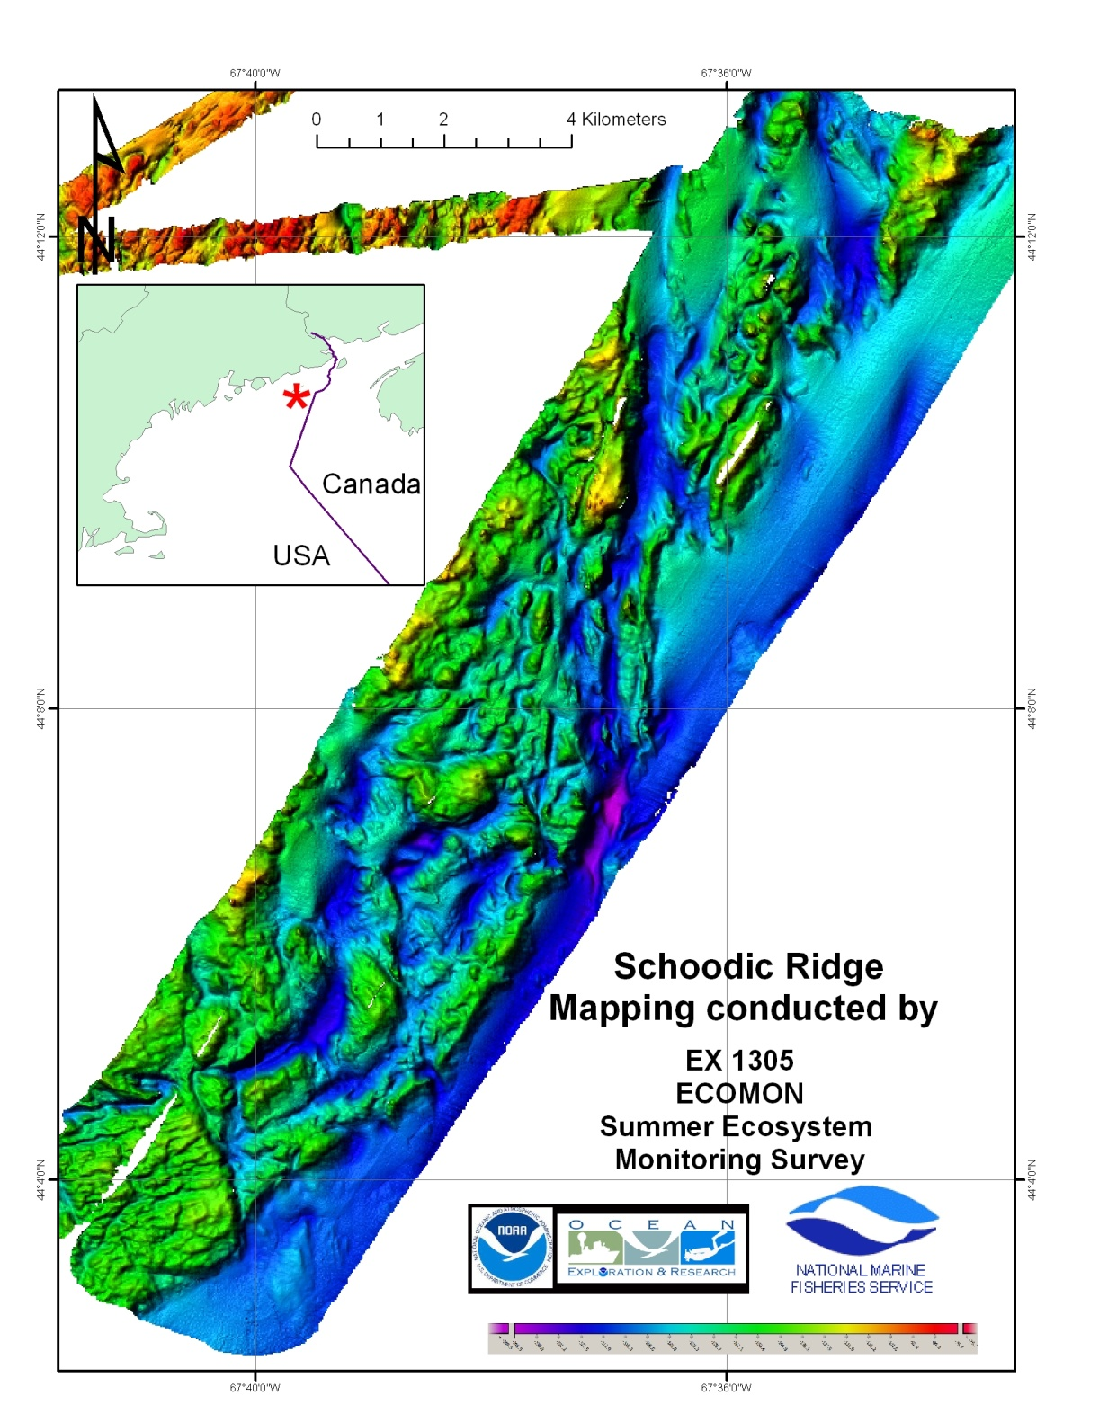

Figure 6: Bathymetric collected in vicinity of Schoodic Rdge.

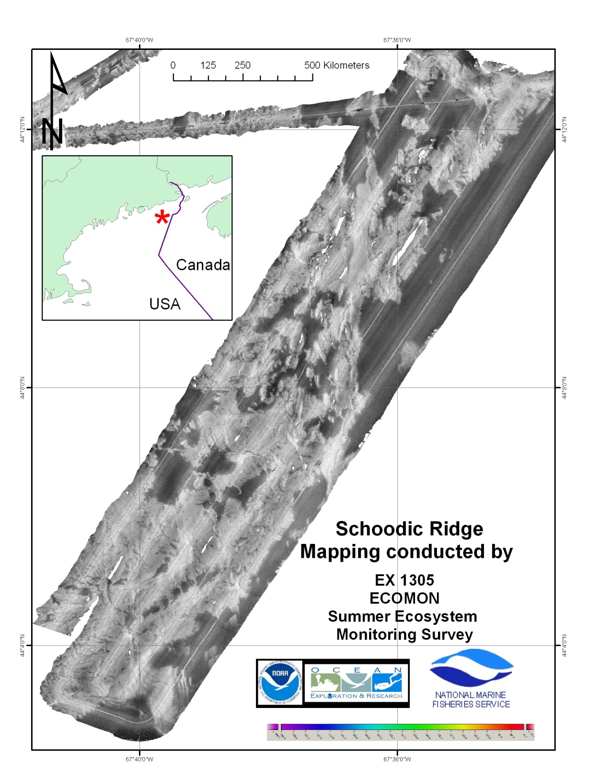

Figure 7: Backscatter collected in vicinity of Schoodic Ridge.

## Wilkinson basin focused mapping areas

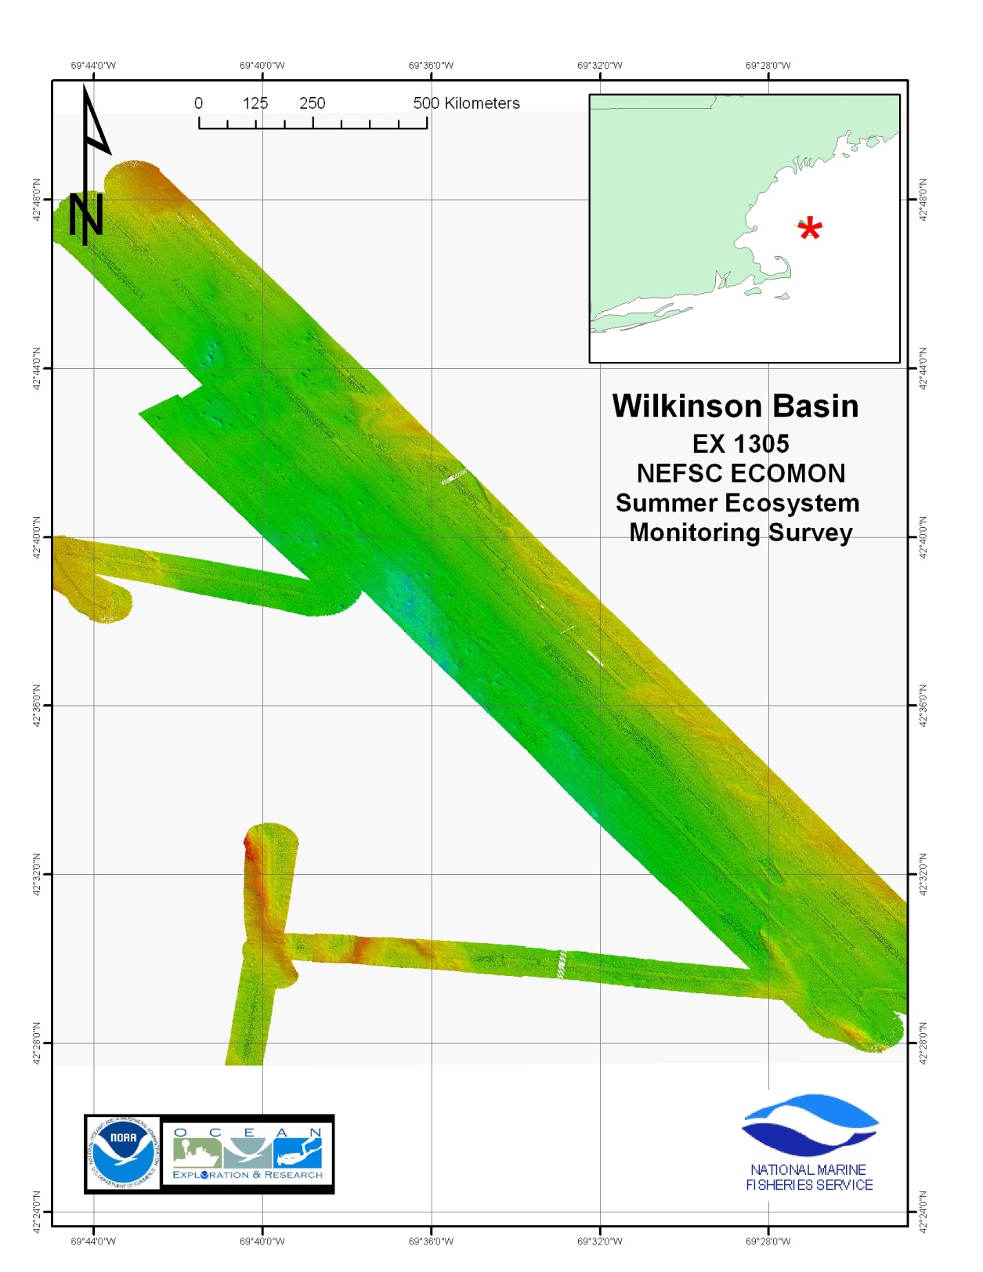

Figure 8: Bathymetry collected in location of Wilkinson Basin.

Various circular features were visible in the Wilkinson basin. No associated gas signals were observed in the water column data.

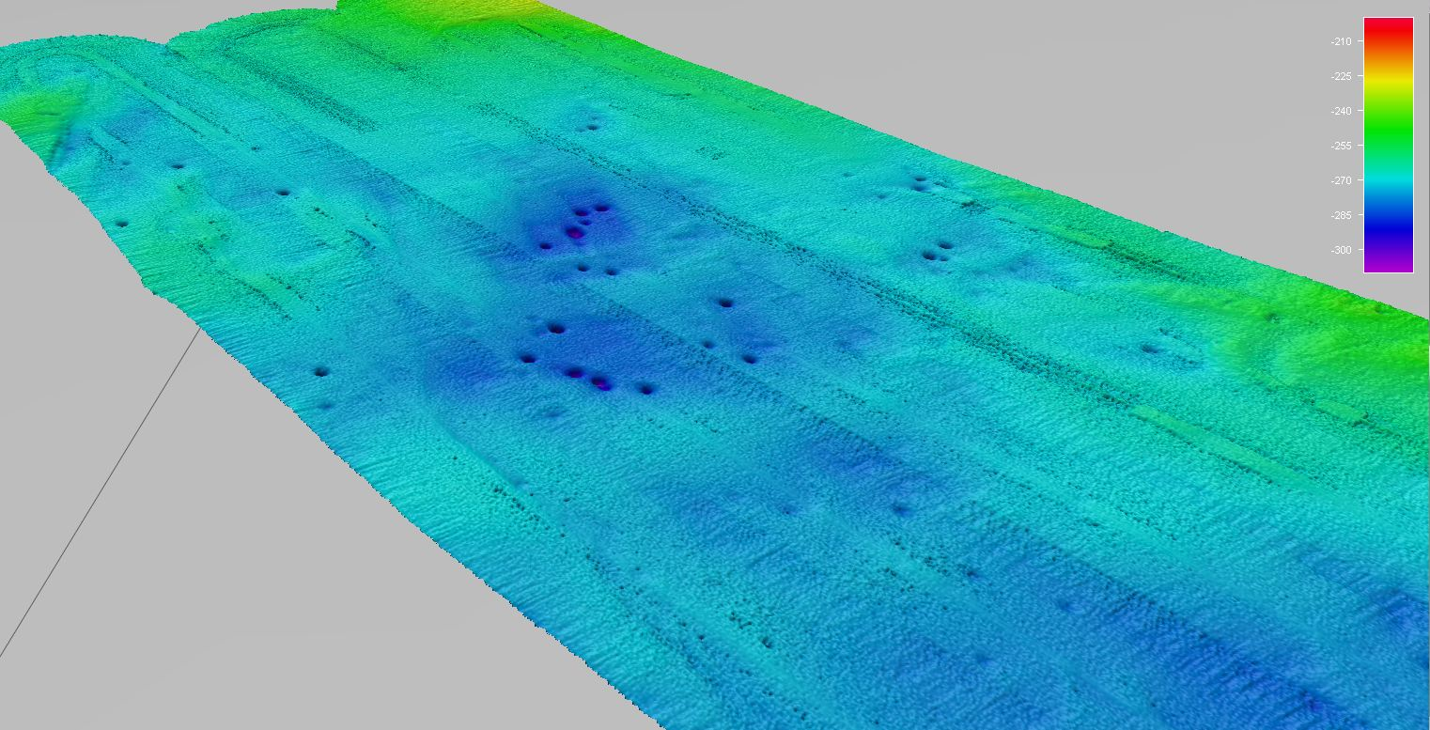

Figure 9: Circular features observed in Wilkinson basin.

# Mapping Statistics

|  |  |
| --- | --- |
| Dates | 08/24/13-09/05/13 |
| Weather delays | 0 day |
| Total non-mapping days | 12 days |
| Total survey mapping days | 1 days |
| Total transit mapping days | 11 days |
| Line kilometers of survey | 3160 km |
| Square kilometers mapped | 2584 sq km |
| Number of bathymetric multibeam files | 209 |
| Data volume of raw multibeam data files | 41.3 GB |
| Number of water column multibeam files | 209 |
| Data volume of water column multibeam files | 139 GB |
| Number of XBT casts | 5 |
| Number of CTD casts | 79 |
| Beginning draft | 14'9" forward, 14'4" aft |
| Ending draft | 14'3" forward, 14'2.5" aft |
| Average ship speed for survey | Not applicable |
|  |  |

# Mapping Sonar Setup

The NOAA Ship *Okeanos Explorer* is equipped with a 30 kHz Kongsberg EM 302 multibeam sonar. Appendix B contains a detailed description of sonar system functionality and technical specifications. For this cruise no changes were made to the standard setup of the mapping sonars onboard.

# Data Acquisition and processing summary

Multibeam sonar (EM 302) data were acquired using Kongsberg Seafloor Information System (SIS ver. 3.6.4). SIS system accounts for all the static offsets and biases during real time acquisition. The motion data from the POS MV 320 (Ver. 4.0.2.0) was directly fed into SIS during data acquisition to account for ship motion (i.e. heave, roll, pitch). Yaw data was provided by the TSS gyro-compasses located on the bridge. Also the real time sound speed near the sonar head (dually measured by Reson Sound Speed sensor and a CTD sensor installed in proximity to the EM 302 receiver) was fed into SIS and the most updated acquired sound speed profile was used in real time to correct soundings for sound speed corrections during data acquisition. Unless there are problems observed in the data, there is no requirement to apply these corrections during post processing. The water column backscatter were collected all the time (except for few files listed in the multibeam data files list) which were recorded into separate to bottom bathymetry and backscatter data as *.wcd files.

CARIS HIPS/SIPS v.7.1.2 SP 2 was used to edit the bathymetric data from the EM 302 multibeam. Edited data was exported to ASCII text files and then imported to QPS Fledermaus Ver. 7.3.4 Build 371 for further processing, visualization, quality control, and product generation.

EK 60 data were collected using Kongsberg GPT firm ware version 2.2.1 in the *.raw data file format.

The QPS Fledermaus MidWater software package (Ver. 7.3.4 Build 371) was used to process EM 302 water column backscatter and EK 60 data and view the resulting Fledermaus SD objects. The programs are the best method available to the mapping department for water column data processing.

**EM 302 Trouble Shooting**

In flat seafloor areas, it was noticed that bottom tracking algorithm is not working properly This was mostly evident in the featureless seafloor regions. Although not conclusive, but it is suspected that this problem was most prevalent to the softer sediment seafloor types. The problem was also more pronounced in the near nadir region in the area where amplitude detection is employed. More than one distinct, with almost similar amplitude returns were observed near the most likely seafloor location in the water column data (Figure ?).

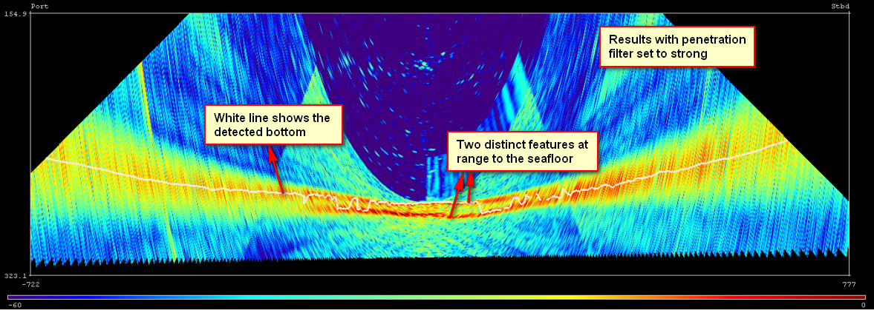

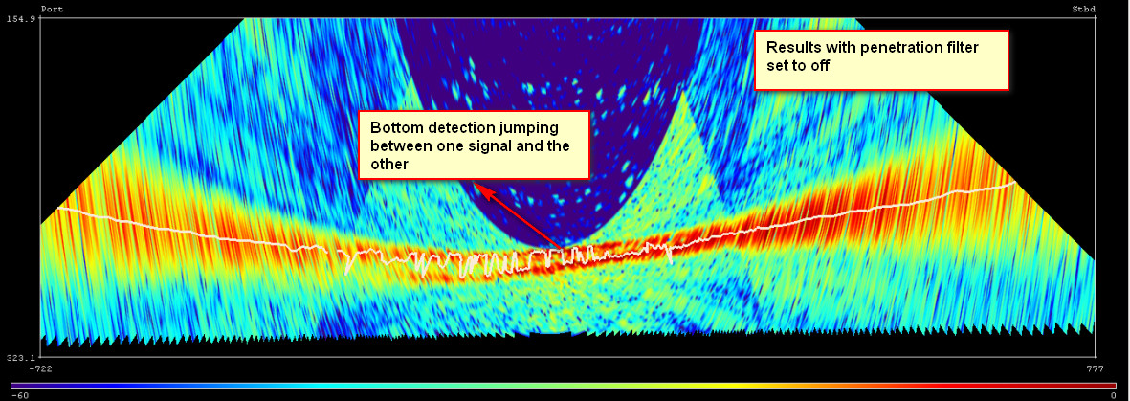

Figure 10: Water column display showing distinct targets very close to the seafloor.

Anticipating that this problem may be related to the absorption in the upper layer of the seafloor, user controlled filters (spike filter, penetration filter: Filters and gains in SIS display) were enabled, which resulted in the picking of the shallowest return from the seafloor. This approach however, did not work well in all the areas where the deeper signal appear to be return from the seafloor. The two signals in the water colmn display were observed to differ as much as 10-20 m (Figure 11). At time of compilation of this report, the cause or rectification of this issue is not known. A support request is being generated for the EM302 manufacturer (Kongsberg, Inc).

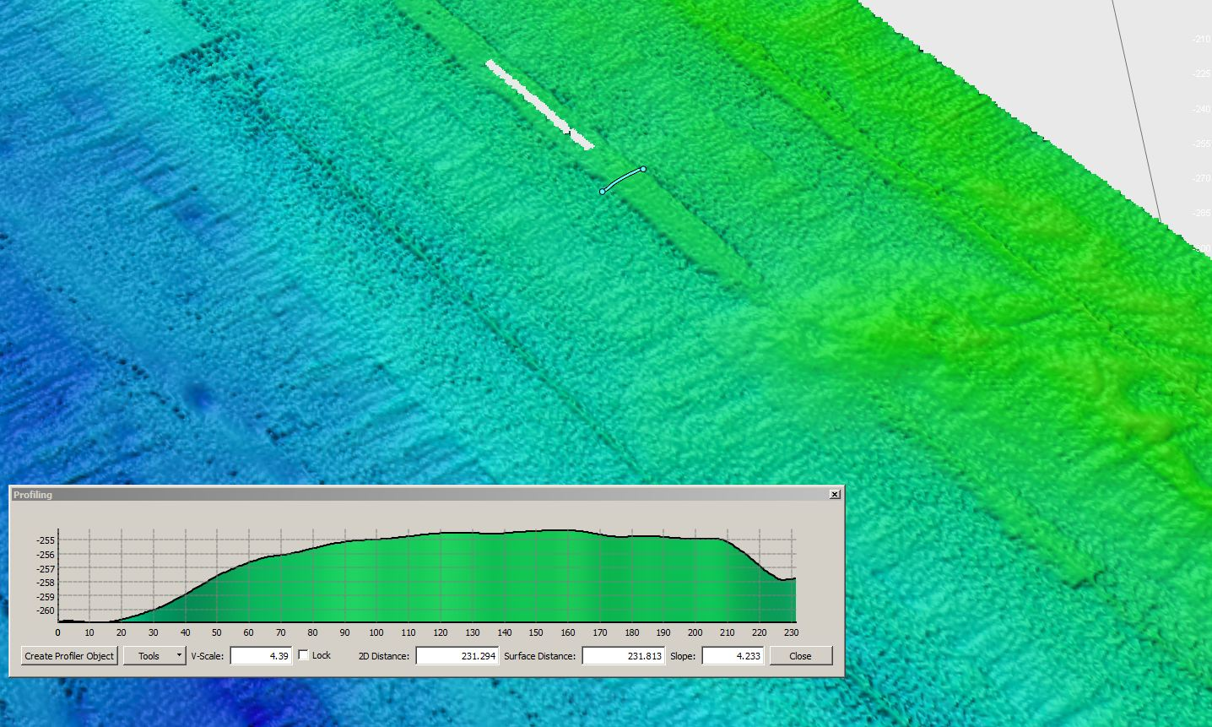

Figure 11: Artifacts resulting due to the inaccurate bottom tracking. The ridge like structure follows the ship track and can be as high as 5-15 m from the surrounding seafloor. The arrows indicate the ridge like structure or high noise in the data corresponding to the filter used as shown in the figure 10.

As editing of the artifact creates large data holidays, it was experimented with to leave the user controlled filters off and the system determine which signal is related to the seafloor. This resulted in system jumping between two signals and resulting data contained high noise. However, this was determined to be a better solution as the data editing is possible to some extent. It is realized that both situations result in sub-optimal quality data.

# Data Archival Procedures

All the underway data collceted by SCS, EM 302 and EK 60 data from the cruise are being prepared to be submitted to NCDDC where the data are being prepared for onward submission to the archival centers. Following is the brief data pipeline excerpts from Data management plan, EX1305.

“All station and biological data will be electronically recorded. At the completion of the cruise, all data will be electronically transmitted to the NEFSC data management system based in Woods Hole, MA. Samples and data collected for specific individuals, agencies or organizations will be processed by same. Plankton samples will be processed through the NEFSC laboratory in Narragansett, RI. Data from the CTD will be processed at the NEFSC Woods Hole Laboratory.

Data collected by Okeanos Explorer underway systems will be documented and processed by OER and data center personnel in accordance with NAO 216-101, and according to processes detailed in the NOAA Ship Okeanos Explorer FY13 Data Management Plan [3], Section VII Data and Product Pipelines (A) Oceanographic Data Archive Pipeline and (B) Multibeam Data Archive Pipeline. Specifically, the Okeanos Explorer telepresence system and two-body ROV system will not be employed on EX1305 and those procedures will not be implemented. Receipt of archive confirmation is anticipated 60-90 days post cruise and will be forwarded to the Commanding Officer and to the Chief Scientist.

Note: The Chief Scientist has verified that all data will be available for public release.”

# Cruise Calendar

|  |  |  |  |  |  |  |
| --- | --- | --- | --- | --- | --- | --- |
| Mon | Tue | Wed | Thu | Fri | Sat | Sun |
|  |  |  |  | 23 Aug  Mission party arrives onboard. Fueling operations in progresss. | 24 Aug  Ship departed N. Kingstown, RI. Conducted EK 60 calibration. EK 60 calibration team dropped off via small boat. | 25 Aug  Commenced sampling at designated stations. |
| 26 Aug  Continue sampling and EK 60 data acquistion | 27 Aug  Continue Sampling and EK 60 data acquistion | 28 Aug  Continue sampling and EK 60 data acquisition | 29 Aug  Continue sampling and EK 60 data acquisition | 30 Aug  Continue sampling and EK 60 data acquisition | 31 Aug  Completed Jordan Basin mapping. Continue sampling and EK 60 data acquistion | 1 Sept  Completed Schoodic Ridge mapping.  Continue sampling and EK 60 data acquistion |
| 2 Sept  Continue sampling and EK 60 data acquisition | 3 Sept  Continue sampling and EK 60 data acquisition. Wilkinson basin mapping conducted | 4 Sept  Continue sampling and EK 60 data acquisition.  EM 302 data acquisition secured.  EK 60 data acquistion secured. | 5 Sept  Arrive North Kingstown, RI |  |  |  |

# References

[1] Lobecker, E., Malik, M., Nadeau, M. and Skarke, A., Mapping Systems Readiness Report 2012, NOAA Ship *Okeanos Explorer*, March 2012.

[2] North East Fisheries Science Center, Project instructions, Summer Ecosystem Monitoring Survey, 26 July 2013.

[3] Gottfried, S., Okeanos Explorer, FY 13 Data management Plan, February 2013.

# Appendices

## Appendix A: Tables of data files collected

**Table of Multibeam EM 302 files collected. File Name format:**

**Line Number _ Date_Time_CruiseID_MB.all**

|  |  |  |
| --- | --- | --- |
| Multibeam File | Water Column file | Comments |
| 0000_20130826_043104_EX1305_MB | 0000_20130826_043104_EX1305_MB.wcd |  |
| 0001_20130826_063104_EX1305_MB | 0001_20130826_063104_EX1305_MB.wcd |  |
| 0002_20130826_083104_EX1305_MB | 0002_20130826_083104_EX1305_MB.wcd |  |
| 0003_20130826_103105_EX1305_MB | 0003_20130826_103105_EX1305_MB.wcd |  |
| 0004_20130826_123104_EX1305_MB | 0004_20130826_123104_EX1305_MB.wcd |  |
| 0005_20130826_143104_EX1305_MB | 0005_20130826_143104_EX1305_MB.wcd |  |
| 0006_20130827_020056_EX1305_MB | 0006_20130827_020056_EX1305_MB.wcd |  |
| 0007_20130827_040057_EX1305_MB | 0007_20130827_040057_EX1305_MB.wcd |  |
| 0008_20130827_060057_EX1305_MB | 0008_20130827_060057_EX1305_MB.wcd |  |
| 0009_20130827_080057_EX1305_MB | 0009_20130827_080057_EX1305_MB.wcd |  |
| 0010_20130827_100056_EX1305_MB | 0010_20130827_100056_EX1305_MB.wcd |  |
| 0011_20130827_120057_EX1305_MB | 0011_20130827_120057_EX1305_MB.wcd |  |
| 0012_20130827_140056_EX1305_MB | 0012_20130827_140056_EX1305_MB.wcd |  |
| 0013_20130827_160057_EX1305_MB | 0013_20130827_160057_EX1305_MB.wcd |  |
| 0014_20130827_180057_EX1305_MB | 0014_20130827_180057_EX1305_MB.wcd |  |
| 0015_20130827_200057_EX1305_MB | 0015_20130827_200057_EX1305_MB.wcd |  |
| 0016_20130827_211743_EX1305_MB | 0016_20130827_211743_EX1305_MB.wcd |  |
| 0017_20130827_231744_EX1305_MB | 0017_20130827_231744_EX1305_MB.wcd |  |
| 0018_20130828_011744_EX1305_MB | 0018_20130828_011744_EX1305_MB.wcd |  |
| 0019_20130828_031743_EX1305_MB | 0019_20130828_031743_EX1305_MB.wcd |  |
| 0020_20130828_051743_EX1305_MB | 0020_20130828_051743_EX1305_MB.wcd |  |
| 0021_20130828_071743_EX1305_MB | 0021_20130828_071743_EX1305_MB.wcd |  |
| 0022_20130828_091743_EX1305_MB | 0022_20130828_091743_EX1305_MB.wcd |  |
| 0023_20130828_111744_EX1305_MB | 0023_20130828_111744_EX1305_MB.wcd |  |
| 0024_20130828_131746_EX1305_MB | 0024_20130828_131746_EX1305_MB.wcd |  |
| 0025_20130828_151745_EX1305_MB | 0025_20130828_151745_EX1305_MB.wcd |  |
| 0026_20130828_171744_EX1305_MB | 0026_20130828_171744_EX1305_MB.wcd |  |
| 0027_20130828_191743_EX1305_MB | 0027_20130828_191743_EX1305_MB.wcd |  |
| 0028_20130828_211744_EX1305_MB | 0028_20130828_211744_EX1305_MB.wcd |  |
| 0029_20130828_231030_EX1305_MB | 0029_20130828_231030_EX1305_MB.wcd |  |
| 0030_20130829_011031_EX1305_MB | 0030_20130829_011031_EX1305_MB.wcd |  |
| 0031_20130829_031031_EX1305_MB | 0031_20130829_031031_EX1305_MB.wcd |  |
| 0032_20130829_051030_EX1305_MB | 0032_20130829_051030_EX1305_MB.wcd |  |
| 0033_20130829_071030_EX1305_MB | 0033_20130829_071030_EX1305_MB.wcd |  |
| 0034_20130829_091030_EX1305_MB | 0034_20130829_091030_EX1305_MB.wcd | Bottom not tracking |
| 0035_20130829_111035_EX1305_MB | 0035_20130829_111035_EX1305_MB.wcd | Bottom not tracking |
| 0036_20130829_131033_EX1305_MB | 0036_20130829_131033_EX1305_MB.wcd | Bottom not tracking |
| 0037_20130829_151035_EX1305_MB | 0037_20130829_151035_EX1305_MB.wcd | Bottom not tracing |
| 0038_20130829_160627_EX1305_MB | 0038_20130829_160627_EX1305_MB.wcd |  |
| 0039_20130829_180626_EX1305_MB | 0039_20130829_180626_EX1305_MB.wcd |  |
| 0040_20130829_190626_EX1305_MB | 0040_20130829_190626_EX1305_MB.wcd |  |
| 0041_20130829_200626_EX1305_MB | 0041_20130829_200626_EX1305_MB.wcd |  |
| 0042_20130829_210626_EX1305_MB | 0042_20130829_210626_EX1305_MB.wcd |  |
| 0043_20130829_220626_EX1305_MB | 0043_20130829_220626_EX1305_MB.wcd |  |
| 0044_20130829_230626_EX1305_MB | 0044_20130829_230626_EX1305_MB.wcd |  |
| 0045_20130830_000626_EX1305_MB | 0045_20130830_000626_EX1305_MB.wcd |  |
| 0046_20130830_010626_EX1305_MB | 0046_20130830_010626_EX1305_MB.wcd |  |
| 0047_20130830_020626_EX1305_MB | 0047_20130830_020626_EX1305_MB.wcd |  |
| 0048_20130830_030627_EX1305_MB | 0048_20130830_030627_EX1305_MB.wcd |  |
| 0049_20130830_040626_EX1305_MB | 0049_20130830_040626_EX1305_MB.wcd |  |
| 0050_20130830_050626_EX1305_MB | 0050_20130830_050626_EX1305_MB.wcd |  |
| 0051_20130830_060626_EX1305_MB | 0051_20130830_060626_EX1305_MB.wcd |  |
| 0052_20130830_070626_EX1305_MB | 0052_20130830_070626_EX1305_MB.wcd |  |
| 0053_20130830_080626_EX1305_MB | 0053_20130830_080626_EX1305_MB.wcd |  |
| 0054_20130830_090626_EX1305_MB | 0054_20130830_090626_EX1305_MB.wcd |  |
| 0055_20130830_100627_EX1305_MB | 0055_20130830_100627_EX1305_MB.wcd |  |
| 0056_20130830_110627_EX1305_MB | 0056_20130830_110627_EX1305_MB.wcd |  |
| 0057_20130830_120626_EX1305_MB | 0057_20130830_120626_EX1305_MB.wcd |  |
| 0058_20130830_130626_EX1305_MB | 0058_20130830_130626_EX1305_MB.wcd |  |
| 0059_20130830_140627_EX1305_MB | 0059_20130830_140627_EX1305_MB.wcd |  |
| 0060_20130830_150626_EX1305_MB | 0060_20130830_150626_EX1305_MB.wcd |  |
| 0061_20130830_160626_EX1305_MB | 0061_20130830_160626_EX1305_MB.wcd |  |
| 0062_20130830_170626_EX1305_MB | 0062_20130830_170626_EX1305_MB.wcd |  |
| 0063_20130830_180626_EX1305_MB | 0063_20130830_180626_EX1305_MB.wcd |  |
| 0064_20130830_190626_EX1305_MB | 0064_20130830_190626_EX1305_MB.wcd |  |
| 0065_20130830_200626_EX1305_MB | 0065_20130830_200626_EX1305_MB.wcd |  |
| 0066_20130830_210626_EX1305_MB | 0066_20130830_210626_EX1305_MB.wcd |  |
| 0067_20130830_220626_EX1305_MB | 0067_20130830_220626_EX1305_MB.wcd |  |
| 0068_20130830_230626_EX1305_MB | 0068_20130830_230626_EX1305_MB.wcd |  |
| 0069_20130831_000626_EX1305_MB | 0069_20130831_000626_EX1305_MB.wcd |  |
| 0070_20130831_010626_EX1305_MB | 0070_20130831_010626_EX1305_MB.wcd |  |
| 0071_20130831_020626_EX1305_MB | 0071_20130831_020626_EX1305_MB.wcd |  |
| 0072_20130831_030626_EX1305_MB | 0072_20130831_030626_EX1305_MB.wcd |  |
| 0073_20130831_040627_EX1305_MB | 0073_20130831_040627_EX1305_MB.wcd |  |
| 0074_20130831_050627_EX1305_MB | 0074_20130831_050627_EX1305_MB.wcd |  |
| 0075_20130831_060626_EX1305_MB | 0075_20130831_060626_EX1305_MB.wcd | Jordan Basin mapping |
| 0076_20130831_070627_EX1305_MB | 0076_20130831_070627_EX1305_MB.wcd | Jordan Basin mapping |
| 0077_20130831_074703_EX1305_MB | 0077_20130831_074703_EX1305_MB.wcd | Jordan Basin mapping |
| 0078_20130831_080232_EX1305_MB | 0078_20130831_080232_EX1305_MB.wcd | Jordan Basin mapping |
| 0079_20130831_085503_EX1305_MB | 0079_20130831_085503_EX1305_MB.wcd | Jordan Basin mapping |
| 0080_20130831_090155_EX1305_MB | 0080_20130831_090155_EX1305_MB.wcd | Jordan Basin mapping |
| 0081_20130831_095850_EX1305_MB | 0081_20130831_095850_EX1305_MB.wcd | Jordan Basin mapping |
| 0082_20130831_100808_EX1305_MB | 0082_20130831_100808_EX1305_MB.wcd | Jordan Basin mapping |
| 0083_20130831_110401_EX1305_MB | 0083_20130831_110401_EX1305_MB.wcd | Jordan Basin mapping |
| 0084_20130831_111538_EX1305_MB | 0084_20130831_111538_EX1305_MB.wcd | Jordan Basin mapping |
| 0085_20130831_114544_EX1305_MB | 0085_20130831_114544_EX1305_MB.wcd | Jordan Basin mapping |
| 0086_20130831_114956_EX1305_MB | 0086_20130831_114956_EX1305_MB.wcd | Jordan Basin mapping |
| 0087_20130831_121924_EX1305_MB | 0087_20130831_121924_EX1305_MB.wcd | Jordan Basin mapping |
| 0088_20130831_125048_EX1305_MB | 0088_20130831_125048_EX1305_MB.wcd | Jordan Basin mapping |
| 0089_20130831_125456_EX1305_MB | 0089_20130831_125456_EX1305_MB.wcd | Jordan Basin mapping |
| 0090_20130831_134313_EX1305_MB | 0090_20130831_134313_EX1305_MB.wcd | Jordan Basin mapping |
| 0091_20130831_134807_EX1305_MB | 0091_20130831_134807_EX1305_MB.wcd | Jordan Basin mapping |
| 0092_20130831_140329_EX1305_MB | 0092_20130831_140329_EX1305_MB.wcd | Jordan Basin mapping |
| 0093_20130831_140803_EX1305_MB | 0093_20130831_140803_EX1305_MB.wcd | Jordan Basin mapping |
| 0094_20130831_142446_EX1305_MB | 0094_20130831_142446_EX1305_MB.wcd | Jordan Basin mapping |
| 0095_20130831_142832_EX1305_MB | 0095_20130831_142832_EX1305_MB.wcd | Jordan Basin mapping |
| 0096_20130831_144750_EX1305_MB | 0096_20130831_144750_EX1305_MB.wcd | Jordan Basin mapping |
| 0097_20130831_145307_EX1305_MB | 0097_20130831_145307_EX1305_MB.wcd | Jordan Basin mapping |
| 0098_20130831_151920_EX1305_MB | 0098_20130831_151920_EX1305_MB.wcd | Jordan Basin mapping |
| 0099_20130831_152351_EX1305_MB | 0099_20130831_152351_EX1305_MB.wcd | Jordan Basin mapping |
| 0100_20130831_155033_EX1305_MB | 0100_20130831_155033_EX1305_MB.wcd | Jordan Basin mapping |
| 0101_20130831_165032_EX1305_MB | 0101_20130831_165032_EX1305_MB.wcd |  |
| 0102_20130831_175032_EX1305_MB | 0102_20130831_175032_EX1305_MB.wcd |  |
| 0103_20130831_185032_EX1305_MB | 0103_20130831_185032_EX1305_MB.wcd |  |
| 0104_20130831_195033_EX1305_MB | 0104_20130831_195033_EX1305_MB.wcd |  |
| 0105_20130831_205033_EX1305_MB | 0105_20130831_205033_EX1305_MB.wcd |  |
| 0106_20130831_215032_EX1305_MB | 0106_20130831_215032_EX1305_MB.wcd |  |
| 0107_20130831_225033_EX1305_MB | 0107_20130831_225033_EX1305_MB.wcd |  |
| 0108_20130831_235032_EX1305_MB | 0108_20130831_235032_EX1305_MB.wcd |  |
| 0109_20130901_005032_EX1305_MB | 0109_20130901_005032_EX1305_MB.wcd |  |
| 0110_20130901_015033_EX1305_MB | 0110_20130901_015033_EX1305_MB.wcd |  |
| 0111_20130901_025032_EX1305_MB | 0111_20130901_025032_EX1305_MB.wcd |  |
| 0112_20130901_035032_EX1305_MB | 0112_20130901_035032_EX1305_MB.wcd |  |
| 0113_20130901_045032_EX1305_MB | 0113_20130901_045032_EX1305_MB.wcd |  |
| 0114_20130901_055032_EX1305_MB | 0114_20130901_055032_EX1305_MB.wcd |  |
| 0115_20130901_065032_EX1305_MB | 0115_20130901_065032_EX1305_MB.wcd |  |
| 0116_20130901_075032_EX1305_MB | 0116_20130901_075032_EX1305_MB.wcd |  |
| 0117_20130901_085032_EX1305_MB | 0117_20130901_085032_EX1305_MB.wcd |  |
| 0118_20130901_095032_EX1305_MB | 0118_20130901_095032_EX1305_MB.wcd |  |
| 0119_20130901_105032_EX1305_MB | 0119_20130901_105032_EX1305_MB.wcd |  |
| 0120_20130901_115032_EX1305_MB | 0120_20130901_115032_EX1305_MB.wcd |  |
| 0121_20130901_125033_EX1305_MB | 0121_20130901_125033_EX1305_MB.wcd |  |
| 0122_20130901_135033_EX1305_MB | 0122_20130901_135033_EX1305_MB.wcd |  |
| 0123_20130901_145033_EX1305_MB | 0123_20130901_145033_EX1305_MB.wcd |  |
| 0124_20130901_155033_EX1305_MB | 0124_20130901_155033_EX1305_MB.wcd | Schoodic Ridge mapping |
| 0125_20130901_161637_EX1305_MB | 0125_20130901_161637_EX1305_MB.wcd | Schoodic Ridge mapping |
| 0126_20130901_171637_EX1305_MB | 0126_20130901_171637_EX1305_MB.wcd | Schoodic Ridge mapping |
| 0127_20130901_172208_EX1305_MB | 0127_20130901_172208_EX1305_MB.wcd | Schoodic Ridge mapping |
| 0128_20130901_182208_EX1305_MB | 0128_20130901_182208_EX1305_MB.wcd | Schoodic Ridge mapping |
| 0129_20130901_183934_EX1305_MB | 0129_20130901_183934_EX1305_MB.wcd | Schoodic Ridge mapping |
| 0130_20130901_184328_EX1305_MB | 0130_20130901_184328_EX1305_MB.wcd | Schoodic Ridge mapping |
| 0131_20130901_194327_EX1305_MB | 0131_20130901_194327_EX1305_MB.wcd | Schoodic Ridge mapping |
| 0132_20130901_195407_EX1305_MB | 0132_20130901_195407_EX1305_MB.wcd | Schoodic Ridge mapping |
| 0133_20130901_205407_EX1305_MB | 0133_20130901_205407_EX1305_MB.wcd | Schoodic Ridge mapping |
| 0134_20130901_210616_EX1305_MB | 0134_20130901_210616_EX1305_MB.wcd | Schoodic Ridge mapping |
| 0135_20130901_211139_EX1305_MB | 0135_20130901_211139_EX1305_MB.wcd | Schoodic Ridge mapping |
| 0136_20130901_221139_EX1305_MB | 0136_20130901_221139_EX1305_MB.wcd | Schoodic Ridge mapping |
| 0137_20130901_221537_EX1305_MB | 0137_20130901_221537_EX1305_MB.wcd | Schoodic Ridge mapping |
| 0138_20130901_231537_EX1305_MB | 0138_20130901_231537_EX1305_MB.wcd |  |
| 0139_20130902_001538_EX1305_MB | 0139_20130902_001538_EX1305_MB.wcd |  |
| 0140_20130902_011538_EX1305_MB | 0140_20130902_011538_EX1305_MB.wcd |  |
| 0141_20130902_021538_EX1305_MB | 0141_20130902_021538_EX1305_MB.wcd |  |
| 0142_20130902_031537_EX1305_MB | 0142_20130902_031537_EX1305_MB.wcd |  |
| 0143_20130902_041538_EX1305_MB | 0143_20130902_041538_EX1305_MB.wcd |  |
| 0144_20130902_051538_EX1305_MB | 0144_20130902_051538_EX1305_MB.wcd |  |
| 0145_20130902_061538_EX1305_MB | 0145_20130902_061538_EX1305_MB.wcd |  |
| 0146_20130902_071538_EX1305_MB | 0146_20130902_071538_EX1305_MB.wcd |  |
| 0147_20130902_081538_EX1305_MB | 0147_20130902_081538_EX1305_MB.wcd |  |
| 0148_20130902_091537_EX1305_MB | 0148_20130902_091537_EX1305_MB.wcd |  |
| 0149_20130902_101538_EX1305_MB | 0149_20130902_101538_EX1305_MB.wcd |  |
| 0150_20130902_111538_EX1305_MB | 0150_20130902_111538_EX1305_MB.wcd |  |
| 0151_20130902_121538_EX1305_MB | 0151_20130902_121538_EX1305_MB.wcd |  |
| 0152_20130902_131538_EX1305_MB | 0152_20130902_131538_EX1305_MB.wcd |  |
| 0153_20130902_141538_EX1305_MB | 0153_20130902_141538_EX1305_MB.wcd |  |
| 0154_20130902_151538_EX1305_MB | 0154_20130902_151538_EX1305_MB.wcd |  |
| 0155_20130902_161538_EX1305_MB | 0155_20130902_161538_EX1305_MB.wcd |  |
| 0156_20130902_171445_EX1305_MB | 0156_20130902_171445_EX1305_MB.wcd |  |
| 0157_20130902_181444_EX1305_MB | 0157_20130902_181444_EX1305_MB.wcd |  |
| 0158_20130902_191445_EX1305_MB | 0158_20130902_191445_EX1305_MB.wcd |  |
| 0159_20130902_201445_EX1305_MB | 0159_20130902_201445_EX1305_MB.wcd |  |
| 0160_20130902_211445_EX1305_MB | 0160_20130902_211445_EX1305_MB.wcd |  |
| 0161_20130902_221445_EX1305_MB | 0161_20130902_221445_EX1305_MB.wcd |  |
| 0162_20130902_231445_EX1305_MB | 0162_20130902_231445_EX1305_MB.wcd |  |
| 0163_20130903_001445_EX1305_MB | 0163_20130903_001445_EX1305_MB.wcd |  |
| 0164_20130903_011445_EX1305_MB | 0164_20130903_011445_EX1305_MB.wcd |  |
| 0165_20130903_021445_EX1305_MB | 0165_20130903_021445_EX1305_MB.wcd |  |
| 0166_20130903_031445_EX1305_MB | 0166_20130903_031445_EX1305_MB.wcd |  |
| 0167_20130903_041444_EX1305_MB | 0167_20130903_041444_EX1305_MB.wcd |  |
| 0168_20130903_051445_EX1305_MB | 0168_20130903_051445_EX1305_MB.wcd |  |
| 0169_20130903_061445_EX1305_MB | 0169_20130903_061445_EX1305_MB.wcd |  |
| 0170_20130903_071445_EX1305_MB | 0170_20130903_071445_EX1305_MB.wcd |  |
| 0171_20130903_081444_EX1305_MB | 0171_20130903_081444_EX1305_MB.wcd |  |
| 0172_20130903_091445_EX1305_MB | 0172_20130903_091445_EX1305_MB.wcd | Wilkinson Basin mapping |
| 0173_20130903_101445_EX1305_MB | 0173_20130903_101445_EX1305_MB.wcd | Wilkinson Basin mapping |
| 0174_20130903_111445_EX1305_MB | 0174_20130903_111445_EX1305_MB.wcd | Wilkinson Basin mapping |
| 0175_20130903_121445_EX1305_MB | 0175_20130903_121445_EX1305_MB.wcd | Wilkinson Basin mapping |
| 0176_20130903_124002_EX1305_MB | 0176_20130903_124002_EX1305_MB.wcd | Wilkinson Basin mapping |
| 0177_20130903_134002_EX1305_MB | 0177_20130903_134002_EX1305_MB.wcd | Wilkinson Basin mapping |
| 0178_20130903_134823_EX1305_MB | 0178_20130903_134823_EX1305_MB.wcd | Wilkinson Basin mapping |
| 0179_20130903_144823_EX1305_MB | 0179_20130903_144823_EX1305_MB.wcd | Wilkinson Basin mapping |
| 0180_20130903_154824_EX1305_MB | 0180_20130903_154824_EX1305_MB.wcd | Wilkinson Basin mapping |
| 0181_20130903_161623_EX1305_MB | 0181_20130903_161623_EX1305_MB.wcd | Wilkinson Basin mapping |
| 0182_20130903_162246_EX1305_MB | 0182_20130903_162246_EX1305_MB.wcd | Wilkinson Basin mapping |
| 0183_20130903_172246_EX1305_MB | 0183_20130903_172246_EX1305_MB.wcd | Wilkinson Basin mapping |
| 0184_20130903_182247_EX1305_MB | 0184_20130903_182247_EX1305_MB.wcd | Wilkinson Basin mapping |
| 0185_20130903_185804_EX1305_MB | 0185_20130903_185804_EX1305_MB.wcd | Wilkinson Basin mapping |
| 0186_20130903_190544_EX1305_MB | 0186_20130903_190544_EX1305_MB.wcd | Wilkinson Basin mapping |
| 0187_20130903_200544_EX1305_MB | 0187_20130903_200544_EX1305_MB.wcd | Wilkinson Basin mapping |
| 0188_20130903_210544_EX1305_MB | 0188_20130903_210544_EX1305_MB.wcd | Wilkinson Basin mapping |
| 0189_20130903_212637_EX1305_MB | 0189_20130903_212637_EX1305_MB.wcd | Wilkinson Basin mapping |
| 0190_20130903_222637_EX1305_MB | 0190_20130903_222637_EX1305_MB.wcd | Wilkinson Basin mapping |
| 0191_20130903_232637_EX1305_MB | 0191_20130903_232637_EX1305_MB.wcd | Wilkinson Basin mapping |
| 0192_20130903_235705_EX1305_MB | 0192_20130903_235705_EX1305_MB.wcd | Wilkinson Basin mapping |
| 0193_20130904_005704_EX1305_MB | 0193_20130904_005704_EX1305_MB.wcd | Wilkinson Basin mapping |
| 0193_20130904_005704_EX1305_MB | 0194_20130904_015704_EX1305_MB.wcd | Wilkinson Basin mapping |
| 0194_20130904_015704_EX1305_MB | 0195_20130904_025705_EX1305_MB.wcd | Wilkinson Basin mapping |
| 0195_20130904_025705_EX1305_MB | 0196_20130904_032604_EX1305_MB.wcd | Wilkinson Basin mapping |
| 0196_20130904_032604_EX1305_MB | 0197_20130904_042604_EX1305_MB.wcd | Wilkinson Basin mapping |
| 0197_20130904_042604_EX1305_MB | 0198_20130904_052605_EX1305_MB.wcd | Wilkinson Basin mapping |
| 0198_20130904_052605_EX1305_MB | 0199_20130904_062604_EX1305_MB.wcd | Wilkinson Basin mapping |
| 0199_20130904_062604_EX1305_MB | 0200_20130904_072604_EX1305_MB.wcd |  |
| 0200_20130904_072604_EX1305_MB | 0201_20130904_082604_EX1305_MB.wcd |  |
| 0201_20130904_082604_EX1305_MB | 0202_20130904_092604_EX1305_MB.wcd |  |
| 0202_20130904_092604_EX1305_MB | 0203_20130904_102604_EX1305_MB.wcd |  |
| 0203_20130904_102604_EX1305_MB | 0204_20130904_112604_EX1305_MB.wcd |  |
| 0204_20130904_112604_EX1305_MB | 0205_20130904_122604_EX1305_MB.wcd |  |
| 0205_20130904_122604_EX1305_MB | 0206_20130904_132604_EX1305_MB.wcd |  |
| 0206_20130904_132604_EX1305_MB | 0207_20130904_142604_EX1305_MB.wcd |  |
| 0207_20130904_142604_EX1305_MB | 0208_20130904_152604_EX1305_MB.wcd |  |
| 0208_20130904_152604_EX1305_MB | 0209_20130904_162604_EX1305_MB.wcd |  |
| 0209_20130904_162604_EX1305_MB | 0000_20130826_043104_EX1305_MB.wcd |  |

**EK 60 files Name format Cruise ID_EK60_Date_Time.raw**

|  |  |
| --- | --- |
| EX1305_EK60_-D20130824-T141741.raw | EX1305_EK60_-D20130826-T154317.raw |
| EX1305_EK60_-D20130824-T145118.raw | EX1305_EK60_-D20130826-T170149.raw |
| EX1305_EK60_-D20130824-T145320.raw | EX1305_EK60_-D20130826-T182022.raw |
| EX1305_EK60_-D20130824-T151615.raw | EX1305_EK60_-D20130826-T193853.raw |
| EX1305_EK60_-D20130824-T151721.raw | EX1305_EK60_-D20130826-T205725.raw |
| EX1305_EK60_-D20130824-T155518.raw | EX1305_EK60_-D20130826-T221558.raw |
| EX1305_EK60_-D20130824-T170607.raw | EX1305_EK60_-D20130826-T233423.raw |
| EX1305_EK60_-D20130824-T182450.raw | EX1305_EK60_-D20130827-T005257.raw |
| EX1305_EK60_-D20130824-T194325.raw | EX1305_EK60_-D20130827-T021126.raw |
| EX1305_EK60_-D20130824-T210200.raw | EX1305_EK60_-D20130827-T032952.raw |
| EX1305_EK60_-D20130824-T222041.raw | EX1305_EK60_-D20130827-T044826.raw |
| EX1305_EK60_-D20130824-T233916.raw | EX1305_EK60_-D20130827-T060657.raw |
| EX1305_EK60_-D20130825-T005748.raw | EX1305_EK60_-D20130827-T072533.raw |
| EX1305_EK60_-D20130825-T021620.raw | EX1305_EK60_-D20130827-T084408.raw |
| EX1305_EK60_-D20130825-T033458.raw | EX1305_EK60_-D20130827-T100240.raw |
| EX1305_EK60_-D20130825-T045331.raw | EX1305_EK60_-D20130827-T112112.raw |
| EX1305_EK60_-D20130825-T061202.raw | EX1305_EK60_-D20130827-T123947.raw |
| EX1305_EK60_-D20130825-T073035.raw | EX1305_EK60_-D20130827-T135820.raw |
| EX1305_EK60_-D20130825-T084904.raw | EX1305_EK60_-D20130827-T151652.raw |
| EX1305_EK60_-D20130825-T100737.raw | EX1305_EK60_-D20130827-T163526.raw |
| EX1305_EK60_-D20130825-T112609.raw | EX1305_EK60_-D20130827-T175357.raw |
| EX1305_EK60_-D20130825-T124443.raw | EX1305_EK60_-D20130827-T191231.raw |
| EX1305_EK60_-D20130825-T140316.raw | EX1305_EK60_-D20130827-T203100.raw |
| EX1305_EK60_-D20130825-T152147.raw | EX1305_EK60_-D20130827-T214935.raw |
| EX1305_EK60_-D20130825-T164021.raw | EX1305_EK60_-D20130827-T230808.raw |
| EX1305_EK60_-D20130825-T175853.raw | EX1305_EK60_-D20130828-T002639.raw |
| EX1305_EK60_-D20130825-T191721.raw | EX1305_EK60_-D20130828-T014511.raw |
| EX1305_EK60_-D20130825-T203559.raw | EX1305_EK60_-D20130828-T030347.raw |
| EX1305_EK60_-D20130825-T215431.raw | EX1305_EK60_-D20130828-T042220.raw |
| EX1305_EK60_-D20130825-T231304.raw | EX1305_EK60_-D20130828-T054052.raw |
| EX1305_EK60_-D20130826-T003145.raw | EX1305_EK60_-D20130828-T065926.raw |
| EX1305_EK60_-D20130826-T015016.raw | EX1305_EK60_-D20130828-T081801.raw |
| EX1305_EK60_-D20130826-T030848.raw | EX1305_EK60_-D20130828-T093631.raw |
| EX1305_EK60_-D20130826-T051436.raw | EX1305_EK60_-D20130828-T105504.raw |
| EX1305_EK60_-D20130826-T063313.raw | EX1305_EK60_-D20130828-T121335.raw |
| EX1305_EK60_-D20130826-T075148.raw | EX1305_EK60_-D20130828-T133206.raw |
| EX1305_EK60_-D20130826-T091024.raw | EX1305_EK60_-D20130828-T145039.raw |
| EX1305_EK60_-D20130826-T102900.raw | EX1305_EK60_-D20130828-T160221.raw |
| EX1305_EK60_-D20130826-T114737.raw | EX1305_EK60_-D20130828-T170217.raw |
| EX1305_EK60_-D20130826-T130609.raw | EX1305_EK60_-D20130828-T180218.raw |
| EX1305_EK60_-D20130826-T142441.raw | EX1305_EK60_-D20130828-T190220.raw |
| EX1305_EK60_-D20130828-T200223.raw | EX1305_EK60_-D20130830-T104803.raw |
| EX1305_EK60_-D20130828-T210221.raw | EX1305_EK60_-D20130830-T114150.raw |
| EX1305_EK60_-D20130828-T220245.raw | EX1305_EK60_-D20130830-T123536.raw |
| EX1305_EK60_-D20130828-T230248.raw | EX1305_EK60_-D20130830-T132922.raw |
| EX1305_EK60_-D20130828-T232251.raw | EX1305_EK60_-D20130830-T142310.raw |
| EX1305_EK60_-D20130829-T002248.raw | EX1305_EK60_-D20130830-T151657.raw |
| EX1305_EK60_-D20130829-T012245.raw | EX1305_EK60_-D20130830-T161048.raw |
| EX1305_EK60_-D20130829-T022242.raw | EX1305_EK60_-D20130830-T170440.raw |
| EX1305_EK60_-D20130829-T032239.raw | EX1305_EK60_-D20130830-T175830.raw |
| EX1305_EK60_-D20130829-T042237.raw | EX1305_EK60_-D20130830-T185223.raw |
| EX1305_EK60_-D20130829-T052234.raw | EX1305_EK60_-D20130830-T194612.raw |
| EX1305_EK60_-D20130829-T062231.raw | EX1305_EK60_-D20130830-T204003.raw |
| EX1305_EK60_-D20130829-T072228.raw | EX1305_EK60_-D20130830-T213353.raw |
| EX1305_EK60_-D20130829-T082229.raw | EX1305_EK60_-D20130830-T222744.raw |
| EX1305_EK60_-D20130829-T092226.raw | EX1305_EK60_-D20130830-T232134.raw |
| EX1305_EK60_-D20130829-T102223.raw | EX1305_EK60_-D20130831-T001525.raw |
| EX1305_EK60_-D20130829-T112221.raw | EX1305_EK60_-D20130831-T010915.raw |
| EX1305_EK60_-D20130829-T122218.raw | EX1305_EK60_-D20130831-T020306.raw |
| EX1305_EK60_-D20130829-T132217.raw | EX1305_EK60_-D20130831-T025658.raw |
| EX1305_EK60_-D20130829-T142215.raw | EX1305_EK60_-D20130831-T035048.raw |
| EX1305_EK60_-D20130829-T152212.raw | EX1305_EK60_-D20130831-T044438.raw |
| EX1305_EK60_-D20130829-T162208.raw | EX1305_EK60_-D20130831-T053829.raw |
| EX1305_EK60_-D20130829-T172207.raw | EX1305_EK60_-D20130831-T063219.raw |
| EX1305_EK60_-D20130829-T182205.raw | EX1305_EK60_-D20130831-T072613.raw |
| EX1305_EK60_-D20130829-T192204.raw | EX1305_EK60_-D20130831-T082004.raw |
| EX1305_EK60_-D20130829-T202204.raw | EX1305_EK60_-D20130831-T091355.raw |
| EX1305_EK60_-D20130829-T212140.raw | EX1305_EK60_-D20130831-T100746.raw |
| EX1305_EK60_-D20130829-T221528.raw | EX1305_EK60_-D20130831-T110138.raw |
| EX1305_EK60_-D20130829-T230912.raw | EX1305_EK60_-D20130831-T115528.raw |
| EX1305_EK60_-D20130830-T000257.raw | EX1305_EK60_-D20130831-T124919.raw |
| EX1305_EK60_-D20130830-T005645.raw | EX1305_EK60_-D20130831-T134309.raw |
| EX1305_EK60_-D20130830-T015033.raw | EX1305_EK60_-D20130831-T143659.raw |
| EX1305_EK60_-D20130830-T024417.raw | EX1305_EK60_-D20130831-T153050.raw |
| EX1305_EK60_-D20130830-T033803.raw | EX1305_EK60_-D20130831-T162440.raw |
| EX1305_EK60_-D20130830-T043147.raw | EX1305_EK60_-D20130831-T171833.raw |
| EX1305_EK60_-D20130830-T052531.raw | EX1305_EK60_-D20130831-T181223.raw |
| EX1305_EK60_-D20130830-T061918.raw | EX1305_EK60_-D20130831-T190615.raw |
| EX1305_EK60_-D20130830-T071303.raw | EX1305_EK60_-D20130831-T195959.raw |
| EX1305_EK60_-D20130830-T080649.raw | EX1305_EK60_-D20130831-T205342.raw |
| EX1305_EK60_-D20130830-T090032.raw | EX1305_EK60_-D20130831-T214730.raw |
| EX1305_EK60_-D20130830-T095416.raw | EX1305_EK60_-D20130831-T224117.raw |
| EX1305_EK60_-D20130831-T233505.raw | EX1305_EK60_-D20130902-T122147.raw |
| EX1305_EK60_-D20130901-T002850.raw | EX1305_EK60_-D20130902-T131537.raw |
| EX1305_EK60_-D20130901-T012235.raw | EX1305_EK60_-D20130902-T140926.raw |
| EX1305_EK60_-D20130901-T021621.raw | EX1305_EK60_-D20130902-T150318.raw |
| EX1305_EK60_-D20130901-T031007.raw | EX1305_EK60_-D20130902-T155704.raw |
| EX1305_EK60_-D20130901-T040354.raw | EX1305_EK60_-D20130902-T165050.raw |
| EX1305_EK60_-D20130901-T045739.raw | EX1305_EK60_-D20130902-T174434.raw |
| EX1305_EK60_-D20130901-T055125.raw | EX1305_EK60_-D20130902-T183818.raw |
| EX1305_EK60_-D20130901-T064515.raw | EX1305_EK60_-D20130902-T193202.raw |
| EX1305_EK60_-D20130901-T073904.raw | EX1305_EK60_-D20130902-T202549.raw |
| EX1305_EK60_-D20130901-T083255.raw | EX1305_EK60_-D20130902-T211934.raw |
| EX1305_EK60_-D20130901-T092647.raw | EX1305_EK60_-D20130902-T221319.raw |
| EX1305_EK60_-D20130901-T102036.raw | EX1305_EK60_-D20130902-T230705.raw |
| EX1305_EK60_-D20130901-T111424.raw | EX1305_EK60_-D20130903-T000052.raw |
| EX1305_EK60_-D20130901-T120812.raw | EX1305_EK60_-D20130903-T005439.raw |
| EX1305_EK60_-D20130901-T130200.raw | EX1305_EK60_-D20130903-T014824.raw |
| EX1305_EK60_-D20130901-T135547.raw | EX1305_EK60_-D20130903-T024210.raw |
| EX1305_EK60_-D20130901-T144936.raw | EX1305_EK60_-D20130903-T033558.raw |
| EX1305_EK60_-D20130901-T154328.raw | EX1305_EK60_-D20130903-T042944.raw |
| EX1305_EK60_-D20130901-T163718.raw | EX1305_EK60_-D20130903-T052332.raw |
| EX1305_EK60_-D20130901-T173108.raw | EX1305_EK60_-D20130903-T061722.raw |
| EX1305_EK60_-D20130901-T182459.raw | EX1305_EK60_-D20130903-T071107.raw |
| EX1305_EK60_-D20130901-T191849.raw | EX1305_EK60_-D20130903-T080453.raw |
| EX1305_EK60_-D20130901-T201240.raw | EX1305_EK60_-D20130903-T085840.raw |
| EX1305_EK60_-D20130901-T210630.raw | EX1305_EK60_-D20130903-T095228.raw |
| EX1305_EK60_-D20130901-T220021.raw | EX1305_EK60_-D20130903-T104616.raw |
| EX1305_EK60_-D20130901-T225409.raw | EX1305_EK60_-D20130903-T114006.raw |
| EX1305_EK60_-D20130901-T234759.raw | EX1305_EK60_-D20130903-T123355.raw |
| EX1305_EK60_-D20130902-T004149.raw | EX1305_EK60_-D20130903-T131742.raw |
| EX1305_EK60_-D20130902-T013540.raw | EX1305_EK60_-D20130903-T141128.raw |
| EX1305_EK60_-D20130902-T022930.raw | EX1305_EK60_-D20130903-T150512.raw |
| EX1305_EK60_-D20130902-T032320.raw | EX1305_EK60_-D20130903-T155858.raw |
| EX1305_EK60_-D20130902-T041710.raw | EX1305_EK60_-D20130903-T165243.raw |
| EX1305_EK60_-D20130902-T051101.raw | EX1305_EK60_-D20130903-T174628.raw |
| EX1305_EK60_-D20130902-T060452.raw | EX1305_EK60_-D20130903-T184012.raw |
| EX1305_EK60_-D20130902-T065844.raw | EX1305_EK60_-D20130903-T193356.raw |
| EX1305_EK60_-D20130902-T075238.raw | EX1305_EK60_-D20130903-T202742.raw |
| EX1305_EK60_-D20130902-T084627.raw | EX1305_EK60_-D20130903-T212127.raw |
| EX1305_EK60_-D20130902-T094016.raw | EX1305_EK60_-D20130903-T221512.raw |
| EX1305_EK60_-D20130902-T103404.raw | EX1305_EK60_-D20130903-T230856.raw |
| EX1305_EK60_-D20130902-T112754.raw | EX1305_EK60_-D20130904-T000239.raw |
| EX1305_EK60_-D20130904-T005625.raw |  |
| EX1305_EK60_-D20130904-T015011.raw |  |
| EX1305_EK60_-D20130904-T024357.raw |  |
| EX1305_EK60_-D20130904-T033740.raw |  |
| EX1305_EK60_-D20130904-T043128.raw |  |
| EX1305_EK60_-D20130904-T052516.raw |  |
| EX1305_EK60_-D20130904-T061902.raw |  |
| EX1305_EK60_-D20130904-T071249.raw |  |
| EX1305_EK60_-D20130904-T080634.raw |  |
| EX1305_EK60_-D20130904-T090019.raw |  |
| EX1305_EK60_-D20130904-T095407.raw |  |
| EX1305_EK60_-D20130904-T104749.raw |  |
| EX1305_EK60_-D20130904-T114135.raw |  |
| EX1305_EK60_-D20130904-T123517.raw |  |
| EX1305_EK60_-D20130904-T132901.raw |  |
| EX1305_EK60_-D20130904-T142244.raw |  |
| EX1305_EK60_-D20130904-T151632.raw |  |
| EX1305_EK60_-D20130904-T161019.raw |  |
| EX1305_EK60_-D20130904-T170401.raw |  |
| EX1305_EK60_-D20130904-T175744.raw |  |
| EX1305_EK60_-D20130904-T185126.raw |  |
| EX1305_EK60_-D20130904-T194510.raw |  |

## Appendix B: EM302 description and operational specs

**EM 302 : Ideal for Ocean Exploration**

There are several features of the *Okeanos Explorer’s* 30 kHz multibeam that make it an excellent tool for ocean exploration. The following is a brief description of these features.

**Depth Range**

The system is designed to map the seafloor in water depths of 10 to 7000 meters. This leaves only the deepest parts of the deeper ocean trenches out of the EM 302’s reach. Moreover, operational experience on the *Okeanos Explorer* has shown consistent EM 302 bottom detection at depth ranges in excess of 8000m. The optimal depth for EM 302 has been found to be > 150 m.

**High Density Data**

In multibeam data, the denser the data, the finer resolution maps you can produce. The system can operate in dual swath, or multi-ping mode, which results in increased along track data density. This is achieved by detecting two swaths per ping cycle, resulting in up to 864 beams per ping.

The *Okeanos Explorer* mapping team typically operates the multibeam in high density equidistant ping mode, which results in up to 864 soundings on the seafloor per ping.

**Full Suite of Data Types Collected**

The system collects seafloor backscatter data, which provides information about the character of the seafloor in terms of bottom type.

The system also collects water column backscatter data, which has the ability to detect gaseous plumes in the water column. The full value of this feature is still being realized.

FM chirp mode is utilized in water depths greater than 1000 meters, and allows for the detection of the bottom further out from nadir than with previous 30 kHz systems.

**Multibeam Primer**

The area of the seafloor covered, or ensonified, by a single beam within a pulse of sound, or ping, is called the beam footprint. This beam footprint is defined in terms of the across track and along track values. Both of these values are dependent on water depth and the beam width at which the sound pulse is transmitted and received. The across track beam width value is also dependent on the receive angle, or “listening” angle, of the system, and the angle from nadir which it is received from. The receive angle for the receive transducer on the *Okeanos Explorer* EM302 is 1°, which is the smallest possible angle currently available for the EM302 system. The further out from nadir a sounding occurs, the larger the footprint will be. For example, as seen in Table 1 below, in 2000 meters of water, a beam footprint will have a radius of 18 meters at nadir but 25 meters by the time it hits the seafloor at an angle 140 degrees out from nadir.

|  |  |  |  |  |
| --- | --- | --- | --- | --- |
| **Calculated acrosstrack acoustic beam footprint for EM 302  (high density ping mode, 432 soundings/profile)** | | | | |
|
| **Water depth (m)** | **Angle from nadir** | | | |
| 50 | 1 deg RX center | 90 deg | 120 deg | 140 deg |
| 100 | 1 | 0.5 | 1 | 1 |
| 200 | 2 | 1 | 2 | 3 |
| 400 | 4 | 2 | 3 | 5 |
| 1000 | 7 | 4 | 6 | 10 |
| 2000 | 18 | 9 | 16 | 25 |
| 4000 | 35 | 19 | 32 | - |
| 6000 | 70 | 37 | - | - |
| 7000 | 105 | 56 | - | - |

Table 1. Calculated across track EM 302 beam footprint. Reference: Kongsberg Product description, Kongsberg document 302675 Rev B, Date 14/06/06, p. 17.

|  |  |  |  |
| --- | --- | --- | --- |
| **Calculated acrosstrack sounding density for EM 302 (high density ping mode, 432 soundings/profile)** | | | |
|
| **Water depth (m)** | **Swath Width** | | |
| 50 | 90 deg | 120 deg | 140 deg |
| 100 | 0.2 | 0.4 | 0.9 |
| 200 | 0.5 | 0.8 | 1.7 |
| 400 | 0.9 | 1.6 | 3.5 |
| 1000 | 1.9 | 3.2 | 6.9 |
| 2000 | 4.6 | 8.1 | 17.4 |
| 4000 | 9.3 | 16.2 | - |

Table 2. Calculated across track EM 302 sounding density. Reference: Kongsberg Product description, Kongsberg document 302675 Rev B, Date 14/06/06, p. 17.

Acrosstrack sounding density describes the spacing between individual soundings on the seafloor in the acrosstrack direction. The maximum swath of the EM 302 is 150 degrees. At this swath, the sounding density will be the least dense, since the beams will be spread out over a larger horizontal distance over the seafloor. As the swath angle (width) is decreased, the sounding density will increase, as the same number of beams are now spread out over a smaller horizontal distance over the seafloor.

|  |  |  |  |  |  |
| --- | --- | --- | --- | --- | --- |
| **Calculated ping rate and alongtrack resolution for EM 302** | | | | | |
| **140 deg swath, one profile per ping** | | | | | |
|  |  |  | **Alongtrack distance between profiles (m)** | | |
| **Water depth (m)** | **Swath Width (m)** | **Ping Rate (pings/second)** | **@4 kts** | **@8 kts** | **@12 kts** |
| 50 | 275 | 3.2 | 0.7 | 1.2 | 1.9 |
| 100 | 550 | 1.8 | 1.1 | 2.2 | 3.3 |
| 200 | 1100 | 1 | 2.1 | 4.2 | 6.3 |
| 400 | 2200 | 0.5 | 4.1 | 8.2 | 12.2 |
| 1000 | 5500 | 0.2 | 10 | 20 | 30 |
| 2000 | 8000 | 0.1 | 15.2 | 30.5 | 45.7 |
| 4000 | 8000 | 0.06 | 19.2 | 38.5 | 57.7 |
| 6000 | 8000 | 0.04 | 24.5 | 49 | 73.4 |

Table 3. Calculated ping rate and along track EM 302 sounding density, one profile per ping. Reference: Kongsberg Product description, Kongsberg document 302675 Rev B, Date 14/06/06, p. 15.

|  |  |  |  |  |  |
| --- | --- | --- | --- | --- | --- |
| **Calculated ping rate and alongtrack resolution for EM 302** | | | | | |
| **140 deg swath, two profiles per ping** | | | | | |
| **Water depth (m)** | **Swath Width (m)** | **Ping Rate** | **Alongtrack distance between profiles (m)** | | |
| **@4 kts** | **@8 kts** | **@12 kts** |
| 50 | 275 | 3.2 | 0.3 | 0.6 | 0.9 |
| 100 | 550 | 1.8 | 0.6 | 1.1 | 1.7 |
| 200 | 1100 | 1 | 1.1 | 2.1 | 3.2 |
| 400 | 2200 | 0.5 | 2 | 4.1 | 6.1 |
| 1000 | 5500 | 0.2 | 5 | 10 | 15 |
| 2000 | 8000 | 0.1 | 7.6 | 15.2 | 22.8 |

Table 4. Calculated ping rate and along track EM 302 sounding density, two profiles per ping. Reference: Kongsberg Product description, Kongsberg document 302675 Rev B, Date 14/06/06, p. 15.

Reference: Kongsberg Product Description: EM 302 multibeam echosounder.

## Appendix C: Acronyms and abbreviations

BOEM: Bureau of Ocean Energy Management

CCOM: Center for Coastal and Ocean Mapping (UNH)

CTD: Conductivity, Temperature, Depth

EEZ: Exclusive Economic Zone

ERT Inc: Earth Resources Technologies, Inc

GSO: Graduate School of Oceanography (URI)

JHC: Joint Hydrographic Center (UNH)

MBES: Multibeam Echo Sounder

NCDDC: National Coastal Data Development Center

NMFS: National Marine Fisheries Service

NEFSC: North East Fisheries Science Center

NGDC: National Geophysical Data Center

NOAA: National Oceanic and Atmospheric Administration

OER: Office of Ocean Exploration and Research

OMAO: Office of Marine and Aviation Operations

SCS: Shipboard Computer System

SOP: Standard Operating Procedure

SST: Senior Survey Technician

ST: Survey Technician

UCAR: University Corporation for Atmospheric Research

UNH: University of New Hampshire

URI: University of Rhode Island

USGS: United States Geological Survey

XBT: Expendable Bathy Thermograph

CSIRO: The Commonwealth Scientific and Industrial Research Organisation

APPENDIX D:

CANADIAN FOREIGN FISHING VESSEL lICENCE

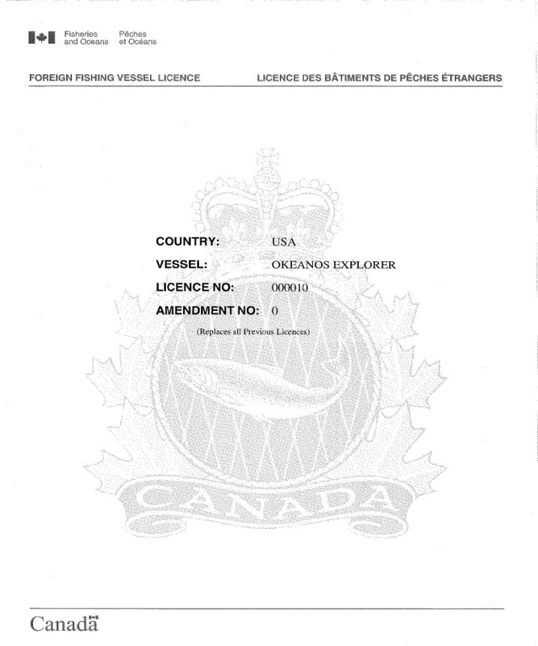

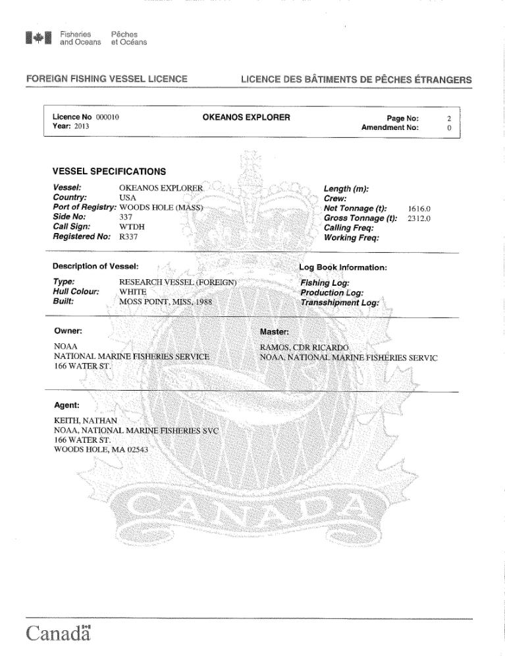

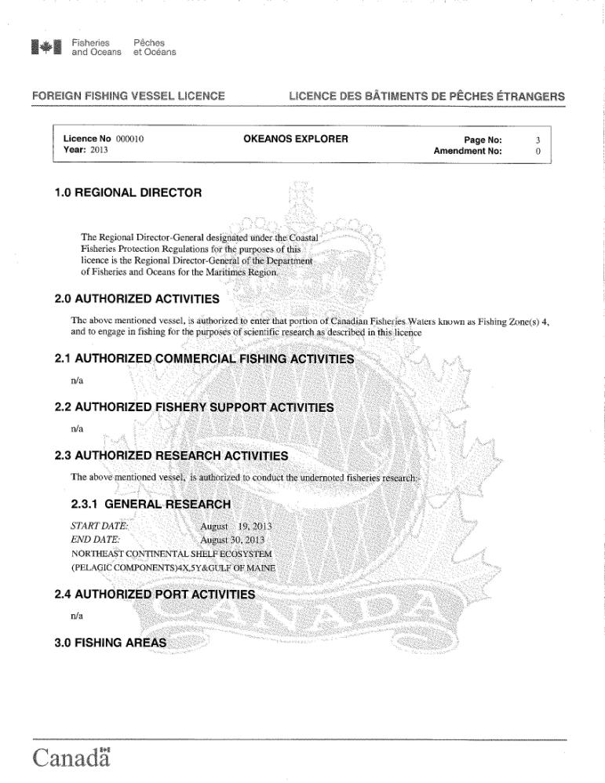

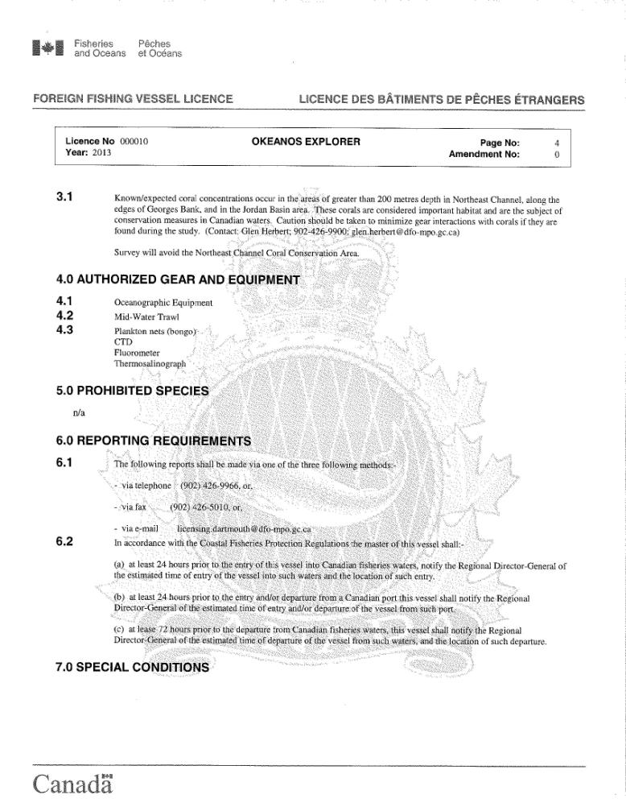

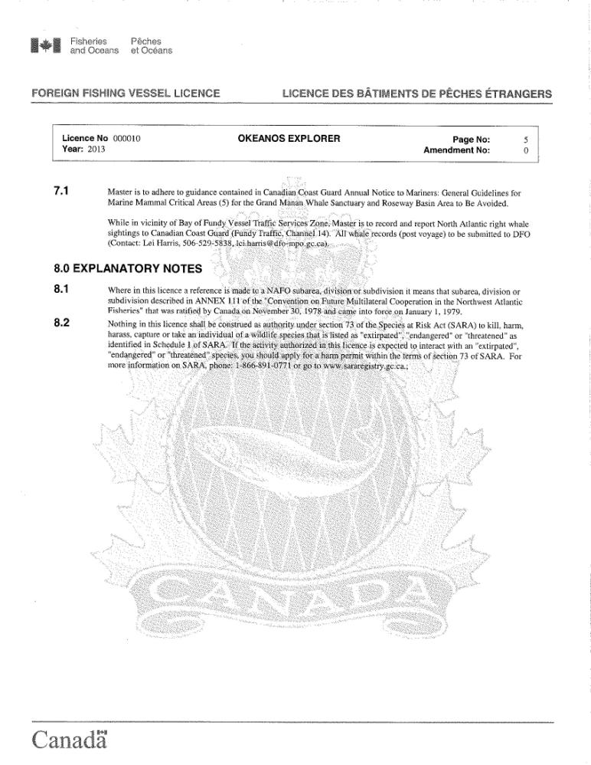

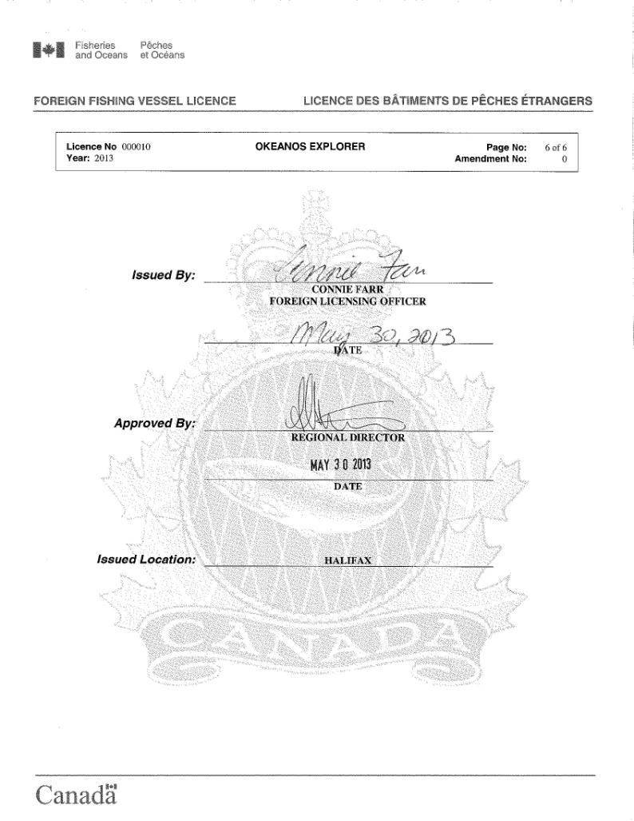

**Appendix E: EK 60 calibration report**

Okeanos Explorer EK60 calibration

Michael Jech, Joseph Godlewski

NEFSC, NMFS

The Simrad 18-kHz EK60 scientific echo sounder was calibrated at the Newport Naval anchorage in Narragansett Bay on 24 Aug. 2013. The Okeanos was anchored, 1-point anchor

from the bow, in approximately 35 m of water. The 18-kHz system was calibrated using a 64-

mm copper (Cu) sphere suspended underneath the split-beam transducer via three monofilament

lines. The transducer had nominally 11o beam width (full angular beam width as measured at the

half-power points). Transceiver settings, 1-ms pulse duration and 1 kW output power, were

selected as they matched data collected by the Northeast Fisheries Science Center (NEFSC)

during fisheries surveys. This was the first calibration of this system at these settings. As a result

of this calibration, the transducer gain was set to 21.53 dB and the “SaCorrection” was set to -

0.74 dB. These are modified from the default values of 22 dB and 0.0 dB for the transducer gain

and SaCorrection, respectively.

The calibration sphere was suspended and moved throughout the acoustic beam using a wireless

calibration system developed at the NEFSC. This system consists of three Cannon MAG-5HS

Downriggers connected to an NEFSC designed Calibration Control Box (P/N EK60WCAL-

10100) which provides power and control signals to the downrigger. (See Figure 1.) Each

calibration control box contains a custom designed circuit board that provides the control signals for downrigger movement, as well as circuitry to read the quadrature signals (SIGA and SIGB) from the 3PS Encoder P/N QUAD101-01-01-01. The downrigger control signals are wirelessly

transmitted to each calibration control box from a laptop PC in the Acoustics Lab of the research vessel. The control software ECHO_Cal is a JAVA-based GUI which allows the operator to

control the movement of the downriggers using either on-screen buttons, or a CH Products IP

Desktop joystick. The control software also provides an option to perform an automated

movement of the sphere through the transducer beam without operator interaction. All control

signals from the PC are transmitted wirelessly to each downrigger, eliminating the need to run

cables to each downrigger position from the Acoustic Lab.

