Okeanos Explorer ROV Dive Summary
Site Name | Nygren Canyon Shallow |  |  |  | 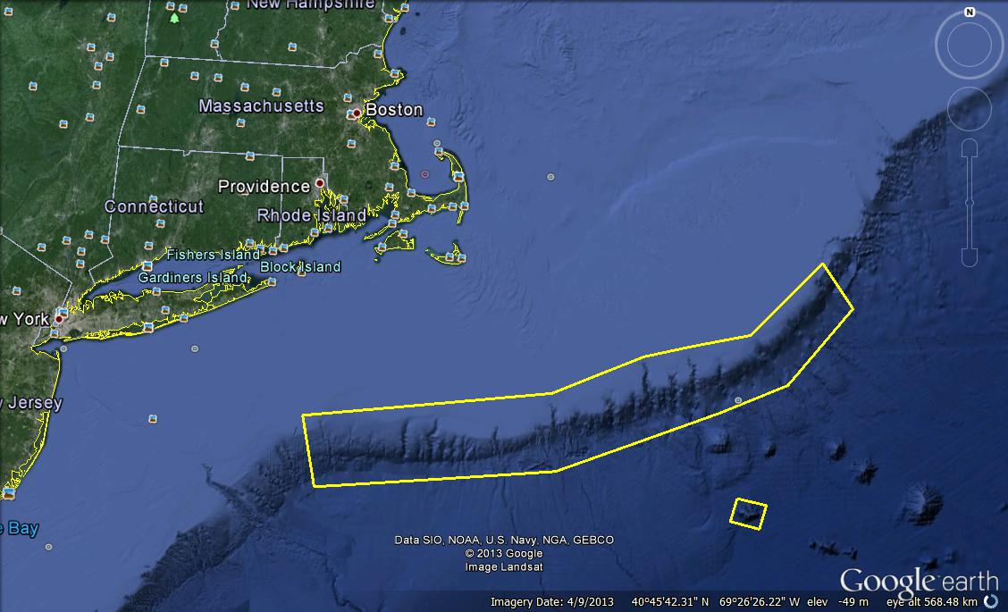
ROV Lead/Expedition Coordinator | David Lovalvo/  Brian Kennedy
Science Team Leads | Amanda Demopoulos  Martha Nizinski
General Area Descriptor | Northwest Atlantic Ocean;  Northeast U.S. Canyons
ROV Dive Name | Cruise Season |  | Leg |  |  | Dive Number
 | EX1304 |  | 2 |  |  | DIVE08
Equipment Deployed | ROV: |  | Deep Discoverer
 | Camera Platform: |  | Seirios
ROV Measurements | CTD |  | Depth |  |  | Altitude
 | Scanning Sonar |  | USBL Position |  |  | Heading
 | Pitch |  | Roll |  |  | HD Camera 1
 | HD Camera 2 |  | Low Res Cam 1 |  |  | Low Res Cam 2
 | Low Res Cam 3 |  | Low Res Cam 4 |  |  | Low Res Cam 2
Equipment Malfunctions
ROV Dive Summary  (From processed ROV data) | In Water at: 2013-08-08T14:49:35.498000  40°, 45.384' N ; 066°, 40.792' W  Out Water at: 2013-08-08T23:08:08.992000  40°, 45.234' N ; 066°, 40.281' W  Off Bottom at: 2013-08-08T22:44:25.085000  40°, 45.379' N ; 066°, 40.331' W  On Bottom at: 2013-08-08T15:25:31.341000  40°, 45.138' N ; 066°, 40.588' W  Dive duration: 8:18:33  Bottom Time: 7:18:53  Max. depth: 914.6 m
Special Notes | ROV went in the water a little later today due to swordfish gear in the dive site and technical issues with the ROV
Scientists Involved  (please provide name / location / affiliation / email) | Primary  Amanda Demopoulos (Science Lead), USGS, ademopoulos@usgs.gov  Amy Baco-Taylor, FSU, abacotaylor@fsu.edu  Andrea Quattrini, Temple, andrea.quattrini@temple.edu  Brian Kinlan, NOAA NOS, Brian.Kinlan@noaa.gov  Ellie Bors, WHOI, ekbors@gmail.com  Erik Cordes, Temple, ecordes@temple.edu  Jamie Austin, Texas, UTIG, jamie@ig.utexas.edu  Jason Chaytor, USGS, jchaytor@usgs.gov  Les Watling, UH, watling@hawaii.edu  Martha Nizinski (Science Lead), NOAA NMFS, nizinski@si.edu  Michael Vechione, NOAA NMFS, VecchioneM@si.edu  Nicole Morgan, FSU, nbmorgan11@yahoo.com  Peter Auster, UCONN, peter.auster@uconn.edu  Rhian Waller, U of Maine, rhian.waller@maine.edu  Robert Carney, LSU, rcarne1@lsu.edu  Santiago Herrera, WHOI, sherrera@whoi.edu  Taylor Heyl, WHOI, theyl@whoi.edu  Tim Shank, WHOI, tshank@whoi.edu  Passive  Brian Kennedy, NOAA OER, Brian.Kennedy@noaa.gov  Clara Smart, URI, clarajsmart@gmail.com  Erick Geiger, URI, egeiger@udel.edu  Kerry McCulloch, WHOI, mcculloc@uoregon.edu  Thomas Ritter, MSU, thomas.ritter@msu.montana.edu
Purpose of the Dive
The purpose of the dive was to characterize 1) the submarine canyon geomorphology and benthic habitats, including possible coral and sponge communities at a depth of ~1400-1700 m on the southwestern wall of Heezen Canyon and 2) groundtruth a model of predicted deep-sea coral occurrence.
Description of the Dive:
Dive # 8 was on a shallow section of the northeastern flank of Nygren Canyon. The ROV was on the bottom at 1526 UTC at 910 m depth. The dive track transited over soft sediment with large boulders to a steeply sloped terrain, with rocks that were heavily encrusted and layered with sediment. Various fauna populated the dramatic rock features throughout the dive. The edges of large rock ledges were colonized by high abundances of solitary corals, sponges, brisingid sea stars, and colonial scleractinians. Later in the dive, the following corals were observed: Acanella, Paramuricea, Jasonisis and Paragorgia on ledges or small sedimented patches. In some areas, there were large surfaces of the rocks encrusted with stoloniferous octocorals. At least 12 additional species of corals were documented, including 4 types of stoloniferans (Clavularia, white, pink, and yellow type), unknown bamboo, cup corals (at least 2 species), Solenosmilia, Lophelia pertusa, Parantipathes?, Anthomastus, and Anthothela. There were several examples of one coral colonizing another, including Anthothela on Paramuricea, and Anthothela on Paragorgia. As with the previous canyon dives, sea stars were diverse and included Chondraster, Tremaster, brisingids, and a yellow sea star. Squat lobsters appeared more abundant on sediment than corals, with a few individuals observed on Jasonisis that differed from the sediment associates. Red crabs were relatively abundant and 2 red crabs were noted eating a pyrosome (colonial, free floating tunicate). There seemed to be a higher diversity of shrimp, with multiple species observed on individual coral colonies. A high diversity of fish fauna was noted throughout the dive and included black dogfish, Antimora, synaphobranchid eels, rattails, Psychrolutidae (fathead), Sebastes, Helicolenus, Hoplostethus, Coryphaenoides, Symphurus, and Hydrolagus. A few highlights from the dive included a large parasitic isopod attached to Hoplostethus, which seemed to interfere with the fish’s ability to swim. Also, a Sebastes was observed eating another fish, with the tail sticking out of its mouth. Several shark egg cases were found attached to Paramuricea throughout the dive, which was the first time during this leg that this association had been noted. Overall, very few cephalopods were observed, including a bobtail squid, an unknown squid (possible Illex or Gonatus), and an octopus (Graneledone verrucosa). As we transited up slope, the rock wall appeared to be composed of sandstone, with patches of dark, manganese coated surfaces. As with our previous canyon dives, we found trash along the dive track, including plastic, traps, and coiled cord. The dive ended over soft sediments where burrows, red crabs, and a variety of fishes were observed. The ROV was off bottom at 661 m at 2240 UTC.

Overall Map of ROV Dive Area |  |  |  | Close-up Map of Main Dive Site
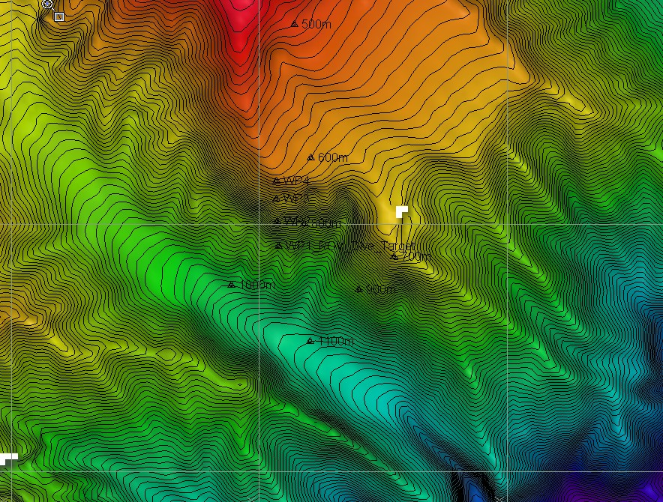 |  |  |  | 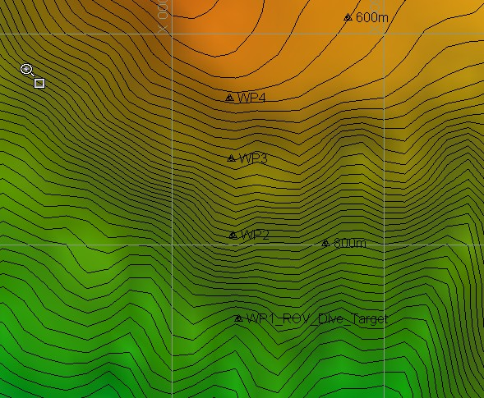
Representative Photos of the Dive
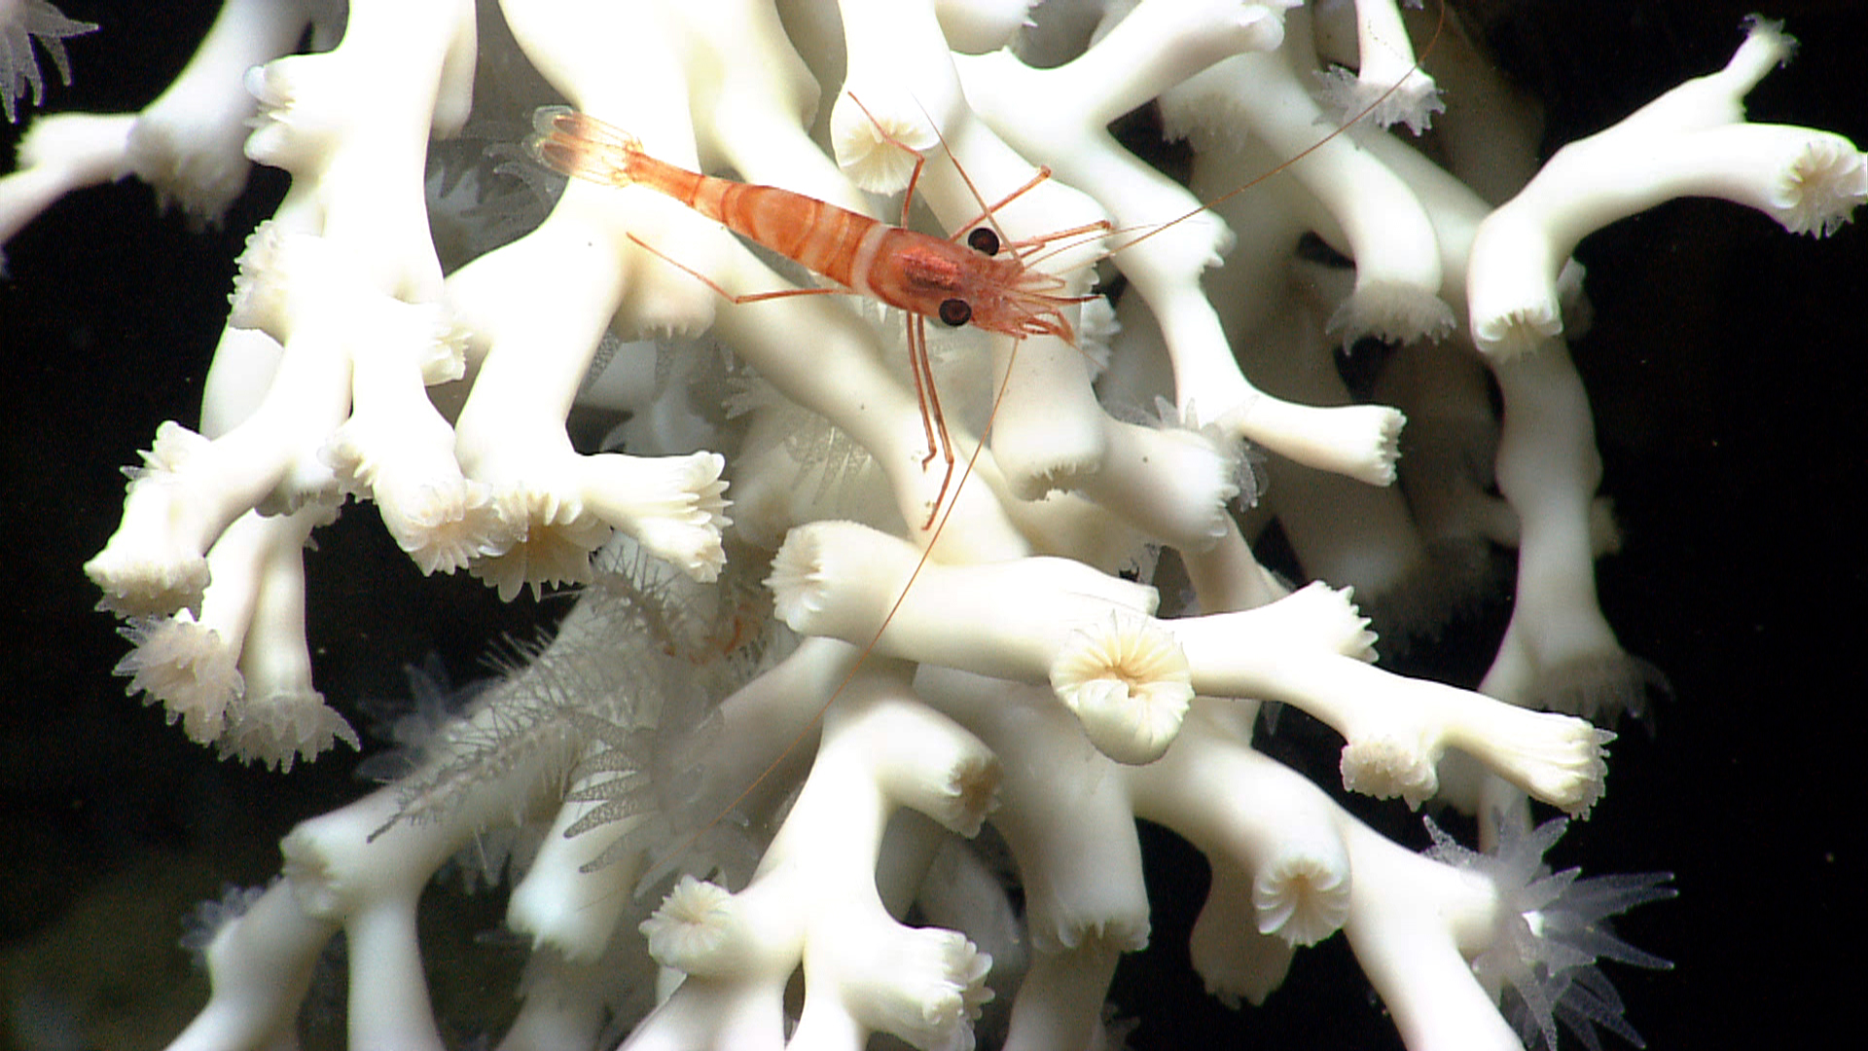 |  |  |  | 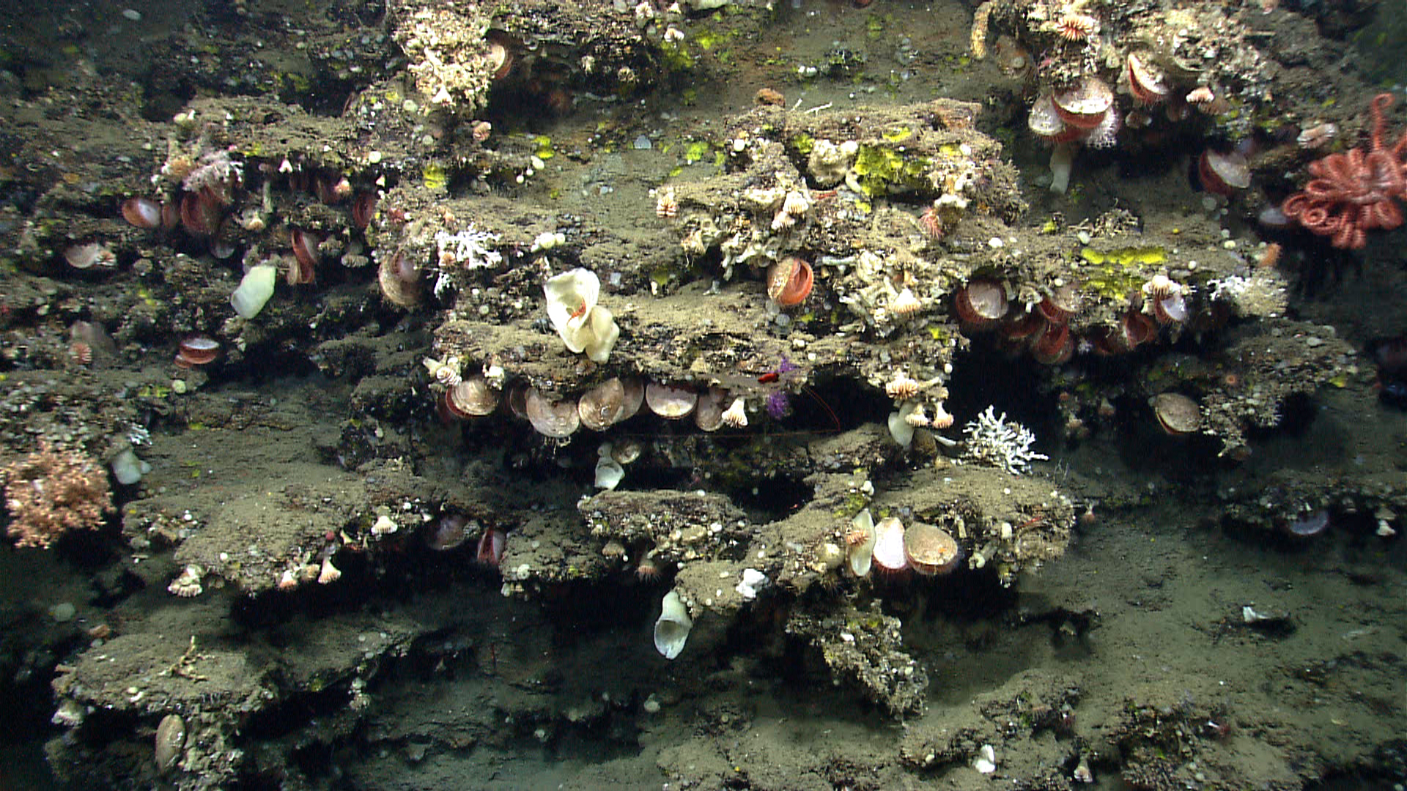
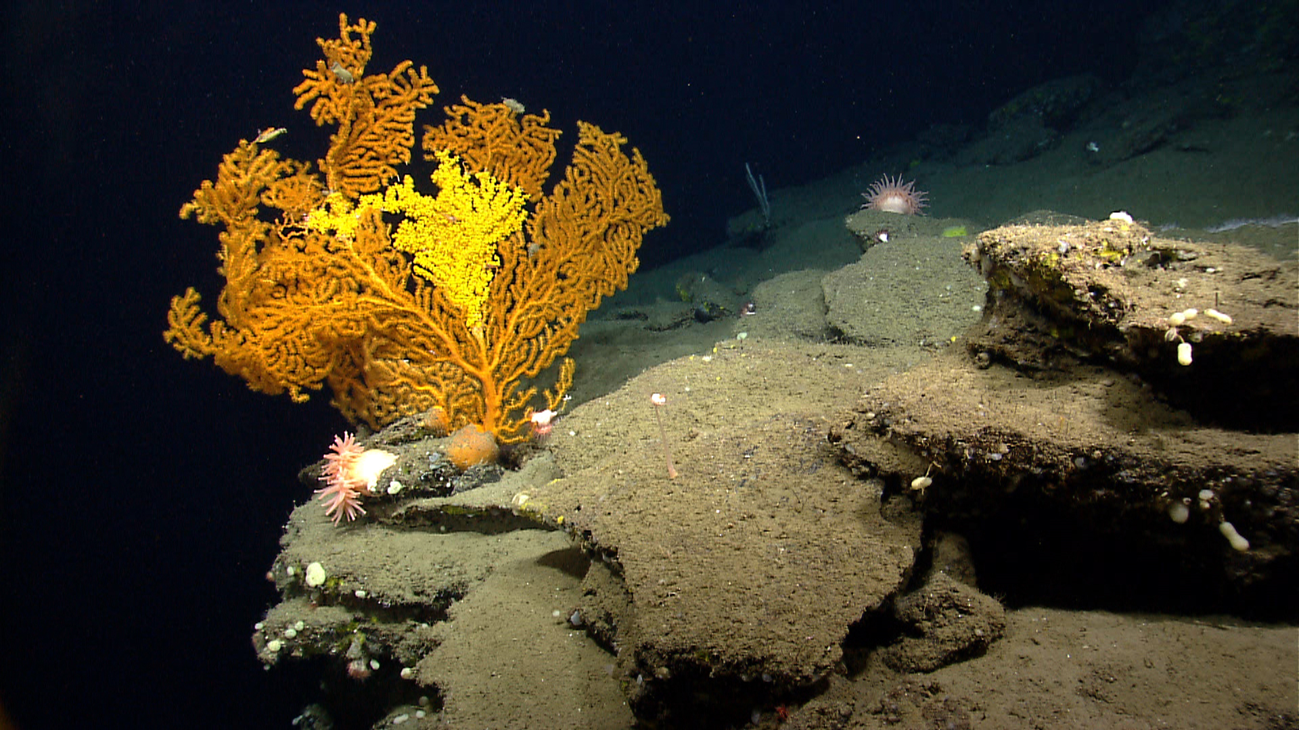 |  |  |  | 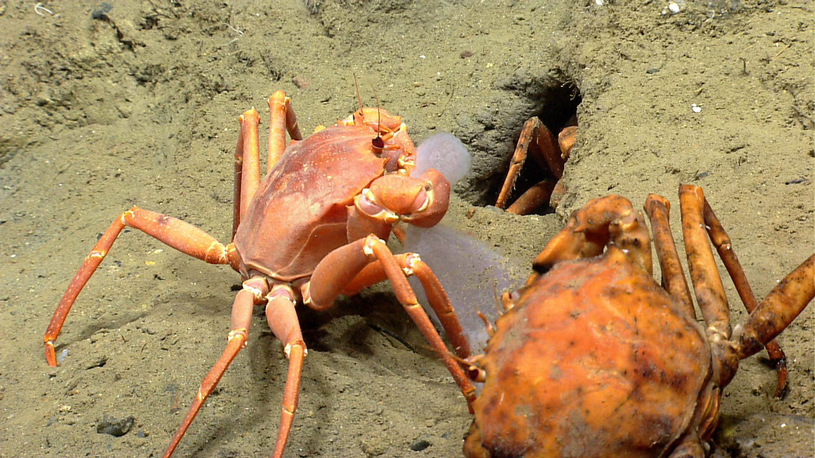
Please direct inquiries to: |  | NOAA Office of Ocean Exploration & Research  1315 East-West Highway (SSMC3 10th Floor)  Silver Spring, MD 20910  (301) 734-1014

